WHITEHAVEN TOWN COUNCIL

Minutes of the Policy and Resources and Finance Meeting held on 30th September 2019

Present: Councillor Hayes; Councillors Arrighi; Councillor O'Kane ; Councillor Walmsley

M Jewell, Clerk and Responsible Financial Officer V Gorley, Assistant Clerk
10/19 Apologies for Absence

There were no apologies for absence.

11/19 Appointment of Chairman

Councillor Walmsley nominated Councillor Hayes as Chairman and this was seconded by Councillor O'Kane.

RESOLVED - That Councillor Hayes be appointed Chairman for the year.

12/19 Appointment of Deputy Chairman

Councillor Hayes nominated Councillor Arrighi as Deputy Chairman and this was seconded by Councillor O'Kane.

RESOLVED - That Councillor Arrighi be appointed Deputy Chairman for the year.

13/19 Declarations of Interest

There were no declarations of interest.

14/19 Minutes of the meeting held on 25th September 2018

It was proposed by Councillor O'Kane and seconded by Councillor Hayes that the minutes held on 25th September 2018 be signed and approved by the Chairman as a correct record.

RESOLVED - That the minutes of the meeting held on 25th September 2018 be approved and signed by the Chairman as a correct record.

15/19 Public Participation

There was no public participation.

16/19 Finance Report

The Committee considered a finance report and budget monitoring figures which appeared to be on target and noted that there were some very small overspends and that it may be necessary to vire in future

- It was proposed by Councillor O'Kane and seconded by Councillor Maudling that a recommendation be made to full Council to approve and note the report.

RECOMMENDED - That a recommendation be made to Full Council that the Finance Report be approved and noted.

- It was proposed by Councill O'Kane and seconded by Councillor Arrighi that a small Working Group be formed comprising members on the Policy and Resources and Finance Committee to work on the budget for 2020/2021 and make recommendations to Full Council.

RECOMMENDED - That a Working Group be formed comprising those members on the Policy and Resources and Finance Committee to work on the budget for 2020/2021 and make recommendations to Full Council.

The Meeting closed at 6:45pm.

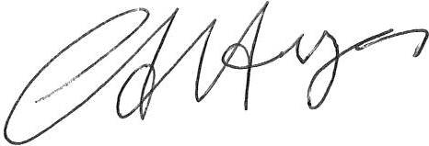
Chairman

