WHITEHAVEN TOWN COUNCIL

Clerk and Responsible Financial Officer: Marlene Jewell
Telephone: 01946 67366
Chairman: Councillor C Maudling

To: Members of Whitehaven Town Council

You are duly SUMMONED to attend a MEETING of WHITEHAVEN TOWN COUNCIL which will be held in THE BEACON PORTAL at THE BEACON, WHITEHAVEN on THURSDAY 29th September 2022 at 6:00pm

Signed. . --·Dated.rJ-. . . 22 Marlene Jewell, Clerk and Responsible Financial Officer

AGENDA

Apologies for Absence

- Declarations of Interest

To receive declarations of interest by elected Members in respect of Agenda items.

If a Member requires any advice on any item involving a possible declaration of interest which could affect his/her ability to speak and/or vote he/she is advised to contact the Clerk at least 24 hours in advance of the meeting.

- Public Participation

- Minutes of the Council Meeting held on 25th August 2022

- Planning Applications

- Finance Report

- Traders Christmas Market Enhancement

- Christmas Lights Switch On

- Quotes for Marquees 2023

- Quotes for Security for Events 2023

- Quote for Advertising in the Guide

- Quotes for Appointment of Internal Auditor

- Former Editor's Office

- Remembrance Sunday

- Allotments

- Quotes for Replacement Bulbs for Festoon

- Street Name and Numbering

- Recommendations from the Policy and Resources and Finance Committee - to follow

- Recommendations from Events Advisory Group for Events in 2023 - to follow

- Concerns about the level of Service provided to the people of Whitehaven by GP Practices and Dentists

- Councillor Ward Matters

- Date, Time and Place of Next Council Meeting

WHITEHAVEN TOWN COUNCIL

Minutes of the Council Meeting held on the 25th August 2022

Present: Councillor C Maudling (Chairman); Councillor E Dinsdale; Councillor R Gill; Councillor C Hayes; Councillor B O'Kane; Councillor G Roberts;

M. Jewell, Clerk and Responsible Financial Officer Member of the Public

2071/22 Apologies for Absence

Apologies for absence were received from:-

Councillor J Rayson Councillor G Dinsdale Councillor J Carr Councillor G Stevens Councillor R Redmond
On Holiday
Work Commitments Work Commitments Other Commitment On Holiday

It was proposed by Councillor Gill and seconded by Councillor Roberts
that the apologies for absence be accepted and noted. A vote was held and it was unanimously

RESOLVED - That the apologies for absence be accepted and noted

2072/22 Declarations of Interest

Councillor Maudling declared an interest in Agenda Item 5 as he was a member of CBC's Planning Panel
Councillor Roberts declared an interest that he was a member of CCC

2073/22 Public Participation

There was no public participation

2074/22 Minutes of the Council Meeting held on 28th July 2022

It was proposed by Councillor Gill and seconded by Councillor Hayes that the Minutes of the Council Meeting held on 28th July be approved
and signed by the Chairman as a correct record. A vote was held and it was unanimously

RESOLVED - That the Minutes of the Council Meeting held on 28th July 2022 be approved and signed by the Chairman as a correct record

2075/22 Annual Governance & Accountability Return For Year Ended 31st March 2022

The Clerk reported that the External Auditors PKF Littlejohn had completed the Annual Governance and Accountability Return for year ending 31st March 2022 and had issued their Report in the last couple of days. This had been previously circulated to Councillors at that time and the Chairman had given permission for it to be included on the Agenda. The Clerk reported that the Auditor's Report had stated that the Return by the Council was in accordance with Proper Practices and no other matters had come to their attention giving cause for concern that relevant legislation and regulatory requirements had not been met and that there were no other matters to be drawn to the attention of the Council. It was proposed by Councillor Gill and seconded by Councillor Maudling that a vote of thanks be given to the Officers for the meticulous way that they had dealt with this and that the External Auditor's Report be approved and noted. A vote was held and it was unanimously

RESOLVED - That a vote of thanks be given to the Officers for the meticulous way that they had dealt with this and that the External Auditor's Report be approved and noted.

2076/22 Planning Applications

The Council considered a list of Planning Applications received from CBC and shown at Appendix 1.

It was proposed by Councillor Roberts and seconded by Councillor Gill that CBC be informed that following consideration of the Planning Applications on Schedule 1 the Council had no representations to make
A vote was held and it was unanimously

RESOLVED - That CBC be informed that following consideration of the Planning Applications on Schedule 1 the Council had no representations to make.

2077/22 Finance Report

The Council considered a Finance Report.
  - Appendix 1 - The Clerk reported that there were 2 extra invoices to consider namely:

Stefan Gates

PKF Littlejohn, Auditors
£335.86 inc VAT - travelling expenses for Science Show - 625 miles @ 45p a mile

£1,200 External Audit Fee

It was proposed by Councillor Gill and seconded by Councillor Roberts
that the invoices on Appendix 1 plus the 2 additional invoices listed above be approved and paid. A vote was held and it was unanimously

RESOLVED - That the invoices on Appendix 1 plus the 2 additional invoices listed above be approved and paid.
- Appendices 2 and 3 - the Council considered Appendices 2 and 3 and it was proposed by Councillor Roberts and seconded by Councillor Hayes that these be approved and noted. A vote was held and it was unanimously
RESOLVED - That Appendices 2 and 3 be approved and noted.

2078/22 Code of Conduct
The Council considered a report on a new Code of Conduct which had recently been approved by CBC. CALC had previously advised that both Allerdale and Copeland were looking to adopt a new Code of Conduct which would be passed to Town and Parish Councils for them to adopt so that there would be a consistent approach. CALC have also advised that all local Councils should adopt the new Code of Conduct.
It was proposed by Councillor Gill and seconded by Councillor Hayes that in
order to have a consistent approach the new Code of Conduct shown at Appendix 1 be approved and adopted and replace the Council's current Code of Conduct. A vote was held and it was unanimously

RESOLVED - That in order to have a consistent approach the new Code of Conduct shown at Appendix 1 be approved and adopted and replace the Council's current Code of Conduct.

2079/22 Trees and Polytunnel on Allotment Plot
The Council considered a report on a request from an allotment tenant to install a polytunnel measuring 20ft(long)xl0ft(wide)xl0ft(high) on the allotment and to plant orange, lemon, lime and pineapple trees in the polytunnel and had stated that they would ensure that the mango and pineapple trees did not grow above 12ft. Councillors on the Allotment Advisory Group were contacted and agreed to

this but the site representative expressed concerns regarding the height of the mango and pineapple trees and if the tenant left the plot who would be responsible for the removal of the trees.
It was proposed by Councillor Gill and seconded by Councillor Hayes that the request be approved subject to the trees being monitored as they grew to maturity as it may well be at that time the Tenant be asked to remove them should there be a problem. A vote was held and it was unanimously

RESOLVED - That the request be approved subject to the trees being monitored as they grew to maturity as it may well be at that time the Tenant be asked to remove them should there be a problem.

2080/22 Representation on the West Cumbria Sites Stakeholder Group

The Council considered a report and heard a verbal report from Councillor E Dinsdale who had attended a meeting of the WCSSG meeting on 2nd August 2022 in the absence of Councillor Maudling who could not attend. Following a discussion it was proposed by Councillor E Dinsdale and seconded by Councillor Gill that a letter be sent to the Chairman and the Secretary of the WCSSG to formally request that the Council nominated person be appointed as the Council representative on the WCSSG. A vote was held and it was unanimously

RESOLVED - That a letter be sent to the Chairman and the Secretary of the WCSSG to formally request that the Council nominated person be appointed as the Council representative on the WCSSG.

Councillor O'Kane came into the Meeting

2081/22 Concerns about the level of service provided to the people of Whitehaven by GP Practices and Dentists

The Council considered a report on the level of service provided to the people of Whitehaven by GP Practices and Dentists and heard a verbal report by Councillor Gill. Following a discussion it was proposed by Councillor Gill and seconded by Councillor Hayes that a letter be sent to CBC urging them to set up an Overview and Scrutiny Task and Finish Group as a matter of urgency to look into the provision of GP and Dentistry practice within the Borough. A vote was held and it was unanimously

RESOLVED - That a letter be sent to CBC urging them to set up an Overview and Scrutiny Task and Finish Group as a matter of urgency to look into the provision of GP and Dentistry practice within the Borough.

2082/22 Zoom Renewal

The Clerk reported that the Zoom Licence expired on 30th September
2022 and the cost of renewal for a further year would be £119.00. Councillors felt that Zoom was a useful tool and it was proposed by Councillor E Dinsdale and seconded by Councillor Gill that the Zoom licence be renewed for a further year. A vote was held and it was unanimously

RESOLVED - That the Zoom Licence be renewed for a further year.

2083/22 Option to opt out of the SAAA Central External Auditor Appointment Arrangements

The Council considered an email from SAAA (Smaller Authorities Audit Appointments) informing the Council that the next 5-year appointing period runs from 2022-23 to 2026-27 and the email was to advise the Council that there was an option to opt out of the central procurement scheme for the next round of 5 year appointments and for a Council to appoint its own External Auditor and that notice to opt out had to be given before 28th October 2022. However the process and the requirements of opting out were quite onerous.
It was proposed by Councillor Gill and seconded by Councillor Roberts that the
status quo be maintained and that the Council does not opt out and continues to be part of the SAAA sector scheme led auditor appointment regime. A vote was held and it was unanimously

RESOLVED - That the status quo be maintained and that the Council does not opt out and continues to be part of the SAAA sector scheme led auditor appointment regime.

2084/22 Street Name and Numbering

The Council considered a report on requests from CBC for comments on proposed street name and numbering for 2 developments namely:-
- Former Romar Factory Ivy Mill Main Street Hensingham proposed to be called 1-278 Ivy Mills, Whitehaven and
- Land south of Waters Edge Close, Kells proposed to be called 1-33 Ladysmith Close, Whitehaven
Councillor Gill said both names were consistent with the areas where they were and it was proposed by Councillor Gill and seconded by Councillor O'Kane that the Council had no objections to the proposed street name and numbering for the 2 developments and that CBC be informed. A vote was held and it was unanimously

RESOLVED - That the Council had no objections to the proposed street name and numbering for the 2 developments and that CBC be informed.

2085/22 Consultation on Cumberland Local Plan

The Council considered a consultation document on the Cumberland Local Plan It was proposed by Councillor Gill and seconded by Councillor Roberts that it be left to individual Councillors to reply with their comments by Monday 5th September 2022. A vote was held and it was unanimously

RESOLVED - That it be left to individual Councillors to reply with their comments by Monday 5th September 2022.

2086/22 Councillor Ward Matters
- Councillor O'Kane said that he had asked about a month ago for the hedge at Victoria Road to be cut. He said it was grossly overhanging and was quite dangerous but yet again CBC had not done it
11. Councillor O'Kane said there were several instances of things not being collected again
u1. Councillor O'Kane commented about the hospital and said he had just come back from Carlisle and the road developments were now underway in the Bothel area and the traffic coming into our area to Carlisle and said that he counted over 300 cars and there was an emergency vehicle with blue lights flashing behind him and the vehicle somehow managed to weave in and out and get through the traffic lights. But at this time of night now an ambulance would have no chance whatsoever because both sides of the road would be gridlocked and there are going to be some really serious repercussions over the next 6 months with the state of that road
1v. Councillor Gill referred to the price of petrol now to get to Carlisle hospital. He said he had been told that because they were going to put drops in his eyes he wouldn't be able to drive which meant that someone would have to drive him or he would have to get public transport which wasn't good enough. He said it had been stated that it took over 45 minutes to get from WCH to Carlisle but that was door to door not bed to bed.
- Councillor E Dinsdale said he had had a telephone call from a resident
who lives at Maple Grove about street lighting and that he had taken a photograph of the street light. He said he thought it was CCC who had done that and said they had chopped it off the street light to base height level. The resident thought there had been a number of them done around the Corkickle area. The Clerk said that this had been discussed a couple of months ago and that CCC had informed the Council that every lamp post in Copeland had been surveyed and those that were dangerous had been chopped off and that there would be a 12 week lead in time for new street lights and when they were received they would be installed. Councillor E Dinsdale said he would inform the resident of this.
v1. Councillor E Dinsdale asked if it was mentioning about what was happening in the Waverly and Councillor Maudling said probably not as

this was Councillor Ward Matters and that it wasn't Councillor Dinsdale's Ward. Councillor Maudling said he thought it was his Ward and at the moment he had no comment because we didn't know anything about it because it had only come to light that week and we didn't know the result of anything or whatever meetings had taken place.
Councillor E Dinsdale said there were 2 key points around this
  - The consultation point and that he understood the process and that from what we could understand the Home Office had imposed this but ultimately for him he didn't personally agree with this but understood that he couldn't do anything about it
  - He said he would encourage all WTC Councillor to look at some of the crime figures that are related to Tangier Street where in 2019 there were 540 crimes reported near Tangier Street and there are only 8% of the streets in the UK that are regarded as more dangerous than this. Councillor E Dinsdale then read out the various types of crime in the area comprising the 540 and said his main point was that we will be receiving vulnerable adults who are not familiar with the UK never mind Whitehaven, never mind key areas of Whitehaven and asked if it was the right thing to do to be situating people in what is the crime hotspot for Cumbria and he questioned if this area was the right place. He said we have vulnerable people coming to this town and in his opinion they could be exploited. He encouraged all Councillors to look at the crime rates on crimerate.co.uk
v11. Councillor O'Kane said that if we didn't pass sensible comments on this we would be letting our residents down and that his only reservation was the location of that particular street and that we did not have full information
vm. Councillor Gill said the roads were getting worse. He said CCC had filled in some potholes but had left half of them. He said he had been told that they were not potholes but surface damage. He said it was just one big hole from one side of the road to the other. He said CCC Mike Hawkins was fighting to get the road repaired.

2087/22 Date Time and Place of next Meeting

The next Council Meeting would be on 29th September 2022 at 6.00pm at the Beacon Portal, Whitehaven.

IN PRIVATE
2088/22 That prior to the following items of business the Chairman moved the following resolution: -

That in view of the special or confidential nature of the business about to be

transacted it is advisable in the public interest that the public and or press be instructed to withdraw from the meeting.
Councillor Roberts proposed this and Councillor Hayes seconded it. A vote was held and it was unanimously

RESOLVED - That in view of the special or confidential nature of the business about to be transacted it is advisable in the public interest that the public and press be instructed to withdraw from the Meeting. All members of the public and press then left the Meeting.

2089/22 Grant Application - EOSG

The Council considered an Application for a Grant of £1,000 from EOSG
It was proposed by Councillor Gill and seconded by Councillor
Roberts that a Grant of £1,000.00 be not awarded to EOSG. A vote was held and it was unanimously

RESOLVED - that a Grant of £1,000.00 be not awarded to EOSG.

2090/22 Grant Application - WADAOS

The Council considered an Application for a Grant of£ 1,267.80 from WADAOS.
It was proposed by Councillor Gill and seconded by Councillor O'Kane that a grant of £1,000.00 be awarded to WADAOS. A vote was held and it was unanimously

RESOLVED - That a grant of£ 1,000.00 be awarded to WADAOS

2091/22 With the Chairman's permission the Clerk mentioned the following:­

Ouotes for Fire Safety Contractor

Further to Minute 2063/22 the Clerk reported that our Architects had received 2 quotes from Fire Safety Contractors. The first quote was for £7,850 and the second quote was for £9,350

It was proposed by Councillor Gill and seconded by Councillor Roberts that the quote of £7,850 be accepted. A vote was held and it was unanimously

RESOLVED - That the quote of £7,850 be accepted

The Meeting closed at 7.05pm

Chairman

WTC 29/09/2022

Item 5

Planning Application for Consideration by Whitehaven Town Council

Application Number
4/22/2332/0Fl

4/22/2341/OF1

4/22/2342/0AI

4/22/2344/0F1

4/22/2344/0Fl

4/22/2355/0FI
Detail
FULL PLANNING APPLICATION FOR 109 DWELLING HOUSES AND ASSOCIATED INFRASTRUCTURE INCLUDING LANDSCAPING, OPEN SPACES, ACCESS, HIGHWAY AND DRAINAGE

LAND TO THE WEST OF VALLEY VIEW ROAD, WHITEHAVEN

PROPOSED CHANGE OF USE OF VACANT SHOP UNIT WITH EXTENSIONS TO PROVIDE 2 NO. ONE BEDROOMED DISABILITY FLATS

IA WESTMORLAND ROAD, WHITEHAVEN

ERECTION OF 3 NO. ILLUMINATED FASCIA SIGNS

HOME BARGAINS, PRESTON STREET, WHITEHAVEN

RENEWAL OF FIRE ESCAPE WALKWAY & HANDRAIL (RETROSPECTIVE)

22 IRISH STREET, WHITEHAVEN

Consultation on updated description for Planning Application:
ROOF PLATFORM TO PROVIDE EXTENDED FIRE ESCAPE WALKWAY & HANDRAIL AND ACCOMMODATE FIRE ESCAPE LADDER (RETROSPECTIVE)

22 IRISH STREET, WHITEHAVEN

SINGLE STOREY SIDE AND REAR EXTENSION AND DEMOLITION OF EXISTING GARAGE,

Application Number Detail

FORMING STORAGE ROOM, ADDITIONAL BEDROOM WITH ENSUITE AND WARDROBE AND GARDEN ROOM WITH OUTDOOR COVERED SEATING AREA

25 STANDINGS RISE, WHITEHAVEN

4/22/2356/0F1

4/22/2357/0Ll

4/22/2360/TPO

4/22/2359/0F1

4/22/2374/0Fl
COVERT 7 BEDROOM HOUSE & GROUND FLOOR RETAIL AREA TO RETAIL ON GROUND FLOOR; 1 BEDROOM FLAT ON FIRST FLOOR; l BEDROOM FLAT ON SECOND FLOOR & A STUDIO FLAT IN LOFT

28 DUKE STREET, WHITEHAVEN

APPLICATION FOR LISTED BUILDING CONSENT (THERE ARE NO ALTERATIONS JUST REPLACING LIKE FOR LIKE) THE GLAZING WILL BE REPLACED AT THE TOP OF THE LIGHTHOUSE ON A LIKE FOR LIKE BASIS. THERE WILL BE LIKE FOR LIKE REPLACEMENT OF THE COPPER SHEETING OVER THE LANTERN ROOF. THE EXTERNAL STONEWORK WILL BE PAINTED TO PREVIOUS COLOURS.

WEST PIER LIGHTHOUSE, WHITEHAVEN

REMOVAL OF A HORSE CHESTNUT TREE PROTECTED BY A TREE PRESERVATION ORDER 5 MANOR GARDENS, WHITEHAVEN

ERECTION OF 24 NO. TWO BED BUNGALOWS, 4 NO. THREE BED BUNGALOWS AND 12 NO. TWO BED HOUSES AND ASSOCIATED WORKS

LAND AT FELL VIEW AND WINDERMERE AVENUE, WOODHOUSE, WHITEHAVEN

PROPOSED LIVING ROOM EXTENSION TO REAR TO CREATE A NEW BEDROOM, SHOWER ROOM AND UTILITY ROOM

Application Number Detail

34 NEWLANDS AVENUE, MIREHOUSE, WHITEHAVEN

4/22/2381/TPO
REDUCTION OF HEIGHT OF TREES SITUATED IN A CONSERVATION AREA

GLEN ARD, INKERMAN TERRACE, WHITEHAVEN

WTC 29/09/2022

Item 6

FINANCIAL REPORT

Purpose of the Report

Members are asked to consider a list of invoices for authorisation and payment as shown at Appendix 1 and approve the recommendations in paragraphs 3.1 and 3.2.

1.0 INTRODUCTION

  - Authorise the payment of all invoices as listed in Appendix 1.

  - The Council is asked to note the cashbook as reconciled with the bank account as shown at Appendix 2 together with income and expenditure at Appendix 3.

0 FINANCIAL POSITION

2. l The bank reconciliation was carried out on 21st September 2022. This shows a balance of £451,209.50. There are currently payments totalling £7,820.21 waiting to be cleared.

2.2 The balance in the deposit account is £453,327.71.

RECOMMENDATION

  - The invoices listed and shown in Appendix 1 be approved and authorised for payment.

  - The Cashbook (Appendix 2) and the Income and Expenditure (Appendix 3) be noted.

29/09/2022

Appendix 1

lnyp_ic _s_f_o_r_Co_o_s_i_d_e_(aj:_i_o_o_b_y_Whitehaven Town Council

Date | Supplier | Category |  | Detail | Total Amount |  | Power | Columnl
25/08/2022 | Eden Springs (UK) Ltd | Supplies & Services |  | Water Cooler Rental & Environmental Levy for water coolers (Aug 2022) | £ | 8.16 | slll LGA 1972
01/09/2022 | The Salway Hall | Premises |  | Room Hire for APM | £ | 120.00 | slll LGA 1972
03/08/2022 | AJ-Securitv (North) Ltd | Events |  | Provision of 2 x security personnel for 1 night on 28.07.2022 | £ | 504.00 | sl44 LGA 1972
06/09/2022 | Sharp Business Systems UK PLC | Supplies & Services |  | Photocopier Charges -19/07/2022 - 31/08/2022 | £ | 102.05 | slll LGA 1972
06/09/2022 | Copeland Borough Council | 3rd | Party | Grass Cutting Contract - September 2022 | £ | 2,045.51 | slll LGA1972
06/09/2022 | Copeland Borough Council | 3rd | Party | Allotment and Pigeon Loft Maintenance Contract - September 2022 | £ | 720.80 | slll LGA 1972
06/09/2022 | Copeland Borough Council | 3rd | Party | Ranger Contract - September 2022 | £ | 3,500.59 | slll LGA1972
06/09/2022 | Copeland Borough Council | 3rd Party |  | Assistant Ranger Contract - September 2022 | £ | 2,227.00 | slll LGA 1972
14/09/2022 | Lockhart Leisure Ltd | Events |  | Supply of 2 x marquee's for Market held on 25th August 2022 | £ | 1,944.00 | sl44 LGA 1972
22/09/2022 | Cumbria Media | Supplies & Services |  | Annual Website software, Annual accessibility software, website maintenance Job No's 443 -  447 | £ | 302.06 | slll LGA 1972

f 11,474.17

WHITEHAVEN TOWN COUNCIL CASH BOOK FROM 1 APRIL 2022

APPENDIX 2

Date
April-2022
01.04.2022
01.04.2022
01.04.2022
4 01.04.2022
s 01.04.2022

Ref Payee

BACS Eden Springs UK Ltd
BACS Sharp Business Systems UK Pie 1080 Copeland Borough Council 1081 Copeland Borough Council
1082 Copeland Borough Council

Employees/ Supplies/ Allowances Premises Services 3rd Party

1.80
51.35

Ground Grants Allotmts Maint

597.85

Civic
Hospitality Ranger/SO W.I.B

1832.52

Ward
Grants Elections

Environmental
Improvements Events Contingencies

Reserves Net Total VAT

£ 1.80 £
£ 51.35 £
f 597.85 f
£ 1,832.52 f

Total

0.36 £
10.27 £
119.57 £
366.50 f

2.16
61.62
717.42
2,199.02

Min. Ref. 1973/22 (i)
1973/22 (i)
1973/22 (i)
1973/22 (i)

6 01.04.2022
7 01.04.2022
BACS Mrs V Gorley BACS Mrs V Gorley

7.65
7.65
2771.20
£ 2,771.20 £
f 7.65
£ 7.65
554.24 £
£
£
3,325.44
7.65
7.65
1973/22 (i)
1973/22 (i)
1973/22 (i)

8 01.04.2022
9 01.04.2022
10 01.04.2022
BACS Westcom IT
1083 Copeland Borough Council BACS CALC

20.00

10603.75
270.00
£ 270.00 £
£ 10,603.75
£ 20.00
54.00 £ 324.00
£ 10,603.75
£ 20.00
1973/22 (i)
1973/22 (i)
1973/22 (i)

11 01.04.2022
12 01.04.2022
13 01.04.2022
14 01.04.2022
15 01.04.2022
16 06.04.2022
17 06.04.2022
18 06.04.2022
19 12.04.2022
20 13.04.2022
14.04.2022
14.04.2022
14.04.2022
21 19.04.2022
22 19.04.2022
May-2022
BACS Viking
BACS Mrs V Gorley BACS Mrs V Gorley BACS Mrs V Gorley BACS CALC
BACS The Fairly Famous Family Ltd
BACS Whitehaven and District Amateur Operatic Society BACS The Georgian House Hotel
DO Water Plus
BACS Newsquest Media Group BACS Staff
BACS HMRC
BACS Cumbria LGPS DD BTGroup
OD Crown Gas & Oil

184.44
15.15
99.79
20.00

5012.77
2020.75
768.14

329.41
60.72

219.00

73.43

1000.00

221.23

1350.00

100.00
£ 60.72 £
£ 184.44
£ 15.15
£ 99.79
£ 20.00
£ 1,350.00 £
£ 1,000.00
£ 100.00 £
£ 221.23
£ 219.00 £
£ 5,012.77
£ 2,020.75
f 768.14
f 73.43 f
f 329.41 f
12.14 £
£ f f
£
270.00 £
£
20.00 £
£
43.80 £

£
£
14.69 £
65.88 £

72.86
184.44
15.15
99.79
20.00
1,620.00
1,000.00
120.00
221.23
262.80
5,012.77
2,020.75
768.14
88.12
395.29
1973/22 (i)
1973/22 (i)
1973/22 (i)
1973/22 (i)
1973/22 (i)
1960/22 (2)
1985/22
1980/22 (iv)
Contract 1979/22
1931/21 (i)
HMRC 6317/17 (ii)
Contract Contract

23 04.05.2022
24 04.05.2022
25 04.05.2022
26 04.05.2022
27 04.05.2022
28 04.05.2022
29 04.05.2022
30 04.05.2022
31 04.05.2022
32 04.05.2022
33 04.05.2022
34 04.05.2022
35 04.05.2022
36 09.05.2022
13.05.2022
13.05.2022
13.05.2022
37 16.05.2022
38 17.05.2022
39 19.05.2022
40 28.05.2022
41 28.05.2022
42 28.05.2022
43 31.05.2022
44 31.05.2022
45 31.05.2022
46 31.05.2022
47 31.05.2022
48 31.05.2022
49 31.05.2022
so 31.05.2022
51 31.05.2022
52 31.05.2022
53 31.05.2022
54 31.05.2022
SS 31.05.2022
56 31.05.2022
57 31.05.2022
58 31.05.2022
59 31.05.2022
60 31.05.2022
61 31.05.2022
62 31.05.2022
63 31.05.2022
64 31.05.2022
65 31.05.2022
66 31.05.2022
67 31.05.2022
BACS Eden Springs UK Ltd
BACS Sharp Business Systems UK Pie BACS Thomas Graham & Sons Limited BACS Viking
BACS Viking BACS CALC
BACS Cumbria Media
1084 Copeland Borough Council 108S Copeland Borough Council
1086 Copeland Borough Council• VOID
1087 Copeland Borough Council 1088 Copeland Borough Council BACS Zurich Municipal
BACS Gifts 2 Impress Ltd BACS Staff
BACS HMRC
BACS Cumbria LGPS OD Crown Gas & Oil
1089 Copeland Borough Council OD BTGroup
OD Water Plus
OD Water Plus
OD Water Plus
BACS Eden Springs UK Ltd BACS Cumbria Loos
BACS Derwent RecyclingServices Ltd BACS Derwent Recycling Services Ltd BACS Derwent Recycling Services Ltd BACS Derwent Recycling Services Ltd 1090 Mrs Julie Hartley - VOID
1091 Copeland Borough Council 1092 Copeland Borough Council 1093 Copeland Borough Council 1094 Copeland Borough Council BACS Sharp Business Systems UK Pie BACS Support Warehouse Limited BACS Mrs V Gorley
BACS Mrs V Gorley BACS Mrs V Gorley BACS Mrs V Gorley BACS Mr CJ Hayes BACS Mr CJ Hayes BACS Mr CJ Hayes BACS Mr CJ Hayes BACS Viking
BACS Cumbria Media BACS PHP Architects Ltd
BACS POD (North West) Ltd

5012.16
2021.36
768.14

12.56
7.24

34.20
1.35
3.60
2.70

420.00

259.71

3391.00
1.80
44.56

32.90
44.90
1914.98
68.00

3157.29

72.81

1.80

49.04
87.20

159.00

94.30
68.00

179.00

600.67

53.05

13.34

240.00
240.00
240.00
240.00

600.67

1704.59

1704.59

1855.83

2917.16

2917.16
1855.83

661.60

349.00

20.33

500.00

£ 1.80 £
f 44.56 £
f 179.00 £
£ 32.90 £
£ 44.90 £
£ 1,914.98
£ 68.00
£ 1,704.59 £
£ 600.67 £

£ 1,855.83 £
£ 420.00 £
£ 3,157.29
£ 661.60 £
f 5,012.16
£ 2,021.36
£ 768.14
£ 259.71 £
£ 2,917.16 £
£ 72.81 £
£ 53.0S
£ 81.36 f
£ 13.34
£ 1.80 f
£ 349.00 £
£ 240.00 £
f 240.00 £
£ 240.00 £
£ 240.00 £

f 1,704.59 f
£ 600.67 f
£ 2,917.16 £
£ 1,855.83 £
49.04 £
87.20 £
12.56
£ 7.24
£ 20.33
£ 159.00
£ 34.20
£ 1.35
£ 3.60
£ 2.70
£ 94.30 £
£ 68.00
£ 3,391.00 £
£ 500.00 £

0.36 £
8.91 £
35.80 £
6.58 £
8.98 £
£
£
340.92 £
120.13 £

371.17 £
84.00 £
£
132.32 £
£
£
£
51.94 £
583.43 £
14.56 f
f
2.67 £
f
0.36 f
69.80 f
48.00 f
48.00 f
48.00 £
48.00 f

340.92 f
120.13 f
583.43 f
371.17 f
9.81 f
17.44 f
f f f
£
f f f f
9.36 £
f
678.20 f
100.00 f

2.16
53.47
214.80
39.48
53.88
1,914.98
68.00
2,045.51
720.80

2,227.00
504.00
3,157.29
793.92
5,012.16
2,021.36
768.14
311.65
3,500.59
87.37
53.05
84.03
13.34
2.16
418.80
288.00
288.00
288.00
288.00

2,045.51
720.80
3,500.59
2,227.00
58.85
104.64
12.56
7.24
20.33
159.00
34.20
1.35
3.60
2.70
103.66
68.00
4,069.20
600.00

1997/22 (i)
1997/22 (i)
1997/22 (i)
1997/22 (i)
1997/22 (i)
2000/22
1997/22 (i)
1997/22 (i)
1997/22 (i) VOID 1997/22 (i)
1997/22 (i)
1998/22
1997/22 (i)
1931/21(i) HMRC 6317/17 (ii)
Contract 1997/22 (i)
Contract
Contract Contract Contract 2014/22 (i)
2014/22 (i)
2014/22 (i)
2014/22 (i)
2014/22 (i)
2014/22 (i)

2014/22 (i)
2014/22 (i}
2014/22 (i)
2014/22 (i)
2014/22 (i)
2014/22 (i)
2014/22 (i)
2014/22 (i)
2014/22 (i)
2014/22 (i)
2014/22 (i)
2014/22 (i)
2014/22 (i)
2014/22 (i)
2014/22 (i)
2014/22 (i)
2014/22 (i)
2014/22 (i)

68 31.05.2022
69 31.05.2022
70 31.05.2022
June-2022
71 12.06.2022
72 13.06.2022
15.06.2022
15.06.2022
15.06.2022
73 17.06.2022
74 18.06.2022
75 19.06.2022
76 22.06.2022
77 22.06.2022
July-2022
78 05.07.2022
79 05.07.2022
80 05.07.2022
81 05.07.2022
82 05.07.2022
83 05.07.2022
84 01.07.2022
85 05.07.2022
86 05.07.2022
87 05.07.2022
88 05.07.2022

BACS The Community Centre. Red Lanning BACS Bee Unique
BACS The Community Centre - Red Lanning

BACS Water Plus
BACS Whitehaven Harbour Commissioners Car Park BACS Staff
BACS HMRC
BACS Cumbria LGPS BACS Mrs Julie Hartley DD Crown Gas & Oil DD BT Group
DD Water Plus
DD Water Plus

BACS Quality Cleaning & Contracting Ltd BACS Al-Security (North) Ltd
BACS Hampshire Flag Company
BACS Carlisle City Fire Protection 1095 Copeland Borough Council BACS Eden Springs UK Ltd
1096 DavidCallow BACS Mrs M Jewell BACS Mr CJ Hayes
BACS Al-Security (North) Ltd
BACS Lockhart Leisure Ltd

500.00

5012.56
2020.96
768.14

154.59

41.34

50.00
15.93

43.95

1.80

250.00

931.90

51.12

6.72

125.90

250.00

2500.00

585.00
385.00
350.74

19.10

23.22
945.00
2615.00
£ 250.00
£ 500.00
£ 931.90

£ 51.12
£ 2,500.00
5,012.56
£ 2,020.96
£ 768.14
£ 250.00
£ 154.59 £
£ 43.95 £
£ 41.34 £
£ 6.72

£ 585.00
£ 385.00 £
£ 350.74 £
£ 50.00 £
£ 15.93
£ 1.80 £
£ 19.10
£ 125.90
£ 23.22
£ 945.00 £
£ 2,615.00 £

£
£
£
£
£
£
7.73 £
8.79 £
1.34 £
£

117.00 £
77.00 £
70.15 £
10.00 £
£
0.36 £
£
£
£
189.00 £
523.00 £
250.00
500.00
931.90

51.12
2,500.00
5,012.56
2,020.96
768.14
250.00
162.32
52.74
42.68
6.72

702.00
462.00
420.89
60.00
15.93
2.16
19.10
125.90
23.22
1,134.00
3,138.00
Ward Grant Mayors Allowance Grant

Contract

1931/21(i) HMRC 6317/17 (ii)
replacement Contract Contract Contract Contract

2042/22 (i)
2042/22 (i)
2042/22 (i)
2042/22 (i)
2042/22 (i)
2042/22 (i)
2042/22 (i)
2042/22 (i)
2042/22 (i)
2042/22 (i)
2042/22 Ii)

89 05.07.2022
90 05.07.2022
91 01.07.2022
92 01.07.2022
93 01.07.2022
94 01.07.2022
95 01.07.2022
BACS BACS 1097
1098
1099
1100
1101
Quality Cleaning & Contracting Ltd Sharp Business Systems UK Pie Copeland Borough Council Copeland Borough Council Copeland Borough Council Copeland Borough Council
J & R Bennett

42.66

600.67

1704.59

2917.16
1855.83

4269.70
480.00
£ 480.00 £
£ 42.66 £
£ 1,704.59 £
£ 600.67 £
£ 2,917.16 £
£ 1,855.83 £
£ 4,269.70 £
96.00 £
8.53 £
340.92 £
120.13 £
583.43 £
371.17 £
853.94 £
576.00
51.19
2,045.51
720.80
3,500.59
2,227.00
5,123.64
2042/22 (i)
2042/22 (i)
2042/22 (i)
2042/22 (i)
2042/22 (i)
2042/22 (i)
2042/22 (i)

96 01.07.2022
97 01.07.2022
98 05.07.2022
99 05.07.2022
100 05.07.2022
101 05.07.2022
102 05.07.2022
1102 J & R Bennett 1103 J & R Bennett
BACS Fluid Productions Limited BACS Mrs V Gorley
BACS Cumbria Media
BACS Whitehaven Heritage Action Group BACS West Coast Surveys Ltd

6.98

550.00

148.00

1000.00
3030.00
85.80

1586.40
£ 3,030.00 £
£ 85.80 £
£ 1,586.40 £
£ 6.98
£ 148.00
£ 1,000.00
£ 550.00 £
606.00 £
17.16 £
317.28 £
£
£
£
110.00 £
3,636.00
102.96
1,903.68
6.98
148.00
1,000.00
660.00
2042/22 (i)
2042/22 (i)
2042/22 Ii)
2042/22 (i)
2042/22 (i)
Grant 2052/22

103 05.07.2022
104 13.07.2022
15.07.2022
15.07.2022
15.07.2022
BACS ZMCD Claims Recoveries Account DD Water Plus
BACS Staff BACS HMRC
BACS Cumbria LGPS

5041.99
1991.53
768.14

52.99
83.00
£ 83.00
£ 52.99
£ 5,041.99
£ 1,991.53
£ 768.14
£ 83.00
£ 52.99
£ 5,041.99
£ 1,991.53
£ 768.14
Refund
DD 1931/21(i) HMRC 6317/17 (i)

105 16.07.2022
106 19.07.2022
107 22.07.2022
108 22.07.2022
Aug-2022
109 01.08.2022
110 01.08.2022
111 01.08.2022
112 01.08.2022
113 01.08.2022
114 01.08.2022
115 01.08.2022
116 01.08.2022
117 01.08.2022
118 01.08.2022
119 01.08.2022
120 01.08.2022
121 01.08.2022
122 01.08.2022
123 01.08.2022
124 01.08.2022
125 01.08.2022
126 01.08.2022
127 12.08.2022
128 12.08.2022
129 14.08.2022
15.08.2022
15.08.2022
15.08.2022
130 15.08.2022
131 15.08.2022
132 19.08.2022
133 23.08.2022
134 23.08.2022
135 31.08.2022
136 31.08.2022
137 31.08.2022
DD DD DD DD

BACS 1104 BACS BACS BACS BACS BACS 1105
1106
1107
1108
1109
BACS BACS BACS BACS BACS BACS DD BACS DD BACS BACS BACS BACS 1110 DD DD DD BACS BACS BACS
Crown Gas & Oil BT Group Water Plus Water Plus

Beck Bottom Community Garden Group Copeland Borough Council
Eden Springs UK Ltd
Al-Security (North) Ltd Deborah McKenna Ltd Lockhart Leisure Ltd
Sharp Business Systems UK Pie Copeland Borough Council Copeland Borough Council Copeland Borough Council Copeland Borough Council Copeland Borough Council Mrs V Gorley
Cleator Moor Brass
Mr Charles E Maudling Mr Charles E Maudling Mrs V Gorley
Fluid Productions Limited Water Plus
Whitehaven Theatre Group Crown Gas & Oil
Staff HMRC
Cumbria LGPS R Shilling
The Mayor Of Carlisle's Charity Fund BTGroup
Water Plus Water Plus
Eden Springs UK Ltd Copeland Borough Council Al-Security (North) Ltd

4.49

49.00
35.50

5042.38
1991.14
768.14

30.00
115.93

68.94

15.93

80.94

44.23

123.31

31.02

25.00

15.93

21.14

102.90

6.80

20.00

1000.00

32.26

600.67

51.12

6.72

1704.59

2917.16
1855.83

736.31

2310.00
1250.00
1690.00

200.00

827.70

400.00

420.00
£ 115.93 £
£ 123.31 £
£ 68.94 £
£ 32.26

£ 736.31
£ 15.93
£ 31.02 £
£ 2,310.00 £
£ 1,250.00 £
£ 1,690.00 £
£ 25.00 £
£ 1,704.59 £
£ 600.67 £
£ 2,917.16 £
£ 1,855.83 £
£ 15.93
£ 4.49
£ 200.00
£ 49.00
£ 35.50
£ 21.14
£ 827.70 £
£ 51.12
£ 1,000.00
£ 80.94 £
£ 5,042.38
£ 1,991.14
£ 768.14
£ 400.00
£ 30.00
£ 102.90 £
£ 44.23 £
£ 6.72
£ 6.80 £
20.00
420.00 £
5.80 £
24.66 £
4.74 £
£

£
£
6.20 £
462.00 £
250.00 £
338.00 £
5.00 £
340.92 £
120.13 £
583.43 £
371.17 £
£
£
£
£
£
£
165.54 £
£

4.05 £
£
£
£
£

20.58 £
1.69 £
£
1.36 £
£
84.00 £
121.73
147.97
73.68
32.26

736.31
15.93
37.22
2,772.00
1,500.00
2,028.00
30.00
2,045.51
720.80
3,500.59
2,227.00
15.93
4.49
200.00
49.00
35.50
21.14
993.24
51.12
1,000.00
84.99
5,042.38
1,991.14
768.14
400.00
30.00
123.48
45.92
6.72
8.16
20.00
504.00
Contract Contract Contract Contract

Ward Grant 2061/22(i)
2061/22(i)
2061/22(i)
2061/22(i)
2061/22(i)
2061/22(i)
2061/22(i)
2061/22(i)
2061/22(i)
2061/22(i)
2061/22(i)
2061/22(i)
2061/22(i)
2061/22(i)
2061/22(i)
2061/22(i)
2061/22(i)
Contract 2069/22
Contract 1931/21(i) HMRC 6317/17(i)
2054/22
Mayors Allowance Contract Contract Contract

£ 1,620.00 £ 324.00 £ 1,944.00
138 | 31.08.2022 | BACS | Lockhart Leisure Ltd |  |  |  |  |  |  |  |  |  | 1620.00
139 | 31.08.2022 | BACS | Sharp Business Systems UK Pie |  |  | 28.49
140 | 31.08.2022 | BACS | Mrs M Jewell |  |  |  |  |  |  | 33.95
141 | 31.08.2022 | BAC5 | Stobbarts Limited |  | 950.00
142 | 31.08.2022 | BACS | Cumbria Media |  |  | 72.00
143 | 31.08.2022 | BACS | Viking |  |  | 49.90
144 | 31.08.2022 | 1111 | Copeland Borough Council |  |  |  |  |  | 1704.59
145 | 31.08.2022 | 1112 | Copeland Borough Council |  |  |  |  | 600.67
146 | 31.08.2022 | 1113 | Copeland Borough Council |  |  |  |  |  |  |  | 2917.16
147 | 31.08.2022 | 1114 | Copeland Borough Council |  |  |  |  |  |  |  | 1855.83 |  | 296.55
148 | 31.08.2022 | BACS | Deborah McKenna Ltd
149 | 31.08.2022 | BACS | PKF Littlejohn LLP |  |  |  | 1000.00
 | Sept-2022
150 | 13.09.2022 | DD | Waterplus Ltd |  |  |  |  | 52.99
 | 15.09.2022 | BACS | Staff | 5041.98
 | 15.09.2022 | BACS | HMRC | 1991.54
 | 15.09.2022 | BACS | Cumbria LGPS | 768.14
151 | 15.09.2022 | BACS | Mirehouse AFC Youth |  |  |  |  |  |  |  |  | 500.00
152 | 16.09.2022 | DD | Crown Gas & Power |  | 75.03
153 | 19.09.2022 | DD | BT Group |  |  | 102.27

£ 28.49 £ 5.70 £ 34.19
£ 33.95 £ 33.95
£ 950.00 £ 190.00 £ 1,140.00
£ 72.00 £ 72.00
£ 49.90 9.98 £ 59.88
£ 1,704.59 £ 340.92 2,045.51
£ 600.67 £ 120.13 £ 720.80
£ 2,917.16 583.43 £ 3,500.59
£ 1,855.83 £ 371.17 £ 2,227.00
£ 296.55 £ 59.31 £ 355.86
£ 1,000.00 £ 200.00 £ 1,200.00

£ 52.99 £ 52.99 Contract
£ 5,041.98 £ 5,041.98 1931/21(i)
£ 1,991.54 £ 1,991.54 HMRC
£ 768.14 £ 768.14 6317/17 (i)
£ 500.00 £ 500.00 Ward Grant
£ 75.03 3.75 £ 78.78 Contract
£ 102.27 £ 20.45 £ 122.72 Contract

£ 15,232.88 £ 165,695.84
47852.26 17248.09 | 7288.05 | 1449.00 | 3931.90 | 5102.74 | 8522.95 | 159.85 | 28468.67 | 7385.50 1486.31 | 0.00 | 83.00 | 21484.64 | 0.00 | 0.00 | £ 150,462.96

WHITEHAVEN TOWN COUNCIL Appendix 3

INCOME 2022-2023
Date | Item | Precept | Interest | Other
01.04.2022 | Allotment Rents 2022/2023 |  |  | 3318.33
 | Zurich Insurance {Claim for damaged bus
12.04.2022 | shelter) |  |  | 83.00
13.04.2022 | HMRC - VAT Refund {March) |  |  | 8862.83
 | Zurich Insurance {Claim for damaged bus
20.04.2022 | shelter) |  |  | 83.00
21.04.2022 | Allotment Rents 2022/2023 |  |  | 977.50
22.04.2022 | Precept 2022/2023 | 455593.93
04.05.2022 | Allotment Rents 2022/2023 |  |  | 260.00
09.05.2022 | Allotment Rents 2022/2023 |  |  | 20.00
11.05.2022 | Thomas Graham credit returned |  |  | 156.55
16.05.2022 | Cheque 1086 returned |  |  | 3500.59
06.06.2022 | Donation from Taylors Fair |  |  | 2500.00
17.06.2022 | HMRC - VAT Refund {May) |  |  | 2711.44
27.06.2022 | HMRC - VAT Refund (April) |  |  | 1974.65
20.07.2022 | Allotment Rents 2022/2023 |  |  | 153.00
28.07.2022 | HMRC - Vat Refund {June) |  |  | 4336.13
29.07.2022 | Sellafield Ltd {Sponsorship} |  |  | 3500.00
12.08.2022 | Allotment Rents 2022/2023 |  |  | 40.00
09.09.2022 | HMRC - VAT Refund {August) |  |  | 2328.27
455593.93 0.00 I 34805.29 1490399.22 I

WHITEHAVEN TOWN COUNCIL
SUMMARISED INCOME& EXPENDITURE STATEMENT FINANCIAL YEAR 2022-2023
Expenditure Net of VAT
Invoices not yet processed Budget

BANK BALANCES BROUGHT FORWARD CBS 53905917 (01.04.2022)
CBS 53906216 (01.04.2022)
TOTAL OPENING BALANCE

INCOME:
Precept
Interest (Deposit) Other Income TOTALINCOME

118,685.91
453,327.71
£ 572,013.62

455,593.93

34,805.29
£ 490,399.22

EXPENDITURE
Employees & Allowances Premises Supplies/Services
3rd Party Grants Allotments
Ground Maintenance Civic Hospitality Ranger
Whitehaven In Bloom Ward Grants Elections
Environmental Improvements Events
Contingencies Reserves
VAT (to be reclaimed)
TOTAL EXPENDITURE

CASH BOOK BALANCE
Brought forward Income Expenditure
Town Council Funds

BANK BALANCES
CBS 53905917 (21/09/2022)
CBS 53906216 (21/09/2022)

Unpresented Cheques 2022/2023

FINANCIALPOSITION

47852.26
17248.09
7288.05
1449.00
3931.90
5102.74
8522.95
159.85
28468.67
7385.50
1486.31
0.00
83.00
21484.64
0.00
0.00
15232.88
£ 165,695.84

£ 572,013.62
£ 490,399.22
£ 165,695.84
I £ 896,111.00 1

451,209.50
453,327.71
1£ 904,s31.21 1
7,820.21

I £ 896,111.00 I

WTC 29/09/2022

Item 9

QUOTATIONS FOR MARQUEE HIRE IN 2023

Purpose of the Report and Recommendation

To consider quotes received from companies to hire marquees for events organised by the Council during 2023.

1.0 INTRODUCTION

    - A number of events are being planned for 2023 for which marquees will be required.

    - Quotes have been sought from 4 companies. Each have been asked to provide a quote for hire of:

      - All size of marquees available to hire;
      - Flooring (suitable for a grassed area);
      - Chairs;
      - Rectangular Tables;

    - Two companies submitted quotes which are attached at Appendix 1. One company did not respond and one company declined to submit a quote as they did not have availability on some of the event dates.

0 RECOMMENDATION

    - Members are asked to consider the quotes received and decide which quote they wish to accept.

l!'irC 29 /09 I2022.
lteVV\ 9
Appe.Ad;',( I ·

Reference number: LLL2004467 Vanessa Gorley

Whitehaven Town Council marquee requirements 2023

1 - 6 x 12 metre clear span framed marquee £675.00 1 - 6 x 15 metre clear span framed marquee £850.00
1- 6 x 18 metre clear span framed marquee £995.00

1- 9 x 12 metre clear span framed marquee £925.00

- - 9 x 15 metre clear span framed marquee £1095.00

- - 9 x 18 metre clear span framed marquee £1300.00

- - 9 x 15 solid flooring inclusive of used carpet. £545.00

Plastic bistro chairs £1.50 each

6 foot trestle tables £6.50 each

4 foot trestle tables £6.00 each

That's brilliant, thank you. Please see quote details below.
Frame Marquees (pinned to grass):
- 6m x 15m Frame marquee (1 truck): £962.55 + Vat
- 6m x 18m Frame marquee (1 truck): £1,118.95 + Vat
- 9m x 15m Frame marquee (1 truck): £1,355.85 + Vat
- 9m x 18m Frame marquee (1 truck): £1,591.60 + Vat

Wooden flooring:
- 6m x 15m (1 truck): £784.30 + Vat
- 6m x 18m (1 truck): £906.20 + Vat
- 9m x 15m (1 truck): £1,089.05 + Vat
- 9m x 18m (1 truck): £1,177.60 + Vat

Delivery/collection charge:
- £369.60 + Vat per truck

All prices are subject to Vat, our site visit & availability.

WTC 29/09/2022

Item 10

QUOTES RECEIVED FOR SECURITY PROVISION AT TOWN COUNCIL EVENTS
Purpose of the Report

To inform Members of a quote received for security provision at events organised by the Council and to consider the quote and appoint the security provider.

1.0 INTRODUCTION

  - The Council are arranging a number of events for 2023 comprising of:

    - Traders Markets on the last Friday of every month commencing May 2023 to August 2023 and a Christmas market in December 2023;
    - Science show in June 2023;
    - Harbour events in partnership with Harbour Commissioner;
    - Proposed Summer Fair in July 2023
    - Other events not yet scheduled.

1.2 Two security personnel would be required for overnight security and at other times during these events. Quotes have been sought for the hourly rate of each personnel for the provision of security from reputable firms. Despite reminders being sent only one firm submitted a quote. The hourly rate quoted was for £17.50 +VAT.

2.0 RECOMMENDATION

  - Members are asked to accept the quote received and appoint the security provider.

WTC 29/09/2022

Item 11

ADVERTISING IN THE CUMBRIA GUIDE

Purpose of the Report

To consider an email received from Steven Murphy, the Managing Director of The Cumbria Guide as to whether the Council would like to continue advertising in The Cumbria Guide in 2023/24 and to make a decision on this.

  - INTRODUCTION

  - Attached at Appendix 1 is an email from Stephen Murphy, the Managing Director of The Cumbria Guide asking if the Council would like to continue advertising in The Cumbria Guide in 2023/24 and the giving costs involved. The Council has advertised in the Cumbria Guide for a number of years.

  - The present contract with The Cumbria Guide which is for a full page spread costing £3,690.00 expires in March 2023.

  - As Members will see from Appendix 1 there are 3 packages. At present the Council contracts for 6 full page adverts which includes artwork and design (the Cumbria Guide is issued every 2 months). It is suggested that if Members wish to continue to advertise in the Cumbria Guide in 2023/24 that the
full page package be chosen at a cost of £3,690.00.

  - Members will note that the cost for 2023/24 for a full page spread is the same as it was for 2022/23 on the basis that the Council agrees to "book in" and agree a package now.

  - The Cumbria Guide is free and is widely circulated throughout Cumbria to shops, hotels etc.

RECOMMENDATION

  - That the Council considers the email and makes a decision as to whether or not to continue to advertise in the Cumbria Guide and if so which package to choose.

Whitehaven Town Council
w-Tc· icr{oq /22.
ITevl l t
kPP 'j:._ l

From: Sent: To: Subject:
Stephen James Murphy <stephen@theguidemediagroup.com> 02 September 2022 10:40
Whitehaven Town Council Stephen Cumbria Guide

Hi Marlene,

Nice catching up again yesterday.
Below are the current Advertising rates for 12 months. Double Page Spread - £5607.00
Full Page £3690.00 ( This is what we ran last year and this year) Half Page £2700.00
All prices are subject to vat where applicable - the above includes art work design and social media support across
all of our platforms.

It has been really awesome to see this market become what it is and the most recent really stirred up a lot of positive chit chat online creating alot of positivity for the town.

Regards to the support from yourselves at WTC, it has been greatly appreciated.

As for the costs set out - I have mentioned Current rates, simply we know price hikes are coming so these may change which I am sure everyone around the table will appreciate.

If you are confident that you would like to proceed with ourselves in a similar format, and book in - then these prices will be fixed as set out.

I'll leave it with you, once again, Thank you for your support as it has been a real pleasure working with you all once again.

Many Thanks Stephen

Stephen Murphy
Business Development Manager
www.cumbriaguide.co.uk
T: 01946 448045 M:07764948613
Facebook lnsta Twitter

The Guide Media Group publishers ofThe Cumbria Guide
CREATIVE DESIGN SOLUTIONS I WEB I PUBLISHING I PRINT

"Top quo/ity free mogo1/.ine.Ji1ntostic company to deal with. 5* recommended. wish more company's were like this x"
Jennifer Nichol Cathedral Antiques Carlisle

WTC 29/09/2022

Item 12

QUOTES FOR APPOINTMENT OF INTERNAL AUDITOR

Purpose of the Report

For members to consider quotes received for the provision of an internal audit service to the Council and to recommend an appointment.

  - INTRODUCTION

  - The Accounts and Audit Regulations 2015 impose a duty on parish councils to maintain an adequate and effective system of internal audit of its accounting records and of its systems of internal controls. The internal auditor is a key part of the Council's internal records.

  - The internal auditor must be both competent and independent from the Council and an internal audit has to include both financial and procedural controls.

  - A strong internal audit will check that the Council has strong processes and controls not only over money but over all areas to help ensure the Council operates legally and complies with all relevant legislation.

  - A good internal audit will come in two parts done at different times of the year and: -

    - Is usually done part way through the financial year in October/November and is mainly an audit of the Council's processes and procedure;
    - It may also include an audit of the transactions to ensure the completeness of the Council's records;
    - The final audit is done after the year end so that balances within the accounts may be verified and that any problems

found at the interim audit have been addressed by the Council;
    - The internal auditor reports to the Council and will submit a written report to the Council after both audits.

QUOTES RECEIVED FOR THE INTERNAL AUDIT SERVICE

  - The Council has asked for quotes for the provision of an internal audit service (two internal audits) for 2022/2023 from competent and experienced people. 2 quotes were received:

    - Quote A was for £250 plus mileage at standard rate of .45p per mile (approximate calculation would be £30.60 for each return journey). This person is Clerk to a Parish Council and has performed audits for one other Town Council.
    - Quote B was for £550. This person was recommended by CALC and has recognised Accountancy qualifications.

3.0 RECOMMENDATION

That members consider the quotes received and appoint an internal auditor.

WTC 29/09/2022

Item 13

LEASE OF FORMEREDITORS OFFICE
Purpose of the Report

To inform Members That Notice has been received from Newsquest's Solicitors terminating the Lease of the Former Editors Office on 30th November 2022.

  - INTRODUCTION

  - Members will recall that the Council entered into a Lease on 10th January 2022 with Newsquest in respect of the Former Editors Office in our building.

  - Newsquest subsequently decorated the office and installed furniture and their own internet connection but have never used the office.

  - Notice has now been received from Newsquest's solicitor to terminate the Lease on 30th November 2022. The office equipment will be removed after that date.

  - The reason for the termination of the Lease is that the editorial structure has been changed and that going forward the office will no longer be required as staff will be working from home.

  - RECOMMENDATION

  - That the Council notes the position.

WTC 29/09/2022

Item 14

REMEMBRANCE SUNDAY 2022

Purpose of the Report

For Members to consider a report on the preparations for Remembrance Sunday and consider the proposals.

1.0 INTRODUCTION

  - Remembrance Sunday 2022 will take place on Sunday 13th November 2022.

  - The procession will meet outside The Copeland Centre, Catherine Street, Whitehaven from I0:00am onwards and then proceed to The Cenotaph in Castle Park, Whitehaven for a short service and the laying of wreaths. The procession will then parade through the town to the United Reform Church, James Street, Whitehaven for the Remembrance Sunday Service.

  - Two Road Closure Applications have been submitted to Copeland Borough Council for Lowther/Catherine Street and Market Place in Whitehaven.

  - Event Poppies will be installed on lamp posts along the Parade Route.

  - The Council has ordered 3 poppy wreaths from the Royal British Legion. One wreath is laid at the Cenotaph in Whitehaven by our Mayor and one wreath is laid at Hensingham and one wreath is laid at Sandwith.

A minimum donation of £18.50 per wreath has been suggested by the co-ordinator. This amount covers the cost of manufacturing and delivery, any amount over this is given to the Poppy Appeal.

  - The United Reform Church have kindly informed us that the hall is available for the serving of refreshments and that there will be no charge for doing this.

  - Tea, coffee and biscuits have been provided in the past, however Councillors may wish to authorise the provision of sandwich platters in addition to this (approx. expenditure for this is £15 for 2 sandwich platters and £40 for tea, coffee and biscuits).

  - The expenditure for Remembrance Sunday will be under Section 137 of the Local Government Act 1972.

2.0 RECOMMENDATION

  - That the Council note the information contained within the report;

  - That Members decide the amount of donation to be made to the Royal British Legion for each wreath;

  - That Members consider whether or not to fund the provision of sandwich platters in addition to tea, coffee and biscuits.

WTC 29/09/2022

Item 15

ALLOTMENTS

Purpose of the Report

To inform Members of quotes received for the safe disposal of asbestos material and of a request from a tenant to install a fence to its original boundary line and of quotes received for the provision of skips to the sites.

1.0 ASBESTOS REMOVAL

  - At the Full Council meeting held on 28th July 2022, members agreed that quotes be sought for the safe disposal of any asbestos identified on the Allotment sites from companies who specialise in the removal of asbestos (minute ref 2062/22 refers).

  - Surveys of the sites have been conducted and quotes have been sought from 2 companies in the local area who specialise in the safe removal of asbestos.

  - Contractor A has quoted £580.00 +VAT. Contractor B has quoted £975.00 + VAT.

.0 REQUEST RECEIVED TO RE-INSTATE A FENCE BACK TO THE ORIGINAL ALLOTMENT BOUNDARY

  - A request has been received from a plot holder on Crow Park to remove an old fence which had been damaged and install a new fence to its original boundary line. This would extend the new fence by 700mm on the communal path, thus reducing the width of the existing communal path to 2
meters (see rough sketch at Appendix 1).

  - The Ranger, Assistant Ranger and Site Rep inspected the area in which the plot is located and measured from the existing fence line to a safe distance away from the adjacent

grass verge and came to the conclusion that it was not practical or safe to permit this request. This was based on:

    - To reduce the width of the path would have direct impact on Rangers using machinery to cut the communal path;
    - Direct impact on tenants using wheelbarrows;
    - There is a steep bank/verge which runs along the communal path and slopes into the plots below.

Photographs were taken during the inspection and are attached at Appendix 2.

3.0 SKIP HIRE QUOTES

- .1 As in previous years quotes have been sought from 3 companies for the delivery and collection of 12-yard open waste skips to each allotment site in October and March/April.

3.2 Only one quote was received for £270 + VAT per skip, however due to fluctuating fuel prices this quote is only for the provision of skips in October 2022. Quotes will need to be sought at a later date for the provision of skips in March 2023.

RECOMMENDATION

  - Councillors are asked to consider the quotes at 1.3 and 3.2 and to decide which quotes to accept.

3.2 Councillors are asked to consider the request from a tenant asking to replace their fence and decide whether or not to permit this.

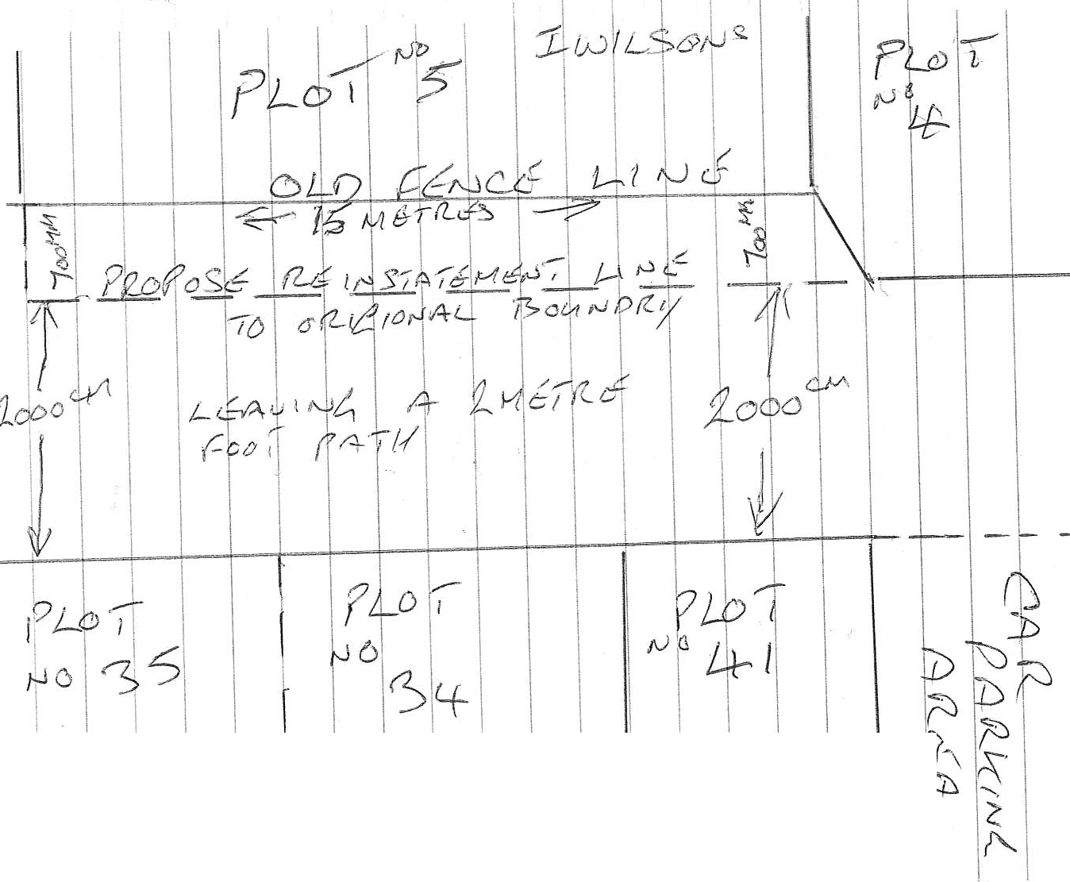Tc 29 /09 I 2022-
LCJ I I
--·
,,...
I I
esQ.(\dC\ I t€N\ I5
Append ;'£ l .

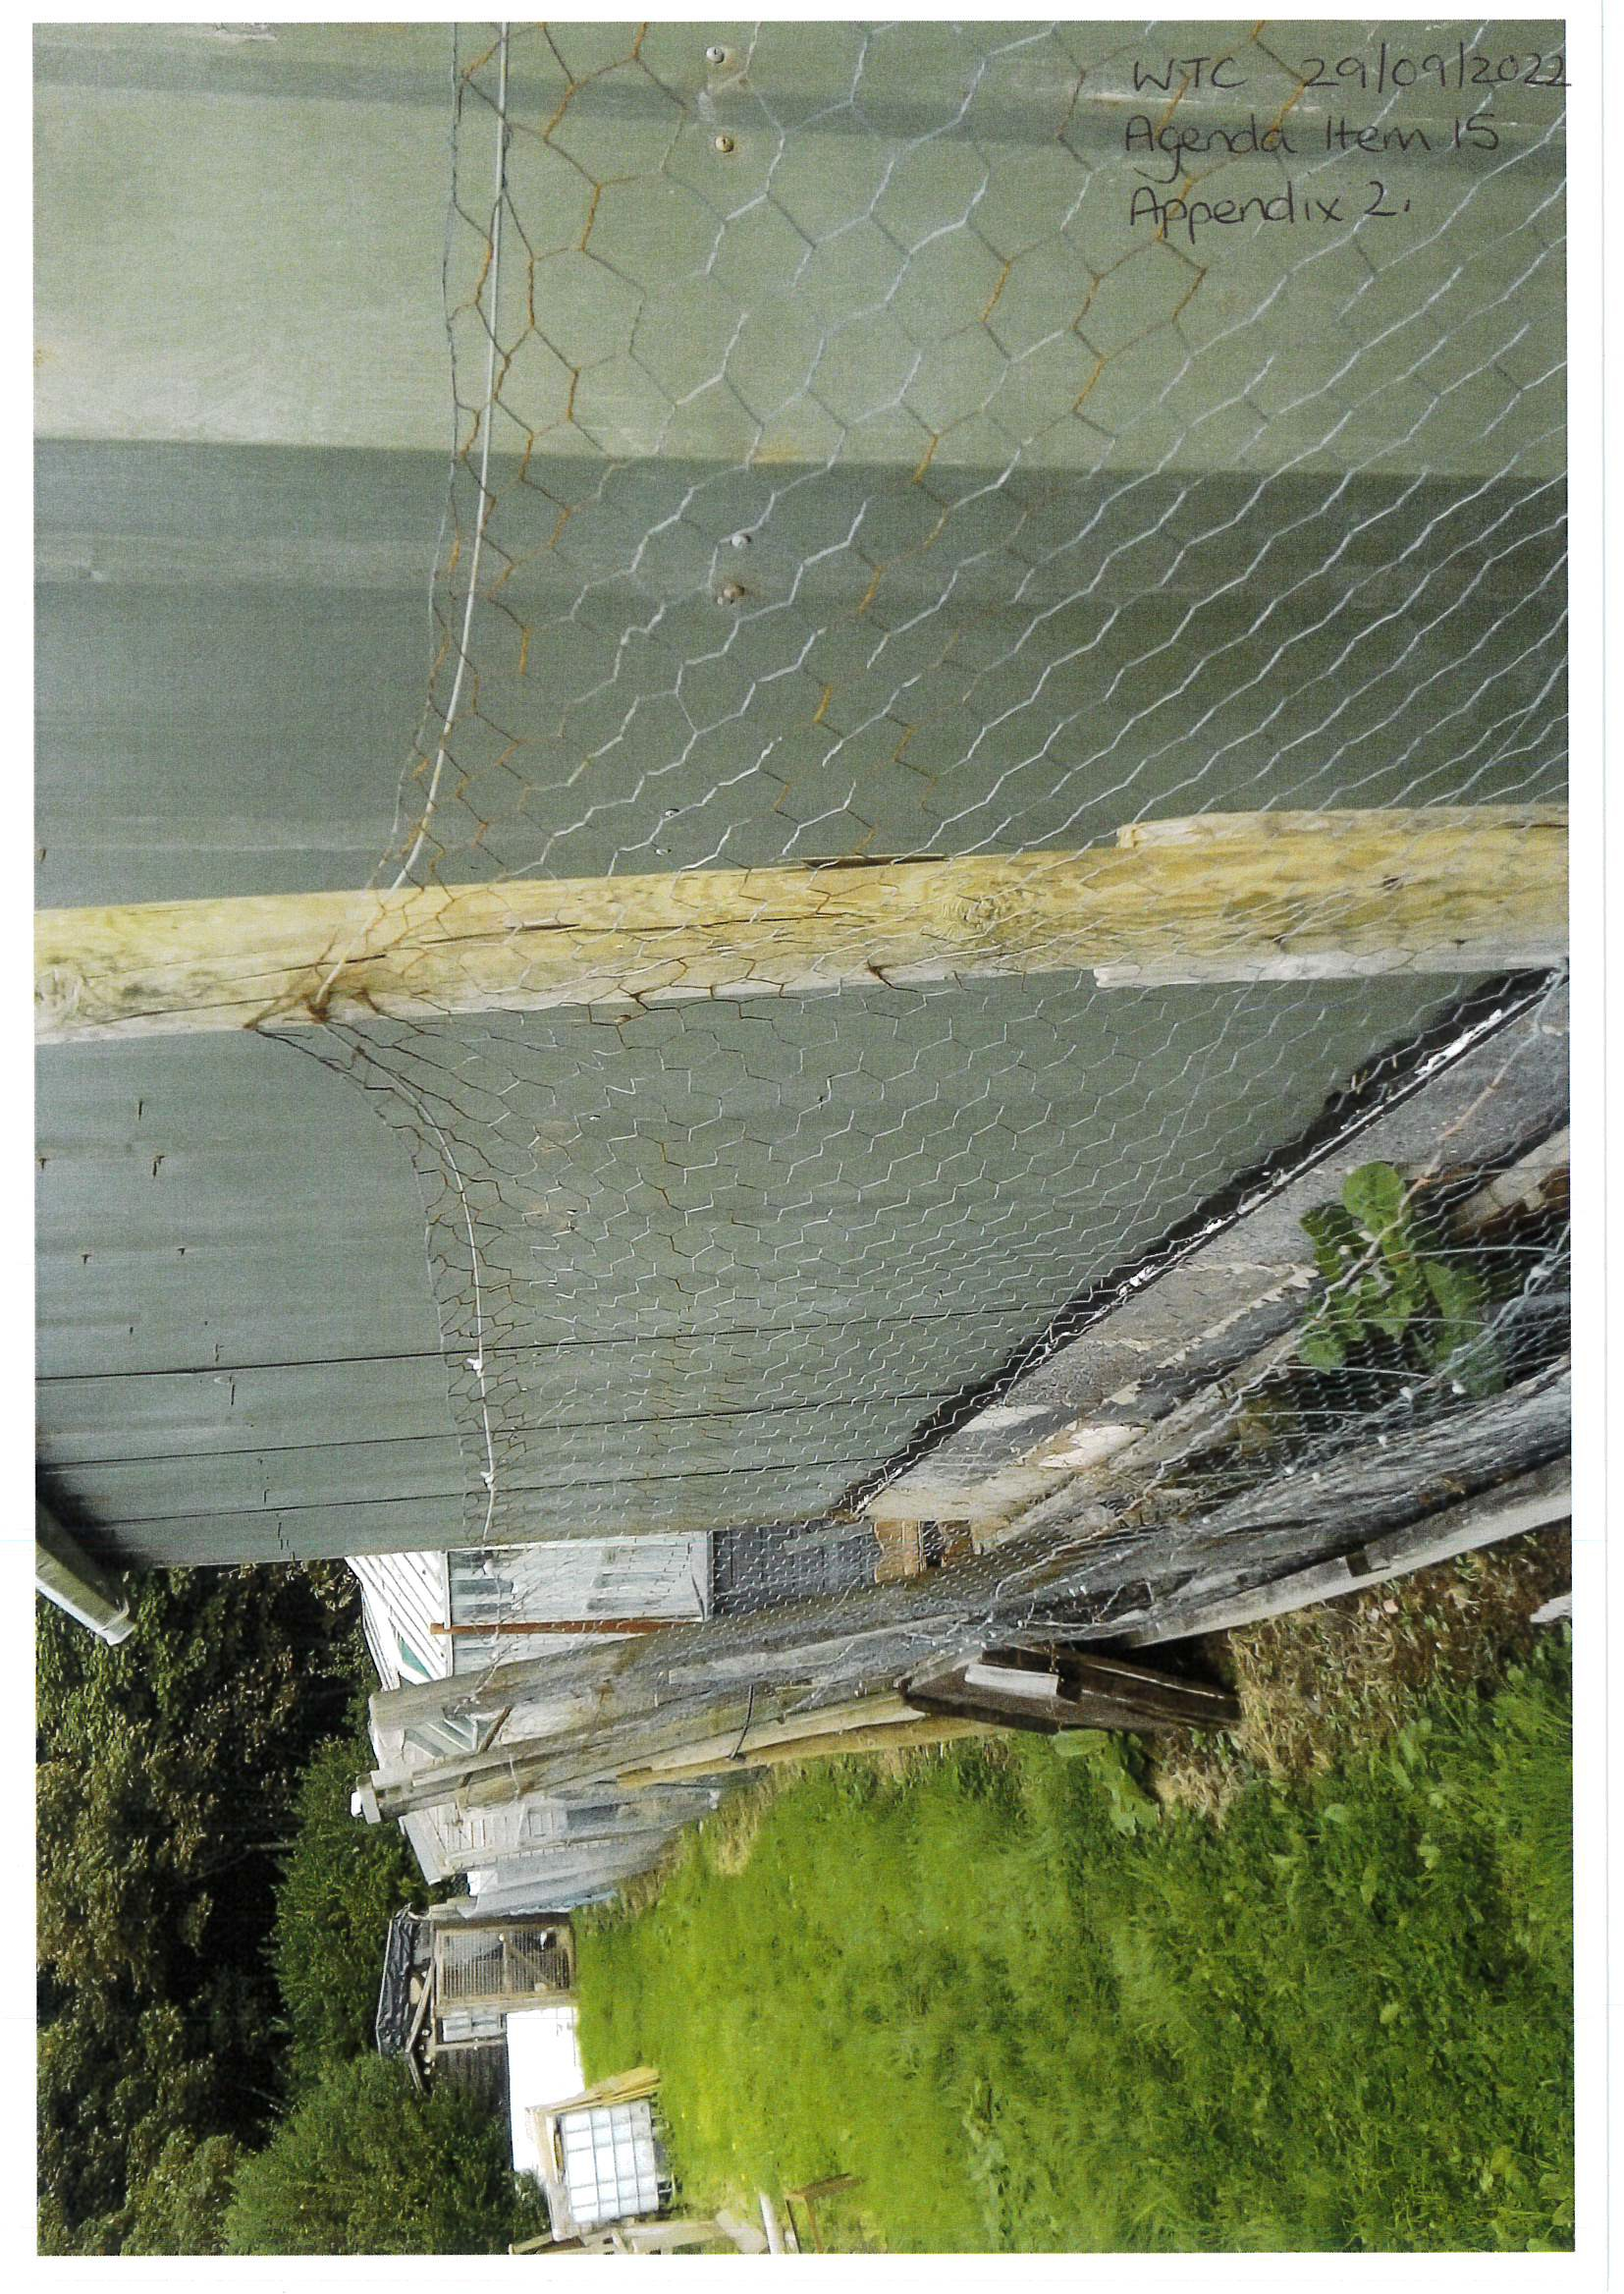

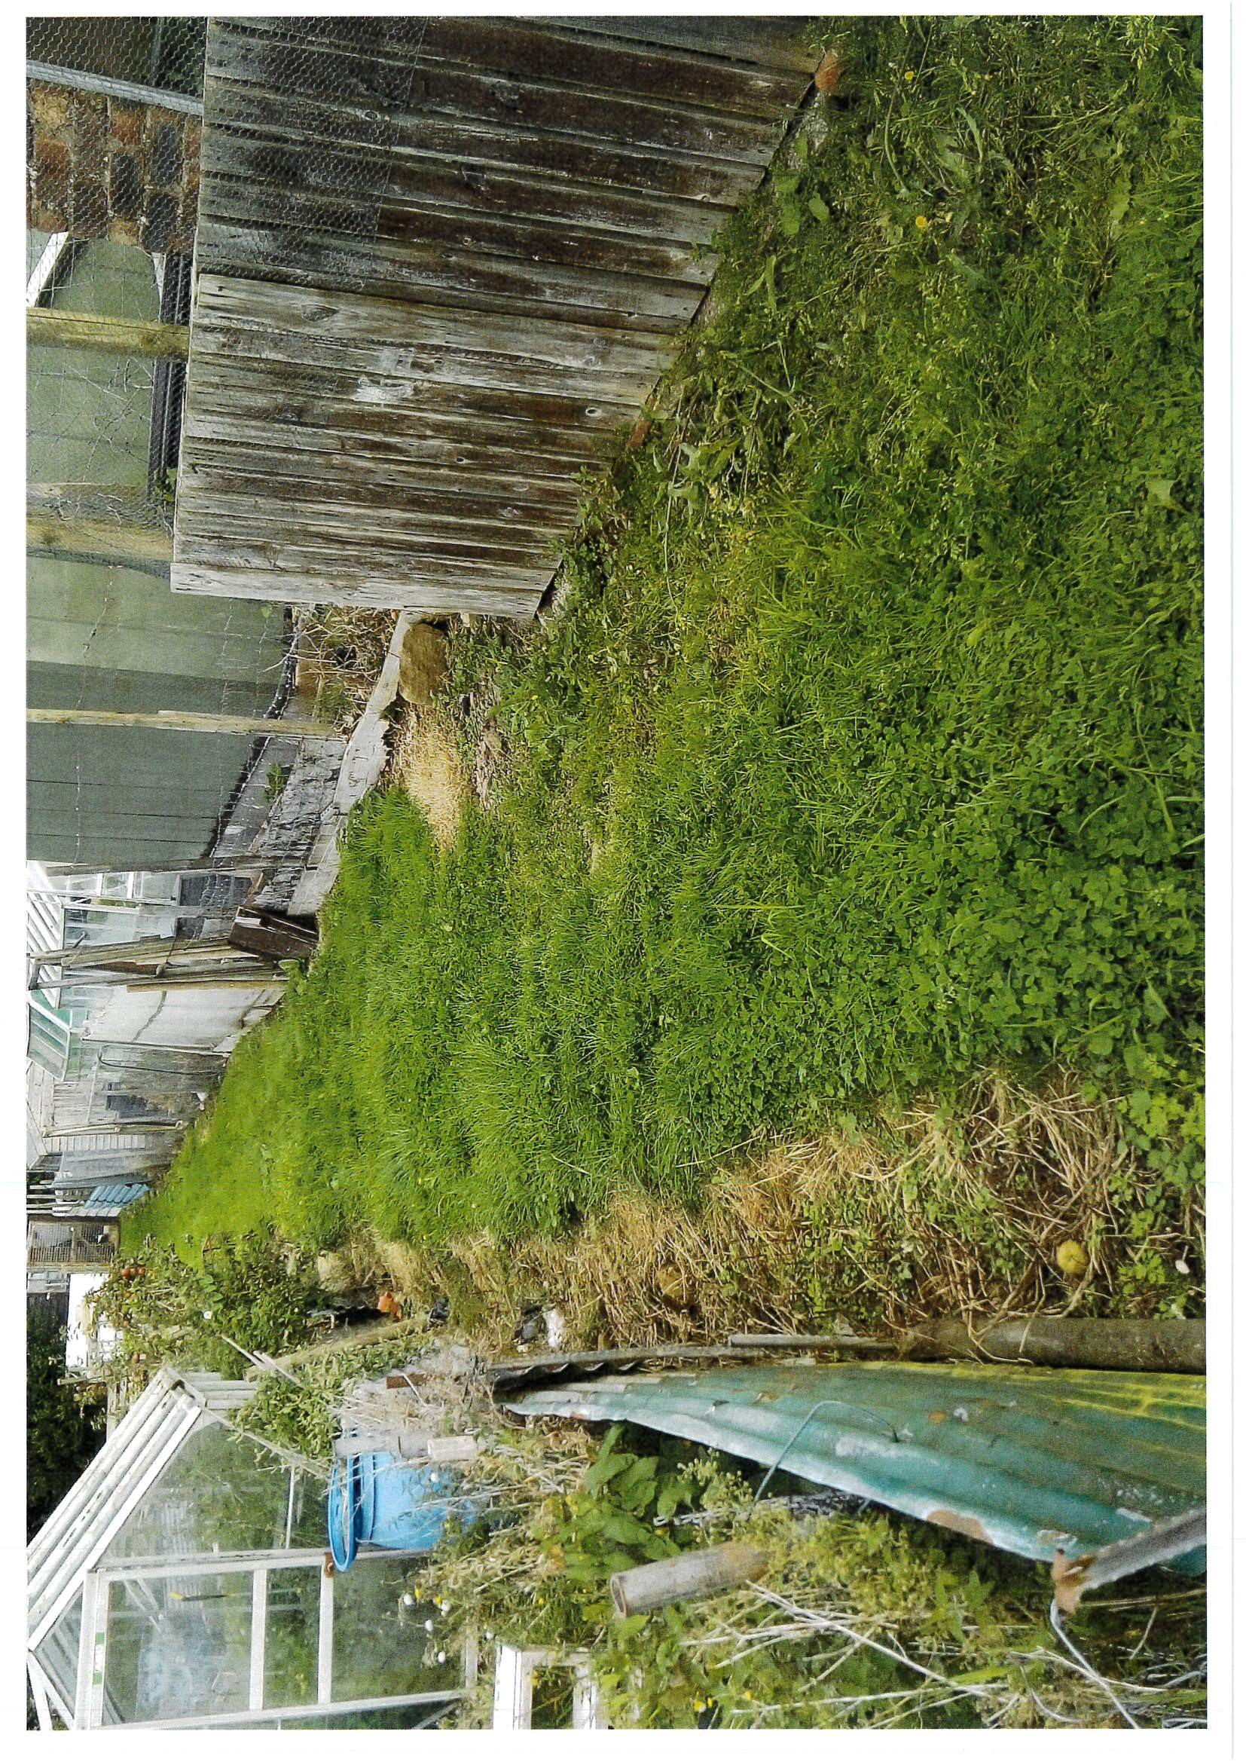

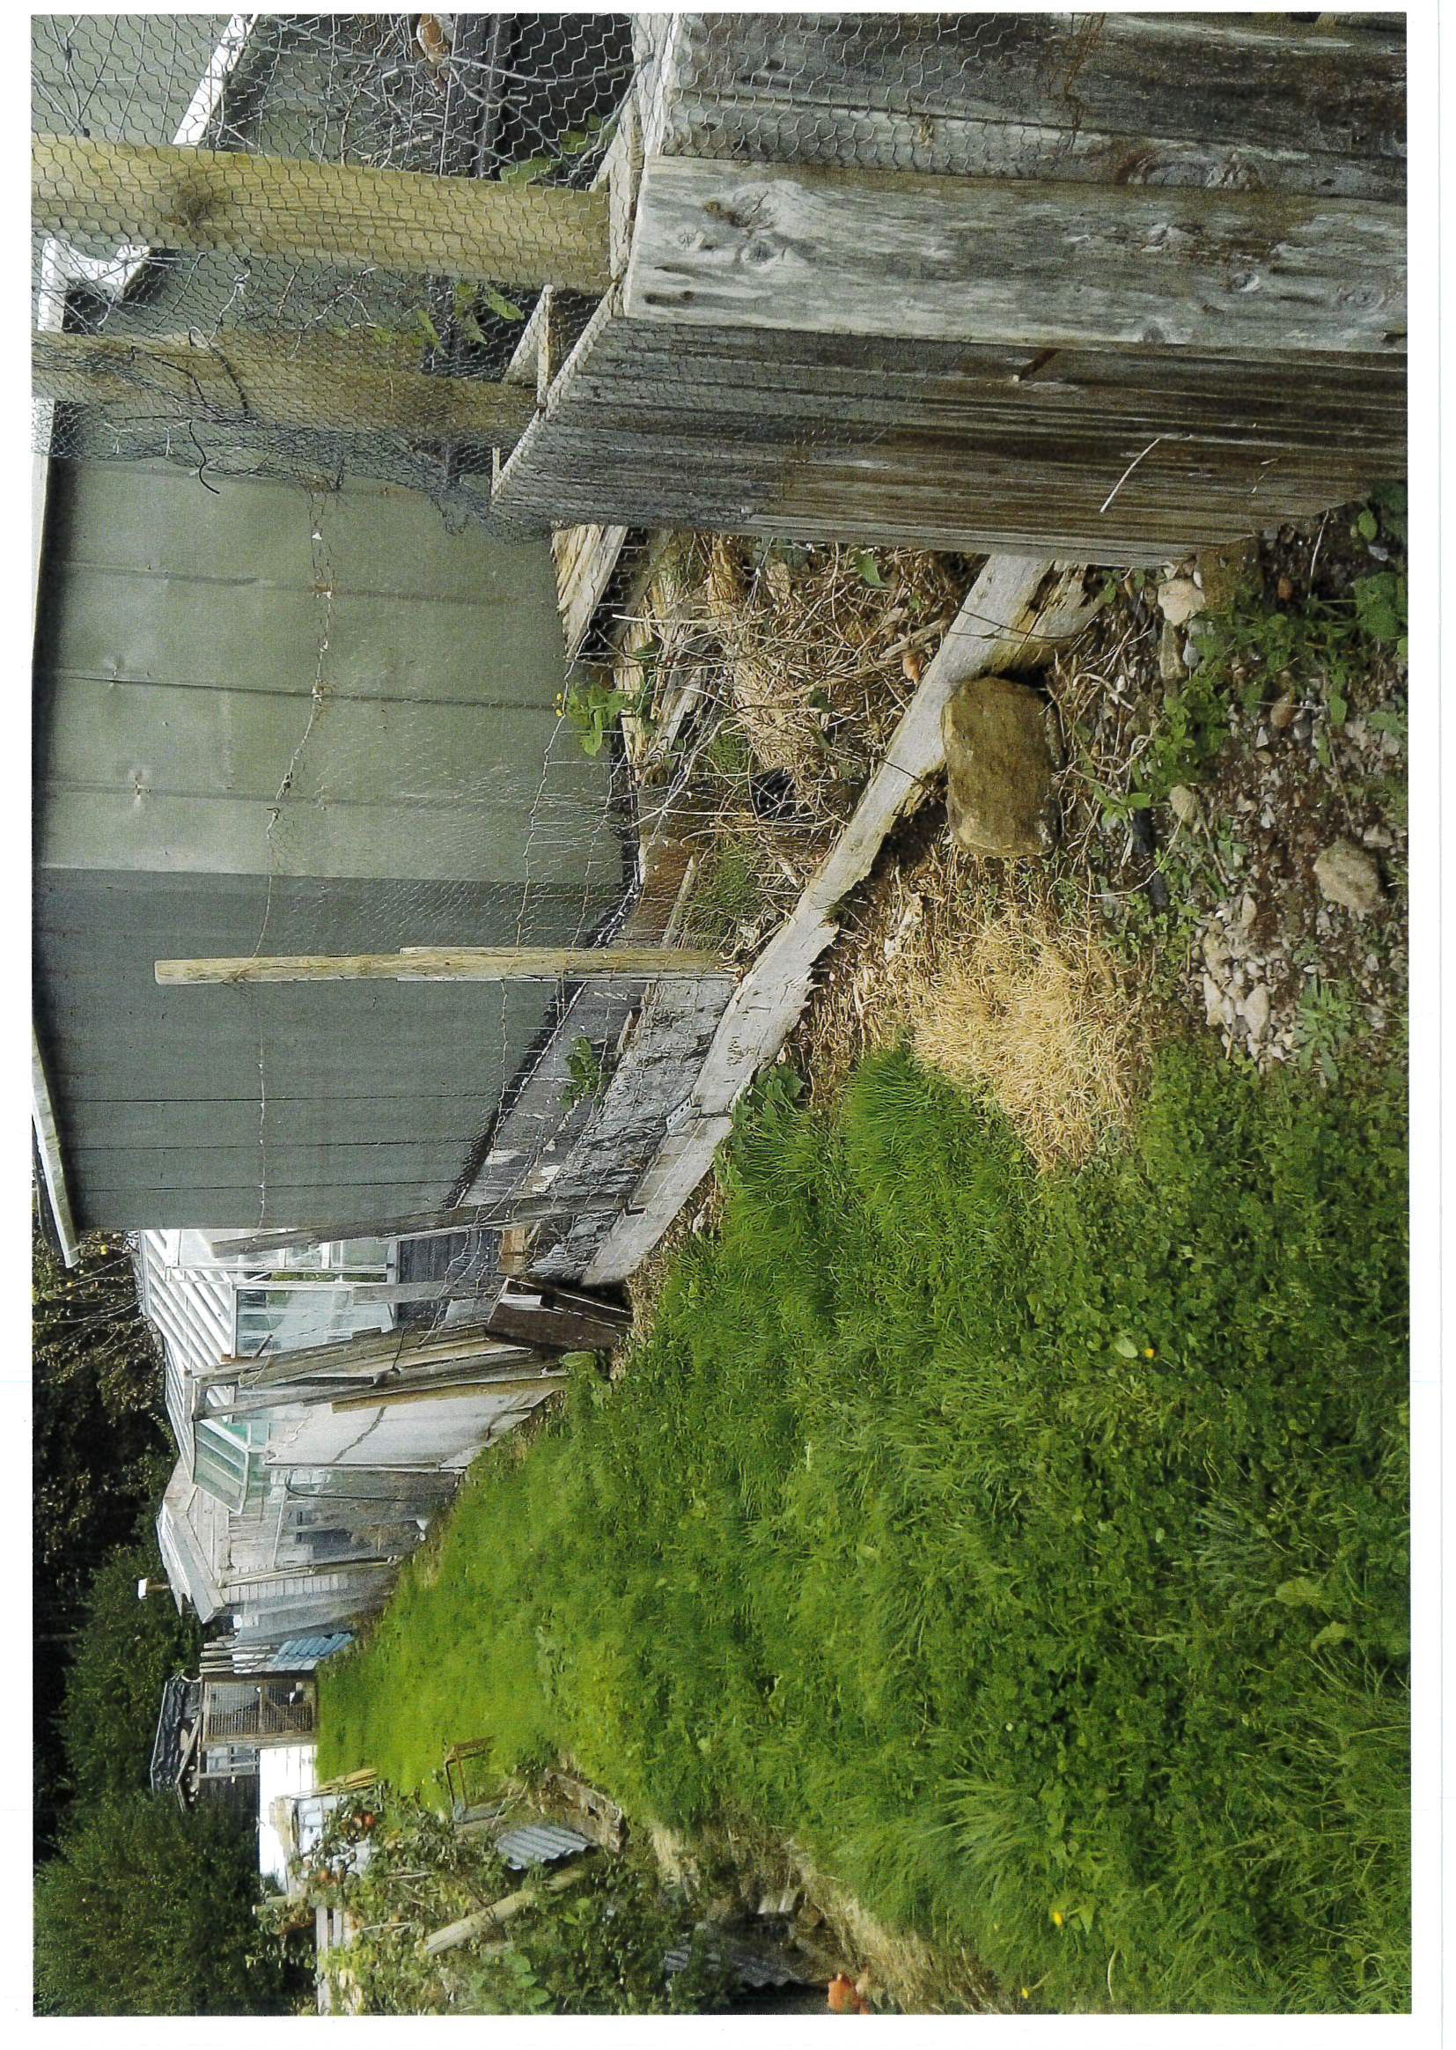

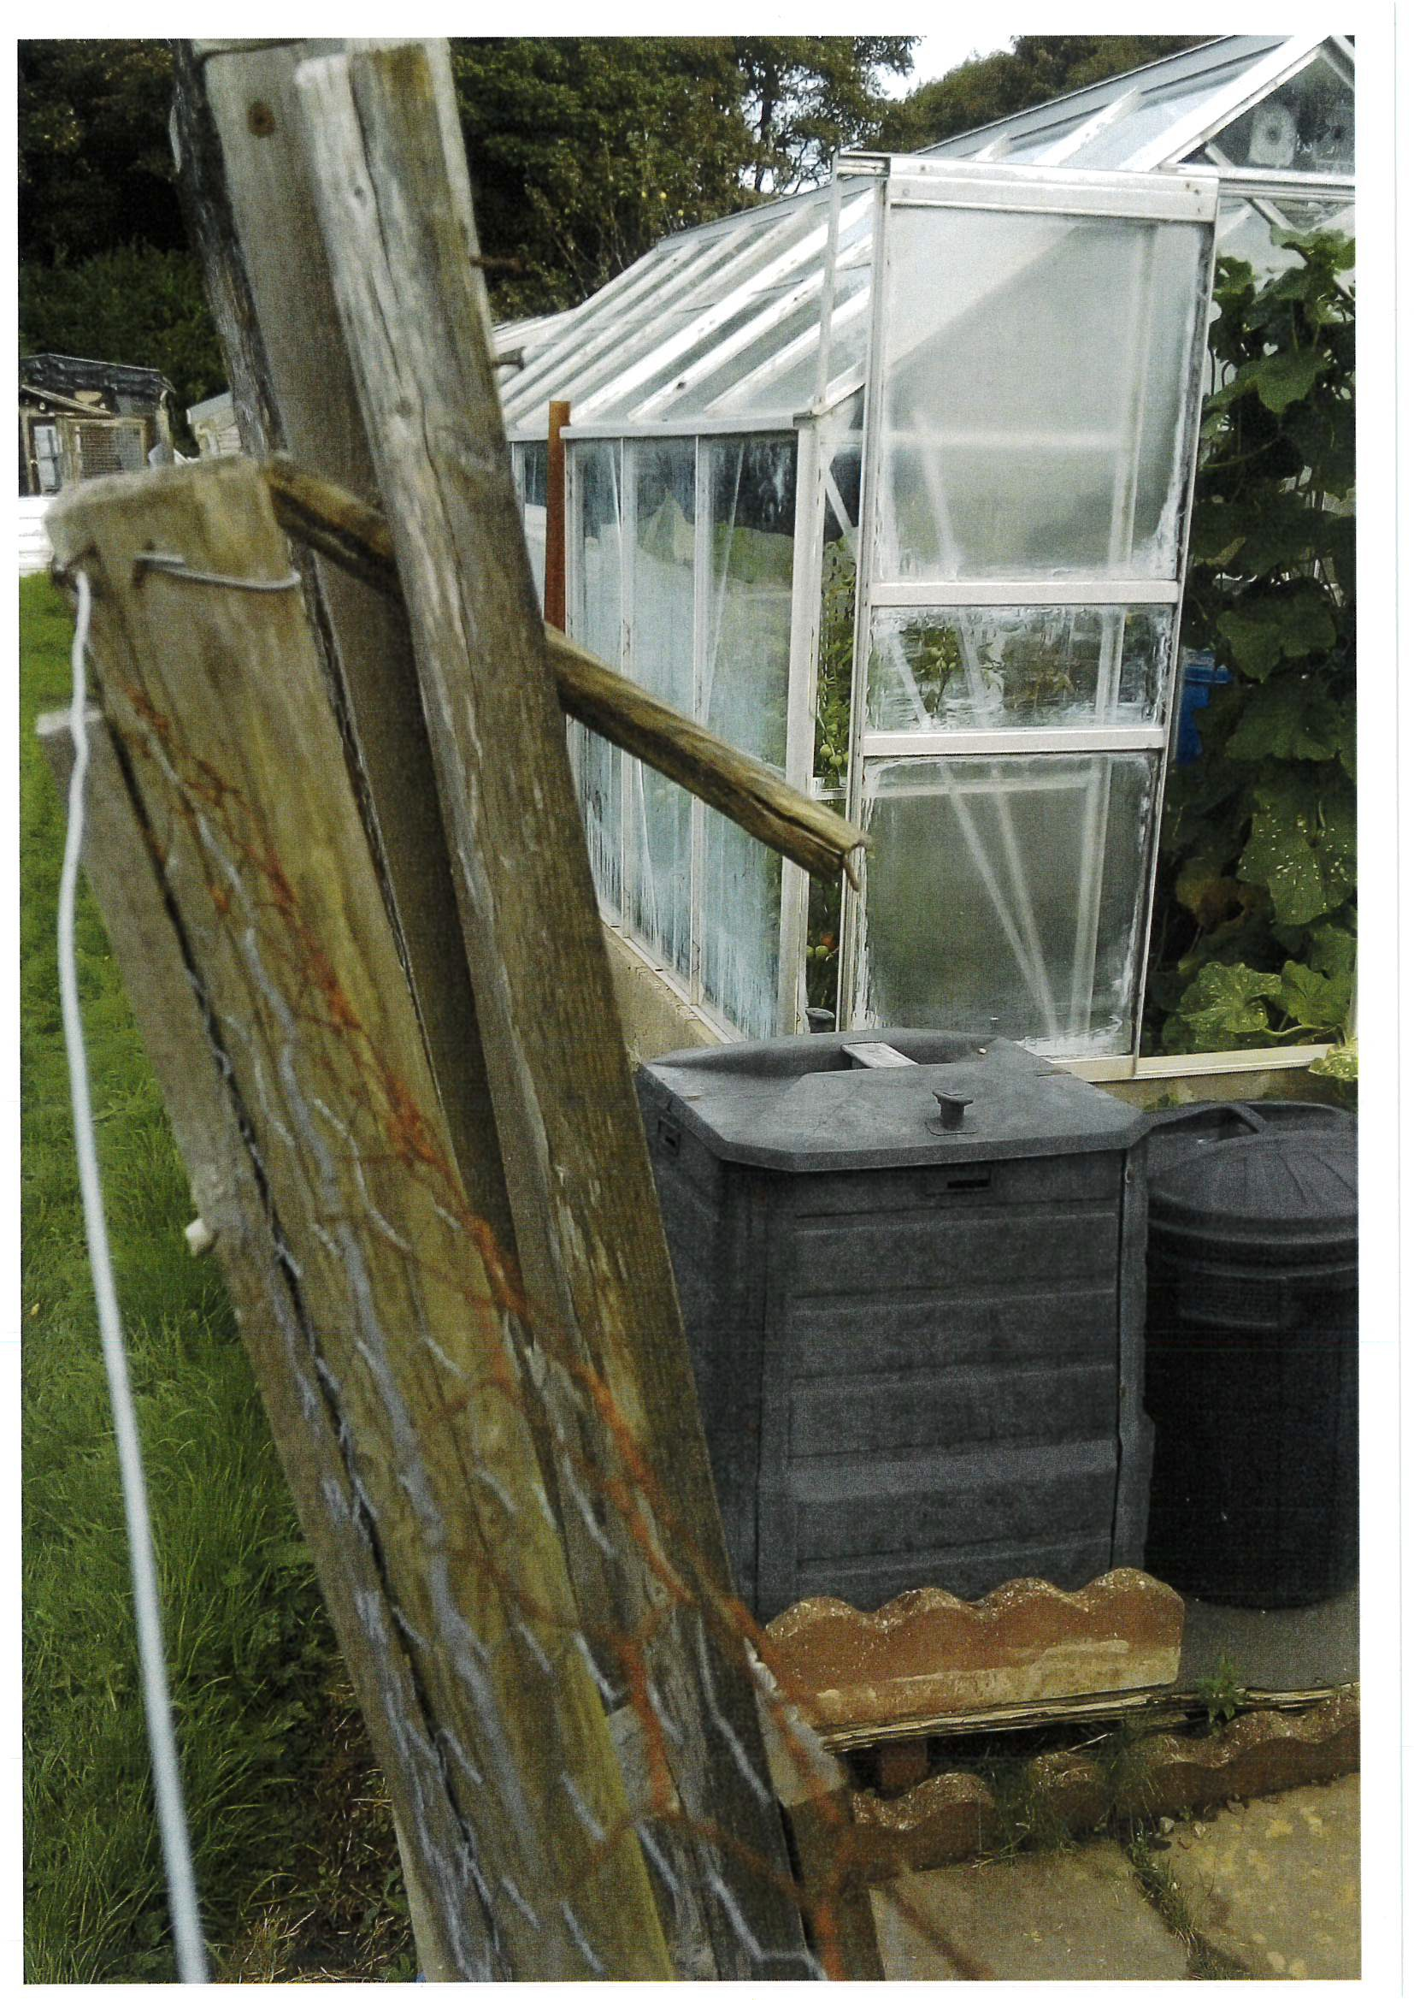

WTC 29/09/2022

Item 16

QUOTES RECEIVED FOR THE PURCHASE OF REPLACEMENT FESTOON LAMPS

Purpose of the Report

To inform Members of quotes received to purchase festoon lamps to replace/increase existing lamps.

  - INTRODUCTION

  - The Council's Christmas lighting contractor has evaluated the lighting stock as part of the ongoing upgrading of the Council's Christmas lights and has recommended that the Council purchase 300 x 230v LED bayonet cap lamps to replace/repair the lamps on the festoon cabling.

  - Quotes have been sought from 4 suppliers and the quotes received for the lamps are as follows:

Supplier A - Supplier B - Supplier C - Supplier D -

2.0 RECOMMENDATION
do not stock this particular voltage;
£897.00 + £15.00 delivery+ VAT
£780.00 + £15.00 delivery+ VAT
£897.00 + delivery charge+ VAT

2.1 To consider the quotes and decide on which supplier to purchase the lamps from.

WTC 29/09/2022

Item 17

STREET NAME AND NUMBERING CONSULTATION

Purpose of the Report

To consider (as Consultees) a report received from Copeland Borough Council regarding the Street Name and Numbering of Land at Edgehill Park, Whitehaven.

  - INTRODUCTION

  - The Council has received a report from Copeland Borough Council regarding the Street Name and Numbering of Land at Edgehill Park, Whitehaven (attached at Appendix 1).

The proposed residential development is located on Land at Edgehill Park and the developer wishes to have new street namesadopted for this phase of the development.

The Developer has suggested the names Burton Way, Perry Drive and Star Brig Lane as these are from an historic list of shipping working out of Whitehaven.

RECOMMENDATION

  - The Council is requested to consider the new street names within the development and give any comments to Copeland Borough Council.

STREET NAMING AND NUMBERING
NEW RESIDENTIAL DEVELOPMENT- LAND AT EDGEHILL PARK, WHITEHAVEN

Lead Officer: Chris Hoban, Strategic Planning Manager

To ask members to decide on the street name for the proposed new residential development on the LAND AT EDGEHILL PARK, WHITEHAVEN

Recommendation: That the street names Burton Way, Perry Drive and Star Brig
Lane be adopted for this development and all the relevant bodies be notified.

Resources Implications: Cost of providing street nameplates if the request is approved.

1.0 Supporting Information

  - This site is a Residential development located on the Land at Edgehill Park, Whitehaven. The developer wishes to have a new street name adopted for this development.

  - The Developer suggested the names Burton Way, Perry Drive and Star Brig Lane for the Street Names as these are from an historic list of shipping working out of Whitehaven.

  - Whitehaven Town Council are currently being consulted.

CONTACT OFFICER: BACKGROUND PAPERS:
Graeme Singleton, Technical Officer Street Naming file

Legend
LJ\ evc1 Access P 01s

-,, .4,,.-

0ac-<lnlonnahon Reier:o HouStltype
Drawings

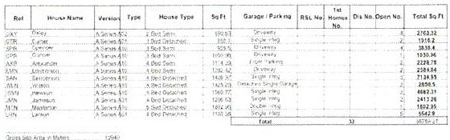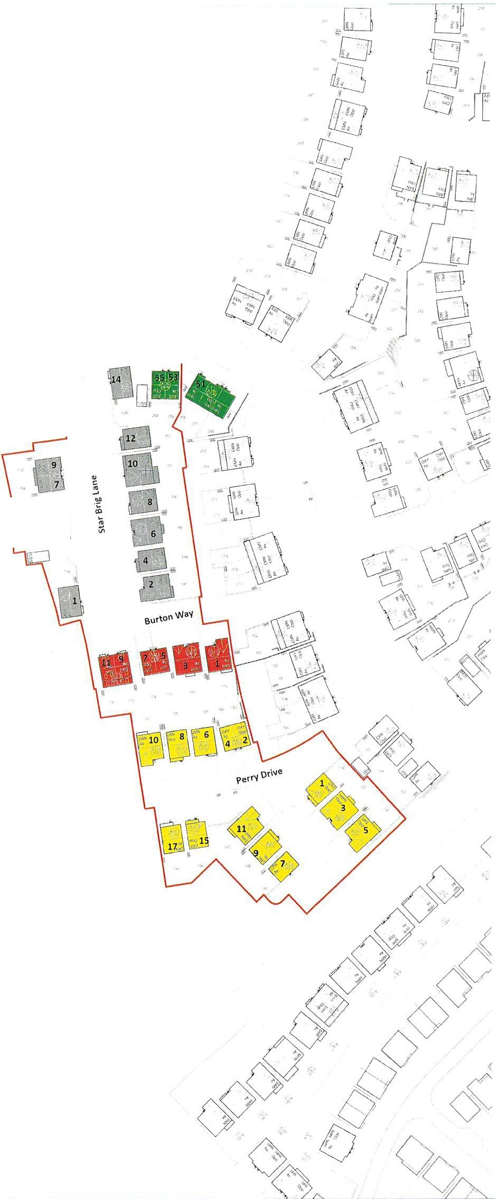

Clyd Way

, 5
"e§
. 3
"

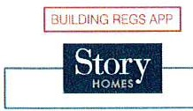

Edgehill, Pl1ase 3b

General Arrangement

20099 909 GA

20099

Story Homes

