WHITEHAVEN TOWN COUNCIL

Clerk and Responsible Financial Officer: Marlene Jewell
Telephone: 01946 67366
Chairman: Councillor C Maudling

To: Members of Whitehaven Town Council

You are duly SUMMONED to attend a MEETING of WHITEHAVEN TOWN COUNCIL which will be held in THE BEACON PORTAL at THE BEACON, WHITEHAVEN on Thursday 24th November 2022 at 6.00 pm

Signed.. \J (l-kP.¼-.-.. jp ( ... Dated.( 8. .No : { _. s/)-.?
Marlene Jewell, Clerk and Responsible Financial Officer

AGENDA

- Apologies for Absence

- Declarations of Interest

To receive declarations of interest by elected Members in respect of Agenda items.

If a Member requires any advice on any item involving a possible declaration of interest which could affect his/her ability to speak and/or vote he/she is advised to contact the Clerk at least 24 hours in advance of the meeting.

- Public Participation

- Minutes of the Council Meeting held on 27th October 2022

- Planning Applications

- Finance Report

- Woodhouse Road Bus Shelter

- Christmas Closing Hours

- Update on Council Offices - Clerk to give a Report

- Concerns about the level of service provided to the people of Whitehaven by GP Practices and Dentists - Councillor Roberts to give a report

- WCSS Group - Report by Councillor E Dinsdale

- Meeting re St Nicholas Gardens

- Councillor Ward Matters

- Date and Time of Next Meeting

IN PRIVATE

That prior to the following items of business the Chairman will move the following resolution:

That in view of the special or confidential nature of the business about to be transacted it is advisable in the public interest that the public and or press be instructed to withdraw.

- Quote for Contract for 2 Operatives 2023/24

- Quote for Grass Cutting 2023/24

- Quote for Maintenance Contract for Allotments and Pigeon Lofts 2023/24

- Staff Pay Increase Report

WHITEHAVEN TOWN COUNCIL

Minutes of the Council Meeting held on the 27th October 2022

Present: Councillor C Maudling (Chairman); Councillor E Dinsdale; Councillor R Gill; Councillor C Hayes; Councillor B O'Kane; Councillor R Redmond; Councillor G Roberts; Councillor G Stevens

M. Jewell, Clerk and Responsible Financial Officer Luke Johnson
Member of the Public Press
2127/22 Apologies for Absence

Apologies for absence were received from:-

Councillor J Rayson Councillor J Carr Councillor G Dinsdale Councillor C Walmsley

2128/22 Declarations of Interest
Holiday
Work Commitments Work Commitments Work Commitments

Councillor Maudling declared an interest in Agenda Item 5 as he was a member of CBC's Planning Panel
Councillor Roberts declared an interest as he was a member of CCC

2129/22 Public Participation

There was no public participation

2130/22 Minutes of the Council Meeting held on 29th September 2022

It was proposed by Councillor Gill and seconded by Councillor Hayes that the Minutes of the Council Meeting held on 29th September 2022 be approved and signed by the Chairman as a correct record. A vote was held and it was unanimously

RESOLVED - That the Minutes of the Council Meeting held on 29th September 2022 be approved and signed by the Chairman as a correct record.

2131/22 Minutes of the Extraordinary Council Meeting held on 18th October 2022

It was proposed by Councillor Gill and seconded by Councillor Roberts that the Minutes of the Extraordinary Council Meeting held on 18th October 2022 be approved and signed by the Chairman as a correct record. A vote was held and it was unanimously

RESOLVED - That the Minutes of the Extraordinary Council Meeting held on 18th October 2022 be approved and signed by the Chairman as a correct record.

2132/22 Planning Applications

Councillor E Dinsdale came into the Meeting following discussion on this item

The Council considered a list of Planning Applications received from CBC and shown at Appendix 1.

  - The Clerk handed out a copy of an email received which related to Planning Application 4/22/2398/0Fl - Former Methodist Church, Lowther Street Whitehaven. The email stated that there was a war memorial window inside the Church and that whilst it was intended to keep the window there was no guarantee of this and that the window was in the process of being registered as a war memorial with the Imperial War Museum and the War Memorials Trust in order to protect this Heritage Asset within the building. It was proposed by Councillor Gill and seconded by Councillor Roberts that the Council support this planning application subject to the War Memorial window being preserved and that CBC be informed accordingly. A vote was held and 7 Councillors voted for the proposal and 1 Councillor abstained.

RESOLVED - That the Council support this planning application subject to the War Memorial window being preserved and that CBC be informed accordingly.

n. It was proposed by Councillor O'Kane and seconded by Councillor Hayes that CBC be informed that following consideration of the Planning Applications on Schedule 1 the Council had no further representations to make. A vote was held and 7 Councillors voted for the proposal and 1 Councillor abstained.

RESOLVED - That CBC be informed that following consideration of the

Planning Applications on Schedule 1 the Council had no further representations to make.

2133/22 Finance Report

The Council considered a Finance Report.
1. Appendix 1 - The Clerk reported that there were 2 extra invoices to consider namely:

Cumbria Media Sandwich Man
£48.00 for uploading website
£60 for extra sandwich platters

It was proposed by Councillor Hayes and seconded by Councillor Roberts that the invoices on Appendix 1 plus the 2 additional invoices listed above be approved and paid. A vote was held and it was unanimously

RESOLVED - That the invoices on Appendix 1 plus the 2 additional invoices listed above be approved and paid.
11. Appendices 2 and 3 - the Council considered Appendices 2 and 3 and it was proposed by Councillor Gill and seconded by Councillor Hayes that these be approved and noted. A vote was held and it was unanimously
RESOLVED - That Appendices 2 and 3 be approved and noted.

2134/22 Quote for Mobile Optimisation
A quote of £750.00 had been received from Cumbria Media, the Council's website provider to carry out mobile optimisation of the Council's website.
The representative from Cumbria Media attended the Meeting and explained that the Council's website was not currently enabled for mobile devices and just shows the same zoomed out website on a phone screen making it hard to navigate. Making it mobile friendly would make it much easier to navigate on mobile devices and therefore more accessible. It was proposed by Councillor Gill and seconded by Councillor Roberts that (i) the Council makes a resolution to suspend Financial Regulation 11 to allow this work to be carried out by Cumbria Media and that having done this (ii) that the reasons for the suspension be recorded and the assessment of the risks be accepted and approved. A vote was held and it was unanimously

RESOLVED - That (i) the Council makes a resolution to suspend Financial Regulation 11 to allow this work to be carried out by Cumbria Media and that having done this that (ii) the reasons for the suspension be recorded and the assessment of the risks be accepted and approved.

2135/22 Quote for Summer Plants for 2023
The Council considered a report containing a quote of £7,410.55 from the Council's preferred suppliers for the provision of flowers for hanging baskets, hexagonal planters, barrier baskets, barrels, cast iron planters, plastic planters, Hensingham ship, Trinity bed, Corkickle bed and the Pelican bed. In order to purchase flowers from the Council's preferred supplier the Council considered suspending Financial Regulation 11 to permit this and also considered the reasons for suspension and the risks given in the report. It was proposed by Councillor Roberts and seconded by Councillor Hayes that (i) the Council makes a resolution to suspend Financial Regulation 11 to allow the flowers to be purchased from the preferred supplier at a cost of £7,410.55 and if made (ii) that the reasons for the suspension are recorded and the assessment of the risks be accepted and approved. A vote was held and it was unanimously

RESOLVED - That (i) the Council makes a resolution to suspend Financial Regulation 11 to allow the flowers to be purchased from the preferred supplier at a cost of £7,410.55 and having made the resolution that (ii) the reasons for the suspension are recorded and the assessment of the risks be accepted and approved.

2136/22 Quote from Localig for Advertisement for the Summer Fair 2023

The Council considered a report on a quote of£ 1,099.52 received from Localiq for advertising the Summer Fair in 2023 The Council had previously agreed that
£1,000.00 should be spent on a Whitehaven News and online package across the various online and print titles for the Summer Fair. It was proposed by Councillor O'Kane and seconded by Councillor Gill that the £1.000.00 approved be not exceeded and that the quote be not accepted. A vote was held and it was unanimously

RESOLVED-That the £1.000.00 approved be not exceeded and that the quote be not accepted.

2137/22 Quotes for St Nicholas Gardens for 2023/2024

The Council considered a quote of £18,000.00 from CBC for the purchase of summer and winter plants for the flower beds in St Nicholas Gardens and for the planting and maintenance of the flowers. Following a discussion it was proposed by Councillor O'Kane and seconded by Councillor Gill that the quote be accepted subject to having a meeting with all parties involved to discuss and plan the way forward and that meetings continue to take place on a regular basis. A vote was held and it was unanimously

RESOLVED - That that the quote be accepted subject to having a meeting with all parties involved to discuss and plan the way forward and that meetings

continue to take place on a regular basis.

2138/22 Quote for Extra Grass Cutting in Cemeteries 2023/24

The Council considered a quote received of £16,882.64 for 4 extra grass cuts in Whitehaven and Hensingham Cemeteries for 2023/24. It was proposed by Councillor Gill and seconded by Councillor Roberts that the quote be accepted with the proviso that in future years the Council enters into meaningful negotiations with the new authority. A vote was held and it was unanimously

RESOLVED - That the quote be accepted with the proviso that in future years the Council enters into meaningful negotiations with the new authority.

2139/22 Allotments

The Council considered a report on a request by a tenant to reinstate a fence on an allotment to its original boundary line. This was originally considered at the Council Meeting on 29th September 2022 where a decision was deferred until a site visit had taken place. A site visit was held on 18th October 2022 and Councillors G Dinsdale and R Gill (Members of the Allotment Advisory Group) attended. After hearing a report on the site visit from Councillor Gill it was proposed by Councillor Hayes and seconded by Councillor Roberts that the request to reinstate the fence to its original boundary line be not approved. A vote was held and it was unanimously

RESOLVED - That the request to reinstate the fence to its original boundary line be not approved.

2140/22 Concerns about the level of Service Provided to the People of Whitehaven by GP Practices and Dentists

Further to Minute 2111/22 the Clerk informed the Council that an email had been received from CBC to say that at the O&S Committee it had been decided to proceed with the "Access to GP and Dental Services Task and Finish Group and that once membership had been confirmed they would meet to confirm the scope of the group and set out a timetable. They would then be reaching out to GP Practices, local residents and Town and Parish Councils for feedback. It was hoped to get the Task and Finish Group up and running by the end of October/beginning of November. Councillor Roberts said that he had attended 2 meetings of Allerdale's O&S Committee and they had established a Task and Finish Group and had had an official meeting with the Commissioners, the people who direct the flow of this work.
He said he was going back to Allerdale on 11/11/22 to receive what reports he could. He said that the Government in its Act regarding Patient Participation in health matters had asked all GPs to set up Participation Groups and he was going to join in in his own surgery.

One member of the Task and Finish Group in Allerdale had spoken to people in 5 different GP Practices and had received no reply from 3, 2 got back in touch and 1 of these said they would like to scrap Patient Pariicipation Groups.
Councillor Roberts said there were a lot of side issues
- Shortage of GPs
- Struggling to find the services
- What will come out in the Report could be quite horrific
Councillor Gill welcomed the fact that CBC were setting up an O&S Task Group to look at this and the Chairman thanked Councillor Roberts for attending the meetings.
No decisions were taken on this as it was for information only

2141/22 Abba Tribute Act

With the agreement of the Chairman the Clerk raised an issue with the booking of the Abba Tribute Act for the Christmas Lights Switch-on on 19th November 2022. The Chairman had booked the Abba Tribute Act in accordance with Minutes 2099/22 vi and 2117/22 but the supplier had only quoted for one performance. Two performances were required and the extra cost for this second performance was £150.00. It was proposed by Councillor Roberts and seconded by Councillor O'Kane that the Booking Agent be paid an extra £150.00 for the Abba Tribute Act to do 2 performances in the afternoon. A vote was held and it was unanimously

RESOLVED - That the Booking Agent be paid an extra £150.00 for the Abba Tribute Act to do 2 performances in the afternoon

2142/22 Councillor Ward Matters

- Councillor Stevens said that she had been to the full planning meeting at Copeland regarding the proposed application by Story Homes behind Valley View. She said there would now be a site visit but there was an awful lot of discussion around the problem at Mirehouse ponds.
- Councillor O'Kane said that he had 2 concerns
  - The letter that had come through about the traffic situation outside St James School. It had really boiled over as several residents had gone berserk and Mayor Starkie had been involved and the CCC had now started to get a little bit more involved. There had been letters going out to parents to try and stop the situation. He said we had all had letters this week from an officer from the CCC who was dealing with traffic particularly the report that he had promised Councillor O'Kane last November and which he didn't have to hand. So possibly it had not been done. He said would be interesting to see whether the Whitehaven News would be looking at the traffic situation outside the junior schools in the area to see just how bad

and dangerous it is because traffic has increased significantly after covid and a lot more parents are bringing their kids to school because of the bus situation.
  - He asked to remind Members that they asked ages ago whether the officers members of County would meet with the Council but so far this has initiated 1 letter from Matthew which everyone has had and his response to that was that there are issues there and we need a face to face meeting even if it's only on zoom because we've all had different thoughts and different circumstances in Wards situations in town and said these need to be sorted out as soon as possible before the TROs are brought out and asked if a separate meeting could be held between all Councillors sometime to discuss the traffic situation in our area and then we can have an overview between us on what we feel are the major problems. The last time the TROs came round we were well fragmented and they just steamrollered stuff including making sure that some areas including the Market Place were changed in terms of the number of disabled spaces and even though the TROs were challenged those TROs were never changed.
111 Councillor E Dinsdale gave a nuclear update. He said the Council was on the Agenda of the WCSSG on Tuesday 1st November 2022 at 1.00pm and a vote would take place around the Council getting a voting seat. So if the Chair was in agreement he could attend on behalf of the Council.
1v Councillor Hayes said that there would be a fireworks display on 4/11/22 on the Rugby League ground at Kells. He said there had been a lot of vandalism of cars but the Police were on the job and were going round interviewing people.
v. Councillor Carr was not present at the Meeting but had sent an email which the Clerk read as follows:-" we have sorted new traffic cones out for St Patrick's school as the parking is getting worse but with the new ones this should help traffic flow and the school. Also the lights between Meadow Road and Green Bank fairy path are getting looked into as they are on CBC land but County look after them. If we have no joy when
I'm home next week with getting answers on why they have been like this for years I will be taking it to our elected mayor and the Cllrs who get paid to look after our community to get it sorted before there's a serious injury or worse when anyone is using this path at night".
v1. Councillor O'Kane said 2 residents had stopped him in town about the new car park in Catherine Street and pointed out that there was a sign showing the amount payable in cash or by card. But payment was only by app. The charges stated payment by cash but when you get onto the car park the charges are only payable by app which adds a standard charge pro rata which then boosts the charge. He said people were attracted by the low charges but then had to pay an additional app charge. The Chairman said this was a private car park. Councillor Hayes said he had

heard they were going to put cash machines in.

2143/22 Date Time and Place of next Meeting

The next Council Meeting would be on 24th November 2022 at 6.00pm at the Beacon Portal, Whitehaven.

The Meeting closed at 7.05pm

Chairman

WTC 24/11/2022
Item 5

Planning Application for Consideration by Whitehaven Town Council

Application Number 4/22/2421/0Fl

4/22/2422/0Fl

4/22/2426/0F1

4/22/2431/0Fl
Detail
WORKS IN RELATION TO CLOSURE OF RETAIL BANK - EXTERNAL: REMOVAL OF EXISTING SIGNAGE, EXTERNAL ATMS, NIGHTSAFE BEZEL AND MAKING GOOD WHERE REMOVALS AFFECT THE BUILDING. INTERNAL: REMOVAL OF NON-ORIGINAL INTERNAL SIGNAGE, FIXTURES, FITTINGS, AND EQUIPMENT RELATING TO THE OPERATION OF THIS RETAIL BANK.

71 LOWTHER STREET, WHITEHAVEN

REPLACEMENT OF WOODEN SASH WINDOWS WITH UPVC WINDOWS

8, 9, 10 ACTON COURT, WHITEHAVEN

CHANGE OF USE FROM REDUNDANT SECOND FLOOR RESIDENTIAL FLAT TO STORAGE

21 DUKE STREET, WHITEHAVEN

RETENTION OF TEMPORARY SERVICE ROAD TO THE REAR OF WHITEHAVEN ACADEMY WHITEHAVEN ACADEMY, CLEATOR MOOR ROAD, WHITEHAVEN

WTC 24/11/2022

Item 6

FINANCIAL REPORT

Purpose of the Report

Members are asked to consider a list of invoices for authorisation and payment as shown at Appendix 1 and approve the recommendations in paragraphs 3.1 and 3.2.

1.0 INTRODUCTION

  - Authorise the payment of all invoices as listed in Appendix 1.

  - The Council is asked to note the cashbook as reconciled with the bank account as shown at Appendix 2 together with income and expenditure at Appendix 3.

0 FINANCIAL POSITION

  - The bank reconciliation was carried out on 16th November 2022. This shows a balance of £402,976.47. There are currently no payments waiting to be cleared.

  - The balance in the deposit account is £453,327.71.

0 RECOMMENDATION

  - The invoices listed and shown in Appendix l be approved and authorised for payment.

  - The Cashbook (Appendix 2) and the Income and Expenditure (Appendix 3) be noted.

24/11/2022

Appendix 1

Invoices for Consideration by Whitehaven Town Council

Date | Supplier | Category | Detail | Total Amount | Power |  | Columnl
25/10/2022 | Eden Springs (UK) Ltd | Supplies & Services | Water Cooler Rental & Environmental Lew for water coolers(Nov 2022) | £ 8.16 |  | slllLGA 1972
27/10/2022 | Cumbria Media | Supplies & Services | Website Mobile Optimisation | £ 750.00 |  | slllLGA 1972
31/10/2022 | Derwent RecvclingServices Ltd | 3rd Partv | 12 vard general waste skip - Crow Park Allotments | £ 324.00 |  | s23 Small Holdines Act 1908
31/10/2022 | Derwent RecvclingServices Ltd | 3rd Party | 12 yard general waste skip - Midgey Allotments | £ 324.00 |  | s23 Small Holdings Act 1908
31/10/2022 | Derwent RecvclingServices Ltd | 3rd Partv | 12 yard general waste skip - Cartgate Allotments | £ 324.00 |  | s23 Small Holdings Act 1908
31/10/2022 | Derwent Recycling Services Ltd | 3rd Party | 12 yard general waste skip - Sneckyeat Allotments | £ 324.00 |  | s23 Small Holdings Act 1908
31/10/2022 | Studio Horn Engineering Design | Premises | Civil and Strutural Engineering design services | £ 1,000.00 |  | slllLGA 1972
01/11/2022 | Mrs V Gorley | Employees & Allowances | Postage for grass cutting quote packages | £ 22.20 |  | slllLGA 1972
02/11/2022 | Copeland Borough Council | 3rd Partv | Grass Cutting Contract - November 2022 | £ 2,045.51 |  | slllLGA 1972
02/11/2022 | Copeland Borough Council | 3rd Party | Allotment and Pigeon Loft Maintenance Contract - November 2022 | £ 720.80 |  | slllLGA 1972
02/11/2022 | Copeland Borough Council | 3rd Partv | Assistant Ranger Contract - November 2022 | £ 2,227.00 |  | slllLGA 1972
02/11/2022 | Copeland Borough Council | 3rd Party | Ranger Contract - November 2022 | £ 3,500.S9 |  | slllLGA 1972
03/11/2022 | Mrs VGorley | Events | 200 x cable ties for event poppies | £ 26.98 |  | s137 LGA 1972
06/11/2022 | Derwent Valley Asbestos Removal Ltd | 3rd Party | Removal of fence panels from an allotment plot | £ 580.00 |  | s23 Small Holdings Act 1908
07/11/2022 | Sharp Business Systems UK PLC | Supplies & Services | Photocopier Charges - 20.09.2022 to 20.10.2022 | £ 72.49 |  | slllLGA 1972
08/11/2022 | Copeland Borough Council | Premises | Room Hire - Beacon Portal - 2hrs on 18.10.2022 | £ 84.00 |  | slllLGA 1972
09/11/2022 | Armstrong Rhead Limited | Premises | M&E tender documentation RIBA Stage 4 | £ 4,725.00 |  | slllLGA 1972
10/11/2022 | Craven Services (North West) ltd | Premises | Drainage CCTV survey | £ 2,280.00 |  | slllLGA 1972
10/11/2022 | Mrs VGorlev | Events | Tea, milk, sugar, biscuits and crisps for Remembrance Sunday Reception | £ 23.41 |  | s137 LGA 1972
10/11/2022 | Mrs v Gorley | Events | Coffee | £ 4.79 |  | s137 LGA 1972
14/11/2022 | Liam Forristal (Starstruck Events) | Events | Hire of stage plus mileagefor Christmas Light Switch On Event | £ 1,240.00 |  | s144 LGA 1972
15/11/2022 | Thomas Graham & Sons Limited | Events | 10 Hi-Vis Yellow Waistcoats with WTC crest | £ 117.00 |  | sl44 LGA 1972
16/11/2022 | Whitehaven Brass Band | Events | Providing Music for Remembrance Sunday | £ 210.00 |  | s137 LGA 1972

£ 20,933.93

WHITEHAVEN TOWN COUNCIL CASH BOOK FROM 1 APRIL 2022

APPENDIX 2

Date
April-2022

Ref Payee

Employees/ Supplies/ Allowances Premises Services 3rd Party

Ground Grants Allotmts Maint

Civic
Hospitality Ranger/SO W.I.B

Ward
Grants Elections

Environmental
Improvements Events Contingencies

Reserves Net Total VAT

Total

Min. Ref.

 | 01.04.2022 | BACS | Eden Springs UK Ltd |  |  | 1.80 |  |  |  |  |  |  | £ 1.80 | £ 0.36 | £ 2.16 | 1973/22 (i}
 | 01.04.2022 | BACS | Sharp Business Systems UK Pie |  |  | 51.35 |  |  |  |  |  |  | £ 51.35 | £ 10.27 | £ 61.62 | 1973/22 (i}
3 | 01.04.2022 | 1080 | Copeland Borough Council |  |  |  |  |  | 597.85 |  |  |  | £ 597.85 | £ 119.57 | £ 717.42 | 1973/22 (i}
4 | 01.04.2022 | 1081 | Copeland Borough Council |  |  |  |  |  |  |  | 1832.52 |  | £ 1,832.52 | £ 366.50 | £ 2,199.02 | 1973/22 (i)
5 | 01.04.2022 | 1082 | Copeland Borough Council |  |  |  |  |  |  |  | 2771.20 |  | £ 2,771.20 | £ 554.24 | £ 3,325.44 | 1973/22 (i)
6 | 01.04.2022 | BACS | Mrs V Gorley | 7.65 |  |  |  |  |  |  |  |  | £ 7.65 |  | £ 7.65 | 1973/22 (i}
7 | 01.04.2022 | BACS | Mrs V Gorley | 7.65 |  |  |  |  |  |  |  |  | £ 7.65 |  | £ 7.65 | 1973/22 (i}
8 | 01.04.2022 | BACS | Westcom IT |  |  | 270.00 |  |  |  |  |  |  | £ 270.00 | £ 54.00 | £ 324.00 | 1973/22 (i}
9 | 01.04.2022 | 1083 | Copeland Borough Council |  | 10603.75 |  |  |  |  |  |  |  | £ 10,603.75 |  | 10,603.75 | 1973/22 Ii}
10 | 01.04.2022 | BACS | CALC | 20.00 |  |  |  |  |  |  |  |  | £ 20.00 |  | £ 20.00 | 1973/22 (i)
11 | 01.04.2022 | BACS | Viking |  |  | 60.72 |  |  |  |  |  |  | £ 60.72 | £ 12.14 | £ 72.86 | 1973/22 (i}
12 | 01.04.2022 | BACS | Mrs V Gorley | 184.44 |  |  |  |  |  |  |  |  | £ 184.44 |  | £ 184.44 | 1973/22 (i}
13 | 01.04.2022 | BACS | Mrs V Gorley | 15.15 |  |  |  |  |  |  |  |  | £ 15.15 |  | £ 15.15 | 1973/22 (i}
14 | 01.04.2022 | BACS | Mrs V Gorley | 99.79 |  |  |  |  |  |  |  |  | £ 99.79 |  | £ 99.79 | 1973/22 (i}
15 | 01.04.2022 | BACS | CALC | 20.00 |  |  |  |  |  |  |  |  | £ 20.00 |  | £ 20.00 | 1973/22 (i}
16 | 06.04.2022 | BACS | The Fairly Famous Family Ltd |  |  |  |  |  |  |  |  | 1350.00 | £ 1,350.00 | £ 270.00 | £ 1,620.00 | 1960/22 (2)
17 | 06.04.2022 | BACS | Whitehaven and District Amateur Operatic Society |  |  |  |  | 1000.00 |  |  |  |  | £ 1,000.00 |  | £ 1,000.00 | 1985/22
18 | 06.04.2022 | BACS | The Georgian House Hotel |  |  |  |  |  |  |  |  | 100.00 | £ 100.00 | £ 20.00 | £ 120.00 | 1980/22 (iv}
19 | 12.04.2022 | DD | Water Plus |  |  |  |  |  | 221.23 |  |  |  | £ 221.23 |  | £ 221.23 | Contract
20 | 13.04.2022 | BACS | Newsquest Media Group |  |  | 219.00 |  |  |  |  |  |  | £ 219.00 | £ 43.80 | £ 262.80 | 1979/22
 | 14.04.2022 | BACS | Staff | 5012.77 |  |  |  |  |  |  |  |  | £ 5,012.77 |  | £ 5,012.77 | 1931/21(i}
 | 14.04.2022 | BACS | HMRC | 2020.75 |  |  |  |  |  |  |  |  | £ 2,020.75 |  | £ 2,020.75 | HMRC
 | 14.04.2022 | BACS | Cumbria LGPS | 768.14 |  |  |  |  |  |  |  |  | £ 768.14 |  | £ 768.14 | 6317/17 (ii)
21 | 19.04.2022 | DD | BTGroup |  |  | 73.43 |  |  |  |  |  |  | £ 73.43 | £ 14.69 | £ 88.12 | Contract
22 | 19.04.2022 | DD | Crown Gas & Oil |  | 329.41 |  |  |  |  |  |  |  | £ 329.41 | £ 65.88 | £ 395.29 | Contract
 | May-2022
23 | 04.05.2022 | BACS | Eden Springs UK Ltd |  |  | 1.80 |  |  |  |  |  |  | £ 1.80 | £ 0.36 | £ 2.16 | 1997/22 (i}
24 | 04.05.2022 | BACS | Sharp Business Systems UK Pie |  |  | 44.56 |  |  |  |  |  |  | £ 44.56 | £ 8.91 | £ 53.47 | 1997/22 (i}
25 | 04.05.2022 | BACS | Thomas Graham & Sons Limited |  |  |  | 179.00 |  |  |  |  |  | £ 179.00 | £ 35.80 | £ 214.80 | 1997/22 (i}
26 | 04.05.2022 | BACS | Viking |  |  | 32.90 |  |  |  |  |  |  | £ 32.90 | £ 6.58 | £ 39.48 | 1997/22 (i}
27 | 04.05.2022 | BACS | Viking |  |  | 44.90 |  |  |  |  |  |  | £ 44.90 | £ 8.98 | £ 53.88 | 1997/22 (i}
28 | 04.05.2022 | BACS | CALC |  |  | 1914.98 |  |  |  |  |  |  | £ 1,914.98 |  | £ 1,914.98 | 2000/22
29 | 04.05.2022 | BACS | Cumbria Media |  |  | 68.00 |  |  |  |  |  |  | £ 68.00 |  | £ 68.00 | 1997/22 (i}
30 | 04.05.2022 | 1084 | Copeland Borough Council |  |  |  |  |  |  | 1704.59 |  |  | £ 1,704.59 | £ 340.92 | £ 2,045.51 | 1997/22 (i)
31 | 04.05.2022 | 1085 | Copeland Borough Council |  |  |  |  |  | 600.67 |  |  |  | £ 600.67 | £ 120.13 | £ 720.80 | 1997/22 (i}
32 | 04.05.2022 | 1086 | Copeland Borough Council - VOID |  |  |  |  |  |  |  |  |  |  |  |  | VOID
33 | 04.05.2022 | 1087 | Copeland Borough Council |  |  |  |  |  |  |  | 1855.83 |  | £ 1,855.83 | £ 371.17 | £ 2,227.00 | 1997/22 (i)
34 | 04.05.2022 | 1088 | Copeland Borough Council |  | 420.00 |  |  |  |  |  |  |  | £ 420.00 | £ 84.00 | £ 504.00 | 1997/22 (i)
35 | 04.05.2022 | BACS | Zurich Municipal |  |  | 3157.29 |  |  |  |  |  |  | £ 3,157.29 |  | £ 3,157.29 | 1998/22
36 | 09.05.2022 | BACS | Gifts 2 Impress Ltd |  |  |  |  |  |  |  |  | 661.60 | £ 661.60 | 132.32 | £ 793.92 | 1997/22 (i)
 | 13.05.2022 | BACS | Staff | 5012.16 |  |  |  |  |  |  |  |  | £ 5,012.16 |  | £ 5,012.16 | 1931/21(i)
 | 13.05.2022 | BACS | HMRC | 2021.36 |  |  |  |  |  |  |  |  | £ 2,021.36 |  | £ 2,021.36 | HMRC
 | 13.05.2022 | BACS | Cumbria LGPS | 768.14 |  |  |  |  |  |  |  |  | £ 768.14 |  | £ 768.14 | 6317/17 (ii)
37 | 16.05.2022 | DD | Crown Gas & Oil |  | 259.71 |  |  |  |  |  |  |  | £ 259.71 | £ 51.94 | £ 311.65 | Contract
38 | 17.05.2022 | 1089 | Copeland Borough Council |  |  |  |  |  |  |  | 2917.16 |  | £ 2,917.16 | £ 583.43 | £ 3,500.59 | 1997/22 (i)
39 | 19.05.2022 | DD | BTGroup |  |  | 72.81 |  |  |  |  |  |  | £ 72.81 | £ 14.56 | £ 87.37 | Contract
40 | 28.05.2022 | DD | Water Plus |  |  |  |  |  | 53.05 |  |  |  | £ 53.05 |  | £ 53.05 | Contract
41 | 28.05.2022 | DD | Water Plus |  | 81.36 |  |  |  |  |  |  |  | £ 81.36 | £ 2.67 | £ 84.03 | Contract
42 | 28.05.2022 | DD | Water Plus |  |  |  |  |  | 13.34 |  |  |  | £ 13.34 |  | £ 13.34 | Contract
43 | 31.05.2022 | BACS | Eden Springs UK Ltd |  |  | 1.80 |  |  |  |  |  |  | £ 1.80 | £ 0.36 | £ 2.16 | 2014/22 (i)
44 | 31.05.2022 | BACS | Cumbria Loos |  |  |  |  |  |  |  |  | 349.00 | £ 349.00 | £ 69.80 | £ 418.80 | 2014/22 (i)
45 | 31.05.2022 | BACS | Derwent Recycling Services Ltd |  |  |  |  |  | 240.00 |  |  |  | £ 240.00 | £ 48.00 | £ 288.00 | 2014/22 (i)
46 | 31.05.2022 | BACS | Derwent Recycling Services Ltd |  |  |  |  |  | 240.00 |  |  |  | £ 240.00 | £ 48.00 | £ 288.00 | 2014/22 (i)
47 | 31.05.2022 | BACS | Derwent Recycling Services Ltd |  |  |  |  |  | 240.00 |  |  |  | £ 240.00 | £ 48.00 | £ 288.00 | 2014/22 (i)
48 | 31.05.2022 | BACS | Derwent Recycling Services Ltd |  |  |  |  |  | 240.00 |  |  |  | £ 240.00 | £ 48.00 | £ 288.00 | 2014/22 (i)
49 | 31.05.2022 | 1090 | Mrs Julie Hartley - VOID
50 | 31.05.2022 | 1091 | Copeland Borough Council |  |  |  |  |  |  | 1704.59 |  |  | £ 1,704.59 | £ 340.92 | £ 2,045.51 | 2014/22 (i)
51 | 31.05.2022 | 1092 | Copeland Borough Council |  |  |  |  |  | 600.67 |  |  |  | £ 600.67 | £ 120.13 | £ 720.80 | 2014/22 (i)
52 | 31.05.2022 | 1093 | Copeland Borough Council |  |  |  |  |  |  |  | 2917.16 |  | £ 2,917.16 | £ 583.43 | £ 3,500.59 | 2014/22 (i)
53 | 31.05.2022 | 1094 | Copeland Borough Council |  |  |  |  |  |  |  | 1855.83 |  | £ 1,855.83 | £ 371.17 | £ 2,227.00 | 2014/22 (i)
54 | 31.05.2022 | BACS | Sharp Business Systems UK Pie |  |  | 49.04 |  |  |  |  |  |  | £ 49.04 | £ 9.81 | £ 58.85 | 2014/22 (i)
55 | 31.05.2022 | BACS | Support Warehouse Limited |  |  | 87.20 |  |  |  |  |  |  | £ 87.20 | £ 17.44 | £ 104.64 | 2014/22 (i)
56 | 31.05.2022 | BACS | Mrs V Gorley | 12.56 |  |  |  |  |  |  |  |  | £ 12.56 |  | £ 12.56 | 2014/22 (i}
57 | 31.05.2022 | BACS | Mrs V Gorley | 7.24 |  |  |  |  |  |  |  |  | £ 7.24 |  | £ 7.24 | 2014/22 (i}
58 | 31.05.2022 | BACS | Mrs V Gorley |  |  |  |  |  |  |  |  | 20.33 | £ 20.33 |  | £ 20.33 | 2014/22 (i)
59 | 31.05.2022 | BACS | Mrs V Gorley |  |  | 159.00 |  |  |  |  |  |  | £ 159.00 |  | £ 159.00 | 2014/22 (i)
60 | 31.05.2022 | BACS | Mr CJ Hayes | 34.20 |  |  |  |  |  |  |  |  | £ 34.20 |  | £ 34.20 | 2014/22 (i)
61 | 31.05.2022 | BACS | Mr CJ Hayes | 1.35 |  |  |  |  |  |  |  |  | £ 1.35 |  | £ 1.35 | 2014/22 (i)
62 | 31.05.2022 | BACS | Mr CJ Hayes | 3.60 |  |  |  |  |  |  |  |  | £ 3.60 |  | £ 3.60 | 2014/22 (i)
63 | 31.05.2022 | BACS | Mr CJ Hayes | 2.70 |  |  |  |  |  |  |  |  | £ 2.70 |  | £ 2.70 | 2014/22 (i)
64 | 31.05.2022 | BACS | Viking |  |  | 94.30 |  |  |  |  |  |  | £ 94.30 | £ 9.36 | £ 103.66 | 2014/22 (i)
65 | 31.05.2022 | BACS | Cumbria Media |  |  | 68.00 |  |  |  |  |  |  | £ 68.00 |  | £ 68.00 | 2014/22 (i)
66 | 31.05.2022 | BACS | PHP Architects Ltd |  | 3391.00 |  |  |  |  |  |  |  | £ 3,391.00 | £ 678.20 | £ 4,069.20 | 2014/22 (i)
67 | 31.05.2022 | BACS | POD (North West) Ltd |  |  |  |  |  |  |  |  | 500.00 | £ 500.00 | £ 100.00 | £ 600.00 | 2014/22 (i)

68 31.05.2022
69 31.05.2022
70 31.05.2022
June-2022
71 12.06.2022
72 13.06.2022
15.06.2022
15.06.2022
15.06.2022
73 17.06.2022
74 18.06.2022
75 19.06.2022
76 22.06.2022
77 22.06.2022
July-2022
78 05.07.2022
79 05.07.2022
80 05.07.2022
81 05.07.2022
82 05.07.2022
83 05.07.2022
84 01.07.2022
85 05.07.2022
86 05.07.2022
87 05.07.2022
88 05.07.2022
89 05.07.2022
90 05.07.2022
91 01.07.2022
92 01.07.2022
93 01.07.2022
94 01.07.2022
95 01.07.2022
96 01.07.2022
97 01.07.2022
98 05.07.2022
99 05.07.2022
100 05.07.2022
101 05.07.2022
102 05.07.2022
103 05.07.2022
104 13.07.2022
15.07.2022
15.07.2022
15.07.2022
105 16.07.2022
106 19.07.2022
107 22.07.2022
108 22.07.2022
Aug-2022
109 01.08.2022
110 01.08.2022
111 01.08.2022
112 01.08.2022
113 01.08.2022
114 01.08.2022
115 01.08.2022
116 01.08.2022
117 01.08.2022
118 01.08.2022
119 01.08.2022
120 01.08.2022
121 01.08.2022
122 01.08.2022
123 01.08.2022
124 01.08.2022
125 01.08.2022
126 01.08.2022
127 12.08.2022
128 12.08.2022
129 14.08.2022
15.08.2022
15.08.2022
15.08.2022
130 15.08.2022
131 15.08.2022
132 19.08.2022
133 23.08.2022
134 23.08.2022
135 31.08.2022
136 31.08.2022
137 31.08.2022

BACS The Community Centre - Red Lonning BACS Bee Unique
BACS The Community Centre - Red Lonning

BACS Water Plus
BACS Whitehaven Harbour Commissioners Car Park BACS Staff
BACS HMRC
BACS Cumbria LGPS BACS Mrs Julie Hartley DD Crown Gas & Oil DD BTGroup
DD Water Plus
DD Water Plus

BACS Quality Cleaning & Contracting Ltd BACS AJ-Security (North) Ltd
BACS Hampshire Flag Company BACS Carlisle City Fire Protection 1095 Copeland Borough Council BACS Eden Springs UK Ltd
1096 DavidCallow BACS Mrs M Jewell BACS Mr CJ Hayes
BACS AJ-Security (North) Ltd
BACS Lockhart Leisure Ltd
BACS Quality Cleaning & Contracting Ltd BACS Sharp Business Systems UK Pie 1097 Copeland Borough Council
1098 Copeland Borough Council
1099 Copeland Borough Council 1100 Copeland Borough Council 1101 J & R Bennett
1102 J & R Bennett
1103 J & R Bennett
BACS Fluid Productions Limited BACS Mrs V Gorley
BACS Cumbria Media
BACS Whitehaven Heritage Actron Group BACS West Coast Surveys Ltd
BACS ZMCD Claims Recoveries Account DD Water Plus
BACS Staff BACS HMRC
BACS Cumbria LGPS DD Crown Gas & Oil DD BTGroup
DD Water Plus
DD Water Plus

BACS Beck Bottom Community Garden Group 1104 Copeland Borough Council
BACS Eden Springs UK Ltd
BACS Al-Security (North) Ltd BACS Deborah McKenna Ltd BACS Lockhart Leisure Ltd
BACS Sharp Business Systems UK Pie 1105 Copeland Borough Council 1106 Copeland Borough Council 1107 Copeland Borough Council 1108 Copeland Borough Council 1109 Copeland Borough Council BACS Mrs V Gorley
BACS Cleator Moor Brass BACS Mr Charles E Maudling BAC5 Mr Charles E Maudling BACS Mrs V Gorley
BACS Fluid Productions Limited
DD Water Plus
BACS Whitehaven Theatre Group DD Crown Gas & Oil
BACS Staff BACS HMRC
BACS Cumbria LGPS BACS R Shilling
1110 The Mayor Of Carlisle's Charity Fund
DD BT Group
DD Water Plus
DD Water Plus
BACS Eden Springs UK Ltd
BACS Copeland Borough Council BACS AJ-Security (North) Ltd

500.00

5012.56
2020.96
768.14

6.98

5041.99
1991.53
768.14

4.49

49.00
35.50

5042.38
1991.14
768.14

30.00

154.59

41.34

50.00
15.93

550.00

115.93

68.94

15.93

80.94

44.23

43.95

1.80

42.66

148.00

123.31

31.02

25.00

15.93

21.14

102.90

6.80

250.00

20.00

931.90

1000.00

1000.00

51.12

6.72

600.67

52.99

32.26

600.67

51.12

6.72

1704.59

1704.59

125.90

2917.16
1855.83

2917.16
1855.83

4269.70
3030.00
85.80

250.00

736.31

83.00

2500.00

585.00
385.00
350.74

19.10

23.22
94S.OO
2615.00
480.00

1586.40

2310.00
1250.00
1690.00

200.00

827.70

400.00

420.00
£ 250.00
£ 500.00
£ 931.90

£ 51.12
£ 2,500.00
£ 5,012.56
£ 2,020.96
£ 768.14
£ 250.00
£ 154.59 £
£ 43.95 £
£ 41.34 £
£ 6.72

£ 585.00 £
£ 385.00 £
£ 3S0.74 £
£ 50.00 £
£ 15.93
£ 1.80 £
£ 19.10
£ 125.90
£ 23.22
945.00 £
£ 2,615.00 £
£ 480.00 £
42.66 £
£ 1,704.59 £
£ 600.67 £
£ 2,917.16 £
£ 1,855.83 £
£ 4,269.70 £
£ 3,030.00 £
£ 85.80 £
£ 1,586.40 £
£ 6.98
£ 148.00
£ 1,000.00
£ 550.00 f
£ 83.00
£ 52.99
£ 5,041.99
£ 1,991.53
£ 768.14
£ 115.93 £
£ 123.31 £
£ 68.94 £
£ 32.26

£ 736.31
£ 15.93
£ 31.02 £
2,310.00 £
£ 1,250.00 £
£ 1,690.00 £
£ 25.00 £
£ 1,704.59 £
£ 600.67 £
£ 2,917.16 £
£ 1,855.83 £
£ 1S.93
£ 4.49
£ 200.00
£ 49.00
£ 35.50
£ 21.14
£ 827.70 £
£ 51.12
£ 1,000.00
£ 80.94 £
£ 5,042.38
£ 1,991.14
£ 768.14
£ 400.00
£ 30.00
£ 102.90 £
£ 44.23 £
£ 6.72
f 6.80 £
f 20.00
£ 420.00

£
£
£
£
£
£
7.73 £
8.79 £
1.34 £
£

117.00 £
77.00 £
70.15 £
10.00 £
£
0.36 £
£
£
£
189.00 £
523.00 £
96.00 £
8.53 £
340.92 £
120.13 £
583.43 £
371.17 £
853.94 £
606.00 £
17.16 £
317.28 £
£
£
£
110.00 £
£
£
£
£
£
5.80 £
24.66 £
4.74 £
£

£
£
6.20 f
462.00 £
250.00 £
338.00 £
5.00 £
340.92 £
120.13
583.43 £
371.17 £
£
£
£
£
£
£
165.54 £
£
£
4.05 £
£
£
£
£
£
20.58 £
1.69 £
£
1.36 £
£
84.00 £
250.00
500.00
931.90

S1.12 2,500.00
5,012.56
2,020.96
768.14
250.00
162.32
52.74
42.68
6.72

702.00
462.00
420.89
60.00
15.93
2.16
19.10
125.90
23.22
1,134.00
3,138.00
576.00
51.19
2,045.51
720.80
3,500.59
2,227.00
5,123.64
3,636.00
102.96
1,903.68
6.98
148.00
1,000.00
660.00
83.00
52.99
5,041.99
1,991.53
768.14
121.73
147.97
73.68
32.26

736.31
15.93
37.22
2,772.00
1,500.00
2,028.00
30.00
2,045.51
720.80
3,500.59
2,227.00
15.93
4.49
200.00
49.00
35.50
21.14
993.24
51.12
1,000.00
84.99
5,042.38
1,991.14
768.14
400.00
30.00
123.48
45.92
6.72
8.16
20.00
504.00
Ward Grant Mayors Allowance Grant

Contract

1931/21(i) HMRC 6317/17 (ii)
replacement Contract Contract Contract Contract

2042/22 (i)
2042/22 (i)
2042/22 (i)
2042/22 (i)
2042/22 (i)
2042/22 (i)
2042/22 (i)
2042/22 (i)
2042/22 (i)
2042/22 (i)
2042/22 (i)
2042/22 (i)
2042/22 (i)
2042/22 (i)
2042/22 (i)
2042/22 (i)
2042/22 (i)
2042/22 (i)
2042/22 (i)
2042/22 (i)
2042/22 (i)
2042/22 (i)
2042/22 (i)
Grant 2052/22
Refund
DD 1931/21(i) HMRC 6317/17 (i)
Contract Contract Contract Contract

Ward Grant 2061/22(i)
2061/22(i)
2061/22(i)
2061/22(i)
2061/22(i)
2061/22(i)
2061/22(i)
2061/22(i)
2061/22(i)
2061/22(i)
2061/22(i)
2061/22(i)
2061/22(i)
2061/22(i)
2061/22(i)
2061/22(i)
2061/22(i)
Contract 2069/22
Contract 1931/21(i) HMRC 6317/17(i)
2054/22
Mayors Allowance Contract Contract Contract 2077/22 (i)
2077/22 (i)
2077/22 (i)

138 | 31.08.2022 | BACS | Lockhart Leisure Ltd |  |  |  |  |  |  |  |  |  | 1620.00 |  | £ 1,620.00 | £ 324.00 | £ 1,944.00 | 2077/22 (i)
139 | 31.08.2022 | BACS | Sharp Business Systems UK Pie |  |  | 28.49 |  |  |  |  |  |  |  |  | £ 28.49 | £ 5.70 | £ 34.19 | 2077/22 (i)
140 | 31.08.2022 | BACS | Mrs M Jewell |  |  |  |  |  |  | 33.95 |  |  |  |  | £ 33.95 |  | £ 33.95 | 2077/22 (i)
141 | 31.08.2022 | BACS | Stobbarts Limited |  | 950.00 |  |  |  |  |  |  |  |  |  | £ 950.00 | £ 190.00 | £ 1,140.00 | 2077/22 (i)
142 | 31.08.2022 | BACS | Cumbria Media |  |  | 72.00 |  |  |  |  |  |  |  |  | £ 72.00 |  | £ 72.00 | 2077/22 (i)
143 | 31.08.2022 | BACS | Viking |  |  | 49.90 |  |  |  |  |  |  |  |  | £ 49.90 | £ 9.98 | £ 59.88 | 2077/22 (i)
144 | 31.08.2022 | 1111 | Copeland Borough Council - VOID |  |  |  |  |  |  |  |  |  |  |  |  |  |  | VOID
145 | 31.08.2022 | 1112 | Copeland Borough Council - VOID |  |  |  |  |  |  |  |  |  |  |  |  |  |  | VOID
146 | 31.08.2022 | 1113 | Copeland Borough Council - VOID |  |  |  |  |  |  |  |  |  |  |  |  |  |  | VOID
147 | 31.08.2022 | 1114 | Copeland Borough Council - VOID |  |  |  |  |  |  |  |  |  |  |  |  |  |  | VOID
148 | 31.08.2022 | BACS | Deborah McKenna Ltd |  |  |  |  |  |  |  |  |  | 296.55 |  | £ 296.55 | £ 59.31 | £ 355.86 | 2077/22 (i)
149 | 31.08.2022 | BACS | PKF Littlejohn LLP |  |  |  | 1000.00 |  |  |  |  |  |  |  | £ 1,000.00 | £ 200.00 | £ 1,200.00 | 2077/22 (i)
 | Sept-2022
150 | 13.09.2022 | DD | Waterplus Ltd |  |  |  |  | S2.99 |  |  |  |  |  |  | £ 52.99 |  | £ 52.99 | Contract
 | 15.09.2022 | BACS | Staff | 5041.98 |  |  |  |  |  |  |  |  |  |  | £ 5,041.98 |  | £ 5,041.98 | 1931/21(i)
 | 15.09.2022 | BACS | HMRC | 1991.54 |  |  |  |  |  |  |  |  |  |  | £ 1,991.54 |  | £ 1,991.54 | HMRC
 | 15.09.2022 | BACS | Cumbria LGPS | 768.14 |  |  |  |  |  |  |  |  |  |  | £ 768.14 |  | £ 768.14 | 6317/17 (i)
151 | 15.09.2022 | BACS | Mirehouse AFC Youth |  |  |  |  |  |  |  |  | 500.00 |  |  | £ 500.00 |  | £ 500.00 | Ward Grant
152 | 16.09.2022 | DO | Crown Gas & Power |  | 75.03 |  |  |  |  |  |  |  |  |  | £ 75.03 | £ 3.75 | £ 78.78 | Contract
153 | 19.09.2022 | OD | BT Group |  |  | 102.27 |  |  |  |  |  |  |  |  | £ 102.27 | £ 20.45 | £ 122.72 | Contract
154 | 22.09.2022 | OD | Waterplus Ltd |  |  |  |  | 6.72 |  |  |  |  |  |  | £ 6.72 |  | £ 6.72 | Contract
155 | 22.09.2022 | DO | Waterplus Ltd |  | 44.23 |  |  |  |  |  |  |  |  |  | £ 44.23 | £ 1.69 | £ 45.92 | Contract
156 | 23.09.2022 | 1115 | Copeland Borough Council (replacement for chq no 1111) |  |  |  |  |  | 1704.59 |  |  |  |  |  | £ 1,704.59 | £ 340.92 | £ 2,045.51
157 | 23.09.2022 | 1116 | Copeland Borough Council (replacement for chq no 1112) |  |  |  |  | 600.67 |  |  |  |  |  |  | £ 600.67 | £ 120.13 | £ 720.80
158 | 23.09.2022 | 1117 | Copeland Borough Council (replacement for chq no 1113) |  |  |  |  |  |  |  | 2917.16 |  |  |  | £ 2,917.16 | £ 583.43 | £ 3,500.59
159 | 23.09.2022 | 1118 | Copeland Borough Council (replacement for chq no 1114) |  |  |  |  |  |  |  | 1855.83 |  |  |  | £ 1,855.83 | £ 371.17 | £ 2,227.00
 | Oct-2022
160 | 04.10.2022 | BACS | The Solway Hall |  | 100.00 |  |  |  |  |  |  |  |  |  | £ 100.00 | £ 20.00 | £ 120.00 | 2097/22 (i)
161 | 04.10.2022 | BACS | Online-Systems |  |  | 60.00 |  |  |  |  |  |  |  |  | £ 60.00 | £ 12.00 | £ 72.00 | 2097/22 (i)
162 | 04.10.2022 | BACS | Sharp Business Systems UK Pie |  |  | 85.04 |  |  |  |  |  |  |  |  | £ 85.04 | £ 17.01 | £ 102.05 | 2097/22 (i)
163 | 04.10.2022 | 1119 | Copeland Borough Council |  |  |  |  |  | 1704.59 |  |  |  |  |  | £ 1,704.59 | £ 340.92 | £ 2,045.51 | 2097/22 (i)
164 | 04.10.2022 | 1120 | Copeand Borough Council |  |  |  |  | 600.67 |  |  |  |  |  |  | £ 600.67 | £ 120.13 | £ 720.80 | 2097/22 (i)
165 | 04.10.2022 | 1121 | Copeland Borough Council |  |  |  |  |  |  |  | 2917.16 |  |  |  | £ 2,917.16 | £ 583.43 | £ 3,500.59 | 2097/22 (i)
166 | 04.10.2022 | 1122 | Copeland Borough Council |  |  |  |  |  |  |  | 1855.83 |  |  |  | £ 1,855.83 | £ 371.17 | £ 2,227.00 | 2097/22 (i)
167 | 04.10.2022 | BACS | Lockhart Leisure Ltd |  |  |  |  |  |  |  |  |  | 1620.00 |  | £ 1,620.00 | £ 324.00 | £ 1,944.00 | 2097/22 (i)
168 | 04.10.2022 | BACS | Cumbria Media |  |  | 302.06 |  |  |  |  |  |  |  |  | £ 302.06 |  | £ 302.06 | 2097/22 (i)
169 | 04.10.2022 | BACS | Tall Ship La Malouine |  |  |  |  |  |  |  |  |  | 300.00 |  | £ 300.00 |  | £ 300.00 | 2097/22 (i)
170 | 04.10.2022 | BACS | PHP Architects Ltd |  |  |  |  |  |  |  |  |  |  | 3938.50 | £ 3,938.50 | £ 787.70 | £ 4,726.20 | 2097/22 (i)
171 | 04.10.2022 | BACS | St James Community Centre |  | 15.00 |  |  |  |  |  |  |  |  |  | £ 15.00 |  | £ 15.00 | 2097/22 (i)
172 | 04.10.2022 | BACS | Mrs V Gorley |  |  | 119.90 |  |  |  |  |  |  |  |  | £ 119.90 | £ 23.98 | £ 143.88 | 2082/22
173 | 13.10.2022 | OD | Water Plus |  |  |  |  | 71.84 |  |  |  |  |  |  | £ 71.84 |  | £ 71.84 | Contract
174 | 14.10.2022 | BACS | Bauer Radio Charities | 50.00 |  |  |  |  |  |  |  |  |  |  | £ 50.00 |  | £ 50.00 | Mayors Allowance
 | 14.10.2022 | BACS | Cumbria LGPS | 768.14 |  |  |  |  |  |  |  |  |  |  | £ 768.14 |  | £ 768.14 | 6317/17 (i)
 | 14.10.2022 | BACS | HMRC | 1991.53 |  |  |  |  |  |  |  |  |  |  | £ 1,991.53 |  | £ 1,991.53 | HMRC
 | 14.10.2022 | BACS | Staff | 5041.99 |  |  |  |  |  |  |  |  |  |  | £ 5,041.99 |  | £ 5,041.99 | 1931/21 (i)
175 | 17.10.2022 | OD | Crown Gas & Power |  | 124.64 |  |  |  |  |  |  |  |  |  | £ 124.64 | £ 6.23 | £ 130.87 | Contract
176 | 19.10.2022 | OD | BT Group |  |  | 132.37 |  |  |  |  |  |  |  |  | £ 132.37 | £ 26.47 | £ 158.84 | Contract
177 | 20.10.2022 | OD | Bryt Energy |  | 37.40 |  |  |  |  |  |  |  |  |  | £ 37.40 |  | £ 37.40 | Contract
178 | 25.10.2022 | DO | Water Plus |  |  |  |  | 6.56 |  |  |  |  |  |  | £ 6.56 |  | £ 6.56 | Contract
179 | 25.10.2022 | OD | Water Plus |  | 42.98 |  |  |  |  |  |  |  |  |  | £ 42.98 | £ 1.66 | £ 44.64 | Contract
180 | 31.10.2022 | BACS | Sandwith Village Group |  |  |  |  |  |  |  |  | 781.32 |  |  | £ 781.32 |  | £ 781.32 | Ward Grant
 | Nov-2022
181 | 01.11.2022 | BACS | Eden Springs UK Ltd |  |  | 6.80 |  |  |  |  |  |  |  |  | £ 6.80 | £ 1.36 | £ 8.16
182 | 01.11.2022 | BACS | Armstrong Rhead Limited |  |  |  |  |  |  |  |  |  |  | 2287.50 | £ 2,287.50 | £ 457.50 | £ 2,745.00
183 | 01.11.2022 | BACS | Copeland Borough Council |  | 70.00 |  |  |  |  |  |  |  |  |  | 70.00 | £ 14.00 | £ 84.00
184 | 01.11.2022 | BACS | Mrs V Gorley |  |  | 4.99 |  |  |  |  |  |  |  |  | £ 4.99 |  | £ 4.99
185 | 01.11.2022 | BACS | RBL Poppy Appeal |  |  |  |  |  |  |  |  |  | 90.00 |  | £ 90.00 |  | £ 90.00 | 2105/22 (i)
 | 01.11.2022 | BACS | W D Ferguson (Sandwich Man) |  |  |  |  |  |  |  |  |  | 45.00 |  | £ 45.00 |  | £ 45.00 | 2105/22 (ii)
 | 01.11.2022 | BACS | Fire Safety Professionals |  |  |  |  |  |  |  |  |  |  | 3850.00 | £ 3,850.00 |  | £ 3,850.00 | 2091/22
 | 01.11.2022 | 1123 | Copeland Borough Council |  |  |  |  |  | 1704.59 |  |  |  |  |  | £ 1,704.59 | £ 340.92 | 2,045.51
 | 01.11.2022 | 1124 | Copeland Borough Council |  |  |  |  |  |  |  | 1855.83 |  |  |  | £ 1,855.83 | £ 371.17 | £ 2,227.00
 | 01.11.2022 | BACS | Sharp Business Systems UK Pie |  |  | 25.00 |  |  |  |  |  |  |  |  | £ 25.00 | £ 5.00 | £ 30.00
 | 01.11.2022 | 1125 | Copeland Borough Council |  |  |  |  | 600.67 |  |  |  |  |  |  | £ 600.67 | £ 120.13 | £ 720.80
 | 01.11.2022 | 1126 | Copeland Borough Council |  |  |  |  |  |  |  | 2917.16 |  |  |  | £ 2,917.16 | £ 583.43 | £ 3,500.59
 | 01.11.2022 | BACS | Viking |  |  | 102.48 |  |  |  |  |  |  |  |  | £ 102.48 | £ 11.00 | £ 113.48
 | 01.11.2022 | BACS | W D Ferguson (Sandwich Man) |  |  |  |  |  |  |  |  |  | 60.00 |  | £ 60.00 |  | £ 60.00
 | 01.11.2022 | BACS | Cumbria Media |  |  | 48.00 |  |  |  |  |  |  |  |  | £ 48.00 |  | £ 48.00
 | 01.11.2022 | BACS | Hensingham Peoples Action Group |  |  |  |  |  |  |  |  | 300.00 |  |  | £ 300.00 |  | £ 300.00 | Ward Grant
 | 01.11.2022 | BACS | Christmas Plus Ltd |  |  |  | 780.00 |  |  |  |  |  |  |  | £ 780.00 | £ 156.00 | £ 936.00 | 2107/22
 | 12.11.2022 | OD | Water Plus |  |  |  |  | 69.97 |  |  |  |  |  |  | £ 69.97 |  | £ 69.97 | Contract
 | 15.11.2022 | BACS | Staff | 6835.29 |  |  |  |  |  |  |  |  |  |  | £ 6,835.29 |  | £ 6,835.29 | 1931/21(i)
 | 15.11.2022 | BACS | HMRC | 3238.51 |  |  |  |  |  |  |  |  |  |  | £ 3,328.51 |  | £ 3,328.51 | HMRC
 | 15.11.2022 | BACS | Cumbria LGPS | 1185.37 |  |  |  |  |  |  |  |  |  |  | £ 1,185.37 |  | £ 1,185.37 | 631/17 (i)

66963.09 17682.34 8174.69 2229.00 3931.90 6459.17 11932.13 159.85 38014.65 7385.50 2567.63 0.00 83.00 23599.64 0.00 10076.00 £ 199,348.59 £ 19,929.78 £ 219,278.37

WHITEHAVEN TOWN COUNCIL Appendix 3

INCOME 2022-2023
Date | Item | Precept | Interest Other
01.04.2022 | Allotment Rents 2022/2023 |  | 3318.33
 | Zurich Insurance (Claim for damaged bus
12.04.2022 | shelter) |  | 83.00
13.04.2022 | HMRC - VAT Refund {March) |  | 8862.83
 | Zurich Insurance (Claim for damaged bus
20.04.2022 | shelter) |  | 83.00
21.04.2022 | Allotment Rents 2022/2023 |  | 977.50
22.04.2022 Precept2022/2023 455593.93
04.05.2022 | Allotment Rents 2022/2023 | 260.00
09.05.2022 | Allotment Rents 2022/2023 | 20.00
11.05.2022 | Thomas Graham credit returned | 156.55
16.05.2022 | Cheque 1086 returned | 3500.59
06.06.2022 | Donation from Taylors Fair | 2500.00
17.06.2022 | HMRC - VAT Refund {May) | 2711.44
27.06.2022 | HMRC - VAT Refund {April) | 1974.65
20.07.2022 | Allotment Rents 2022/2023 | 153.00
28.07.2022 | HMRC - Vat Refund (June) | 4336.13
29.07.2022 | Sellafield Ltd (Sponsorship) | 3500.00
12.08.2022 | Allotment Rents 2022/2023 | 40.00
12.08.2022 | HMRC - VAT Refund {July) | 2807.80
09.09.2022 | HMRC - VAT Refund {August) | 2328.27
 | Zurich Insurance (Claim for damaged bus
11.10.2022 | shelter) | 4460.00
18.10.2022 | HMRC - VAT Refund (September) | 2621.27
21.10.2022 | Allotment Rents 2022/2023 | 343.33
11.11.2022 | Newsquest (Rent Former Editors Office) | 972.33
16.11.2022 | HMRC - VAT Refund (October) | 1964.98
455593.93 0.00 I 47975.oo I 503568.931

1£ ss6,3o4.1s I
 |  |  |  | Expenditure Net |  | Invoicesnot yet
WHITEHAVEN TOWN COUNCIL |  |  |  | of VAT |  | processed | Budget
SUMMARISEDINCOME& EXPENDITURESTATEMENT FINANCIAL YEAR 2022-2023
BANK BALANCES BROUGHT FORWARD
CBS 53905917 (01.04.2022) |  | 118,685.91
CBS 53906216 (01.04.2022) |  | 453,327.71
TOTAL OPENING BALANCE |  | £ 572,013.62
INCOME:
Precept |  | 455,593.93
Interest (Deposit)
Other Income |  | 47,975.00
TOTAL INCOME |  | £ 503,568.93
EXPENDITURE
Employees & Allowances |  |  |  | 66963.09
Premises |  |  |  | 17682.34
Supplies/Services |  |  |  | 8174.69
3rd Party |  |  |  | 2229.00
Grants |  |  |  | 3931.90
Allotments |  |  |  | 6459.17
Ground Maintenance |  |  |  | 11932.13
Civic Hospitality |  |  |  | 159.85
Ranger |  |  |  | 38014.65
Whitehaven In Bloom |  |  |  | 7385.50
Ward Grants |  |  |  | 2567.63
Elections |  |  |  | 0.00
Environmental Improvements |  |  |  | 83.00
Events |  |  |  | 23599.64
Contingencies |  |  |  | 0.00
Reserves |  |  |  | 10076.00
VAT (to be reclaimed)  TOTAL EXPENDITURE | £ |  |  |  | 19929.78  219,278.37
CASH BOOK BALANCE
Brought forward | £ |  |  |  | 572,013.62
Income | £ |  |  |  | 503,568.93
Expenditure | £ 219,278.37
Town Council Funds | !£ ss6,304.1s 1
BANKBALANCES
CBS 53905917 (16/11/2022) | 402,976.47
CBS 53906216 (16/11/2022) | 453,327.71

Unpresented Cheques 2022/2023

FINANCIALPOSITION I £ ss6,304.1s 1

WTC 24/11/2022

Item 7

DAMAGE TO WOODHOUSE ROAD BUS SHELTER

Purpose of the Report and Recommendation

To inform Members of recent damage to the bus shelter at Woodhouse Road and to decide the action to be taken.

1.0 INTRODUCTION

    - The Council installed a bus shelter on Woodhouse Road in October 2019.

    - Since then there have been 4 incidents of vandalism to the bus shelter as follows:

      - November 2021 - 4 panels smashed
      - January 2022 - 3 panels smashed
      - March 2022 - 1 panel smashed
      - November 2022 - 1 panel smashed

    - There have never been any witnesses to any of these incidents.

    - Our insurance cover has a £100 excess on each claim and as a single panel costs approximately £88 to replace there is no point in making a claim.

  - 0 RECOMMENDATION

    - Members are asked to consider this and decide what action should be taken.

WTC 24/11//2022

Item 8

CHRISTMAS CLOSING

Purpose of the Report and Recommendation

To consider Christmas closing for the Council's Office..

  - INTRODUCTION

  - The Council's Office is normally closed between Christmas and New Year. This year Christmas Day is on a Sunday and Boxing Day on the Monday which means that Monday 26th and Tuesday 27th December 2022 are substitute days off. Similarly New Year's Day is on a Sunday which means that Monday 2rd January 2023 is a substitute day off.

RECOMMENDATION

  - That the Council Office closes on Friday 23rd December 2022 and re-opens on Tuesday 3rd January 2023.

TC lLl /2-2
::[Tefv\ \ \

Whitehaven Town Council Nuclear Report West Cumbria Sites Stakeholder Group
Tuesday 1 November 2022
1300-1600

- Welcome by the Chairman

- NOA report - followed by Q&A

- Sellafield Ltd series of reports - followed by Q&A

  - Sellafield Ltd
  - Environment Agency
  - Office of Nuclear Regulation

- Low Level Waste Repository and Nuclear Waste Services series of reports - followed by Q&A

  - (LLWR) Nuclear Waste Services
  - Environment Agency
  - Office of Nuclear Regulation

- Game Changers - joint presentation Sellafield Ltd and Nuclear National Laboratory - followed by Q&A

- Update on WCSSG re-structure

The Chair (Dave Moore) opened up with a brief description about WCSSG re-structure. Roger Denwood (GMB) asked who is taken ownership of the re-structure? His understanding was the autonomy sits with the main Councils Borough/County who would cascade information down.

Bob Jones (Chair of the Enables) confirmed it would be the enables group that would pull ideas togethers and feed them into the stakeholders group.

Bob explained that it was his understanding that Copeland Borough Councillors attended stakeholder meetings and would feedback concerns.

A request was given by NOA to get the view of the new authority.

- Vote - request from Whitehaven Town Council to Become members of the WCSSG

The Chair confirmed that a request had been received to join the WCSS group from Whitehaven Town Council. The Chair then gave a description around back ground of membership.

I was then invited to speak on behalf of the Council. Key points were submitted about why Whitehaven should become a member which included the belief that we had the most nuclear workers within our boundaries of not just West Cumbria put within the whole of the United Kingdom.

I then invited the group to submit any questions that they might have.

The Chair said rather than move to a vote can I ask if any members have concerns about Whitehaven joining?

Roger Denwood said, would it not be wise to wait for the enables group to come up with a proposal? They might put forward that we invite Mayport, Millam, and Workington.

The Chair confirmed that the group have a process in place that allows Councils & groups to submit an application.

The Chair confirmed he was happy to move the application forward put if there was concerns we could defer the application.

Bob Jones said his only concern was why Whitehaven and not Cleator Moor & Egremont how do we differentiate ? What's the rachial behind accepting Whitehaven?

The Chair confirmed that St Bees had been blocked in the past put were now on board.

St Bees responded by confirming it took them over 30 years to get on the stakeholders group. St Bees had concerns about opening the flood gates and wanted confirmation around criteria. St Bees also commented that a Town Council is a Parish Council, they have the same standing in law.

St Bees followed on to say it might be as well to sit back and look at the criteria.

Stephen Saunders, ONR commented just as an observer we come to meetings like this all over the country and a key question should be what is your purpose? I come to these meetings to answer questions from the public and the representatives are representing the public.

The Chair then asked would you like to defer this discission or take it now?

I then requested to speak to the meeting. I reiterated the main points within the submission that Whitehaven Town Council had submitted.

I claimed we have the highest number of Sellafield workers that are working outside of the Sellafield site.

We represent over 23,00 residents. I also requested to be involved within the enabling process. I explained to the meeting Due to the borough Councils no longer going to exist we had a grass root gap to fill and we can only fill this gap with Town & Parish Councils.

The Chair asked the committee to take a vote.

Bob Jones did take on board the points that had been made put did believe this was bigger than Whitehaven Town Council.

Paul Turner Cumbria County Councillor for Gosforth then proposed the decision be deferred to we know what the enabler group will recommend.

Roger Denwood seconded the proposal.

A vote was taken and 8 members decided to defer the vote.

I was then invited to joining the enables group meeting which will take place Tuesday 22nd November.

Summery

Agenda item 6 & 7 was the key parts of this meeting for Whitehaven Town Council.
I am disappointed that the voting members of WCSSG did not move this application forward. There was nothing preventing Whitehaven Town Council being voted on through process which is...

Purpose:
The Group exists to:

- ProYide an actiYe, t\\·o-\,·ay channel of communication between the sites operators, the NOA, regulators and local stakeholders.
- Gi,·e an opportunity for questioning the operators, the NOA and regulators.
- AllO\\" stakeholders the opportunity to comment on and influence strategies and plans.
- ProYide a forum for stakeholders to gain an understanding of future opportunities rele,·ant to the local community - for example, fusion reactors,
\rnrk being unde1taken b>-· Nuclear National Laboratories to inform future strategies, such as hydrogen uses and the uses of radionuclides from the im·entory stored at the Sellafield site.
- The group ma_v therefore im·ite organisations outside of the nuclear industry
\,·hich may ha,·e an impact on the abm·e.
- Represent local ,ie\\·s and input timely adYice to the NDA.
- Comment on the performance of NDA with regards achie,·ement of performance plans, value for money etc.
- Commission and receiYe reports about site actiYities and their impact on, for example safety and em·ironment and health.
- Re,ie\,· arrangements for matters including emergency response.
- Scrutinise and input into the prioritisation of \rnrk programmes.
- Prmide ,ie\\·s and comments to the NOA on the future of the site.
- Pro,·ide ,·ie\\·s on the NDA contract and the performance of the operators.
- Set up task groups to address specific issues as required.
- Set up \,,ider local consultation via public meetings and other mechanisms as required.

Membership:
WCSSG membership "·ill reflect the representational structure of the local community and its interests, along \\ith the operational status of the site and needs of the NDA. On that basis the WCSSG should hm·e pro\·ision to include:

- Elected representatiYes of the local community.
- Local community groups \,ith an interest in the site, including ernironmental groups.
- Appointed representati\·es of rele\·ant organisations such as regulators, local authorities, unions, emergency and health setTices.
- A representatiYe of the NDA.
- RepresentatiYes of the sites contractor/ operator.
- Independent ad,·ice to support members as appropriate.
- Representation from members of the public and local emironmental groups.
- Members of youth groups/schools/colleges etc.

Membership:
Voting Members

3 Elected members of Copeland Borough Council

3 Elected members of Allerdale Borough Council

3 Elected members of Cumbria County Council

6 RepresentatiYes of the local parish councils

1 Representati,·e of Isle of Man Department of Local GoYernment and the En,·ironment
1 Representatiw of Churches Forum

1 GMB

- Unite

- Prospect

On a positive note I am pleased that Whitehaven Town Council will play a part within the enables group.

The Enablers working group ,ms formed in 2015 in response to the launch ofthe Nuclear Decommissioning Authority's (NOA) Strategy III consultation. Elements within the consultation document fall under the heading of 'critical enablers' and includes areas like, socio economics, infrastructure, funding and finance, transport and logistics and research and cle\'elopment. The Enablers working group was tasked
,.\ith re,i.ewing the critical enablers section of the strategy document and proposing any amendments or suggestions on behalf ofthe West Cumbria Sites Stakeholder Group.

Follo\\ing formal submission of WCSSG's response to the strategy III consultation, the WCSSG ratified the terms of reference to agree the Enablers Working Group should continue to ensure the NOA Strategy recommendations translate into Sellafield Ltd documents and that community ,i.e\\·s continue to be heard.

The meeting was recorded on video and I would strongly encourage all Whitehaven Town Council members to watch agenda items 6 & 7 which start 2.00 hours into the recording, I have attached a link to the video of the meeting below.

https://wcssg.co.uk/meetings-event/west-cumbria-sites-stakeholder-group-21/

If the link does not work search for West Cumbria Sites Stakeholder Group. On the home page you will find an option to click on meetings and events. The video meeting from 1st November can be found in this section. Run the time bar onto 2.00 hours.

WTC 24/11//2022

Item 12

MEETING RE ST NICHOLAS GARDENS

Purpose of the Report and Recommendation

To inform Members of the recent meeting held between CBC, the Town Council and Reverend Jackson regarding St Nicholas Gardens

  - INTRODUCTION

  - Further to Minute 2137/22 whereby it was agreed that the quote of
£18,000 from CBC for the purchase of summer and winter plants for flower beds in St Nicholas Gardens and for the planting and maintenance of the flowers be accepted. This was subject to regular meetings being held with representatives of the Church, Whitehaven Town Council and Copeland Borough Council. A meeting was held on 9th November 2022. Present at the meeting were Alan Clements Contracts Manager CBC, Ingrid Morris Open Spaces Officer CBC, Reverend Jackson, Jane Nicolson Admin for St Nicholas, Marlene Jewell Clerk WTC and Vanessa Gorley Assistant Clerk WTC.

  - The meeting was to discuss how the Town Council money would be spent and to plan for next year. The Contracts Manager said it had taken two to three years to get the flower beds sorted out and remove the overgrown bushes etc which had not been maintained for some years. He said the flower beds were now well established and received a lot of positive feedback from the public and visitors.

  - It was agreed that the flower beds would be planted out the same as last year except for the 2 circular beds which would have a centre feature.

  - The Clerk said that it would not be acceptable for wild flowers to be planted in St Nicholas Gardens as this would not be in keeping with what was the centrepiece of the Town. This was agreed to.

  - It was agreed that the raised plinth area behind the cafe would be better maintained and the 3 flower beds in this area would be planted out

  - It was also agreed that there would be more maintenance of the raised beds at the back of the Gardens

  - It was agreed that there would be another meeting early in the new year to progress things.

REPLACEMENT SEATS
  - Following the meeting the Rev Jackson, the Clerk and Assistant Clerk had a walk around the gardens and inspected the seats. There were 2 seats that were in a bad state and could not be repaired and which are shown by the photographs at Appendix 1.

  - The Council has previously bought replacement seats for St Nicholas Gardens and the cost of a 2 new seats to include the replacement of the commemorative plaques is £1,759.58. There is money in the budget that could be used for the 2 replacement seats at a cost of
£1,759.58

RECOMMENDATION
  - That the Council notes and approves paragraphs 1.1 to 1.7 above

  - That the Council decides whether or not to fund 2 replacement seats including commemorative plaques for St Nicholas Gardens at a cost of £1,759.58.

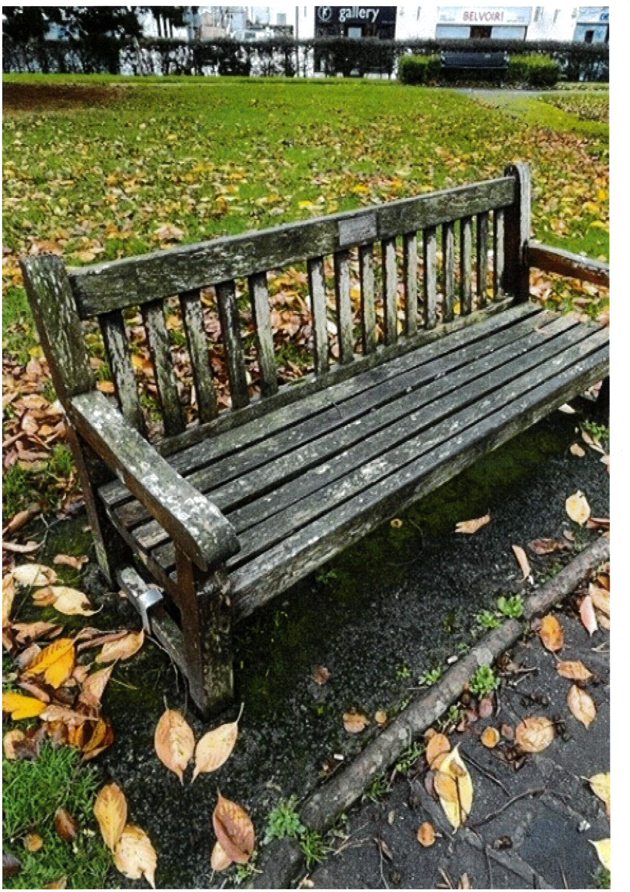

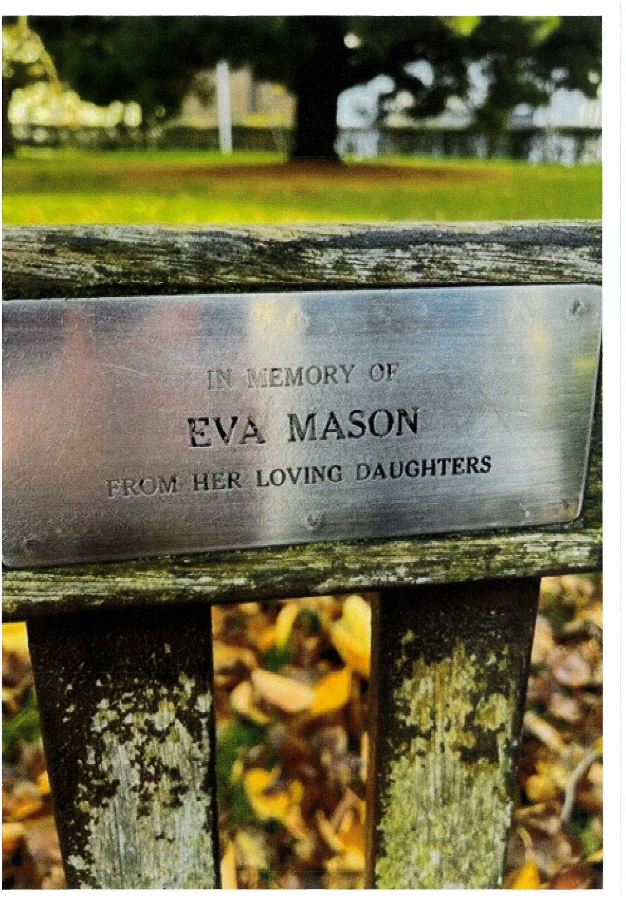

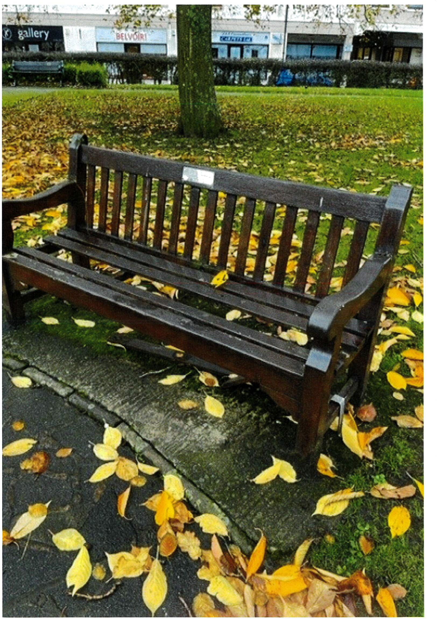

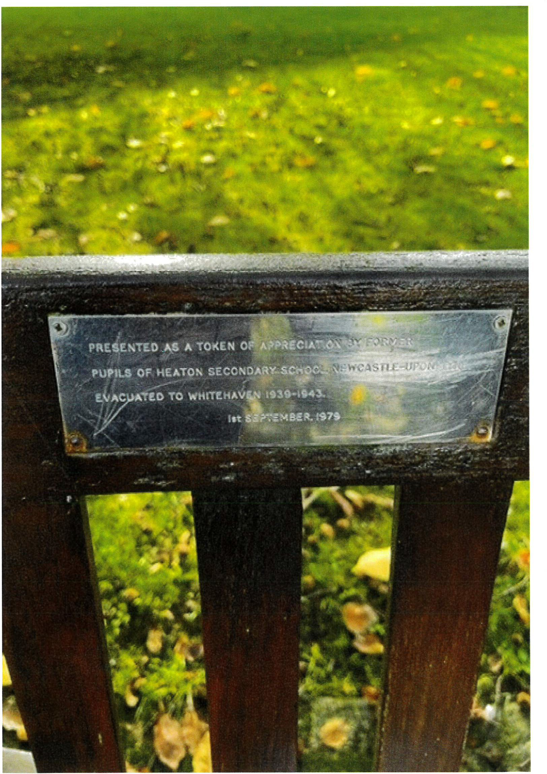

(https://uk.glasdon.com/)

Quote Basket - 2 items
Please check your quote items below and then proceed to create your quick quote by selecting 'Finalise Quote'.

Product Description Qty Price Total
□

Lowther"' Seat (Slats: Brown Enviropol Material, Fixing: Concrete surface fixing bolts and tamper resistant fixing covers, Memorial Plaque (150 x 40mm))

X remove (Cart.asp?
delid=l 59451921&storeid=67236&returnurl=&fromcart=ok)
£733.16 £1,466.32

◄ Continue Shopping (https://uk.glasdon.com/)

" Recalculate

Currency is British Pound.
If you have a Promotional Code please enter it in the box below and click on the 'Apply' button.

Subtotal £1,466.32
Delivery £0.00
Tax £293.26
.................,.............
Total £1,759.58

iii Finalise Quote

© Glasdon UK Limited 2022. All rights reserved.

