WHITEHAVEN TOWN COUNCIL

Clerk to the Council: Chairman:
Marlene Jewell Telephone: 01946 67366 Councillor Chris Hayes

To: Members of the Whitehaven Town Council

You are duly SUMMONED to attend an MEETING of WHITEHAVEN TOWN COUNCIL which will be held in THE HARBOUR GALLERY at THE BEACON, WHITEHAVEN
Date: 26th August 2021 Time: 6.00pm

Signed... ... ...... .. ... .. ... ...Dated.l. ( A-µ 5tt 2 a 2 / Marlene Jewell, Clerk and Responsible Financial Officer

AGENDA
- Apologies for Absence

To receive apologies for absence

- Declarations of Interest

To receive declarations of interests by elected members in respect of Agenda items

If a Member requires any advice on any item involving a possible declaration of interest which could affect his/her ability to speak and/or vote he/she is advised to contact the Clerk at least 24 hours in advance of the meeting.

- Public Participation

- Minutes of Meeting held on 10th August 2021

- Planning Applications

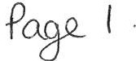
- Finance Report

- Town Council Apologies

- Repairs to Office Building

- Recommendations from Events Advisory Group - To follow

- Whitehaven in Bloom

- Councillor Ward Matters

- Date and Time and Venue of Next Meeting

IN PRIVATE

That prior to the following items of business the Chairman will move the following resolution:-

That in view of the special or confidential nature of the business about to be transacted it is advisable in the public interest that the public and or press be instructed to withdraw.

- Councillor Ward Grant - CVG

- Application for Grant - WAU 16

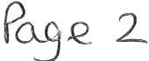

WHITEHAVEN TOWN COUNCIL

Minutes of the Council Meeting held on 10th August 2021 Present: Councillor C Hayes (Chairman); Councillor R Gill;
Councillor C Maudling; Councillor B O'Kane; Councillor J Rayson; Councillor G Roberts;

M. Jewell, Clerk and Responsible Financial Officer

- Gorley, Assistant Clerk Member of the Public
Before the start of the Meeting the Chai1man invited all Councillors to join with him in wishing Councillor Redmond who was in hospital a speedy recovery.
Councillor Gill asked that a get well card be sent to Councillor Redmond.

1838/21 Apologies for Absence

Apologies for absence were received from Councillor E Dinsdale, Councillor G Dinsdale, Councillor R Redmond, Councillor C Walmsley and Councillor L Walmsley

1839/21 Declarations of Interest

Councillor G Roberts declared an interest in Item 11 as he was a member of CCC.
Councillor Maudling declared an interest in Item 5 he was a member of CBC's Planning Panel.

1840/21 Public Participation

There was no public paiiicipation

1841/21 Minutes of the Meeting held on 24th June 2021

It was proposed by Councillor Gill and seconded by Councillor Roberts that the Minutes of the Meeting held on 24th June 2021 be approved and signed by the Chairman as a con-ect record. A vote was held and 5 Councillors voted for the proposal and 1 Councillor abstained.

RESOLVED -That the Minutes of the Meeting held on 24th June 202lbe approved and signed by the Chairman as a con-ect record

1842/21 Planning Applications

The Council considered a report on Planning Applications received and shown at Appendix 1.
  - Councillor Roberts referred to land to the West Of Casa Mia (4/21/2263/DOC and 4/21/2268/0R l ) and said there were 2 matters - the discharge of conditions and approval of reserved matters. He said it should be noted that other issues like drainage and access have not been addressed by CCC and these could prove problematic and therefore he objected to these two items going forward. Councillor Roberts proposed that CBC be informed of these objections and this was seconded by Councillor Gill. A vote was held and 5 Councillors voted for the proposal and l Councillor abstained.
RESOLVED - That CBC be informed that the Council objected to planning applications 4/21/2263/DOC and 4/21/2268/0Rl because issues like drainage and access have not been addressed by CCC and these could be problematic
11. Councillor O'Kane raised a point of concern on planning applications in that he could not follow the link for the planning app on the CBC website and thought that CBC should send the Council more details on planning applications like they used to. Councillor O'Kane proposed that CBC be requested to provide more details on each planning application that they send to the Council so that the Council can see what it's about and go back to the previous system where the Council were given outline details by CBC and this was seconded by Councillor Gill. A vote was held and 5 Councillors voted for the proposal and 1 Councillor abstained.

RESOLVED - That CBC be requested to provide more details on each planning application that they send to the Council so that the Council can see what it's about and go back to the previous system where the Council were given outline details by CBC.

1843/21 Finance Report

The Council considered a Finance report.

1. Appendix1 - It was proposed by Councillor Gill and seconded by Councillor Roberts that the Invoices shown at Appendix 1 be approved and paid. A vote was taken and it was unanimously

RESOLVED - That the Invoices shown on Appendix 1 be approved and paid.

ii. Appendices 2 and 3 - It was proposed by Councillor Gill and seconded by Councillor Roberts that Appendices 2 and 3 be approved and noted. A vote was held and it was unanimously
RESOLVED- ThatAppendices 2 and 3 be approved and noted.

1844/21 Purchase of Seagull Proof Bags

The Council considered a repo1i on the purchase of seagull proof bags. The Council had last purchased 500 seagull proof bags in 2016 and stocks were running low. 3 quotes had been sought and 2 had been received. It was proposed by Councillor Gill and seconded by Councillor Roberts that 500 seagull proof bags be purchased from Company A at a cost of £1,575.00 plus
£45.00 carriage plus VAT. A vote was held and it was unanimously

RESOLVED - That 500 seagull proof bags be purchased from Company A at a cost of £1,575.00 plus £45.00 carriage plus VAT

1845/21 Council Events

The Clerk reported on Council events and said
- that due to covid the organisers of Viking Re-enactment to be held on 7th and 8th August 2021had postponed the event until some time next year.
- That following a meeting that Gerard Richardson had with CCC a Cumbria County Council Community Grant for £3,290.00 had been applied for and granted to the Council for the purchase of 10 gazebos to be stored in the Council offices. The firm supplying the gazebos informed the Council that they could supply 10 gazebos at a cost of £3,190.00 plus sandbags at a cost of£ 110.00 plus delivery of£ 120.00 plus VAT making a total of £3,420.00 which was a shortfall of£ 130.00. Approval was being sought to pay the extra£130.00. It was proposed by Councillor Roberts and seconded by Councillor Gill that the shortfall of£ 130 .00 be paid from the Events budget so that the gazebos could be purchased. A vote was held and it was unanimously
RESOLVED - That the shortfall of£ 130.00 be paid out of the Events budget so that the gazebos could be purchased.

1846/21 Whitehaven in Bloom

The Council considered a report on action that was taken to provide hanging baskets and barrels on the harbour due to the Harbour Commissioners being unable to source these. The Council's suppliers Bennett Brothers said they had

12 spare hanging baskets at a cost of £7.50 each and the l O spare wooden baskets belonging to the Council barrels could be filled with compost and flowers at a cost of £30.00 each. As there was not time to get Council authority for these the Mayor said that as the Harbour was part of Whitehaven in Bloom he would make a donation and pay for the flowers out of his expenses .
Councillor Gill congratulated Councillor O'Kane and the Mayor for their actions in facilitating this and proposed that the expenditure for the hanging baskets and the barrels be paid for out of the Whitehaven in Bloom budget. This was seconded by Councillor Roberts. A vote was held and it was unanimously

RESOLVED - That the expenditure for the hanging baskets and the barrels be paid for out of the Whitehaven in Bloom budget.

1847/21 Venue for Council Meetings

The Clerk referred to Minute 1833/21 when it was agreed that the Council hold its Council Meetings at The Harbour Gallery at The Beacon at their quoted rate of £40.00 per hour. However it was subsequently discovered that the Beacon had 2 tariffs for the hire of the room - £40.00 per hour during normal office hours of 9-5 and £60 an hour after that. However following discussions with the Beacon it had been agreed that the Council would be charged at the rate of £40.00 per hour. This information was for information only and no decisions were taken.

1848/21 New Unitary Councils

The Clerk said that after the announcement about the new Unitary Councils there had been little further detail and hoped that there would be more detailed information to present to the September Meeting. Councillor Roberts said that the CCC had put in a judicial review of the proposals for a unitary authority but no further details were available on this
A general discussion took place on the transfer of assets etc but no decisions were made although specific mention was made about the mace and the mayoral civic regalia which were held be CBC.

1849/21 Recommendations from Allotment Advisory Group

Councillor Rayson declared an interest as she was an allotment holder.

The Assistant Clerk informed the Council on the current position on allotments. A meeting of the Allotments Advisory Group had taken place on 9th August 2021 and the following recommendations were made for consideration by the
Council:-

1. To give approval to a request from a tenant on the Crow Park Allotments to plant 2 small patio trees on the allotment

11. To give approval to a request from a tenant on Cartgate Allotment Site to swap his plot for another plot on the site which was shortly to become available. This was for medical reasons.
n1. To give approval to a request from a tenant on Crow Park Allotment Site for a set of steps to be installed by the Council down a grassy bank which became very slippery in wet weather and which tenants had to use to get to their allotments. The cost of this work to be catTied out by the Ranger and Assistant Ranger was £415.00 plus Vat. The Allotments Advisory Group recommended that the work be carried out at this cost to avoid any health and safety issues.
1v. That the debris left on an allotment site by a previous tenant and consisting of wooden pallets and tyres be removed by the Council Rangers at a cost of approximately £100.00
v. That the request from the owner of 5 Crow Park for permission for their contractor to use the communal access way on the Crow Park Allotment Site in order to install a new septic tank in their rear garden be approved subject to stringent conditions being imposed. The Clerk said she had prepared an Undertaking for the Contractor to sign which contained conditions imposed by the Council in consideration of giving permission to use the communal access and read the Undertaking out.
v1. That a site visit to the 4 Allotment Sites be arranged with the Allotments Advisory Group and the Allotment Sites' Representatives.
It was proposed by Councillor Roberts and seconded by Councillor Hayes that the recommendations in i to vi above be approved and actioned. A vote was held and 5 Councillors voted for the proposal and 1 Councillor abstained.

RESOLVED - That the recommendations in i to vi above be approved and actioned.

1850/21 Councillor Ward Matters

1. Councillor Maudling referred to ongoing problems with e-scooters and said that the Police were handling a lot of problems with people being drunk and on drugs
11. Councillor O'Kane referred to the state of the hedge on Victoria Road (Bleach Green) and said it was an overgrown and was a hazard. He said it was the same as Church Street (St Nicholas Gardens) in Whitehaven. He said a letter should be sent to Emanuele asking if these can be cut as a matter of urgency
111. Councillor O' Kane asked if there was any update on the bus shelter at Bransty and the Assistant Clerk said no as we were still looking for the owner of the land
1v. Councillor Gill said that the state of the Roads in Hensingham is appalling
v. Councillor Roberts said there were the same problems at Barras Moor with traffic and planning applications.
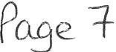

v1. Councillor Hayes said that in Kells Ward they had had a very good meeting with the Police and the Highways Department

1851/21 Date and Time of Next Meeting

The next Council Meeting be held on 26th August at 6.00pm at the Harbour Gallery, The Beacon

IN PRIVATE
1852/21 That prior to the following item of business the Chairman moved the following resolution: -

That in view of the special or confidential nature of the business about to be transacted it is advisable in the public interest that the public and or press be instructed to withdraw from the meeting.
Councillor Roberts proposed this and Councillor Gill seconded it. A vote was held and it was unanimo usly.

RESOLVED-That in view of the special or confidential nature of the business about to be transacted it is advisable in the public interest that the public and press be instructed to withdraw from the Meeting. All
members of the public and press then left the Meeting.

IN PRIVATE

1853/21 Councillor Ward Grant- CVG

Further to Minute 1837/2 l Councillor Arrighi was not in attendance but the Clerk read out an email from her that had been received earlier that day. There had been no response from Mr Forster.
It was proposed by Councillor O' Kane and seconded by Councillor Gill
that a letter be sent to the Copeland Veterans Group asking them to provide full details of the expenditure for the£1,000Ward Grant prior to the next Meeting otherwise the Council will request the return of the £1,000 Ward Grant in full. A vote was held and it was unanimously

RESOLVED - That a letter be sent to the Copeland Veterans Group asking them to provide full details of the expenditure for the£1,000 Ward Grant ptior to the next Meeting otherwise the Council will request the return of the £ l ,000 Ward Grant in full.

1854/21 Application for Grant - WAU16

The Council considered an application from WAU16 and it was proposed by Councillor Gill and seconded by Councillor Maudling that the matter be moved
p°'-o/-g

to the next Council Meeting for conside ration. A vote was held and it was unanimou sly

RESOLVED - that the matter be moved to the next Council Meeting for consideration.

1855/21 Application for Grant- WHC

The Council were informed that the application for a grant from WHC had been withdrawn as the applicant had received full sponsorship for the project

The Meeting closed at 7.20pm

Chairman

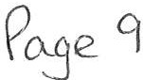

WTC 24/06/2021
Item 5

Planning Application for Consideration by Whitehaven Town Council

Application Number

4/20/2334/0R1

4/21/2350/0 F1

4/21/2351/0F1

4/21/2353/0F1

4/21/2359/TPO

4/21/9003
Consultation on Additional and Updated Information: RESERVED MATTERS APPLICATION FOR 26 DWELLINGS
AND ASSOCIATED INFRASTRUCTURE FOLLOWING OUTLINE APPROVAL 4/17/2143/001
FORMER ROMAR FACTORY, IVY MILL, MAIN STREET,
HENSINGHAM, WHITEHAVEN

ERECTION OF DWELLING WITH DETACHED GARAGE
PLOT 13, COLLIERS WAY, WHITEHAVEN

THE INSTALLATION OF 1 NO. UPSTAND FITTED WITH 2 NO.
?KW ELECTRICAL OUTLETS FOR THE CHARGING OF ELECTRIC VEHICLES, ASSOCIATED CABLING AND ANCILLARY WORKS, INCLUDING THE INSTALLATION OF A VEHICLE PROTECTION BARRIER AROUND THE UPSTAND CAR PARK AT THE OLD TOWN HALL, DUKE STREET, WHITEHAVEN

GROUND FLOOR ACCESSIBLE BEDROOM AND ENSUITE BATHROOM TO REAR
17 CUMBERLAND ROAD, WHITEHAVEN

RETROSPECTIVE PERMISSION TO REMOVE DEAD/DANGEROUS TREES WITHIN A CONSERVATION AREA WINDMILL BROW, WHITEHAVEN

PROVISION OF 5 NO. TEMPORARY CLASSROOM BUILDINGS, AND ASSOCIATED ANCILLARY DEVELOPMENT, TO ACCOMMODATE ST BRIDGETS PRIMARY SCHOOL, PARTON UP TO 31sr JULY 2022
BRANSTY PRIMARY SCHOOL, HAIG AVENUE, WHITEHAVEN

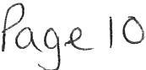

WTC 26/08/2021

Item 6

FINANCIAL REPORT

Purpose of the Report

Members are asked to consider a list of invoices for authorisation and payment as shown at Appendix 1 and approve the recommendations in paragraphs 3.1 and 3.2.

- INTRODUCTION

- Authorise the payment of all invoices as listed in Appendix 1.

- The Council is asked to note the cashbook as reconciled with the bank account as shown at Appendix 2 together with income and expenditure at Appendix 3.

  - FINANCIAL POSITION

  - The bank reconciliation was carried out on 18th August 2021. This shows a balance of £368,885.92. There are however cheques to the value of £457.06 still to be presented and cleared.

  - The balance in the deposit account is £450,400.11.

  - RECOMMENDATION

  - The invoices listed and shown in Appendix 1 be approved and authorised for payment.

  - The Cashbook (Appendix 2) and the Income and Expenditure (Appendix 3) be noted.

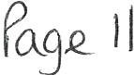

26/08/2021

Appendix 1

Invo icesfor Considerat ion by Whitehaven Town Council

Date | Supplier | Category | Detail |  | Total Amount | Power | Columnl
19/07/ 2021 | J & R Bennett | 3rd Party | Flowers for 166 hanging baskets, 12 half moon baskets, 32 half barrier baskets and 4  bulk bags compost | £ | 3,972.00 | s144 LGA 19 72
19/07/ 2021 | J & R Bennett | 3rd Party | Plants, compost and planting for 10 barrels and 12 hanging baskets for Whitehaven  Harbour | £ | 468.00 | s144 LGA 1972
19/07/2021 | J & R Bennett | 3rd Party | Summer bedding 2021 | £ | 3,147.24 | s144 LGA 1972
25/07/2021 | Ede n Springs (UK) Ltd | Supplies & Services | 1 x 18.51wat er and environmental levy for August | £ | 7.56 | slllLGA 1972
29/07/2021 | Viking | Supplies & Services | A4 & A3 Copier Paper | £ | 46.18 | slllLGA1972
01/08/2021 | Copeland Borough Council | 3rd Party | Assistant Ranger Contract - August 2021 | £ | 2,199.02 | slll LGA 19 72
01/08/2021 | Copeland Borough Council | 3rd Party | Grass CuttingContract - August 2021 | £ | 1,995.62 | slllLGA 1972
01/08/2021 | Cope land Borough Council | 3rd Party | Parks & Open Spaces Ranger Cont ract - August 2021 | £ | 3,325.44 | slll LGA 19 72
01/08/2021 | Copeland Borough Council | 3rd Party | Allotment Maintenance Contract - August 2021 | £ | 717.42 | s23 Small Holding s Allotments Act 1908
04/08/2021 | So lway M anagem en t Ltd | Prem i ses | Legionella Risk Assessment | £ | 300.00 | Health and Safet y at Work Act 1974
13/08/2021 | Graham Roberts | Premises | WD-40spray | £ | 3.75 | s111LGA 1972

£ 16,182.23

P e 12

WHITEHAVEN TOWN COUNCIL CASH BOOK FROM 1 APRIL 2021

APPENDIX 2
Employees/ Supplies/ Community Ground Civic Ward Environmental

Date Ref Payee Allowances Premises Services 3rd Party Grants Allotm ts Market Aprll -2021
01/04/2021 991 Copeland Borough Council 10603.75
15/04/2021 992 HMRC 2155.02
15/04/2021 BACS St a ff 4364.68
15/0 4/20 21 BACS Cumbria LGPS 1825 .02
19/04/2021 DD Crown Gas & Oil 251.05
20/04/2021 DD ST Group 70.42
Plan Maint Hospi tality Ranger / SO W.I.S Grants Elections Im provements Events Contingencies Reserves NetTotal VAT Total Min. Re f.
10603.75 10603.75 1723/21 (i)
2155.02 2155.02 HMRC
4364.68 4364.68 1666/20
1825.02 1825.02 6317/17 (ii)
251.05 50.21 301.26 Contract
70.42 14.08 84.50 Contract
1000.00 1000.00 1733/21

- 30/04/2021 BACS Vulture Club
- 30/04/2021 993 Copeland Borough Council
- 30/04/2021 SACS Eden Springs (UK) Ltd 1.80
- 30/04/2021 SACS Clyde & Co
- 30/04/2021 BACS Derwent Recycling Services Ltd
- 30/04/2021 BACS Derwent Recycling Services Ltd
- 30/04/2021 SACS Derwent Recycling Services Ltd
- 30/04/2021 994 Copeland Borough Council
- 30/04/2021 995 Copeland Borough Council
- 30/04/2021 996 Copeland Borough Council
- 30/04/2021 997 Cope la nd Borough Council
1000 .00

70.83

240.00
240.00
240.00

597.85

1663.02

2771.20
1832. 52
70.83 14.17 85.00 1761/21 (i)
1.80 0.36 2.16 1761/21(i)
232.30 232.30 232.30 1761/21 (i)
240.00 48.00 288.00 1761/21 (i)
240 .00 48.00 288.00 1761/21 (i)
240 .00 48 .00 288.00 1761/21 (i)
1663.02 332.60 1995.62 1761/21 (i)
597 .85 119.57 717.42 1761/21 (i)
2771.20 554.24 3325.44 1761/21 (i)
1832.52 366.50 2199.02 1761/21 (i)
15.20 15.20 1761/ 21 (i)

- 30/04/2021 998 Copeland Borough Council
- 30/04/2021 SACS Water Plus Limited
- 30/04/2021 BAC5 Water Plus limited
15.20

27.11
54.42
27.11 27.11 1761/21 (i)
54.42 54.42 1761/21 (i)
209.68 41.94 251.62 1761/21(i)

- 30/04/20 21 SACS Whitehaven Gas & Plumbing 209 .68
19 30/04/2021 SACS Cumbria Media 356.00
20 30/04/202 1 999 Viking 173 .80
21 30/04/202 1 1000 Mrs VGorley 8.48 21.51
M ay-2021
14/05/2021 SACS Staff 4771.51
14/05/2021 1001 HMRC 2256.63
14/05/2021 SACS Cumbria LGPS 164.94
22 14 /05/2021 SACS Imperative Training Limi ted 120.00
23 17 /05/2021 DD Cro wn Gas & Oil 238.33
24 19/05/2021 DD BT Group 67.21
- 25/05/2021 SACS Friends of St JINS
- 25/05/2021 SACS Roseh ill Youth Theatre
- 25/05/2021 SACS Deborah McKen na Ltd
- 27/05/2021 SACS POD (North West) Ltd 800.00
Ju ne-2021
- 03/06/2021 BACS Eden Springs (UK) Ltd 19.80
- 03/06/2021 SACS DerwentRecycling Services Ltd
- 03/06/2021 1003 Copeland Borough Council
- 03/06/2021 1004 Copeland Borough Council
- 03/06/2021 1005 Copeland BoroughCouncil
- 03/06/2021 1006 Copeland Borough Councli
35 03/06/2021 1007 Mrs J Hart ley 250.00
36 03/06/2021 SACS Cumbria Media 349.58
37 03/06/2021 1008 Sharp BusinessSystems 144.79
38 03/06/2021 1009 Westcom IT 214.19
39 03/06/2021 BACS Mrs V Gorle y 159.00
40 03/06/2021 SACS Zurich Municipal 3233.79
41 03/06/2021 SACS CALC 1878.49
42 03/06/2021 SACS Sharp BusinessSystems 2700 .00
43 03/06/2021 SACS Mrs VGorley 7.98
- 03/06/2021 SACS Mrs MJewell
- 03/06/2021 SACS Tradeprint
15/06/2021 1010 HMRC 2257.03
15/06/2021 SACS Cumbria LGPS 210.12
15/06/2021 SACS Staf f 4516.89
46 17/06/2021 DD Crown Gas & Oil 192.98
47 21/06/2021 DD BT Group 71.71
- 28/06/2 021 SACS Eden Springs (UK) Ltd 1.80
- 28/06/2021 SACS Carlisle City Fire Protection 38.25
- 28/06/2021 1011 Copeland BoroughCouncil
- 28/06/2021 1012 Copel and Borough Council
- 28/06/2021 1013 Copeland Borough Council
- 28/06/2021 1014 Copeland Borough Counci l

1000.00

240.00

597.85

597.85

1663.02

1663.02

1832 .52

2771.20

1832.52

2771.20

500.00
356.00 356.00 1761/21 (i)
173.80 4.56 178.36 1761/21(i)
29.99 29.99 1761/21 (i)

4771.51 4771.51 1666/20
2256.63 2256.63 HMRC
164.94 164.94 6317/17 (ii)
120.00 24.00 144.00
238.33 47.66 285.99 Contract
67 .21 13.44 80.65 Contract
500.00 500.00 Ward Grant
1000 .00 1000 .00
1000.00 1000.00 200.00 1200.00
800.00 160.00 960.00 MayorsAllowance

19.80 3.96 23.76 1794/2 1 (i)
240.00 48.00 288.00 1794/21 (i)
1832.52 366.50 2199.02 1794/21(i)
1663.02 332.60 1995.62 1794/2 1 (i)
2771.20 554.24 3325.44 1794/2 1 (i)
597.85 119.57 717.42 1794/21 (i)
250.00 250.00 1794/21 (i)
349.58 349.58 1794/21 (i)
144.79 28.96 173.75 1794/21 (i)
214.19 42.84 257.03 1764/21
159.00 159.00 1794/ 21 (i)
3233.79 3233.79 1794/21 (i)
1878. 49 1878.49 1794/21 (i)
2700.00 540.00 3240.00 1763/21
7.98 7.98 1794/21 (i)
59.40 59.40 11.88 71.28 1794/21 (i)
340.68 340.68 68.14 408.82 1794/21 (i)
2257.03 2257.03 HMRC
210.12 210.12 6317/17 (ii)
4516.89 4516.89 1666/20
192.98 9.65 202.63 Contract
71.71 14.34 86.05 Contract
1.80 0.36 2.16
38.25 7.65 45.90
1832.52 366.50 2199.02
1663.02 332.60 1995.62
2771.20 554.24 3325.44
597.85 119.57 717.42
32.48 6.50 38.98

54 28/06/2021 1015 Viking
- 28/06/2021 1016 Water Plus limited
- 28/06/2021 1017 Water Plus Limited
57 28/06/2021 1018 Water Plus li mited 194.80
32.48
18 .98
117.50
18.98 18.98
117.50 117.50
194.80 10.71 205.51

58 28/06/2021 SACS Cumbria Media 170.00
59 28/06/2021 1019 Bec k Bottom Community Garden Group• VOID Jul y-2021
60 17/ 07/ 2021 DD Crown Gas & Oil 77.54
61 19/07/2021 1020 Fledglings (replaces chq no 990)
170.00 170.00

77.54 3.88 81.42 Contract
200.00 200.00 200.00 Ward Grant
2256.82 2256.82 HMRC

19/07/202 1 102 1 HMRC
2256.82
4517.10 4517.10 1666/20

19/0 7/2021 SACS Staff 4517.10
19/07/20 21 SACS Cumbria LGPS 733.36
62 20/07/2021 DD BT Group 68.59
63 30/07/2021 SACS Eden Springs (UK) Ltd 1.80
733.36 733.36 6317/17 (ii)
68.59 13.72 82.31
1.80 0.36 2.16

P09e_ /3

64 30/07/2021 BACS Roseh ill Youth Theatre 100.00 100.00 100.00

65 30/07/2021 BACS
66 30/07/2021 BACS
67 30/07/2021 1022
68 30/07/2021 1023
69 30/07/2021 1024
70 30/07/2021 1025
71 30/07/2021 1026
72 30/07/2021 1027
73 30/07/2021 BACS
74 30/07/2021 BACS
Copeland Borough Council  Bauer Radio Ltd |  | 20.00 |  |  |  |  | 1687.75 | 20.00  1687.75
Copeland Borough Counc il  Copeland Borough Council | 20.73 |  |  |  | 1832.52 |  |  | 20.73  1832.52
CopelandBoroughCouncil Copeland Borough Council |  |  |  | 1663.02 | 2771.20 |  |  | 1663.02  2711.20
Copeland Borough Council |  |  | 597.85 |  |  |  |  | 597.85
Mr Alan Clements |  |  |  |  |  | 22.52 |  | 22.52
Lockhart leisu re ltd |  |  |  |  |  |  | 595 .00 | 595.00
Whitehaven Gas & Plumbing | 110.00 |  |  |  |  |  |  | 110.00

20.00
337.55 2025.30
20.73
366.50 2199.02
332.60 1995.62
554.24 3325.44
119.57 717.42
22.52
119.00 714.00
22.00 132.00

75 30/07/2021 BACS Glasdon UK Ltd 2554 .08 2554.08 510.81 3064.89
- 30/07/2021 BACS Beck BottomCommunity Garden Group - replaces chq no1019 100.00 100.00 100.00 Ward Grant
- 30/07/2021 BACS Beck Bottom Community Garden Group 80.00 80.00 80.00 Ward Grant
Aug-21
13/08/2021 BACS Cumbria LGPS 733.36 733.36 733.36 631/17 (ii)
13/08/2021 BACS Staff 4516.89 4516.89 4516.89 1666/20
13/08/2021 1028 HMRC 2257.03 2257.03 2257.03 HMRC
38352.86 12306.93 9602.14 270.00 2000.00 3640.24 0.00 0.00 6652.08 0.00 18414.88 22.52 880 .00 0.00 2554.08 3682.83 0.00 232.30 98318.56 8238.67 £106,617.23

WHITEHAVENTOWN COUNCIL Appendix 3

INCOME 2020-2021  Date | Item |  | Precept | Interest | Other
01.04.2021 | Allotment | Rents 2021/2022 |  |  | 2460.00
14.04.2021 | Allotment | Rents 2021/2022 |  |  | 470.00
15.04.2021 | Allotment | Rents 2021/2022 |  |  | 100.00
15.04.2021 | HMRC - VAT Refund - March 2021 |  |  | 2339.13
19.04.2021 | Allotment Rents 2021/2022 |  |  | 100.00
30.04.2021 | 2021-2022 Precept |  | 433573.86
30.04.2021 | Allotment Rents 2021/2022 |  |  | 260.00
04.06 .20 21 | CBC - Refund |  |  | 24.60
07.06.2021 | Allotment Rents 2021/2022 |  |  | 450.00
11.06.2021 | HMRC - VAT Refund - May 2021 |  |  | 2496.39
14.06.2021 | HMRC - VAT Refund - Apr il 2021 |  |  | 1860.36
14.06.2021 | Allot ment Rents 2021/2022 |  |  | 40.00
23.06.2021 | Sellafie ld Sponsorship |  |  | 3000.00
28.06.2021 | Allotment Rents 2021/2022 |  |  | 291.00
30.07.2021 | All ot ment Rents 2021/2022 |  |  | 310.00
13.08.2021 | Allotment Rents 2021/2022 |  |  | 90.00
16.08.2021 | HMRC - VAT Refund - June & July |  |  | 3815.79

433573.86 0.00 18107.27 1451681.131

WHITEHAVEN TOWN COUNCIL |  | Expenditure Net  of VAT | Invoices not yet  processed | Budget
SUMMARISED INCOM E & EXPEN DITURE STATEMENT
FINANCIAL YEAR 20 21 - 2022
BANK BALANCESBROUGHT FORWARD
CBS 53905917 (01.04.2021) | 23,364.96
CBS 53906216 (01.04.2021) | 450,400.11
TOTAL OPEN I NG BALANCE | £ 473,765.07
INCOM E:
Prece pt | 433,573.86
Intere st (Deposit)
Other Income | 18,107.27
TOTAL INCOME | £ 451,681.13 !
EXPENDITURE
Employ ees & Allowances |  | 38352.86
Premises |  | 12306.93
Supplies/ Services |  | 9602.14
3rd Par ty |  | 270.00
Grants |  | 2000.00
Allotments |  | 3640.24
Marke ts |  | 0.00
Community Plan |  | 0.00
Ground Maintenance |  | 6652.08
Civic Hospitality |  | 0.00
Ranger |  | 18414.88
WhitehavenIn Bloom |  | 22.52
Ward Grants |  | 880.00
Elections |  | 0.00
Environmental Improvements |  | 2554.08
Events |  | 3682.83
Contingencies |  | 0.00
Reserves |  | 232.30
VAT (to be reclaimed) |  | 8238.67
TOTAL EXPEN DITURE |  | £ 106,617.23
CASH BOOK BALANCE
Brought forward |  | £ 473,765.07
Income |  | £ 451,681.13
Expenditu re |  | £ 106,617.23
Town Council Funds |  | I £ s1s,s2s.91 1
BANK BALAN CES
CBS 53905917 (18/08/ 20 21) |  | 368,885.92
CBS 539062 16 (18/08/ 20 21) |  | 450,400.11
1 £ s19 , 2ss.03 1

Unpresented Cheques 2021/ 2022

FINANCIAL POSITION
457.06

I £ s1s,s2s.91 1

f lb

Whitehaven Town Council

From:
Sent:
To:
Subject: Attachments:
w-rc ::lb (o \ ;2_1

'IcB\-1 '<
Bagshaw, Samantha <Samantha.Bagshaw@cumbria.gov.uk>
17 August 2021 14:25
Cumbria Association, of Local Councils FW: Parish Council Apologies
LTNS Parish Council NALC advice.pdf

Dear Colleague,

Recently, CALC has been dealing with an issue around how parish councils receive apologies. Section 85 of the 1972 Local Government Act says that council must 'accept' apologies based on the explanation that they receive as to
why the councillor is absent. This explanation must not breach privacy and therefore can be general eg 'due to work commitments' or 'family commitments' etc. The minutes must state that the apology is accepted (it can be noted and accepted) and, if possible, the reason given. It is important that the apologies are received in writing to the council before the meeting begins.

Many councils are in the habit of 'noting' apologies. In the interest of clarity, please ensure that apologies are accepted and are given in writing with an explanation.

However, if a council has accepted a verbal apology and agrees to 'note' it, there is no power to prosecute the councillor or the council. The only option available anyone challenging the legality of the council's actions is to take the council to judicial review at the High Court.

Kind regards,

Samantha Bagshaw Chief Officer
Cumbria Association of Local Councils (CALC)

Please note that all CALC officers are working from home. Please see the new contact details below.

Contact details:
Samantha Bagshaw - off ice@calc .org.uk Monday to Thursday AM

Sonia Hutchinson - Mob 07551 678497 Monday, Tuesday AM, Thursday and Friday

Chris Shaw- Mob07551 678521

Post: Fire and Rescue Service Headquarters, Carleton Avenue, Penrith, Cumbria, CAlO 2FA
Email: office@calc.org.uk Web: www.calc.org.uk

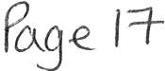

WTC 26/08/21
Item 8

REPAIRS TO COUNCIL BUILDING

To consider a report on repairs necessary to the Council building and to authorise works to be carried out

  - INTRODUCTION

  - On Friday 6th August 2021 during heavy rainfall it was discovered that the kitchen ceiling was leaking and the roof was leaking in the Council Offices.

  - Our Rangers had been sent to Millom to help out with the flooding there but a Copeland operative came to the building and cleaned out a gutter rnnning along the kitchen roof and that seems to have stopped the leak but he did say he thought the lead flashing may need to be replaced.

  - Numerous local contractors were contacted about the leaks and there was no reply from some, 2 were no longer trading, l said they were taking on no more work until after Christmas and some others that I left a voicemail with explaining the situation did not reply. Eventually a contractor from Egremont agreed to come and inspect the building on Saturday Th August 2021. He then submitted an estimate for the works to be carried out which is shown at Appendix 1

  - In the meanwhile further quotes have been requested from other contractors and will be reported to the Council if any are received.

  - This has been logged with our insurance company although they have informed us that we cannot claim for fair wear and tear which this appears to be.

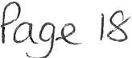

  - Further to Minute 1820/21 the Legionnella Risk Assessment was carried out and the contractor submitted the Risk Assessment shown at Appendix 2. Councillors will see at paragraph 3.0 of the Risk Assessment that amongst other things it is recommended that the combination water heater located in the old photo booth header tank on the first floor should be cleaned and chlorinated and the tank inspected annually. Quotes have been sought for this work but have not yet been received but any received will be reported at the Council Meeting.

RECOMMENDATION

  - It is recommended that the Council
    - approve the necessary repairs to the roof and a authorise the expenditure and
    - to authorise works to be carried out to the combination water heater header tank and the expenditure

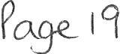

Wl1itcllaven Town Council

Date 11/08;2021

Re: Roofing 11\'0rks \'\'hitehaven 'lP .. bu1lci1 1g

Tl1ank 1'Cll for your enquiry for roof repairs to <1ilL'\f 1"operl\ pleast' find enclosed 01.,r
spet if1r ations and p11ces for works involved.

1· suppl> and erect scaifolding to include A I per11,1ts

- Rt::pair various loosR m1ss1ng and hrol·en s:atE-s

- Remove defec•i,e sk) I ght and slate over \'Old

ALL FOR THE SUM OF £1.450.00 PLUS \1.6.T

Trusting the enclosed rnPets w1tl1 your apf.t0\'11 ,11Hi ,=ic,c..,ring ,ou c ,ir l'cSt attPnt1on at all

R Mussen

tA-?--rc... Jo I 2/
t T evl x 2
Site Na ft?aven Town Hall Report No: 383
Survey Date: 12th July 2021

Legionella Risk Assessment

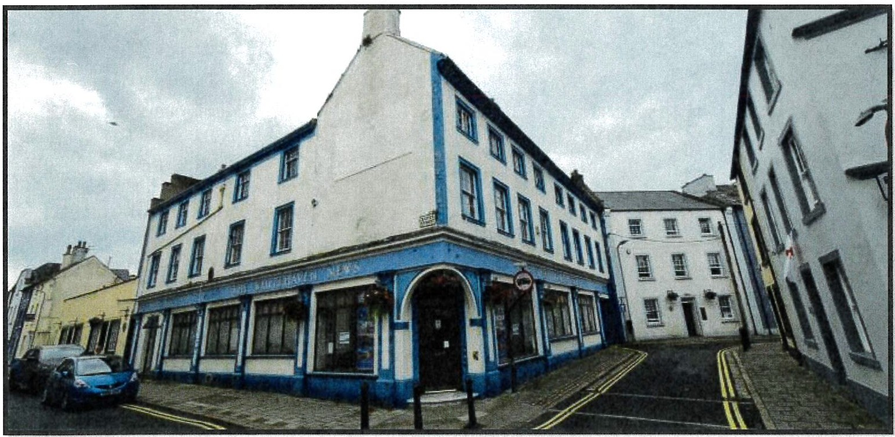

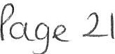
Date - 12th July 2021
Next Review Date - 12th July 2023
Posit ion : 'Water1lygiene Consultant
Surveyed and Checked By: IainJaratne
--
Handover Date: July 2021

LCA Registration Number: 2019/3539
Legionella Control Association

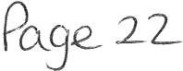

Objectives of the Survey & Risk Assessment

It is the objective of this survey and risk assessment to;

- Identify and assess the risk of exposure to Legionella from water systems on site.
- Recommend remedial actions to cont ro l and manage the proliferation of Legionella within water systems on site and/or reduce the amount of aeroso l produced.
- Identify and assess if Managements Procedures, Management Arrangements, and the Scheme for Control are adequate to effectively control the risk of exposure.

This risk assessment has been carried out in accordance with LB (ACoP) Approved Code of Practice & guidance from HSG274 - Part 2 "The control of Leqionella bacteria in hot & cold water systems".LB ACoP gives practical advice regarding an employer' s duties in
relat ion to the control of Legionella bacteria in the workplace with respect to;

- The Health and Safety at Work Act 1974- Sections 2, 3 and 4
- The Management of the Health and Safety at Work Regulations 1999
- The Control of Substances Hazardous to Health (COSHH) Regulations 2002 and Amendment 2003

In accordance with the requirements of LB ACoP this Risk Assessment has been undertaken to include;
- Potential for water droplet formation;
- Potential for Legionella bacteria to proliferate;
- A detailed plan of the water system(s);
- Details of how the water system(s) operate;
- The nature and the degree of risk posed by the buildings water system(s);
- Details of the remedial actions required to minimise the risk.

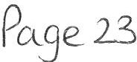

Contact Details

 | New Abbey Road
Address | Dumfries  DG2 8ER
Name | lain Jardin e
Com pa ny | So l way Water Management
Posit ion | Water Hygiene Co nsult ant
Telephone | 07802433947
Em ail | iain@solwaywatermanagement.co.uk
Web | www.solwaywatermanagement .co.uk

Sh ou ld you require any further assistance or info rm ation regarding this report please contact lain Jar di ne.

A colour coding system has been used in this document.

Prior it y and/or Risk Rating | Solway Water Management Suggested Time Bound Restrictions
 | Indicat es urgent attention is required and should be addr essed, Within 1 Month.
Medium | Ind icates improvements are required and shou ld be addressed, Within 3 Months.  Indicates refinements are required and shou ld be addressed, Within 6 Months.  Indicat es good practises and protocols are being carried out.
Low
No Further
Action

Note - Ultimately it is the "Responsible Person" who should set time bound restrictions for the completion of the recommended remedial actions in respect of what is reasonably practicable.

Cont ent s Page

Section | Sub  Section | Description |  | Page
1.0 |  | Executive Summary & Site Risk Rating |  | 5
2.0 |  | Legionnaires Disease |  | 6
3.0 |  | Remedial Action Plan |  | 7
 | 3.1 | Supporting Photographs & Info rm at ion
 | 3.2 | Limitations of the Survey and Risk Assessm ent
4.0 |  | Site Survey Information |  | 13
 | 4.1 | Site Overview
 | 4.2 | Site Management Structure
 | 4.3 | Review of The Written Scheme
 | 4.4 | Overview of Water Systems on Site - Table 1
 | 4.5 | Dead End Survey Section
5.0 |  | Assessment of the Risk |  | 20
 | 4.1 | Risk Score Cards
6.0 | 5.1 | Appendices  Assessors Competency  - | -- | 23  ·-
7.0 | l e !onella Control Association Ce tifi cation of M embe! ship |  | 26
8.0 | Definition of "Reasonably Practicable" |  | 27

9.0

-
Bibliography 28
-

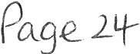
10.0 Schematic Drawing(s) 29

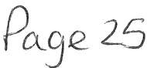

1.0 Executive Summary & Site Risk Rating
The inherent risk is the risk associated with the system before any action has been taken to control it. This sit es inherent risk rating has been classified as MEDIUM risk.
The residual risk is the risk remaining after the applicat ion of control measures, therefore if you adhere to the recommendations on page 7 to 8 including the supporting photographs and information, then this will reduce the risk rating to= ..· This will
demonstrate that the site has reduced the risk of contracting Legionnaires Disease to "As Low As is Reasonably Practicable (ALRAP)".
For a more detailed explanation of the inherent risk rating mechanism, refer to section
  - of this document.

Significant Findings from The Risk Assessment.
Refer to section 3 remedial action plan.

Risk Assessment Reviews

The risk assessment is a li ving document that must be reviewed and maintained to ensure it remains up to date. It shou ld be reviewed regularly and speci fi call y whenever there is reason to suspect it is no longer valid. This may result from, e.g.
    - Changes to the water system or its use;

    - Changes to the use of the building in which the water system is installed;

    - The avai labi lit y of new information about risks or control measures;

    - The results of checks indicating that control measures are no longer effective;

    - Changes to key personnel;

    - A case of Legionnaires' disease associated with the system.

2.0 Legionnaires Disease

Legionnaires' disease is a potentially fatal form of pneumonia which can affect anybody, but which principally aff e cts those who are susceptible because of age, illness, and
immuno suppres sion. It is caused by the bacterium Legionel!a pneumothorax and related bacteria. Legionella bacteria can also cause less serious illnesses which are not fatal or permanently debilitating (e.g. Pontiac Fever, Loch Goilhead Fever). The collective term used to cover the group of diseasescaused by Legionella bacteria is legionellosis.

It is an airborne disease that is normally contracted by inhaling tiny droplets of water (aerosols), or in droplet nuclei (the particles left after the water has evaporated) contaminated with Legionella, deep into the lungs. There is evidence that the disease may also be contracted by inhaling Legionella bacteria following ingestion (aspiration) of contaminated water by susceptible individuals.

Up to 300 cases of Legionnaire s 'disease is reported each year in the UK with approximately 12% of infections result ing in fat alit ies.

Habitat and Infection

Legionella species occur naturally in soil, rivers, and lakes and have the ability to successfully coloni se man-made water systems, which often provide ideal conditions of nutrition and temperature for their proliferation . The following factors must be present to result in the occurrence of infection. This is commonly referred to as the Legionel/osis
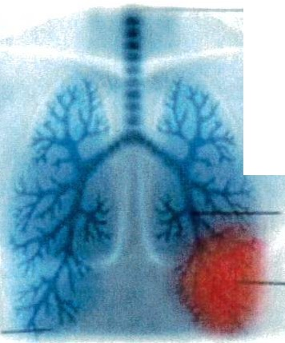
Causation Chain .
lf 1',\-..H t,;ii&
(WlndPlpe)

- Presenc e of Legionella b act eria;
- Presence of condit ion s that favour growth
- Generation of a respire -able aerosol;
- Inhal at ion of a contaminated aerosol by a Susceptible Population.

Lunq

Airways (bronclll)
Legionnaire
dilene
CIIUMI
pn.umonla
(Infection

Remedial Action Plan

Recommended Remedial Action | Priority/ Risk | Always Sign &  Date When Completed
Note: The risk from exposure to Legionella Bacteria in hot & cold supplies should be managed correctly as set out in HSG274 - Part 2. The control of Legionella Bacteria in hot & cold wat er syst ems .

- Ensur e the reccomendat ions below are implemented immediately.

- All hot and cold outlets that are not used weekly should be flushed for 5 minut es to reduce stagnation. Refer to page 9 from more information.
- The combination water heater located in the old photo booth header tank was inspected and has sediment & slime wit hin in. Ensur e t his is cleaned and chlorinated ASAP and continue to inspect the tank annually. Refer to page 10 for more information.
- Ensure a Legionella logbook is produced to keep all records of the above records in.

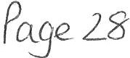

Recommended Remedial Action Priority/Risk |  | Always Sign &  Date When Completed
Note - Temperature control is the traditional strategy for reducing the risk of Legionella in water systems. Cold water systems should be maintained, where possible , at a temperature below 20°C. Hot water systems should be stored at least 60 °C and distributed so that it reaches a temperature of 50°C within one minute at the outlets.
- There is currently no monthly monitoring schedule in place. Hot & cold temperatures throughout the property should be monitored & recorded monthly to ensure they are within parameters as per the guidelines set out in HSG274- Part 2 - Table 2.1

- Ensure that cold outlets are tested & recorded for temperature compliance on a monthly basis, cold temperatures should reach 20°C within 2 minutes,
- Ensure that hot outlets are tested & recorded for temperature
compliance on a monthly basis, they should reach >S0°C within 1 minute.
- Refer to page 11 for more information and page 17 for outlets that need checked monthly .

Recommended Remedial Action Priority/Risk |  | Always Sign & Date When Completed
Note: Persons appointed to implement the Legionella control measures and strategies on site should be suitably informed, instructed, and trained.
- Ensure the responsible and deputy responsible persons attend Legionella Awareness Training.

  - Supporting Photographs & Additional Information
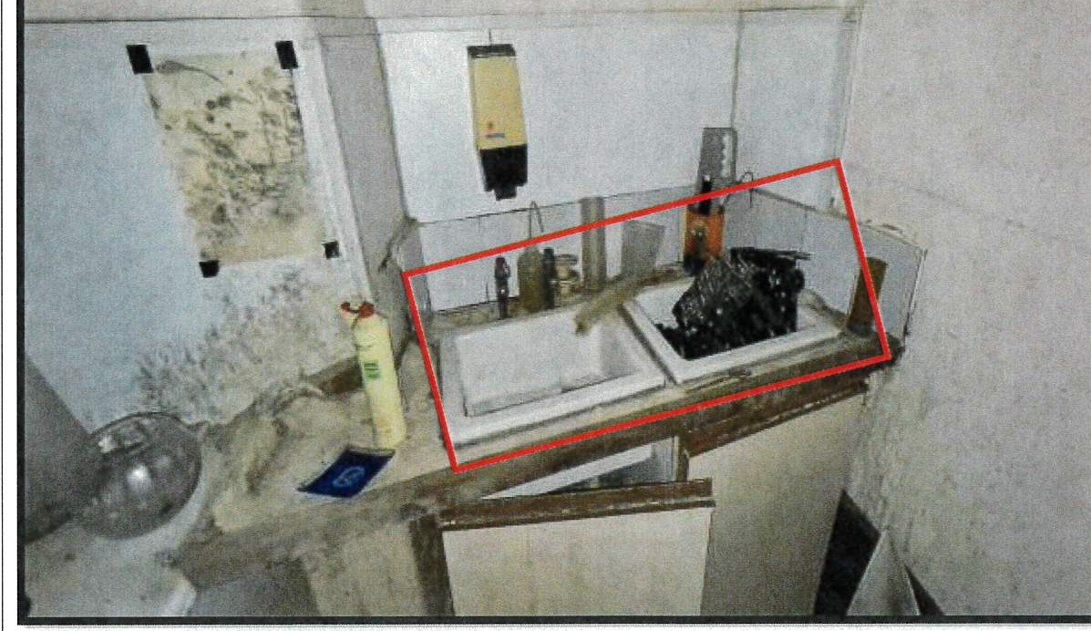
Note -An infrequently used outlet {IUO) is as a hot or cold outlet that has not been used within 7 days. Infrequently used outlets that are not flushed weekly can cause stagnation, thus increasing the risk for bacteria to proliferate.
Ensure they are flushed weekly for 1 - 5 minutes depending on the length of pipe work; make sure that flushing is document in the site logbook.
1', :,r :
11 1 1 w 1 1
/ '.1\1I I I
,
' 1 1 1 ,
, 1 1 11 1 1 : 1
I '

Note - Combination water heaters have a small header tank incorporated within their design. They should be treated the same as cold water storage tanks and must be fully compliant, additionally they should be inspect ed every year and cleaned and chlorinated if necessary.
Sediment & slime was present in the header tank
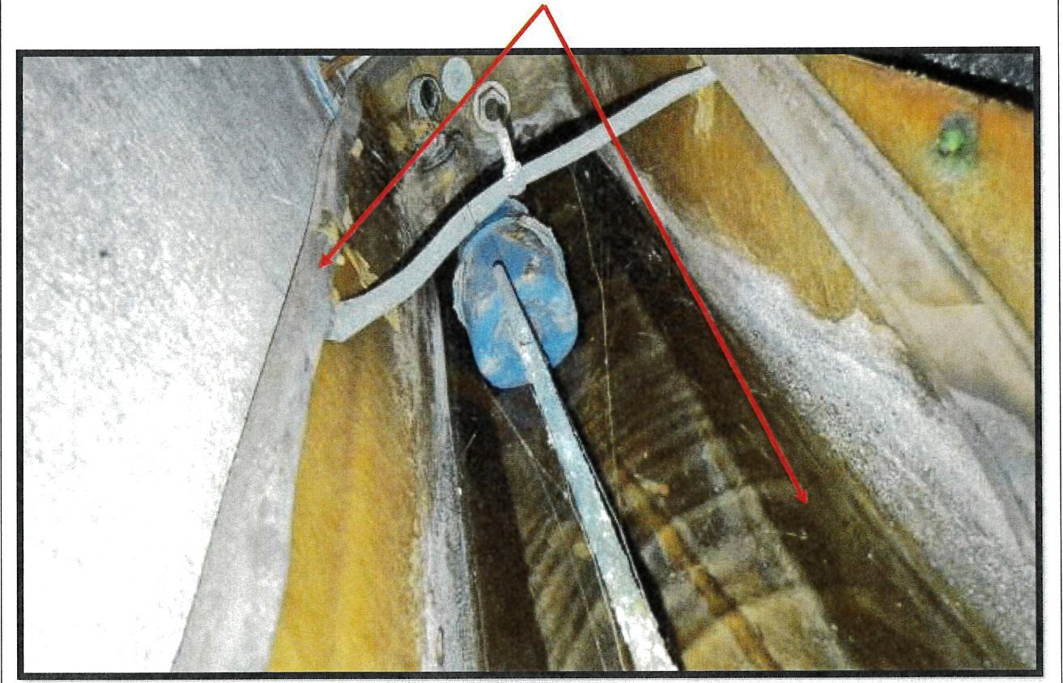

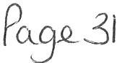

Note - Temperature cont ro l is t he trad it io nal st r at egy for reducing t he risk of
Legione lla in water system s. Co ld w at er syst ems shou ld be maint ained, where possible, at a t emperat ure below 20°C. Hot water systems shou ld be st o r e d at least 60°C and
dist ribu t ed so that it reaches a t emperature of S0 °C w it hin one minut e at t he out let s.

Hot & cold t emperatu res shou ld be mo ni t ored & recor ded mont hly to ensu re th ey are wit hin param et ers as per the gui de lines set out in HSG274 - Part 2 - Table 2.1- Page 31
- see extract below.

I-lot water | R,r r'\Or'-C/'Culati ng S',M'l>m s . \3.1<8 te rn;::,ara.tu rt>S at S8r t n 61 PQ<ms ( S \ | MONhf,
s.ervices | Owt ls1. ful'!Nlst owt:e t and lon g bra'10"'98 10 C\Jt5-s,s1 co confirm th,;y a,,e at  a m ,'11m....Jm of O .:ic w 11.ri,n C.'1 B m ,'"1'-'I E- (55 o.c 1n hsal: r-ca:.e p --e rn .;St.G)
 | For c-rcula1r: 9 sy5.t&mo t.aka tetnpsra:u r&S at returr legs of pr,ncipsJ  loopa {se,-,w nel p c.nt a.) to , ,::,rl,rm 1ney,a e at a m-.ri,mum c! 50 'C {55 "C | M onth l',
 | ,n hOOl t<1care Dr8dTl..OOS) e!"' p e,-atvre m eaaurem enrs rr.ay be taken on ,ne
 | 6Jr'ace of m0taJhe p,p&, ./Orl<
 | For c,rcu tanf' g SYSt€W' S: take uim p,gra;:uros aJ: >'9lurn legs Of 6. 1.0ord1 are  loocs. rerr oerarUfT!l 111easJ, rG<1'1e,n s can be t 3A-e-i on tl'l<il surtace of o,P&S. Cut whe<,; tnis .s not i:;.racttcable. i:10 1emps-a tuf9 of w ate,, from ll'!e las, outl;;-c on eac, 1 loci;:: r'Uayb e m ea SJJe d ano crii s sho,..lcl b e g,eate,- than | Q c.ane-t1 (td ally on a ro, 1ng mornh , rera)
 | 50 'C v,.th -i CY"e m ,r u t e o' "' nr ,ng ( 55 'C ,n n sa, thc a r s p remis es ) If t h s
 | tsrr pe ratu rs ns.e ,s slcv\o t ar ,o,ald be cc:-tfirrred U;at the ou tlet ..s on a long -59 ano not 1.11is t , ,e flow a.,<;1 ..et:..rn "31> ' a !ad ., it>.;,; ;0,;.al are;i
 | All HWS 8:-,St eM S ta><e TE.lffiPE.lrot u'8 0 8 ! a r8Pr0 &8nt81r il 6E)lect,Qf1 Cf Ot!'8r po,nrB ("1t €\rffi00i3%1) o,.;r E:<tS of &on g •e o,oo sy&te-ms ano ron,ar, IOOP-il ,n o.rcutaur.g s-;s,e m a) 10 co nf,'lTI 111(' / ani at a m ,n ,rn m o f eo 'C ( "C ,n  he>altl1eare pr9m ,sesi to c <Gate a t.im r:,.1urti proH o' ch9 w t·.01eSVSt m | R&p.-e&0nrat M l ae<e::t,c.., Of O!T10r S0"1t>"<ll OutiOtS con,;;..Cll<OO O" a r0 tat0na1  c as,s to e,-,s,.; lt\8
 | c,.,,;, a c,.;f riEld time. riod | whote &>/ S ts m ,s tsacn,ng
 |  | satisfac:tor ; tem psr-a:.urs; l"Or
 |  | 199 ,cnet.a = nttcl
Cold water  ,..enr i<:e;s | C"leck ten1perature.s a1 oon1.re1,ap s •t; D<Cal t, tJ-.c;,e ri-tr ano  !i.,rthe&t il'Cm tne co·.::: tanl< , t,,.,i m.a:,, alw n <;tud s ou•e, -<3y locl,,t,cn a 0'1 | M on thly
1009 tirarchas to zC'lSSc,- floor IG've ls l T "IG Oudets ShOulC! be bEl<IOw
:20 •c witn , n r,vo rrun.Jt0 & Of rur.r.rig il'19 COIO tao ro ,0011,t,t ar-, 1c c.a1
heat ga,n whc;;l1 rr ,g<11 n o t b;; parer,! sfler cnern"lute observe ths
 | Lhe<r'OClrT\et8r rea::ing tlJ> r n9 u S.'.1,-,g
 | Ta ternoera.ures a1 a rffirase ntatMl 6e<'7C1J(ln of 0tner oo,nts IC ccnfir-m tr ey at e telo.-. 20 •c 10 c reaie a tem o& atu,s p,,:,file of me w.-io>e S) .stem cN a d8finoo ttrr.9 gp noo . P9ak t9ffiPGratuf9:S o,- a,~; tGmp9f an, ies Iha,  an3 8lc),..,. ro fa.1sr.oulC oo an :ria ,ca tc • cf a 'Oeahood ero olem | Roo, eoen1at1 s e.occoe'i  Of oms, s..ntinel 0ull8t3  cor .sto erec o n a l() !.'.tl ,on aJ o a5ta to ensu re t/19
 |  | whlls 6Y'-,! em ,a rea c hing
 |  | satis fac 1or1 t &m p Sta t ure s -er
 |  | legior,eUa COntlOI
 | o i eci< 1./'>aemal ,nsu!at o n to arisu, e u ,s 11,r.act and con s .o er | .11.nn u all>;
 | ....w.100,p,cof;ng wh0<9 oom co r.en ts aro exoo soo to tl".e out000r
 | en•11rcn,ne.')!

Limitations of the Survey & Risk Assessment
Any water systems ident ified as not being included in the scope of the survey are listed below. This will be due to no or rest r ict ed access, the availability of assistance from site personnel, the availability of information relating to the management arrangements and records associated with the written scheme.

I Comments

N/A

Whilst every effort has been made to ensure that the assessment has been as comprehensive as possible, it should be recognised that it is impossible to guarantee that every syst em has been identified and so no liability can be accepted for omissions from this report particularly if no competent site contact was made available. Diligence sh ould be maintained regarding the potential risk of all water systems. If a system is subsequently identified which has a potential for proliferating Legionella bacteria, for which no precautions are currently detailed, then Solway Water Management Ltd should be contacted with a view to advising on the implementation of suitable procedures and reviewing this risk assessment.

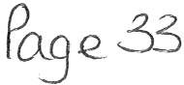

Site Survey Information
  - Site Overview

Site Description

The site is used as a Town Hall located in the middle of the town of Whit ehaven. The property is open Monday - Friday and operates daily from 8.00am to 16.00pm.
Demographics

There is currently 1 female staff employed at the site, and there are approx. 10 visit ors per week.

Water Supply Description

All cold outlets are fed direct from the mains and all domestic hot water is supp li ed from a combination water heater.
Refer to the schematic drawing for further detail.

Site Management Structure

Duty Holder:
The person on whom the statutory duty falls under, the company owner.
Name: | Whitehaven Town Council
Title: | Whitehaven Town Council
Telephone: | 01946 67366
Email: | clerk@whit ehavent owncounci l.co.uk
Responsible Person:
The duty holder should appoint a person to take day to-day responsibility for controlling any identified risk from Legionella bacteria. The appointed responsible person should be a manager, director or have similar status and sufficient authority, competence and knowledge of the installation to ensure that all operational procedures are carried out in a timely and effective manner. If a duty- holder is self-employed or a member of a partnership and is competent, they may appoint themselves. Those appointed to carry out control measures and strategies
should be suitably informed, instructed, trained and their suitability assessed.
Name: | Marlene Jewell
Title: | Clerk and Responsible Financial Officer
Telephone: | 01946 67366
Email: | clerk@whit ehaventowncouncil.co.uk
Deputy Responsible Person:
The appointed deputy responsible person should in the absence of or at the request of the responsible person take day to-day responsibility for controlling any identified risk from Legionella bacteria: Those appointed to carry out control measures and strategies shou ld be suitably informed, instructed, trained and their suitability assessed: Staff responsibilities and lines of communication should be
properly defined and clearly documented.
Name: | Vanessa Gorley
Title: | Assist ant Clerk
Mobile: | 01946 67366
Email: | clerk@whit ehavent owncouncil.co .uk

  - Review of Written Scheme

L8 ACoP requires that, there should be a written scheme for controlling the risk from exposure which should be implemented and eff ectively managed. The scheme should specify measures to be taken to ensure that it remains effective. The scheme should include:

- an up-t o-dat e plan showing layout of the plant or syst em, including parts temporarily out of use;
- a description of the correct and safe operation of the system;
- the precautions to be taken;
- checks to be carried out to ensure efficacy of scheme and the frequency of such checks;
- remedial action to be taken in the event that the scheme is shown not to be effective.

The Written Scheme may consist of Management Procedures, Management Arrangements, the Control Scheme, and record keeping systems. The Written Scheme is often referred to a Legionella Policy or Management Plan.

The Health and Safety Executive UK have highlighted that failings in the Written Scheme is a common significant contributing factor in a number of Legionellosis Outbreaks . Specific failings include a lack of defined responsibilit y, communication and the training and competence of those who have respon sibi lit ies to control the risks from Legionella bacteria.

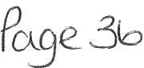

Consideration |  | Yes/No? | Further Action  Required
Management Procedures
Is there a current Legionellosis Management Plan in place?  Are procedures in place to ensure that a Risk Assessment and Reviews are undertaken?  Are escalation procedures in place to deal with failure to achieve  the control limits of the Control Scheme? |  | No Yes  No | Yes No  Yes
Management Arrangements
Is the Duty Holder identified in writing? |  | Yes | No
Has the Responsible & Deputy Person been identified in writing?  Are the roles and responsibilities of all parties defined in writing? |  | Yes No | Yes Yes
Is there a current ACoPL8 Risk Assessm ent or Review available? |  | Yes | Yes
Have the recommendations of the current Risk Assessment been |  | No | Ye s
signed off?
Training & Competency
Are training or refresher records available for  involved in the Control Scheme? | all personnel | No | Yes
Control Scheme
Is there a Logbook available?  Is there an asset register available?  Is there a schematic drawing of the water systems available ? |  | No  Yes Ye s | Yes  No No

Survey Notes

The following observation s were made during the site survey in relation to the assessment of t he Written Scheme.
Comments
Item

  - Overview of Water Systems on Site

Asset ID Asset & Frequency of Checks Location
CW H0l | Combination Water Heater  {monthly check) | Old Photo Bot h
H&C0l | Hot & Co ld Temperature Check  {monthly) | Staff Kitchen Sink
H&C02 | Hot & Cold Temperature Check  {monthly) | Ladies Toilet Wash Hand Basin

Hot Water Survey Section
Asset ID | Combination Water Heater  (CWHOl) | 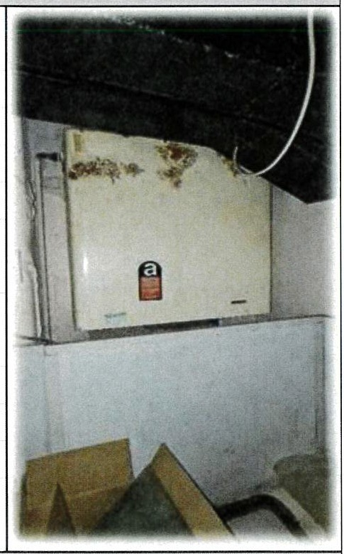
Location | Old Photo Booth
Make/Model | Heatrae Sadia
Orientation | Vertical
Volume Litres | Approx. 25 Litres
Primary heat  source | Electric Immersion
Secondary heat
source
Expansion vessel | No
Supplied By | Mains
Flow Temperature | 63 C
Return  Temperature | N/A
Asset Compliance Checklist
Drain valve at  lowest point? | No
Inspection hatch?  Suitable Insulation? | No  Yes
Hot Water Re­ circulated?  De-Stratification  Pump Fitted? | No  No

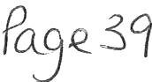

Dead End Survey Section
No dead legs were identified on site. '
'
System: Location :
M at erial: Diameter (mm):
Length (m):

Assessment of the Risk
Risk Score Card Mechanism

To enable the clear categorisation of the degree of risk associated with specific water systems within a building, a score card mechanism has been used for those systems that are deemed to present a reasonably foreseeable risk of exposure to Legionella bacteria.
This risk score card is based on a number of specific weighted contributing factors in respect of the characteristics and operating conditions of the water systems, which combined form the Legionella Causation Chain.
This risk scorecard does not take into account the assessment of the Written Scheme, including any Management Procedures, Management Arrangements or the performance of the Control Scheme.
The inherent risk rating of the building (as opposed to the residual risk rating) is determined by the highest scoring risk system identified.
Inherent Risk Score Ratings

Systems assessed during the survey using this score card mechanism may be categorised as High, Medium, Low, or Very Low Risk .
Some water systems may be deemed to represent a negligible level of risk of exposure to Legionella bacteria. Such systems will be common in their design, makeup and operational use and therefore may be attributed a pre-assessed risk rating of Very Low. Therefore, these systems may not require the completion of a sit e-speci fi c risk score card.
The highest risk scoring system identified determines the overall inherent risk rating for the sit e.

Risk Category | Risk Score
Low | 95
M edium | 96 to 120
 | >120

Site Name: Whitehaven Town Hall
w
Rep ort No: 383 Survey Dat e: 12^{t} ^{h} July 2021
,,,\t,,\• /i tt

Inherent Risk Score Cards

MAINS COLD WATER  Risk Parameter | Risk Rating | Numerical Value | Numerical Score
1. Formation of Water Droplets
Droplets | Medium | 20 | 20
Aerosol | High | 30
2. Water Condition
Auto Chemical Controller | Low | 05
Average | Low/Medium | 10 | 10
Contaminated | Medium/High | 20
Heavily Contaminated | High | 30
3. Water Temperature
Below 20°C 21·c- 25•c | Low  Medium | 10  20 | 10
26°C - 45•c | High | 30
46°C- 5o·c | Medium | 20
Above 50°C | Low | 10
4. Water Turnover
Stagnation Issues | High | 30 | 30
Low Turnover | Medium | 20
Moderate Turnover | Medium/Low | 10
High Turnover | Low | 05
5. Demographics
Low Populations | Low | 10
Average Populations | Medium | 20 | 20
Susceptible Populations | High | 30
6. Density of Exposed Population
Low Density | Low | 10 | 10
Medium Density | Medium | 20
High Density | High | 30
 |  | Total Numerical  Value | 100 MEDIUM

Site Name: White haven Town Hall
Repor t N o: 383 Survey Date: 12 ^{th} July 2021

Valu e 110
HOT WATER HEATER
Risk Parameter | Ris k Rating | Numerical Value | Numer ical Score
1. Formation of Wat er Droplets
Droplets | Medium | 20 | 20
Aerosol | High | 30
2. Wat er Condition
Auto Chemical Controller | Low | 05
Average | Low/Medium | 10
Contaminated | M edium/ High | 20 | 20
Heavily Contaminated | High | 30
3. Water Temperatur e  Below 20°C | Low | 10
21°C - 25°C | Medium | 20
26°C - 45 °C | High | 30
46°C - 50°C | Medium | 20
Above 50°C | Low | 10 | 10
4. Water Turnover
Stagnation Issues | High | 30 | 30
Low Turn over | M edium | 20
Moderate Turnover | Medium/Low | 10
High Turnover | Low | 05
5. Demograph ics
Low Populations | Low | 10
Average Populations | Medium | 20 | 20
Susceptible Populations | High | 30
6. Density of Exposed Population
Low Densit y | Low | 10 | 10
Medium Density | Medium | 20
High Density | High | 30
 |  | Total Numerical

MEDIUM

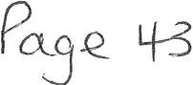

Appendices
  - Assessors Competency

lain Jardine is competent, suitably trained and holds the relevant experience to carry out water safety risk assessments to the required standard, he holds the following qualifications: -

    - SVQ- Domestic Plumbing Level 3 (time served plumber);

    - City & Guilds - Risk Assessment of Water Systems;

    - City & Guilds - Legionella Awareness & Acop L8;

    - City & Guilds - RPZ Valves & Backflow Requirements;

    - City & Guilds - Disinfection of Hot & Cold-Water Systems;

    - WMSoc - Risk Assessment in Cooling Systems;

    - WMSoc - Risk Assessment of Water Systems;

    - WMSoc - HTM04 - 01 Monitoring the Risks of Waterborne Pathogens;

    - WMSoc - HTM04 - 01 Managing & Controlling the Risk of Waterborne Pathogens in Healthcare Water Systems;

    - STA - Swimming Pool Plant Operators Course;

    - BPEC - Water Bylaws 2004 & Water Supp ly Regulations 1999;

    - BISHTA Hot Tub & Spa Water Hygiene Management Training;

    - WMSoc - Full Member of The Water Management Society.

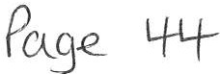

CE RT 1 Fl CAT£ 0 F ME M BE RS l 1 IP

THf WATER MANAGEMENT SOCIETY
F OVND [ O 1960

This is to certify that

Mr lain Jardine

having fulfilled the conditions of membership required by the Council of Management
has been elected Full
Member of the Water Management Society and fs hereby entit led to use the designation

M..W.M.Soc

, ,- - C.haJtmiln
... - .. (J,e}fl, f at){ ( ,· r,r<.,r.a .\.t'C'
• {/ ~ M2485/16 M mbPf,;J,,p •10
18/07/2016 t',;Jre o f f.'-«tion

23/02/2016/FP8lR74/10/0/32016

CERTIFICATE OF ACHIEVEMENT FOR

lain JardinP

City Guilds
Accredited

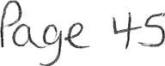

Who-succ;essfullycompleted the course

WH004 Risk Asse srnenl for Legfonella Contro l

DURATION

3 days

COURSE VENUE

PPL Trainin!l Ltd , York 0A TE OF COURSE
23rd eb,uary 2016 - 251.11 February 2016

Course Director Ma naging Oire<:tot

PP!. TM NING

01904 606090

www .pp ltra lnlng.co,uk

•

ppl ·aining

7.0 Legionella Control Association Certification of Membership
As a condition of membership to the Legionella Control Association, Solway Water Managem ent Ltd are committed to distributing the code of conduct and registration certificate. Please find below a copy of our current certificate of registration.
Legionella Control Association
ACode of Conduct for Service Provktefs

C ert ifi cate of Regist ratio n
This is to Ctilify tt,at lhe lollowvig company nas submdnOd a neg151n1bon ll!der - Conoiiior.s mCompliance as laid out m the LCA s Cod e of Condud foe SelVICe PnNlders
Name of company: Solway Water Managemem

Registration Number. 201913539 Cert:Jfica te vafld until 31st August 2020
Reg,stratx,c:, under lhe follow,ng serv,ces call!,gones
(1) l,..,e.g..i.,o._neUCaddR_isk"So-ovcas ent Services
1.2. Coa""9 S-Jaa"'"
1.l "- .., o,t.,Syswns
1A. saD:"T'R"J.
(3) atnCold Water Monitoring and Inspection Setwiices (4> Clemlingand Disinfection Senices
(6)Training Services
(n l..egionelta Anlltybcal Services
7, 5ampi"9
7 ...,_
7).,_l'Of'B,&h:inof A.-, SlS
(8) Plant and Equipment
I 1 linstdabcn
a.2-.......
- s«v,c,,c;
1,c-,g,,.,..s. ,.,iy

This Certifi"cate Is only vaJid if lhe C.ompa ny named listed on the LCA
website www .leg ion lacontrot.cwg.u k/ d ir ectory.php
c;,,.,,,..._ ,

t...giorwlla Conbal -tlan Umilad -- -laatm•- =w• ul arg.ull
f" llrvm,d tra Plic u:c;;-n;

8.0 Definition of "Reasonably Practicable"

L8v4 2013 requires duty holders to comply with the approved code of practice "so far as is reasonably practicable."
"To carry out a duty so far as is reasonably practicable means that the degree of risk in a particular act ivity or environment can be balanced against time, trouble, cost and physical difficulty of taking measures to avoid the risk. If these are so disproportionate to the risk that it would be unreasonable for the people concerned to have to incur them to prevent it, they are not obliged to do so. The greater the risk, the more likely it is reasonable to go to very substantial expense, trouble and invention to reduce it. But if the consequences and extent of a risk are small, insistence on great expense would not be considered reasonable. It is important to remember that the judgement is an objective one and the size or financial position of the employer, are immaterial".

"So far as is practicable", without the qualifying word 'reasonably', implies a stricter standard. This term generally embraces whatever is technically possible in the light of current knowledge, which the person concerned had or ought to have had at the time. The cost, time, and trouble involved are not taken into account."

These two definitions are not defined in the HSW Act and ultimately, it will be for the courts to decide their application in particular cases.

Bibliography
The specific legislation and guidance that is r eferred to in this report includes:

    - Healt h & Safety at Work etc. Act 1974;
    - Management of Health & Safety at Work Regulations 1999;
    - Control of Substances Hazardous to Health Regulations 1999;
    - Water Supply (Water Fittings) Regulations 1999;
    - The Notification of Cooling Towers and Evaporative Condensers Regulations 1992;
    - Private Water Supplies Regulations 1991;
    - Approved Code of Practice and Guidance: Legionnaires' Disease The control of legionella bacteria in water systems (L8) 2013 and HSG274 p art sl -3;
    - PD 855468:2015 Specification for design, installation, testing and maintenance of services supplying water for domestic use within buildings and their curtilages;
    - BSRIA Application Guide to Legionellosis AG19/2000: Operation and Maintenance;
    - BSRIA Application Guide to Legionello sis AG20/2000: Risk Assessment;
    - BSRIA Application Guide to Legionellosi s AG21/2000: Legionell osis Control Logbook;
    - CIBSE TM13:2002 Minimising the Risk of Legionnaire s' Disease;
    - Health Technical Memorandum 04-01The Control of Legionella Part A Design, Inst allat ion & Testing;
    - Health Technical Memorandum 04-01 The Control of Legione lla Part B Operational Management;
    - HPA & HSE Management of Spa Poo ls: Controlling the Ri sks of Inf ect ion 2006;
    - PWTAG : Swimming Pool Water Treatment & Quality Standards 1999;
    - TMV Association Recommended Code of Practice for Safe Water Temperatures 2000;
    - WMS Guide to Risk Assessments.

WaWi

Sit e Name: Whit ehaven Town Hall
Report No: 383 Sur vey Date: 12th July 2021

- - - - MAP.,;,\ Gt W::>t

10.0 Schematic Drawing

Solway Water Management Ltd

Old Photo B00_th

1c

-t
- CWH

Sink
LI
Sink 01
L I A.

Ladies Gents Staff Kitchen Cl_eaners
I
l I

CD
(v
.:E 29
2x WHBs
2x WCs

I
2x
UR WCs
2x WHBs
1 1

Sink

Sink
L I

WTC 26/08/2021

Item 10

WHITEHAVEN IN BLOOM
Purpose of the Report and Recommendation

To inform Members of a quote received for Winter planting in Whitehaven 2021 and to consider whether to suspend Financial Regulations in order that the estimate be accepted and to inform members of quotes received for the purchase of additional planters and barrier baskets.
  - INTRODUCTION

  - Attached at Appendix 1 is a quote for the provision of flowers for the Winter season from the Council's preferred supplier. The quote is to supply the flowers for 8 hexagonal planter bases, 20 barrels, 12 cast iron planters, 5 aluminium planters, 6 plastic planters, Trinity bed, the Pelican bed, the Corkickle badge bed, the Hensingham Ship and Wilkinson's window boxes.

  - In order to purchase flowers from the Council's preferred supplier the Council will have to consider suspending Financial Regulation 11 to permit this. In order to suspend Financial Regulation 11, Financial Regulation 18 states that "The Council may by resolution of the Council duly notified prior to the relevant meeting of Council, suspend any part of these Financial Regulations provided that reasons for the suspension are recorded and that an assessment of the risks arising has been drawn up and presented in advance to members of the Council".

  - The reasons for suspension are as follows:

    - It is a value for money service;
    - It is a quality service - the Council is constantly asked who provides the flowers;
    - The preferred supplier is very community orientated, has pride in the flowers they provide and even helps with the planting of them in town.

Risks:

    - There is a risk that the flowers could be obtained cheaper by another supplier but this is a very small risk as the cost per plant is very low and the quality is very high.

  - The badge bed at Corkickle is a busy entrance into the Town and could be further improved with the addition of 2 x 3-tiered planters and 4 barrier baskets. Quotes have been sought from 3 suppliers and they are:

    - Supplier A- £1505.20 + VAT
    - Supplier B - £1523.84 + VAT
    - Supplier C - £2072.90 + VAT

Councillors should note that the tiered planters supplied by Supplier B are not the same designs as the ones the Council currently own but are the only ones that they provide. The planters supplied by Supplier A and B are the same or similar to the ones owned by the Council both in design and dimensions (Appendix 2).

  - BUDGET IMPLICATIONS

  - The 2021/2022 Budget for Whitehaven in Bloom is £20,000.00 and to date £7,609.76 has been spent.

  - RECOMMENDATION

  - It is recommended that the Council considers making a resolution to suspend the Financial Regulation 11 to allow the flowers to be purchased from the preferred supplier and if making the resolution

  - Agree to the reasons for the suspension which will be recorded and also that the assessment above of the risks provided be accepted and approved.

  - To consider whether or not to purchase 2 additional 3-tiered planters and 4 barrier baskets and to decide which quote to accept.

d,¥ I.
A_5ev\OC\ I!.eM \ 0
Z.Jo(0 202.l

QUOTE: Whitehaven Town Council Winter Bedding for 2021

Quantity
20 Barrels
6 Plastic
Type
Polys Polys Total
15 300
25 150
Bellis Bellis Total
0 0
12 72
Wallflower Wallflower, Total
2 40
3 18
Cineraria Cineraria, Total
1 20
2 12
Tulips Tulips, Total
20 400
40 240

12 Metal Black
8 Tier Bottoms
5 Civic Stainless
25 300
25 200
50 250
120 0
12 144
24 192
25 76
484
3 36
3 24
9 27
145
2 24
2 16
0 0
72
40 480
40 320
80 400

184 0

Polys Total
Bellis Bellis Total
Wallflower Wallflower, Total
Cineraria
Cineraria, Total
Tulips, Total

Pelican Bed
1300 10 X 3 30
200
5x9 45
750

Badge Bed Hensingham Ship Roper St Bed
380
100
500
2280
100
100
0
230
100
3x3 9
10 X 3 30
339
0
4 X 3 12
7 X 3 21
78
660
250
500
2160

Extras: Cordylines
Wilkos Planters
15 £1.00
(Cyc lamen x 8, violas x 2 (6 pack), heather x 4 plus a few polys to bulk out)
£15.00
£22.00

(°\)
 | Plants: | Palys | 3480 | £1.15 | 4pk= 870 |  | £1,000.50
 |  | Bellis perennis | 714 | £1.20 | 6pk= 119 |  | £142.80
 |  | Cordyline | 15 | £1.00 |  |  | £15.00
 |  | Wallflower | 484 | £1.00 |  |  | £484.00
 |  | Cineraria | 150 | £1.50 | 6pk= 25 |  | £37.50
 | Bulbs: | Tulip (Bulbs) | 4000 | £0.10 |  |  | £400.00
 |  |  |  |  |  | Plants | £1,716.80
 |  |  |  |  |  | Bulbs | £400.00
 |  |  |  |  |  |  | £2,116.80
-lb

Pagoda
Tower

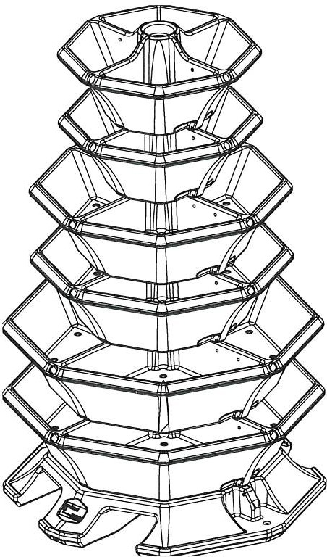

Benefits
- Available w1tl1 2, 3, 4, 5, 6 or 7 llers
, Rain Groove to pIevent 1,vater staining
- Soft Edge sides for healt111er plants
- Large capacity w ater reservoir 111 each tier

Ir 1ou·re loof:1119 for a unique and styl1,r1 pla,1ter then the geV1ew, P;,g0d,1 Tnw':r IS the h1gh-11nr,1ct answer I he self-vvatenng planter 11nrned1ately grabs your attention, pro v1cl1n9 high style and colour
to boch urban and rural areas This octagonal tower has large water reser11oirs rn e,,ch trer, all of whrch are frlleci from a single pornt In the top tier All plants are watered via the caprllary matting system v,h,ch dramat,,ally cuts drn..vn on t11e time spent and cost of watering
WTC.. Z b (Og/ 2 _o2-1
do. \+eM_ 10
A cli'x: 2,
Once planted, the Pagoda Tower comes to life, boasting a truly oeaut1ful display of plants and rtowers The height can be changed to best su,t tilt: space avarlable, by adding or removing
trers Use c11l seven tiers to create a stu11111ng cen trep iece which Is an ImpressIve two metres h19h The planter can also be easily moved, using tl1e fork- lift runne rs built
,nto the base

Tiers | Height | Compost | Water
 |  | capacity | capacity
2 | 710 mm | 1301 | 371
3 | 96 0mm | 1541 | 741
4 | 1210 m m | 2361 | 931
5 | 1460 m m | 2841 | 1121
6 | 1710m m | 308l | 1211
7 | 1960 m m | 3901 | 1301
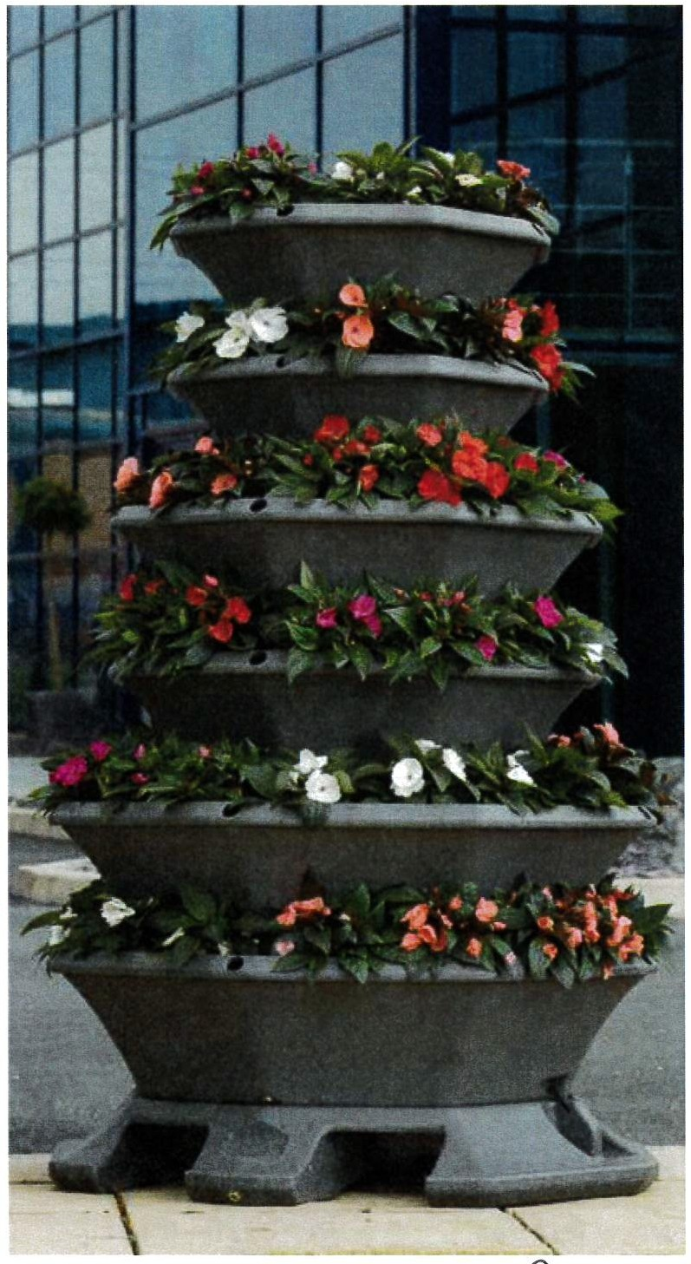Base Footprint 1090 x 1090 mm Available ,n all ou, colours See page 4
53

6

O1332 856039 www gev1e w s co u k/bro ch ure

Call: 01773 830 930 e-mail: sales@amb e rol.co .u k

self watering p lanters
_ r l"'1 J( •v t o

Self Watering Planters
Tiered planters
Octagonal Fountain Planter

a.. W,d1v\.

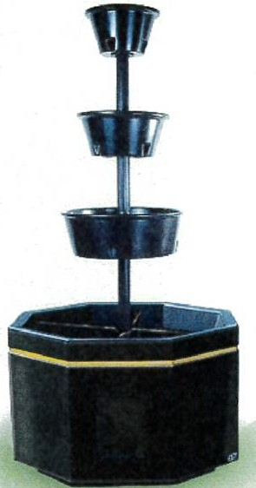

Octagonal Fountain Planter

\ 2-00 MI/\A.

Octagonal Fountain Planter
With its Octagonal plant, base, this tall tiered unit a stunning accompaniment to large spaces and buildings.

Available colours &
textures

\.i_ \-
2350 N\vV\

0  One Tier | 0  Two Tier | 0  Three Tier | One Tier Specification;  - 815mm x 815mm x 460mm  - Water reservoir capacity 30 litres  - Compost capacity 180 litres REF: PFT1
Two Tier Specification;
- 815mm x 815mm x 1200mm
- Water reservoir capacity 42 litres
- Compost capacity 214 litres REF: PFT2
Three Tier Specification:
- 815mm x 815mm x1680mm
- Water reservoir capacity 48 litres
- Compost capacity 239 litres REF: PFT3

Flo wer To wer - Oct ag onal B ase

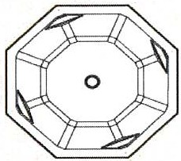  P lan eleva tion or Octngonal Base Flower Tower |  | 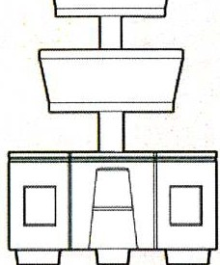  Three Tier | 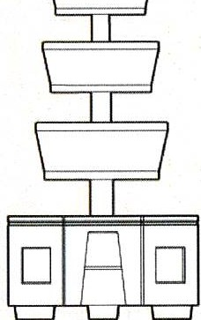  Four Tier | OneTier Specification:  - 1200mm x 1200mm x 730mm  - Water reservoir cap acity 225 litres  - Compost capacity 500 litres REF: POCT1
Two Tier Speclflcall on:
- 1200mm x 1200mm x 1400mm
- Water reservoir capacity 233 lllres
- Compost capacity552 litres REF: POCT2
Three Tler Specification:
- 1200mm x 1200mm x 1920mm
- Water reservoir capacity 239 litres
- Compost capacity 577 litres
REF: POCT3
(§IS@]  One TI er | □ □  1\vo Tler
Four Tier Specification:
- 1200mm x 1200mm x 2560mm
- Water reservoir capacity 264 litres
- Compost capacity 673 litres REF: POCT4

Flower Tower - Square Base

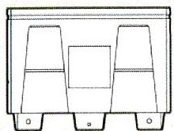  One Tier | 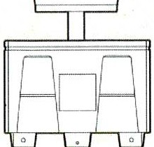  TwoTier | 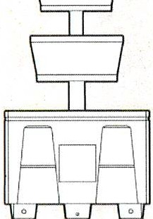  Three Tier | 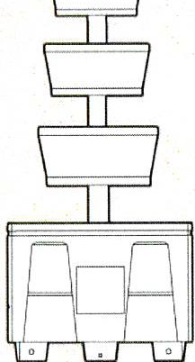  Four Tier | One Tier Specification;  - 1000mm x 1000mm x 730mm  - Water resel'Volr capac i ty 225 l itres  - Compost capacity 400 litres REF; PMS1
Two Tier Specification:
- 1000mm x 1000mm x 1400mm
- Water reseNoir capacity 233 litres
- Compost capacity 452 \ijres REF; PMS2
Three Tier Specification;
- 1000mm x 1000mm x 1920mm
- Water reservoir capacity 239 litres
- Compost capacity 477 litres REF: PMS3
Four Tier Specification:
- 1000mm x 1000mm x 2560mm
- Water reservoir capacity 264 litres
- Compost capacity 573 litres REF: PMS4
Please Note: All measurements and capacities are approximate P e55
Enquire about planters or bespoke products

Pr·vacy • ferms

