es, o

Produced for:
Whitehaven Town Council

Author:
Sophie Ross

Date:
24th March 2021

Valid Until:
23rd April 2021

www.riso.co.uk
Print Solution

Whitehaven Town Council 148, Queen Street, Whitehaven,
Cumbria CA28 7AZ

24th March 2021

Dear Venessa Gorley,

OUR PROPOSAL TO SUPPLY A PRINTING SOLUTION

Further to our recent discussions, I am pleased to enclose our proposal to supply Whitehaven Town Counci l with a RISO ComColor print solution.

Unlike trad itional toner printing, our unique and award winning ComColor technology works on a cold printing process. This offers high speed full colour printing, increased reliability, low running costs and the flexibility to print on a wide range of weighted stocks.

I hope that the agreement meets with your satisfaction and I look forward to discussing this proposal in due course. In the meantime, should you require any further information or clarification please do not hesitate to contact me.

Yours sincere ly

Sophie Ross
Dea ler Account Manager RISO (UK) LTD
Tel: 07920077236
Email: sross@riso.co.uk

www.riso.co.uk

Contents Page

Why Choose RISO? 4
Green Alternative 6
Unique technology 7
Proposed Solution

www.riso.co.uk

Why Choose RISO?
RISO is a leadingglobalmanufacturer of high quality printers and offers high-speed, high-volume print solutions to a wide variety of clients in diverse markets all around the world.

- Our unique inkjet technology delivers:
  - Lowest running cost for colour on the market
  - Products that consume up to 80% less energy than toner devices
  - Award winning product reliability
  - Environmental friendly products that emit 0% emissions
- Nationwide emergency response averages under 4 hours
- Approved supplier to the Institute of School Business Leadership (ISBL)
- DBS approved employees
- Over 25 years experience in supplying print solutions and support to a wide range of customers in the UK

•

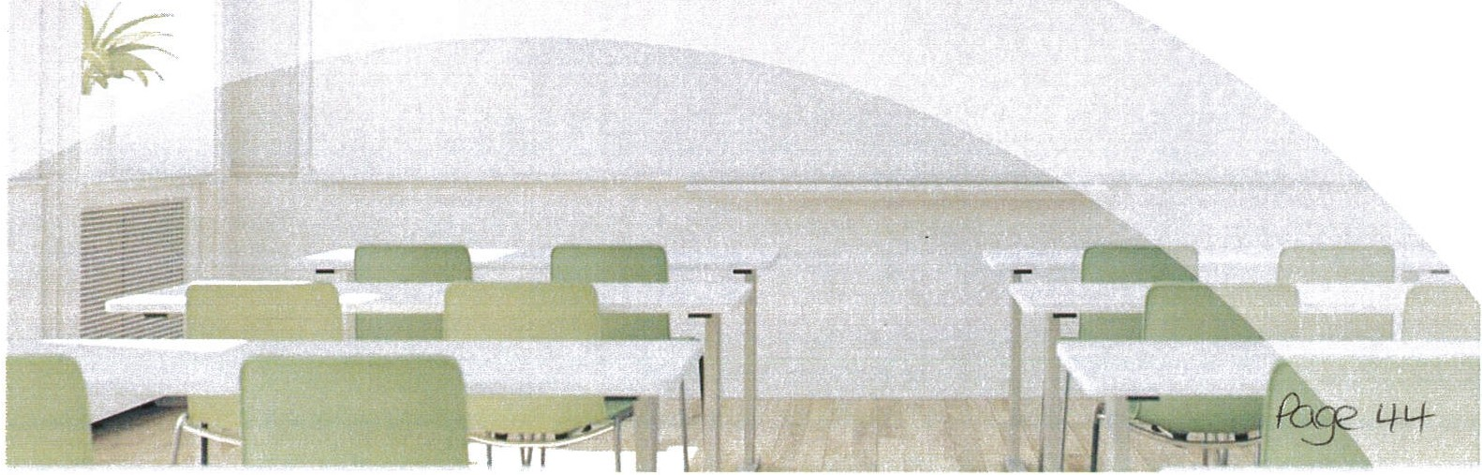

Why Choose RISO?
RISO is a leading globalmanufacturer of high quality printers and offers high-speed, high-volumeprint solutions to a wide variety of clients in diversemarkets all around the world

- Our unique inkjet technology delivers:
  - Lowest running cost for colour on the market
  - Products that consume up to 80% less energy than toner devices
  - Award winning product reliability
  - Environmental friendly products that emit 0% emissions
- Nationwide emergency response averages under 4 hours
- DBS approved employees
- Over 25 years experiencein supplying print solutions and support to a wide range of customers in theUK

•

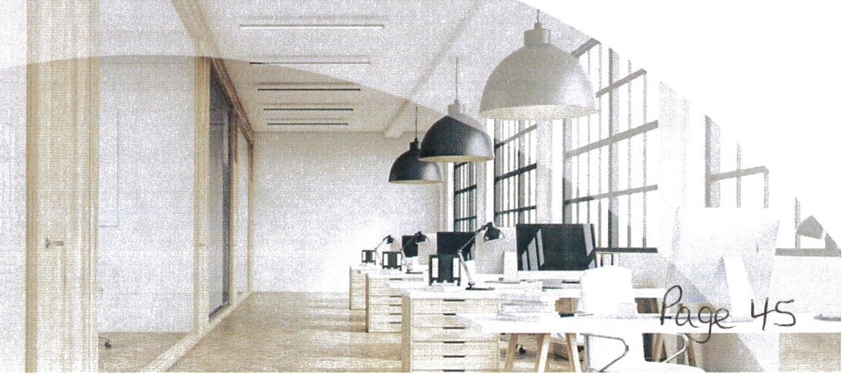

Our Products and Services
RISO has over 75 years experience globally in the installation and servicing of printing solutions. Our aim is to use this experience to benefit all our existing and prospective customers.

RISO has enabled many companies to significantly reduce their print costs through the use of our unique technologydesigned and manufactured by us.

. · Products

We have an extensive range of products to suit every requirement, including full print solutions service on which you can rely. Our unique technology combined with the our consultative approach enables us to offer you the best cost saving solutions and the most effective working practices, coupled with the right equipment/software for your needs.

RISO offers full installation, training and service/softwaresupport to ensure the best possible user experience

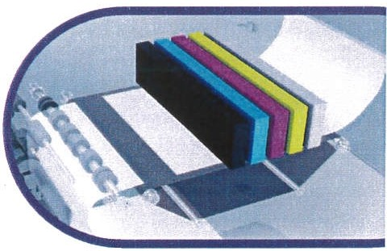
G The RISO Advantage
Special in-line print heads for speed and reliability
RISO's unique FORCEJET™ technology has in-line print heads arranged in parallel across the print head. This minimises the number of moving parts to support high print speed and high levels or reliability.
24 in-line print heads allow printing of A3+ size in a single pass. Special fast-dryingink
RISO has developed fast-drying oil-based inks for the ComColor Series. Since they are fast-drying they
allow ultra-high-speed duplex printing, preventing image transfer and eliminating paper curling.

Wide print area
With the use of an optional feed tray, the ComColor series printers can handle paper sizes
of up 340mm x 550mm. Maximum print area is 314mm x 548mm allowing for SRA3 full bleed

Scan here to see our unique technology in action

www.riso.co.uk

Green Alternative
@ High speed printers with low energy consumption
The ComColor Inkjet Series uses a cold printing process that does not require heat to fix images onto a page. This helps keep down the overall energy consumption, even when printing at maximum speed.

Printer A

RISO ComColor FT523O RISO ComColor GD963O
170 Wh**

- based on theaverage ENERGY STAR ce<bfied pnnten w,U,a print speed of 65 ppm.
160 Wh**
•• Powercoo lion perpagebased on TEC calcu!abon for ENERGY STAR cerbfiedimaging eqt11pment.

0 A smaller carbon footprint
In addition to the low energy usage of RISO full-colour printers and digital duplicators, the lack of heat in the printing process eliminates the need for compensatory cooling, further reducing energy consumption and cost. This reduction in energy consumption in turn further reduces RISO printers' carbon footprint- the amount of carbon dioxide emitted through combustion of fossil fuels that leads to ozone depletion.

Q Zero emissions
U nli ke toner-basedprinters, RISO printers are free from ozone emissions, toner particle emissions, silica dust, and other air pollutants. Also, RISO printers do not emit greenhouse gases

Unique Technology
RISO's inkjet printers use an innovative patented technology called FORCEJET™. Our customers benefit from this unique technology in several ways:

Speed
Ultra-fast colour A4 cutsheet printer with speeds of 160ppm.

Cost
Lowest cost for colour on the market.

Reliability
Cold technology and simple paper paths result in significant reductions in downtime.

Environmentally friendly
Up to 80% less energy used over toner devices, 0% harmful emissions, the ComColor consumes only 0.15Wh per page.

The Technology Argument

0 FORCEJET™ () Toner

- Cold process Capable of up to 10m prints
vs
•
•

80% less energy
& 0% emissions
- Lowest cost for colour
- Heat Fusion
Short life cycle - up to 1.5m prints
•
•

High energy use & harmful emissions
- High cost for colour

www.riso.co.uk

Whitehaven Town Council

From:
Sent:
To:
Subject: Attachments:
Cornelius, Cainan <Cainan.Corne lius@sharp.eu> 26 March 2021 10:25
Whitehaven Town Council RE:
BROCHURE_MX- 6051_5051_40 51_3551_3051_2651_B_C.pdf; Whitehaven Town
Council.pdf

Hello Vanessa and Marlene

Please find attached the updated quote. I did send one last week but apparently you didn't receive it. I apolog ise for that. It would seem that my IT isn't quite as robust working from home as it is in the office...

You will find two options in this quote.

Option one is for a brand new machine. The machine is a Sharp 2651 with an inner finisher. This will copy, print, scan, staple and collate. As it is the most up to date technology, it will fully integrate with Microso ft and will offer you future proofing. This machine is also faster than your current machine. This is an A3/A4 machine like you currently have and footprint wise it is actually slightly smaller than your current device.

Option two is for a Sharp Refurbished MFD. In order to manage expectations, there is approximately a four week wait time on refurbished devices at this time. Like the new option, it too will offer all the same spec as above. In order to secure one of these machines we do need an order from you as the 4 wee k wait starts at contrac t signing.

I will give you a call shortly to run through this quote and answer any questions you may have. Best Regards
Cainan

Sharp Business Systems UK PLC 500 Olympic Park
Longbarn Boulevard Warrington
WA2 0XF

Cainan Cornelius
Sales Account Manager
T:
M:
+44 (0)1616 946087
+44 (0)7848 450107

E:
cainan.cornelius@sharp. eu

W:
www.sharp.co.uk

Whitehaven Town Council
Official Quotation
Courtesy of Cainan Cornelius 07848 450 107

Date: 26/03/2021Quote number: 9DJFJDGJDFGB
This quote is valid for 30 days

SHARP
Be O rigina l.

SHARP
Be Original.

Vanessa Gorley
Whi tehaven Town Council 148 Queen Street
Whitehaven Cumbria CA28 7AZ
26 March 2021

Dear Vanessa

Thank yotJ for giving Sharp the opportun ity to put forward a proposal for new multifunction printers and the associated managed print service for Whitehaven Town Counc il.

Sharp has been successful in reducing the print spend for thousands of companies throughout the UK, whilst still improving both the print performance and service provided. I have attached a selection of testimonials and case studies of organizations similar to Whitehaven Town Council, for your perusal.

Please find enclosed your revised proposal , which I would recommend to you based
on the discussions we have had. I think you will agree this proposal offers great value over the term of the contract, whilst improving both the speed, security and functionality available to your staff. It also includes information on our award-winning products, service and maintenance.

I believe this proposal meets your identi fied goals. If you have any questions regarding any of the following content, please do not hesitate in contacting me and I would be delighted to assist in any way that I can.

Yours Sincerely,

Cainan Cornelius Account Manager
Sharp Business Systems Ltd
07848 450 107

To fully appreciate the full range of services and capabiliti es of Sharp Business Systems UK Pie please visit our website: www.sharp.co.uk

P0je_S /

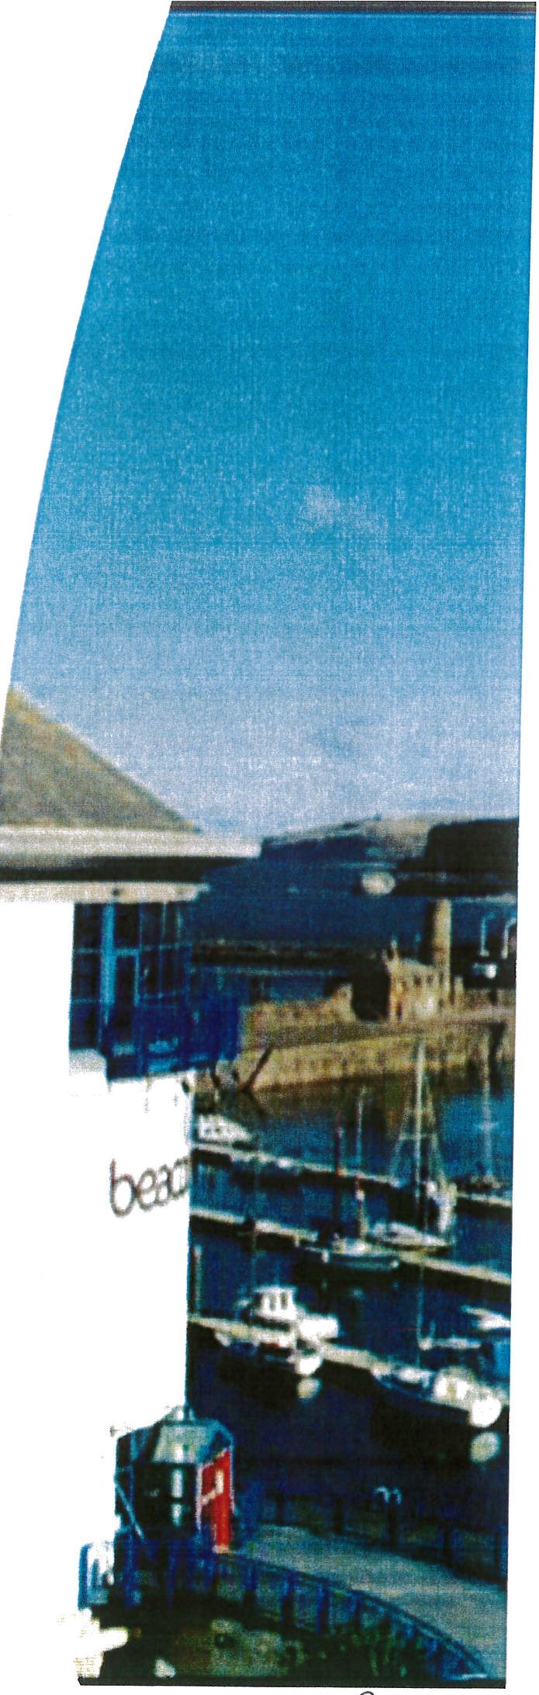
Pases2-.

Your Wo rld

Support, guidance
and sol ution s that help you ach ieve your
busin ess goals,
novv and into the future.

From our initial conversation and consultation
with you, we have identified a number of key
requirements that a technology partner needs to be and to deliver;

Your Challenges
  - Obsolete equipment
  - Old Technology

Our Proposed Solution
I advisethe Sharp MX357F A4 multi function device for your document processing requirements. This willincrease your speed and functionality and will provide cost savingsas an extra benefit..

Equipment Lease Costs ^{SHARP}
Be O rigi.nal.

Lease Costs - Brand New Sharp 2651with inner finisher (staple/ collate)

Outright Purchase 3-year rental
5 year rental
Service & Consumables
£2700.00

£214.00 per quarter

£135.00 per quarter

Our managed print service offers a fully inclusive 'cost-pe r-copy' maintenance and consumables agreement.

A4 Mono

A4 colour
£0.0025

£0.025

Sharp's Service Agreement Includes:

All requested servicecalls

All bl ack and colour toner
All required parts and labour

24/ 7 website customer support portal to log service queries and request s

One stop remote toner monitoring and replenishment
OneStop remote automatic meter-reading software system

All Prices are subject ta VAT@ 20%

Equipment Lease Costs

SHARP
Be Original.

Lease Costs - Refurbished Sharp A3 device with finisher (approximate 4 week waiting list)

Outright Purchase 3-yearrental
5 year rental
Service & Consumables
£1900.00

£99.00 per quarter

£155.00 per quarter

Our managed print service offers a fully inclusive'cost-per-copy' maintenance and consumables agreement.

A4 Mono

A4 colour
£0.0025

£0.025

Sharp's Service Agreement Includes:

All requested service calls
All required parts and labour

All black and colour toner
24/ 7 websit e customer support portal to log service queries and requests

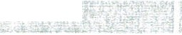
One stop remote toner monitoring and replenishment

All Prices are subject to VAT@ 20%
OneStop remote automatic meter-reading soft ware system

Sharp MX2651 with Inner Finisher
SRA3 Colour MFP

Specification

Print, copy, scan, fax, file, staple and collate Colour print andcopy speeds of up to 26ppm Fast warm-up time of just 20 seconds
Standard 650 sheet paper capacity, maximum 6300 sheets· 1
Duplex scanning reverse single pass feeder RSPF
Direct printing from uss·2
Industry leading security features, including SSL wh it elisting
In novat ive self-healing system for safe system recovery

Single sign-on brings easy access to public cloud storage services Wireless LAN and optional 2 Line LAN support
Range of finishing options available

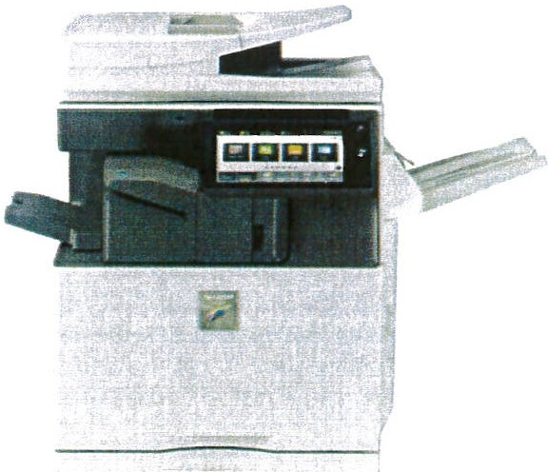

au:,••

SHARP
Be Original.

Operation Panel
Easy to Use

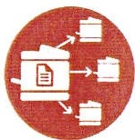
Print Release
Appl icat ion Portal
Cloud Services

- 1. Number of sheets based on 80g/m2
·2. Not as standard

Sharp

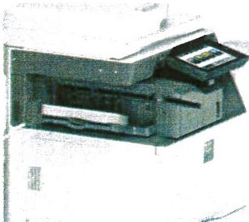
p0!)€- 55

Service Sta tist ics ^{SHARP}
Be Original.

Success built on service

We aim to be with you within the working day or faster i f required. Each customer is treated
individua lly with bespoke requirements. Our service engineers carry out our minimum call procedure on every visit. This key strategy has proven to keep our customers' machines working for longer between calls, thus giving the greatest operational availability. We are proud to publish our service performance statistics:

. . .. .. .. .. . . . . . . .. .. ...." . . .. . ... .. .... .
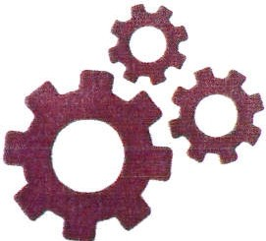
1ac ine left

. . . . ... .. .. .. ,.
98%' i 12%
of the time i Remote support fix
•• •••••.:•••••••
I
.. .. .. .. . . ,. ., ., . , .... ., • • c • • • • ,. 1',,• .. .. .. . . .. . ... ,. ., -4• • • • • • • • ,. • • • --• • • • • •i • •
I
I

204

:.

+ •• •••••• i

Firsttime
9fix4ra%te

Engineers ••'•'••• 1
Industry leadingMIF Ratlo of 222:1 i O
I
1240-300 standard) '

P°'-32-sb

Award Winn ingProducts ^{SHARP}
Be O riginal.

Product quality evidenced by award wins

Buyers Lab (BLI) is the global document imaging industry resource for unbiased and reliable information , test data and competitive selling tools. Buyers Lab Picks are industry recognised awards, based
on rigorous testing - extensive durability assessments and evaluation of key attributes such as usability, image quality and value for money.

Sharp
2019 Copier rvtFP Line of the Year

.......MJC.<1355W
Sharp MX-M4070

Sh.,-pMX-M6070
Sh-,,MX-&090N
0,.,IS: Pl-'Q (lu.;.,lgf>Vo\imc
80,pp,rl Cuiib.,, -

si-,,MJC.7540N

Sharp MX-M90S
Ouh.l OOcorn Goo,Ml'-P Ovh,ta,,on,gi:i.O(tss.ON;1""t'••;c,w,,e
=Oli:.'I".. ,,...
l'(h:;,p,·,,O;:ia,r

Po 9 e s1-

OneStop Software ^{SHARP}
B-: Original.

Proactive machine monitoring

r H s OneStop?
OneStop is machine monitoring software that gives Sha rp the power to provide accurate service mana geme nt information on our customers machines across the UK. This software
is used to report information, so you don't have to.

OneStop enhances our abilit y t o provide a proactive Managed Print Service for customers, bringing many benefits:

- Proactiv e Toner Ordering
Toners ordered by the device and delivered as you need them. Standard re-ordering when a% of toner remains.
No need to stockpile toners on site. Increasedconfidence in toner supply.

- Automated Meter-Reading Collection:
Accurate, not estimated billing. Greate r control of your prin ting costs. Confidence in bill ing process.
Comp letely automated, hassle-free service.
•' ' OneStop
e MPSKey
-··

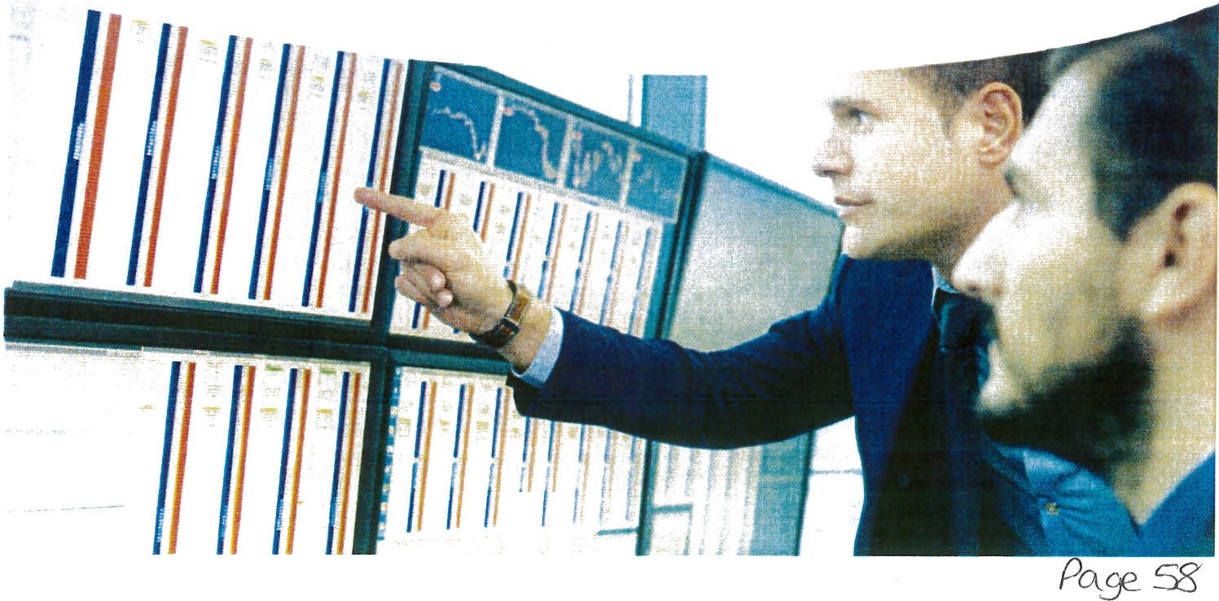
It

Document Management ^{SHARP}
Be O riginal.

Stream Ii ning colla borat ion betwee n depart ment s

Sharp's consultants can transform your business's paper based system with El ectronic Document Management, which securely automate processes and increase efficiency.

Functions such as Accounts Payable, Sales Order Processing and HR can be fully automated, reducing the time staff spend matching documents, keying in data and author ising payments . This increases p roductivity in other areas, such as customer service or debt collection.

Easy retrieval and Collaboration
Searching for and retrieving documents can be time consuming, with an EDMS system you can find documents, or related files like purchase orders, delivery notes, or invo ices with a simple click. With EDMS, in formatio n sharing and collaboration is simple, workflows can circulate
documents without the need to print, which can then be authorised from anywhere in the world on a mobile device, tablet or PC.

Security
Today, document security is vital. EDMS all ows access contro l for different user groups or
individuals, providing bett er control over sensitive documents.EDMS also l eavesa trail of who has accessed or viewed a docum ent, providing date, time, and acti ons taken.

System Integration
Our EDMS syst em has APls th at int egrat e with most Finance, ERP and HR systems, ensuring that data is accurate and up to date.

Environmen tal Initiatives
Low emission solutions that help protect the planet

SHARP
Be O riginal.
'-'

ISO 14 001
Our environmental management system shows that we care about the environment and have done from the beginning. We have been accredited since 2009.
Print Management Software
  - Makes peop le more aware of their printing behaviours
  - Highlights environmental aspects.
  - Print release saves paper.
  - Shows your carbon and energy savings.

Single Use Plastics
Sharp is committed to its continued compliance with the European directive for removing single use plastics from the manufacturing process, making us one of the greenest manufacturers on the planet.

Solar Panels
£65,000 invested in 192 solar panels at our Sharp Central office in the West Midlands saving approx. 12,804kgof CO2 since instal led .
OneStop Fleet Management
Our OneStop is a proactive fleet management monitoring software, reducing the need to submit meter readings as toner is automaticall y sent directly.

Consolidation
There are energy and carbon savings when you consolidate a large printer fleet down to few strategically placed multifunction devices.

Device Features
    - Motion sensors wake up the MFP when a person is near.
    - Recyclable toner cartridges and auto eject.
    - Cartridge yields are higher than competitors, saving on deliveries and CO2 production.
    - Machine Warm ups continue to reduce with each new range.
    - Reduced Warm up for scanning mean s less
electricity is requ ired.
Recycling Programmes
- SBSUK have achieved zero waste to landfill. 534 trees have in pr incip le been saved in the last year by recycling paper and card!
- 3.66 tonnes of DMR dry mixed recycling have been achieved in last 12 months.
- 26.34 tonnes of CO2 saved by recover
and recycle activities nationwide.

Page 0 o

Don't just take our word for it!
From small nurseries to nat io nal unive rsit ies, t ho usa nds of e d ucatio nal bodies t rus t Sharp with alt t he ir technology needs, includ ing:

INTO®
e
ij.,
, .<)-
The University 0£
,- -- "'1!-" Sheffield,
G)st PAV L'S ACADEITTY

PRIFYSGOL
BA N G O R
UNIVERSITY
IIIETON
WcoLLEGE

littl00 WIS I
n u r serv

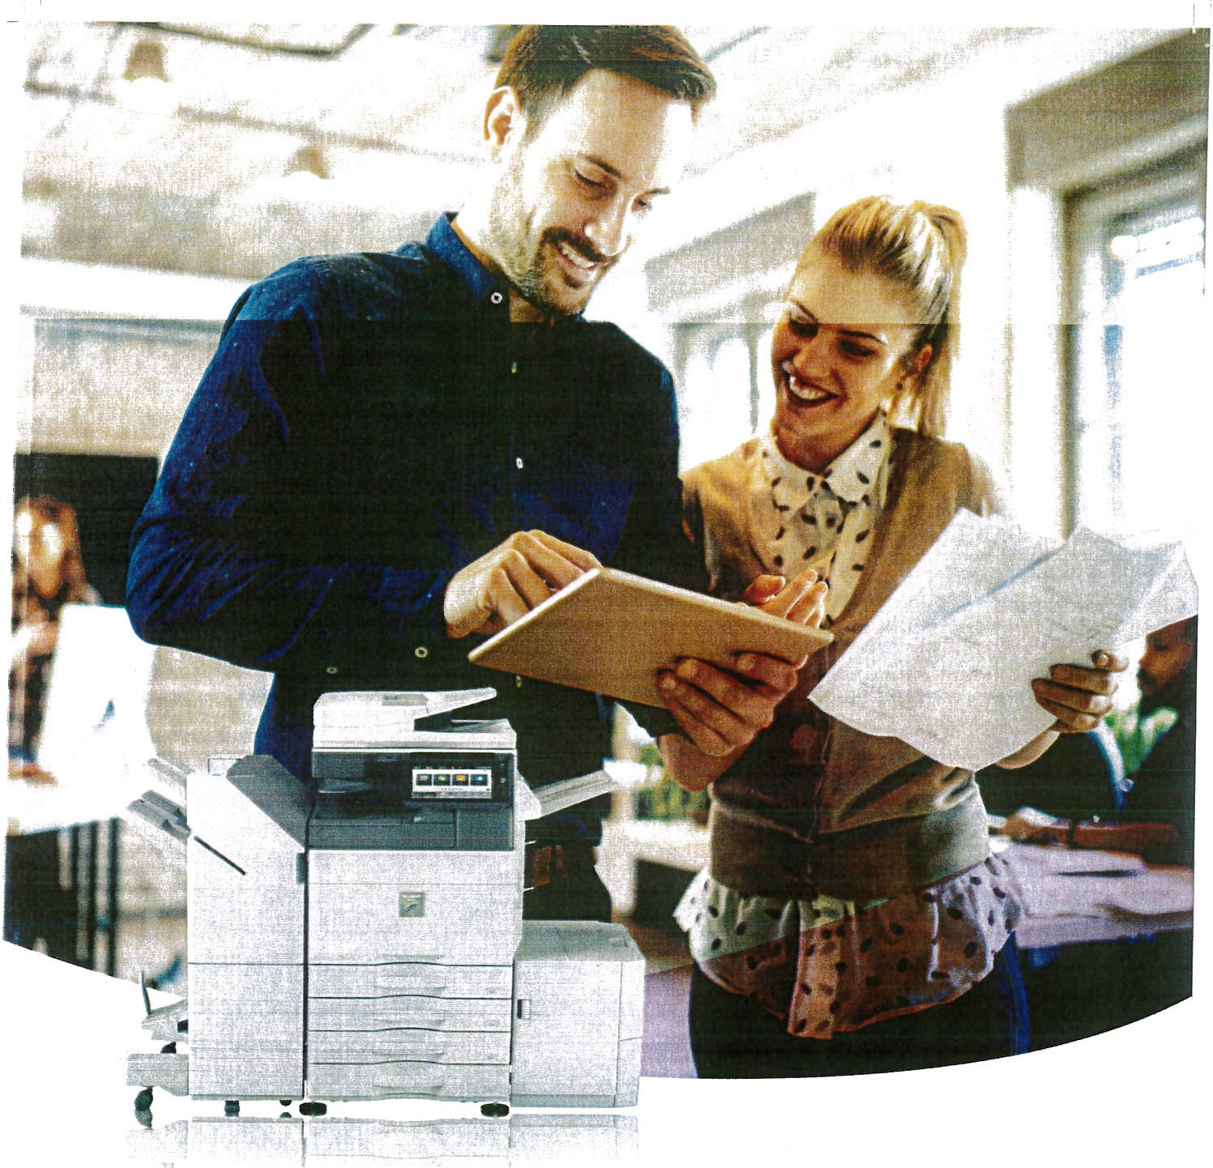

MX-6051/5051/4051 MX-3551/3051/ 2651
A3 Colour MFPs

SHARP
www.sharp.co.uk Be Original.

- i

Made to work smarter.
To increase business productivit y sometim es you just need technology that helps you do things more efficientl y.

The powerful performanceand intuitivecontrol of Sharp'senterprisedevices have been recognised with the prestigious Buyers Lab. Copier MFP Line of the Year Award 2019 and 'Ease of Use· Pacesetter Award. Our A3 colour Multifu nc tion Printers (MFPs) build or these capabilitieswith their enhanced featureset and super ior functionalit1.

They havean adaptable set of tools that can be tailored to suit both the way you work and your budget. So they are theiceal choice for small & medium businesses (SMBs) or mediumsize workgroupsin largeorganisations that want to work smarter not harde.r
From creating information for everyday tasks. to prod U<:;ing high quality reports and presentationsor secure11 sharing vital
documents youcan do it all quickly and efficiently. even when
you're on the move.

P b3 ' 1

- -- - - - - - - - - - - - - - - -

Sim ply m ore produc ti ve
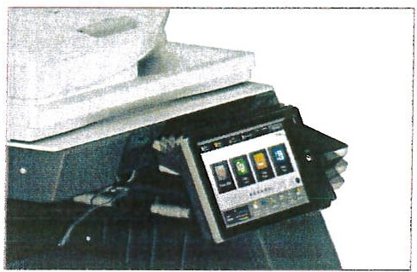
These MFPs are designed to help you do much morein much iesstime.
10.1" tiltable touchscreen control panel.

High speed printing / scanning- get an instant productivity boost with print speeds ranging from 26 to 60 pages per minute(ppm). And youcanprint on paper up to SRA3 size and weights of 300gsm. There are alsoa number of featuresthat are designed to streamline produc tion, including a Reversing Single Pass Feeder (RSPF) For fast digitisat ion of your documents. And, as no one lii<es
in ter rup tion s, the higher speed MFPs' ' also !et you top up the toner without pausing copy/printJ ob s which maintains productiv ity and reduces any downt ime.
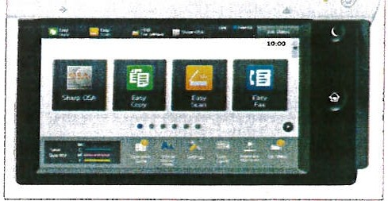

Users can customise the home screen formore efficient working.

Efficient storage - easily print, scan and retrieve documents with a high capacity 500GB onboard Hard Disk Drive (HOO) and an efficient Document Filing system.

Automat ic optimisat ion - whateverapplication youuse, Adobe PostScript 3 ensures that the text and grapfiics are always printed accurately and an image density sensor maintainsconsis,ent imagequality.When scanr.ir.g, the Auto Set function automatically optimi sesthe resoiution, pagesize and orientation.

Optimiseddirect PDF printing - the new Adobe Embedded Printer Engine (AEPE)enhances printi ng for the technology drivenworkplace.It helps to deiiver up to 80% faster printin g from mobile.cloud and USB.

Easy monitoring - thelights of the StatusCommunication Bar instant ly show thestatus of the MFP.

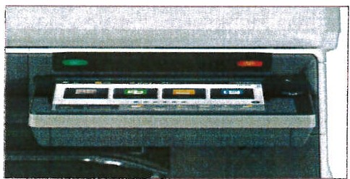
Visu al feedback indicates MFP activit y.

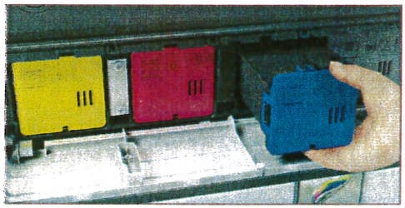
Ongoing savings - to reduce waste and help you achieve your environmental goasl the toner cartridge stayslocked in place until the toner has been fuilyused up.

-I
_i
- i41
Intuitive control - quickly accessthe most cor-imoniy used functior,s usinga tillable, iarge10.l" touchscreeri control panel You can also dragand drop any me,r., :cons onto the home screen to sui t your needs.

Toner cartridges automatically eject only when fully exhausted .

Complete protection.
Effective security is essential to all businesses. These 1\ ·1FPs
are load ed with tools that keep your information safe.

Rapid recovery
The system at the neart of your MFPcanbecome corrupted if an update fails or it is:he target of c ma icious attack. So
these next generation MFPs inclu a e aninrovac've Sd-Healing System. It storesa master copy of theoperationalsett mgson the system, which can be used to safely recover the system if there is ever aproblem. It ensures that you cancontinue working, while also protectingyour valuable information
and intellectual property.
Instant validation
lntormaiton that is openly shared between applications or sent by email can beinterceptedor compromised. These MFPs provide the same high-levelprotection usec by many government organisations. Their SSL Certificate Validation automatically checks that all third-party servers communicating with your MFP are safe. Any unauthorised or maliciousattempts to access your inforri ation are mstantly blocked.

Authorised useonly
These MFPs use a whitelistof approved3pprcat1ons ana operating firmware to prevertany unauthorised access. Theyactivelymonitor all activity and er.sure that any un nown applications are instantly blocked.logged and reported.

Certified as safe
Havingbeer valida!ed by the Protection Profile for Hardcopy Devices(HCD-PPvi .0) theseMFPs pr ovide the most advanced level of security aemandedby business. government and
•nilitary organisat;ons. They can safely handle :ven tre most cor f demial,rforrration.
Advanced email encryp tion
To proce ct any1nformat101beingsent by email from the MFPit 1s automaticaliy encryptedusing the S/MIMc standard. It's almost impossible to decipherthe data if it is
,ntercepted and it canalso be validated as safeusing advanced electronicsignatures.

, I

..- ·- - -- - - - - - - - - - - - - - - - -- -- ·- ----- - - -· - - - - -- ··· - ---- - .

Get going fast - an ywhere.
Tirne :s valuab le, so being able to quickly print and scan vvherever you are means you can spend more time doing V' /hat's import ant.

When you are workingon the move youstill need to be able to access and produce information. These MFPs hel p you work more efficiently and flexibly, by enabling you to print, copy, scan and share the information you need when ar,d wha eyou need 1t .

Effortless conne ctivit y
Sharp's Office Direct Print enables convenient walk-up printing and scanning without logginginto your PC. Simply insert a USB memory sr,ck in the MFP and you can immediately print any stored images and Microsoft Office fiies. You can also scan and sa1•e documents straight to the USB stick,. ·

In addition, you have ar optiona! facility for wirelessprinting ·- directly from anyWiFi enabled laptops.tablets, or smartphones without theneed to set up a wireless LAN. It means you can
use a much broaderrange of devices and work in many more businesslocations.

Tr eseMFPs aiso suppo r t dual LANs that can be connected to two different networks. So if your workplace has two separate networks, which might have different security or usage restrictions,you can still share the MFP with all users.

Eas ily access everythin g
Noone enjoys having to remember additionalusernames and passwords. A Single Sign-On facility mearis you only haveto log in once at the touchscreen control panel. You can then quickly and securely print and storeinformationin theclou.d, using Google Drive", OneDrive" for Business, SharePoint Online, Box, Dropbox and Cloud Portal Off,ce. Tnere'salso a Gmail connector for scanning to email a11d Exchange Online
(MS365 email).
Choose where to print
There's no need to riskleavingimportant or sensitive informationunattended.Using the Print ReleJse feature yoL can send your print jobs to a IT'ain MFPand then print them off whenever you want on any·connected device. Simply walk up, log on and print your documents.

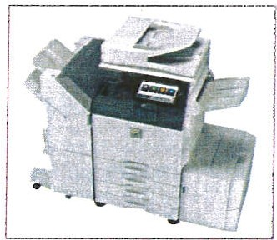
USS Office Direct Print and Print Releas e.
make for more flexible and efficient working'..

Mobi lity made s imple
Tr.ese MFPs let you pr•nt and scanon rhe movein seconds. Simply link your mobile device to theMFP by moving it close to the optional NFC card reader·• or by scanringthe MFP's QR code' '. Eith er way,it sets it all up for you.

You can then print from and scan to mobiles and tablets over your wireless netwo rk using Sharpdesk Mobiie or print from a1y app that supportsGoogleClou d Print"" or any Android device with the Sharp Print Service Plugin
I

Re ducing complexity
The optional Sharp OSA (Open SystemArchitecture)makes it much easier to print from and srareinfcrrr a:ion with your network and cloud-basedapp!ic a,ions.

· : 1><111ir< " .IX-·"'lllf •· 1Pf1W"'S;i ,'1,\·ES18 M ire, ;: ,:,<.Uf I :l.. J plf r. ·-·

'l ife <;:i 1M- ·A'I.XZ
And the Apokation Centre Portal ma,es theMF? ,,.,ore adaptable by providingsoftwareJpdates and clo·Jd corn ectcr apps that enable agileupdating

App ir.:JI 11 :m'\n l,Jnl('.J'IC n Mr.. •-I?. , :;:')( ,l,(IJ! 'l {1C<:!, l( . i(E"l l!t":5, .l f'\flP lJ•)n,, I NFC. ,· .1•c
·,:a('er· ;:o , :,,)l'>i ,OS and•\.'icruid Ji:•lices

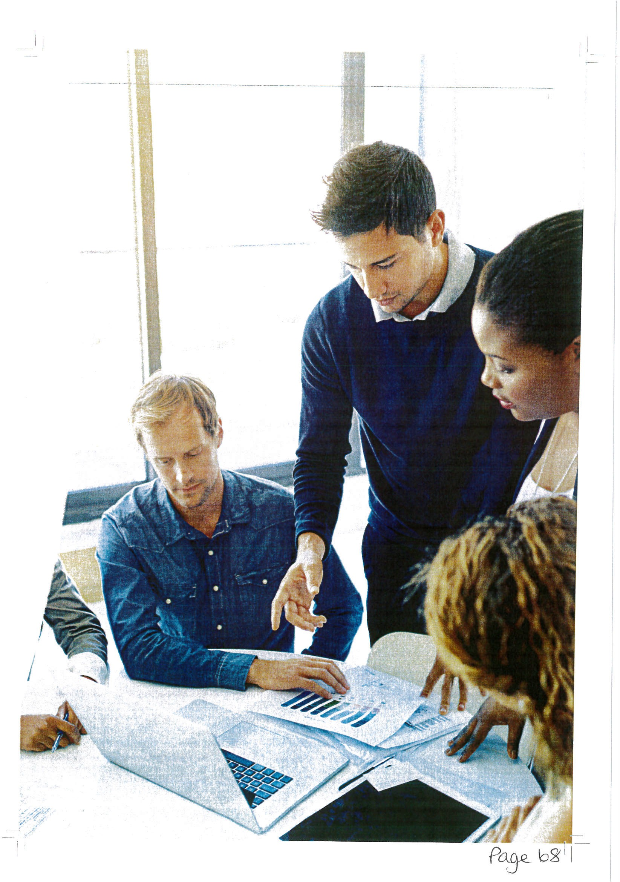

-- I I
I I --

Even more efficiency.
As \v2ll as enhancing productivity our MFPs are designed to sa,; e t1n1e and money by optimising everyday tasks.

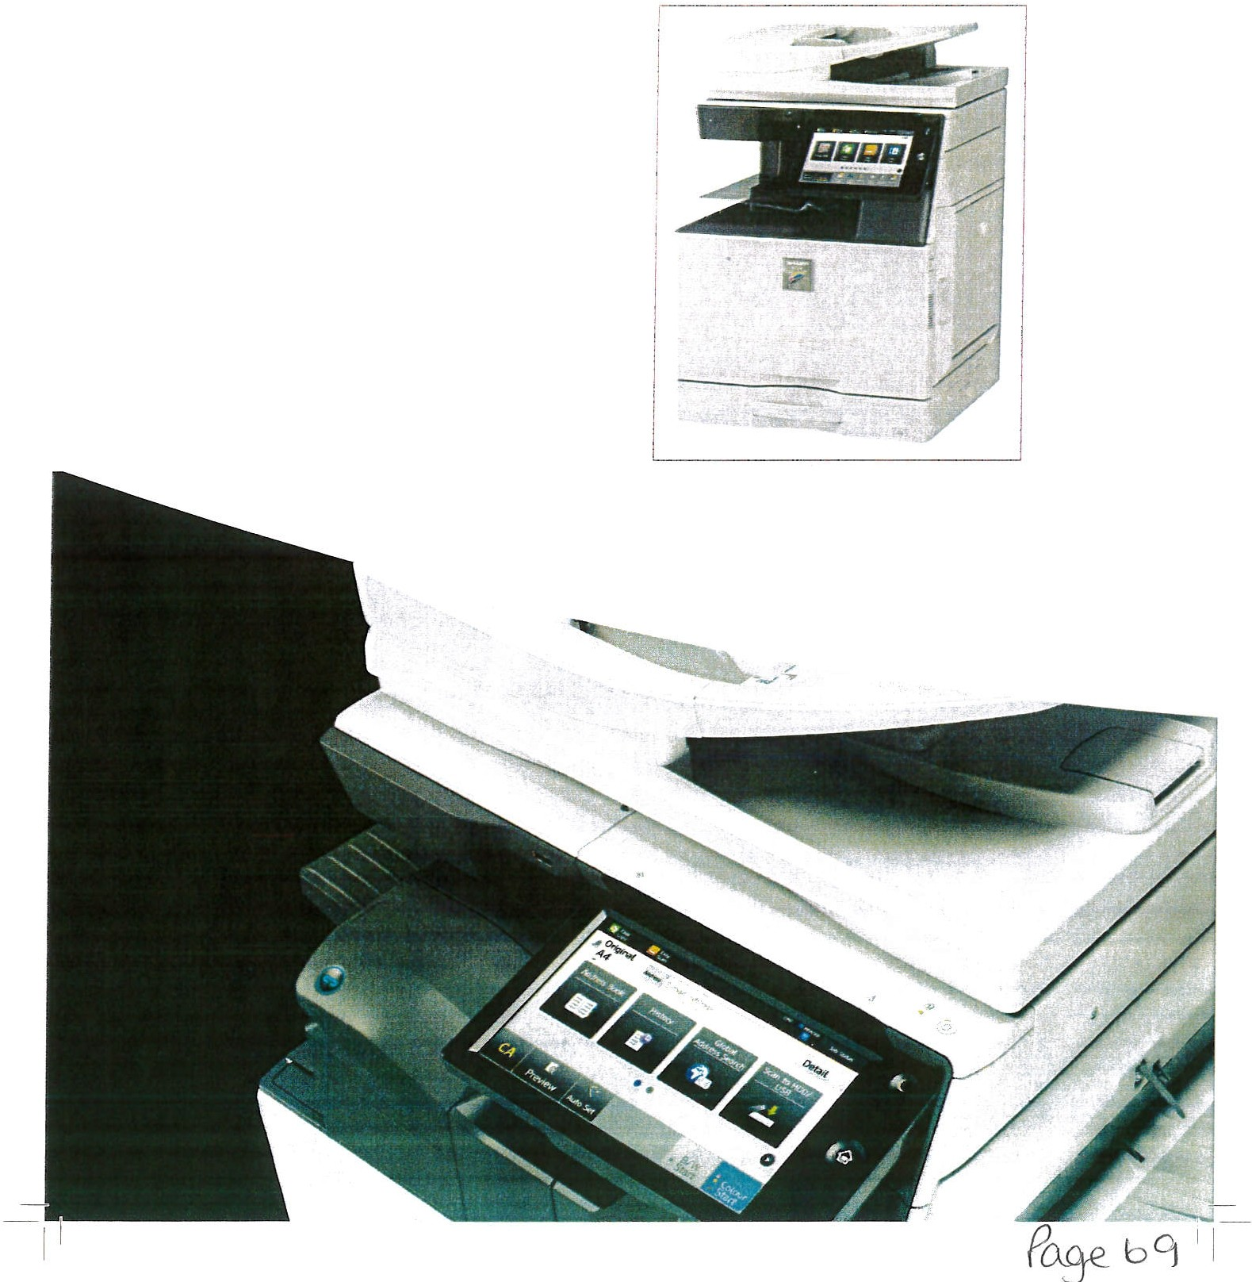
Giving you more choice
Create professional lookingdocuments with a range of finishing options. including punch, saddle sritching, stapleless stapling and a job separator. And youcar- keep working for longerby using the additional capacity paper drawers.

Bu ilt-in energ y e fficiency
Sharp MFPsare designed to work extremely efficiently.so you save on running costs. To reduceenergy consumotion they includeautomatic, configurable power settings, so they only operate during selected time periods. Before starting each job you are also prompted to use the most environmentally friendly settings - likeEco Scan,which preventsunnecessary functions from powering up in the background. And our !cw-melt toner uses less energy on every print or copy run.

Optimised Software Solutions
V\/e've create d a rangeof Optimised Software Solut10 0s to help you reduce your costs, increaseefficiency and
, rnorove security .

0 e • 4D
(!)
Op ti m,J«t Opt1m 11t(j Opnm1Hd Optlrn1n d OpliniiWG
i'1'n1,rog I I< J ,1,;oiJ., •, 1.a, 1. J
Optimised | Optimised | Optimised | Optimised | Optimised
Printing Solutions | Scanni ng Solutions | Mobile Solutions | Worl<flow Solutions | Managing Solutions
Monitor and manage | Save time and | Create a more flexible | Help restore the | Ease the burden of
your i:;rint and opy | avoid costly errors | team oy helping | productiv1t, you | managing your MFPs
usage, eliminate | by simplifying and | people connect | need to achieve and | and build aconsistent
unautho rised  use, track ard recover  costs and reduce waste. | automating how you store and srare  documents - whatever  their format. | tablets, phones and laptops simply ard securely, so they're  always 1n :ouch | maintain profitable growth by stre3mlining and simplifying  repetitivetasks. | Pnnt Security policy.

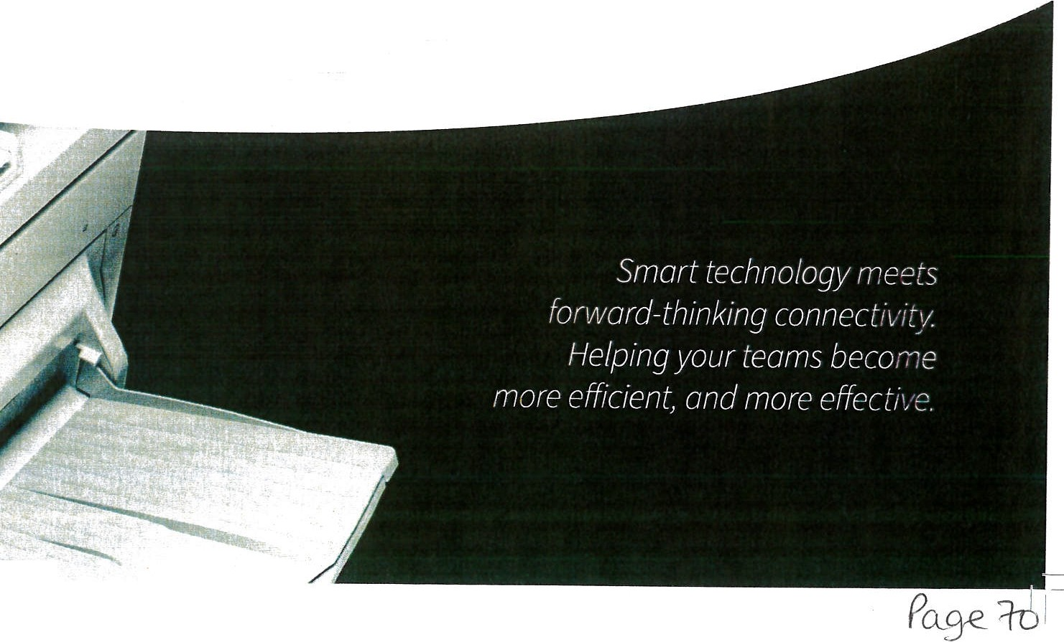
-1-I I

1 I__

-·- · - - - - -- - - - - - - - - -

- MX-FN28
,
Fin,s11er

- MX-FN29
Saddle Stitch

......

-, I

13.

MX-TU16

LJ.

- MX-LC17 N Large Capacity Tray (A4)
7.MX-UTl0
Utility Table
Job

Fi11ishe1

  - MX-FN30 '- I
Exit Tray
Cabin et

8.MX-LTl0
Long Paoer F;,eding Tray

9. MX-TR19 N

Finisher
-
Base unit
-
--
I
10. MX-FN27 N
Finisher
•
Separator Tray ,
rII ·-..
E, it Tray Unit

  - MX-FN31
Saddle Stitch Fin isher
",.
, - ...
- MX-RB25 N
Paper Pass Unit

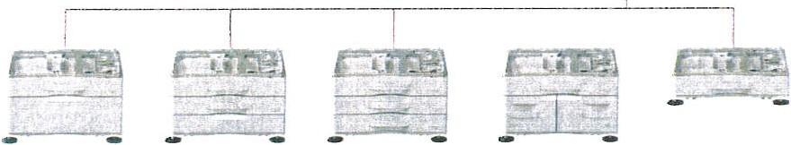

1. MX-DE25 N | 2. MX-DE26 N | 3. MX-DE27 N | 4. MX-DE28 N | 5. MX-OE29N
Stand with | Stand with | Stand with | Stand with | 550-Sheet
550-Sheet | 2 x 550-Sheet | 3 x 550-Sheet | 550 + 2,100-Sheet | Paper Drawer
Paper Drawer | Paper Drawers | Paper Drawers | Paper Drawers

Options

Sase Unit
  - MX-DE25 N Stand with 550-Sheet Paper Drawer
550 Sheets··. SRA3 toASR!60 -3COg.m'I
  - MX-DE26 N Stand with 2 x550-Sheet Paper Drawer
S50sheets• : each for lcwe<.rnd1Jpper tn:,1s SRAJ to A.SP '.60 • 300 ,'rn -)
  - MX-DE27 N Stand with3 x S50-Sheet Paper Drawer
550sheets ·1 each for!owerand upper trJ ri, SRA.3 to SR 60- 300g/m ·l
  - MX- DE28N Stand with 550+ 2,100-SheetPaper Drawer
Upper tray: SRA3- ASR,550she ts;• {£0- 300g/m:) Lower tray ILeit ),A4. l.200sheets' (60 - lOSg_ m') Lower tray \Righr): A4 -BS, S-CGsheets ·1 {60- lCSg/m: l
5 . MX-DE29 N 550-Sheet Paper Drawer
550 shee s··,SRAJ tot,.5R (60 - 300:;;m;,
- MX- LC17N Large Capacity Tray (A4)
3.000sheets· •1 A-1- BS(00- ;20 ym:1
- MX-UTl OUtility Table

Fini shing
- MX·LnoLongPaper Feeding Tray R comrnended ar b<1nn er pn r. t i ng
- M X-TR19 N ExitTray Unit
- MX- FN27 N Inner Finisher
A:{- BS{offset/staple}, SRA3 -A 5R\no.i offset.l Offset tray (upper):max. 5110- sheerpaper cap•acir:; "':
Staplingcapac1ty: max.SO-sheet muili-positlofl 5;:ap te··
Staph position: 3 locations1fron t :ear o, i poirit 3tit-cn;n ;
Manu al Stapling: l-pointat rear i.rtat:;, Ss ee(S1c,-1.g, 'm!.\ J. (;'. n ti; 18C g1.m=:-
Stap leiess capacity: rra.i5- ee{ '6.J.,g.irn-1, 4 sh';!-d · - Sl...J. :,,r". 3 sheet (81.5-105g/ m-1
Staple!essposition: 1-po)ntat rear (St.1r.t;, A3- 85
Optional Punch Module for MX·FN27 N:
MX- PN14C • 2/ 4 Hole Punch Module MX- PN1 4 D- 4 Hole Wide Punch Module

-- I I

Oo ions

- MX-RB25 N Paper Pass Unit
Ro:>Qt,ired 11he us11gM:\-FN23.M:(-FN29 M;<"-FN30:t.M-\ FN31
- M X· TR20 Job Separator Tray R-;q11 r'3-:;i\.t>'. 7t_:1 s E1it rr ly CJb1net 13. MX-TU16 Exit Tray Cabinet
- MX-FN28 lk Finisher
4..3' N - /ISP 1ofh et/'; t.:1ple)S, PAJ - ASR!nonoffset} Off:;e,t uay :upp t:irJ· md.'( 1.000 -sheet paper c aoa ci ty· : Stdotngcap,11..:.t;: ma.( 50-sh et mult1-pos 1t1onstciple"
Staplpostiion i -pom t Jt front /Flat), l-pc111t 'Hb2:ck {fl a t• 2point c;:1it:h·n g
- MX - FN29 lk Saddle StitchFinisher
- \3'N• /\5 offst/'s! t pleS)R./13,- \SR 1non offset)
Qrlset tr y tupper l: mJ..:. 1.000-ihee l paper -:aoac ity·
Stapli:1gca pa,:alj: ma x. 5-0 she-et multi - p O$:tlon sl dple"
Srapie pos iti on . l -po1nc at lrcnt1Flat),1-po,n t Jt bar:,;(flar•, 2po int stirci1r 5 S,1d:i,le tit-:h rray ilowe,t)· 7 se ts{ll -tS -.hpet oe}:; , 10se[sl 6· l !J sh':'ers,J
iG :;c?rs ' i °1<;.h P0 f'>I 1::. s heE1ts m.1xn n Pt

OptionalPunch Module for MX-FN28 & MX-FN29:
MX-PNlSC - 2/ 4 HolePunchModule MX-PN15D ·4 H ole Wide Punch Module
- MX-FN30 3k Fin isher
A3· B51oifset 15tap1e).SR 3 - ASR(nonoffset,
Offs r. r.JJ {:.;ppe rl: max. 3,000-shPet paperc3pac;r/ Stao hngc apa c;ty: ma . '55-sheet multi-position s.taple '
Stacie position: I-point at front tSlantl, !-pointdtback1_Slant J :?po1;1t >t1tchm Ma11u<1I Stern i r1g: l -po 1t1t at re-:1r {flat}, -15 '>heet f64 ,yn, ).40 s.ht- t, 18•) /111° ' Staµlele .i .;pac.:! t ;: rna. cS-sheet {6 4-g /m -}, 4 sh et16S- l..Ji.f mr-.
3 sheet 181.5• 10, ym')
5taUlt"les:.00 n:on: 1-µomt at rear {Sl ami. AJ · 85
- MX-FN3 1 3k Saddle Stitch Finisher
..\J 8.51c i fset 1staple}. 5RA3 - A5R{non offset,
Offs<! tray fupperl:ma>.3.000-sheet pap er capaci ty· '
5taplingcaoac1t:1:m a x.65-sheetmulti-posilion 'itap! ·
St<1µle po sition. 1-pomt Jt front (Slane), 1 -po rnt at back 1Sfantj , 1 p o int st i tch i ng Manual s,apiing: I ·point at rear (FlutJ. 45sheets f64 g.,m!), -W :.he-:ts 180 g/m StaplelF!ss capilcity: ma.<.5-sh e et {6 4 g / m <).4 s e et {6 5 - 8 1.4 g/mi ;,
3 sh ee t (81. 5 · 105 g/m')
Stc1µieh s sDO$tt1on:l- potn t. u rea1 (SldntJ,AJ· 85
)addle st1td 1 trd ;tl ow r}; lU s ts :11-1s sheets). IS sers-/6· 10,n eet:i},
25 sets tl-5 sheets] 20sheets ma:,.p e r se t

Optional Punch Module for MX·FN30 & MX·FNJl : MX·PN16C • 2/ 4 HolePunchModule
MX-PN160 - 4 Hole Wide Punch Module

Pnnt1ng

MX-PKlJ PS3ExpansionKit
f "l,;1ll ie s Pw tScript printing

MX-PUlODi rect Print Expansion Kit MX-PFlO Barcode Font Kit

Faxing
MX-FX15 Fax Expans ion Ki t
MX-FWXl In ternet Fax Expans i on Kit

C:,n 11e ct i v1ty
MX-EBlS Wireless LANAdaptor
Er.abio:s ronn clion towirelessnet von,s
Sc anni n
MX-EB19 Enhanced Compression Kit
E<1ab 1escreation of highcompression DDFs
MX-EB20 OCR Expansion Kit AR-SU! Stamp Uni t
Marks atr=:adyscann ed jocurnems ior ch e-d <ing
Sharp OSA'

MX-AMXl Application Integration Module
MX-AMX2 Application Communication Module
MX-AMX3 External Account Module

Secun ty

MX-FR62U Data Security Kit
C::>n :merc ral 'ier51cn

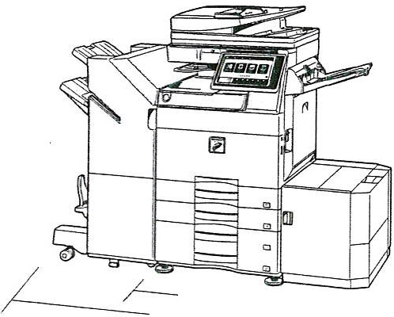
Modelshown MX-5051 T
I550mm

,_,,._60.!rn,n----/ / -L

" l. 6"9 mm ¥fflotf'I EN$htr tny lM ff '/ ..,.. .

ShOw n withoptionalequipment.

Qualcomm · DirectOffice
SAP

- 1
I
I
'A"do,be.
-
C I R TI F'IED

_ Wcrt,. ·#llh
Apple AirPrint
•
CITR•IX'

Geri en l
Enginespeed l JJ n .µ,,,: •.A-.-, 1 1.n ..i=,0 1
M. •SJ:'.:
1,.11,. ,1'1'l l Ml •JS: J M<-r>5 J
MX l USl
Control paneldisplay

SRA)
,,
13
I ,
15
"
l) . • .:!",r:. lo Jr U".0 r'lt·-:hs,: r,>.:.r
'- t ·Nor!c S c a nn r
Sca n method
Resolution !Joi,
L•1. )(,6( ': 1 3C. !
t,.t'.o;. 4 .,S 1,.l5S; '! H.51_ 6,j!

File formats

P J!)hscan f•,1 . omtu· ::ia n I_:
j>J!l ( ] f ! •_'J, 0 1N • CC n; l,,lfl t l ppl i.;:J t .on:
One-sided Two-s ided
1r 25
.1on, 2,m ::oo ;:;no,.).;or: P. '1:11...1l ,..n 1 ( i-(1,1
:i..::O.(-:iCO. , liOCl t ·::tJ1•1ol t t· .:'l00

nF::.:,_[jF Pl)F' A· l.J
. PDf //.i· l, b 1>nc, vpt 1 DD.::

Paper size t I 11,- ·ta.,,
Paper weight t;· ·
r, y
M.,lt 1·0: ;p 1:.
Papercapacity Ste!- --Aa l':

[)r ..,11,:1;
Warm-up time"' 5,;:,..Jr Js ,
.t,.t. . ;;n=.i '1.11. ; <1..:,1
MX-40 5 !' J 5 ) i J CS :h S.
Memory ·GB;
( op: r; :>nnt t r ' t ·i:J.

Power req uirements
Power consumption ;kli ) t i, ;
\U ?U } i· s 1.:1
M X-4051 / 5: L 10s.:,. is :
Oimensions.. n T,)1w u;(I"'
Weig ht £
1,x1-;;os1'5c 1
M:,(- UH l 5':1 . os.:.,: :;;s:
Copier
Original pape r size rMh, Firstcopy time•• :.<:'Co,J ·,. IAX•505i ' 5 El
.U- 4 CSl ' 35 5:, J OS.: 2€5
Cont inuous copies t\11:(1
Print resolution cp,1
l''.c'\, (: •cur\
3ca , ffVW
A:0" - $R A J

03V· C:.i 0 1.,
1 ,· I 1 pl 1.. :, pJ -;5! l);
Colour B/W
3:· 26"1
/ 0" l 'i'·

u
RdteJ !(.>..;:a t , \ \, " 0,t C: U% . St ,'')JHZ

! .J- ' rl O! c,.:JJ V)
t, .;.: 2:!0( f' 2 0111
51JG 1!.i. t; ,c 8 J.:

,;
Full colour BjW
4.3 7
6 i J 7
?.')99

60')A 5VO,60 C, 400

Scan destinations

Oocament Filing
Doc um e nt filing capacity• u
Qu1-.;k l, 1,e 'c :d .t r Stor ed jobs <l1 Storage folders·

Confidential storage,

'lletwor'< P rint er
ResO!ution Up,
- fX·;( t 5t1:ll
M'<-JG.Sl :.3Si '3'l S .-Jc ,:':;
Interlace-

Supported OS

Network prot ocols Printinf ptot oc:ots.

POl

Ava ilab le fon t s­
Cht.P pJc t DF"·· ••1 . JPEG" ', I\P5 s ea rc ha ble PDf "1'· ,
,11:iO n- • u flKP' i J(-:., 1 -. ; , u ,, t.;i-:1. ··: :r xr .
-.:.:1 t'-' .<t" lP ff )
.')( .:,r ·r,..,..m;ii/,.-:-:=i.kro, ,· FTP ;,?r,, .,.: . r.etJJ('",t k fo lr' e r
fS\ Jf)i . JS8 • ort ,' HOO J l

Pages File s
:?"I/no rn 10
:o.:x.o ..0-'.!0
- c , p;.p;i nl, s,:1n, . ).c r)r-; :-n1; s:on
Q..M.: •;i1;!:;id r. mau fulc:er. .:ui t-o, · fol:; r
;m.-u UiOOJ
P l£ \ \IO'O ;,rc?e : u c:r. f:>• ma u\&cu to m fold!!r J

: zoo, .:1._0,0 l:00 t fit10. 6QC ffl'1J1vJ l r r) ( €00
-:i-.?O.<=.500. n oc fe qJ 1va l1:c t ,. 500
-1"> l. V. .:O. E..!Ss?· u: oo o as! •n.:,rlO!JOOJSe •T.
Op <, al .Z..'O. r -Jary LAN _up J O(t
·,.l(ir,(!-,...,._':i ,w ' 1:)11 . 2C02R?, 201 - .2J l? R2 Ol il,
'il ndo ,Y l 7.o.1. IC
,1.a: ..-·i:5 ; no5. n r, we.to:.. 1Lr 10 11. 10 11,
:r1.3. ";)_14·,·
! ( .? "!P ,l !=v -t IP•. iei
o , R.J,1 TCP(pc t"..9J C0'.,IZOP3 •-e ma il pr1:1tir >!- h T/P
r"> lur ;:,u : nb kl!, g µnr1t fil !). IPD. SMB,WSD
.St;: 1 da« t ;iCL&e,nu ,mon
Cp: i:c"'l.lt l <lob c"•P o s Scr p t' J""
3t · 1 •:; fc r l"': l. 1:. 3 ·x1·s ro r .Ad obe ?oia S;:tiot 3

1
?r n:
1: 1...
J;..tl
'}O"i • -j<JIJ. 'JJ O(,:;qu; v .:, m) .( 'lO i .J e 11J 111 1n
CO Jrn ode l
!lvO· l! ·";O:,MX·OCS,l ,......,. j :.)5 1 , 111,.60e , ouc % .JC
eq urvale ., tl 1600;de-::,end1ng01 COi)ymode '

FJ X
COmp, es.sion method
Commun ication protocol

"Ai' .iR;\lMR·; mi::
S,.10- G ,'G3

Gra dat ion leve ls
Zoom range ll.ir
Preset copyratios• \letnc .•
Wireles s LAN
Complia nt regu lat ion Accessmode
Security

25 - 4CO. t2:i - 2CG1J<;ing RSPF) n JY.,ncP m n-'i
U rn os '.5R, SE)

- - ' 0 j
I EE£S 0 2 d n .' 1 b
, 1 ;n .<"tru c tcr m ed . o ftw ,, r r> ,; p in,r c ,.
Wt l'. ;'v J..,1N/J 2-r r, 11e d P5K, WP/../ WPM}- 1Jt€d
Tran smission time:0· · ,...d 1
l Mode:m-spud l.!;.s{ Transmisi.osnresolutiondo" Recordin i wi 'dth
M ernor y •<.:-B )

Toner Y\elds
t.?S.:ir: a, 1
Jl.600-: .c1.)0 ,lft:h t l>tO'TI.Jh C to:lb a c k 1: .!..? '< 97.J S;:dJ 1 406.41 391 \U t·J Fine) AJ- ,J,S
: ,b\.1:1• Ill

E,i,P" '. W".l 2 "5K.WPAl EAP' '
MX·26S1 . MX• l 051 /6l fl l , NX3S5.l/&l/71
e.lad: tp,ag .s =- 5.Qb ,: OY@t ge ,: 4C'(
::-va ,P t s,;.;::overa : 2.i..<.
NJ er.t,J•. p "?S .)t ' £?" a .,. : 2-4--<
't -:!&.r.'Jl008"-"S" "at: :-c ...:c >1n t 24k

MX·40S J'J61/1,l MX:•S05l /S Q.71 , M)(-6QS.lj 60n
:'.:t x li:\ o Jg '> f. r S°JQCO" "W"J g,a "1!ft'
! CyJn P "S <bJ :;.i.t: o-.'(M' s"/ · : 2.-'\
M .: r.t .:1'.;,: ~ at S: r a :•: -1'r<
-Yel{ c-,·,r( p.lg" '"- ; ':.:..i,: <"",t-1"lgE';- :2.1-

"' L i e ?l!t<ting,:• OrJy Short• t,dg, fffdi!'l1can beus,d "Nlth J.5paper., • At raced'IOlt.11,e, u•c(73.4"F). May varydependin1 ,on;o .:ondibo.asMIO«r.11oomf1\t... 'Jlltw:nStlt1:iflg:ttw-MF?Yl.l rile powMbl.i«on . 4Sse,:o nds when sUrtln&th e MFP - lhe mH, npow-t<switch."' When starting the MrPvia die power butto!'I. 40 on ds witf'n-;;t.utmithe tl F? ·,i.,1,ttt. n tth. ·•Yo.1'1ffl dartinJtheawi'..-iathe powet'tNtton. 33seconds when uarting

the1,UP•Ila lha tN in p :nont<:h. · • HOOup.tcftydepfflds on procuremen1 Md rcin11st.nus. ""lnd udint adjustH'\ wd pron.iberaocM,•,•
e,(H'di(!Joi.+tstM.ts.fTo«i. ut p.ap,f'f"l r.ly. u.s.c'IIdOCumfflt glau. withou t Auto

ColoUf S,,.>f.f'ctionJ n d Au:o Colour -MFP in fully ritadyco ndition. IAJ y varydepending i,n opNalingcor,cfluons a nd en-.ironmffll:·. • .>pp \ic bN' to-S'oi-A"Jn!,APmodi?."''fbwdonShaqfs M V31ldJrd ch.1rt,usingdocument fffde.r dnd lon fffding. U.sm f.Kt04Yde fau l1 sett ing-s -..ith Au10 ColourSe!Kti oo o ff." Sn ns ed willv a,:ydepffldingtJn lhe p,eol dat.utnfllt lirl4:the ,;c-M C",. -u R MXE• 820. " u !=!f"QUir es opl10n <M MX·E8 l' l
. , . Cob.tr/&f'Y'S(J Ol'lly. • ti Slorageopaoty '"till Yarydq>endi ng on 1he typeoldocumentand the scan tlings. •11Som e fe.sturMrequi ape'on(\I,...,.MKOSreq,.iffl !llll•PXll "" bwd on Sharp '\ st;,1,Ma r d cll a rt ..,ith approll. 700
ch.1r.tem1.1MIonfffdf\g)a t .taindm1reso lut1011in SuperCilmod e. ll ,600bps. JBIGcomprM.slon .

DHi i:n Jnd .spwflc:u, . ioM -svi)iMto W nie w1tohutp1ionrotice.Allinfoarlmionwascorre<alttimeofprint.Mierosort.Eiat.?o t.Ofl.e<kNe,Sh -. l>iln!ctory.'Mndows ,.l nd Windo wS.lre e1thet
r.!gitr.tdt m1rb or mdemarlcs of Micnxoft Corpon tionin tM USand/or othetcountries.Ml.d PostScript l .ltl"e.rhtt1f$Stltltd '-'C"tr adf!t:'n.arlG"of. S lncorporawd inthl"US aod/oroth,rcountrits . Googte Onv-e,Gn'l,el. id. Goog!Cetoud Pr•nt .1rt tradema, 1tsolGoo gte llC. The Google Orivt trad«ni ril:isus \'¥ltft ptrJNSsioCl,,m>n\Goog4!.llC. IIOll;Ra • nwfc.o, ttert'<IU ade rn.lrkof B,ox 1nc.
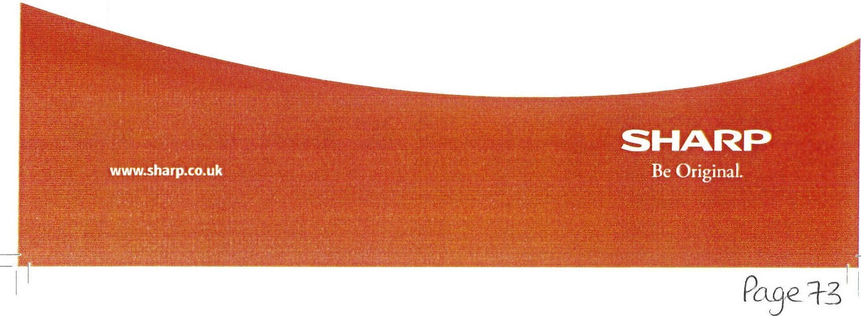
QRCod t i s .> stff'!d tradtmitt ol OeNSOWAVEINCORPORATED1n Japan.indolhe,countntsA. i1?1int .lnd M,t,CM"t tT t01.lrilsol -' '9ielnc..
l(' USJndothNcountrin.PCliu in«f'd tr-'Cfem1 rlcof
tradtm3cril ,3i csa:lm a!l nt us. LP,r Uffe,d ntht US.1ndother countli,s.Allother compa,ny na.rnts.product nan'lt'sand l0j0ty1Jcs .Ji(l!' bo,r
2019. , t-:,'IX '"'°5lJSC.Sl/40S ljlS5'4'30Sl/2SSl 8rochure fJob19729). Alltn dem a rks llt knowl fHi . E&O.
H-"t l·hc b rd Co y. Qualcomm DirK tOffice I\ .t p rod uct of Qualcomm r« hflologi<!S, Inc:. a nd/or its su bsidi1ri t s. Qualcornmis ,1 i:radfln.lrii oi ()@ b.wimlococ-po
intheUS othercounttin. Oir«tOffietisa
i>f :H own,n.OSharp Corpo,auon February

Whitehaven Town Council

From:
Sent:
To:
Subject: Attachments:
Steve Bailey <steve@copyprintsolutions.co.uk> 17 March 2021 12:16
Whitehaven Town Council
Future copier and printer requirements
2515_5015.pd;f 51.pdf; 2651_2 51S_4505.pdf; 2505AC-5005AC.pdf

Hi Marlene,

Please find attached a few options available to your council off ices.

My professional opinion I would recommend you go with the Toshiba offers for value for money. If you have any questions please do not hesitate to call me.
Kind regards,

Steve Bailey - Business Development Manager

T:- 01618760187

M:- 07737730650

Unit 2, Block C, The Courts, Kestrel Road, Trafford Park, M17 lSF

www.copyprintsolutions.co.uk

copyprlnt
SOLUTIONS

SHARP

TOSHIBA

1

'\
c□pldp r in t
J,
SOLUTIONS

r Service

Copy Print Solutions Ltd have built their customer base on a service ethos which is to always try and maintain a hassle free process. We achieve this through a number of contributing factors:-

Our Technicians are trained from the main manufacturers themselves not a third party, we work with Toshiba and Sharp so we get technical data when it is released, updates to firmware and modifications on parts when they are launched.

Proactive monitoring software that automatically dispatches toners at set levels (we usually set this at 25% however this can be adjusted depending on environment) customers always have a set of toners spare and when a spare is used we replenish the spare so you never run out of toner.

We stock all consumable items at our warehouse in Trafford Park, engineers also carry parts needed for day to day repairs.

Within our industry a service level agreement (SLA) is common to 4 hours, we also adhere to this but our last year average was under 2 hours.

We have trained technicians who are also office/warehouse based and these deal with the jobs that can be cleared over the phone such as driver issues dealt with through Teamviewer remote software.

C, c□p[dp r in t
#
0,)
&

SOLUTIONS

What we use to maintain a great service
58,070 996
58.070 996
...
4'8◄, ll
◄8, ◄l)
.6,,6 .
68.00 '¾i 5).000-.
48,41) 65
39, 755 1,388 2,202 - 35,9 75 2,068
HS
460
58.070 ••• ass o
39 , 75S 1,388 2,202 35,976 2,058
Our secure online remote software
-
17,83 2: U20
"'-I
1 742 750. 0 ... 100 .0 0 "4 0.00"¾I
9,34.<t lJ14
shows us real time information on
21.926 ,..
l;J
so.oo ', S0.00 t,i, 50.00
16,636 35-4 toner levels and meter readings as
Z5'4, 711 • 371 29,204 53
Zs.4 1 711 • 371 29,204 " well as service alert informat ion
lS-•Ull 9 :n1 b ow u= .¼.ow 29.2•)4-..
"
..

U , 507 370
11,507 370
10,534 514 and pro-active toner
-
10 , 514 51 4
60 50.00 C. 75.0!l
11,507 370 G.I hew 10,Sl◄ St< replenishment
14,116 033 1,166 28,◄'18 2,631
100.00"...
50.00% 5O.OO .lo
l ! ,l. 7 ,....

13,251 091

14,116 033 1,166 -- 28,40
l:!.08 SL8 1,c,3s tt'oo""(I
J,1)32 it'IS 1-;.'.S O;r.,
u!.OO.o:o-ae-
5900..... 62.00,

l00--00 %

We use TeamViewer to assist users remotely with drivers, firmw are and Papercut. We
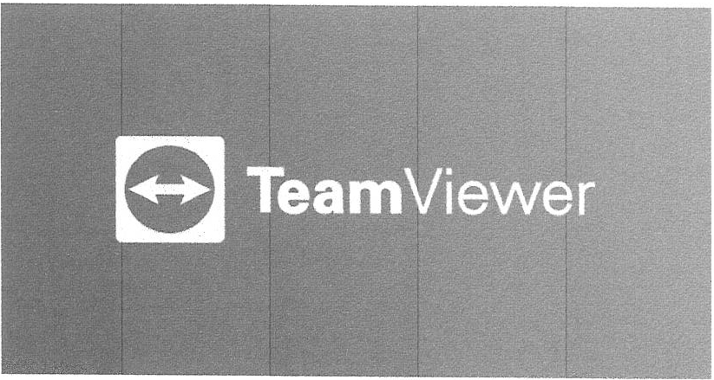
resolve 95% of software issues remotely.
,2631

.i fJl. copyprint
., F
SOLUTIONS
g:
a.:::.

Where do we cover

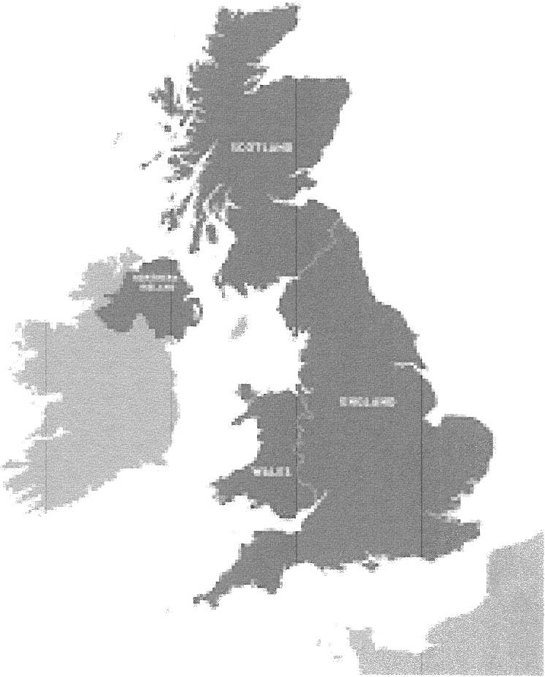We cover the whole of the UK, we directly service our machines in the North West and work with our print partner Toshiba for anything further.
1. ,
i-:.
'°' {
. .
*
,.._ - -.
,.'

We have machines as far north as the Scottish Highlands and as far down as Cornwall.

With customer locations ranging from single devices on building sites to over thirty machines in a corporate head office we always respond to our 4 hour SLA with last years' average under 2 hours with a 95% first time fix rate.

c□p'=Jpr in t
.,
SOLUTIONS

(\)

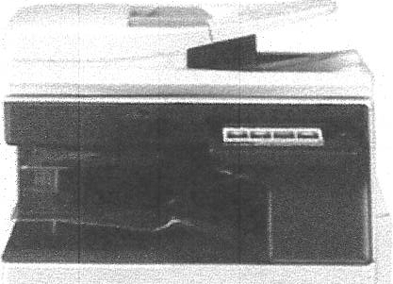
lx New SharR MX-2651N

- 26 pages per minute in mono and colour
- 100 sheet reversing document feeder
- AS-SRA3 paper {56-300gsm)
- 50 sheet internal staple finisher
- 2 x 550 sheet paper trays
-
- 10.1" Colour Touch Screen
- Mobile Desk Unit
- Cloud enabled -

i, c□p(dp r in t
C;'
(i-

SOLUTIONS

Machine costs:

lx Brand New Sharp MX-2651
Purchase cost £2,495 ex VAT 3 Year lease - £78.59 Per Month 5 Year lease - £51.65 Per Month

Full Service Costs
In cludes toners, parts, labour and maintenance Colour - £0.028* per page (£28 per 1,000) Mono - £0.0028* per page (£2.80 per 1,000)
* fixed for contract term

* No minimum billing
* We employ our own engineers
* Delivery, installat ion and training included
* Remote suppor t via Teamviewer

c□p(dp r in t
C,
SOLUTIONS

(::i)

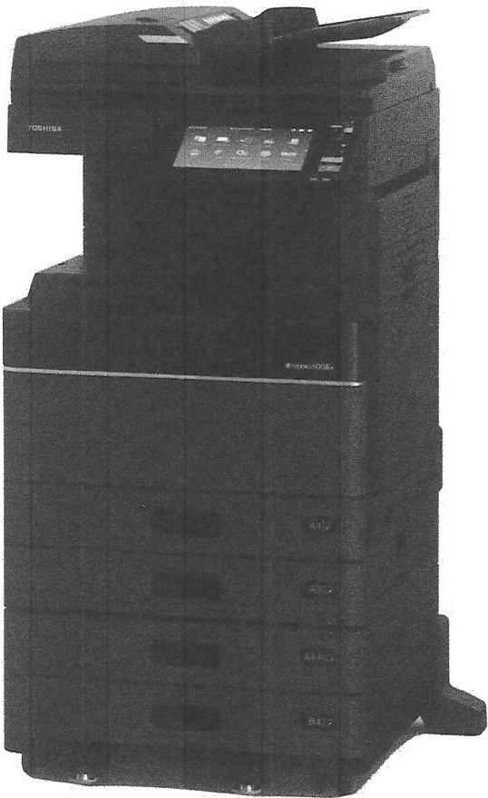
lx New Toshiba e-st udio _2515 AC

- 25 pages per minute in colour and mono
- 100 sheet reversing document feeder
- A5-SRA3 paper (52-300gsm)
- Postscript enabled
- 50 sheet internal staple finisher
- 1,200 x 1,200 dpi
- 2 x 550 sheet paper trays
- 1 x 100 sheet multi purpose bypass
- 320 GB Secure HOD
- 4GB RAM
- Mobile desk unit
- Cloud enabled

