WHITEHAVEN TOWN COUNCIL

Clerk and Responsible Financial Officer: Marlene Jewell
Telephone: 01946 67366
Chairman: Councillor C Hayes

To: Members of Whitehaven Town Council

You are duly SUMMONED to attend a MEETING of WHITEHAVEN TOWN COUNCIL which will be held in THE BEACON PORTAL at THE BEACON, WHITEHAVEN on Thursday 29th February 2024 at 6.00 pm

Signed...M. ... ..Dated.- - - ..2-:Q 2-Lj--
Marlene Jewell, Clerk and Responsible Financial Officer

AGENDA

- Apologies for Absence

- Declarations of Interest

To receive declarations of interest by elected Members in respect of Agenda items.

If a Member requires any advice on any item involving a possible declaration of interest which could affect his/her ability to speak and/or vote he/she is advised to contact the Clerk at least 24 hours in advance of the meeting.

- Public Participation

- Minutes of the Council Meeting held on 25th January 2024

- Planning Applications

- Report from Cumberland Council

- Finance Report

- Hewlett Packard Support

- Contract for Collecting, Setting Up, Removal and Return of Council Equipment used during Council Events

- Press Statements - Councillor Gill to give a report

- Castle Park - Clerk to give a repo1i

- Report on Firewalk - Chairman to give a report

13 WCSSG- Councillor E Dinsdale to give a report

- Road Traffic Regulation Order for Whitehaven

- Amendments to Copeland Local Plan

- Councillor Ward Matters

- Date and Time of Next Meeting

IN PRIVATE

That prior to the following items of business the Chairman will move the following resolution:
That in view of the special or confidential nature of the business about to be transacted it is advisable in the public interest that the public and or press be instructed to withdraw.

- Office Accommodation - Clerk to give a report

- St Nicholas Gardens - Clerk to give a report

WHITEHAVEN TOWN COUNCIL

Minutes of the Council Meeting held on the 25th January 2024

Present: Councillor C Hayes (Chairman); Councillor R Gill; Councillor J Carr; Councillor E Dinsdale; Councillor A Pearson; Councillor G Roberts; Councillor R Redmond; Councillor A Spedding; Councillor R Taylor; Councillor R White

M. Jewell, Clerk and Responsible Financial Officer V Gorley, Assistant Clerk
Members of the Public

Prior to the Meeting starting the Chairman and the Councillors introduced themselves to the public and the Chairman referred to fire alarms/escape and toilets

2434/24 Apologies for Absence

Apologies for absence were received from:

Councillor G Dinsdale Councillor B O'Kane
Maternity Leave ill

It was proposed by Councillor Hayes and seconded by Councillor Roberts that the apologies for absence be accepted and noted. A vote was held and it was unanimously

RESOLVED - That the apologies for absence be accepted and noted.

2435/24 Declarations of Interest

Councillor Hayes declared that he was a member of the Whitehaven Tidy Town Committee and the Harbour Users Group.
Councillor Taylor declared that he was a member of the Red Lonning Community Centre
Councillor Gill declared that he was a member of the Whitehaven Heritage Action Group

2436/24

2437/24
Public Participation

JC attended and made the following points
- He had been looking in Buttons shop where the photos were and said what a fine shop it used to be like a lot of buildings in town that were going downhill.
- He said years ago he used to be a member of what was the Town Centre Group of Whitehaven. It was an amalgamation of the Civic Society, Copeland Council representatives, The Heritage Group and the Chamber of Trade. They were trying to promote the Town.
- They produced quite a bit of literature and he said he had brought some with him for the Council to have a look at
- He wondered if even though the Town Centre Group didn't exist anymore whether the literature could be of any use to anybody.
- He said where we were falling down was Workington and Carlisle had a Town Centre Manager and that was his job full time and we hadn't got one
- The Town Centre Group didn't cost anything because everybody on it was a volunteer and JC wondered (he said he knew the town was run down with online shopping like a lot of towns) if there was any mileage in re-forming something like the Town Centre Group who if it wasn't costing anything as everyone was a volunteer to sort of promote the town
- JC said he had brought some of the type of things they had done - eg if there was a firm who wanted to expand they would contact them and send literature out to them to see if they had any interest in coming to Whitehaven. He said Copeland Council used to give them some funds but unfortunately over the years it started to decline and then fell away and now it didn't exist any more and he just wanted to bring this to the Council's attention and for the Council to look at it and see if there was any mileage in re-forming such a group if there was enough volunteers to do it
The Clerk asked about the brochure and JC said he had brought it for the Council to keep
The Chairman thanked JC for attending

Minutes of Council Meeting held on 30th November 2023

The Clerk apologised for the error in Minute 2425/23 which should have read seconded by Councillor Spedding not Councillor Pearson and asked that the Minutes be amended. It was proposed by Councillor Roberts and seconded by Councillor Hayes that subject to the amendment above the Minutes of the Meeting held on 30th November 2023 by approved and signed by the Chairman

as a c01Tect record. A vote was held and 9 Councillors voted for the proposal and 1 Councillor abstained

RESOLVED - That subject to the amendment above the Minutes of the Meeting held on 30th November 2023 by approved and signed by the Chairman as a correct record.

2438/24 Minutes of the Extraordinary Council Meeting held on 17th January 2024

Councillor Gill asked if the press were at the last meeting and the Clerk asked if it was in the Minutes that the Press were present and Councillor Gill said no.
Councillor Gill said there had been a report in the Whitehaven News yesterday quoting him and he wondered how they got the quote and the Clerk said she didn't know but that the meeting had been in public. Councillor Gill said the newspaper article had quoted verbatim what he had said so obviously it had been recorded
Councillor E Dinsdale said they were assisted by him as at the end of the Meeting the Council had agreed that the public should be consulted on the road traffic changes and Councillor Gill said that the Council would consult with them through its Officers not through Councillor Dinsdale. Councillor E Dinsdale said it was his Ward and to answer Councillor !Gill's question it was him and Councillor Gill said that he was out of order in his view and Councillor E Dinsdale said in his view he wasn't.
Councillor Gill said that any public statement to the media should go through the Clerk or the Chairman and asked that an item be placed on the Agenda for the next Council Meeting to discuss this point.
Councillor E Dinsdale referred to page 20 and the title Road Traffic Regulation Order for Whitehaven and said within point 3 on page 14 to the report that for map 4 this should be residents parking only and within the itemised list where it said proposal Map 4 where it has been bullet pointed further down and says from Corkickle no objection or comments on this and he did comment. The Clerk said she had written it down on the plan what was said and Councillor E Dinsdale said he had commented on it and it was in the Minutes and Councillor E Dinsdale said it would be worthwhile checking that it did get
submitted to Cumberland Council because it was a really key point because he had originally submitted that. The Clerk said it had been submitted to CC and that a response had been received which had been sent to all Councillors by email that day. Councillor E Dinsdale said he would look at it. The Clerk said that the matter would be going back to the Council for further discussion because of certain points.
It was proposed by Councillor Roberts and seconded by Councillor Gill that the Minutes of the Extraordinary Meeting held on 17th January 2024 by approved and signed by the Chairman as a correct record. A vote was held and it was unanimously
RESOLVED - That the Minutes of the Extraordinary Meeting held on 17th

January 2024 by approved and signed by the Chairman as a conect record.

2439/24 Planning Applications

1. Councillor Roberts referred to planning application 4/23/2164/PIP in respect of 108 Victoria Road - 3 dwellings and refened to subsequent plans and access onto that road and pointed out that the application was faulted because of the number of dwellings (3) to be erected at the rear of another property so there would be 4 dwellings with one access. It was proposed by Councillor Roberts and seconded by Councillor Taylor that Cumberland Council be informed that the application was faulted because of the number of dwellings (3) to be erected at the rear of another property so there would be 4 dwellings with one access. A vote was held and it was unanimously
RESOLVED - That Cumberland Council be informed the application was faulted because of the number of dwellings (3) to be erected at the rear of another property so there would be 4 dwellings with one access.

11. Councillor White referred to planning application 4/23/2355/0Fl - 8 Corkickle, Whitehaven and wanted to know how many holiday lets there would be, the parking and access details and parking availability. He also wanted to know whether extra Council Tax was charged for holiday lets as this could have an effect on housing. It was proposed by Councillor White and seconded by Councillor Hayes that Cumberland Council be asked how many holiday lets there would be, the parking and access details and parking availability. Also whether extra Council Tax was charged for holiday lets as this could have an effect on housing. A vote was held and it was unanimously
RESOLVED - That Cumberland Council be asked how many holiday lets there would be, the parking and access details and parking availability. Also whether extra Council Tax was charged for holiday lets as this could have an effect on housing.

m. Councillor Taylor refened to planning application 4/24/2017/OF1 - The Boat Shed, North Shore and asked if it was possible to get more clarity on this and asked what the intent was from Cumberland Council with the piece of land as he had been under the impression that the land was earmarked for development purposes eg car park/hotel/part of the bus exchange. The Clerk said that all of this detail could be seen on CC's website. It was proposed by Councillor Taylor and seconded by Councillor Can that a letter be sent to Cumberland Council asking them what their intent was with this piece of land. A vote was held and it was

RESOLVED - That a letter be sent to Cumberland Council asking them what their intent was with this piece of land.
1v. There were no further representations on any other planning application on Schedule one and it was proposed by Councillor Hayes and seconded by Councillor White that Cumberland Council be informed that with the exception of i-iii above there were no further representations on any other planning application on Appendix 1.

2440/24
RESOLVED - There with the exception of i-iii above there were no further representations on any other Planning Applications listed on Appendix 1.
Report from Cumberland Council

Councillor J Ghayouba who represents Bransty Ward on Cumberland Council attended and gave the following report.
He said he didn't have a lot to bring to the Meeting and the main item was an
ask from the Council with regard to the Community Investment Plan. Councillor Ghayouba said the Whitehaven and Coastal Community Panel had put together a local investment plan where they had set out their priorities and how they wanted to try and improve the community and they wanted a representative from the Town Council to go to their community network meetings to provide feedback on the local investment plan that had been published and said he believed that it had been emailed to the Clerk and to the Council so that they could have a read and that the next Meeting was on 13th February 2024.
The Chairman said that he would go along.
The Clerk said that Councillor Hawkins had said that it was normally the Chairman of Town Councils who attended and that she had received an email from Tamsin Beatty who said that only 1 person was needed but that if after attending the first meeting the Chairman felt there should be another Councillor or 2 Councillors to accompany them then that would be in order.
Councillor Ghayouba said that he wanted to encourage all Councillors to read the investment plan thoroughly and feed their comments into the Chairman so that when he attended the meeting he would have the all the Council's comments
- Councillor Ghayouba said the TRO consultation would close at the beginning of February 2024. He knew there was a lot of concern in respect of disabled parking etc. He said his understanding from speaking with the officers was that residents don't get what they don't want so that if there were proposals out there and a sea of views against the proposals he didn't think CC would go ahead and force it on people. One of the things to take into account was that a lot of the proposals were legacy proposals and asked the Council to encourage people to go on the CC website and leave their comments.

2441/24
The Chairman thanked Councillor Ghayouba for the presentation
Councillor E Dinsdale said he had spent 3 hours going round his Ward on Monday getting a direct feel and said there were strong feelings from the Aladdin's Cave/Chemist part of the Market where you have 3 shops and the bird seed/tobacco shop and all 3 businesses were on that part of the Market where it was loading only outside and were firmly of the opinion that their businesses would benefit more from disc badge parking. There were also feelings from the butchers side where there had been no change at all around more blue disc parking and he had told them all to submit their comments on the consultation to CC and that he would also do it as a Town Councillor. He said he welcomed the increase in disc parking to the Market, Swingpump Lane and the top of Strand Street.
The Clerk asked Councillor Ghayouba if the public consultation would be advertised and he confirmed it would and said if a resident was in an area of town affected they should get a letter from CC. Councillor Ghayouba confirmed that he would let the Clerk know the period for public consultation.
Finance Report

The Council considered a Finance report

1. Appendix 1 - Invoices paid to avoid late payment fees as no Council Meeting since November 2023. It was proposed by Councillor Gill and seconded by Councillor Hayes that the invoices paid be noted and approved. A vote was held and it was unanimously

RESOLVED - That the invoices paid be noted and approved

11. Appendix 2 - The Assistant Clerk reported that there was an invoice on Appendix 2 for£18,000 from Cumberland Council which was the total amount set aside in the Town Council budget for 2023/24 for St Nicholas Gardens. There was no breakdown of costs to show how the figure had been arrived at. It was proposed by Councillor Roberts and seconded by Councillor Hayes that the invoice be not paid until a breakdown of costs had been received, A vote was held and it was unanimously
RESOLVED - That that the invoice be not paid until a breakdown of costs had been received.
111. Appendix 2 - The Assistant Clerk reported that there was 1 additional invoice to consider on Appendix 1 namely
Bennett Brothers £50 plus VAT for Christmas Tree

It was proposed by Councillor Gill and seconded by Councillor Hayes that the invoices shown on Appendix 1 plus the 1 extra invoice be approved and paid. A vote was held and it was unanimously

RESOLVED - That the invoices shown on Appendix 1 plus the 1 extra invoice be approved and paid.

2442/24

2443/24
1v. Appendices 3 and 4 - It was proposed by Councillor Gill and seconded by Councillor Hayes that Appendices 3 and 4 be approved and noted. A vote was held and it was unanimously
RESOLVED - That Appendices 3 and 4 be approved and noted.
Internal Auditors Report

The Council considered a report received from the Council's Internal Auditor. Everything was satisfactory. Councillor Gill moved a vote of thanks be given to the staff and that the Internal Auditors Report be approved. This was seconded by Councillor Hayes. A vote was held and it was unanimously

RESOLVED - That a vote of thanks be given to the staff and that the Internal Auditors Report be approved.
Quotes Received for planting and Maintenance of Summer and Winter Plants in Whitehaven 2024/25

The Council considered quotes received for planting, maintenance and watering of summer and winter plants in Whitehaven for 2024/25. Five quotes were sought and two were received as follows:-

Contractor A Contractor B
£48,472.50 plus VAT
£54,998.64 plus VAT

It was proposed by Councillor Gill and seconded by Councillor Hayes that the quote of £48,472.50 plus VAT from Contractor A be accepted. A vote was held and it was unanimously
RESOLVED - That the quote of £48,472.50 plus VAT from Contractor A be accepted.
2444/24 Quote Received for Erection, Maintenance, Repair and Dismantling of Christmas Lights in Whitehaven 2024/25

The Council considered a report on a quote of £24,500.00 plus VAT received from Cumberland Council for the erection, maintenance, repair and dismantling of Christmas Lights in Whitehaven for 2024/25. It was reported that this was

an increase of£ 100 and was the first increase in 6 years. In order to accept this quote the Council had to consider suspending Financial Regulation 11 to permit this. Financial Regulation 18 states that the Council may by resolution duly notified prior to the relevant Meeting of the Council suspend any part of the Financial Regulations provided that reasons for the suspension are recorded and an assessment of the risks arising had been drawn up and presented to the Council in advance. It was proposed by Councillor Gill and seconded by Councillor White that (i) The Council suspends Financial Regulation 11 to allow Cumberland Council to erect, maintain, dismantle and repair the Christmas Lights in 2024/25 at a cost of £24, 500.00 plus VAT and
(ii) Having made the resolution that the reasons for the suspension as stated in the report be recorded and also that the assessment of the risks stated in the report be accepted and approved. A vote was held and it was unanimously

RESOLVED - That (i) The Council suspends Financial Regulation 11 to allow Cumberland Council to erect, maintain, dismantle and repair the Christmas Lights in 2024/25 at a cost of £24, 500.00 plus VAT and
(ii) Having made the resolution that the reasons for the suspension as stated in the report be recorded and also that the assessment of the risks stated in the report be accepted and approved.

2445/24
Quote received for the Erection, Repair, Maintenance and Dismantling of Bunting in Whitehaven 2024

The Council considered a report on a quote of £4,446.91 plus VAT from Cumberland Council for the erection, repair, maintenance and dismantling of bunting in Whitehaven for Town Council events. In order to accept this
quote the Council had to consider suspending Financial Regulation 11 to permit this. Financial Regulation 18 states that the Council may by resolution duly notified prior to the relevant Meeting of the Council suspend any part of the Financial Regulations provided that reasons for the suspension are recorded and an assessment of the risks arising had been drawn up and presented to the Council in advance. It was proposed by Councillor Gill and seconded by Councillor Taylor that (i) The Council suspends Financial Regulation l l to allow Cumberland Council to erect, maintain, repair and dismantle the
bunting in Whitehaven at a cost of £4,446.91 plus VAT and
(ii) Having made the resolution that the reasons for the suspension as stated in the rep011 be recorded and also that the assessment of the risks stated in the report be accepted and approved. A vote was held and it was unanimously

RESOLVED - That (i) The Council suspends Financial Regulation 11 to allow Cumberland Council to erect, maintain, repair and dismantle the bunting in Whitehaven at a cost of £4,446.91 plus VAT and
(ii) Having made the resolution that the reasons for the suspension as stated in the report be recorded and also that the assessment of the risks stated in the report be accepted and approved.

2446/24

2447/24
Quote for Purchase of additional Bunting

The Council considered a report on the purchase of 530 metres of Union
Jack bunting from the Hampshire Flag Company at a cost of £777.70 plus VAT In order to accept this quote the Council had to consider suspending Financial Regulation 11 to permit this. Financial Regulation 18 states that the Council may by resolution duly notified prior to the relevant Meeting of the Council suspend any part of the Financial Regulations provided that reasons for the suspension are recorded and an assessment of the risks arising had been drawn up and presented to the Council in advance. It was proposed by Councillor Gill and seconded by Councillor Taylor that (i) The Council suspends Financial Regulation 11 to allow the purchase of 530 metres of Union Jack bunting from the Hampshire Flag Company at a cost of £777.70 plus VAT and
(ii) Having made the resolution that the reasons for the suspension as stated in the report be recorded and also that the assessment of the risks stated in the report be accepted and approved. A vote was held and it was unanimously
RESOLVED - That (i) The Council suspends Financial Regulation 11 to allow The purchase of 530 metres of Union Jack Bunting from The Hampshire Flag Company at a cost of £777.70 plus VAT and
- Having made the resolution that the reasons for the suspension as stated in the report be recorded and also that the assessment of the risks stated in the report be accepted and approved.
Consideration of purchasing Lamp Post Banner Brackets

The Clerk reported on a suggestion by Cumberland Council's Lighting Department to purchase 5 Lamp Post Banner Brackets at a cost of £450.00 plus VAT to be used for Christmas lights displays and advertising.
It was proposed by Councillor Gill and seconded by Councillor Roberts that 5 lamp post banner brackets be purchased at a cost of £450 plus VAT. A vote was held and it was unanimously

RESOLVED - That 5 Lamp Post Banner Signs be purchased at a cost of
£450.00 plus VAT

Councillor Gill asked that a letter be sent to Brian Holmes to thank him for all the help and advice that he had given to the Council over the years and to wish him well for the future and this was agreed.

2448/24 Councillor Ward Matters

  - Councillor White said he had been considering alongside Councillor Hawkins having another session with Home Group which they had had last autumn. He asked if any Councillors had any other residents with Home Group issues and said maybe we should organise an evening session in the town to discuss these
11. Councillor White referred to his Ward Grant and funding for the Boxing Club in his Ward and said he would speak to the Clerk about this after the Meeting
111. Councillor Taylor raised 3 issues
- Viberoptix had been installing round Hillcrest and had left an unfinished job on Highfields and he had been in touch with the foreman that day to get tarmac round the connection boxes and made good because it was creating a tripping hazard
- There had been gangs of youths from Woodhouse estate kicking down people's doors and people had been complaining about this. The kids had been approached and some had been captured on door bell cameras. He said they were going to have a community engagement session and that Councillor Forster had been engaging with the Police and doing walks rounds the estate. The youths had said they were coming from Woodhouse because there were more Police up there
- On Hillcrest Avenue a barrier had appeared round the bus stop and now elderly people using the bus stop were having to go on the grass where it was all flooded and muddy and causing serious problems for the residents and that he was trying to sort this out
1v. Councillor E Dinsdale said he had spent over 3 hours the previous Monday in the Market talking to shop keepers and businesses about the proposed draft changes and they really welcomed the Swingpump Lane and Strand Street and the additional blue badge parking that has been allocated in the Market. He said they would like to see the blue badge parking go a bit further on the other side of the Market which is Kinsellas Shop, the Post Office, the butchers and where there was a loading bay in front of Aladin's Cave, the birdseed and tobacco shop and the Chemist they would like to see blue badge parking there. The businesses considered that the Traffic Wardens were being a bit over zealous and believed that this was having an impact on businesses and would like to see a more common sense approach in particular to loading and unloading. They said that maybe a meeting could be arranged with the Supervisor of the Traffic Wardens as they would like to see a common sense approach
- Councillor Pearson raised 3 issues
  - Street lighting - he had reported on the Whitehaven to St Bees main road there were 2 footpaths leading from one estate to the

other from Greenbank down towards Mirehouse and the 2 street lights that light up the entrances to these footpaths are out and were causing absolute blackspots. He said he had reported this to CC highways who said they had looked at one and it was an underground problem that would cost a lot of money and they had no intention to do any work. So he had been in touch with Councillor Williamson and told her it was a road that was renowned for speeding and these 2 footpath entrances cross this busy, dangerous road and these lights are very important and they have been out for months
  - 2 lights had been out on Bowness Road for 6 months
  - During the cold snap for some reason they don't grit Woodhouse Hill and he had had a lot of concerned people going to him and saying it would turn into sheet glass which it did and there was chaos. He said things were not being looked at properly as to what was causing danger to the public. Councillor Pearson said that he had reported these on the CC website.
v1. Councillor Taylor said there were also other areas not gritted - there were 2 accidents at Barras Moor on the hill going down and on Hillcrest the bus route had not been gritted and this was causing, in bad weather conditions, real dangerous problems and thought it was something that we should ask clarification on from CC.
v11. Councillor Ghayouba said Cumberland was aware of Harras Moor as residents had been in touch with him about it and in the case of Harras Moor the Highways Team told him that they had gritted Harras Moor but there had been some rain. He said that in terms of gritting routes these had been put out for review and would be constantly under review and that each Cumberland Councillor had a dedicated Highways Mentor who would be a single point of contact where they could go to raise concerns and with whom they had direct contact for highways issues and would be given feedback on any issues.
v111. Councillor Carr said he had nothing as such but that he had been walking on the 09 side - and the Cattle Arch behind the school and it was good to see that the pigeon loft had been cleaned up and the full length of the cycle path there had been cleaned. He said it all looked really clean
1x. Councillor Hayes said he had been delighted to attend the opening of the Howgill Play Centre and said it was a great building for kids and that there were a few places left.
Councillor Hayes said parking for the school was bad so that needed to be kept an eye on
Councillor Hayes said he had been unable to do the Christmas Lights competition on Kells due to illness and that he had donated the prizes to Kells RLFC to raise money for the kids

2449/24

2450/24
Date and Time of next Meeting

The next Council Meeting would be on Thursday 29th February at 6.00pm in the Beacon Portal

Councillor E Dinsdale left the Meeting

IN PRIVATE
That prior to the following items of business the Chairman moved the following resolution:

That in view of the special or confidential nature of the business about to be transacted it is advisable in the public interest that the public and or press be instructed to withdraw. Councillor Roberts proposed this and Councillor Gill seconded this. A vote was held and it was unanimously

RESOLVED - That the public and or press be instructed to withdraw.

St Nicholas Gardens

The Clerk reported on the quote that had been accepted for the planting, watering and maintenance in St Nicholas Garden for 2024/25.
The Clerk reported that the Church had agreed that the Gardens could be used for Town Council events in 2024/25 and last year the Council made a contribution of £250 to the Church for the electricity used during our events in St Nicholas Gardens. It was proposed by Councillor Hayes and seconded by Councillor Taylor that a contribution of £300 be made to the Church for electricity used during Town Council events in St Nicholas Gardens in 2024/25. A vote was held and it was unanimously

RESOLVED - That a contribution of £300 be made to the Church for electricity used during Town Council events in St Nicholas Gardens in 2024/25.

Councillor Taylor stated that himself and Councillor O'Kane were going to try to get the Angels reinstated on St Nicholas Tower and said the Angels were not in a very good condition so they were looking at getting a projector and he had spoken to contractors about community work to see if they could do the electrical installation.

2451/24 Office Accommodation

Further to Minute 2422/24 the Clerk reported that nothing had changed and that she was still waiting to hear from NALC about VAT. The Clerk referred to a quote that had been received in 2022 from Kone the provision of a lift in the building and that she had written to them that week asking for a revised quote. The Clerk said that she would be looking at starting to submit some grant applications in the next few weeks. It was proposed by Councillor Hayes and seconded by Councillor Taylor that the report be approved and noted. A vote was held and it was unanimously

RESOLVED-That the report be approved and noted

The Meeting closed at 7.15

Chairman

WTC 29/02/2024
Item 5

Planning Application for Consideration by Whitehaven Town Council

Application Number 4/24/2021/0Fl

4/24/2034/0Fl

4/24/2035/0B1

4/24/2036/0Bl
Detail
SINGLE STOREY SIDE EXTENSION
6 EARLS ROAD, WHITEHAVEN

THE REMOAL OF 6 ANTENNAS, AND INSTALLATION OF 6 ANTENNAS ON NEW SUPPORT STEELWORK, REPLACEMENT OF EQUIPMENT CABINET AND INSTALLATION OF ANCILLARY EQUIPMENT ON NEW SUPPORT STEELWORK
BRITISH TELECOM, CATHERINE STREET, WHITEHAVEN

VARIATION OF CONDITION 2 TO ALTER HOUSE TYPES, REMOVE PARKING COURTS & CHANGE THE HOUSING MIX OF APPROVED APPLICATION 4/21/2195/0Rl APPROVAL OF RESERVED MATTERS FOR ACCESS, APPEARANCE, LANDSCAPING, LAYOUT & SCALE FOR 85 DWELLINGS FOLLOWING OUTLINE APPROVAL 4/16/2415/001
HARRAS DYKE FARM, HARRAS DYKE, WIDTEHAVEN
VARIATION OF CONDITION 2 TO ALTER HOUSE TYPES, REMOVE PARKING COURTS & CHANGE THE HOUSING MIX OF PLANNING APPLICATION 4/21/2196/0Rl APPROVAL OF RESERVED MATTERS FOR ACCESS, APPEARANCE, LANDSCAPING, LAYOUT & SCALE FOR 5 DWELLINGS FOLLOWING OUTLINE APPROVAL 4/16/2416/001

Application Number Detail

HARRAS DYKE FARM, HARRAS DYKE, WHITEHAVEN

4/24/2049/0Fl

4/24/2052/0Fl

4/24/2054/TPO

4/24/2055/TPO

4/24/2058/0F1
ALTERATIONS AND EXTENSIONS FOR ACCESSIBLE GROUND FLOOR BEDROOM AND SHOWER ROOM
8 CRUMMOCK AVENUE, WHITEHAVEN

PROPOSED TWO STOREY SIDE EXTENSION & FRONT PORCH
41 JERICHO ROAD, WHITEHAVEN

APPLICATION TO FELL A MATURE HOLLY TREE SITUATED WITHIN A CONSERVATION AREA AND ECO PLUG THE STUMP
105 QUEEN STREET, WHITEHAVEN

REDUCTION OF UP TO 20% AND CROWN LIFT UP TO 2.5M OF A BIRCH TREE PROTECTED BY A TREE PRESERVATION ORDER
LAND TO REAR OF 15 TO 20 SCOTCH STREET, WHITEHAVEN

REMOVE EXISTING ROOF AND UPBIOLD TO 1.5 STOREY TO PROVIDE FIRST FLOOR BEDROOMS, REAR EXTENSION TO PROVIDE ADDITIONAL LIVING ACCOMMODATION AND NEW ROOF STRUCTURE
12 STANDINGS RISE, WHITEHAVEN

WTC 29/02/2024

Item 7

FINANCIAL REPORT
Purpose of the Report

Members are asked to consider a list of invoices for authorisation and payment as shown at Appendix 1 and approve the recommendations in paragraphs 3.1 and 3.2.
1.0 INTRODUCTION

    - Authorise the payment of all invoices as listed in Appendix 1.
    - The Council is asked to note the cashbook as reconciled with the bank account as shown at Appendix 2 together with income and expenditure at Appendix 3.

0 FINANCIAL POSITION

    - The bank reconciliation was carried out on 21st February 2024. This shows a balance of £279,163.40. There are payments to the value of £60.00 waiting to be cleared.

    - The balance in the deposit account is £610,571.03.

0 RECOMMENDATION

    - The invoices listed and shown in Appendix 1 be approved and authorised for payment.
    - The Cashbook (Appendix 2) and the Income and Expenditure (Appendix 3) be noted.

29/02/2024

Appendix 1

Invoices for Consideration by Whitehaven Town Council

Date | Supplier | Category | Detail | Total Amount |  | Power Columnl
25/01/2024 | Eden Springs UK Ltd | Supplies& Services | Water Dispenser Hire & Environmental Levy for February 2024 | £ | 9.24 | slllLGA 1972
02/02/2024 | Arborscape | 3rd Party | Emergency Tree Removal from Midgey Allotments | £ | 367.20 | s23 Smallholdings & Allotments Act 1908
04/02/2024 | Mrs VGorley | Employees/Allowances | Re-imbursementfor purchase of toilet rolls | £ | 4.99 | slll LGA 1972
06/02/2024 | Cumberland Council | Premises | MeetingRoom Hire (17/01/2024 and 25/01/2024) | £ | 168.00 | slllLGA 1972
06/02/2024 | Mrs VGorley | Supplies & Services | Re-imbursement for postage | £ | 1.50 | slllLGA 1972
06/02/2024 | Sharp Business Systems UK PLC | Supplies & Services | Photocopier Chargesminimum fee for January 2024 | £ | 30.00 | slllLGA 1972
12/02/2024 | Hampshire Flag Company Ltd | Earmarked Reserves | Union Jack Bunting | £ | 933.24 | s144 LGA 1972
15/02/2024 | Arborscape | 3rd Party | Allotment Maintenance Contract - January 2024 | £ | 369.60 | s23 Smallholdings & Allotments Act 1908
19/02/2024 | Christmas Plus | 3rd Party | Clusterline (Christmas Lights) | £ | 1,896.00 | s144 LGA 1972
20/02/2024 | Mrs VGorley | Events | Re-imbursement for 2 buckets for Firewalk event | £ | 3.00 | s144 LGA 1972
20/02/2024 | Viking | Supplies & Services | Copier Paper and stamps | £ | 308.48 | slllLGA 1972

£ 4,091.25

WHITEHAVEN TOWN COUNCIL CASH BOOK FROM 1 APRIL 2023

APPENDIX 2

Date
April-2023

01.04.2023
06.04.2023
06.04.2023
4 06.04.2023
5 12.04.2023
14.04.2023
14.04.2023

Ref

1157
BACS BACS BACS DD
BACS BACS

Payee

Unpresented cheques b/fwd from 2022/2023
Copeland Borough Council Newsquest Media Group Hensingham ARLFC Youth Hensingham ARLFC Youth Water Plus
Staff
HMRC

Unpresented
cheques as of Employees/ Supplies/
31.03.23 Allowances Premises Services 3rd Party

2850.31
12100.75

5294.59
2112.52

Grants

Ground
Allotmts Maint

64.51

Civic
Hospitality Ranger/SO W.I.B

Ward
Grants Elections

1000.00
750.00

Environmental
Improvements Events Contingencies

289.00

Reserves Net Total VAT

£ 2,850.31
£ 12,100.75
289.00 £
1,000.00
750.00
64.51
5,294.59
£ 2,112.52

Total

2,850.31
£ 12,100.75
57.80 £ 346.80
£ 1,000.00
£ 750.00
64.51
5,294.59
£ 2,112.52

Min.Ref.

carried f/wd 2223/23 (i)
2110/22
Ward Grant - 2022/23 Ward Grant - 2022/23 Contract
2162/22
HMRC

14.04.2022
BACS Cumbria LGPS
752.33
£ 752.33
£ 752.33
6317/17 (ii)

6 14.04.2022
7 14.04.2022
8 17.04.2023
9 19.04.2023
10 22.04.2023
11 22.04.2023
12 28.04.2023
13 28.04.2023
14 28.04.2023
15 28.04.2023
16 28.04.2023
17 28.04.2023
18 28.04.2023
19 28.04.2023
20 28.04.2023
21 28.04.2023
22 28.04.2023
23 28.04.2023
24 28.04.2023
25 28.04.2023
26 28.04.2023
27 28.04.2023
28 28.04.2023
29 28.04.2023
30 28.04.2023
31 28.04.2023
May-2023
BACS npower Business Solutions
BACS Mr D Horner
OD Crown Gas & Power
OD BTGroup OD Water Plus DD Water Plus
BACS Eden Springs UK Limited BACS POD (North West) Ltd
BACS Derwent Recycling Services Ltd BACS Derwent Recycling Services Ltd BACS Mrs V Gorley
BACS CALC
BACS Copeland Borough Council BACS POD (North West) Ltd
BACS Sharp Business Systems UK Pie BACS Mrs M Jewell
BACS Thomas Graham & Sons Limited
BACS Mrs V Gorley
BACS npower Business Solutions
BACS Mrs M Jewell BACS The Solway Hall BACS Mrs M Jewell BACS Mrs V Gorley BACS Mr C Maudling
BACS Whitehaven Heritage Action Group
BACS Viking

4.49

18.50

2.48

195.40

332.68

41.77

70.00

120.00

129.15

7.70

2005.98

52.98

49.85
570.34

2013.41

12.27

300.00
300.00

500.00

59.57

1000.00

15.00

1000.00

5.60

100.00
100.00
£ 570.34 £
£ 500.00
£ 332.68 £
£ 129.15 £
£ 12.27
£ 41.77 £
£ 7.70 £
£ 15.00 £
£ 300.00 £
£ 300.00 £
£ 4.49
£ 2,005.98
£ 70.00
£ 1,000.00
£ 52.98 £
£ 18.50
59.57
2.48
£ 2,013.41 £
£ S.60
120.00
£ 100.00
£ 100.00
195.40
£ 1,000.00
£ 49.85 £
28.52 £
£
66.53 £
25.83 £
£
1.41 £
1.54 £
3.00 £
60.00
60.00

14.00
200.00
10.60 £
£
11.91 £
£
100.67 £
£
24.00 £
£
£
£

9.97
598.86
500.00
399.21
154.98
12.27
43.18
9.24
18.00
360.00
360.00
4.49
2,005.98
84.00
1,200.00
63.58
18.50
71.48
2.48
2,114.08
5.60
144.00
100.00
100.00
195.40
1,000.00
59.82
Contract
2223/23 (i)
Contract Contract Contract Contract 2235/23 (i)
2235/23 (i)
2235/23 (i)
2235/23 (i)
2235/23 (i)
2235/23 (i)
2235/23 (i)
2235/23 (i)
2235/23 (i)
2235/23 (i)
2235/23 (i)
2235/23 (i)
2235/23 (i)
2235/23 (i)
2235/23 (i)
2235/23 (i)
2235/23 (i)
2235/23 (i)
2235/23 (i)
2235/23 (i)

32 02.05.2023
33 15.05.2023
15.05.2023
15.05.2023
15.05.2023
34 19.05.2023
35 23.05.2023
36 23.05.2023
37 31.05.2023
38 31.05.2023
39 31.05.2023
40 31.05.2023
41 31.05.2023
42 31.05.2023
43 31.05.2023
44 31.05.2023
45 31.05.2023
46 31.05.2023
47 31.05.2023
48 31.05.2023
49 31.05.2023
so 31.05.2023
51 31.05.2023
52 31.05.2023
June-2023
53 05.06.2023
15.06.2023
15.06.2023
15.06.2023
54 16.06.2023
55 16.06.2023
56 19.06.2023
57 30.06.2023
BACS DD BACS BACS BACS DD DD DD BACS BACS BACS BACS BACS BACS BACS BACS BACS BACS BACS BACS BACS BACS BACS BACS

OD BACS BACS BACS DD BACS DD
OD
Zurich Municipal Crown Gas & Power Cumbria LGPS HMRC
Staff
BT Group Water Plus Water Plus
Whitehaven Community Trust
Mrs MJewell
Derwent Recycling Services Ltd Derwent Recycling Services Ltd Newsquest Media Group Arborscape
Mrs VGorley
Sharp Business Systems UK Pie Rachael Kelly Bookkeeping Services Market Place (Europe) Ltd
Mrs VGorley Mr C Maudling
Messrs K R Wilson & Sons T/ A Cumbria Loos
Cumbria Media
Carlisle City Fire Protection
Starboard Systems limited T/A Scribe Accounts

TV licensing
Staff HMRC
Cumbria LGPS
Crown Gas & Power
Beck Bottom Community Garden Group
BT Group Water Plus

752.33
2112.93
5294.18

110.00

5294.18
2112.93
752.33

265.78

42.63

120.00

159.00

116.63
3497.69

132.91

450.00

10.50
25.00
250.00

5.80

314.00

1994.00

134.94

1000.00

14.10

300.00
300.00

312.00

8.59

1029.00

100.00

480.00

349.00
£ 3,497.69
£ 265.78
£ 752.33
£ 2,112.93
£ 5,294.18
£ 132.91
£ 42.63
£ 14.10
£ 1,000.00
£ 100.00
£ 300.00 £
300.00 £
450.00
£ 312.00
£ 10.50
£ 25.00
£ 250.00
£ 480.00
£ 5.80
£ 110.00
349.00
314.00
120.00
1,994.00

159.00
£ 5,294.18
£ 2,112.93
£ 752.33
£ 116.63
£ 1,029.00
134.94
8.59

53.16 £
£
£
£
26.58 £
1.68 £

60.00
60.00
90.00 £
62.40 £

5.00

96.00 £
£
£
69.80 £
£
24.00
398.80

5.83

26.99 £
£
3,497.69
318.94
752.33
2,112.93
5,294.18
159.49
44.31
14.10
1,000.00
100.00
360.00
360.00
540.00
374.40
10.50
30.00
250.00
576.00
5.80
110.00
418.80
314.00
144.00
2,392.80

159.00
5,294.18
2,112.93
752.33
122.46
1,029.00
161.93
8.59
Contract Contract 6317/17 (ii) HMRC 2162/22
Contract Contract Contract Grant 2279/23 (i)
2279/23 (i)
2279/23 (i)
2279/23 (i)
2279/23 (i)
2279/23 (i)
2279/23 (i)
2279/23 (i)
2279/23 (i)
2279/23 (i)
2279/23 (i)
2279/23 (i)
2279/23 (i)
2279/23 (i)
2281/23

DD 2162/22
631/17 (ii) HMRC
Contract Ward Grant Contract Contract

58 30.06.2023
Jul-2023
OD Water Plus
40.74
40.74 £
1.34
42.08
Contract

59 03.07.2023
60 03.07.2023
61 07.07.2023
62 07.07.2023
63 07.07.2023
64 07.07.2023
BACS AJ Security (North) Ltd BACS Lockhart Leisure Ltd BACS Eden Springs UK Limited BACS Mrs V Gorley
BACS Arborscape
BACS Newsquest Media Group

2.99

7.70

289.00

110.00
4290.00
3410.00
4,290.00
3,410.00
£ 7.70
£ 2.99
£ 110.00
£ 289.00
858.00 £ 5,148.00
682.00 £ 4,092.00
1.54 £ 9.24
£ 2.99
22.00 £ 132.00
57.80 £ 346.80
2110/22
2110/22
2301/23 (i)
2301/23 (i)
2301/23 (i)
2301/23 (i)

65 07.07.2023
66 07.07.2023
67 07.07.2023
68 07.07.2023
69 07.07.2023
70 07.07.2023
71 07.07.2023
72 07.07.2023
73 07.07.2023
74 07.07.2023
75 07.07.2023
76 07.07.2023
77 07.07.2023
78 07.07.2023
79 07.07.2023
80 07.07.2023
81 07.07.2023
82 07.07.2023
83 07.07.2023
84 07.07.2023
85 07.07.2023
86 07.07.2023
87 07.07.2023
88 07.07.2023
14.07.2023
14.07.2023
14.07.2023
89 16.07.2023
90 19.07.2023
91 24.07.2023
92 24.07.2023
Aug-2023

1158 Cumberland Council
1159 Cumberland Council
1160 Cumberland Council
1161 Cumberland Council
1162 Cumberland Council
1163 Cumberland Council BACS Arborscape
BACS Sharp Business Systems UK Pie BACS Amberol Ltd
BACS Mrs V Gorley
1164 Cumberland Council BACS Mr CJ Hayes
BACS Mrs V Gorley BACS Mrs M Jewell
BACS Eden Springs UK Limited 1165 J & R Bennett
1166 J & R Bennett 1167 J & R Bennett BACS SDEG Limited BACS Mr CJ Hayes
BACS Al Security (North) Ltd BACS Deborah McKenna Ltd BACS Mrs V Gorley
BACS PHP Architects Ltd BACS Staff
BACS HMRC
BACS Cumbria LGPS
OD Crown Gas & Power
DD BTGroup
DD Water Plus DD Water Plus

38.26

51.91

S.49 5294.19
2112.92
752.33

70.00

7.70

1588.50

70.31

42.63

95.02

117.87

312.00

12.20

1789.82
1789.82
1789.82

5250.26
5250.26
5250.26

348.98
34.00

51.00
34.00

3909.00
2831.25
46.70

378.71

780.00
1250.00
1,789.82 £ 357.96
1,789.82 £ 357.96
1,789.82 357.96
5,250.26 1,050.05 £
5,250.26 £ 1,050.05 £
5,250.26 £ 1,050.05
312.00 62.40
95.02 19.00 £
348.98 69.80
34.00
70.00 £ 14.00
38.26
SI.OD £
34.00
7.70 1.54
3,909.00 781.80
2,831.25 £ 566.25 £
46.70 £ 9.34 £
378.71 75.74
51.91 £
780.00 £ 156.00 £
£ 1,250.00 250.00 £
£ 5.49
£ 1,588.50 317.70
E 5,294.19 £
£ 2,112.92 £
£ 752.33 £
70.31 3.52 £
117.87 23.57
12.20
42.63 1.68
2,147.78
2,147.78
2,147.78
6,300.31
6,300.31
6,300.31
374.40
114.02
418.78
34.00
84.00
38.26
SI.OD
34.00
9.24
4,690.80
3,397.50
56.04
454.45
51.91
936.00
1,500.00
5.49
1,906.20
5,294.19
2,112.92
752.33
73.83
141.44
12.20
44.31
2301/23 (i)
2301/23 (i)
2301/23 (i)
2301/23 (i)
2301/23 (i)
2301/23 (i)
2301/23 (i)
2301/23 (i)
2301/23 (i)
2301/23 (i)
2301/23 (i)
2301/23 (i)
2301/23 (i)
2301/23 (i)
2301/23 (i)
2301/23 (i)
2301/23 (i)
2301/23 (i)
2301/23 (i)
2301/23 (i)
2301/23 (i)
2301/23 Ii)
2301/23 (i)
2301/23 (i)
2162/22
HMRC 631/17 (ii) Contract Contract Contract Contract

93 01.08.2023
94 01.08.2023
BACS BACS
Cumberland Council
St James Community Centre
70.00
15.00
70.00
15.00
14.00
£
84.00
15.00
2321/23 (i)
2321/23 Ii)

95
96
97
98
99
100
101
102
103
104
105
106
107
108
109
110

111
01.08.2023
01.08.2023
01.08.2023
01.08.2023
01.08.2023
01.08.2023
01.08.2023
01.08.2023
01.08.2023
01.08.2023
01.08.2023
01.08.2023
01.08.2023
03.08.2023
14.08.2023
15.08.2023
15.08.2023
15.08.2023
15.08.2023
21.08.2023
BACS BACS BACS 1168
1169
BACS 1170 BACS BACS BACS BACS BACS BACS BACS DD BACS BACS BACS BACS DD
Arborscape
Viking
G &AM Lawson Cumberland Council Cumberland Council
Sharp Business Systems UK Pie Cumberland Council
Mr E Dinsdale
Mrs VGorley
Whitehaven Harbour Commissioners
Mr CJ Hayes
Eden Springs UK Limited The Fairly Famous Family Mr E Dinsdale
Crown Gas & Power Top of the Shops Staff
HMRC
Cumbria LGPS BTGroup

3.87

1.90

108.63

5293.98
2113.13
752.33

70.00

7.70

85.54

150.86

42.65

21.14

138.49
304.00

1789.82

5250.26

6S0.00

194.40

800.00

1250.00
304.00
150.86 £
194.40 £
1,789.82
5,250.26
42.65
70.00
3.87
£ 21.14
£ 800.00
E 1.90
£ 7.70
£ 1,250.00
108.63
£ 85.54
£ 650.00
£ 5,293.98
£ 2,113.13
£ 752.33
138.49
60.80 £
30.17 £
38.88
357.96
1,050.05 £
8.53 £
14.00

£
160.00 £

1.54 £
250.00

4.28 £
£

£
27.70 £
364.80
181.03
233.28
2,147.78
6,300.31
51.18
84.00
3.87
21.14
960.00
1.90
9.24
1,500.00
108.63
89.82
650.00
5,293.98
2,113.13
752.33
166.19
2321/23 (i)
2321/23 (i)
2321/23 (i)
2321/23 (i)
2321/23 (i)
2321/23 Ii)
2321/23 (i)
2321/23 Ii)
2321/23 (i)
2321/23 (i)
2321/23 (i)
2321/23 (i)
2321/23 (i)
2321/23 (i)
Contract Ward Grant 2162/22 HMRC 631/17 (ii) Contract

112 22.08.2023
113 22.08.2023
114 29.08.2023
115 29.08.2023
Sept-2023
DD Water Plus DD Water Plus DD Bryt Energy DD Bryt Energy
43.93

726.37
276.74

12.40
43.93
12.40
726.37
276.74
1.72

36.32
13.84
45.65
12.40
762.69
290.58
Contract
Contract Contract Contract

116
117
118
119
120
121
04.09.2023
04.09.2023
04.09.2023
04.09.2023
04.09.2023
04.09.2023
BACS Newsquest Media Group BACS Al Security (North) Ltd BACS Arborscape
BACS Cumberland Council BACS Cumberland Council
BACS Sharp Business Systems UK Pie
999.45

19.50
20.00
25.00

308.00

390.00
999.45 £ 199.89 £
390.00 £ 78.00 £
308.00 61.60
£ 19.50
£ 20.00
£ 25.00 5.00
1,199.34
468.00
369.60
19.50
20.00
30.00
2335/23 (i)
2335/23 (i)
2335/23 (i)
2335/23 (i)
2335/23 (ii
2335/23 (i)

122
123
124
125
126
127
128
129
04.09.2023
04.09.2023
04.09.2023
04.09.2023
04.09.2023
04.09.2023
04.09.2023
04.09.2023
BACS Cumberland Council BACS Lockhart Leisure Ltd BACS Lockhart Leisure Ltd BACS Eden Springs UK Limited BACS Mr CHayes
BACS Mrs V Gorley BACS Mrs V Gorley
BACS Proud and Diverse Cumbria

34.20
81.00
12.50
70.00

7.70

1000.00

5250.00
288.00
£ 70.00
£ 5,250.00
£ 288.00
7.70
£ 34.20
£ 81.00
£ 12.50
£ 1,000.00
14.00
1,050.00
57.60 £
1.54 £
£
£
84.00
6,300.00
345.60
9.24
34.20
81.00
12.50
1,000.00
2335/23 (i)
2335/23 Ii)
2335/23 (i)
2335/23 (i)
2335/23 (i)
2335/23 (i)
2335/23 (i)
2335/23 (i)

130
131
132
133
134
05.09.2023
05.09.2023
05.09.2023
11.09.2023
15.09.2023
15.09.2023
15.09.2023
15.09.2023
BACS Cumberland Council BACS Cumberland Council BACS Fluid Productions
BACS Northern Trust Company Ltd
BACS Beck Bottom Community Garden Group BACS Staff
BACS Cumbria LGPS BACS HMRC

5294.58
752.33
2112.53
1789.82

5250.26

229.00

1172.00

1571.74
£ 1,789.82 357.96 £
£ 5,250.26 £ 1,050.05 £
£ 1,172.00 £ 234.40 £
£ 1,571.74 115.15
229.00
5,294.58
752.33
2,112.53
2,147.78
6,300.31
1,406.40
1,686.89
229.00
5,294.58
752.33
2,112.53
2335/23 (i)
2335/23 (i)
2335/23 (i)
2335/23 Ii)
Ward Grant
2162/22
631/17 (ii) HMRC

135
136
137
18.09.2023
19.09.2023
19.09.2023
DD Crown Gas & Power DD Bryt Energy
DD BTGroup
79.51
82.55

131.22
79.51
82.55
131.22
3.98
4.13 £
26.24 £
83.49
86.68
157.46
Contract
Contract Contract

138 22.09.2023
139 22.09.2023
140 22.09.2023
1171 Whitehaven Trophies DD Water Plus
DD Water Plus

43.93

12.40
172.00
172.00
43.93
12.40
£
1.72
172.00
45.65
12.40

Contract Contract

141
142
143
144
145
146
147
148
149
150
151
152
153
154
155
Oct-2023 02.10.2023
02.10.2023
02.10.2023
02.10.2023
02.10.2023
02.10.2023
02.10.2023
02.10.2023
02.10.2023
02.10.2023
02.10.2023
02.10.2023
02.10.2023
02.10.2023
02.10.2023

BACS Eden Springs UK limited
BACS Rural Services Partnership limited
BACS Mrs V Gorley BACS Mr CJ Hayes BACS Mr CJ Hayes
BACS AJ Security (North) Ltd BACS Deborah McKenna Ltd
BAC5 Sharp Business Systems UK Pie
BACS Arborscape
BACS BHF Shops limited BACS Glasdon UK limited BACS MrsV Gorley
BACS MrsV Gorley
1172 Cumberland Council
BACS MrsV Gorley

5.49
1.53
19.08

7.70
121.82

77.00

14.75

49.98

308.00

1789.82

5250.26

390.00
170.90

1400.00

15.55

3.98

7.70
121.82
5.49
1.53
19.08
£ 390.00
£ 170.90 £
£ 77.00 £
£ 308.00
£ 1,400.00
£ 49.98 £
14.75
15.55
7,040.08
3.98

1.54
24.36

78.00 £
34.18 £

61.60
280.00 £
10.00 £

1,408.01

9.24
146.18
5.49
1.53
19.08
468.00
205.08
92.40
369.60
1,680.00
59.98
14.75
15.55
8,448.09
3.98

236S/23 (i)
2365/23 (ii
2365/23 (ii
2365/23 (i)
2365/23 (i)
2365/23 (i)
2365/23 (i)
2365/23 (i)
2365/23 (i)
2365/23 (i)
2365/23 (i)
2365/23 (ii
2365/23 (i)
2365/23 (i)
2365/23 (i)

156
157
158
159
160
02.10.2023
02.10.2023
02.10.2023
02.10.2023
02.10.2023
BACS Moore
BACS Cumbria Media BACS MrsV Gorley
BACS Eden Springs UK limited
1173 Cumberland Council

310.32

7.70
1365.00

5.60

1200.07
1,365.00 273.00 £
310.32 £
5.60 £
7.70 £ 1.54 £
1,200.07
1,638.00
310.32
5.60
9.24
1,200.07
2365/23 (i)
2365/23 (i)
2365/23 (ii
2365/23 (i)
2365/23 (i)

161
162
163
164
165
166

167
168
169
170
171
172
173
174
175
176
177
178
02.10.2023
02.10.2023
02.10.2023
02.10.2023
02.10.2023
02.10.2023
13.10.2023
13.10.2023
13.10.2023
13.10.2023
16.10.2023
18.10.2023
19.10.2023
19.10.2023
22.10.2023
22.10.2023
31.10.2023
31.10.2023
31.10.2023
31.10.2023
31.10.2023
BACS Sharp Business Systems UK Pie BACS Northern Trust Company Ltd 1174 Cumberland Council
BACS Miss K Magnay
BACS West Cumbria Search and Rescue
BACS Mrs V Gorley BACS Staff
BACS HMRC
BACS Cumbria LGPS
BACS LR Somerfield - West Cumbria Search and Rescue DO Crown Gas & Power
BACS Red Lanning Community Centre
DD Bryt Energy
DD BTGroup
DD Water Plus
DD Water Plus
BACS Eden Springs UK limited BACS St James Community Centre BACS G & A M Lawson
BACS Cumbria Waste Recycling Ltd
BACS Sharp Business Systems UK Pie

40.00
100.00

5294.19
2112.92
752.33
100.00

19.50

110.01

152.92

42.63

15.00
15.00

119.90

133.97

6.80

25.42

12.19

1335.00
2874.00

700.00

421.74
15.00 £
421.74 £
19.50
40.00
100.00
119.90
5,294.19
2,112.92
752.33
100.00
110.01
700.00
£ 152.92 £
£ 133.97 £
£ 42.63 £
£ 12.19
£ 6.80 £
£ 15.00
1,335.00
2,874.00
25.42 £
3.00 £
84.35 £

£
£
23.98 £

5.50

7.65 £
26.79 £
1.68 £
£
1.36
£
267.00 £
574.80 £
5.08 £
18.00
506.09
19.50
40.00
100.00
143.88
5,294.19
2,112.92
752.33
100.00
115.51
700.00
160.57
160.76
44.31
12.19
8.16
15.00
1,602.00
3,448.80
30.50
2365/23 (i) DD 2365/23 (i)
Mayors Allowance
2366/23
2365/23 (i)
2162/22
HMRC 631/17 (ii)
2365/23 (i)
Contract Ward Grant Contract Contract Contract Contract 2386/23 (i)
2386/23 (i)
2386/23 (i)
2386/23 (ii
2386/23 (i)

179
180
181
182
31.10.2023
31.10.2023
31.10.2023
31.10.2023
1175 Cumberland Council BACS AJ Security (North) Ltd 1176 Cumberland Council BACS MrsV Gorley

175.00

7.90
1789.82
5250.26

390.00
7,040.08 £ 1,408.01 £
390.00 78.00
175.00 35.00 £
7.90 £
8,448.09
468.00
210.00
7.90
2386/23 (i)
2386/23 (i)
2386/23 (i)
2386/23 (i)

183
184
185
186
187
31.10.2023
31.10.2023
31.10.2023
31.10.2023
31.10.2023
Nov-2023
BACS Mr CJHayes
BACS Northern Trust Company Ltd
BACS Greenbank Community Association BACS West Cumbria Search and Rescue BACS RBL Bransty
39.51

1000.00

150.00
75.00

421.74
£ 39.51
£ 421.74
£ 1,000.00
£ 150.00
£ 75.00
£
84.35 £
£
£
£
39.51
506.09
1,000.00
150.00
75.00
2386/23 (i)
2386/23 (ii
Grant

2368/23 (ii)

188
189
190
191

192
193
194
195
196
197

198
199
200
201
202
203
204
205
206
207
208
10.11.2023
10.11.2023
10.11.2023
10.11.2023
16.11.2023
16.11.2023
16.11.2023
16.11.2023
20.11.2023
20.11.2023
22.11.2023
22.11.2023
29.11.2023
Dec-23 01.12.2023
04.12.2023
04.12.2023
04.12.2023
04.12.2023
04.12.2023
04.12.2023
04.12.2023
04.12.2023
04.12.2023
04.12.2023
BACS BACS BACS BACS BACS BACS BACS DD DD DD DD DD BACS

DD BACS BACS BACS BACS BACS 1177
1178
1179
BACS BACS
Viking
Viking
The UK Firework Company Karen's Bakes
Staff
HMRC
Cumbria LGPS Crown Gas & Power Bryt Energy
BT Group Water Plus Water Plus WADAOS

Northern Trust Company Ltd Eden Springs UK Limited Arborscape
Lockhart Leisure Ltd
Derwent Recycling Services Ltd Derwent Recycling Services Ltd J& R Bennett
J& R Bennett
J& R Bennett
Mr C Hayes
Sharp Business Systems UK Pie

6870.20
3374.33
1086.00

67.60

242.72
159.89

43.93
80.82
44.10

164.28

7.70

28.61

1000.00

12.40

308.00

300.00
300.00

474.75
459.00
972.75

4125.00
75.00

230.98

£
£ 2865.00 E
£
£
£
£
£
£
£
80.82 £
44.10 £
4,125.00 £
75.00
6,870.20
3,374.33
1,086.00
242.72 £
159.89 £
164.28 £
43.93 £
12.40
1,000.00

230.98 £
7.70
308.00 £
2,865.00 £
300.00 £
300.00 £
474.75
459.00 £
972.75 £
67.60
28.61 £
16.16 £
8.82 £
825.00 £
£
£
£
£
48.55
7.99 £
32.86 £
1.72 £
£
£

84.35
1.54 £
61.60 £
573.00 £
60.00
60.00
94.95 £
91.80 £
194.35 £
£
5.72 £
96.98
52.92
4,950.00
75.00
6,870.20
3,374.33
1,086.00
291.27
167.88
197.14
45.65
12.40
1,000.00

315.33
9.24
369.60
3,438.00
360.00
360.00
569.70
550.80
1,167.30
67.60
34.33

2193/23
2368/23 (i)
2162/22
HMRC 631/17 (ii) Contract Contract Contract Contract
Contract Grant

Contract
2409/23 (i)
2409/23 (i)
2409/23 (i)
2409/23 (i)
2409/23 (i)
2409/23 (i)
2409/23 (i)
2409/23 (i)
2409/23 (i)
2409/23 (i)

209
210
211
212
213
04.12.2023
04.12.2023
04.12.2023
04.12.2023
04.12.2023
1181
BACS BACS 1182
BACS
Cumberland Council Broadcast Events Mrs VGorley
Whitehaven Brass Band
Catherine Marcangelo
1789.82
5250.26

23.53
210.00

1380.00 £
£
£
200.00
7,040.08 £ 1,408.01
1,380.00
23.53
210.00
200.00
8,448.09
1,380.00
23.53
210.00
200.00
2409/23 (i)
2409/23 (i)
2409/23 (i)
2409/23 (i)
2409/23 (i)

214
215
216
217
04.12.2023
04.12.2023
04.12.2023
04.12.2023
BACS BACS BACS BACS
Amberol Ltd Arborscape Glasdon UK Limited
The Bread and Butter Theatre Co

30.00

308.00
1747.94

620.00
1,747.94 £
308.00 £
30.00 £
620.00 £
349.59
61.60 £
6.02 £
124.00 £
2,097.53
369.60
36.10
744.00
2409/23 (i)
2409/23 (i)
2409/23 (i)
2367/23

218 04.12.2023
1183 Cumberland Council
19.50
19.50
£ 19.50
2409/23 (i)

219 | 04.12.2023 | BACS | Mrs V Gorley |  |  |  |  |  |  |  |  |  | 5.99 |  |  |  |  |  | 5.99 |  |  | 5.99 |  | 2409/23 (i)
220 | 04.12.2023 | BACS | Logan Paul Murphy Music |  |  |  |  |  |  |  |  |  |  |  |  |  | 3SO.OO |  | £ 350.00 |  |  | 350.00 |  | 2409/23 (i}
221 | 04.12.2023 | BACS | Eden Springs UK Limited |  |  |  | 7.70 |  |  |  |  |  |  |  |  |  |  |  | £ 7.70 |  | 1.54 | 9.24 |  | 2409/23 (i)
222 | 04.12.2023 | BACS | St James Community Centre |  |  | 15.00 |  |  |  |  |  |  |  |  |  |  |  |  | £ 15.00 |  |  | 15.00 |  | 2409/23 (i)
223 | 04.12.2023 | BACS | Mrs V Gorley |  |  |  |  |  |  |  |  |  |  |  | 26.98 |  |  |  | £ 26.98 |  |  | £ 26.98 |  | 2409/23 (i)
224 | 05.12.2023 | BACS | Al Security (North) Ltd |  |  |  |  |  |  |  |  |  |  |  |  |  | 351.00 |  | £ 351.00 |  | 70.20 | £ 421.20 |  | 2409/23 (i)
225 | 05.12.2023 | BACS | Rachael Kelly Bookkeeping Services |  |  |  | 300.00 |  |  |  |  |  |  |  |  |  |  |  | £ 300.00 |  |  | £ 300.00 |  | 2409/23 (i)
226 | 05.12.2023 | BACS | The Dance Ranch |  |  |  |  |  |  |  |  |  |  | 900.00 |  |  |  |  | £ 900.00 |  |  | £ 900.00 |  | Ward Grant
227 | 05.12.2023 | BACS | Hensingham Peoples Action Group |  |  |  |  |  |  |  |  |  |  | 300.00 |  |  |  |  | £ 300.00 |  |  | £ 300.00 |  | Ward Grant
228 | 05.12.2023 | BACS | Bauer Radio Ltd |  |  |  | 1920.00 |  |  |  |  |  |  |  |  |  |  |  | £ 1,920.00 |  | 384.00 | £ 2,304.00 |  | 2203/23 (ii)
229 | 05.12.2023 | BACS | Rosehill Youth Theatre |  |  |  |  |  |  |  |  |  |  | S00.00 |  |  |  |  | 500.00 |  |  | 500.00 |  | Ward Grant
230 | 11.12.2023 | BACS | Derwent Recycling Services Ltd |  |  |  |  |  |  | 300.00 |  |  |  |  |  |  |  |  | 300.00 |  | 60.00 | 360.00
231 | 11.12.2023 | BACS | Derwent Recycling Services Ltd |  |  |  |  |  |  | 300.00 |  |  |  |  |  |  |  |  | 300.00 |  | 60.00 | £ 360.00
232 | 11.12.2023 | BACS | Mr CJ Hayes | 29.00 |  |  |  |  |  |  |  |  |  |  |  |  |  |  | £ 29.00 |  |  | £ 29.00
233 | 11.12.2023 | BACS | West Cumbria Search and Rescue |  |  |  |  |  | 1000.00 |  |  |  |  |  |  |  |  |  | £ 1,000.00 |  |  | 1,000.00 |  | Grant
234 | 11.12.2023 | BACS | Bee Unique | 500.00 |  |  |  |  |  |  |  |  |  |  |  |  |  |  | £ 500.00 |  |  | S00.00 |  | Mayors Allowance
235 | 11.12.2023 | BACS | Sharp Business Systems UK Pie |  |  |  | 68.13 |  |  |  |  |  |  |  |  |  |  |  | £ 68.13 |  | £ 13.63 | £ 81.76
236 | 11.12.2023 | 1184 | Cumberland Council |  |  |  |  |  |  |  | 1789.82 | 5250.26 |  |  |  |  |  |  | £ 7,040.08 |  | 1,408.01 | £ 8,448.09
237 | 11.12.2023 | 1185 | Cumberland Council |  |  | 70.00 |  |  |  |  |  |  |  |  |  |  |  |  | £ 70.00 |  | £ 14.00 | 84.00
238 | 12.12.2023 | DD | Information Commissioners |  |  |  | 35.00 |  |  |  |  |  |  |  |  |  |  |  | £ 35.00 |  |  | 35.00 |  | DD
239 | 15.12.2023 | 1186 | Cumberland Council |  |  |  |  | 9084.78 |  |  |  |  |  |  |  |  |  |  | 9,084.78 |  |  | £ 9,084.78
240 | 15.12.2023 | BACS | Fluid Productions |  |  |  |  |  |  |  |  |  |  |  |  |  | 694.28 |  | £ 694.28 |  | 138.86 | £ 833.14
241 | 15.12.2023 | DD | Crown Gas & Power | 312.09 |  |  |  | £ |  |  |  |  |  |  |  |  |  |  |  | 312.09 | 62.41 | £ | 374.50 | Contract
242 | 15.12.2023 | BACS | Viking |  |  |  | 12.93 |  |  |  |  |  |  |  |  |  |  |  | £ 12.93 |  | 2.59 | £ 15.52
 | 15.12.2023 | BACS | Staff | 5490.73 |  |  |  |  |  |  |  |  |  |  |  |  |  |  | £ 5,490.73 |  |  | £ 5,490.73 |  | 2162/22
 | 15.12.2023 | BACS | HMRC | 2271.06 |  |  |  |  |  |  |  |  |  |  |  |  |  |  | £ 2,271.06 |  |  | £ 2,271.06 |  | HMRC
 | 15.12.2023 | BACS | Cumbria LGPS | 794.04 |  |  |  |  |  |  |  |  |  |  |  |  |  |  | £ 794.04 |  |  | £ 794.04 |  | 631/17 (ii)
243 | 19.12.2023 | DD | Bryt Energy |  |  |  | 130.81 |  |  |  |  |  |  |  |  |  |  |  | £ 130.81 |  | £ 27.30 | 158.11 |  | Contract
244 | 20.12.2023 | DD | BTGroup |  |  |  | 130.06 |  |  |  |  |  |  |  |  |  |  |  | £ 130.06 |  | £ 26.01 | 156.07 |  | Contract
245 | 21.12.2023 | BACS | G & A M Lawson |  |  |  |  |  |  |  |  |  |  |  | 100.00 |  |  |  | £ 100.00 |  | £ 20.00 | 120.00
246 | 21.12.2023 | BACS | Lockhart Leisure Ltd |  |  |  |  |  |  |  |  |  |  |  | 1770.00 |  |  |  | £ 1,770.00 |  | £ 3S4.00 | 2,124.00
247 | 21.12.2023 | BACS | Midgey Ghyll Allotment Association |  |  |  |  |  |  |  |  |  | 1030.00 |  |  |  |  |  | 1,030.00 |  |  | 1,030.00 |  | Ward Grant
248 | 22.12.2023 | DD | Water Plus |  |  |  |  | 12.19 |  |  |  |  |  |  |  |  |  |  | 12.19 |  |  | 12.19 |  | Contract
249 | 22.12.2023 | OD | Water Plus |  |  | 42.63 |  |  |  |  |  |  |  |  |  |  |  |  | 42.63 |  | £ 1.68 | 44.31 |  | Contract
250 | Jan-2024  02.01.2024 | DD | Northern Trust Company Ltd |  |  |  |  |  |  |  |  |  |  |  | 421.74 |  |  |  | £ 421.74 |  | 84.35 | 506.09 |  | Contract
251 | 12.01.2024 | DD | Water Plus |  |  |  |  | 389.92 |  |  |  |  |  |  |  |  |  |  | £ 389.92 |  |  | 389.92 |  | Contract
252 | 15.01.2024 | BACS | Beeware Pest Services |  |  |  |  | 100.00 |  |  |  |  |  |  |  |  |  |  | £ 100.00 |  | 20.00 | 120.00 |  | 2369/23
253 | 15.01.2024 | BACS | Western LakesLtd |  |  | 17.77 |  |  |  |  |  |  |  |  |  |  |  |  | £ 17.77 |  | 3.33 | 20.00
254 | 15.01.2024 | BACS | UK Firewalk |  |  |  |  |  |  |  |  |  |  |  | 319.00 |  |  |  | £ 319.00 |  |  | 319.00
 | 15.01.2024 | BACS | HMRC | 2230.33 |  |  |  |  |  |  |  |  |  |  |  |  |  |  | £ 2,230.33 |  |  | 2,230.33 |  | HMRC
 | 15.01.2024 | BACS | Cumbria LGPS | 794.04 |  |  |  |  |  |  |  |  |  |  |  |  |  |  | £ 794.04 |  |  | 794.04 |  | 631/17 (ii)
 | 15.01.2024 | BACS | Staff | 5531.46 |  |  |  |  |  |  |  |  |  |  |  |  |  |  | £ 5,531.46 |  |  | £ 5,531.46 |  | 2162/22
255 | 16.01.2024 | DD | Crown Gas & Power |  |  |  | 375.01 |  |  |  |  |  |  |  |  |  |  |  | 375.01 |  | 75.01 | £ 450.02 |  | Contract
256 | 19.01.2024 | DD | Bryt Energy |  |  |  | 189.23 |  |  |  |  |  |  |  |  |  |  |  | 189.23 |  | £ 9.46 | 198.69 |  | Contract
257 | 19.01.2024 | DD | BT Group |  |  |  | 113.08 |  |  |  |  |  |  |  |  |  |  |  | 113.08 |  | 22.62 | 13S.70 |  | Contract
258 | 25.01.2024 | DD | Water Plus |  |  | 28.29 |  |  |  |  |  |  |  |  |  |  |  |  | £ 28.29 |  |  | 28.29 |  | Contract
259 | 26.01.2024 | BACS | Mr CJ Hayes | 42.40 |  |  |  |  |  |  |  |  |  |  |  |  |  |  | £ 42.40 |  |  | 42.40
260 | 26.01.2024 | BACS | Arborscape |  |  |  |  | 308.00 |  |  |  |  |  |  |  |  |  |  | £ 308.00 |  | 61.60 | £ 369.60
261 | 26.01.2024 | BACS | POD (North West) Ltd |  |  |  |  |  |  |  |  |  |  |  | 800.00 |  |  |  | £ 800.00 |  | 160.00 | £ 960.00 |  | 2426/22
262 | 26.01.2024 | BACS | Eden Springs UK Limited |  |  |  | 8.20 |  |  |  |  |  |  |  |  |  |  |  | £ 8.20 |  | £ 1.64 | £ 9.84
263 | 26.01.2024 | BACS | St James Community Centre |  |  | 15.00 |  |  |  |  |  |  |  |  |  |  |  |  | £ 15.00 |  |  | 15.00
264 | 26.01.2024 | BACS | Bauer Radio Ltd |  |  |  |  |  |  |  |  |  |  |  | 330.00 |  |  |  | £ 330.00 |  | 66.00 | £ 396.00
265 | 26.01.2024 | BACS | Al Security (North) Ltd |  |  |  |  |  |  |  |  |  |  |  | 390.00 |  |  |  | £ 390.00 |  | £ 78.00 | £ 468.00
266 | 26.01.2024 | BACS | Mrs VGorley |  |  |  |  | 193.08 |  |  |  |  |  |  |  |  |  |  | £ 193.08 |  | £ 38.62 | 231.70
267 | 26.01.2024 | BACS | Sharp Business Systems UK Pie |  |  |  | 2S.OO |  |  |  |  |  |  |  |  |  |  |  | 25.00 |  | £ 5.00 | 30.00
268 | 26.01.2024 | 1187 | J & R Bennett |  |  |  | 50.00 |  |  |  |  |  |  |  |  |  |  |  | 50.00 |  | £ 10.00 | 60.00
269 | 26.01.2024 | BACS | Arborscape |  |  |  |  | 308.00 |  |  |  |  |  |  |  |  |  |  | 308.00 |  | £ 61.60 | 369.60
270 | 26.01.2024 | 1188 | Cumberland Council |  |  |  |  |  |  |  | 1789.82 | 5250.26 |  |  |  |  |  |  | 7,040.08 |  | £ 1,408.01 | 8,448.09
271 | 26.01.2024 | 1189 | Cumberland Council |  |  |  | 19.50 |  |  |  |  |  |  |  |  |  |  |  | 19.50 |  |  | 19.50
272 | Feb 2024  01.02.2024 | DD | Northern Trust Company Ltd |  |  |  |  |  |  |  |  |  |  |  | 421.74 |  |  |  | £ 421.74 |  | £ 84.35 | 506.09 |  | Contract
273 | 02.02.2024 | BACS | The UK Firework Company Ltd |  |  |  |  |  |  |  |  |  |  |  | 3375.00 |  |  |  | £ 3,375.00 |  | £ 675.00 | £ 4,050.00 |  | 2391/23
274 | 05.02.2024 | DD | Water Plus |  |  |  |  | 32.07 |  |  |  |  |  |  |  |  |  |  | £ 32.07 |  |  | £ 32.07 |  | Contract
275 | 09.02.2024 | BACS | Cartgate Allotment Society |  |  |  |  |  |  |  |  |  | 600.00 |  |  |  |  |  | £ 600.00 |  |  | 600.00 |  | Ward Grant
276 | 09.02.2024 | BACS | Viking |  |  |  | 42.85 |  |  |  |  |  |  |  |  |  |  |  | £ 42.85 |  | £ 8.S7 | 51.42
277 | 09.02.2024 | BACS | In Stitches |  |  |  |  |  |  |  |  |  | 500.00 |  |  |  |  |  | £ 500.00 |  |  | £ 500.00 |  | Ward Grant
278 | 09.02.2024 | BACS | Deborah McKenna Ltd |  |  |  |  |  |  |  |  |  |  |  | 1375.00 |  |  |  | £ 1,375.00 |  | 275.00 | £ 1,650.00
 | 15.02.2024 | BACS | Staff | 5531.45 |  |  |  |  |  |  |  |  |  |  |  |  |  |  | 5,531.45 |  |  | £ 5,531.45 |  | 2162/22
 | 15.02.2024 | BACS | HMRC | 2230.34 |  |  |  |  |  |  |  |  |  |  |  |  |  |  | £ 2,230.34 |  |  | £ 2,230.34 |  | HMRC
 | 15.02.2024 | BACS | Cumbria LGPS | 794.04 |  |  |  |  |  |  |  |  |  |  |  |  |  |  | £ 794.04 |  |  | £ 794.04 |  | 631/17 (ii)
279 | 16.02.2024 | DD | Crown Gas & Power |  |  |  | 368.65 |  |  |  |  |  |  |  |  |  |  |  | £ 368.65 |  | 73.73 | 442.38 |  | Contract
280 | 19.02.2024 | DD | Bryt Energy |  |  |  | 136.93 |  |  |  |  |  |  |  |  |  |  |  | £ 136.93 |  | 45.44 | £ 182.37 |  | Contract
281 | 19.02.2024 | DD | BT Group |  |  |  | 127.11 |  |  |  |  |  |  |  |  |  |  |  | 127.11 |  | £ 25.42 | £ 152.S3 |  | Contract
282 | 20.02.2024 | BACS | Greenbank Community Association |  |  |  |  |  |  |  |  |  | 1000.00 |  |  |  |  |  | 1,000.00 |  |  | £ 1,000.00 |  | Ward Grant
283 | 20.02.2024 | BACS | Kendal Town Council | 84.00 |  |  |  |  |  |  |  |  |  |  |  |  |  |  | 84.00 |  |  | £ 84.00 |  | Mayors Allowance
284 | 20.02.2024 | BACS | Hensingham ARLFC Youth |  |  |  |  |  |  |  |  |  | 500.00 |  |  |  |  |  | 500.00 |  |  | 500.00 |  | Ward Grant
285 | 20.02.2024 | BACS | Red Lenning Community Centre |  |  |  |  |  |  |  |  |  | 250.00 |  |  |  |  |  | 2S0.00 |  |  | 250.00 |  | Ward Grant
2850.31 |  |  |  |  | 95814.33 | 17937.88 | 16664.47 | 13113.51 | 5000.00 | ####### | 17898.20 | 0.00 52502.60 | 11474.93 | 10938.00 | 0.00 | 0.00 30325.32 | 2646.20 | 15762.76 £ 303,311.83 |  |  | £ 30,034.91 | £ 333,345.92

WHITEHAVEN TOWN COUNCIL Appendix 3

INCOME 2023-2024
Date | Item | Precept | Interest | Other
03.04.2023 | Allotment Rents 2023/24 |  |  | 3520.00
06.04.2023 | HMRC - VAT Refund (March 2023) |  |  | 3012.02
17.04.2023 | Allotment Rents 2023/24 |  |  | 820.00
27.04.2023 | Allotment Rents 2023/24 |  |  | 200.00
28.04.2023 | Precept2023/2024 | 495901.48
10.05.2023 | Allotment Rents 2023/24 |  |  | 120.00
11.05.2023 | HMRC - VAT Refund (April 2023) |  |  | 744.28
06.06.2023 | HMRC - VAT Refund (May 2023) |  |  | 885.02
06.06.2023 | Allotment Rents 2023/24 |  |  | 73.00
30.06.2023 | Sellafield - Science Show Sponsorship |  |  | 4500.00
07.07.2023 | Allotment Rents 2023/24 |  |  | 85.00
07.07.2023 | HMRC - VAT Refund (June 2023) |  |  | 7487.48
04.08.2023 | HMRC - VAT Refund (July 2023) |  |  | 2816.14
08.09.2023 | HMRC - VAT Refund (August 2023) |  |  | 3185.35
02.10.2023 | Credit Adjustment |  |  | 100.00
05.10.2023 | HMRC - VAT Refund (September 2023) |  |  | 2331.65
07.11.2023 | HMRC - VAT Refund (October 2023) |  |  | 2495.22
30.11.2023 | NNDR Refund |  |  | 100.99
07.12.2023 | HMRC - VAT Refund (November 2023) |  |  | 4198.14
09.01.2024 | HMRC - VAT Refund (December 2023) |  |  | 2656.84
06.02.2024 | HMRC - VAT Refund (January 2024) |  |  | 2105.24

495901.48 0.00 I 41436.37 I 537337.85 I

 |  | Expenditure Net | Invoices not yet
WHITEHAVEN TOWN COUNCIL |  | of VAT | processed | Budget
SUMMARISEDINCOME& EXPENDITURESTATEMENT
FINANCIALYEAR 2023-2024
BANKBALANCESBROUGHT FORWARD
CBS 53905917 (01.04.2023) | 225,111.47
CBS 53906216 (01.04.2023) | 460,571.03
TOTAL OPENING BALANCE | £ 685,682.50
INCOME:
Precept | 495,901.48
Interest (Deposit)
Other Income | 41,436.37
TOTAL INCOME | £ 537,337.85
EXPENDITURE
Unpresented cheques b/fwd from 2022/2023 |  | 2850.31
Employees & Allowances |  | 95814.33
Premises |  | 17937.88
Supplies/Services |  | 16664.47
3rd Party |  | 13113.51
Grants |  | 5000.00
Allotments |  | 10383.32
Ground Maintenance |  | 17898.20
Civic Hospitality |  | 0.00
Ranger |  | 52502.60
Whitehaven In Bloom |  | 11474.93
Ward Grants |  | 10938.00
Elections |  | 0.00
Environmental Improvements |  | 0.00
Events |  | 30325.32
Contingencies |  | 2646.20
Reserves |  | 15762.76
VAT (to be reclaimed) |  | 30034.91
TOTAL EXPENDITURE |  | £ 333,345.92
CASH BOOK BALANCE
Brought forward |  | £ 685,682.50
Income |  | £ 537,337.85
Expenditure |  | £ 333,345.92
Town Council Funds |  | I £ ss9,674.43 1
BANK BALANCES
CBS 53905917 (21/02/2024) |  | 279,163.40
CBS 53906216 (21/02/2024) |  | 610,571.03
1£ ss9,734.43 1

Less Unpresented Cheques

FINANCIALPOSITION
60.00

I £ ss9,674.43 1

WTC 29/02/2024

Item 8

Hewlett Packard Enterprise Support Service for Hardware

Purpose of the Report and Recommendation

To consider renewing a I-year contract for support services for hardware.

INTRODUCTION

  - The Council entered a 3-year support services contract with Hewlett Packard Enterprises in respect of the hardware. This expired on 16th January 2019.

  - Following discussions with Westcom IT, Council agreed to enter a I-year contract in 2019, 2020, 2021,2022 and 2023 for support services for hardware with Support Warehouse who act on behalf of Hewlett Packard Enterprise (minute ref 1214/19, 1545/20, 1695/21, 1958/22 and 2205/23 refers).

  - This contract is now due for renewal and a quote for £93.51
+ VAT for a 1-year support service contract for the hardware (Shown at Appendix 1).

RECOMMENDATION

  - Members are asked to consider whether to renew the support services contract for hardware with Support Warehouse on behalf of Hewlett Packard Enterprise.

Quotation for For
From

••
SupportWarehouse
•

RENEWAL EXPERTS

Hewlett Packard Enterprise Services Contract Whitehaven Town Council
Support Warehouse Ltd
w Tc.. 2ct lo2../2c2..'t­
F\ /'\dCA :B:-e.N\ g'

I I ('Ch,,

Hewlett Packard
Enterprise

Quotation Summary

Quotation Number: Quotation Valid Until: Support Start Date: Support End Date:
List Price:
Applicable Discounts: Final Price:
Invoicing Terms:
Order Authorisation Full name
Order Number (if applicable)
Date Signature Contact Us Tel:
Email:
Visit:
CQ00000030ED64 25/03/2024
11/03/2024
10/03/2025
£ 93.51
£ 0.00
£ 93.51 (All prices are excluding applicable taxes) UP_FRONT

0800 072 0950
gb@supportwarehouse.com www.supportwarehouse.com

Quotation Detail
Pricing Document | 58654649 | Service Agreement ID | 1087 5517 8550
 |  | System Handle | WTC-CDS
Equipment Address | Room 3, Lowther Street | Software Update Address
Hardware Contact | Vanessa Gorley | Software Contact
Telephone | 01946 66992 | Telephone
Coverage Period | 11/03/2024 to 10/03/2025
Service Level (s): HPE Tech Care Basic wDMR SVC
The following pricing includes any applicable Hardware, Collaborative and Software Support
ate

Description
Serial
Number
HPE-EOSL-96- HP ML10v2 E3-1220v3 8GB1TB ODD UK ISS I Svr/TV
I CN65440ND7
I
-
From D
11/03/2024
-
To Date
Quantity Price
I
10/03/2025 1
£
93.51
l

Product No

Why choose Support Warehouse to deliver your HPE Services Contract?
Account Management - Your account manager will help you to manage your services contract, and will arrange quarterly support reviews for you to ensure that the service levels within the services contract remain appropriate for the applications running on the hardware. If your IT environment changes, with the addition or decommissioning of hardware, we can update your services contract at any time.
Renewal Service - Your account manager will remind you when your services contract is due to expire, normally 45 to 90 days in advance. This gives us enough time to review your current IT support, take into account any changes that have taken place in your IT environment, and create an up-to-date tailored quotation.
Flexible Payment Options - You can choose invoicing terms to suit your budget and business preferences, as we offer upfront, annual or quarterly payment options (subject to terms and conditions). Please note that the payment and invoicing terms for this quote are stated in the quotation summary (final price is subject to change if invoicing terms are changed).
Assistance with HPE tools - We are experienced in using the proprietary tools and resources available to make managing your IT support easier. We can help you to link your support with the Support Centre portal and introduce you to contacts that can assist with installing IRS.
Support for the whole lifecycle - Support Warehouse can provide support for your IT environment from initial product purchase through to decommissioning and technology refresh.
Consolidate your IT Support - Your account manager will help you to consolidate your various IT support agreements and certificates under one HPE services contract. This can include HPE hardware and some multi-vendor hardware.
Flexibility - Once a services contract is in place with HPE, it is possible for you to add new hardware to the contract (with 30 days' notice) or remove hardware from the contract (with 90 days' notice). Any difference in cost will be invoiced or credited accordingly. Services Contracts can also be cancelled entirely, subject to minimum periods of cover and notice periods.

WTC 29/02/24

Item 9

CONTRACT FOR COLLECTING, SETTING UP, REMOVAL AND RETURN OF COUNCIL EQUIPMENT USED DURING COUNCIL EVENTS

Purpose of the Report and Recommendation

To inform Members of the present position regarding the position on the collecting. setting up, removal and return of Council equipment used during Council events

  - INTRODUCTION

  - The Council will recall that Cumberland Council did not wish to enter into the agreement for the provision of the services of two Rangers to undertake work in the parish of Whitehaven. The agreement ends on 31st March 2024.

  - A contract has been entered into with a local company for the planting and watering and maintenance of summer and winter plants in Whitehaven.

  - A document has been prepared asking for quotes to collect, set up, remove and return the Council's equipment used during our events which start in May 2024 and which form part of the work carried out by the Rangers.

RECOMMENDATION

  - It is recommended that when the quotes are received they be considered at the next Council Meeting and a decision made

WTC 29/02/24

Item 14

PROPOSED ROAD TRAFFIC REGULARION ORDER FOR WHITEHAVEN

Purpose of the Report and Recommendation

To inform Members of the response received from Cumberland Council to the Town Council's comments on the proposed Road Traffic Regulation Order and to inform the Council of 7 additional proposals received from Cumberland Council for consideration

  - INTRODUCTION

  - The Council considered the proposed Road Traffic Regulation Order for Whitehaven at its Meeting on 17th January 2024. The Council's comments were then sent to Cumberland Council (Minute 2433/24 refers). Cumberland's response to the Council's comments are shown at Appendix 1

  - Cumberland Council have forwarded 7 additional proposals for consideration by the Council (see Appendix 1) and the date for commenting on these proposals has been extended to 8th March 2024.

RECOMMENDATION

  - That the Council considers these 7 additional proposals and any comments be forwarded to Cumberland Council

Whitehaven Town Council
L,u°TC :?-9 lo.2.)
JTE]v\ {4-

APP8'-JD-,lY- \

From: Sent: To:
Cc:
Subject:
Traffic Team West <TrafficTeam.West@cumberland.gov.uk> 25 January 2024 10:13
Whitehaven Town Coundf
Reeves, Matthew J
RE: Whitehaven Traffic Regulation Order Review 2023

Good Morning,

Thank you for your comments regarding Whitehaven TRO.

There are a couple of points I'd like to address/provide justification for.

Pro osal lJ- Pelican Crossings are not addressed as part of Traffic Regulation Orders, however your request is noted.
Proposal 9 - The justification for this proposal is that existing traffic are going against the one way system
to turn up this road. Technically, this manoeuvre is illegal. However, your observation that Michael Street may be used as an alternative is a valid observation.
Proposal 10 - I am contacting the school directly for comments on this.
Proposal 20 - We reviewed the whole of Market Place, as well as the majority of town centre as we wanted to strike a balance between Disc, Disabled and Loading Bays. We deemed this to be the best option. Overall, the proposals would see a significant increase in disc parking throughout the town centre.

Red tonning,-We believe the issues surrounding Red Lanning will not be solved by parking restrictions and that a bigger scheme for this area is needed. Work is still ongoing deciding options for safety improvements in the area.
tn r Street Bus Stops - We met with the Bus Infrastructure team & Stagecoach to discuss the possibility of moving it. We decided against this as there are many elderly users with limited mobility. We are trying to encourage the use of public transport, whereas moving the bus stop further away may discourage this. Even though the alternative route doesn't seem like much, it would have major implications for the timetable.

St Begh - The council do not provide off street parking.

Again, thank you for your feedback. We are still gathering responses currently, however you will get another chance to comment at the next stage of formal consultation.

Kind Regards

Ben Carter
Traffic Management Officer I Highways & Transport
Place, Sustainable Growth and Transport I Cumberland Council
Lillyhall Depot I Joseph Noble Road I Lillyhall I Workington I Cumbria I CA14 4JH

M: 07879113112
cumberland.gov.uk

asked that Cumberland Council be contacted on this to share the justification for this
- Proposal Map 10 - Jericho Road. The Council supported this but queried if it was sufficient and in line with the schools expectations. The Council also suggested that this be reviewed in 12 months time
- Proposal Map 11 - Strand Street. No objections and no comments on this
- Proposal Map 12 - Duke Street. No objections and no comments on this
- Proposal Map 13 - Park Drive. No objections and no comments on this
- Proposal Map 14 -Irt Avenue. No objections to this but the Council felt it would be worth reviewing in 12 months to see if it was working
- Proposal Map 15 - Swingpump Lane. No objections and no comments on this
- Proposal Map 16 - St Johns Court. No objections and no comments
- Proposal Map 17 - Monkwray Court. No objection and no comments
- Proposal Map 19 - Lowther Street Part 1. No objections and no comments
- Proposal Map 19 - Lowther Street Part 2.No objections and no comments
- Proposal Map 20 - Market Place. Agreed. However the Council considered that the whole of the Market Place should be looked at eg that side of the road from the Anchor Vaults to number 13 Market Place
- Proposal Map 20 - Winston Drive. No objections and no comments
- Proposal Map 21 - James Pit Road. No objections and no comments
- Proposal Map 22 - Strand Street. No objections and no comments
- Proposal Map 23 - Lowther Street Loading Bays. No objections and no comments
- Proposal Map 24. Duke Street Loading Bay. No objections and no comments
- Councillor Gill said that he would be making comments direct to
Cumberland Council around West Cumberland Hospital and the parking issues on estate roads
- The Council were concerned that there were no proposals in the RTRO for
Red Lanning relating to the amount of traffic etc from the 2 schools and that this had been raised several times and asked that consideration be given to this
- The Council wanted the RTRO to move the central bus stop from Lowther Street. During the pandemic the bus service had been re-routed
3

Can you please let me know the procedure after all consultations have been considered and the timescales. I look forward to hearing from you.
Regards

Marlene

From: Traffic Team West <TrafficTeam.West@cumberland.gov.uk>
Sent: 20 December 2023 09:53
Subject: Whitehaven Traffic Regulation Order Review 2023

Dear Consultees,
Over recent months, officers have undertaken a full review of parking restrictions in Whitehaven taking into consideration requests received from the public and local councillors.
A total of 24 proposals have been developed from this review process. An overview plan is attached outlining the general locations, together with individual drawings showing the detail for each proposal. A full list of the locations is as follows:

If you would like to comment on any of these proposals, please let us know by close of play on
Friday 2nd February 2024. Any response, favourable or otherwise, would be welcome. Kind regards,
Ben Carter
Traffic Management Officer I Highways & Transport
Place, Sustainable Growth and Transport I Cumberland Council
Lillyhall Depot I Joseph Noble Road I Lillyhall I Workington I Cumbria I CA14 4JH
cumberland.gov.uk

This e-mail contains confidential information (which may also be legally privileged) and is intended solely for the use of the intended named recipient. If you are not the intended recipient you may not disclose, copy, distribute or retain any part of this message or its attachments. If you have received this message in error please notify the originator immediately by using the reply facility in your e-mail software. Incoming and outgoing emails may be monitored in line with current legislation. All copies of the message received in error should be destroyed. Any views or opinions expressed are solely those of the original author. This email message has been scanned for viruses, and declared to be virus free at the point of exit from Council's network.

WARNING:
********WARNING: Who is this email really from - ? It may not be the person you think it is! Check from internal sources before responding! Don't be scammed!*********
Email attachments may contain malicious and harmful software. If this email is unsolicited and contains an attachment DO NOT open the attachment and advise the ICT Service Desk immediately. Never open an attachment or click on a link within an email if you are not
ex ectin it or it looks sus icious. Do not forward chain emails.
5

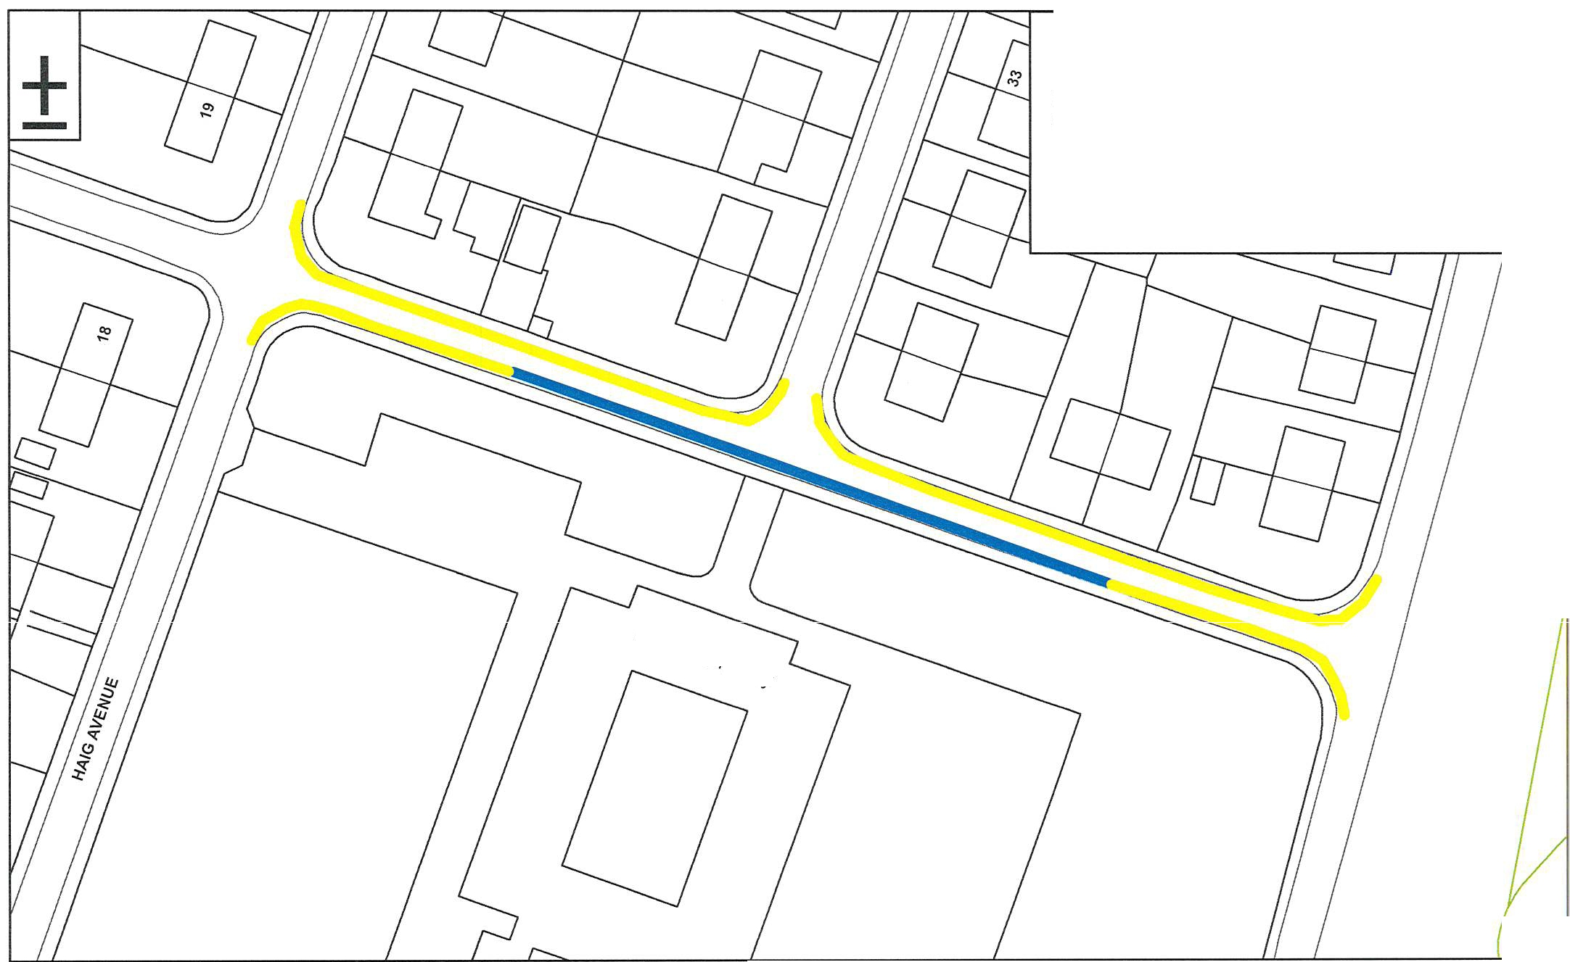
Key:

Proposed 'No Waiting Between 8.00am and 6.00pm on a Monday to Friday ':

Existing 'School Keep Clears':

E3rc1f)Sfy p,..
'''17c11y

 | Proposal 31 | ".,..0.., 0""..,."...  /"'-/ '-'"'-  Cumberland  Council  Drawing No: W31AM00
 | Whitehaven Traffic Regulation Order Review
This produce includes mapping data licensed from Ordnance Survey. (c) Crown  Copyright 2023. License Number AC0000861732 | Bransty Primary School Mona Road
 | Whitehaven
 |  | Drawn By: BC | Scale: NTS | Date: 09/02/2024

Whitehaven Town Council

From: Sent: Subject:
Attachments:
Carter, Ben C <Ben.Carter@Cumberland.gov.uk> 12 February 2024 10:28
Whitehaven Traffic Regulation Order 2023 Proposals.zip

Dear Consultees,

We have decided to extend the consultation period until the 8th March 2024. We have 6 additional proposal to be consulted upon and letters are due to be sent out today.

If you would like to comment on any of these proposals, please let us know by close of play on Friday 8th March 2024. Any response, favourable or otherwise would be welcome.

Kind Regards

Ben Carter
Traffic Management Officer I Highways & Transport
Place, Sustainable Growth and Transport I Cumberland Council
Lillyhall Depot I Joseph Noble Road I Lillyhall I Workington I Cumbria I CA14 4JH

M: 07879113112
cumberland.gov.uk

This e-mail contains confidential information (which may also be legally privileged) and is intended solely for the use of the intended named recipient. If you are not the intended recipient you may not disclose, copy, distribute or retain any part of this message or its attachments. If you have received this message in error please notify the originator immediately by using the reply facility in your e-mail software. Incoming and outgoing emails may be monitored in line with current legislation. All copies of the message received in error should be destroyed. Any views or opinions expressed are solely those of the original author. This email message has been scanned for viruses, and declared to be virus free at the point of exit from Council's network.

Whitehaven Town Council

From: Sent: Subject:
Attachments:
Carter, Ben C <Ben.Carter@Cumberland.gov.uk> 14 February 2024 11:11
FW: Whitehaven Traffic Regulation Order 2023 W31AM00 - Mona Road.pdf

Dear Consultees,

Please find additional proposal. This is the final one.

If you would like to comment on any of these proposals, please let us know by close of play on Friday 8th March 2024. Any response, favourable or otherwise would be welcome.

Ben Carter
Traffic Management Officer I Highways & Transport
Place, Sustainable Growth and Transport I Cumberland Council
Lillyhall Depot I Joseph Noble Road I Lillyhall I Workington I Cumbria I CA14 4JH

M: 07879113112
cumberland.gov.uk

From: Carter, Ben C
Sent: Monday, February 12, 2024 10:28 AM
Subject: Whitehaven Traffic Regulation Order 2023 Dear Consultees,
We have decided to extend the consultation period until the 8th March 2024. We have 6 additional proposal to be consulted upon and letters are due to be sent out today.

If you would like to comment on any of these proposals, please let us know by close of play on Friday 8th March 2024. Any response, favourable or otherwise would be welcome.

Kind Regards

Ben Carter
Traffic Management Officer I Highways & Transport
Place, Sustainable Growth and Transport I Cumberland Council
Lillyhall Depot I Joseph Noble Road I Lillyhall I Workington I Cumbria I CA14 4JH

M: 07879113112
cumberland.gov.uk

Whitehaven Town Council

From: Sent:
To:

Subject: Attachments:
Whitehaven Town Council 14 February 2024 13:04
hayes.chris4@gmail.com; Raymond Gill; Johnnie Carr; edwin dinsdale; Gemma Dinsdale; Brian O Kane; alan pearson; Ryan Redmond; grahamroberts1952 @gmail.com; sped98; RYAN TAYLOR; Robert White
FW: Whitehaven Traffic Regulation Order 2023 W31AM00 - Mona Road.pdf

Dear Councillors

Please see the below email from Ben Carter with one additional proposal.
This will also be included on the Agenda for discussion at the Council Meeting on 29th February 2024. Regards
Marlene

From: Carter, Ben C <Ben.Carter@Cumberland.gov.uk>
Sent: 14 February 2024 11:11
Subject: FW: Whitehaven Traffic Regulation Order 2023 Dear Consultees,
Please find additional proposal. This is the final one.

If you would like to comment on any of these proposals, please let us know by close of play on Friday 8th March 2024. Any response, favourable or otherwise would be welcome.

Ben Carter
Traffic Management Officer I Highways & Transport
Place, Sustainable Growth and Transport I Cumberland Council
Lillyhall Depot I Joseph Noble Road I Lillyhall I Workington I Cumbria I CA14 4JH

M:07879113112
cumberland.gov.uk

From: Carter, Ben C
Sent: Monday, February 12, 2024 10:28 AM
Subject: Whitehaven Traffic Regulation Order 2023 Dear Consultees,
We have decided to extend the consultation period until the 8th March 2024. We have 6 additional proposal to be consulted upon and letters are due to be sent out today.

If you would like to comment on any of these proposals, please let us know by close of play on Friday 8th March 2024. Any response, favourable or otherwise would be welcome.

1

Key:

Proposed 'No waiting at any time restrictions':

l'

(I)
e"
ff, ,,
""
,,,

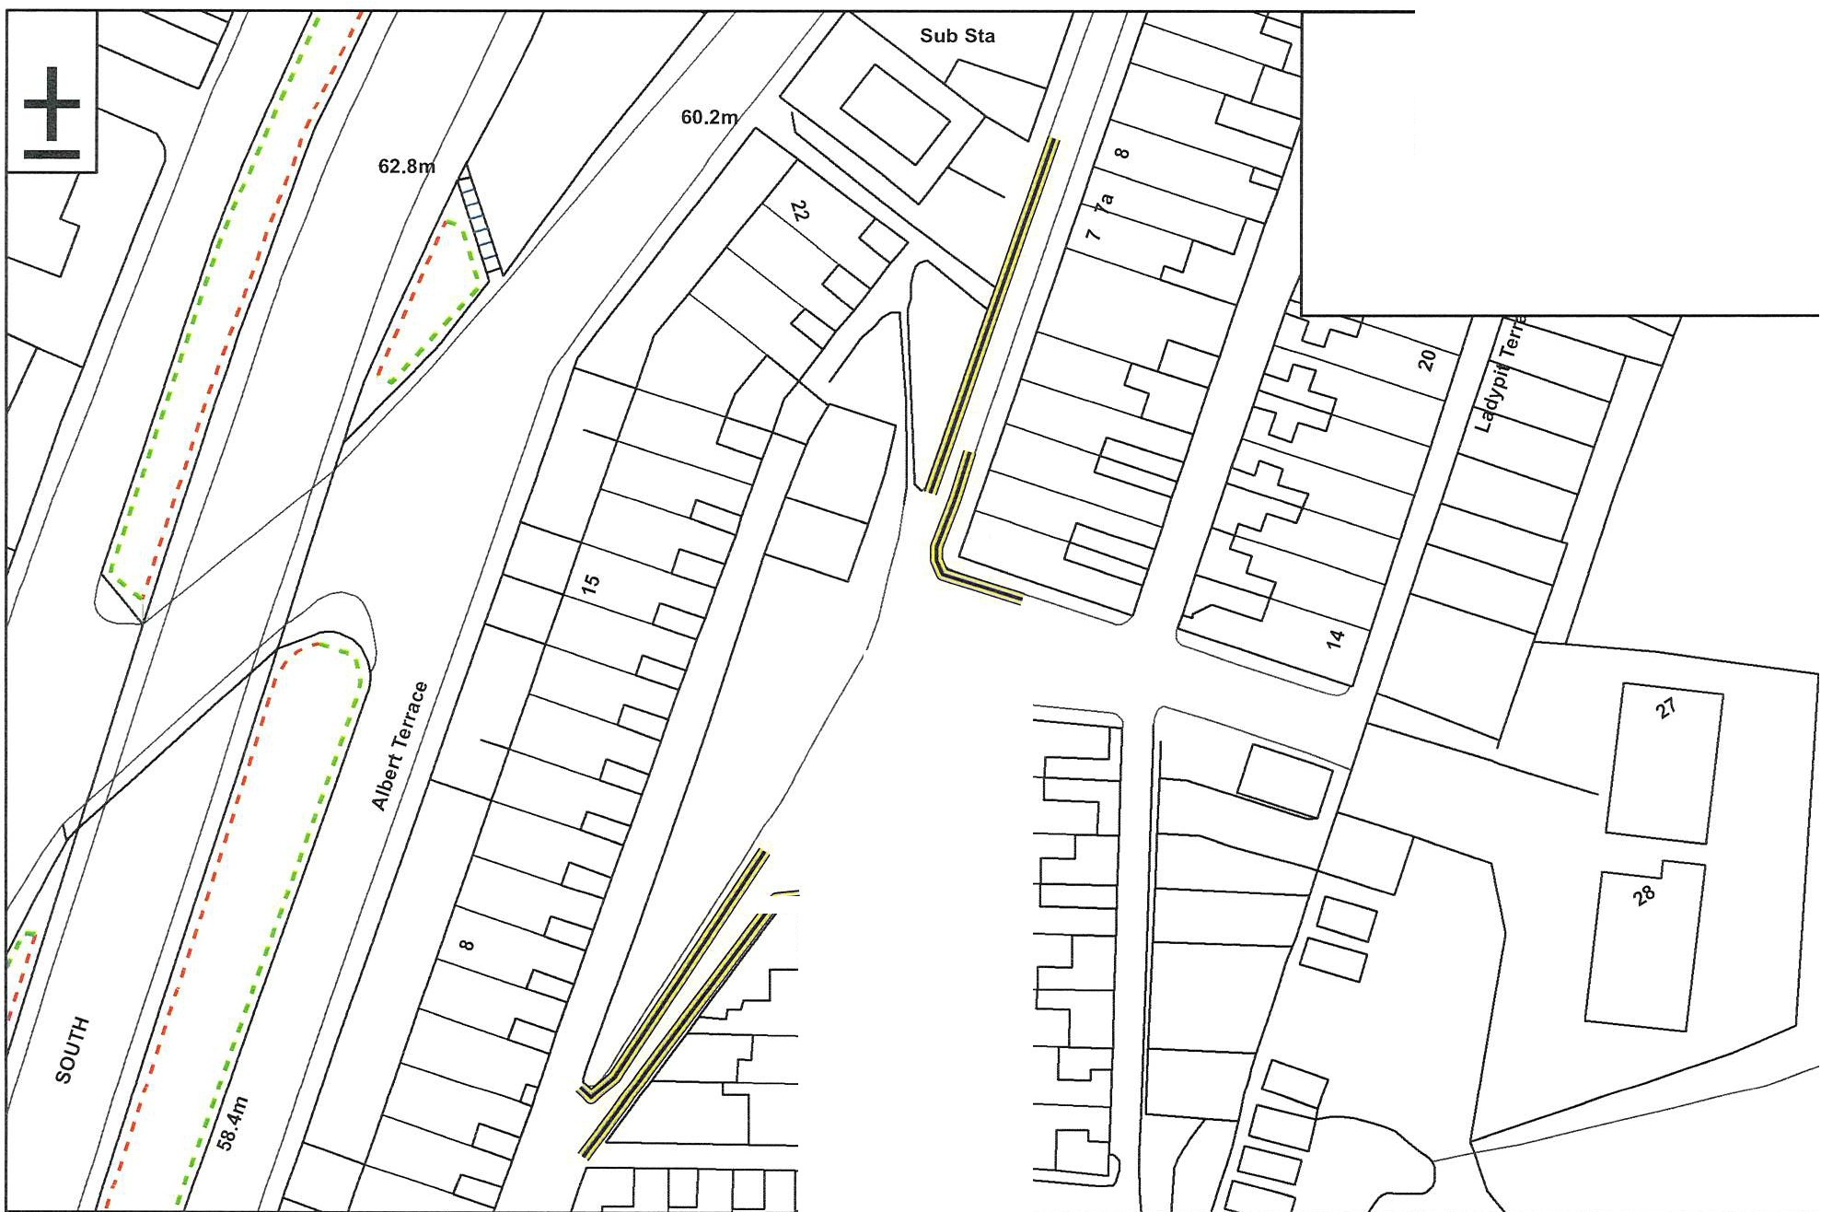

This produce includes mapping data licensed from Ordnance Survey. (c) Crown
Copyright 2023. License Number AC0000861732
" 'b

Proposal 25
Whitehaven Traffic Regulation Order Review Victoria Place/Lady Pit
Whitehaven

-.,
.r-../ ----
""ffi"
Cumberland Council
Drawing No: W25AM00
Drawn By: BC Scale: NTS Date: 23/08/2023

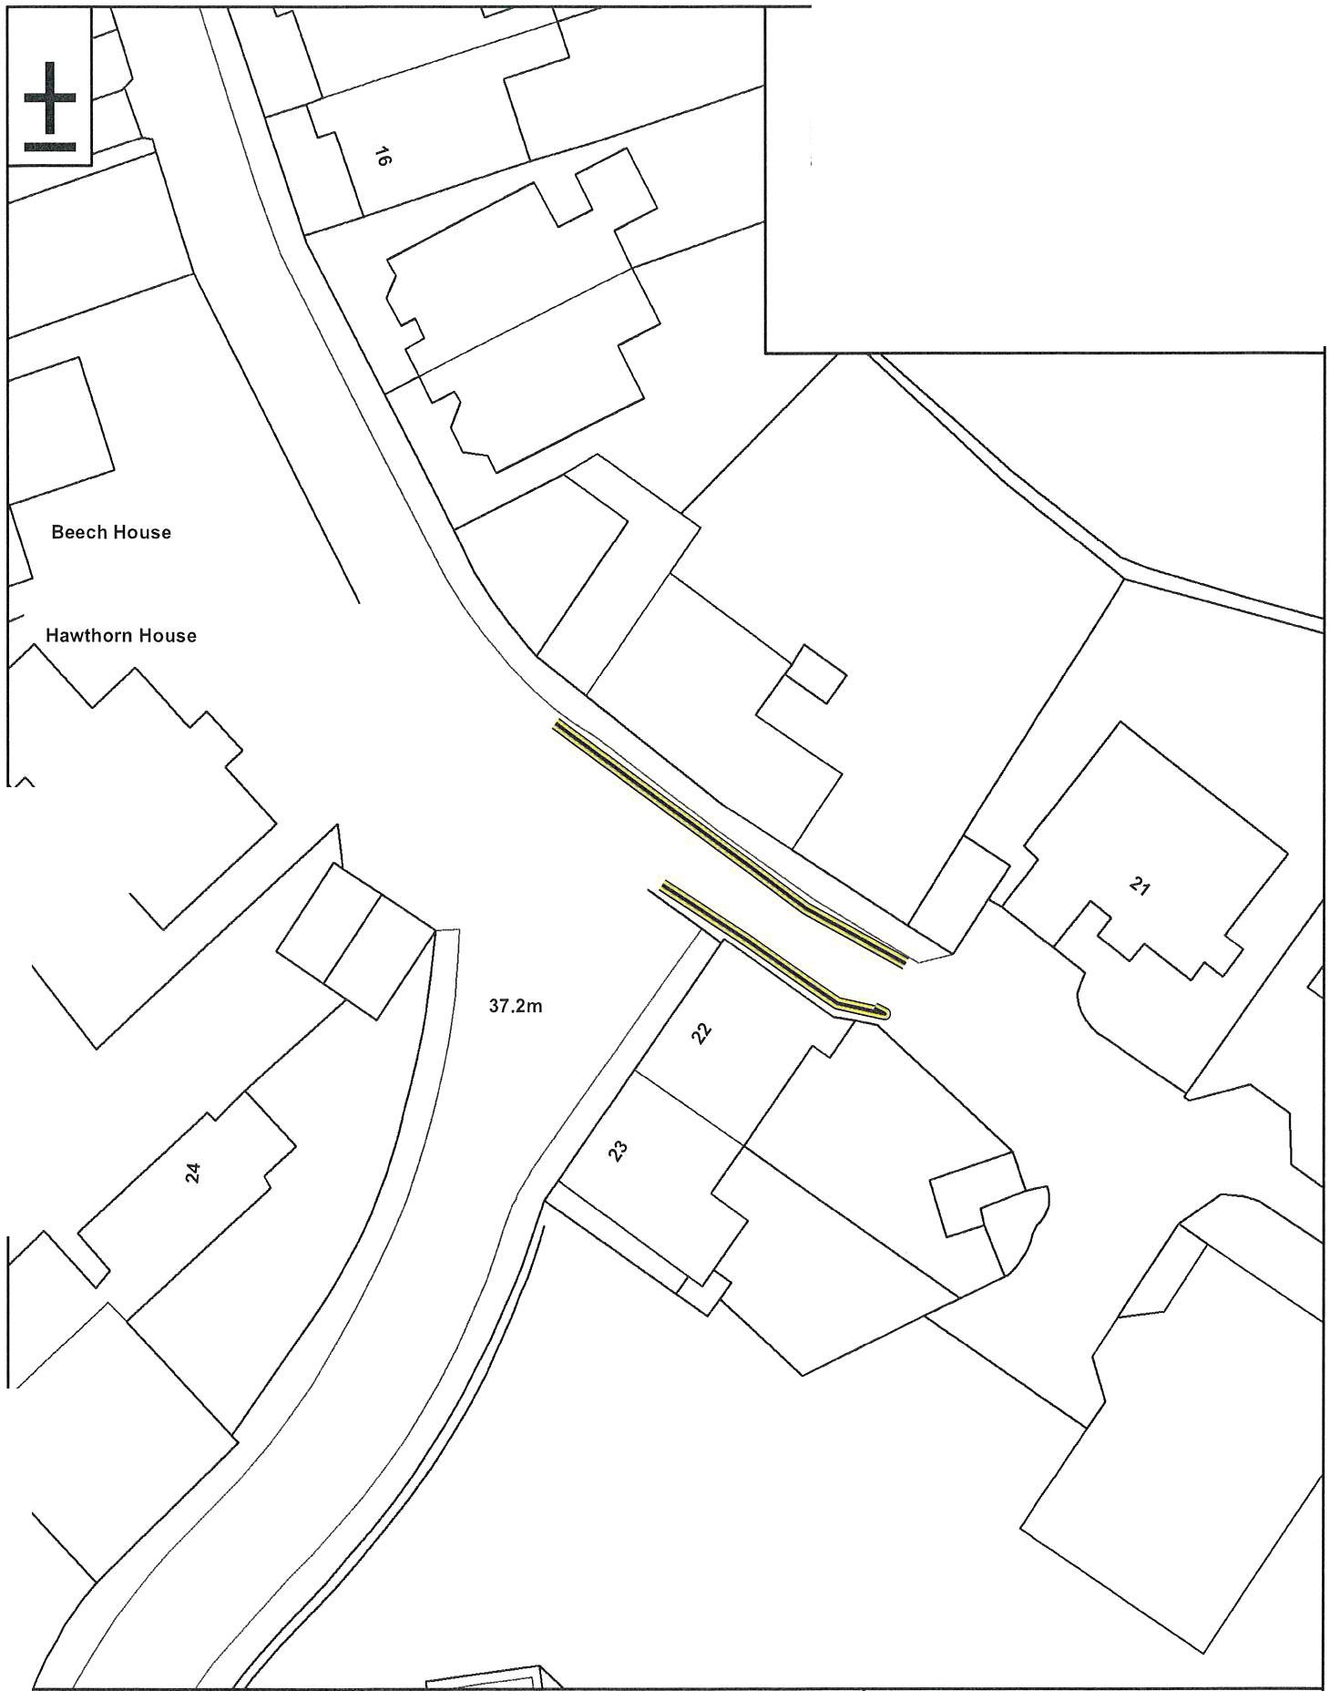
Key:

Proposed 'No waiting at any time' restrictions:

This produce includes mapping data licensed from Ordnance Survey.  (c) Crown Copyright 2006. License Number AC0000861732 | Proposal 28  Whithaven Traffic Regulation Order Foxhouses Road  Whitehaven | ",,.._ffi".......'...  ""-/ �  Cumberland Council
 |  | Drawing No: W28AM00
 |  | Drawn By: BC | Scale: NTS | Date: 23/08/2023

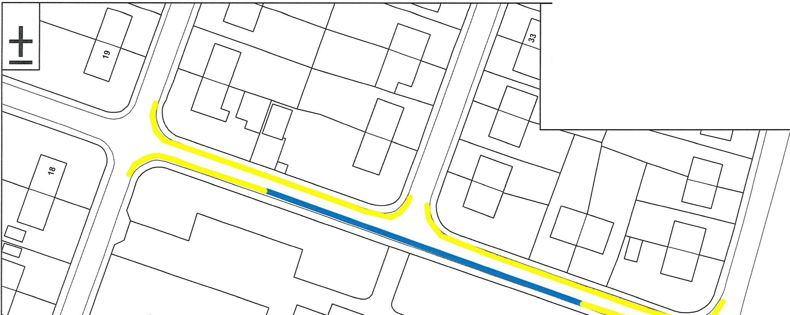
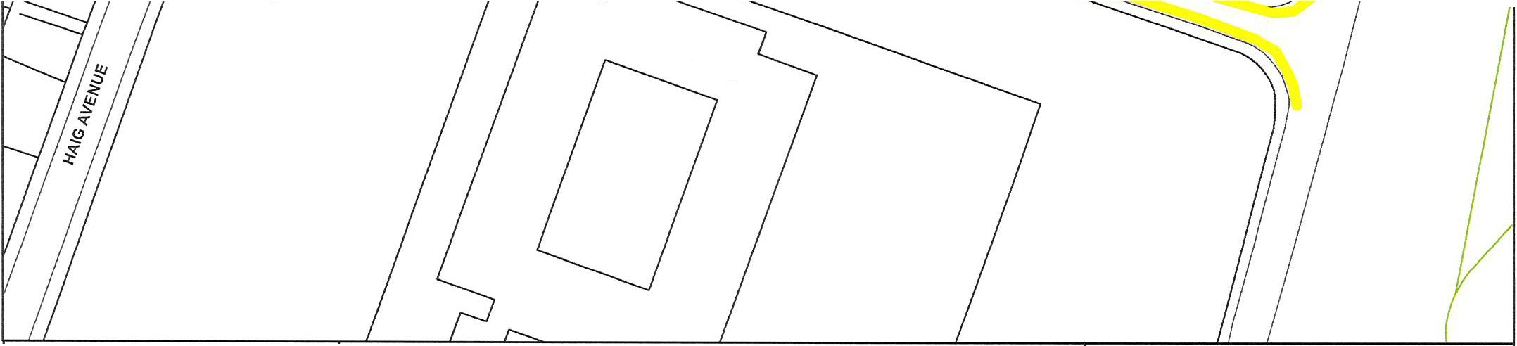
Key:

Proposed 'No Waiting Between 8.00am and 6.00pm on a Monday to Friday ':

Existing 'School Keep Clears':

8rensty P.
T!l?Jery

This produce includes mapping data licensed from Ordnance Survey. (c) Crown  Copyright 2023. License Number AC0000861732 | Proposal 31  Whitehaven Traffic Regulation Order Review Bransty Primary School  Mona Road | "-/'-"../"ffi.",."...  Cumberland  Council
 |  | Drawing No: W31AM00
 | Whitehaven
 |  | Drawn By: BC | Scale: NTS | Date: 09/02/2024

- "'
+

Existing 'No waiting
Key:

m
co
5al

>
"E
.E
"O
Cl)
IX)

"'
;:::;;;•=========== ;-;
at any time restrictions':

Proposed 'No waiting
at any time restrictions':

:::,

82.3m
-----

sed1o<d sueel

OJ
a.

.!"E'
$
·".:'
E
0
>

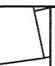
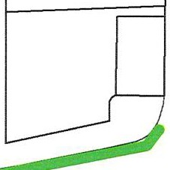
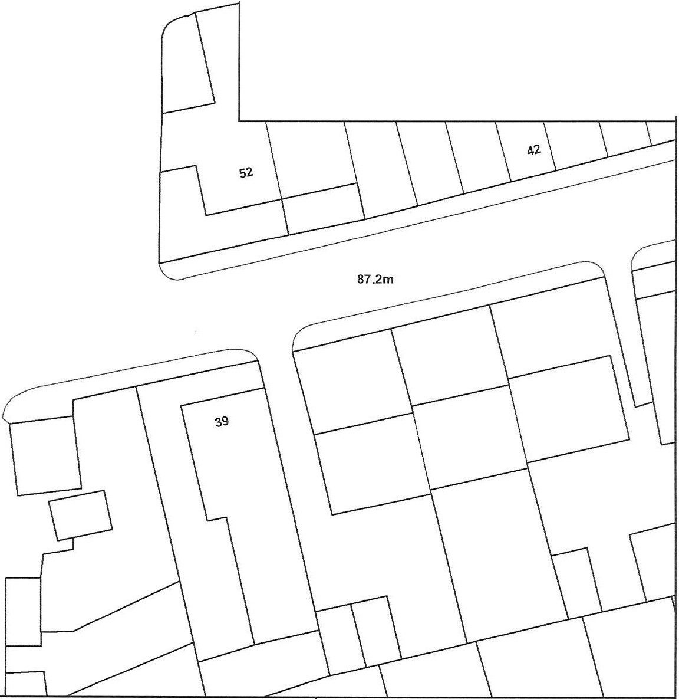

This produce includes mapping data licensed from Ordnance Survey. (c) Crown
Copyright 2023. License Number AC0000861732
Proposal 26
Whitehaven Traffic Regulation Order Review Bedford Road
Whitehaven
,,,.,,......,, '-""-
Cumberland
"'ffi""
Council
Drawing No: W26AMOO
Drawn By: BC Scale: NTS Date: 23/08/2023

,^{I\} i·:·:
+-
Key:

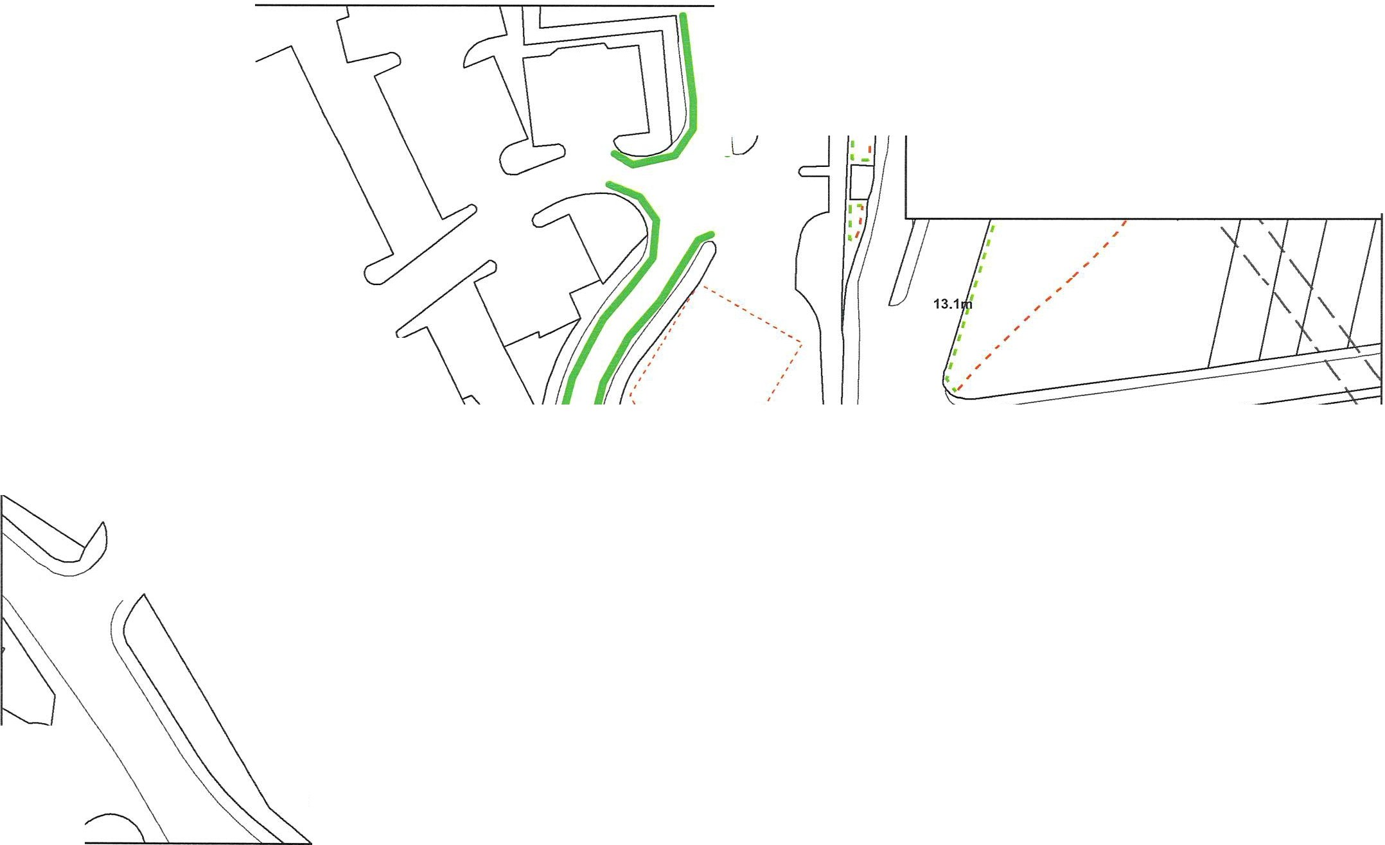
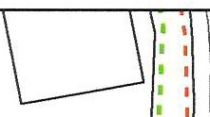
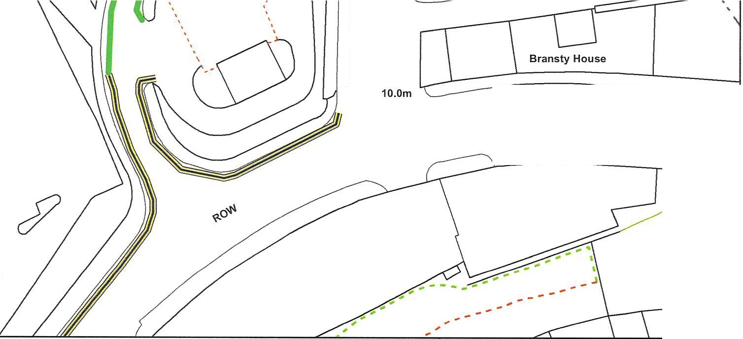
Existing 'No waiting
at any time restrictions':

Proposed 'No waiting
at any time restrictions':

C
<l:
0
0::
>­
I­
I/)
z

<{
0::
al

Def

 | Proposal 29 | ""- "'ffi"  /"'../ '-/'-  Cumberland  Council  Drawing No: W29AM00
This produce includes mapping data licensed from Ordnance Survey. (c) Crown  Copyright 2023. License Number AC0000861732 | Whitehaven Traffic Regulation Order Review Station Approach (Tesco)  Whitehaven
 |  | Drawn By: BC | Scale: NTS | Date: 23/08/2023

Key:

Existing 'No waiting
at any time restrictions':

Proposed 'No waiting
at any time restrictions':

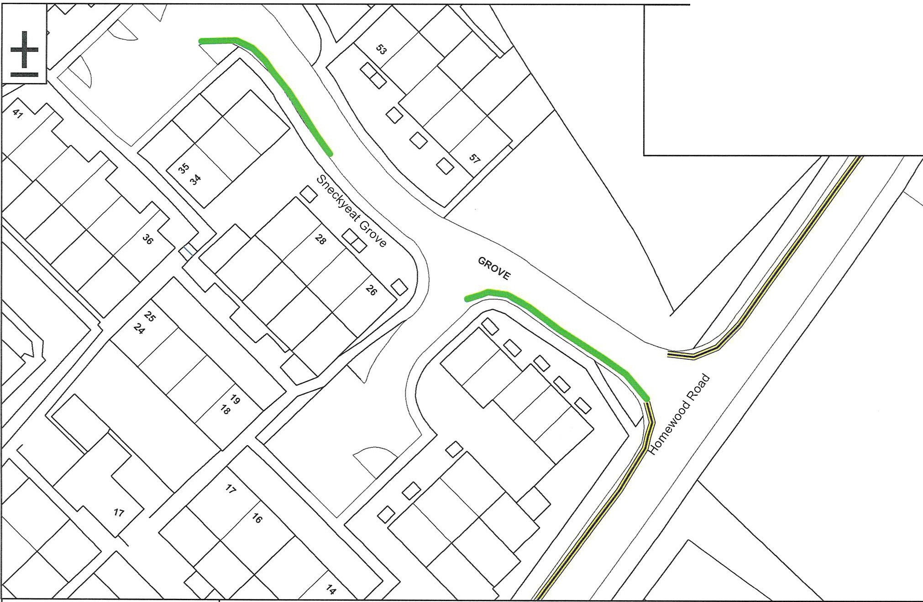

This produce includes mapping data licensed from Ordnance Survey. (c) Crown
Copyright 2023. License Number AC0000861732

Proposal 27
Whitehaven Traffic Regulation Order Review Sneckyeat Grove
Whitehaven
",,."._'ffi,,...
Cumberland Council
/'../ '-"
Drawing No: W27AM00
Drawn By: BC Scale: NTS Date: 23/08/2023

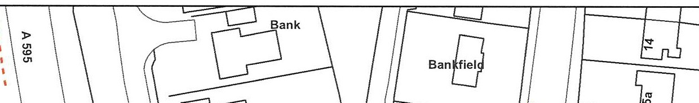
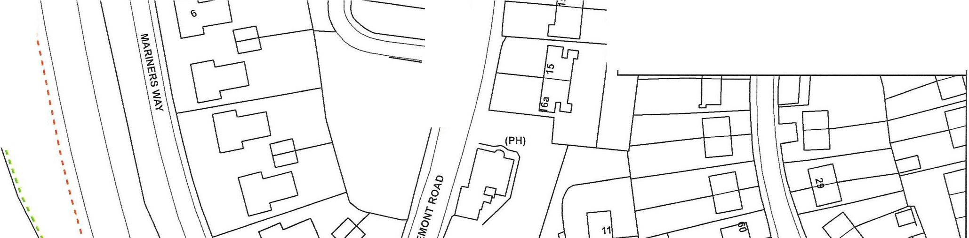
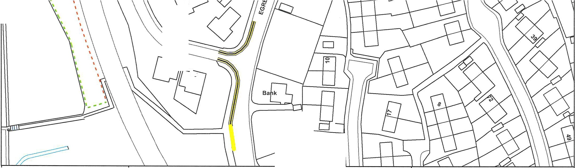
' Key:
+-
'
Proposed 'No waiting
at any time restrictions':

I
1: '
'
t
I
I
I
I
1•
1,' ,
t:::;}
Camadine
T, Existing 'Bus Stop':

2
\

"-------
... 7115

q Westmea
"'

 | Proposal 30 | -"/'0-/ 0,.'-.".'  Cumberland  Council  Drawing No: W30AM00
This produce includes mapping data licensed from Ordnance Survey. (c) Crown  Copyright 2023. License Number AC0000861732 | Whitehaven Traffic Regulation Order Review Mariners Way & Church Hill  Whitehaven
 |  | Drawn By: BC | Scale: NTS | Date: 09/02/2024

