WHITEHAVEN TOWN COUNCIL

Clerk and Responsible Financial Officer: Marlene Jewell
Telephone: 01946 67366
Chairman: Councillor C Hayes

To: Members of Whitehaven Town Council

You are duly SUMMONED to attend a MEETING of WHITEHAVEN TOWN COUNCIL which will be held in THE BEACON PORTAL at THE BEACON, WHITEHAVEN on Thursday 28th March 2024 at 6.00 pm

Signed.. t\. --- ·-·· Dated.. :?...M� ..+.9. ±
Marlene Jewell, Clerk and Responsible Financial Officer

AGENDA

- Apologies for Absence

- Declarations of Interest

To receive declarations of interest by elected Members in respect of Agenda items.

If a Member requires any advice on any item involving a possible declaration of interest which could affect his/her ability to speak and/or vote he/she is advised to contact the Clerk at least 24 hours in advance of the meeting.

- Public Participation

- Minutes of the Council Meeting held on 29th February 2024

- Planning Applications

- Report from Cumberland Council

- Finance Report

- Allotments

- Public Service Protection Orders

- Road Traffic Regulation Order for Whitehaven

- Amendments to Copeland Local Plan

- Street Name and Numbering Former Sekers Site

- Councillor Ward Matters

- Date and Time of Next Meeting

IN PRIVATE

That prior to the following items of business the Chairman will move the following resolution:
That in view of the special or confidential nature of the business about to be transacted it is advisable in the public interest that the public and or press be instructed to withdraw.

- Office Accommodation - Clerk to give a report

- Councillor Ward Grant

- Grant Application - WCT

WHITEHAVEN TOWN COUNCIL

Minutes of the Council Meeting held on the 29th February 2024

Present: Councillor C Hayes (Chairman); Councillor R Gill; Councillor E Dinsdale; Councillor B O'Kane; Councillor G Roberts;
Councillor R Redmond; Councillor A Spedding; Councillor R Taylor; Councillor R White

M. Jewell, Clerk and Responsible Financial Officer V Gorley, Assistant Clerk
Members of the Public

Prior to the Meeting starting the Chairman and the Councillors introduced themselves to the public and the Chairman referred to fire alarms/escape and toilets

2452/24 Apologies for Absence

Apologies for absence were received from:

Councillor G Dinsdale Councillor A Pearson Councillor J CatT
Maternity Leave Holiday
Work Commitments

It was proposed by Councillor Roberts and seconded by Councillor Gill that the apologies for absence be accepted and noted. A vote was held and it was unanimously
RESOLVED - That the apologies for absence be accepted and noted. Councillor Taylor entered the Meeting
2453/24 Declarations of Interest

Councillor Hayes declared that he was a member of the Whitehaven Tidy Town Committee and the Harbour Users Group.
Councillor Taylor declared that he was a member of the Red Lonning

Community Centre

2454/24 Public Participation

Peter Tyson attended the meeting and made the following points:
- He said a stranger had come to Whitehaven and asked him where the Whitehaven Town Council Headquarters were and he asked what was happening to the building as it still had Whitehaven News on it. He said he was sure it was time that the Council had its name on it. The Chairman said the old name would be taken down and asked the Clerk to answer the question. The Clerk said the name change was in the proposals for the refurbishments of the building and would be done at some point.
- He said he had been at a meeting at the Golf Club on behalf of Councillor Alan Pearson and it was about sports facilities in Copeland and the 3 recognised areas. He said it was quite a good meeting, very constructive and very encouraging and to watch this space.

2455/24 Minutes of Council Meeting held on 25th January 2024

It was proposed by Councillor Gill and seconded by Councillor Roberts that the Minutes of the Council Meeting held on 2sr1i January 2024 be approved and signed by the Chairman as a correct record. A vote was held and 7 Councillors voted for the proposal and 1 Councillor abstained

RESOLVED - That the Minutes of the Council Meeting held on 25th January 2024 be approved and signed by the Chairman as a correct record.

2456/24 Planning Applications

The Council considered a list of Planning Applications shown at Appendix 1.

Councillor Roberts made representations in respect of Planning Applications 4/24/2305/0B 1 and 4/24/2306/0B 1 said he objected to these for the following reasons:-
- The proposals to change certain aspects of the layout will lead to problematic parking problems for property owners leading to an overcrowded development
- The proposals in relation to the right of way have caused tilted planning balance with adverse impacts
- That this proposal will cause moderate landscape harm and cause significant harm to neighbouring residents and to road users and nearby footpaths
- That the applications are deeply flawed and should not be granted

It was proposed by Councillor Roberts and seconded by Councillor Gill that Cumberland Council be informed of the above objections. A vote was held and it was unanimously
RESOLVED - That Cumberland Council be informed of the above objections. There were no other representations on the Planning Applications on Appendix 1 Councillor White entered the Meeting
2457/24 Report from Cumberland Council

Councillor Mike Hawkins attended and gave a report on behalf of Cumberland Council.
Councillor Hawkins congratulated the Town Council on their recent Firewalk Event. He said it was a really good initiative by the Council. It was an excellent event, very well run with professional organisers. He said it had brought a lot of people into the town on a Tuesday night and it has benefitted a lot of charities. Councillor Hawkins made the following points:-
- The TROs had been delayed again until the end of March because 2 new proposals had been added - 2 at Bransty and 1 at Egremont Road. The consultation had been extended until the 24th of March
- Play parks had been highlighted as areas of common concern by the Whitehaven Coastal and Community Panel and there was an ongoing review of play areas in Whitehaven
- On 13th February there was an informal invited meeting looking at other priorities around the table. It was a useful meeting away from the formal panels
- The future of family services for Cumberland - there was another ongoing review now that we were one unitary authority. There was a drop- in held at Whitehaven Library on 22nd February and Councillor Ghayouba and Councillor Williamson were there. There was a plan for a one stop hub in town. He had heard that day that it would be the old Barclays Bank. But that there were other services out there like the one on Kells. He said the idea was that you could go somewhere for a one stop with everybody in 1 building
- There was going to be a Planting for Pollinators at the Beacon on 16th March for anyone to join in who wanted to join in. He said he would have preferred it to be on Greenbank hill.
- The Cenotaph - Councillor Hawkins apologised and said he had not really done anything about this. He said the Cenotaph Review Group were going to look at this and he was waiting to hear available meetings dates from Councillor J Forster so that he could inform the Town Council.
- Councillor Hawkins said Peter Tyson had referred to a meeting that afternoon which was about a tranch of funding coming from Sport

England who had identified 10 areas across the country that needed investment and we had 3 of these areas, Mirehouse, Kells and Woodhouse. He said they wanted it to be bottom led up not top down. He mentioned the cycle way from Mirehouse to St Bees which he thought would be a game changer
- The next meeting of the Whitehaven Coastal Panel would be on 14th March at the Community Centre on Mirehouse at 6.00pm
The Chairman thanked Councillor Hawkins for his report
2458/24 Finance Report

The Council considered a Finance report

  - Appendix 1 - The Assistant Clerk reported that there were 3 additional invoices to consider on Appendix 1 namely:-

Eden Springs Cumbria Media Viking
£9.84 Water
£172 Website updates
£22.13 Photocopier paper

It was proposed by Councillor Gill and seconded by Councillor Roberts that the invoices shown on Appendix 1 plus the 3 extra invoices be approved and paid. A vote was held and it was unanimously

RESOLVED - That the invoices shown on Appendix 1 plus the 3 extra invoices be approved and paid.

- Appendices 2 and 3 - It was proposed by Councillor Gill and seconded by Councillor Roberts that Appendices 2 and 3 be approved and noted. A vote was held and it was unanimously
RESOLVED - That Appendices 2 and 3 be approved and noted.
2459/24 Hewlett Packard Enterprises Support Services for Hardware

The Council considered a report on the renewal of a 1 year contract with Hewlett Packard Enterprises in respect of Hardware. The quote for the renewal was
£93.51 plus VAT. It was proposed by Councillor Hayes and seconded by Councillor Taylor that the supp011 services contract be renewed for a year at a cost of £93.51 plus VAT. A vote was held and 8 Councillors voted for the proposal and 1 Councillor abstained
RESOLVED - That the support services contract be renewed for a year at a cost of £93.51 plus VAT.

2460/24 Contract for Collecting, Setting Up, Removal and Return of Council Equipment used during Council Events

The Council considered a report on a contract for the collection, setting up, dismantling and return of Council equipment used during Council events. At present only one person had expressed an interest and a quote is awaited and the matter will be reported back to Council for decision. It was proposed by Councillor Gill and seconded by Councillor Roberts that the report be noted and Approved. A vote was held and it was unanimously

RESOLVED - That the report be noted and approved.

2461/24 Press Statements

Following Minute no 2438/24 Councillor Gill referred to the last meeting when he said he had been surprised to see a report in the Whitehaven News verbatim of the Council meeting. He said there was nothing wrong with that but thought that the Council should have a rule that when it is concerned with Council business that all press releases should go through the Chair or the Clerk and moved that this be adopted as a rule which was seconded by Councillor Hayes.

Councillor E Dinsdale said he reserved the right to put in the public domain anything that he deemed to be in the public interest and he wished this to be noted in the Minutes.

It was proposed by Councillor Gill and seconded by Councillor Hayes that reports of full Council Meetings to the media should be made via the Clerk or the Chairman and that any Councillor wishing to make a report to the media direct should have the Courtesy to report it to the Chair or Clerk .

Councillor O'Kane said it was the purpose for which somebody records a Meeting and what it was used for. He said it was everybody's right in the room to record the Meeting and that was not open to debate but what was open to debate was someone could select little bits to substantiate their argument and that was where it fell down. He said what the Council should be doing was having a proposal and a vote and that's it. The recording has the
potential to cause more and more problems
A vote was held and 7 Councillors voted for the proposal, 1 Councillor voted against and 1 Councillor abstained
Councillor E Dinsdale said the media had been sent a full recording and it had not been pieced up.
RESOLVED - That reports of full Council Meetings to the media should be made via the Clerk or the Chairman and that any Councillor wishing to make a report to the media have the courtesy to report it to the Chair or Clerk

2462/24 Castle Park

The Clerk read out an email received from Councillor Emma Williamson in respect of Castle Park in which she asked that in future any problems should be reported to her so that she could address them promptly. It was proposed by Councillor Hayes and seconded by Councillor Roberts that this be noted. A vote was held and it was unanimously

RESOLVED - That this be noted.

2463/24 Cumberland Council Grounds Maintenance Contracts 2024

The Clerk reported that a letter had been received from Cumberland Council earlier that week to say that the Cumberland Council Parks and Open Spaces Team would not be undertaking any additional external grounds maintenance contract work for the 2024 season in order to allow them to concentrate on maintaining and improving standards across their own existing sites but were still able to offer support with organising/delivering annual and routine play inspections and repairs if required. They thanked the Council for our custom and the opportunity to deliver grounds maintenance to us up until now. It was proposed by Councillor Hayes and seconded by Councill Roberts that this be noted. A vote was held and it was unanimously

RESOLVED - That this be noted

2464/24 Report on Firewalk

The Chairman reported that 31 people took part in the Firewalk and hundreds were outside watching. It had been a great event. He said about £8,500 had been raised for charity and that it had been a brilliant initiative and thanked everyone who took part. He said the videos were superb and the organiser of the event had taken 181 photographs. He said the buzz round the town had been amazing.
Councillor E Dinsdale congratulated eve1yone who took part

2465/24 WCSSG

Councillor E Dinsdale said he had been requested by Councillor Hayes to attend the Nuclear Stakeholders meeting at Cleator Moor on 6th February as Councillor Gill had been unable to attend. He said there were two main parts of the Agenda:
- Martin Walkinshaw giving an update of the GDF Process
- Bob Jones giving an update on the consultation on social impact spend

- GDF - Martin went through the current or what was at that particular time the areas that had been detailed to potentially be a host for the GDF.

Allerdale had currently dropped out and there was South Holderness which is in the East Riding of Yorkshire. So that would mean that we had two potential hosts on that east coast push out.
There was Lincolnshire and two in Copeland - mid Copeland and South Copeland. But since Martin's briefing there has been an email come out from a nuclear stakeholders point of view to confirm that they (South Holderness) have now dropped out.
Martin gave timescales around consultations but in particular around how the timescales had slipped from a GDF construction point of view and said they had gone right out there to the 2050s.
Councillor E Dinsdale said he had played a part in the initial consultations which was the management of the safety process. Back in 2013 CCC had voted not to carry the process on, Copeland voted in favour of it, and Allerdale voted in favour.
Councillor E Dinsdale said he had asked Martin what the estimated costs were now for the completed project in 2050 and he said £50 billion.
Councillor E Dinsdale said the initial cost of the initial project in 2013 was
£14 billion but it was not £14 billion it was £12 billion. This slid out to a point at £38 billion. He said this affected every single tax payer and every single energy customer in the UK. Councillor E Dinsdale said in 2013 he spoke in favour of carrying the process on at probably the biggest local meeting that we have ever had in Cumbria. He said that nobody was voting at that particular time for a GDF everyone was voting to carry the process on to try and give it as much of an opportunity we could. He said all of this had cost us all from a community point of view £38 billion and it was a national nuclear scandal.
- Socio-economic response by Bob Jones on behalf of the stakeholders Councillor E Dinsdale said this was more of a process thing around how we deal with socio-economic issues. He said he had asked a question of all stakeholders "do you think as a community that we are rewarded enough for the nuclear service that we provide?"
He said as a community we store 85% of the country's nuclear waste and 140 tonnes of plutonium. Councillor D Moore responded to the question and said it was a debate they had had for many years and probably nearly everyone would say no. Councillor Sam Pollen responded and said he believed that this should be an Agenda item for future stakeholder meetings.
Councillor E Dinsdale said that at the moment we are going through a cost
of living crisis, rent rocketing, our local infrastructure including roads and rail are creaking to breaking point and hospital services are being transferred to other areas. Our town is looking unloved and we use terms like working in collaboration and partnership with the nuclear industry but in his opinion there shouldn't be any romance without any finance. He asked what the rent would be to store 85% of the country's nuclear waste and 140 tonnes of plutonium. He said what we needed was a process

which looked at the interim measures until we get a GDF and this process should look at what a fair rent would be for services that we provide.
Councillor E Dinsdale quoted "there's nothing going on but the rent and as West Cumbrians we've got to have a job if you want to be with me". We as Whitehaven and West Cumbria need security for our future.
The Chairman thanked Councillor E Dinsdale for his report

There was no decision made on the report as it was for information only

2466/24 Road Traffic Regulation Order for Whitehaven

- The Council considered the 7 additional proposals that had been made to the Road Traffic Regulation Order for Whitehaven by Cumberland Council. Following a discussion it was proposed by Councillor Taylor and seconded by Councillor Hayes that the following Town Council representations be forwarded to Cumberland Council in response to the consultation on the 7 additional proposals

  - Proposal 25 - Victoria Place/Lady pit - That this be approved
  - Proposal 26 - Bedford Road - That this be approved
  - Proposal 27 - Sneckyeat Grove - That this be approved
  - Proposal 28 - Foxhouses Road - Councillor White objected to this and said he would be sending a separate response to CC
  - Proposal 29 - Station Approach (Tesco) - That this be approved
  - Proposal 30 - Mariners Way and Church Hill - That this be approved
  - Proposal 31 - Bransty Primary School Mona Road - That this be approved A vote was held and it was unanimously
RESOLVED - That above Town Council representations be forwarded to Cumberland Council in response to the consultation on the 7 additional Proposals

- Councillor O'Kane raised the Lowther Street Bus stop and concerns about the bus stop being in the centre of town in reply to Cumberland Council's statement that they had decided against moving because of elderly users with limited mobility and that moving the bus stop further away may discourage the use of public transport and that the alternative route would have major implications for the timetable. Councillor O'Kane said during the pandemic the bus stop had been re-routed by the County Council and the Council had been led to believe that this was a potential change. He said the Council had asked for it to be moved and we hadn't been involved in the discussions on this and wanted to know how the Council could be included to potentially move the bus stop. He said Stagecoach don't run our town and should not be allowed to decide this. It was proposed by

Councillor O'Kane and seconded by Councillor Gill that the Town Council requests a meeting with Cumberland Council to discuss the possibility of modifying the Lowther Street bus stop to meet the suggestions made by the Town Council. A vote was held and it was unanimously

- RESOLVED - That the Town Council requests a meeting with Cumberland Council to discuss the possibility of modifying the Lowther Street bus stop to meet the suggestions made by the Town Council.

2467/24 D-Day Flags

The Clerk informed the Council that information had been received from CALC about official D-Day Flags. It was proposed by Councillor Taylor and seconded by Councillor Hayes that four 6ft x 4ft flags be purchased at a cost of £34.50 plus delivery plus VAT per flag. A vote was held and it was unanimously

RESOLVED - That four 6ft x 4ft flags be purchased at a cost of £34.50 plus delivery plus VAT per flag.

2468/24 Amendments to Copeland Local Plan

The Clerk reported that an email had been received from Cumberland Council regarding consultation on the amendments to the Copeland Local Plan and giving a link for access to the amendments. Comments were to be received by 28th March 2024. The documents containing the amendments were 226 pages Long. Following a discussion it was proposed by Councillor Gill and seconded by Councillor Hayes that Cumberland Council be asked to provide details of the amendments that are relevant to Whitehaven. A vote was held and it was unanimously

RESOLVED - That Cumberland Council be asked to provide details of the amendments that are relevant to Whitehaven.

2469/24 Councillor Ward Matters

- Councillor Carr - Although Councillor Carr could not be present he had asked the Clerk to read out some comments. He said he had been contacted by a tenant asking for help with a water issue in their garden that they had had for months. The garden had been flooding from the field behind and the tenant had rung United Utilities who said it wasn't them so they rang the council and someone (PT)came to look at it and said they would sort it out. Then they came back and said it was Home Group it belonged to. The tenant rang them and was told it wasn't them but a few weeks later PT came back with someone from Home Group who he said he would deal with it now and that they would dig holes behind fence to see what was going on and gave the Tenant their number

but that was weeks ago. The Tenant had tried to ring them on more than I occasion but there was no answer and also left messages again with no response. The Tenant said every time it rains it gets worse and the garden was flooded, the mortar was now coming out of inside the garden wall and it was either going to come down or worse. The Tenant did not know what this was causing to the structure of the house. The Tenant showed the person from Home Group the videos they had and they Home Group agreed it was bad and they would sort it.
11. Councillor Gill said the Council had had Home Group here and they promised us they were going to resurrect the walk around the Wards and this has never happened and that they come here and do nothing. He said he had just seen on social media today that Home Group were holding drop in sessions for people on Cleator Moor and said what about here. Councillor Gill thought we should write to Home Group and ask them when they are going to honour the promise they made to this Council.
111. Councillor Redmond said there had been youths kicking their doors and he thanked the Police for their response.
Iv. Councillor Taylor said Cumberland Council were changing all the LED light heads in his Ward and had done an excellent job, very tidy
- Councillor Taylor said he had raised a formal complaint with Viberoptix because on Ruskin Drive they had left it in an absolute disgrace. They had dug all the road up to put a terminal box in and left clay all over the road so he had put in a formal complaint and asked them if they could send a road sweeper round
v1. Councillor Taylor referred to litter bins and said he still had not had a response from Cumberland Council and had raised it on the portal but couldn't get a bin where the residents want it. He said where the residents wanted a bin was on the collection round.
vii. Councillor O'Kane noted on Facebook that there was a play area group on Bransty set up to initiate a play area on Bransty
vm. Councillor O' Kane referred to the state of the roads and in particular the junction of Aikbank Road which was reported 4/5 months ago and has now become really dangerous.
Ix. Councillor O'Kane said there were lights out on New Road. Going towards Whitehaven on the left hand side the lights had been out for several months
x. Councillor O'Kane said residents lights had been out since October and there had been no response to complaints.

Councillor Gill left the Meeting and did not return

x1. Councillor Roberts said a few residents had been going on about the brown water in the Harbour and that he had recently met Deanne Shallcross and would be having a meeting with her to see what could be

done. He said he believed they had identified the problem. The Chairman said he could give a report on this
xii. Councillor Hayes said he had attended a meeting in the Marina Office and Professor Muir said they had found where the source was from and had finally got BR to admit their part in it and that the British Coal Board were not doing anything at the minute. He said the plan was to re­ route it temporarily and then find a total solution. He said in a few weeks' time the tunnel would be closed for over a week and there would be a press release from the Sellafield scientists about this at the end of March
x111. Councillor Hayes said he had met ladies from In Stitches who were aged from 20 to 92. They were all making chicks for Easter to sell to local people.
- Councillor Hayes said he had attended a prize giving event at the Harbour Youth Group and that there had been some amazing things being achieved - Duke of Edinburgh, sailing awards, Archery etc. He said it was a great club with sports facilities, snooker and it was absolutely btilliant
- Councillor Spedding said he was going to go through Castle Park at the weekend with a camera to see if there were any outstanding issues
- Councillor White said Home Group would be arranging a meeting with himself and Councillor Mike Hawkins
xv11. Councillor White said that in relation to 52 Esk Avenue an enforcement officer would be looking at the high trees.
xv111. Councillor E Dinsdale said on the previous Monday he had got a call from the Whitehaven News about anti- social behaviour at Morrisons and McDonalds and he said that personally he had not actually seen anything but that didn't mean it hadn't happened as he had seen stuff on social media. He said the Police were issuing Dispersal Orders
x1x. Councillor Pearson was not at the Meeting but had asked Peter Tyson to mention something on his behalf. This was Story Builders and flooding on the Greenbank estate. This was just to be noted as it may be a serious problem later on
2470/24 Date and Time of next Meeting

The next Council Meeting would be on Thursday 28th March at 6.00pm in the Beacon Portal

2471/24 IN PRIVATE
That prior to the following items of business the Chairman moved the following resolution:

That in view of the special or confidential nature of the business about to be

transacted it is advisable in the public interest that the public and or press be instructed to withdraw. Councillor Roberts proposed this and Councillor Gill seconded this. A vote was held and it was unanimously

RESOLVED - That the public and or press be instructed to withdraw. Councillor E Dinsdale left the Meeting and did not return

2472/24 Office Accommodation

Further to Minute 2451/24 the Clerk reported that the Council were still waiting to hear from NALC on the VAT position and that until this was sorted the matter could not proceed.
There was no decision made on this as it was for information only

2473/24 St Nicholas Gardens

Further to Minute 2441/24 ii the Clerk reported that a breakdown of the costs had not been received from CC but that they had informed the Council that this would be supplied.
There was no decision made on this as it was for information only

The Meeting closed at 8.05

Chairman

WTC 28/03/2024

Item 5

Planning Application for Consideration by Whitehaven Town Council

Application Number 4/23/2327/0Fl

4/24/2065/0Fl

4/24/2066/0Fl

4/24/2078/0Ll

4/24/2083/0Fl

4/24/2084/0Fl

4/24/2085/0Fl
Detail
Consultation on Amended and Additional Information: FOUR NO. DETACHED TOWN HOUSES HENSINGHAM HOUSE, EGREMONT ROAD, WHITEHAVEN

REPLACEMENT DWELLING TYPES ON PLOTS 12, 14, 15, 15A, 16 AND 16A INCLUSIVE-6 DWELLINGS

PLOTS 12, 14, 15, ISA, 16 AND 16A HIGH STILE GARDENS, WHITEHAVEN
REPLACE CONSERVATORY WITH KITCHEN EXTENSION AND CONVERT GARAGE TO UTILITY ROOM, TOILET AND STORE

5 PARK DRIVE, WHITEHAVEN

LISTED BUILDING CONSENTFOR INSTALLING KITCHEN IN GROUND FLOOR, INSTALLING FOUR SOLID FUEL STOVES AND INSTALLING DECORATIVE WINDOW GRILLES TO BASEMENT AND GROUND FLOOR WINDOWS

153 QUEEN STREET, WHITEHAVEN

PROPOSED DETACHED BUNGALOW

LAND TO NORTH WEST OF OAK CRESCENT, WHITEHAVEN

REAR SINGLE STOREY EXTENSION

25 GRANT DRIVE, WHITEHAVEN

FULL PLANNING APPLICATION FOR 107 DWELLING HOUSES AND ASSOCIATED

Application Number

4/24/2086/0A1
Detail

INFRASTRUCTURE INCLUDING LANDSCAPING, OPEN SPACE, ACCESS, HIGHWAY AND DRAINAGE - VARIATION OF DRAINAGE SCHEME, DETACHED GARAGE DESIGN AND LANDSCAPING SCHEME APPROVED UNDER APPLICATION REF 4/22/2332/0Fl

LAND TO THE WEST OF VALLEY VIEW ROAD, WHITEHAVEN

APPLICATION FOR CONSENT TO DISPLAY ALUMINIUM COMPOSITE SIGNS TO THE NORTH AND SOUTH FACE OF BUILDING
THE OLD BANK, SWINGPUMP LANE, WHITEHAVEN

WTC 28/03/2024

Item 7

FINANCIAL REPORT
Purpose of the Report

Members are asked to consider a list of invoices for authorisation and payment as shown at Appendix 1 and approve the recommendations in paragraphs 3.1, 3.2 and 3.3.
1.0 INTRODUCTION

  - Authorise the payment of all invoices as listed in Appendix 1.
  - The Council is asked to note the cashbook as reconciled with the bank account as shown at Appendix 2 together with income and expenditure at Appendix 3.

  - Councillors may recall that it was resolved not to pay an invoice from Cumberland Council for£18,000 for works carried out in St Nicholas Gardens for the 2023/24 season until a breakdown of the costs had been received (minute ref 2441/24 (ii) refers). The breakdown of costs has now been received and is attached at Appendix 4.

0 FINANCIAL POSITION

  - The bank reconciliation was carried out on 20th March 2024. This shows a balance of £261,224.60. There are payments to the value of £30,175.50 waiting to be cleared.

  - The balance in the deposit account is £610,571.03.

0 RECOMMENDATION

  - The invoices listed and shown in Appendix 1 be approved and authorised for payment.

  - The Cashbook (Appendix 2) and the Income and Expenditure (Appendix 3) be noted.

  - To authorise payment of the invoice for £18,000 from Cumberland Council for the works carried out during the 2023/24 season in St Nicholas Gardens following receipt of a breakdown of the costs involved.

28/03/2024

Appendix 1

Invoices for Consideration by Whitehaven Town Council

Date | Supplier | Category | Detail | Total Amount |  | Power | Column!
11/01/2024 | Cumberland Council | 3rd Party | Contribution towards plantin2/work in St Nicholas Gardens for 2023/2024 season | £ | 18,000.00 | s144 LGA 1972
15/02/2024 | On Line Systems (Northern) Ltd | Supplies & Services | Various website maintenance programs | £ | 1,164.00 | slll LGA 1972
01/03/2024 | LGS Electrical | 3rd Party | Test and check a de-fib and removal of a de-fib | £ | 120.00
08/03/2024 | Sharp Business Systems UK PLC | Supplies & Services | Photocopier Charges 17/11/23 • 19/02/24 | £ | 42.61 | slllLGA 1972
08/03/2024 | Cumberland Council | Premises | NNDR Charge for Unit at Sneckyeat for 2024/2025 | £ | 2,391.83 | slllLGA 1972
08/03/2024 | Cumberland Council | Premises | NNDR Charge for 148 Queen Street for 2024/2025 | £ | 12,100.7S | slll LGA 1972
09/03/2024 | nPower Business Solutions | 3rd Party | Seasonal Illumination Electric Charge | £ | 994.80 | s144 LGA 1972
10/03/2024 | Arborscape | 3rd Party | Allotment Maintenance Contract - February 2024 | £ | 369.60 | s23 Smallholdings & Allotments Act 1908
18/03/2024 | Derwent Valley Asbestos Removal Ltd | 3rd Partv | Removal of asbestos sheets from Allotment at Sneckyeat | £ | 660.00
19/03/2024 | Mr CJ Hayes | Employees & Allowances | Mileage Claim | £ | 8.50 | slll LGA 1972
22/03/2024 | Cumberland Council | Premises | Room Hire - 29.02.2024 | £ | 84.00 | slllLGA 1972

£ 35,936.09

WHITEHAVEN TOWN COUNCIL CASH BOOK FROM 1 APRIL 2023

APPENDIX2

Date
April-2023

01.04.2023
06.04.2023
3 06.04.2023
4 06.04.2023
s 12.04.2023
14.04.2023
14.04.2023
14.04.2022

Ref

1157
BACS BACS BACS DD BACS BACS
BACS

Payee

Un presented cheques b/fwd from 2022/2023
Copeland Borough Council Newsquest Media Group Hensingham ARLFC Youth Hensingham ARLFC Youth
Water Plus Staff HMRC
Cumbria LGPS

Unpresented
cheques as of Employees/ Supplies/
31.03.23 Allowances Premises Services 3rd Party Grants

28S0.31
12100.75

5294.S9
2112.52
752.33

Ground
Allotmts Maint

64.51

Civic
Hospitality

Ward
Ranger/SO W.I.B Grants Elections

1000.00
750.00

Environmental Improvements Events

289.00

Contingencies

Reserves Net Total VAT

£ 2,850.31
12,100.75
289.00
1,000.00
£ 750.00
£ 64.51
5,294.59
£ 2,112.52
£ 7S2.33

S7.80

Total

£ 2,850.31
12,100.75
346.80
1,000.00
750.00
64.51
5,294.59
2,112.52
752.33

Min. Ref.

carried f/wd 2223/23 (i)
2110/22
Ward Grant - 2022/23 Ward Grant - 2022/23 Contract
2162/22
HMRC 6317/17 (ii)

6 14.04.2022
7 14.04.2022
8 17.04.2023
9 19.04.2023
10 22.04.2023
11 22.04.2023
12 28.04.2023
13 28.04.2023
14 28.04.2023
15 28.04.2023
BACS BACS DD OD OD OD BACS BACS BACS
BACS
npower Business Solutions
MrD Horner Crown Gas & Power BT Group
Water Plus
Water Plus
Eden Springs UK limited POD (North West) Ltd
Derwent Recycling Services Ltd Derwent Recycling Services Ltd

332.68

41.77

129.15

7.70
570.34

12.27

300.00
300.00

500.00

15.00
£ 570.34 £
£ 500.00
332.68 £
£ 129.15 £
£ 12.27
41.77 £
£ 7.70 £
£ 15.00 £
300.00 £
300.00
28.52 £
£
66.53 £
25.83 £

1.41
1.54 £
3.00 £
60.00 £
60.00 £
598.86
500.00
399.21
154.98
12.27
43.18
9.24
18.00
360.00
360.00
Contract
2223/23 (i)
Contract Contract Contract Contract 2235/23 (i)
2235/23 (i)
2235/23 (i)
2235/23 (i)

16 28.04.2023
17 28.04.2023
18 28.04.2023
19 28.04.2023
20 28.04.2023
21 28.04.2023
22 28.04.2023
23 28.04.2023
24 28.04.2023
25 28.04.2023
BACS BACS BACS BACS BACS BACS BACS BACS BACS BACS
Mrs VGorley CALC
Copeland Borough Council
POD (North West) Ltd
Sharp Business Systems UK Pie Mrs MJewell
Thomas Graham & Sons Limited
Mrs VGorley
npower Business Solutions
Mrs M Jewell
4.49

18.50

2.48

70.00

2005.98

52.98

2013.41

59.57

1000.00

5.60
4.49
£ 2,005.98
£ 70.00 £
1,000.00 £
£ 52.98 £
£ 18.50
£ 59.57 £
£ 2.48
£ 2,013.41 £
£ 5.60
£ 4.49
£ 2,005.98
14.00 84.00
200.00 £ 1,200.00
10.60 63.58
18.50
11.91 £ 71.48
£ 2.48
100.67 2,114.08
5.60
2235/23 (i)
2235/23 (i)
2235/23 (i)
223S/23 (i)
2235/23 (i)
223S/23 (i)
2235/23 (i)
223S/23 (i)
2235/23 (i)
223S/23 (i)

26 28.04.2023
27 28.04.2023
28 28.04.2023
29 28.04.2023
BACS BACS BACS
BACS
The Solway Hall Mrs MJewell Mrs VGorley
Mr C Maudling

195.40
120.00

100.00
100.00
E 120.00
E 100.00
£ 100.00
£ 195.40
24.00 £
£
144.00
100.00
100.00
195.40
223S/23 (i)
2235/23 (i)
2235/23 (i)
2235/23 (i)

30 28.04.2023
31 28.04.2023
May-2023
BACS BACS
Whitehaven Heritage Action Group
Viking

49.85
1000.00
£ 1,000.00
£ 49.85
£ 1,000.00
9.97 £ 59.82
223S/23 (i)
2235/23 (i)

32 02.05.2023
33 15.05.2023
15.05.2023
15.05.2023
15.05.2023
34 19.05.2023
35 23.05.2023
36 23.05.2023
37 31.05.2023
38 31.05.2023
39 31.05.2023
40 31.05.2023
41 31.05.2023
42 31.05.2023
43 31.05.2023
44 31.05.2023
45 31.05.2023
46 31.05.2023
47 31.05.2023
48 31.05.2023
49 31.05.2023
50 31.05.2023
51 31.05.2023
52 31.05.2023
June-2023
BACS OD BACS BACS BACS OD OD OD BACS BACS BACS BACS BACS BACS BACS BACS BACS BACS BACS BACS BACS BACS BACS BACS
Zurich Municipal Crown Gas & Power Cumbria LGPS HMRC
Staff
BT Group Water Plus Water Plus
Whitehaven Community Trust
Mrs M Jewell
Derwent Recycling Services Ltd Derwent Recycling Services Ltd Newsquest Media Group Arborscape
Mrs V Gorley
Sharp Business Systems UK Pie Rachael Kelly Bookkeeping Services Market Place (Europe) Ltd
Mrs VGorley Mr C Maudling
Messrs K R Wilson & Sons T/A Cumbria Loos
Cumbria Media
Carlisle City Fire Protection
Starboard Systems Limited T/A Scribe Accounts

7S2.33
2112.93
5294.18

110.00

265.78

42.63

120.00
3497.69

132.91

450.00

10.50
25.00
250.00

5.80

314.00

1994.00

1000.00

14.10

300.00
300.00

312.00

100.00

480.00

349.00
£ 3,497.69
£ 265.78 £
£ 752.33
£ 2,112.93
£ 5,294.18
£ 132.91
£ 42.63
14.10
1,000.00
100.00
300.00 £
300.00 £
450.00 £
£ 312.00 £
£ 10.50
£ 25.00 £
£ 250.00
£ 480.00
£ 5.80
110.00
349.00 £
314.00
120.00
1,994.00

53.16
£
£
£
26.58 £
1.68 £
£
£
£
60.00
60.00
90.00
62.40

5.00
£
96.00 £
£
£
69.80 £
£
24.00
398.80
3,497.69
318.94
752.33
2,112.93
5,294.18
159.49
44.31
14.10
1,000.00
100.00
360.00
360.00
540.00
374.40
10.50
30.00
250.00
576.00
5.80
110.00
418.80
314.00
144.00
2,392.80
Contract Contract 6317/17 (ii) HMRC 2162/22
Contract
Contract Contract Grant 2279/23 (i)
2279/23 (i)
2279/23 (i)
2279/23 (i)
2279/23 (i)
2279/23 (i)
2279/23 (i)
2279/23 (i)
2279/23 (i)
2279/23 (i)
2279/23 (i)
2279/23 (i)
2279/23 (i)
2279/23 (i)
2281/23

53 05.06.2023
15.06.2023
15.06.2023
15.06.2023
54 16.06.2023
55 16.06.2023
56 19.06.2023
57 30.06.2023
58 30.06.2023
Jul-2023
DO TV Licensing
BACS Staff BACS HMRC
BAC5 Cumbria LGPS
OD Crown Gas & Power
BACS Beck Bottom Community Garden Group
OD BTGroup
DO Water Plus
OD Water Plus

5294.18
2112.93
752.33
159.00

116.63

40.74

134.94

8.59

1029.00
159.00
5,294.18
2,112.93
£ 752.33
£ 116.63
£ 1,029.00
£ 134.94
8.59
40.74

£
£
5.83 £
£
26.99 £
£
1.34
159.00
5,294.18
2,112.93
752.33
122.46
1,029.00
161.93
8.59
42.08
OD 2162/22
631/17 (ii)
HMRC
Contract Ward Grant Contract Contract Contract

59 03.07.2023
60 03.07.2023
61 07.07.2023
62 07.07.2023
63 07.07.2023
BACS BACS BACS BACS
BACS
AJ Security (North) Ltd Lockhart Leisure Ltd EdenSprings UK limited Mrs VGorley Arborscape

2.99

7.70

110.00
4290.00
3410.00
4,290.00 £
3,410.00 £
7.70 £
2.99
110.00
858.00 £
682.00
1.54
£
22.00 £
5,148.00
4,092.00
9.24
2.99
132.00
2110/22
2110/22
2301/23 (i)
2301/23 (i)
2301/23 (i)

64 07.07.2023
BACS Newsquest Media Group
289.00
289.00
57.80 £
346.80
2301/23 (i)

2301/23 (i)
65 | 07.07.2023 | 1158 | Cumberland Council |  |  |  |  | 1789.82 |  |  |  |  |  | 1,789.82 | £ | 357.96 | £ | 2,147.78
66 | 07.07.2023 | 1159 | Cumberland Council |  |  |  |  | 1789.82 |  |  |  |  |  | 1,789.82 | £ | 357.96 | £ | 2,147.78
67 | 07.07.2023 | 1160 | Cumberland Council |  |  |  |  | 1789.82 |  |  |  |  |  | 1,789.82 |  | 357.96 | £ | 2,147.78
68 | 07.07.2023 | 1161 | Cumberland Council |  |  |  |  |  | 5250.26 |  |  |  |  | 5,250.26 |  | 1,050.05 |  | 6,300.31
69 | 07.07.2023 | 1162 | Cumberland Council |  |  |  |  |  | 5250.26 |  |  |  |  | 5,250.26 | E | 1,050.05 | £ | 6,300.31
70 | 07.07.2023 | 1163 | Cumberland Council |  |  |  |  |  | 5250.26 |  |  |  |  | 5,250.26 | £ | 1,050.05 | £ | 6,300.31
71 | 07.07.2023 | BACS | Arborscape |  |  |  | 312.00 |  |  |  |  |  |  | 312.00 |  | 62.40 |  | 374.40
72 | 07.07.2023 | BACS | Sharp Business Systems UK Pie |  |  | 95.02 |  |  |  |  |  |  |  | 95.02 | E | 19.00 | E | 114.02
73 | 07.07.2023 | BACS | Amberol Ltd |  |  |  |  |  |  | 348.98 |  |  |  | 348.98 |  | 69.80 | £ | 418.78
74 | 07.07.2023 | BACS | Mrs VGorley |  |  |  |  |  |  | 34.00 |  |  |  | 34.00 |  |  |  | 34.00
75 | 07.07.2023 | 1164 | Cumberland Council |  | 70.00 |  |  |  |  |  |  |  |  | 70.00 | E | 14.00 |  | 84.00
76 | 07.07.2023 | BACS | Mr CJHayes | 38.26 |  |  |  |  |  |  |  |  |  | 38.26 |  |  | £ | 38.26
77 | 07.07.2023 | BACS | Mrs V Gorley |  |  |  |  |  |  | 51.00 |  |  |  | 51.00 |  |  | £ | 51.00
78 | 07.07.2023 | BACS | Mrs M Jewell |  |  |  |  |  |  | 34.00 |  |  |  | 34.00 |  |  | £ | 34.00
79 | 07.07.2023 | BACS | Eden Springs UK limited |  | 7.70 |  |  |  |  |  |  |  |  | 7.70 | £ | 1.54 | £ | 9.24
80 | 07.07.2023 | 1165 | J & R Bennett |  |  |  |  |  |  | 3909.00 |  |  |  | 3,909.00 | £ | 781.80 |  | 4,690.80
81 | 07.07.2023 | 1166 | J & R Bennett |  |  |  |  |  |  | 2831.25 |  |  |  | 2,831.25 | E | 566.25 |  | 3,397.50
82 | 07.07.2023 | 1167 | J& R Bennett |  |  |  |  |  |  | 46.70 |  |  |  | 46.70 | £ | 9.34 |  | 56.04
83 | 07.07.2023 | BACS | SDEG limited |  |  |  |  |  |  |  |  | 378.71 |  | 378.71 |  | 75.74 | £ | 454.45
84 | 07.07.2023 | BACS | Mr CJ Hayes | 51.91 |  |  |  |  |  |  |  |  |  | 51.91 |  |  | £ | 51.91
85 | 07.07.2023 | BACS | AJ Security (North) Ltd |  |  |  |  |  |  |  |  | 780.00 |  | 780.00 |  | 156.00 | £ | 936.00
86 | 07.07.2023 | BACS | Deborah McKenna Ltd |  |  |  |  |  |  |  |  | 1250.00 |  | 1,250.00 |  | 250.00 | E | 1,500.00
87 | 07.07.2023 | BACS | Mrs VGorley | 5.49 |  |  |  |  |  |  |  |  | £ | 5.49 |  |  | £ | 5.49
88 | 07.07.2023 | BACS | PHP Architects Ltd |  | 1588.50 |  |  |  |  |  |  |  | £ | 1,588.50 | £ | 317.70 | £ | 1,906.20
 | 14.07.2023 | BACS | Staff | 5294.19 |  |  |  |  |  |  |  |  | £ | 5,294.19 |  |  | £ | 5,294.19
 | 14.07.2023 | BACS | HMRC | 2112.92 |  |  |  |  |  |  |  |  | E | 2,112.92 |  |  | £ | 2,112.92
 | 14.07.2023 | BACS | Cumbria LGPS | 752.33 |  |  |  |  |  |  |  |  | £ | 752.33 |  |  | £ | 752.33
89 | 16.07.2023 | OD | Crown Gas & Power |  | 70.31 |  |  |  |  |  |  |  | £ | 70.31 |  | 3.52 | £ | 73.83
90 | 19.07.2023 | OD | BT Group |  |  | 117.87 |  |  |  |  |  |  | £ | 117.87 | £ | 23.57 | £ | 141.44
91 | 24.07.2023 | OD | Water Plus |  |  |  | 12.20 |  |  |  |  |  | £ | 12.20 |  |  | E | 12.20
92 | 24.07.2023 | OD | Water Plus |  | 42.63 |  |  |  |  |  |  |  | £ | 42.63 | E | 1.68 | £ | 44.31
93 | Aug-2023  01.08.2023 | BACS | Cumberland Council |  | 70.00 |  |  |  |  |  |  |  |  | 70.00 | £ | 14.00 | £ | 84.00
94 | 01.08.2023 | BACS | St James Community Centre |  | 15.00 |  |  |  |  |  |  |  |  | 15.00 |  |  | £ | 15.00
95 | 01.08.2023 | BACS | Arborscape |  |  |  | 304.00 |  |  |  |  |  |  | 304.00 |  | 60.80 | £ | 364.80
96 | 01.08.2023 | BACS | Viking |  |  | 150.86 |  |  |  |  |  |  | £ | 150.86 |  | 30.17 | E | 181.03
97 | 01.08.2023 | BACS | G & A M Lawson |  |  |  |  |  |  |  |  | 194.40 | £ | 194.40 | E | 38.88 | £ | 233.28
98 | 01.08.2023 | 1168 | Cumberland Council |  |  |  |  | 1789.82 |  |  |  |  | £ | 1,789.82 | £ | 357.96 | £ | 2,147.78
99 | 01.08.2023 | 1169 | Cumberland Council |  |  |  |  |  | 5250.26 |  |  |  | £ | 5,250.26 | £ | 1,050.05 | £ | 6,300.31
100 | 01.08.2023 | BACS | Sharp Business Systems UK Pie |  |  | 42.65 |  |  |  |  |  |  | E | 42.65 | £ | 8.53 | £ | 51.18
101 | 01.08.2023 | 1170 | Cumberland Council |  | 70.00 |  |  |  |  |  |  |  | E | 70.00 |  | 14.00 | £ | 84.00
102 | 01.08.2023 | BACS | Mr E Dinsdale | 3.87 |  |  |  |  |  |  |  |  | £ | 3.87 |  |  | E | 3.87
103 | 01.08.2023 | BACS | Mrs V Gorley |  |  | 21.14 |  |  |  |  |  |  | E | 21.14 |  |  | £ | 21.14
104 | 01.08.2023 | BACS | Whitehaven Harbour Commissioners |  |  |  |  |  |  |  |  | 800.00 |  | 800.00 | £ | 160.00 | £ | 960.00
105 | 01.08.2023 | BACS | Mr CJ Hayes | 1.90 |  |  |  |  |  |  |  |  |  | 1.90 |  |  | £ | 1.90
106 | 01.08.2023 | BACS | Eden Springs UK limited |  | 7.70 |  |  |  |  |  |  |  | £ | 7.70 | £ | 1.54 | E | 9.24
107 | 01.08.2023 | BACS | The Fairly Famous family |  |  |  |  |  |  |  |  | 1250.00 | E | l,2S0.00 | £ | 250.00 | £ | 1,500.00
108 | 03.08.2023 | BACS | Mr EDinsdale | 108.63 |  |  |  |  |  |  |  |  | £ | 108.63 |  |  | E | 108.63
109 | 14.08.2023 | DO | Crown Gas & Power |  | 85.54 |  |  |  |  |  |  |  | £ | 85.54 |  | 4.28 | £ | 89.82
110 | 15.08.2023 | BACS | Top of the Shops |  |  |  |  |  |  |  | 650.00 |  | E | 650.00 |  |  | £ | 650.00
 | 15.08.2023 | BACS | Staff | 5293.98 |  |  |  |  |  |  |  |  | £ | 5,293.98 |  |  | £ | 5,293.98
 | 15.08.2023 | BACS | HMRC | 2113.13 |  |  |  |  |  |  |  |  | E | 2,113.13 |  |  | £ | 2,113.13
 | 15.08.2023 | BACS | Cumbria LGPS | 752.33 |  |  |  |  |  |  |  |  | £ | 752.33 |  |  |  | 752.33
111 | 21.08.2023 | DO | BT Group |  |  | 138.49 |  |  |  |  |  |  |  | 138.49 |  | 27.70 | E | 166.19
112 | 22.08.2023 | OD | Water Plus |  | 43.93 |  |  |  |  |  |  |  |  | 43.93 | £ | 1.72 | £ | 45.65
113 | 22.08.2023 | OD | Water Plus |  |  |  | 12.40 |  |  |  |  |  |  | 12.40 |  |  | £ | 12.40
114 | 29.08.2023 | DO | Bryt Energy |  | 726.37 |  |  |  |  |  |  |  |  | 726.37 | £ | 36.32 | E | 762.69
115 | 29.08.2023 | OD | Bryt Energy |  | 276.74 |  |  |  |  |  |  |  |  | 276.74 |  | 13.84 | E | 290.58
116 | Sept-2023  04.09.2023 | BACS | Newsquest Media Group |  |  | 999.45 |  |  |  |  |  |  |  | 999.45 | £ | 199.89 | £ | 1,199.34
117 | 04.09.2023 | BACS | AJ Security (North) Ltd |  |  |  |  |  |  |  |  | 390.00 |  | 390.00 | £ | 78.00 | £ | 468.00
118 | 04.09.2023 | BACS | Arborscape |  |  |  | 308.00 |  |  |  |  |  | E | 308.00 |  | 61.60 | £ | 369.60
119 | 04.09.2023 | BACS | Cumberland Council |  |  | 19.50 |  |  |  |  |  |  | £ | 19.50 |  |  | £ | 19.50
120 | 04.09.2023 | BACS | Cumberland Council |  |  | 20.00 |  |  |  |  |  |  | £ | 20.00 |  |  | £ | 20.00
121 | 04.09.2023 | BACS | Sharp Business Systems UK Pie |  |  | 25.00 |  |  |  |  |  |  | E | 25.00 |  | 5.00 |  | 30.00
122 | 04.09.2023 | BACS | Cumberland Council |  | 70.00 |  |  |  |  |  |  |  | £ | 70.00 | E | 14.00 |  | 84.00

2301/23 (i)
2301/23 (i)
2301/23 (i)
2301/23 (i)
2301/23 (i)
2301/23 (i)
2301/23 (i)
2301/23 (i)
2301/23 (i)
2301/23 (i)
2301/23 (i)
2301/23 (i)
2301/23 (i)
2301/23 (i)
2301/23 (i)
2301/23 (i)
2301/23 (i)
2301/23 (i)
2301/23 (i)
2301/23 (i)
2301/23 (i)
2301/23 (i)
2301/23 (i)
2162/22
HMRC 631/17 (ii) Contract Contract Contract Contract

2321/23 (i)
2321/23 (i)
2321/23 (i)
2321/23 (i)
2321/23 (i)
2321/23 (i)
2321/23 (i)
2321/23 (i)
2321/23 (i)
2321/23 (i)
2321/23 (i)
2321/23 (i)
2321/23 (i)
2321/23 (i)
2321/23 (i)
2321/23 (i)
Contract Ward Grant 2162/22 HMRC 631/17 (ii) Contract Contract Contract Contract Contract

2335/23 (i)
2335/23 (i)
2335/23 (i)
2335/23 (i)
2335/23 (i)
2335/23 (i)
2335/23 (i)
123 | 04.09.2023 | BACS | Lockhart leisure Ltd |  |  |  |  |  |  |  |  | 5250.00 |  | 5,250.00 | £ | 1,050.00 |  | 6,300.00 | 2335/23 (i)
124 | 04.09.2023 | BACS | Lockhart Leisure Ltd |  |  |  |  |  |  |  |  | 288.00 |  | 288.00 | £ | 57.60 | £ | 345.60 | 2335/23 (i)
125 | 04.09.2023 | BACS | Eden Springs UK limited |  |  | 7.70 |  |  |  |  |  |  |  | 7.70 | £ | 1.54 | £ | 9.24 | 2335/23 (i)
126 | 04.09.2023 | BACS | Mr CHayes | 34.20 |  |  |  |  |  |  |  |  |  | 34.20 |  |  | £ | 34.20 | 2335/23 (i)
127 | 04.09.2023 | BACS | Mrs V Gorley | 81.00 |  |  |  |  |  |  |  |  |  | 81.00 |  |  | £ | 81.00 | 2335/23 (i)
128 | 04.09.2023 | BACS | Mrs V Gorley | 12.50 |  |  |  |  |  |  |  |  |  | 12.50 |  |  | £ | 12.50 | 2335/23 (i)
129 | 04.09.2023 | BACS | Proud and Diverse Cumbria |  |  |  | 1000.00 |  |  |  |  |  |  | 1,000.00 |  |  | £ | 1,000.00 | 2335/23 (i)
130 | 05.09.2023 | BACS | Cumberland Council |  |  |  |  |  | 1789.82 |  |  |  |  | 1,789.82 | £ | 357.96 | £ | 2,147.78 | 2335/23 (i)
131 | 05.09.2023 | BACS | Cumberland Council |  |  |  |  |  |  | 5250.26 |  |  |  | 5,250.26 |  | 1,050.05 | £ | 6,300.31 | 2335/23 (i)
132 | 05.09.2023 | BACS | fluid Productions |  |  |  |  |  |  |  |  | 1172.00 |  | 1,172.00 |  | 234.40 | £ | 1,406.40 | 2335/23 (i)
133 | 11.09.2023 | BACS | Northern Trust Company Ltd |  |  |  |  |  |  |  |  |  | 1571.74 | 1,571.74 |  | 115.15 | £ | 1,686.89 | 2335/23 (i)
134 | 15.09.2023 | BACS | Beck Bottom Community Garden Group |  |  |  |  |  |  |  | 229.00 |  |  | 229.00 |  |  | E | 229.00 | Ward Grant
 | 15.09.2023 | BACS | Staff | 5294.58 |  |  |  |  |  |  |  |  |  | 5,294.58 |  |  | £ | 5,294.58 | 2162/22
 | 15.09.2023 | BACS | Cumbria LGPS | 752.33 |  |  |  |  |  |  |  |  |  | 752.33 |  |  | E | 752.33 | 631/17 (ii)
 | 15.09.2023 | BACS | HMRC | 2112.53 |  |  |  |  |  |  |  |  |  | 2,112.53 |  |  | £ | 2,112.53 | HMRC
135 | 18.09.2023 | DO | Crown Gas & Power |  | 79.51 |  |  |  |  |  |  |  |  | 79.51 | £ | 3.98 | £ | 83.49 | Contract
136 | 19.09.2023 | DO | Bryt Energy |  | 82.55 |  |  |  |  |  |  |  |  | 82.55 |  | 4.13 | E | 86.68 | Contract
137 | 19.09.2023 | DD | BTGroup |  |  | 131.22 |  |  |  |  |  |  |  | 131.22 | £ | 26.24 | £ | 157.46 | Contract
138 | 22.09.2023 | 1171 | Whitehaven Trophies |  |  |  |  |  |  |  |  | 172.00 |  | 172.00 |  |  | E | 172.00
139 | 22.09.2023 | DD | Water Plus |  | 43.93 |  |  |  |  |  |  |  |  | 43.93 | E | 1.72 | £ | 45.65 | Contract
140 | 22.09.2023 | DD | Water Plus |  |  |  |  | 12.40 |  |  |  |  |  | 12.40 |  |  | £ | 12.40 | Contract

141
142
143
144
145
146
147
148
149
150
151
152
153
154
155
156
157
158
159
160
161
162
163
164
165
166

167
168
169
170
171
172
173
174
175
176
177
178
Oct-2023 02.10.2023
02.10.2023
02.10.2023
02.10.2023
02.10.2023
02.10.2023
02.10.2023
02.10.2023
02.10.2023
02.10.2023
02.10.2023
02.10.2023
02.10.2023
02.10.2023
02.10.2023
02.10.2023
02.10.2023
02.10.2023
02.10.2023
02.10.2023
02.10.2023
02.10.2023
02.10.2023
02.10.2023
02.10.2023
02.10.2023
13.10.2023
13.10.2023
13.10.2023
13.10.2023
16.10.2023
18.10.2023
19.10.2023
19.10.2023
22.10.2023
22.10.2023
31.10.2023
31.10.2023
31.10.2023
31.10.2023
31.10.2023

BACS BACS BACS BACS BACS BACS BACS BACS
BACS BACS BACS BACS BACS 1172 BACS BACS BACS BACS BACS 1173 BACS
BACS
1174
BACS BACS BACS BACS BACS BACS BACS OD BACS DO DO DD DD BACS BACS BACS BACS
BACS

Eden Springs UK limited
Rural Services Partnership Limited
Mrs VGorley Mr CJHayes Mr CJ Hayes
AJ Security (North) Ltd Deborah McKenna Ltd
Sharp Business Systems UK Pie
Arborscape
BHF Shops Limited Glasdon UK limited MrsV Gorley
Mrs VGorley Cumberland Council MrsVGorley Moore
Cumbria Media
Mrs VGorley
Eden Springs UK limited
Cumberland Council
Sharp Business Systems UK Pie Northern Trust Company Ltd Cumberland Council
Miss K Magnay
West Cumbria Search and Rescue
Mrs VGorley Staff
HMRC
Cumbria LGPS
LR Somerfield. West Cumbria Search and Rescue Crown Gas & Power
Red Lanning Community Centre
Bryt Energy BTGroup Water Plus
Water Plus
Eden Springs UK limited
St James Community Centre
G &AM Lawson
Cumbria Waste Recycling Ltd
Sharp Business Systems UK Pie

5.49
1.53
19.08

40.00
100.00

5294.19
2112.92
752.33
100.00

19.50

110.01

152.92

42.63

15.00

7.70
121.82

77.00

14.75

310.32

7.70

15.00

119.90

133.97

6.80

25.42

49.98

1365.00

308.00

12.19

1335.00
2874.00

1789.82

5250.26

700.00

390.00
170.90

1400.00

15.55

3.98

5.60

1200.07

421.74

7.70 £
121.82 £
5.49
1.53
19.08
390.00
170.90 f
77.00 £
308.00 £
1,400.00
49.98 £
£ 14.75
£ 15.55
£ 7,040.08
£ 3.98
1,365.00 £
£ 310.32
£ 5.60
£ 7.70
£ 1,200.07
£ 15.00 f
421.74 £
19.50
£ 40.00
£ 100.00
£ 119.90
£ 5,294.19
£ 2,112.92
752.33
100.00
110.01 £
700.00
152.92
133.97 £
42.63 f
£ 12.19
£ 6.80
£ 15.00
£ 1,335.00 £
£ 2,874.00 f
25.42

1.54 £
24.36 f

78.00
34.18 £
15.40 £
61.60
280.00
10.00 £
f
f 1,408.01 £

273.00

1.54

3.00 f
84.35 £
f
f
£
23.98 f

5.50

7.65 £
26.79 f
1.68

1.36 £
f
267.00 f
574.80 E
5.08

9.24
146.18
5.49
1.53
19.08
468.00
205.08
92.40
369.60
1,680.00
59.98
14.75
15.55
8,448.09
3.98
1,638.00
310.32
5.60
9.24
1,200.07
18.00
506.09
19.50
40.00
100.00
143.88
5,294.19
2,112.92
752.33
100.00
115.51
700.00
160.57
160.76
44.31
12.19
8.16
15.00
1,602.00
3,448.80
30.50

2365/23 (i)
2365/23 (i)
2365/23 (ii
2365/23 (i)
2365/23 (i)
2365/23 (i)
2365/23 (i)
2365/23 Ii)
2365/23 (i)
2365/23 (i)
2365/23 (i)
2365/23 (i)
2365/23 (i)
2365/23 (ii
2365/23 (i)
2365/23 (i)
2365/23 (i)
2365/23 (i)
2365/23 (i)
2365/23 (i)
2365/23 (i) DD 2365/23 (ii
Mayors Allowance
2366/23
2365/23 (i)
2162/22
HMRC 631/17 (ii)
2365/23 (i)
Contract Ward Grant Contract Contract Contract Contract 2386/23 (i)
2386/23 Ii)
2386/23 (i)
2386/23 (i)
2386/23 (i)

179
180
181
182
183
31.10.2023
31.10.2023
31.10.2023
31.10.2023
31.10.2023
1175
BACS 1176 BACS BACS
Cumberland Council AJ Security (North) Ltd Cumberland Council Mrs VGorley
Mr CJ Hayes

39.51

175.00

7.90
1789.82
5250.26

390.00
7,040.08 £ 1,408.01
390.00 f 78.00
175.00 35.00
7.90
39.51
8,448.09
468.00
210.00
7.90
39.51
2386/23 (i)
2386/23 (i)
2386/23 (i)
2386/23 (i)
2386/23 (i)

184
185
186
187

188
189
190
191
31.10.2023
31.10.2023
31.10.2023
31.10.2023
Nov-2023
10.11.2023
10.11.2023
10.11.2023
10.11.2023
16.11.2023
16.11.2023
16.11.2023
BACS BACS BACS BACS

BACS BACS BACS BACS BACS BACS
BACS
Northern Trust Company Ltd Greenbank Community Association West Cumbria Search and Rescue RBL Bransty

Viking Viking
The UK Firework Company
Karen's Bakes
Staff HMRC
Cumbria LGPS

6870.20
3374.33
1086.00

80.82
44.10

1000.00

150.00
75.00

4125.00
75.00
421.74
421.74
1,000.00
150.00
75.00

£ 80.82
£ 44.10
£ 4,125.00 £
£ 75.00
£ 6,870.20
3,374.33
1,086.00
84.35
f f E

16.16
8.82
825.00

£
506.09
1,000.00
150.00
75.00

96.98
52.92
4,950.00
75.00
6,870.20
3,374.33
1,086.00
2386/23 (i)
Grant

2368/23 Iii)

2193/23
2368/23 (i)
2162/22
HMRC 631/17 (ii)

192
193
194
16.11.2023
20.11.2023
20.11.2023
DO Crown Gas & Power
DD Bryt Energy
DD BT Group
242.72
159.89

164.28
£ 242.72 E
£ 159.89 f
f 164.28 E
48.55 £
7.99 E
32.86 £
291.27
167.88
197.14
Contract Contract Contract

195 22.11.2023
196 22.11.2023
197 29.11.2023
Dec-23
OD Water Plus
OD Water Plus BACS WADAOS
43.93

1000.00

12.40
£ 43.93 f
f 12.40
f 1,000.00
1.72 £
45.65
12.40
1,000.00
Contract Contract Grant

198
199
200
201
202
203
204
205
206
01.12.2023
04.12.2023
04.12.2023
04.12.2023
04.12.2023
04.12.2023
04.12.2023
04.12.2023
04.12.2023
DO BACS BACS
BACS
BACS BACS 1177
1178
1179
Northern Trust Company Ltd Eden Springs UK limited Arborscape
Lockhart Leisure Ltd
Derwent Recycling Services Ltd Derwent Recycling Services Ltd J & R Bennett
J & R Bennett
J & R Bennett

7.70

308.00

300.00
300.00

474.75
459.00
972.75
230.98

2865.00
£
£
£
£
£
230.98
7.70
308.00 E
2,865.00 £
300.00 E
300.00 f
474.75 £
459.00 E
972.75 E
84.35
1.54
61.60
573.00
60.00
60.00
94.95 £
91.80
194.35
315.33
9.24
369.60
3,438.00
360.00
360.00
569.70
550.80
1,167.30
Contract
2409/23 (ii
2409/23 (ii
2409/23 (i)
2409/23 lil 2409/23 (i)
2409/23 (i)
2409/23 (i)
2409/23 (i)

207
208
209
210
04.12.2023
04.12.2023
04.12.2023
04.12.2023
BACS BACS 1181 BACS
Mr CHayes
Sharp Business Systems UK Pie
Cumberland Council
Broadcast Events
67.60

28.61

1789.82

5250.26
£
£
£
1380.00 £
67.60 £
28.61 £ 5.72 E
7,040.08 f 1,408.01
1,380.00
67.60
34.33
8,448.09
1,380.00
2409/23 (i)
2409/23 (i)
2409/23 (ii
2409/23 (i)

211
212
213
214
215
216
217
04.12.2023
04.12.2023
04.12.2023
04.12.2023
04.12.2023
04.12.2023
04.12.2023
BACS 1182 BACS BACS BACS BACS
BACS
Mrs VGorley Whitehaven Brass Band Catherine Marcangelo Amberol Ltd Arborscape
Glasdon UK limited
The Bread and Butter Theatre Co

30.00

308.00

1747.94
23.53
210.00

200.00

620.00 £
23.53
210.00
200.00
1,747.94 E
308.00 E
30.00
620.00
f
f f
349.59 f
61.60 £
6.02 f
124.00 f
23.53
210.00
200.00
2,097.53
369.60
36.10
744.00
2409/23 (i)
2409/23 (i)
2409/23 (i)
2409/23 (i)
2409/23 (i)
2409/23 (i)
2367/23

218 04.12.2023
1183 Cumberland Council
19.50
£ 19.50
£ 19.50
2409/23 (i)

219
220
221
222
223
224
225
226
227
228
229
230
231
232
233
234
235
236
237
238
239
240
241
242

243
244
245
246
247
248
249

04.12.2023
04.12.2023
04.12.2023
04.12.2023
04.12.2023
05.12.2023
05.12.2023
05.12.2023
05.12.2023
05.12.2023
05.12.2023
11.12.2023
11.12.2023
11.12.2023
11.12.2023
11.12.2023
11.12.2023
11.12.2023
11.12.2023
12.12.2023
15.12.2023
15.12.2023
15.12.2023
15.12.2023
15.12.2023
15.12.2023
15.12.2023
19.12.2023
20.12.2023
21.12.2023
21.12.2023
21.12.2023
22.12.2023
22.12.2023
Jan-2024

BACS Mrs V Gorley
BACS Logan Paul Murphy Music BACS Eden Springs UK limited BACS St James Community Centre BACS Mrs V Gorley
BACS AJ Security (North) Ltd
BACS Rachael Kelly Bookkeeping Services BACS The Dance Ranch
BACS Hensingham Peoples Action Group
BACS Bauer Radio Ltd
BACS Rosehill Youth Theatre
BACS Derwent Recycling Services Ltd BACS Derwent Recycling Services Ltd BACS Mr CJ Hayes
BACS West Cumbria Search and Rescue
BACS Bee Unique
BACS Sharp Business Systems UK Pie
1184 Cumberland Council
1185 Cumberland Council
OD Information Commissioners
1186 Cumberland Council BACS Fluid Productions DO Crown Gas & Power BACS Viking
BACS Staff BACS HMRC
BACS Cumbria LGPS DD Bryt Energy
DD BTGroup
BACS G & A M Lawson BACS Lockhart leisure Ltd
BACS Midgey Ghyll Allotment Association DD Water Plus
DD Water Plus

29.00

500.00

5490.73
2271.06
794.04

15.00

70.00

42.63

7.70

300.00

1920.00

68.13

35.00

312.09
12.93

130.81
130.06

9084.78

1000.00

300.00
300.00

12.19

1789.82

5250.26

S.99

900.00
300.00

500.00

1030.00

26.98

£
350.00 £
£
£
£
351.00 £

£
£
£
£
£
£

£
£
£
£
£
694.28 £
£
£
£
£

£
100.00 £
1770.00 £
£
£
£
5.99
350.00
7.70
15.00
26.98
351.00
300.00
900.00
300.00
1,920.00 £ S00.00 300.00
300.00 £
29.00
1,000.00
500.00
68.13 £
7,040.08
70.00 £
35.00
9,084.78
694.28 £
312.09 £
12.93
5,490.73
2,271.06
794.04
130.81 £
130.06 £
100.00
1,770.00
1,030.00
12.19
42.63

1.54 £
£

70.20

384.00 £
£
60.00 £
60.00

13.63
1,408.01
14.00 £
£
£
138.86 £
62.41 £
2.59
£
£
£
27.30 £
26.01
20.00
354.00 £
£
£
1.68 £
5.99
350.00
9.24
15.00
26.98
421.20
300.00
900.00
300.00
2,304.00
500.00
360.00
360.00
29.00
1,000.00
500.00
81.76
8,448.09
84.00
35.00
9,084.78
833.14
374.50
15.52
5,490.73
2,271.06
794.04
158.11
156.07
120.00
2,124.00
1,030.00
12.19
44.31
2409/23 (i)
2409/23 (i)
2409/23 (i)
2409/23 (i)
2409/23 (i)
2409/23 Ii)
2409/23 (i)
Ward Grant Ward Grant 2203/23 (ii)
Ward Grant
2441/24 (i)
2441/24 (i)
2441/24 (i)
Grant Mayors Allowance
2441/24 Ii)
2441/24 Ii)
2441/24 (i) DD 2441/24 (i)
2441/24 (i)
Contract
2441/24 (i)
2162/22
HMRC 631/17 (ii) Contract Contract 2441/24 Ii)
2441/24 (i)
Ward Grant Contract Contract

250
251
252
253
254

255
256
257
258
259
260
261
262
263
264
265
266
267
268
269
270
271
02.01.2024
12.01.2024
15.01.2024
15.01.2024
15.01.2024
15.01.2024
15.01.2024
15.01.2024
16.01.2024
19.01.2024
19.01.2024
25.01.2024
26.01.2024
26.01.2024
26.01.2024
26.01.2024
26.01.2024
26.01.2024
26.01.2024
26.01.2024
26.01.2024
26.01.2024
26.01.2024
26.01.2024
26.01.2024
Feb 2024
DD DD BACS BACS BACS BACS BACS BACS DO 00 DO 00 BACS BACS BACS BACS BACS BACS BACS BACS BACS 1187 BACS 1188
1189
Northern Trust Company Ltd
Water Plus
Beeware Pest Services
Western Lakes Ltd UK Firewalk HMRC
Cumbria LGPS Staff
Crown Gas & Power
Bryt Energy BTGroup Water Plus Mr CJ Hayes Arborscape
POD (North West) Ltd
Eden Springs UK Limited
St James Community Centre Bauer Radio Ltd
AJ Security (North) Ltd
Mrs VGorley
Sharp Business Systems UK Pie
J& R Bennett Arborscape Cumberland Council Cumberland Council

2230.33
794.04
5531.46

42.40

17.77

28.29

15.00

375.01
189.23
113.08

8.20

25.00
50.00

19.50

389.92
100.00

308.00

193.08

308.00

1789.82

5250.26
421.74 £
£
£
£
319.00 £
£
£

£
800.00 £
£
£
330.00 £
390.00 £
421.74 £
389.92
100.00
17.77 £
319.00
2,230.33
794.04
5,531.46
375.01 £
189.23
113.08 £
28.29
42.40
308.00
800.00 £
8.20 £
15.00
330.00
390.00 £
193.08 £
25.00 £
50.00 £
308.00 £
7,040.08
19.50
84.35 £
£
20.00 £
3.33

75.01
9.46 £
22.62 £
£
£
61.60 £
160.00 £
1.64 £

66.00 £
78.00
38.62
5.00 £
10.00
61.60 £
1,408.01 £
506.09
389.92
120.00
20.00
319.00
2,230.33
794.04
5,531.46
450.02
198.69
135.70
28.29
42.40
369.60
960.00
9.84
15.00
396.00
468.00
231.70
30.00
60.00
369.60
8,448.09
19.50
Contract Contract 2369/23
2441/24 (i)
2441/24 (i) HMRC 631/17 (ii)
2162/22
Contract Contract Contract Contract
2441/24 (iii)
2441/24 (iii)
2426/22
2441/24 (iii)
2441/24 (iii)
2441/24 (iii)
2441/24 (iii)
2441/24 (iii)
2441/24 (iii)
2441/24 (iii)
2441/24 (iii)
2441/24 (iii)
2441/24 (iii)

272 01.02.2024
273 02.02.2024
274 05.02.2024
275 09.02.2024
DD Northern Trust Company Ltd BACS The UK Firework Company Ltd OD Water Plus
BACS Cartgate Allotment Society

32.07

600.00
421.74 £
3375.00 £
£
£
421.74
3,375.00
32.07
600.00
84.35
675.00 £
506.09
4,050.00
32.07
600.00
Contract
2391/23
Contract Ward Grant

276
277
278

279
280
281
282
283
284
285
286
287
288
289
290
09.02.2024
09.02.2024
09.02.2024
15.02.2024
15.02.2024
15.02.2024
16.02.2024
19.02.2024
19.02.2024
20.02.2024
20.02.2024
20.02.2024
20.02.2024
22.02.2024
22.02.2024
22.02.2024
25.02.2024
28.02.2024
Mar-2024
BACS BACS BACS BACS BACS BACS 00
00
00
BACS BACS BACS
BACS BACS BACS BACS BACS BACS
Viking
In Stitches
Deborah McKenna Ltd
Staff HMRC
Cumbria LGPS Crown Gas & Power Bryt Energy
BTGroup
Greenbank Community Association
Kendal Town Council Hensingham ARLFC Youth
Red Lanning Community Centre Red Lanning Community Centre UK Firewalk
Whitehaven Amateur Boxing Club Water Plus
Water Plus

5531.45
2230.34
794.04

84.00

43.93
42.85

368.65
136.93
127.11

62.02

S00.00

1000.00

500.00
250.00
400.00

2000.00

1276.00

1375.00 £
£
£
£

£
£
£
£
£
£
42.8S
500.00
1,375.00 £
5,531.45
2,230.34
794.04
368.65
136.93 £
127.11
1,000.00
84.00
500.00
250.00
400.00
1,276.00
2,000.00
43.93
62.02
8.57

275.00 £
£
£
£
73.73 £
45.44 £
25.42 £
£
£
£
£
£

£
1.72 £
£
51.42
500.00
1,650.00
5,531.45
2,230.34
794.04
442.38
182.37
152.53
1,000.00
84.00
500.00
250.00
400.00
1,276.00
2,000.00
45.65
62.02

Ward Grant

2162/22
HMRC 631/17 (ii) Contract Contract Contract Ward Grant
Mayors Allowance Ward Grant Ward Grant Ward Grant

Ward Grant Contract Contract

291 01.03.2024
292 02.03.2024
293 04.03.2024
DD Northern Trust Company Ltd DD Water Plus
BACS Eden Springs UK Limited

8.20

13.44
655.77 £
£
655.77 131.15
13.44
8.20 £ 1.64
786.92
13.44
9.84
Contract Contract

294 | 04.03.2024 | BACS | Arborscape |  |  |  |  | 306.00 |  |  |  | £ | 306.00 | 61.20 |  | 367.20
295 | 04.03.2024 | BACS | Mrs V Gorley | 4.99 |  |  |  |  |  |  |  | E | 4.99 |  |  | 4.99
296 | 04.03.2024 | BACS | Cumberland Council |  | 140.00 |  |  |  |  |  |  |  | 140.00 | 28.00 |  | 168.00
297 | 04.03.2024 | BACS | Mrs VGorley |  |  | 1.50 |  |  |  |  |  | £ | 1.50 |  | £ | 1.50
298 | 04.03.2024 | BACS | Sharp Business Systems UK Pie |  |  | 25.00 |  |  |  |  |  |  | 25.00 | 5.00 | £ | 30.00
299 | 04.03.2024 | BACS | Hampshire Flag Company Ltd |  |  |  | 777.70 |  |  |  |  |  | 777.70 | £ 155.54 | £ | 933.24
300 | 04.03.2024 | BACS | Arborscape |  |  |  |  | 306.00 |  |  |  | £ | 308.00 | £ 61.60 | E | 369.60
301 | 04.03.2024 | BAC5 | Christmas Plus |  |  |  | 1580.00 |  |  |  |  |  | 1,580.00 | 316.00 | E | 1,896.00
302 | 04.03.2024 | BACS | Mrs VGorley |  |  |  |  |  |  |  | 3.00 |  | 3.00 |  | E | 3.00
303 | 04.03.2024 | BAC5 | Viking |  |  | 302.90 |  |  |  |  |  | E | 302.90 | 5.58 | E | 308.48
304 | 04.03.2024 | BAC5 | Eden Springs UK Limited |  |  | 8.20 |  |  |  |  |  |  | 8.20 | l.64 | £ | 9.84
305 | 04.03.2024 | BACS | Cumbria Media |  |  | 172.00 |  |  |  |  |  | E | 172.00 |  | E | 172.00
306 | 04.03.2024 | BACS | Viking |  |  | 18.44 |  |  |  |  |  | E | 18.44 | 3.69 | E | 22.13
307 | 04.03.2024 | BACS | St Benedict, RUFC |  |  |  |  |  |  | 700.00 |  |  | 700.00 |  | E | 700.00 | Ward Grant
308 | 04.03.2024 | 8ACS | Mirehouse AFC Youth |  |  |  |  |  |  | 350.00 |  |  | 350.00 |  |  | 350.00 | Ward Grant
309 | 04.03.2024 | BACS | Mi rehouse Residents Group |  |  |  |  |  |  | 300.00 |  |  | 300.00 |  | E | 300.00 | Ward Grant
310 | 06.03.2024 | BACS | Mrs MJewell | 57.12 |  |  |  |  |  |  |  |  | 57.12 |  |  | 57.12 | Mayors Allowance
311 | 06.03.2024 | BACS | Mrs M Jewell | 483.00 |  |  |  |  |  |  |  |  | 483.00 |  |  | 483.00 | Mayors Allowance
312 | 11.03.2024 | DD | Crown Gas & Power |  |  | 296.90 |  |  |  |  |  | E | 296.90 | 59.38 | E | 356.28 | Contract
313 | 15.03.2024 | 1191 | J & R Bennett |  |  |  |  |  | 696.25 |  |  | £ | 696.25 | 139.25 |  | 835.50
314 | 15.03.2024 | 1192 | Cumberland Council |  |  |  | 24400.00 |  |  |  |  |  | 24,400.00 | 4,880.00 | E | 29,280.00
315 | 15.03.2024 | BACS | Support Warehouse Ltd |  |  | 93.51 |  |  |  |  |  | E | 93.51 | 18.70 |  | 112.21
 | 15.03.2024 | BACS | Staff | 5531.45 |  |  |  |  |  |  |  | E | 5,531.45 |  |  | 5,531.45 | 2391/23
 | 15.03.2024 | BAC5 | HMRC | 2230.34 |  |  |  |  |  |  |  | E | 2,230.34 |  |  | 2,230.34 | HMRC
 | 15.03.2024 | BACS | Cumbria LGPS | 794.04 |  |  |  |  |  |  |  | E | 794.04 |  | E | 794.04 | 631/17 (ii)
316 | 19.03.2024 | DD | BTGroup |  |  | 126.05 |  |  |  |  |  | £ | 126.05 | 25.21 | £ | 151.26 | Contract
317 | 19.03.2024 | DD | Bryt Energy |  |  | 110.56 |  |  |  |  |  |  | 110.56 | 53.24 | E | 163.80 | Contract

2850.31 104915.27 18121.81 17827.73 39871.21 5000.00 ####### 17898.20 0.00 52502.60 12171.18 14688.00 0.00 0.00 30325.32 3925.20 16418.53 E 347,588.14 E 35,983.45 E 383,570.77

WHITEHAVEN TOWN COUNCIL Appendix 3

INCOME 2023-2024
Date | Item | Precept | Interest | Other
03.04.2023 | Allotment Rents 2023/24 |  |  | 3520.00
06.04.2023 | HMRC - VAT Refund (March 2023) |  |  | 3012.02
17.04.2023 | Allotment Rents 2023/24 |  |  | 820.00
27.04.2023 | Allotment Rents 2023/24 |  |  | 200.00
28.04.2023 | Precept 2023/2024 | 495901.48
10.05.2023 | Allotment Rents 2023/24 |  |  | 120.00
11.05.2023 | HMRC - VAT Refund (April 2023) |  |  | 744.28
06.06.2023 | HMRC - VAT Refund (May 2023) |  |  | 885.02
06.06.2023 | Allotment Rents 2023/24 |  |  | 73.00
30.06.2023 | Sellafield - Science Show Sponsorship |  |  | 4500.00
07.07.2023 | Allotment Rents 2023/24 |  |  | 85.00
07.07.2023 | HMRC - VAT Refund (June 2023) |  |  | 7487.48
04.08.2023 | HMRC - VAT Refund (July 2023) |  |  | 2816.14
08.09.2023 | HMRC - VAT Refund (August 2023) |  |  | 3185.35
02.10.2023 | Credit Adjustment |  |  | 100.00
05.10.2023 | HMRC - VAT Refund (September 2023) |  |  | 2331.65
07.11.2023 | HMRC - VAT Refund (October 2023) |  |  | 2495.22
30.11.2023 | NNDR Refund |  |  | 100.99
07.12.2023 | HMRC - VAT Refund (November 2023) |  |  | 4198.14
09.01.2024 | HMRC - VAT Refund (December 2023) |  |  | 2656.84
06.02.2024 | HMRC - VAT Refund (January 2024) |  |  | 2105.24
04.03.2024 | Credit Adjustment |  |  | 350.00
07.03.2024 | HMRC - VAT Refund (February 2024) |  |  | 1820.55

495901.48 0.00 I 43606.92 1 s39508.4o I

 |  |  |  | Expenditure Net |  | Invoices not yet
WHITEHAVEN TOWN COUNCIL SUMMARISEDINCOME& EXPENDITURE STATEMENT FINANCIALYEAR 2023-2024 |  |  |  | of VAT |  | processed | Budget
BANKBALANCESBROUGHT FORWARD
CBS 53905917 (01.04.2023) |  | 225,111.47
CBS 53906216 (01.04.2023) |  | 460,571.03
TOTALOPENING BALANCE |  | £ 685,682.50
INCOME:  Precept |  | 495,901.48
Interest (Deposit)
Other Income |  | 43,606.92
TOTAL INCOME |  | £ 539,508.40
EXPENDITURE
Unpresented cheques b/fwd from 2022/2023 |  |  |  | 2850.31
Employees & Allowances |  |  |  | 104915.27
Premises |  |  |  | 18121.81
Supplies/Services |  |  |  | 17827.73
3rd Party |  |  |  | 39871.21
Grants |  |  |  | 5000.00
Allotments |  |  |  | 11070.78
Ground Maintenance |  |  |  | 17898.20
Civic Hospitality |  |  |  | 0.00
Ranger |  |  |  | 52502.60
Whitehaven In Bloom |  |  |  | 12171.18
Ward Grants |  |  |  | 14688.00
Elections |  |  |  | 0.00
Environmental Improvements |  |  |  | 0.00
Events |  |  |  | 30325.32
Contingencies |  |  |  | 3925.20
Reserves |  |  |  | 16418.53
VAT (to be reclaimed) |  |  |  | 35983.45
TOTALEXPENDITURE |  |  |  | £ 383,570.77
CASH BOOK BALANCE
Brought forward |  |  |  | £ 685,682.50
Income |  |  |  | £ 539,508.40
Expenditure |  |  |  | £ 383,570.77
Town Council Funds | 1£ |  |  |  | 841,620.13 1
BANK BALANCES
CBS 53905917 (20/03/2024) |  |  |  |  | 261,224.60

CBS 53906216 (20/03/2024)

Less Unpresented Cheques

FINANCIALPOSITION
610,571.03
1£ s11,19s.63 1

30,175.50

1£ s41,620.13 I

WORK CARRIED OUT AT ST NICHOLAS GARDENS IN 2023
�--J, c., 28'/ 06/2-024
A_geiAci_GJl .t..eV\A1-
Appe.AdI Y'. 4- .
TOTAL COST INCLUDING

DATE | WORK CARRIED OUT | GRADE 1 | GRADE 2 | GRADE 3 | VEHICLES
01/06/2023 | Planting |  | 7.5
02/06/2023 | Planting | 7 |  | 7
05/06/2023 | Planting | 7.5 | 7.5
06/06/2023 | Planting | 22.5 | 15
04/10/2023 | Planting | 11.5
10/10/2023 | Planting |  |  | 7.5
11/10/2023 | Planting | 37.5 | 6 | 12.5
12/10/2023 | Planting | 22.5 | 7.5 | 7.5
13/10/2023 | Planting | 36.5 | 7 | 14.5
17/10/2023 | Planting | 28.5
17-20/10/2023 | Planting |  | 18
19/10/2023 | Planting | 10
14/12/2023 | Planting | 7 |  |  | £10,161.75
15/06/2023 | Bed Maintenance |  | 7.5
16/06/2023 | Bed Maintenance | 36 | 7 | 7
19/06/2023 | Bed Maintenance | 15 | 7.5
20/06/2023 | Bed Maintenance | 7.5
02/07/2023 | Bed Maintenance |  | 6
11/07/2023 | Bed Maintenance | 15
12/07/2023 | Bed Maintenance | 22.5 | 7.5
13/07/2023 | Bed Maintenance | 12
14/07/2023 | Bed Maintenance | 1
01/08/2023 | Bed Maintenance | 6
02/08/2023 | Bed Maintenance | 7.5 |  | 7.5
08/06/2023 | Spraying |  |  | 1 | £6,639.24
17/10/2023 | Collecting compost | 13 |  |  | 340.81
 | Supply plants / compost |  |  |  | 6761.48

Total Cost £23,903.28

INVOICE 780
Date_ _ - ,_I IIf I A;, ---
To

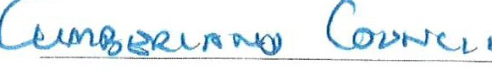
- & R.
BENNETT
BROOK HOUSE OISTINGTON WORKINGTON CUMBRIA CA14 5YA
Telephone (01946) 834140
Mobile 07512 353 137
VAT Reg No 257 0383 59
EEC Plant Passport No UK/EW 101510
\ A I I ;J "1 ,::({
riie,;1rJ/;J
-
1,71t_i--;-' -6LJ<
-
(!;t3t--.t...l.S1_f1,_y -fJJ4_
) /1.,.2
/
l/-.oo<D
I
1'°u b. I f 5
-
�
---
--
--
---

'--
---- ---
I-
-
---
�
-----
--
--
--
I
()0
3./ 1-- r;
Q()
oo
&,l OS
....-=r-.2. 0
TOTAL
...
I-
-
%
----- -
'!_AT@ JO
-
--
--t5-N{W-t91J
[B'JEC[EllflEJO
·-
...f'o
I
_42z
2177

--
..<. :o

-

INVOICE 4
Date_ 2 e:,f- l /x,:;.;_--
To CL\f\,, t>- f\c l l) (!. ( .
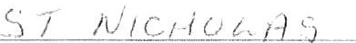

- & R.
BENNETT
BROOK HOUSE DISTINGTON WORKINGTON CUMBRIA CA14 5VA
Telephone (01946) 834140
Mobile 07512 353 137
VAT Reg. No. 257 0383 59
EEC Plant Passport No UK/EW 101510

,) l c)
JLo
!So
., I
LtL Z
4 i (
i 1,'\·
00-
() \..)
0 C.'
C(1i '</ I'';,,.
tiL-Lfi I G-0
l- /) / ·- ,1 O
I ,J ()
- - -·
--
-
--
----
. - -
-
·-.-...
C fli/lrc: IR\
- - u '(/ 1.6 l.b:&'
-
..._
-
-2-6 JUN ?023
-
-
... _...... ------
.
-
-
-
- -
VAT@
,.........
---
/ (!%
TOTAL lZ.3 t1- C1
I
1, fJ
0 ({
...� er 0
t-/-0
1-,g s--o

'--

--- -·
9V
Oo
?, G
I - 3t,
C ( A/ (::' ,;{ /I I I /)
r'h

1- t, VI
oo

' -·\ ._r:1
t-.....! 1=J t) If(: ( 1--:{u
11) (I f,/ /.,( (./
�I .
f) (:;; t-/ 1) I) 0 i'.
i O ,._�
OU
:
I -...'.) ,_')
e,,;,,& uH !:
).2 <' / /.
I -1.)
I -.)o
/ ()1, /<-- / };J i' I /i J,{ 1 / < l( ,v/
,,tI-n _{I} _{·:10}
\,J1-11 '1, ::-
--
6 /1,, ( t
' (, f /, _ _13 ,.;- G-o ,u I r]
,<o

./..,riu-
I <>io
' (, 11 J..._ (-) C.,-1:::( r-t 'it,/ t1 ;'l;Wv
4/(,. .)...

'� /
STAHLEY LOGS

TAX INVOICE
Cumberland Council Attention: Anne Bell Whitehaven Commercial Park Moresby Park
Whitehaven CA28 BYD
Invoice Date 17 Oct 2023
Invoice Number INV-0392
JN & P Stanley

Description | Quantity | Unit Price | VAT | Amount GBP
Compost Dumpy | 18.00 | 60.00 | 20% | 1,080.00
 |  |  | Subtotal | 1,080.00
TOTAL VAT 20% |  |  |  | 216.00
TOTAL GBP 1,296.00

Due Date: 17 Nov 2023
Account No:- 60596783 Sort Code:- 01-09-54
VAT No:- 9355113333
BSL No:- 0541328-0001 Ready To Burn No - WS2016/00001

-x- - - - - - - -- - - - - - - - - - - - - - - - - - - - - - - - - - - - -- - - - - -- - - -- - - - -

PAYMENT ADVICE
To: JN & P Stanley
Customer Invoice Numbe.r
Amount Due Due Date
Amount Enclosed
Cumberland Council INV-0392
1,296.00
17 Nov 2023

Enter the amount you arc paying above

Registered Office: JN & P Stanley, Ponsonby Farm. Ponsonby, Seascale, Cumbria, CA20 lBX. United Kingdom.

WTC 28/03/2024

Item 5

Planning Application for Consideration by Whitehaven Town Council

Application Number 4/23/2327/0Fl

4/24/2065/0Fl

4/24/2066/0Fl

4/24/2078/0L1

4/24/2083/0Fl

4/24/2084/0Fl

4/24/2085/0Fl
Detail
Consultation on Amended and Additional Information: FOUR NO. DETACHED TOWN HOUSES HENSINGHAM HOUSE, EGREMONT ROAD, WHITEHAVEN

REPLACEMENT DWELLING TYPES ON PLOTS 12, 14, 15, 15A, 16 AND 16A INCLUSIVE- 6 DWELLINGS

PLOTS 12, 14, 15, 15A, 16 AND 16A HIGH STILE GARDENS, WHITEHAVEN

REPLACE CONSERVATORY WITH KITCHEN EXTENSION AND CONVERT GARAGE TO UTILITY ROOM, TOILET AND STORE

5 PARK DRIVE, WHITEHAVEN

LISTED BUILDING CONSENTFOR INSTALLING KITCHEN IN GROUND FLOOR, INSTALLING FOUR SOLID FUEL STOVES AND INSTALLING DECORATIVE WINDOW GRILLES TO BASEMENT AND GROUND FLOOR WINDOWS

153 QUEEN STREET, WHITEHAVEN

PROPOSED DETACHED BUNGALOW

LAND TO NORTH WEST OF OAK CRESCENT, WHITEHAVEN

REAR SINGLE STOREY EXTENSION

25 GRANT DRIVE, WHITEHAVEN

FULL PLANNING APPLICATION FOR 107 DWELLING HOUSES AND ASSOCIATED

Application Number

4/24/2086/0A 1
Detail

INFRASTRUCTURE INCLUDING LANDSCAPING, OPEN SPACE, ACCESS, HIGHWAY AND DRAINAGE - VARIATION OF DRAINAGE SCHEME, DETACHED GARAGE DESIGN AND LANDSCAPING SCHEME APPROVED UNDER APPLICATION REF 4/22/2332/0FI

LAND TO THE WEST OF VALLEY VIEW ROAD, WHITEHAVEN

APPLICATION FOR CONSENT TO DISPLAY ALUMINIUM COMPOSITE SIGNS TO THE NORTH AND SOUTH FACE OF BUILDING
THE OLD BANK, SWINGPUMP LANE, WHITEHAVEN

WTC 28/03/2024

Item 8

ALLOTMENTS

Purpose of the Report

To inform Members of requests received from tenants and quotes received for the provision of skips to the sites.

  - TENANT REQUESTS

  - A new tenant at Sneckyeat is seeking the Councils permission to grow 5 fruit trees on their plot. This would help with drainage of a boggy area on the plot. The tenant would like to grow heritage fruit trees (English Russet Apple and Victoria Plum as an example) and will ensure that they do not reach a height more than 1Oft. The tenant has experience in the growing and management of trees. Clause
2.4.3 of the Allotment Tenancy agreement states "The Tenant shall not plant any tree, shrub hedge or bush without first obtaining the Council's written permission. "

  - Plot 19 Crow Park has become available to rent and the tenant of Plot 33 Crow Park has asked if he can be transferred to this plot thereby leaving Plot 33 available to rent. The tenant is of good character and has proved their commitment by the work that they have carried out on Plot 33.

2.0 SKIP HIRE QUOTES

  - As in previous years quotes have been sought from 3 companies for the delivery and collection of 12-yard open waste skips to each allotment.

  - Quotes have been received from 2 suppliers and they are:

    - Supplier A - £385.00 + VAT
    - Supplier B - £300.00 + VAT

3.0 RECOMMENDATION

3.1 To consider the tenant requests at 1.1 and 1.2 and to decide whether or not to grant permission and to consider the quotes at 2.2 and to decide which quote to accept.

WTC 28/03/24

Item 9

CONSULTATION ON PUBLIC SPACES PROTECTION ORDERS

Purpose of the Report and Recommendation

To consider the consultation document published by Cumberland Council on Public Spaces Protection Orders and to decide the Council's response to the consultation.
  - INTRODUCTION

  - Cumberland has recently published a Consultation Document on Public Spaces Protection Orders (see Appendix 1). The Consultation closes on 12th April 2024. In the Consultation Document there is reference to a questionnaire that Cumberland Council are asking everyone to complete so that Cumberland Council can collect information and insights. The questionnaire can be accessed via https://consult.cumberland.gov.uk

  - A copy of the Consultation Document which includes the proposed Draft Order is attached at Appendix 1

  - For Members information/comparison copies of the PSPOs which were prepared by CBC and which have now expired are attached at Appendix 2

2.0 RECOMMENDATION

  - That the Council comments on the Consultation Document and these comments be sent to Cumberland Council and
  - That Ward councillors complete the questionnaire for their Individual Wards

r.,; v',
"00""'
,r,../ �
Cumberland
v-J1C 22 /06 / 2.02't
A3ev\da I.\:eM 9
    - Menu

Council

Consultation on Public Space Protection Order

Page 1 of 5
Closes 12 Apr 2024

This service needs cookies enabled.

Introduction
Cumberland Council, a unitary council in Cumbria, assumed responsibility for all council services previously provided by Allerdale Borough Council, Carlisle City Council, Copeland Borough Council, and Cumbria County Council on April 1, 2023.

As part of our routine review process every three years, we are currently evaluating the implementation of a Public Space Protection Order (PSPO) across the entire Cumberland area.

To facilitate this review, we are utilising a questionnaire to collect information and insights. The specific areas under consideration include addressing anti­ social behaviour (ASB) in city/town centres, parks, and open spaces, as well as regulating various activities to maintain public order.

The key areas being reviewed are as follows:

- Addressing Anti-Social Behaviour (ASB) in city/town centres, parks, and open spaces.
- Regulating begging that may cause or likely to cause anti-social behaviour.
- Managing camping/sleeping in a manner that may lead to anti-social behaviour.
- Introducing a code of conduct for buskers, street performers, and public speakers.

- Restricting the sale of goods on the street or canvassing without prior authorisation and adherence to a valid code of conduct.
- Controlling drinking/possession of alcohol in specified areas where it may cause or likely to cause ASB.
- Governing the use of e-scooters, scooters, skateboards, and motor­ propelled vehicles (excluding mobility scooters) in a manner that causes or is likely to cause anti-social behaviour.
- Restricting the use of vehicles causing anti-social behaviour in parks or open spaces, including excessive noise, music, revving, and congregating.
- Requiring dogs to be on leads/excluded in certain areas, such as designated play areas.

Proposed Conditions for Specific Areas (city/town centres):

- Drinking/possessing alcohol.
- Managing E-scooters, scooters, skateboards, motor-propelled vehicles, etc.
- For more information about the proposals, please read the ProRosed Draft Order.
- To contribute to this review, we kindly ask you to answer the following questions

Public Space Protection Order (PSPO) maps can be viewed using the drop­ down lists below:

Dog Exclusion/ASS Dog on Lead/ASB
Town, City Centres and Retail Parks

Continue >

Save and come back later...

Accessibility Terms of Use Cookies Privacy He>lp / feedback

""1;
00,,,..

r'-/ '-"
Cumberland
Council PROPOSED DRAFT ORDER
CUMBERLAND COUNCIL
ANTI-SOCIAL BEHAVIOUR, CRIME AND POLICING ACT 2014, SECTIONS 59-68 CUMBERLAND COUNCIL PUBLIC SPACES PROTECTION ORDER (NO. 1) 2024

Cumberland Council ("The Council") hereby makes the following Order under the Anti-Social Behaviour, Crime and Policing Act 2014, Section 59 ("the Act)

- This Order applies to the public areas shown on the plans annexed to this Order (the Restricted Areas) FOR CONSULTATION:
  - Challenging anti-social behaviour by groups or individuals in open and Public Spaces and Car Parks in the district (Schedule 1 restricted Areas).
  - No person shall beg. Where it causes or is likely to cause anti-social behaviour. (Schedule 1 restricted Areas)
  - No person shall camp or sleep overnight with or without a tent, where their behaviour, and the behaviour of their visitors or associates, causes, or attracts anti-social behaviour and/or has a detrimental effect on the quality of life of those in the locality. (Schedule 1 restricted Areas)
  - A code of conduct for Buskers is currently in place, therefore, no person shall breach this by causing a nuisance to nearby premises or members of the public. This will also apply to street performers/public speakers and includes obstructing the highway, pavement, or shop entrances, or using street furniture including public seats, lamp posts and railings. (Breach of the code of conduct, or, operating without one, will result in a breach of the PSPO.) (Schedule 1 restricted Areas)
  - No selling of goods, no canvassing of services or charities (without prior written consent from the Council, this must be presented to the authorised officer upon request, failure to do so will result in a breach of the PSPO). (Schedule 1 restricted Areas)
  - No person shall refuse to stop drinking alcohol or hand over any containers (sealed or unsealed) which are believed to contain alcohol, when required to do so by an authorised officer to prevent public nuisance or disorder. (Schedule 1 restricted Areas)
Where a Police Officer, Police Community Support Officer or a person duly authorised by the Council reasonably believes that a person has been consuming alcohol, or that a person intends to consume alcohol in circumstances in which doing so would be a breach of that prohibition, the person may be required:
    - Not to consume alcohol or anything reasonably believed to be alcohol.
    - To surrender anything in that person's possession which is, or which may reasonably believe to be alcohol or a container for alcohol.
Anything surrendered to him or her as a result of a requirement imposed may be disposed of by the authorised officer in whatever way he or she thinks appropriate.

A Police Officer or an authorised person who imposes such a requirement must tell the person that failing without reasonable excuse to comply with the requirement is an offence.
A requirement imposed by an authorised person is not valid if the authorised person is asked to show evidence of his or her authorisation but fails to do so.
  - Riders of scooters I E-Scooters, Skateboards and Motor Propelled vehicles (mobility scooters are exempt) being used on footpaths so as to cause nuisance and annoyance. (Schedule 1 restricted Areas)
  - A person shall be guilty of an offence if, at any time on any open space, park, pedestrianised area or car park within the District to which this Order applies if they are carrying out any of the following activities(Schedule 1 restricted Areas):
    - driving or permitting a vehicle to be used in a manner that causes or is likely to cause harassment, alarm, risk or distress to any person;
    - Running or revving of engines in such a manner as to cause a nuisance;
    - Racing or driving around the location at speed;
    - sounding the horn;
    - playing loud music;
    - congregating in a car park for the purposes of socialisation without permission; and or
    - any variation of the above unless:
      - they have a reasonable excuse for doing so; or
      - theowner, occupier or other person or authority having control of the land has consented (generally or specifically) to their doing so
- Any person in charge of a dog within the restricted area shall be in breach of this Order if he/she:
  - fails to keep the dog on a lead and under physical control at all time on any land which has been designated as a dog on lead area, identified in Schedule 2 restricted areas annexed here to
  - fails to put a dog on lead by direction by an authorised officer
  - allows the dog to foul in a public place and then fails to remove the waste and dispose of it in an appropriate receptacle. ((Schedule 4 restricted Areas)
  - takes a dog onto, or permits the dog to enter or remain on, any land which has been designated as a dog exclusion area, identified in Schedule 3 Restricted areas annexed here too.
The provisions of this order relating to the control of dogs shall not apply to any person who is registered blind in accordance with section 29 of The National Assistance Act 1948, to any person and to any person suffering a disability and in sole charge of a dog trained to assist with his/her mobility, manual dexterity, physical coordination or ability to lift and carry everyday objects and the said dog has been trained by a prescribed charity.

Appeals
Any challenge to this order must be made in the High Court by an interested person within six weeks of it being made. An interested person is someone who visits the restricted area.

This means that only those who are directly affected by the restrictions have the right to challenge. The right to challenge also exists where an order is varied by the Council.
Interested persons can challenge the validity of this order on two grounds; 1) that the Council did not have the power to make the order or to include particular prohibitions or requirements or that 2) one of the requirements of the legislation has not been complied with.
When an application is made, the High Court can decide to suspend the operation of the order pending the Court's decision, in part or totality. The High Court has the ability to uphold the order, quash it, or vary it.
A person who is guilty of an offence under the Order shall be liable on summary conviction to a fine not exceeding level 3 on the standard scale.

This Order will come into force on day XXXXXXXX and may be cited as CUMBERLAND COUNCIL PUBLIC SPACES PROTECTION ORDER (NO. 1) 2024

This Order shall remain in force until XXXXXXXX 2027

GIVEN under the Common Seal of the Cumberland Council

Authorised signatory.

SCHEDULE 1 Restricted Areas

Town and City Centre Areas - ASB and Alcohol

Bridge Street Retail Park Whitehaven
Carlisle City Centre
Cleator Moor Town Centre
Cockermouth Town Centre
Derwent Howe Retail Park Workington
Dunmail Park Workington
Egremont Town Centre
Preston Street Retail Park Whitehaven
Whitehaven Town Centre
Workington Town Centre

Schedule 2 Restricted Areas.

Areas for 'Dogs on Leads' - Plans to be Finalised (illustrative purposes only)

Cemeteries

Carlisle | CA2 6AT
Stanwix | CA3 OAT
Upperby | CA2 4LH
Brigham | CA13 OXH
Cockermouth | CA13 9DF
Dearham, Maryport | CAlS
St Pauls and Causewayhead | CA7 4PQ
Maryport Cemetery
Harrington Road, Workington | CA14 2UL
Salterbeck, Workington | CA14 SHW
Flimby, Workington | CAlS 8TJ
Netherwasdale Cemetery | CA20 lET
Low Road Cemetery, Whitehaven | CA28 9HU
Hensingham Cemetery, Whitehaven
Distington Hall Crematorium | CA14 4QY
Beckermet Cemetery | CA212XP
St Joseph's Burial Ground | CA26 3PX
Beck Bottom and Beck Bottom Cemetery,
Whitehaven
North Road Cemetery, Egremont | CA22

Closed Churchyards, Nature Reserves, Parks & Open Spaces

Abbeytown Church ' | Wigton | CA7 4SY
Banklands | Workington | CA14 3EU
All Saints | Cockermouth | CA13 9PJ
St. Mungo's Church | Dearham | CA15 7HX
St. Nicholas' Church | Flimby | CA15 8TJ
St. Michael's Church | Workington | CA14 2EZ
St. Mary's Church | Maryport | CA15 7HX
St. John's Church | Workington | CA14 3AW
St. Mary's Churchyard | Sebergham | CAS 7HS
St. Mary's Church | Harrington | CA14 SPW
All Soul's Church | Maryport | CA15 7NL
Home Cultram Abbey | Abbeytown | CA7 4SG
St Joseph's Church | Seascale | CA20 lPU
St John's Church | Cleator Moor | CA25 SBY
St John's Church | Beckermet | CA212XT
St James's Church and Kirk | Whitehaven
St Cuthbert's Church | Seascale | CA20 lQU
St Bridget's Church | Moresby | CA28 6PB
St Bega's RC Church | Cleator Moor | CA25 SQH
Silecroft Beach Play Area | Silecroft | LA25 4NY
Ramsey Drive Playing Field | Parton | CA28 6RE
Land at Calderbridge | Whitehaven | CA20 lDB

King George V Playing Field | Cleator Moor | CA2S SJA
Greenbank Playing Field |  | CA28 9QX
Copeland Athletics Stadium | Hensingham | CA28 8SD
North Road Cemetery | Egremont | CA22 2SY
Church of the Holy Spirit | Distington | CA14 STD
High Road Welfare Field | Kells | CA28 9PQ
Trinity Gardens, Scotch Street | Whitehaven | CA28 7DG
The Priory Church of St Mary's and St Bega | St Bees | CA27 ODR
St Paul's Church, Church Street | Frizington | CA16 3ST
St Mary's and St Michael's Churchyard | Egremont | CA22 2AY
St Luke's Church, Haverigg | Millom | LA18 4HB
St Leonard's Church, Bankend View | Cleator | CA23 3DB
Egremont Castle | Egremont | CA22 2JW
Skate Park | Egremont | CA22 2DY
Orgill, | Egremont | CA22 2HH
Playing Field, Moor Row | Whitehaven | CA22 2UT
Outrigg | St Bees | CA27 OAN
Playing Field, Arlecdon | Frizington | CA26 3XD
Castle Park | Whitehaven | CA28 7RA
St Joseph's Church | Frizington | CA26 3PX
Playing Field | Lowca | CA28 6PT
Recreation Ground | Moresby | CA28 8XW
Land at High Street | Whitehaven | CA28 7PT
Land at Jericho | Whitehaven | CA28 6TJ
Land at Woodhouse | Whitehaven | CA28 9HZ
Pavillion | Millom | LA18 SOW
Playing Field ' | Gosforth | CA20 lAN
Trinity Churchyard I | Carlisle | CA28 7BU
Ennerdale Road Sports Pitch | Maryport | CAlS 8HN
Workington Hall Park Playing Field | Workington | CA144AA
Moorclose Sports Field | Workington | CA14 SBF
Jane Pit Playing Field | Workington | CA14 2DB
Lowther Street Playing Field, Flimby | Workington | CAlS 8PP
West Lane Playing Field, Flimby - | Workington | CAlS 8QS
Siddick Ponds | Workington | CA141NQ
Harrington Nature Reserve, Pond Area | Workington | CA14 SLB

SCHEDULE 3 Restricted Areas

Areas for "Dog Exclusion" - Plans to be Finalised (illustrative purposes only)

Closed Play Areas (and Skate Parks)

Hunter's Drive | Seaton | CA141QQ
Ennerdale Road | Maryport | CA15 7ND
Camp Road | Maryport | CA15 6JL
Bellbrigg Lanning | Cockermouth | CA13 9BZ
Harris Park | Cockermouth | CA13 ODF
Horse Close Skate Park | Workington Hall Park | CA14 4EA
Kirkstead Play Area | Kirkstead Road | CA2 7RD
Bitts Park | Dacre Road | CA3 8UZ
Briar Bank | Briar Bank | CA3 9SP
Broad Street | Petteril Street | CAl 2AJ
Carliol Drive | Carliol Drive | CAl 2RF
Chances Park | Dunmallet Rigg | CA2 6NU
Clarksfield | Scotland Road | CA3 9HH
Crindledyke | Crindledyke Close | CA6 4BX
Dale End Field | London Road | CAl 3EJ
Denton Holme | Denton Street | CA2 SJY
Fusehill Street | Grey Street | CAl 2HJ
Gleneagles Drive | Fulford Walk | CA3 9RA
Hammond's Pond | Buchanan Road | CA2 4SD
Houghton | Tribune Drive | CA3 OLF
Jubilee Road | Jubilee Road | CA2 400
Melbourne Park | Borland Avenue | CAl 2TJ
Milbourne Street | Milbourne Street | CA2 SXD
Morton West | Richmond Green | CA2 6SZ
Parkland Village | Pennine View Close | CAl 3GW
Pasture Walk | Pasture Walk | CAl 2LB
St James' Park | Clifton Street | CA2 SNG
The Beeches | Glaramara Drive | CA2 6QP
Turnstone Park | Fulmar Place | CA2 7NW
Windsor Way | Windsor Way | CA3 OPF
Yewdale Park | Hutton Way | CA2 7TH
Sports Court, Woodhouse | Whitehaven | CA28 9HZ
Play Area, Welfare Fields | Kells | CA28 9BA
Playing Field at Town End | Seascale | CA20 lPZ
Village Green | Kirksanton | LA18 4NN
The Park, Thornhill | Egremont | CA22 2SP
Play Park, Mirehouse Shops | Whitehaven | CA28 8ER
Playground | Whicham | LA18 SLS
Play Area Scalegill Road | Moor Row | CA24 3JN
Play Area and associated land  Coronation Drive | Frizington | CA26 3QF
Play Area, East Road | Lowca | CA28 6QH

Community Recreational Park | Ennerdale | CA23 3AS
Playground | Kirkland | CA26 3XX
Playground, Barfs Road | Distington | CA14 STE
Play Area, Bootle Station | Bootle | LA19 SXB
Recreation Ground | Bootle | LA19 SUL
Play Park, Castle Park | Whitehaven | CA28 7AL
Play Park, Churchill Drive | Moresby | CA28 8XA
Play Area, Fairfield Arlecdon | Frizington | CA26 3XA
Play Area, Gosforth play fields | Gosforth | CA20 lAY
Play Ground, Haverigg Beach | Haverigg | LA18 4GY
Play Area, High Street | Whitehaven
Play Area, Hinnings Road | Distington | CA14 SUW
Play Area, Jacktrees Road | Cleator Moor | CA25 SBB
Play Area, Jericho | Whitehaven | CA28 6TJ
Play Area | Keekle | CA28 SRQ
Play Area, Ling Road | Egremont | CA22 2JU
Play Area, Main Street | Parton | CA28 6HZ
Playing Field, Mill Hill | Cleator Moor | CA25 SRX
Play Area and Tennis Court,  Millam Park | Millam | LA18 4JA
Play Area, Newlands Avenue | Whitehaven | CA28 9SW
Land at Nursery School, Main Street | Frizington | CA28 3PF
Play Area, Orgill | Egremont | CA22 2HL
Play Area,Pica | Workington | CA14 4QA
Play Area, Prospect Row | Cleator | CA23 3DE
Play Area, Recreation Ground | Moresby | CA28 8XW
Play Area, Seascale Foreshore | Seascale | CA20 lPZ
St Nicholas's Gardens | Whitehaven | CA28 7DG
Playing Fields | Ravenglass | CA181SW
Kie Park and Basketball Court | Whitehaven | CA28 8ST
Play Area, Hensingham | Whitehaven | CA28 8QL
Play Area, Bank End View | Bigrigg | CA22 2TH
Play Area, Outrigg | St Bees | CA27 0AA
Land at School Green | Beckermet | CA212YD
St Bees Beach Play Area | St Bees | CA27 0ES

MUGAs - Carlisle Area

Site Name | 1st Line Address | Postcode
Chances Park | Langrigg Road | CA2 6PD
Dale End Field | London Road | CAl 3EJ
Hammond's Pond | Buchanan Road | CA2 4SD
Melbourne Park | Borland Avenue | CAl 2TJ
Raffles | Raffles Avenue | CA2 7EB
Trinity Churchyard | Head Street | CA2 7BQ

Schedule 4 Restricted Area Whole Cumberland Area - dog fouling.

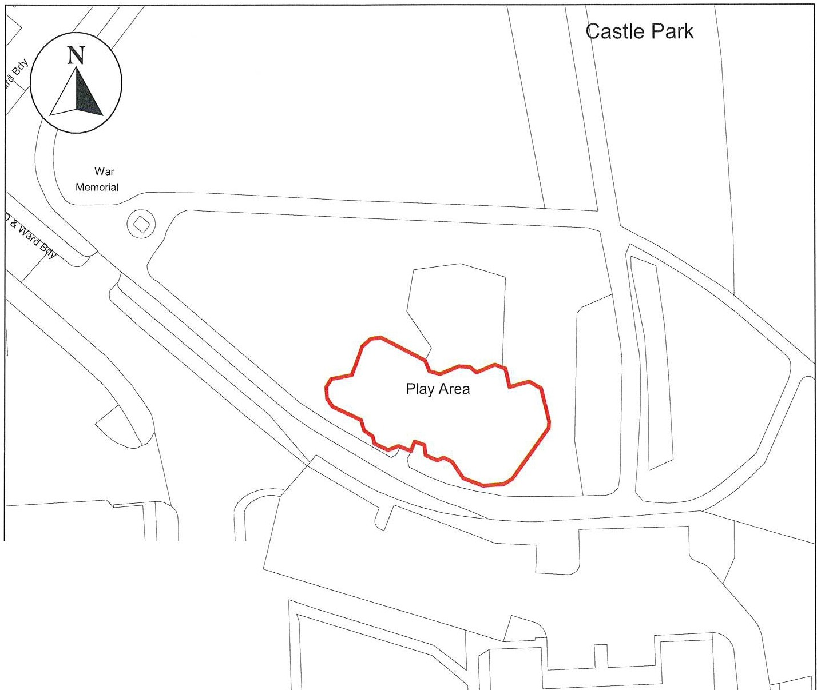
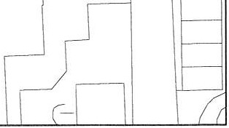
Public Space Protection Order Cumberland Council 2024

Shelter

1 to 33
Whitehaven Castle

ANTI-SOCIAL BEHAVIOUR CRIME AND POLICING ACT 2014

Play Area at Castle Park, Flatt Walks, Whitehaven, CA28 7AL

"/"',,.,/ '-""-
"'ffi"

Cumberland Council
Neighbourhoods
Education and Enforcement Allerdale House
Workington CA14 3YJ
Scale: 1 : 750
Date: February 2024
©crown copyright database rights 2024 ordnance survey AC0000861732

Public Space Protection Order Cumberland Council 2024
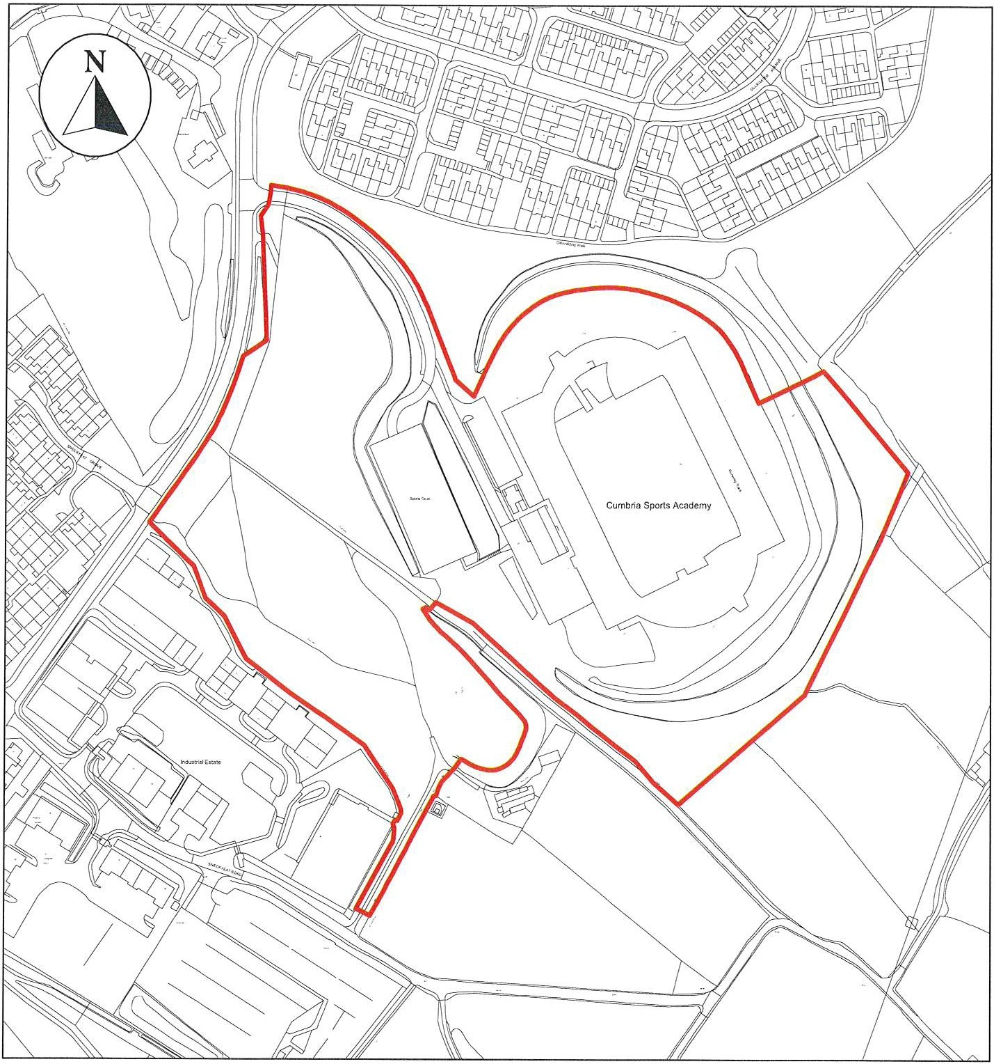
ANTI-SOCIAL BEHAVIOUR CRIME AND POLICING ACT 2014

Cumbria Sports Academy, Overend Road, Whitehaven, CA28 85D

""�"'ffi,,.�'-,./",\.

Cumberland Council

Neighbourhoods
Education and Enforcement Allerdale House
Workington CA14 3YJ

Scale: 1 : 3,000
Date: February 2024
©crown copyright database rights 2024 ordnance survey AC0000861732

Public Space Protection Order Cumberland Council 2024
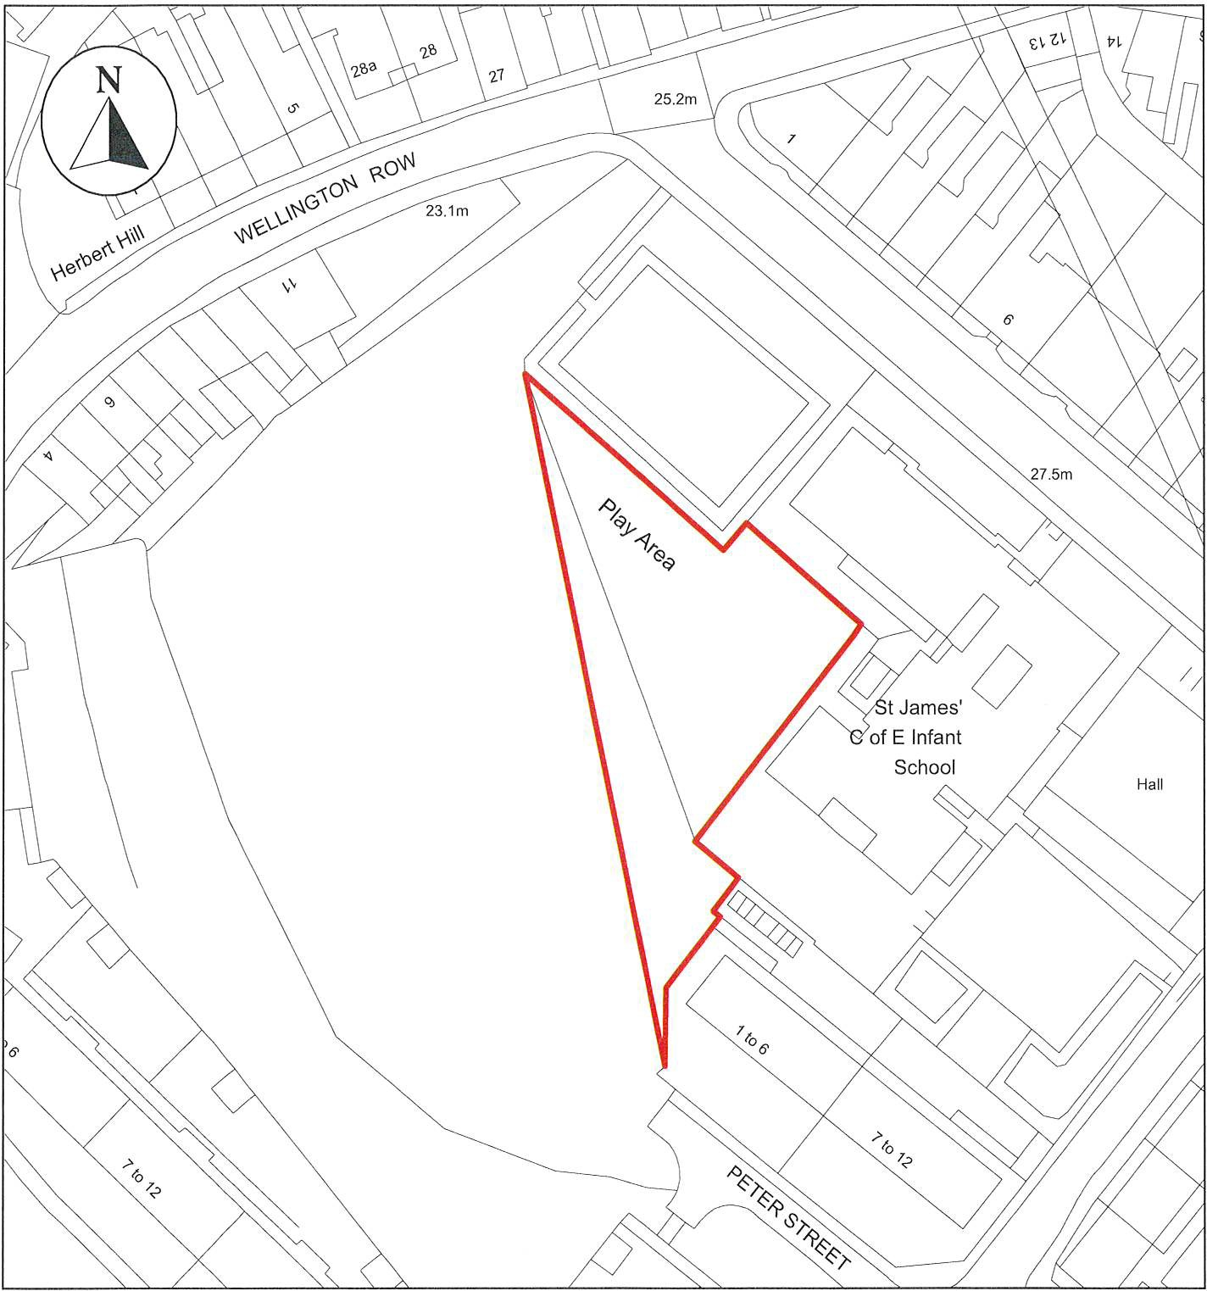

�oo,,.,
ANTI-SOCIAL BEHAVIOUR CRIME AND POLICING ACT 2014

Play Area, High Street, Whitehaven, CA28 7HA

"' V"'-
""""
-"-/

Cumberland Council
Neighbourhoods
Education and Enforcement Allerdale House Workington
CA14 3YJ
Scale: 1 : 750
Date: February 2024
©crown copyright database rights 2024 ordnance survey AC0000861732

Public Space Protection Order Cumberland Council 2024
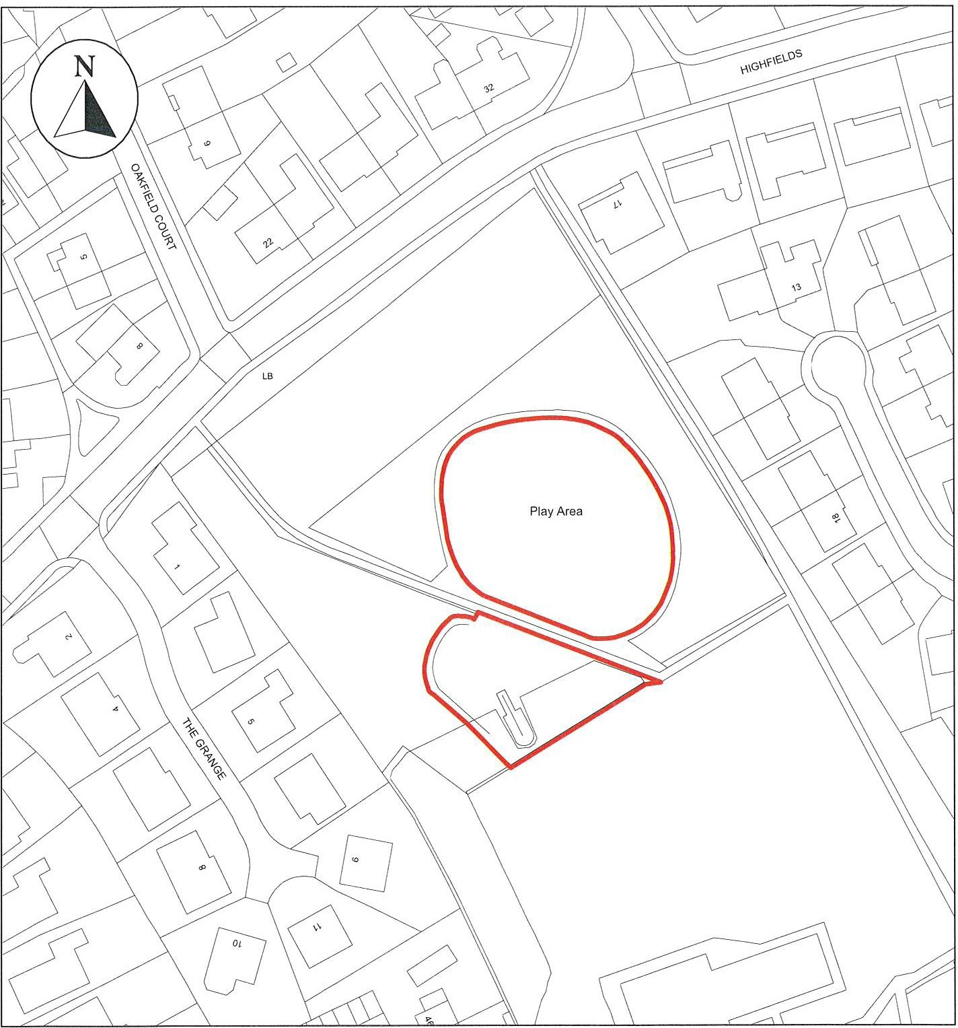
ANTI-SOCIAL BEHAVIOUR CRIME AND POLICING ACT 2014

Play Areas at Jericho, Whitehaven, CA28 6TJ
ffi,..

,-.,,,,; �
� '--""'

Cumberland Council
Neighbourhoods
Education and Enforcement Allerdale House Workington
CA14 3YJ
Scale: 1 : 1,000
Date: February 2024
©crown copyright database rights 2024 ordnance survey AC0000861732

Public Space Protection Order Cumberland Council 2024

L 1 I '------' J ' ' I \..,..--' '----
_{N} L

[
7
M
-
�
�
L_J
D

\.
□

'
�

"<"D'' �
J

'\

⁰,-...
N

I 7L_
:.:.:.;,

90.6m '---....._ ----
D
Araunah
Ful <D

V 90.6m

D
CJ
□
LU LU "\
I

40
L_J Ii

Lr-1
7
�

r ""N '

\ / r
�
'- LB
<t ""''
<D
N
�
LJ L,
'-

l
t I �
\
\
7
L ; ,\
Play Area

.\
� I\
I
r
u
�
(/)
0z
0
r
0
17
(/)
ii

�
_LJ D

Recreation Gr

LJ I m
r °'
I �

91.6m

ANTI-SOCIAL BEHAVIOUR CRIME AND POLICING ACT 2014

Kells Play Area, Whitehaven, CA28 98A
oo,,,,,.,.

,..,.,, V",
.,,,,....., '-"""

Cumberland Council
Neighbourhoods
Education and Enforcement Allerdale House Workington
CA14 3YJ
Scale: 1 : 750
Date: February 2024
©crown copyright database rights 2024 ordnance survey AC0000861732

Public Space Protection Order Cumberland Council 2024

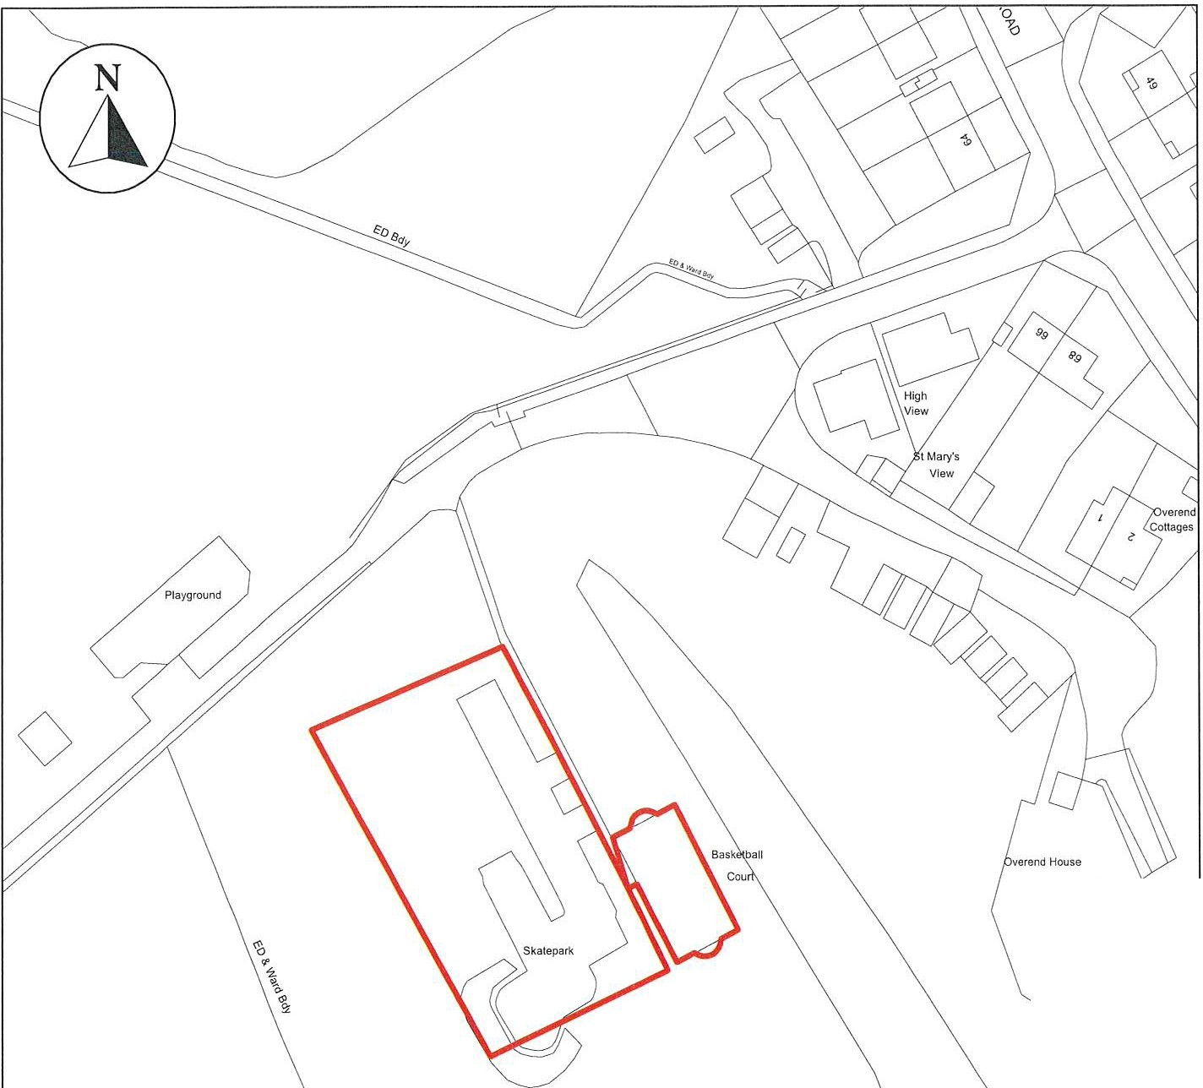
0

tment Gardens

ANTI-SOCIAL BEHAVIOUR CRIME AND POLICING ACT 2014

Kie Park, Hensingham, Whitehaven, CA28 SST

".".,"...f,_,,f. i,.,�"",,

Cumberland Council

Neighbourhoods
Education and Enforcement Allerdale House
Workington
CA14 3YJ

Scale: 1 : 1,000
Date: February 2024
©crown copyright database rights 2024 ordnance survey AC0000861732

Public Space Protection Order Cumberland Council 2024

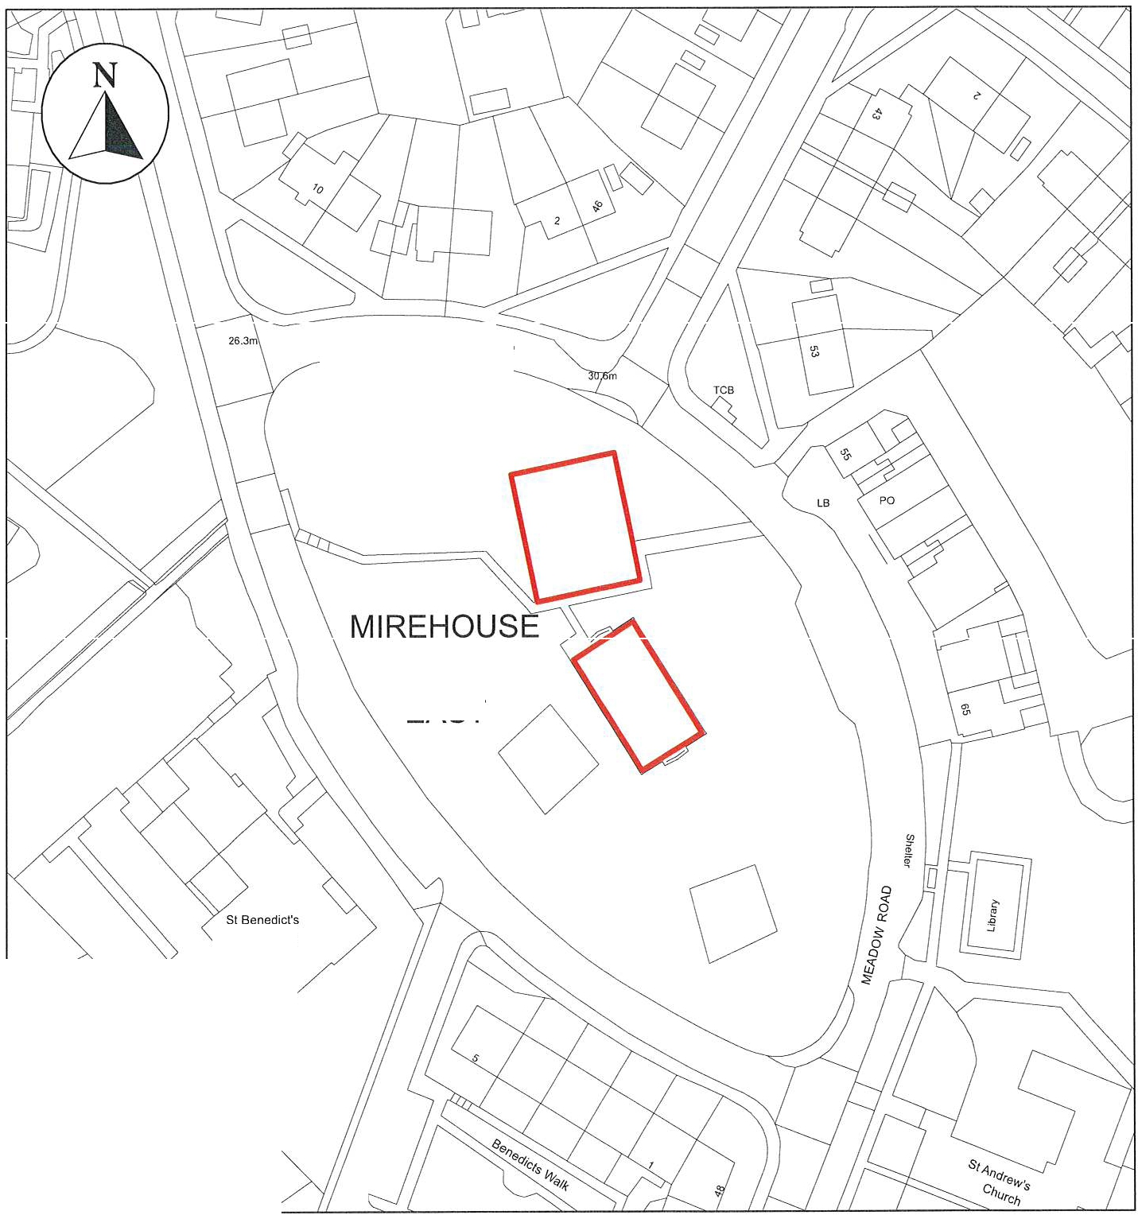
WHINLATTER

RoAo

EAST

Church

ANTI-SOCIAL BEHAVIOUR CRIME AND POLICING ACT 2014

Land at Mirehouse, Whitehaven, CA28 8BN

.�,.",."..l.ft,.;, ffi"V-""-- "

Cumberland
Council

Neighbourhoods
Education and Enforcement Allerdale House
Workington CA14 3YJ

Scale: 1 : 1,000
Date: February 2024
©crown copyright database rights 2024 ordnance survey AC0000861732

Public Space Protection Order Cumberland Council 2024
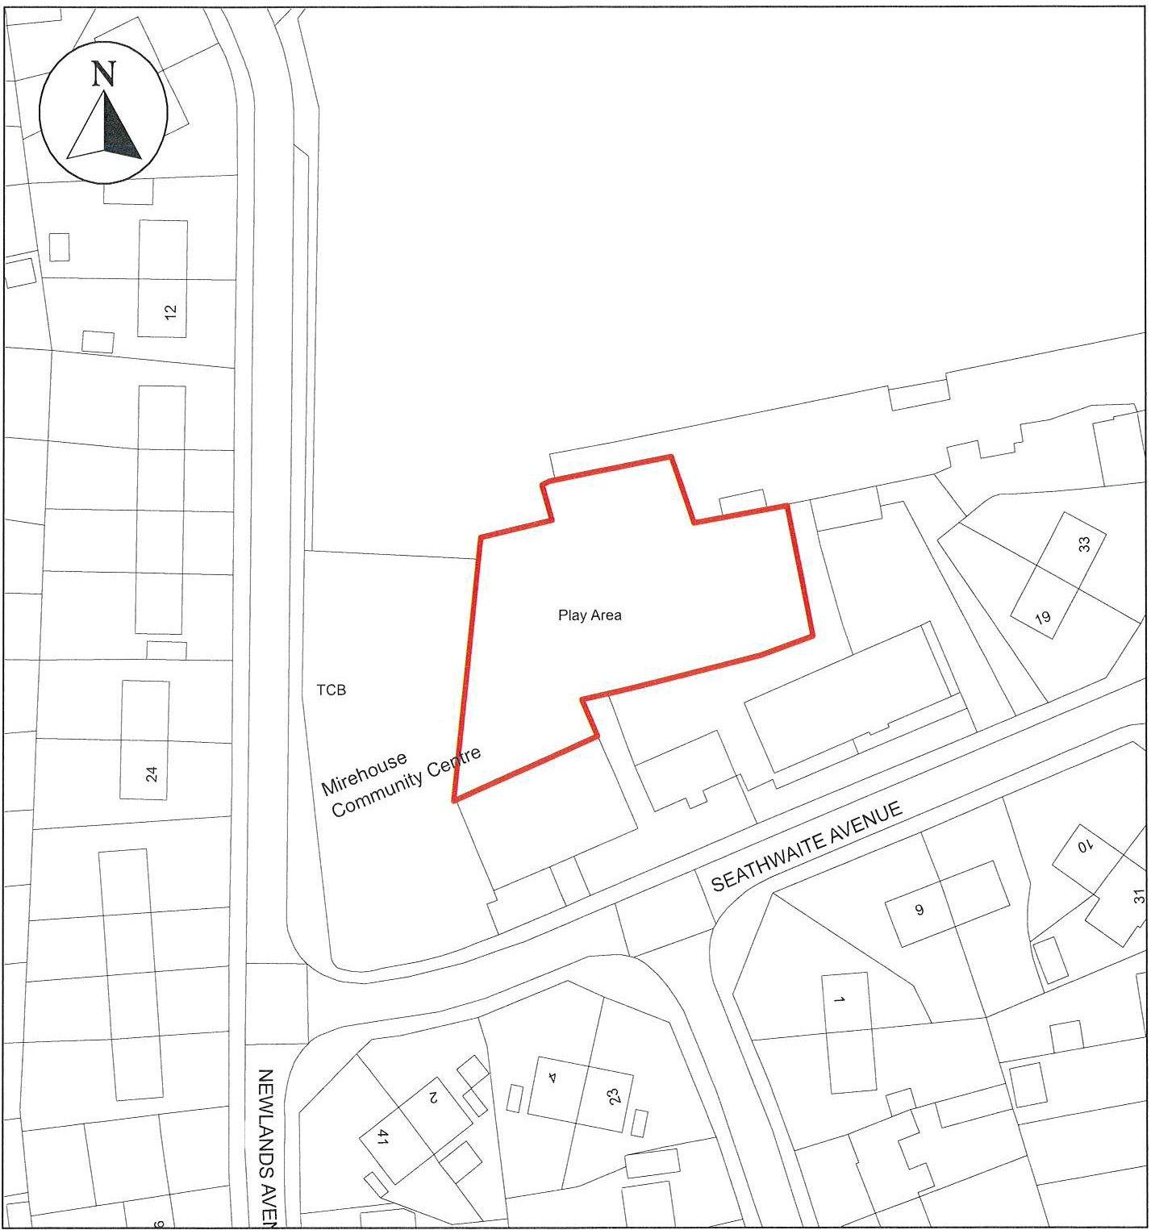
ANTI-SOCIAL BEHAVIOUR CRIME AND POLICING ACT 2014

Land off Newlands Avenue, Whitehaven, CA28 95W

"ffi,,,..,.

Neighbourhoods

Scale: 1 : 750

...,,,⁻...,..._.,;.
�
'--""'-
Education and Enforcement Allerdale House
Date: February 2024

Cumberland

Council
Workington CA143YJ
©crown copyright database rights 2024 ordnance survey AC0000861732

