WHITEHAVEN TOWN COUNCIL

Clerk and Responsible Financial Officer: Marlene Jewell
Telephone: 01946 67366
Chairman: Councillor R Gill

To: Members of Whitehaven Town Council

You are duly SUMMONED to attend a MEETING of WHITEHAVEN TOWN COUNCIL which will be held in THE BEACON PORTAL at THE BEACON, WHITEHAVEN on Thursday 26th June 2025 at 6.00 pm

Signed... M. --- -- Dated... (9 ::;r . - .S....
Marlene Jewell, Clerk and Responsible Financial Officer
AGENDA

- Apologies for Absence

- Declarations of Interest

To receive declarations of interest by elected Members in respect of Agenda items.

If a Member requires any advice on any item involving a possible declaration of interest which could affect his/her ability to speak and/or vote he/she is advised to contact the Clerk at least 24 hours in advance of the meeting.
- Public Participation

- Minutes of the Annual Council Meeting held on 29th May 2025
- Report from Cumberland Council
- Planning Applications

- Finance Report

- Quote for Winter Bedding Plants 2025/26

- Electoral Review of Cumberland Council: Draft Recommendations

- Allotment Update Report
- Trustee on the Whitehaven Relief in Need Committee
- WCSSG- Councillor E Dinsdale to give a report

- Councillor Ward Matters
- Date and Time of Next Meeting

IN PRIVATE

That prior to the following items of business the Chairman will move the following resolution:
That in view of the special or confidential nature of the business about to be transacted it is advisable in the public interest that the public and or press be instructed to withdraw.
- Office Renovation Update - To Follow
- Application For Grant - WADAOS
- Application for Grant - WTG

WHITEHAVEN TOWN COUNCIL

Minutes of the Annual Council Meeting held on the 29th May 2025

Present: Councillor C Hayes (Deputy Chairman in the Chair); Councillor J Carr; Councillor E Dinsdale; Councillor G Dinsdale; Councillor R Gill; Councillor R Redmond; Councillor A Spedding; Councillor R Taylor; Councillor R Wbite

M. Jewell, Clerk and Responsible Financial Officer

V. Gorley, Assistant Clerk

Councillor Mike Hawkins, Cumberland Council Members of the Public
The Press

Introduction
2772/25 The Chairman welcomed everyone to the Annual Meeting of the Town Council and asked the Councillors to introduce themselves.
For housekeeping purposes he explained that there was no scheduled testing of fire alarms and if the fire alarm rang asked that people file out in an orderly manner. He indicated where the toilets were.
He said they would proceed with the business of the Council and the first item on the Agenda was the appointment of the Chairman/Mayor

2773/25 Appointment of Chairman/Mayor

Councillor C Hayes nominated Councillor R Gill for the position of Chairman/Mayor for 2025/26. This was seconded by Councillor A Spedding

Councillor G Dinsdale nominated Councillor E Dinsdale for the position of Chairman/Mayor for 2025/26. This was not seconded so the nomination fell

A vote was held and 7 Councillors voted for Councillor Gill and 1 Councillor abstained and 1 Councillor voted against
RESOLVED-That Councillor R Gill be appointed Chairman/Mayor for

2025/26. Councillor Gill then took the Chair and signed the Declaration of Acceptance of Office.
Councillor Gill thanked his colleagues for their support and said that he hoped to serve the Council and show their trust in him

Councillor G Dinsdale said she was not very well and left the Meeting and did not return

2774/25 Appointment of Deputy Chairman/Deputy Mayor
Councillor Gill asked for nominations for the position of Deputy Chairman/Deputy Mayor

Councillor A Spedding nominated Councillor C Hayes for the position of Deputy Chairman/Deputy Mayor and this was seconded by Councillor Gill

Councillor C Hayes nominated Councillor R Taylor for the position of Deputy Chairman/Deputy Mayor and this was seconded by Councillor E Dinsdale

A vote was held and 5 Councillors voted for Councillor C Hayes, 1 Councillor voted against and 2 Councillors abstained and 2 Councillors voted for Councillor R Taylor and 6 abstained

RESOLVED - That Councillor C Hayes be appointed Deputy Chairman/Deputy Mayor for 2025/26. Councillor C Hayes signed the Declaration of Acceptance of Office

Councillor R Taylor asked to be excused and the Clerk asked him ifhe would be returning and he said no

2775/25 Apologies for Absence

Apologies for absence were received as follows:-

Councillor G Roberts Councillor A Pearson
illness

Family Commitment

It was proposed by Councillor Hayes and seconded by Councillor White that the apologies for absence be accepted and noted. A vote was held and it was unanimously

RESOLVED - That the apologies for absence be accepted and noted

2776/25 Declarations of Interest
Councillor Hayes declared that he was a member of the the Harbour Users Group.
Councillor Gill declared that he was a member of the Whitehaven Heritage Action Group
2777/25 Minutes of the Council Meeting held on 24th April 2025
It was proposed by Councillor Gill and seconded by Councillor Hayes that the Minutes of the Meeting held on 24th April 2025 be approved and signed by the Chairman as a correct record. A vote was held and it was unanimously

RESOLVED -That the Minutes of the Meeting held on 24th April 2025 be approved and signed by the Chairman as a correct record.
2778/25 Minutes of the Extraordinary Council Meeting held on 22nd May 2025
It was proposed by Councillor Hayes and seconded by Councillor Carr that the Minutes of the Extraordinary Council Meeting held on 22nd May 2025 be approved and signed by the Chairman as a correct record. A vote was held and it was unanimously
RESOLVED-That the Minutes of the Extraordinary Council Meeting held on 22nd May 2025 be approved and signed by the Chairman as a correct record.
2779/25 Council's Bank Account
The Council considered a report on the authorised signatories for the Council's Bank Accounts. The Clerk reported that 4 signatories were required and it was recommended that Councillor C Hayes, Councillor R Gill and Councillor BO'Kane remain as signatories and one other Councillor be appointed as signatory for 2025/26. Councillor Carr said he would be a signatory and a vote was held and it was unanimously
RESOLVED - That Councillor C Hayes, Councillor R Gill and Councillor O'Kane remain as signatories for the Council Bank Accounts 2025/26 and that Councillor J Carr be appointed as a signatory for the Council Bank Accounts for 2025/26

2780/25 Review and Adoption of Standing Orders
The Council considered a report on the review and adoption of Model Standing Orders shown at Appendix 1 to the report. The Standing Orders had last been reviewed and approved by the Council on 29th May 2024 and further amended following CALC's recommendations on 24th April 2025.
It was proposed by Councillor Hayes and seconded by Councillor White that the Model Standing Orders shown at Appendix 1 be approved and adopted and that they be further reviewed at the next Annual Meeting in May 2026. A vote was held and it was unanimously
RESOLVED - That the Model Standing Orders shown at Appendix 1 be approved and adopted and that they be further reviewed at the next Annual Meeting in May 2026.
2781/25 Review and Adoption of Financial Regulations
The Council considered a report on the review and adoption of Model Financial Regulations shown at Appendix 1. The Model Financial Regulations were last reviewed and approved by the Council on 29th May 2024 and further amended following CALC's recommendations on 27th March 2025.
It was proposed by Councillor Hayes and seconded by Councillor White that the Model Financial Regulations shown at Appendix 1 be approved and adopted and that they be further reviewed at the next Annual Meeting of the Council in 2026. A vote was held and it was unanimously
RESOLVED - That the Model Financial Regulations shown at Appendix 1 be approved and adopted and that they be further reviewed at the next Annual Meeting of the Council in May 2026.
2782/25 Review and Adoption of the Council's Code of Conduct
The Council considered a report on the Code of Conduct shown at Appendix 1 to the report which had last been approved and adopted at the Annual Meeting on 29th May 2024. It was proposed by Councillor Hayes and seconded by Councillor White that the Code of Conduct shown at Appendix 1 to the report be approved and adopted and that it be reviewed at the Annual Meeting in May 2026. A vote was held and it was unanimously
RESOLVED - That the Code of Conduct shown at Appendix 1 to the report be approved and adopted and that it be reviewed at the Annual Meeting in May 2026.
2783/25 Chairman's Allowance
The Council considered a report on the Chairman's Allowance for 2025/26

which had been included in the Budget as £3,063

- It was proposed by Councillor Hayes and seconded by Councillor Carr that the expenses of the Office of Mayor (the Mayors Allowance of
£3,063 for 2025/26) be approved together with the expenditure specified in paragraph 1.6 of the report. A vote was held and 6 Councillors voted for the proposal and 1 Councillor abstained

RESOLVED -That the expenses of the Office of Mayor (the Mayors Allowance of £3,063 for 2025/26) be approved together with the expenditure specified in paragraph 1.6 of the report.

- It was proposed by Councillor Hayes and seconded by Councillor Spedding that the Mayor's Allowance continue to be administered in the Council's Office and that the Mayor is reimbursed on production of a receipt for the expenditure incurred provided that it is expenditure specified in 1.6 above. A vote was held and it was unanimously

RESOLVED - That that the Mayor's Allowance continue to be administered in the Council's Office and that the Mayor is reimbursed on production of a receipt for the expenditure incurred provided that it is expenditure specified in 1.6 above.

2784/25 Appointments to Committees

The Council considered a report on appointments to the two Standing Committees of the Council for 2025/26
The Clerk asked for volunteers and the following Councillors put their names
forward for the two Committees:-
Policy and Resources and Finance Committee Councillor Hayes
Councillor White
Councillor Carr Councillor Gill
It was proposed by Councillor Hayes and seconded by Councillor Carr that the above Councillors be appointed to sit on the Policy and Resources and Finance Committee for 2025/26. A vote was held and it was unanimously
RESOLVED - That the above Councillors be appointed to sit on the Policy and Resources and Finance Committee for 2025/26.

Staffing Committee

Councillor Hayes Councillor Gill

It was proposed by Councillor Gill and seconded by Councillor Hayes that the above Councillors be appointed to sit on the Staffing Committee for 2025/26. A vote was held and it was unanimously

RESOLVED -That the above Councillors be appointed to sit on the Staffing Committee for 2025/26.

2785/25 Adoption of Terms of Reference for Committees

The Council considered a report showing at Appendix 1 the Terms of Reference for the Policy and Resources and Finance Committee and the Staffing Committee. It was proposed by Councillor Gill and seconded by Councillor White that the Terms of Reference for the Policy and Resources and Finance Committee and the Staffing Committee shown at Appendix 1 of the report be approved. A vote was held and it was unanimously
RESOLVED-That the Terms of Reference for the Policy and Resources and Finance Committee and the Staffing Committee shown at Appendix 1 of the report be approved.

2786/25 Appointment to and Terms of Reference for Advisory Groups

The Council considered a report on the appointment to and Terms of reference to Advisory Groups.
The Clerk asked for volunteers to sit on the Advisory Groups and the following Councillors put their names forward:-

Events Advisory Group

Councillor Hayes Councillor Spedding
Gerard Richardson - co-opted

It was proposed by Councillor Hayes and seconded by Councillor White that the Councillors named above be appointed to sit on the Events Advisory Group and that Gerard Richardson be co-opted onto the Events Advisory Group for

2025/26. A vote was held and it was unanimously

RESOLVED - That the Councillors named above be appointed to sit on the Events Advisory Group and that Gerard Richardson be co-opted onto the Events Advisory Group for 2025/26
Allotment Advisory Group Councillor Gill
Councillor Hayes Councillor Carr Councillor Spedding

It was proposed by Councillor Hayes and seconded by Councillor White that the Councillors named above be appointed to sit on the Allotments Advisory Group for 2025/26. A vote was held and it was unanimously

RESOLVED - That the Councillors named above be appointed to sit on the Allotments Advisory Group for 2025/26.
Steering Group on Office Accommodation Councillor Hayes
Councillor White Councillor Gill

It was proposed by Councillor Hayes and seconded by Councillor White that the Councillors named above be appointed to sit on the Steering Group for Office Accommodation for 2025/26. A vote was held and it was unanimously

RESOLVED - That the Councillors named above be appointed to sit on the Steering Group for Office Accommodation for 2025/26.
St Nicholas Gardens Advisory Group Councillor Hayes
Councillor Spedding

It was proposed by Councillor Hayes and seconded by Councillor Carr that
the above Councillors be appointed to the St Nicholas Gardens Advisory Group for 2025/26. A vote was held and it was unanimously

RESOLVED - That the above Councillors be appointed to the St Nicholas Gardens Advisory Group for 2025/26.

Terms of Reference for Advisory Groups

It was proposed by Councillor Hayes and seconded by Councillor Carr that the Terms of Reference for Advisory Groups be approved. A vote was held and it was unanimously

RESOLVED-That the Terms of Reference for Advisory Groups be approved

2787/25 Review of Representations on or Work with Outside Bodies and Arrangements for reporting back

The Council considered a report on the representation on or work with External Bodies and arrangements for reporting back. It was reported that Councillor Hayes presently represents the Council on the Harbour Users Group and Whitehaven Tidy Town Committee
Councillor E Dinsdale represents the Council on the WCCSG. Both Councillors agreed to continue to represent the Council on these External Bodies.
It was proposed by Councillor White and seconded by Councillor Carr that (i) the above mentioned Councillors continue to represent the Council on those External Bodies for 2025/26 and (ii) that whenever a Councillor is appointed to represent the Council on or work with an External Body that the Councillor reports back to the next full Council Meeting. A vote was held and it was unanimously

RESOLVED - That the above mentioned Councillors continue to represent the Council on those External Bodies for 2025/26 and (ii) that whenever a Councillor is appointed to represent the Council on or work with an External Body that the Councillor reports back to the next full Council Meeting.
2788/25 Council's Insurance Cover

The Council considered a report confirming the Council's Insurance Cover. It was proposed by Councillor Hayes and seconded by Councillor White that the Insurance Policy be approved and noted. A vote was held and it was unanimously
RESOLVED - That the Insurance Policy be approved and noted.

2789/25 Subscriptions to Other Bodies

The Council considered a report containing details of subscriptions to Other Bodies which the Council paid. It was proposed by Councillor Hayes and seconded by Councillor White that the report be noted. A vote was held and it was unanimously

RESOLVED - That the report be noted.

2790/25 Combined Health and Safety and Risk Assessment

The Council considered a report on a combined Health and Safety Policy and Risk Assessment which was shown at Appendixl to the report. It was proposed by Councillor Hayes and seconded by Councillor White that the documents shown at Appendixl of the report be approved and signed and that they be reviewed at the next Annual Meeting of the Council in May 2026. A vote was held and it was unanimously

RESOLVED - That the documents shown at Appendixl of the report be approved and signed and that they be reviewed at the next Annual Meeting of the Council in May 2026.

2791/25 Review of Section 137 Expenditure

The Council considered a report on Section 137 Expenditure which was shown at Appendix 1 to the report. It was proposed by Councillor White and seconded by Councillor Hayes that the Section137 Expenditure shown at Appendix 1 to the report be approved. A vote was held and it was unanimously
RESOLVED - That the Section 137 Expenditure shown at Appendix l to the report be approved.

2792/25 Financial Risks Assessment

The Council considered a report on the Risk Assessment and Management (Financial and Operational) shown at Appendix 1 and as recommended by the Council's Internal Auditor. It was proposed by Councillor White and seconded by Councillor Hayes that the Risk Assessment (Financial and Operational) shown at Appendix 1 to the report be approved. A vote was held and it was unanimously

RESOLVED - That the Risk Assessment (Financial and Operational) shown at Appendix 1 to the report be approved.

2793/25
Review of Asset Register

The Council considered a report on the Asset Register shown at Appendixl to

the report. It was proposed by Councillor Hayes and seconded by
Councillor White that the Asset Register shown at Appendix 1 to the report be approved and that it be further reviewed at the Annual Meeting in 2026. A vote was held and it was unanimously

RESOLVED - That the Asset Register shown at Appendix 1 to the report be approved and that it be further reviewed at the Annual Meeting in 2026.

2794/25
Review of FOi and Data Protection Legislation

The Council considered documentation relating to Freedom of Information and Data Protection legislation. It was proposed by Councillor Hayes and seconded by Councillor White that the documents on the Council's website relating to Data Protection and Freedom of Information be approved and reviewed at the Annual Meeeting in 2026 unless any changes need to be made in which case the matter will be referred to full Council at that time. A vote was held and it was unanimously

RESOLVED - That the documents on the Council's website relating to
Data Protection and Freedom of Information be approved and reviewed at the Annual Meeeting in 2026 unless any changes need to be made in which case the matter will be referred to full Council at that time.

2795/25 Review of Social Media Policy

The Council considered a report on its Social Media Policy shown at Appendix 1 to the report. It was proposed by Councillor Hayes and seconded by Councillor White that the Social Media Policy be approved and then reviewed at the Annual Meeting in 2026. A vote was held and 6 Councillors voted for the proposal and 1 Councillor voted against
RESOLVED - That the Social Media Policy be approved and reviewed at the Annual Meeting in 2026
2796/25 Recommendations made by a Committee

The Council considered a report on Recommendations made by the Policy and Resources and Finance Committee at their Meeting on14th October 2024 and subsequently approved by full Council on 31'¹ October 2024. It was proposed by Councillor Hayes and seconded by Councillor White that the recommendations made by the Policy and Resources and Finance Committee at their Meeting on 141h October 2024 and subsequently approved by full Council on 31'¹ October 2024 be noted and approved. A vote was held and it was unanimously

RESOLVED - That the recommendations made by the Policy and Resources

and Finance Committee at their Meeting on 14th October 2024 and subsequently approved by full Council on 31'¹ October 2024 be noted and approved.

2797/25 Time and Place of Ordinary Council Meetings

The Council considered a list of the Time and place of ordinary Council Meetings for 2025/26 up to and including the next Annual Meeting as follows:-

Thursday 26th June 2025 Thursday 31st July 2025 Thursday 28th August 2025 Thursday 25th September 2025 Thursday 30th October 2025 Thursday 27th November 2025 Thursday 29th January 2026 Thursday 26th February 2026 Thursday 26th March 2026 Thursday 30th April 2026 Thursday 28th May 2026

Unless otherwise notified all Meetings will take place in the Beacon Portal at 6.00pm until the renovations to our building at 148 Queen Street, Whitehaven have been completed after which they will be held there
It was proposed by Councillor Hayes and seconded by Councillor Carr that the list of the time and place of ordinary Council Meetings for 2025/26 up to and including the Annual Meeting be approved. A vote was held and it was unanimously

RESOLVED - That the list of the time and place of ordinary Council Meetings for 2025/26 up to and including the Annual Meeting be approved.
2798/25 Date Time and Place of next Council Meeting

The date and time of the next Council Meeting is Thursday 26th June 2025 at 6.00pm at the Beacon Portal

The Chairman made a statement that the Chairman's Allowance would mainly be used for charitable purposes for his Charity which was Mayfield School

The Meeting closed at 6.35

Chairman

WTC 26/06/2025
Agenda Item 6

Planning Application for Consideration by Whitehaven Town Council

Application Number Detail
4/25/2167/0FI EXTENSION TO THE REAR OF AN EXISTING
DWELLING TO PROVIDE DISABLED ACCOMMODATION
98 ESKAVENUE, WHITEHAVEN

4/25/2173/0Fl DOUBLE SIDE EXTENSION
174HIGHROAD, WIDTEHAVEN

4/25/2174/0FI PROPOSED .REAR SINGLE STOREY EXTENSION
FORFAMILYROOMANDUTILITY, SINGLE STOREY SIDE GARAGE EXTENSION CAIRNEY, 10 CHURCH HILL, WHITEHAVEN

4/25/2176/0Fl CONVERSION OF EXISTING BUILDING TO 4 NO.
RESIDENTIAL UNITS INCLUDING ROOM IN THE ROOF EXTENSION WITH DORMER WINDOWS TO THE EASTERN END OF THE BUILDING
THE SURGERY, CATHERINE STREET, WHITEHAVEN
4/25/2177/0Ll LISTED BUILDING CONSENT FOR THE
CONVERSION OF EXISTING BUILDING TO 4 NO. RESIDENTIAL UNITS INCLUDING ROOM IN THE ROOF EXTENSION WITH DORMER WINDOWS TO THE EASTERN END OF TJ:,IE BUILDING
THE SURGERY, CATHERINE STREET, WHITEHAVEN
4/25/2181/0Bl VARIATION OF CONDITION 2 (PLANS) FOR
REVISED HOUSE TYPES & LAYOUT OF PLANNING APPROVAL 4/20/2474/0Rl - RESERVED MATTERS APPLICATION (ACCESS, APPEARANCE,

Application Number Detail

LANDSCAPING, LAYOUT & SCALE) FOR ERECTION OF 335 DWELLINGS INCLUDING ASSOCIATED INFRASTRUCTURE
PHASE 3, EDGEIDLL PARK, WHITEHAVEN

4/25/2193/0Fl

4/25/2194/0F 1

4/25/2204/AO1

4/25/2205/0E1

4/25/2206/0F 1
PROPOSED SINGLE STOREY EXTENSIONS TO SIDE AND REAR & INTERNAL ALTERATIONS TO PROVIDE ADDITIONAL LIVING ACCOMMODATION TO EXISTING DWELLING
5 GILL CLOSE, WHITEHAVEN

ALTERATIONS TO EXISTING CONSERVATORY, NEW FRONT DOOR ACCESS AND STEPS AND CONVERSION OF DETACHED GARAGE INTO ONE BEDROOM ANNEX
94 BRANSTY ROAD, WIDTEHAVEN

APPLICATION FOR CONSENT TO DISPLAY TWO BUILDING SIGNS
40-41 KING STREET, WHITEHAVEN

LAWFUL DEVELOPMENT CERTIFICATE FORA PROPOSED SINGLE STOREY REAR EXTENSION WITH LEAN-TO ROOF
55 RANNERDALE DRIVE, WHITEHAVEN

PROPOSED CONVERSION OF VACANT STORE ADJOINING DWELLING INTO A KITCHEN/LIVING ROOM AND BEDROOM WITH SHOWER ROOM (EXTENSION OF EXISTING DWELLING)
GRACE BARN, SANDWITH

WTC 26/06/2025

Item 7

FINANCIAL REPORT
Purpose of the Report

Members are asked to consider a list of invoices for authorisation and payment as shown at Appendix 1 and approve the recommendations in paragraphs 3.1 and 3.2.
  - INTRODUCTION
  - Authorise the payment of all invoices as listed in Appendix 1.
  - The Council is asked to note the cashbook as reconciled with the bank account as shown at Appendix 2 together with income and expenditure at Appendix 3.

  - FINANCIAL POSITION
  - The bank reconciliation was carried out on 17th June 2025. This shows a balance of£453,0I4.35. There are no payments 9utst,u1ding,
  - The balance in the deposit account is £436,400.98

  - RECOMMENDATION
  - The invoices listed and shown in Appendix 1 be approved and authorised for payment.

  - The Cashbook (Appendix 2) and the Income and Expenditure (Appendix 3) be noted.

26/06/2025

Appendix!

Invoices forConsideratio'll by Whitehaven Town Council
!
Oil/05[2025 28/05/2025
:-30to5/202s+
·;;::;.AfbPl'.S{aj3 _::,
Arborscape
··Y-;A); CU'rit'{
,,.---.,
category
:_;')f:d!_P:!i@ 3rd Party E'ven:tS:t
Su22_Hes & Services '.Srd':p_art_i ,:,;
,
t- -' f:,;_:
Detail
'· ...--_,-;"f!_8d5;:'B9fi':li,?t:S_.a'-rid.-e(a'i'irS_ -£o.ritradi: :··Afrdl-·'iti2•s·0: • .-•
Resurfacing paths at Crow Park
:: ,o_;,ern1g!Jt'.S€Curlfy:PfoviSiO'n (o3/o5t202s-1 Advertising
A11btrr[en-rM?1ritefiill'.liie.'cdrit'@"cr-:;May:,2:b2S-
Beds, Borders and Planters Contract- May 2025
- °Reiir\til.!ikffi'eil-£-_fot,p_i:ifchii'S.\'!_:6f-.Cal:lfe';t1es Fina SO% fee - Stefan Gates
Power
->:< -:.:·:. ,-:- >,<si41fl:.GA i97:2:; >-"''..
- t
l Coiumnl
•;;,' i:>·-·,
£
+ --
£
--£_.
2,443.20
-·.-_,.49z:00
s.23Small Holdings &Allotments Act 1926
'.fa-44..tGA:197:z·.-, -
s144 LGA 1972
cJ:·:•_._·, .. ,.
3!£Q 2025
1·-:'oi/06/io2st
:l :,"
12/06/2025
N_ uest Media C-;mun
····p;r,1JOr[Gap -;-·:: ·/:-.t,1·"·
Arborscape
381.60
'--"·!-6$8 8(f. ; - -'s.23''Sr_ni:iil:Holdinil'i'.&,Affotiri€iits"-Act).9:Z-6,:'" ..:,
: Mri,.V.§offev·.
Deborah McKenna Lto
;· it_& R;..senii·ett
-
-.-'.EfuP.J.i),BeS/AIIOt a!I_cii'S· '•
3rd Party
-;,:_:
£
4,800,00
I
.....,---,--
Events
-.-.-..-.
·+f-- ,'...\,>;;1'6:-00--/-
£ 1,650.00
s144 LGA 1972
••s._ii'1o\GA!QYi
s144 LGA 1972
s1_44;'LGA h
_
.
Su'ffime'.r::'tlBddfn"8··2tµ's
.' .· . r,
- '·p.;:1-2i:,So'i.l:
--J
·16/06/ioiS.,
Ol/06/2025
;1110.6tto2S
Total Amount
£_:/·::-!/:S,415:28
.. Date
:£ 22,578.38

Expenditure Net Invoices not yet

WHITEHAVEN TOWN COUNCIL  SUMMARISED INCOME & EXPENDITURE STATEMENT FINANCIAL YEAR 2024-2025 |  | of VAT | processed | Budget
BANK BALANCES BROUGHT FORWARD
CBS 53905917 (01.04.2025) | 92,200.21
CBS 53906216 (01.04.2025) | 581,114.51
TOTAL OPENING BALANCE | £ 673,314.72
INCOME:
Precept | 524,003.00
Interest (Deposit)
Other Income | 53,844.25
TOTAL INCOME | £ 577,847.25
EXPENDITURE
Employees & Allowances |  | 27061.13
Premises |  | 17369.67
Supplies/Services |  | 9829.67
3rd Party |  | 300.00
Grants |  | 0.00
Allotments |  | 2782.84
Ground Maintenance |  | 0.00
Civic Hospitality |  | 0.00
Ranger |  | 375.00
Whitehaven In Bloom |  | 0.00
Ward Grants |  | 2580.36
Elections |  | 0.00
Environmental Improvements |  | 0.00
Events |  | 3500.77
Contingencies |  | 0.00
Reserves |  | 246463.40
VAT (to be reclc1imed) |  | 51363.49
TOTAL EXPENDITURE |  | £ 361,746.64
CASH BOOK BALANCE
Brought forward |  | £ 673,314.72
Income |  | £ 577,847.25
Expenditure  Town Council Funds |  | £ 361,746.64  1£ ss9,415.33 1

BANK BALANCES

CBS 53905917 (17/06/2025)

CBS 53906216 (17/06/2025)

453,014.35
436,400.98
1£ 889,415.33 1

Less Unpresented Cheques

FINANCIAL POSITION ss9,41s.33 1

WHITEHAVEN TOWN COUNCIL Appendix 3

INCOME 2024-2025
Date | Item | Precept | Interest | Other
01.04.2025 | Allotment Rents |  |  | 2896.50
07.04.2025 | Allotment Rents |  |  | 450.00
07.04.2025 | HMRC - VAT Refund - March |  |  | 23024.49
10.04.2025 | Allotment Rents |  |  | 310.00
16.04.2025 | Precept | 524003.00
22.04.2025 | Allotment Rents |  |  | 440.00
24.04.2025 | Allotment Rents |  |  | 40.00
07.05.2025 | Allotment Rents |  |  | 140.00
12.05.2025 | HMRC - VAT Refund - April |  |  | 11050.23
20.05.2025 | Allotment Rents |  |  | 120.00
06.06.2025 | Allotment Rents |  |  | 40.00
06.06.2025 | HMRC - VAT Refund - May |  |  | 15333.03
524003.00 0.00 53844.251 s11841.zs I

:ii
4
,tl'- Htit,l 'j tl e "

0'' t'"ltltl N l

•Eg' e
3) ''

lP1

1g:l

tl tj ti i

i{'
i
85 88
'
'8'
- !" 1
l: 1: l: "l:
&Jl 85
"8 g"IJ'S 8 '"',., "'3¹::

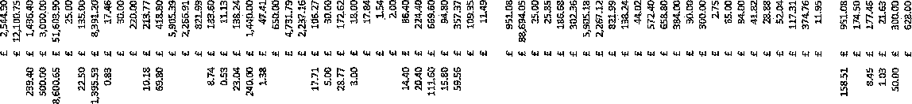
gg g ;m8• 8• ffi 8 8re 1818 i88 88 q• 8
""""
., e'
'
'.'.]
....., "'.., ,
rl
'"
"
•

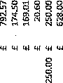
t ffi 888S8 88i
g g g
"'Q" a g 8 <,
i
m m
m

§ 9 g * ti N §
N ·-

rlm M
gN R W



0
'
'
f
ii
';
&:11
1
j
'
Ii ;
H
............................................................ .., .................................................

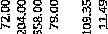

................................................ M...4<4<"'"'"'"'"'

i
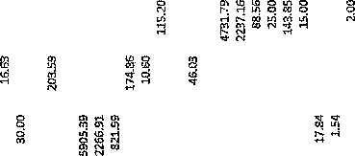
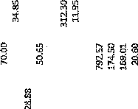
't "
1"'

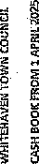
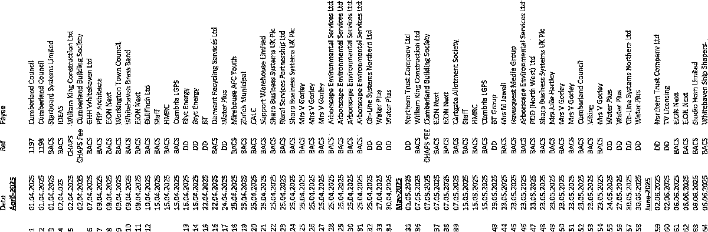

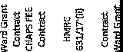

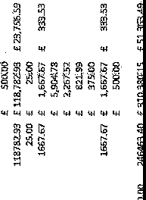
8 25 :;img:si:s .ii
:!lg §§ . -
· "' "''""' "'"' "'
,-,/.,,-,,,, «<'
"" "'"'

g
d

•g 8 I
§
g 8
•

8

'
'
!'
I
I
; ; "i

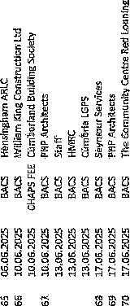

WTC 26/06/2025

Item 8

QUOTE RECEIVED FOR THE SUPPLY OF WINTER BEDDING PLANTS FOR WHITEHAVEN
Purpose of the Report and Recommendation

To inform Members of a quote received for Winter planting 2025 in Whitehaven and to consider whether to suspend Financial Regulations in order that the quote be accepted.

  - INTRODUCTION

  - Attached at Appendix 1 is a quote of £1,926.60 (inclusive of VAT) for the provision of flowers for the 2025 Winter season from the Council's preferred supplier. The price for 2024 was £1,909.80 (inclusive of VAT).
The quote is to supply the flowers for 12 planter bases, 24 barrels, 12 cast iron planters, 5 aluminium planters, 5 plastic planters, Trinity bed, Hensingham Ship and Wilkinson's window boxes.
  - In order to purchase flowers from the Council's preferred supplier the Council will have to consider suspending Financial Regulation 5 to permit this. In order to suspend Financial Regulation 5, Financial Regulation 19.2 states that "The Council may by resolution of the Council duly notified pri9r to the relev;int meeting of Coµncil, sµspend any part of these Financial Regulations provided that reasons for the suspension are recorded and that an assessment of the risks arising has been drawn up and presented in advance to members of the Council".
  - The reasons for suspension are as follows:

    - It is a value for money service.
    - It is a quality service - the Council is constantly asked who provides the flowers.

    - The preferred supplier is very community orientated, has pride in the flowers they provide and even helps with the planting of them in town.

Risks:

    - There is a risk that the flowers could be obtained cheaper by another supplier, but this is a very small risk as the cost per plant is incrndibly low and the quality is very high.

  - BUDGET IMPLICATIONS

  - The 2025/2026 Budget for Whitehaven in Bloom is
£15,000.00 and to date £5,601.25 + VAT has been spent.

  - RECOMMENDATION

  - It is recommended that the Council considers making a resolution to suspend the Financial Regulation 5 to allow the flowers to be purchased from the preferred supplier and if making the resolution.

  - Agree to the reasons for the suspension which will be recorded and also that the assessment above of the risks provided be accepted and approved.

Mtff'fFPE 'Quo-;;€,,
J. & R.
(vU077i::
,;s6 :
J. & R.

-

)ATE I {,•

Iit
il,_'i1 "",',l£ t'<,,s-,J,.,

I '.\""
"' I ;t_
,,,.!,

r...na,-JCit,,.
BEI\INETT
BR00K HOUSE D!STINGTON
:WVBteE
DATE I {,,I (,I:zS-
TO WJilfJiMfl .;,r ,} ;[',: y;..,I Colle
BENNETT
BROOKHOUSE

OISTINGTQN

TO \,,/1-Uf'€ Hfl 1/ t?N -r OWJo.L
\+II N -1GA, (f,t:::a I) t ,J {

W!JRKINGTON
CUMBRIA GA14 5YA
Telephone
Mobile·!
VATITo{t Wu.25703&3 59
'Bo. | 4-ff. i.) ll,U , ,,Jes ,_,,_ |  | f A,, | ,.,,,
f..fJ vq | ,/t<., lot..'1,q-µ,.-(i,1,u1, i,.30 |  | 7$? | (!f.)
10t, I | i-1'ffl<'f",..,-''. |  | Ii s:- | Cv
 |  |  | 4 qt | (JO
P.t.J ..,, ,,-r,, ·"1, fl ,..-j.,:J ,.:rj-!st
,.
7-.SO | U'f'/41' ,,,,..,-i., |  | ! <'""C | co
g, 00& | ,.., iP |  | //I.0 | do
) |  |  | /, f e, | CJ 0
I
 |  |  | ,707 | f",/'',
 | VAT@ flO % |  | - I t,,., t | 4--(7,
 | TOTAL |  | 8 t+,(} | it-O
HSBC
SORT GODE ACCOUNT NUMBER
._ -

\J1JJ"'t, d 0e-n.01µG- ;s.02. S:
WORKINGTON
CUMBRIA GA14 5YA
ToiephOne
Mobile:
I <'o,
2..Sot:
-
-,<_1 ,1:"" I""''
•
- ;,r. r:,J..t..-1
f,.l'f., f,, ,va-1•-r f-{u...
f-fl<
6€'
- '"
-C' .r tJU. u_-.,.,.--::,t-
1-•o
, _,_°1_
WIT Reg.11-0.2571)383 51:l

; q,'>
,;)-,
AO'- /..;.f;,;
'15' "i"'ude
2. .s, lr (It,.
.SO· !4f;
i+ o L,r.i4₁,
H
• ,.,.., •· ..?t..OVt:;-il
I "-
Oo
/)O
00
(JJ,...-1}. ftt-
,.,, •iii p
{l (_1/ £, <I/,"' u...
.,,,111t..;. r::c..,ve"'
"1- ·-· •• i c.
! . $"I• A
,_,.,,...
I -'<o
t -"- P
,.,_t.."C. "
f,t.l'li.Jfi:-'
_{7-Y} r t...,,,,,
51+ ' t,..f,.
_:,'
,,b'':,, £,f;,
tJ'C·L.'f' ..-.9 ,. f,.,; .,,..
hJOLLfl-ovG .5
.0£LU.:5
! <3<>
/-:!,O
i -Jo
"7'fI";- (,\
{3()-;,--"(c..-45
l+1
ft,.
- L;,./1.tr;;.
,f1 I) t,. v ;/ H ,1'",;;.,s.
1<o·c
.
lt,rf "" 6f1<
4-$. 4-lf'..
'25'
,:2..4 i3.,; rl A€ t...'\'
,f O t..'f,1:/ ii.,,,,u,
i-.JO
(1
e..i
. J{ 'f.,,.4.f;; \J I'll, :,.
_-,i.,,
;t"
)LS,S
3-2..
GIL
K.1..
fE, .f(f '
91
tJi
Ji.I,
.9...07.
,<:,:.,..
-:, &
;,,t;("
;.3·5,
.b I
9?
J... 'I
J '7C1'
(ti;,
e;,c
c;t.,
0
..
{S)(;J
Do
o
g.,
CJO
I,;,()
h D
.<h
•• -51:)'·
:5-o
70
.,..
,51:i' •
VAT@ A.0 %
,·o
20
SORTCODE
HSBC
TOTAL I07'i!
•
AGCOUIIT NUMBER
-

.

kttr11e | - 1 ""t> 1 | i.J •.o:,1, | t-.30
Pc t-1,, | d"':"".r,!e,, |  | J-:3 0

WTC 26/06/2025
Item9

ELECTORAL REVIEW OF CUMBERLAND COUNCIL: DRAFT RECOMMENDATIONS

Purpose of the Report

To inform the Council of a consultation documentation received from The Local Government Boundary Commission for England relating to new proposals for new electoral arrangements for Cumberland.

  - INTRODUCTION

  - Attached at Appendix 1 is consultation documentation received from The Local Government Boundary Commission for England.

  - There is a public consultation on this which runs from 3rd June 2025 to 11th August 2025 and when all representations have been considered the Boundary Commission is aiming to publish the final recommendations in December 2025. Once these have been through both houses of Parliament the new electoral arrangements are scheduled to come into effect at authority elections in 2027.

  - Some of the relevant points have been highlighted on the attached document but a few basic points are:

    - 55 Councillors for Cumberland Council (currently 46)
    - 12 Councillors for Whitehaven Town Council representing 10 Wards (presently 12 Wards). Two Wards namely Mirehouse and Whitehaven Central North will each have 2 Councillors
    - The boundaries of the Wards for Whitehaven Town Council are shown on the plans at Appendix 1.
  - Members are asked to consider the consultation document so far as it relates to Whitehaven and formulate a response.

This is a very detailed document which may raise questions and Members may wish to have more time to give a response. If this is the case Members may wish to have a separate meeting to deal with this one issue
  - RECOMMENDATION
  - It is recommended that Members consider the issue and decide the way ahead

Whitehaven Town Council
w--rc (cb(:1-s t,-Cetv\ 9 MPFtst>1 I

From: Sent:
To:
Subject: Attachments:
reviews <reviews@lgbce.org.uk> 03 June 2025 11:31
Whitehaven Town Council
Electoral Review of Cumberland Council: Draft Recommendations
Whitehaven.jpg

Local Government Boundary Commission

3 June 2025
Dear Marlene Jewell

Electoral Review of Cumberland Council: Draft Recommendations

The Local Government Boundary Commission for England has published proposals for new electoral arrangements for Cumberland.
The electoral arrangements for Whitehaven Town Council may change because of our proposals. Please find attached a map outlining the proposed electoral arrangements for your council.
We propose that 55 councillors should be elected to Cumberland Council in future. We also propose new ward boundaries across the authority.
A public consultation on the proposals will run from 3 June to 11 August 2025.
Once we have considered all responses to the consultation, we aim to publish final recommendations in December 2025. We will then lay a draft order in both houses of Parliament. Subject to parliamentary scrutiny, the new electoral arrangements are scheduled to come into effect at the authority's elections in 2027.

We considered all representations received from local people and organisations during our initial consultation when drawing up our proposals. We have sought to balance statutory criteria we must follow when drawing up these proposals, and we seek to:

- Make sure that, within an authority, each councillor represents a similar number of electors
- Create boundaries that are appropriate, and reflect community ties and identities
- Deliver reviews informed by local needs, views and circumstances

We are now inviting comments on the proposals before we finalise the new electoral arrangements in your area. We will consider every response we receive during the consultation period and will weigh each response against the criteria above.

1

If you would like to explore the draft recommendations, you can do so by visiting our website at https://www.lgbce.org.uk/all-reviews/cumberland. Interactive pages give access to the full recommendations They allow people to explore maps of the proposals in greater detail and make comments. We also accept comments:

by email by post
reviews@lgbce.org.uk
Review Officer (Cumberland) LGBCE
7th Floor
3 Bunhill Row London EC1Y 8YZ

The Commission's main website contains further information about the electoral review and our work: http://www.lgbce.org.uk
We will write to you again when we publish our final recommendations. Yours sincerely
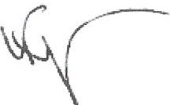
Verni Fagun Review Officer
reviews@lgbce.org.uk
0330 500 1525
Local Government Boundary Commission for England, 7'" Floor, 3 Bunhill Row, London, EC1Y 8YZ Tel: 0330 500 1525; Fax: 0330 500 1526;reviews@lgbce.org.uk;www.lgbce.org.uk

Local Government Boundary Commission for England
Local Government

Boundary Commission
reviews@lgbce.org.uk lgbce.org.uk
7th Floor, 3 Bunhill Row, London, EClY 8YZ


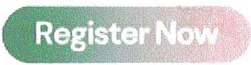
Join us at the LGA Conference and Exhibition Meet us on stand C46

2

Arlecdon &,! Moresby, Distington & Arlecdo Moresby

•ts Park
& Harr k...,._. _ _,

Wed,

Cleator Moor
Kells

Mlrehouse

j,\ ' I

S.ndwith
' \
Bigrlgg & Moor Row
\

Egremont

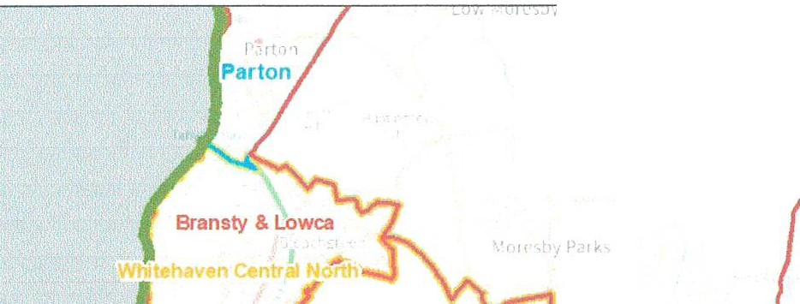
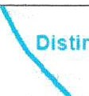
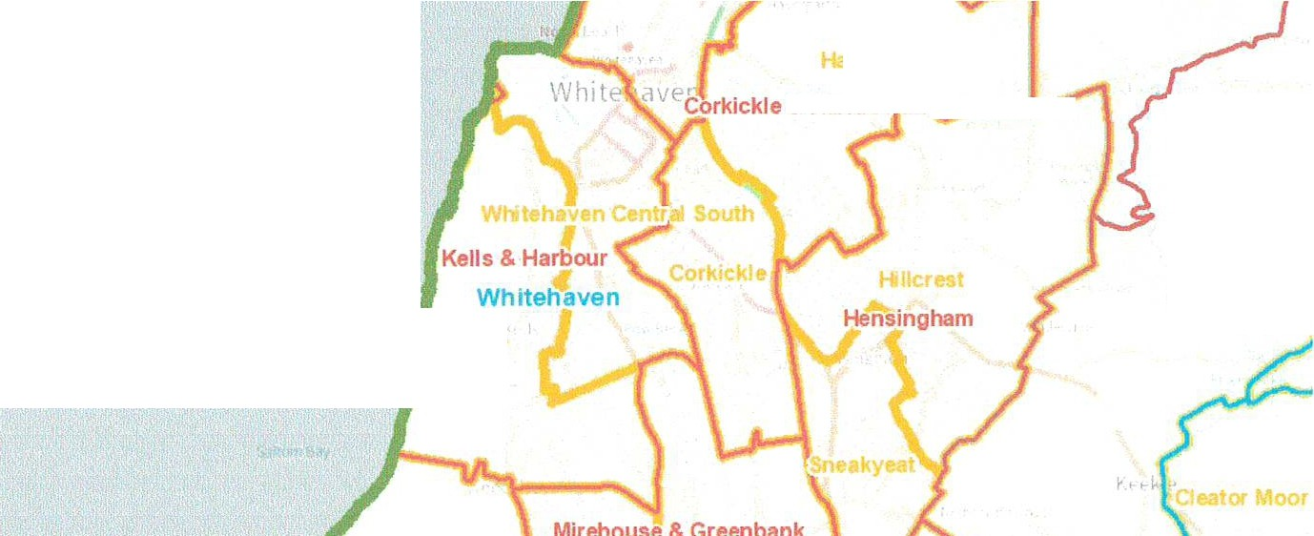
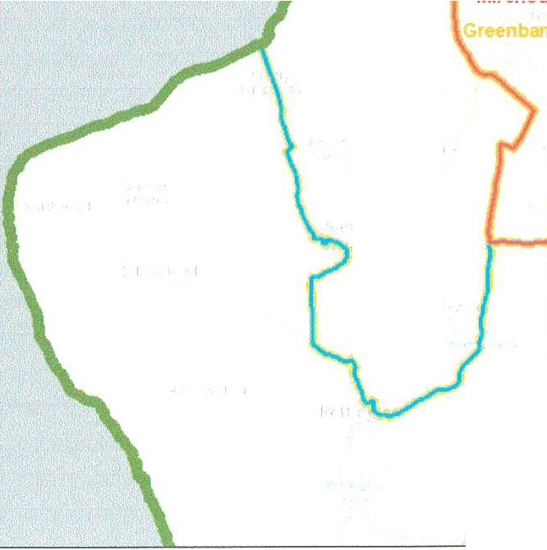
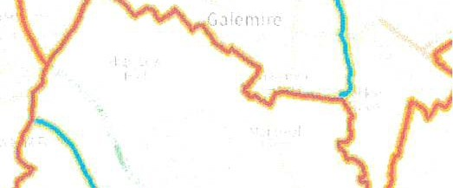
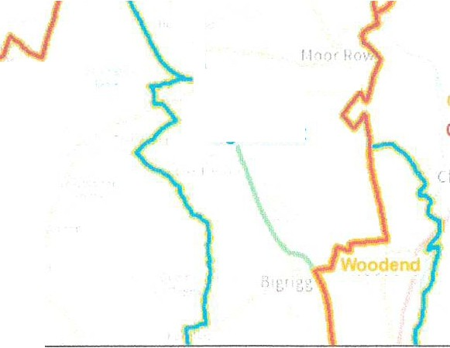

St Bees & Sandwith

St. Bees

Moresby, Distington & ArlecdonJ;.,i.
Moresby

Weddicar

4liia.

K4:tl1
1singham

FrLtington

" ' f

,Ct'Nnbantl

MlfehOUH

I. ,,
S.ndwlth
·,
\
II
iog &Moor
\
Eg emont

Cleator Moor
o.. tar M,-- "-··'th
Cleator Moor South

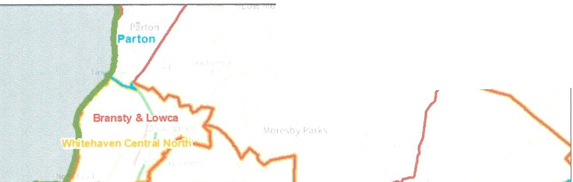
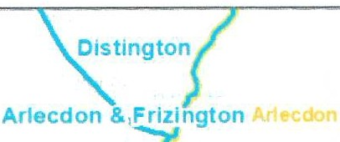
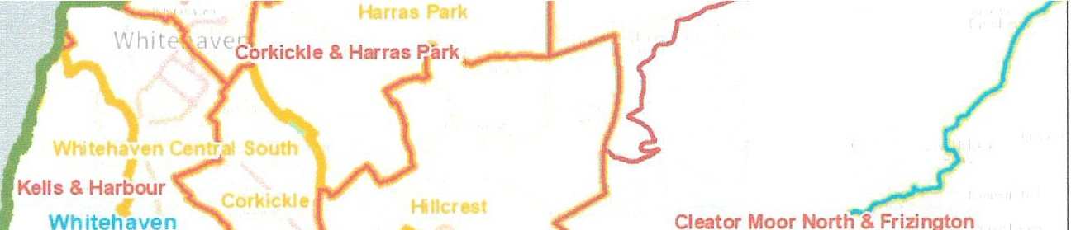
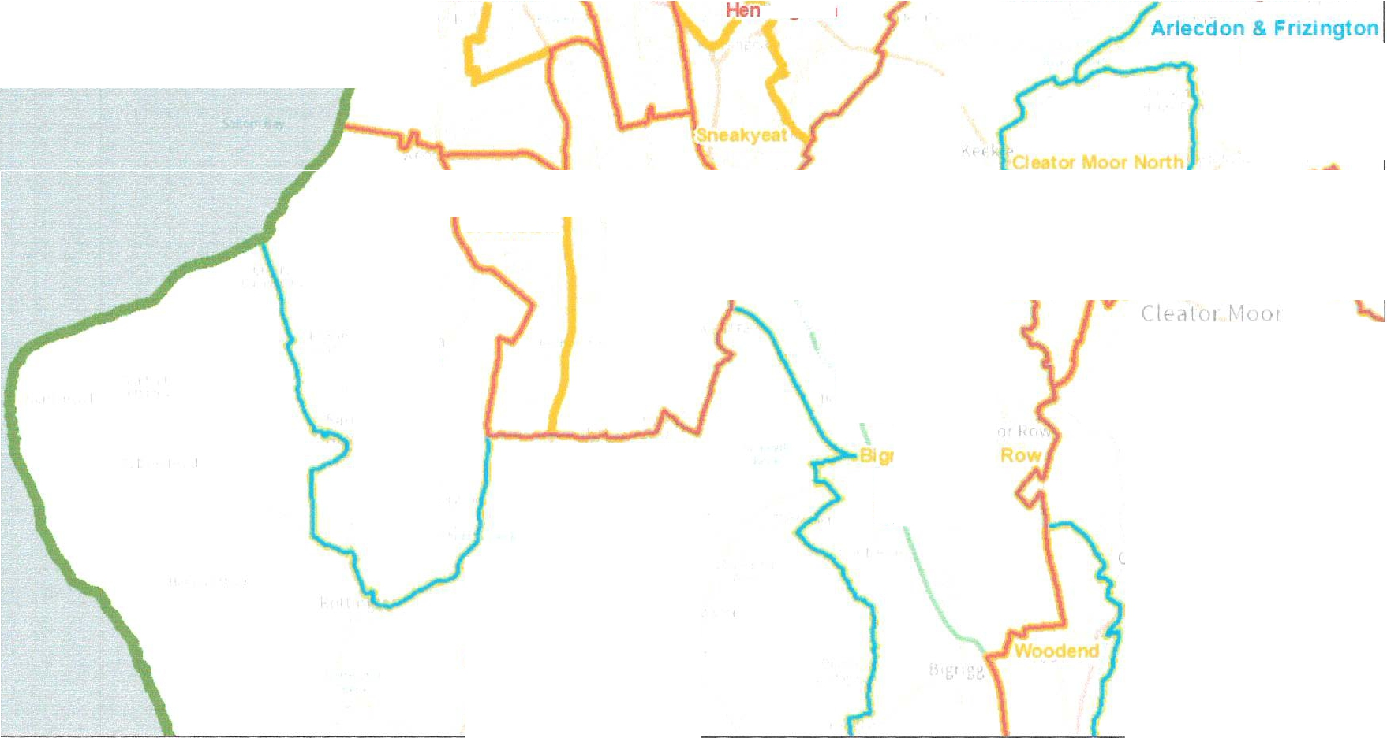
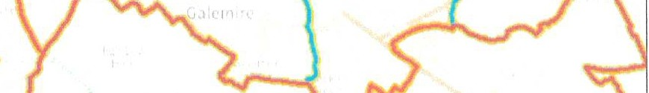
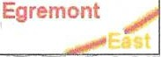
Local Government ou_Q ary Commission

Parish Warding Arrangements for Whitehaven

Qrnstrict
r--,Draft
c:::JParish
L--..1Recommendations
Parish Ward
0 32: 0 6
Kiiomete19
u
: +:
1xc..; --.;;; ;- :.

St Bees & Sandwith

St. Bees

Whitehaven Town Council

From:
Sent: To: Subject:
The Local Government Boundary Commission for England
<reviews@lgbce.org.uk> 03 June 2025 17:07
Whitehaven Town Council
Cumberland Ward Boundary Review - Draft Recommendations

The
Local Government Boundary Commission
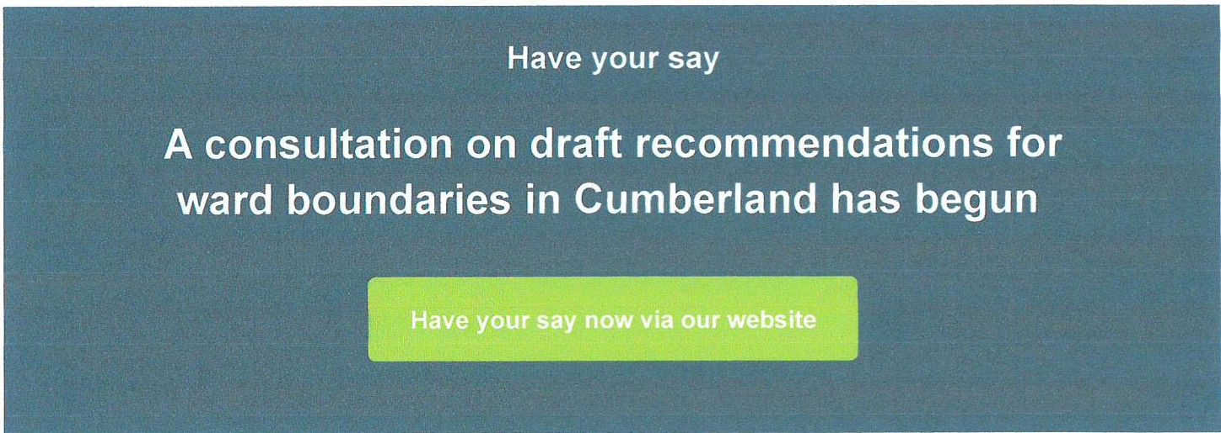
for England

Today we published draft recommendations for new wards, ward boundaries, and ward names for Cumberland Council.

We are now inviting comments on those recommendations. Our consultation closes on 11 August 2025.
If you represent a local organisation or community group in Cumberland, please pass this message on to your members or anyone you think who might be interested in the review. You can share the message by email or through social media by using the buttons at the bottom right of the page.

Draft recommendations report

Draft recommendations map

Summary of the draft recommendations

As a result of our draft recommendations for new warding patterns, we propose making changes to the parish electoral arrangements for the following parish and town councils:

- Atkton
- Allhallows
- Arlecdon & Frizington
- Beckenne>J
- oltons
- Cleator Moor
- Cockermouth
- Palsto11
- rnmQnt
- Kingmoor
- MaryQort
- M1llom
- Oughters1de & Al erbj'.

" t._Cu1_rbert Witl-iout
- Slflnwix Rural
- WesJward
" White>haVSIJ.
- Wigton
- Workington

Have your say
You can take part in the consultation by clicking the button at the top of this message or

through our review.
, which includes further information about the Commission and the

We encourage everyone who has a view on the draft recommendations to contact us, whether you support them or whether you wish to propose alternative arrangements.

We will consider every representation received during consultation, whether it is submitted by an individual, a local group or an organisation.

We will weigh each submission against the legal criteria which we must follow when drawing up electoral arrangements:

2

to deliver electoral equality: where each councillor represents roughly the same number of electors as others across the authority;
that the pattern of wards should, as far as possible, reflect the interests and identities of local communities;
that the electoral arrangements should provide for effective and convenient local government.

It is important that you take account of the criteria if you are suggesting an alternative pattern of wards.

If you wish to put forward a view, we would also urge you to ensure that evidence supports your submission.

For example, if you wish to argue that two areas should be included in the same electoral ward, make sure you tell us why they should be together, providing evidence about community facilities, ties, organisations, and amenities, rather than simply asserting that they belong together.

Our website features that explains the process and our policies, as well as guidance on how to take part in each part of the process.

Promote the review in your area with our promotional poster

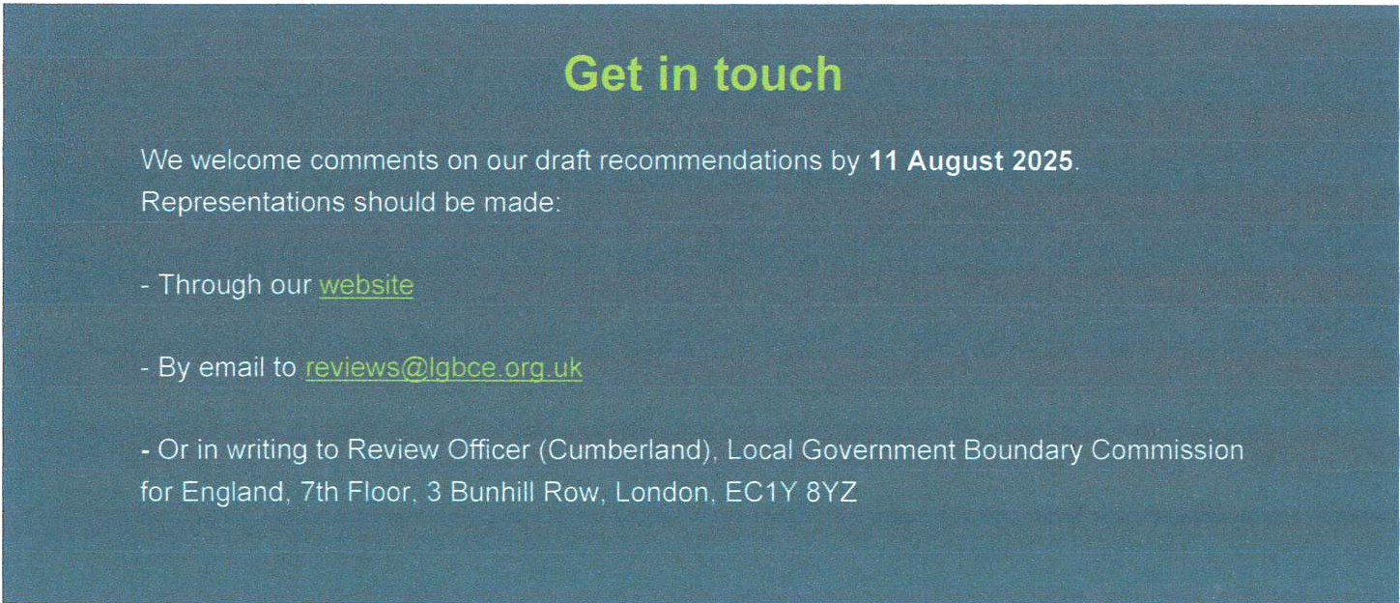

½ a @) in ®

3

Local Government Boundary Commission
li1&Ui likHI i#1,M,i
rtH·14iN

4

Local Government Boundary Commission

Local Government Boundary Commission
June 2025
Summary Report
The fuff report and detailed maps: httD1·11www labc@ nm uklill-revlenlcumbedand

Have your say
We ,11t• now c011s1,l\111q to,:;11 ['lr.('Jlf,• 011 """'· t••1t1cr11,,I w.trrh Im C1.1mb+"fl;:mf1 C11U1'1.1I 'Ne> h.11.-r ;t, r1r,...,,, ni•nit abo JI PW hnal fef ,")fllfll(·lk ,111,x,-.. Jn<1 Wt· wi:1f'rn\",id!'f (•VtHy p,,!f'.C ni ·• i( •11,·t, •\•) WCl!•l.t' lrum k11;1l Jr11u;,•; ,lrld
peo.:il< . ff!t),'lfOk!;.-.oi who1n 111r, hnn- _Jf \\1 t·llw1 1: rd,llr:-. lr, lht• whdl' ··1i.mnl .11,:,,1 ·M f11!'.I ,, jJ.lrl ,,1,1·

II yu1 a•JUH• 'htt·i ,lt.l r, rn111me•1(J,1htms.. µl thl" 1..t11tIOll.J'h II yrn, ,torn!funk (llJ' r,;HY111inrn11d,1:1011•, .ir rqt1! kr Cut11ta.irl,md Wll w,ml lu t1u,tr itl!Crt'iill\Cµr{J l,.):,,<lb lo· II d,lh.''8111 oatte,n of mi ..
Council
on the new electoral arrangements
Draft Recommendations
Cumberland

Weaim topropose a pattern of wards for Cumber1and Council which d lvers:
- Bectoral equallty: each councillor represents a slmlar number of e'8ctors.
- Community klentity: reflects the Identity and Interests of local communities.
- Effective and c:onvenient local government: helping your council discharge its responsibilities effective .

A good pattern of wards should:
- Provide good eHK:toral equality. with each councillOf representing. ascloselyas possible, the same number of electors.
- Refloct community interests and identities and include evidence of community links.
- Be basedon strong, easily identifiable boundaries.
- Help the council deliver elfectlve and convenient local government.

Electoral equality
- Does your proposal mean that councillors would represent roughly thesame number of electors as elsewhere in the council area?

Community identity
- Transport links: are there good links across your proposed ward? Is there any tom, of public transport?
- Community groups: !s there e parish counci, residents association or another group that represents the area?
- Facllltloa: does your pattern of wards reftect where local peopte go for shops, medical servk::es. leisure facilities etc?
Write to:
Review Officer (Cumber1and)
LGBCE. 7th Floor. Bunhlll Row.
London, ec,v svz

- lnt,rests: what issues bind the community together or separate ii from other parts of your area?
- ldenttflabl• boundaries: are there natural or constructed features which make strong boundaries for your PfOPoSals?

Effective local government
- Are any of the prop0sad wards too large or small to be represented effectively?
- Aretheproposed namesof thewardsappropriate?

Useful tips
- You canexplore themaps onour website at lgbc:e. org.uk
- We publish all submissions we receive on our website.

Our website: https://www.lgbce.org.uk/all revlews/cumberland
Email:
revlews@lgtx:e.org.uk
X:
@LGBCE

Who we are
- The Local Government Boundary Commission
for England is an independent body set up by ParUament.
- We are not part of government or any political
party.
- We are accounla e to Parliament through a committee of MPs chaired by the Speaker of the House of Commons.
- Our main role is to carry out electoral reviews of
local authorities throughout England.

Electoral review
An electoral review examines and proposes new electoral arrangements for a local authority, inciuding:
- The total number of councillors representing the council's electors ('council size'),
- The names, number and boundaries of wards or electoral divisions.
- The number of councitlors for each ward or divfskJn.

Why Cumberland?
- The Commission is carrying out an electoral review of Cumber1and as it is a new local authority

Our proposals
- We propose that the council should have 55 councillors in future. representing 55 single­ councillor wards.

You have until 11 August 2025 to have your say on the recommendations

Summary of our recommendations
Our draf't recommendatJons propose lhal Cumberland Council should have 55 councillors, an Increase of 9 from the existing arrangements.

Those councillors should represent 55 single-councillor wards across the councllarea.

Before drawing up the draft recommendations, the Commission earned out a public consuttation inviting proposals for a new pattem of wards for Cumber1and.

We have considered an of the submissions we received during that phase of consultation. The boundaries of most wards should change.

An outline of the proposals is shown in the map to the right

Wewelcome commentson our draft recommendations. whether you support the proposals or wish to put forward alternative arrangements.

Have your say at
https://www.lgbce.org.ukJall-reviews/cumberland
- view tne map ot our recommendations down to street level.
- zoom into the areas thatInterest you most.
- find more guidance on how to have your say.
- read the full report of our recommendations.
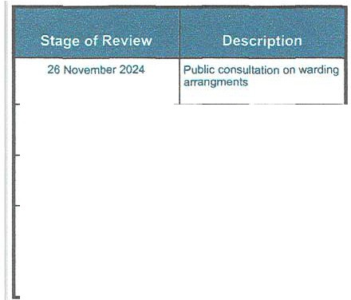
- sendus your views diroct.ly.
24 February 2025
Overview of draft recommendations for Cumberland Council
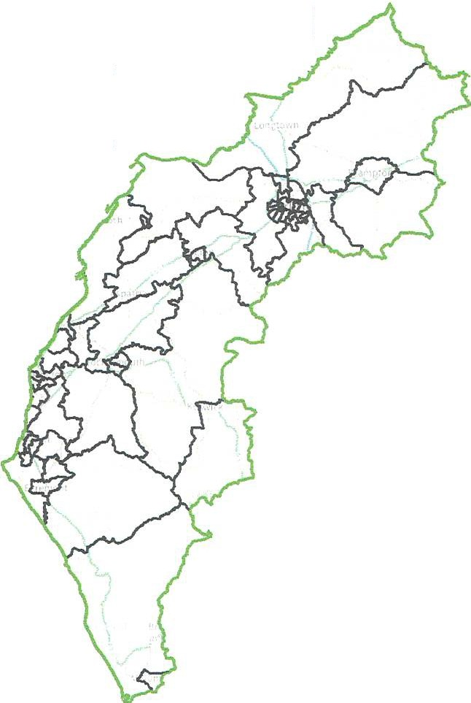
View this map online:
https:flwww.lgbce.org.uk/all-revlews/cumbertand Follow the review on X: @LGBCE
For ward details, pleas.a see the full draft
recommendationsreport, ava!labfe at: https:/lwww.lgbce.org.uk/all•revlews/cumlMirfand

3 June  11 August 2025  - - | Publlc consultation on draft recommendations
2 December 2025 | Pubiicatlon of final recommendations
May 2027 | Subject to parliamentary approval - implementationof new arrangements at local elections

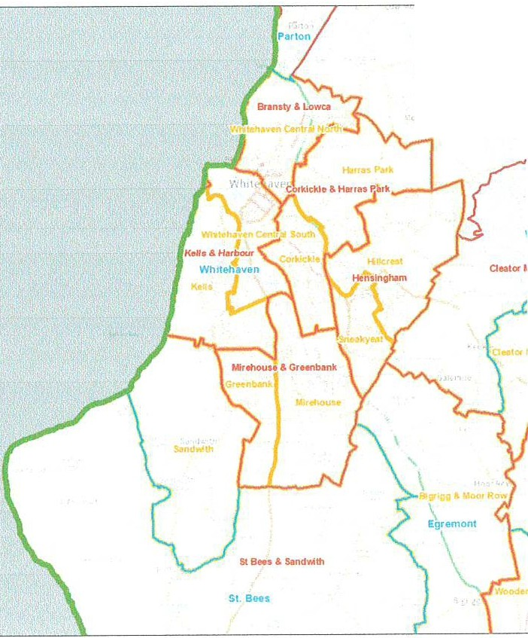
Artecda
Morott,f,Obtlngton & Al1
Mo,asby
t:1! ue
m...',."
PanshWard
CJf!l'TY'llendations
□Parish
Parish warding Arrangements for
Whitehaven

Oi trict
Bo,unde.ry Canmlssloo
Local Government
..

T
Local Government Boundary Commission
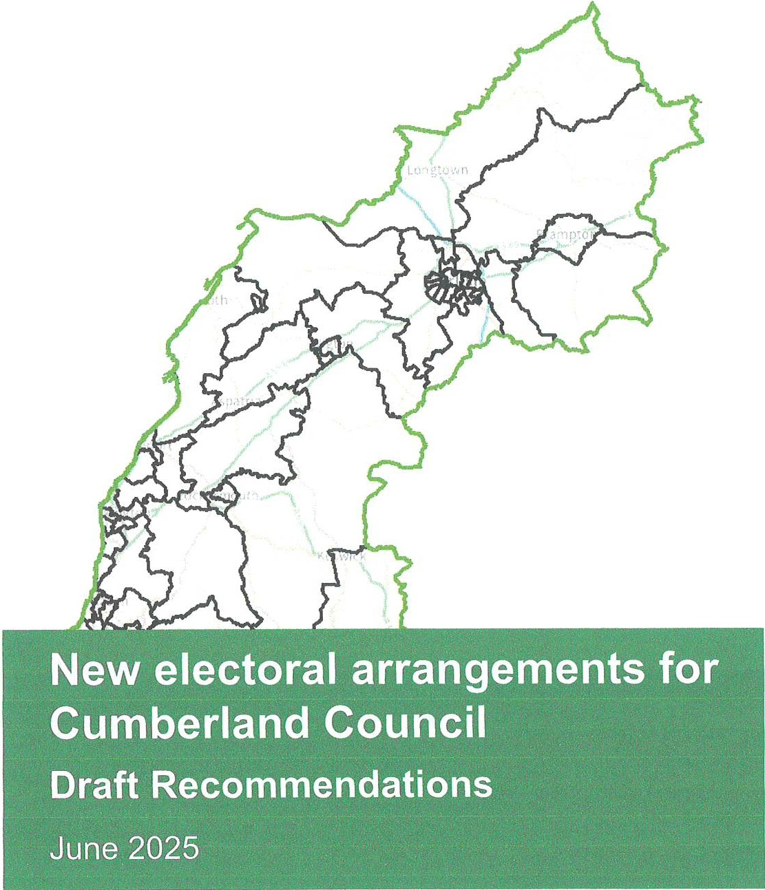

-

Translations and other formats:
To get this report in another language or in a large-print or Braille version, please contact the Local Government Boundary Commission for England at:
Tel: 0330 500 1525
Email: reviews@lgbce.org.uk

Licensing:
The mapping in this report is based upon Ordnance Survey material with the permission of Ordnance Survey on behalf of the Keeper of Public Records
© Crown copyright and database right. Unauthorised reproduction infringes
Crown copyright and database right. Licence Number: AC 0000807452 2025

A note on our mapping:
The maps shown in this report are for illustrative purposes only. Whilst best efforts have been made by our staff to ensure that the maps included in this report are representative of the boundaries described by the text, there may be slight variations between these maps and the large PDF map that
accompanies this report, or the digital mapping supplied on our consultation portal. This is due to the way in which the final mapped products are produced. The reader should therefore refer to either the large PDF supplied with this report or the digital mapping for the true likeness of the boundaries intended. The boundaries as shown on either the large PDF map or the digital mapping should always appear identical.

Contents
Introduction
Who we are and what we do What is an electoral review?
Why Cumberland? 2
Our proposals for Cumberland 2
How will the recommendations affect you? 2
Have your say 3
Review timetable 3
Analysis and draft recommendations 5
Submissions received 5
Electorate figures 5
Number of councillors 6
Ward boundaries consultation 6
Draft recommendations 7
North-east 9
Carlisle and Houghton 15
Fells & Salway 23
Workington & Seaton 27
Whitehaven and neighbouring parishes 32
Midwest and Central Cumberland and Maryport 36
South Cumberland 41
Conclusions 48
Summary of electoral arrangements 48
Parish electoral arrangements 48
Have your say 56
Equalities 60
Appendices 62
Appendix A 62
Draft recommendations for Cumberland Council 62
Appendix B 67
Outline map 67
Carlisle and Houghton 68
Whitehaven and surrounding wards 69

Workington and surrounding wards 70
Appendix C 73

Submissions received 73
Appendix D 75

Glossary and abbreviations 75

Introduction
Who we are and what we do
The Local Government Boundary Commission for England (LGBCE) is an independent body set up by Parliament.1 We are not part of government or any political party. We are accountable to Parliament through a committee of MPs chaired by the Speaker of the House of Commons. Our main role is to carry out electoral reviews of local authorities throughout England.

- The members of the Commission are:

  - Professor Colin Mellors OBE (Chair)
  - Andrew Scallan CBE (Deputy Chair)
  - Amanda Nobbs OBE

What is an electoral review?
- Steve Robinson
- Wallace Sampson OBE
- Liz Treacy

- Ailsa Irvine (Chief Executive)

- An electoral review examines and proposes new electoral arrangements for a local authority. A local authority's electoral arrangements decide:

  - How many councillors are needed.
  - How many wards or electoral divisions there should be, where their boundaries are and what they should be called.
  - How many councillors should represent each ward or division.

- When carrying out an electoral review the Commission has three main considerations:

  - Improving electoral equality by equalising the number of electors that each councillor represents.
  - Ensuring that the recommendations reflect community identity.
  - Providing arrangements that support effective and convenient local government.

- Our task is to strike the best balance between these three considerations when making our recommendations.

1 Under the Local Democracy, Economic Development and Construction Act 2009.

- More details regarding the powers that we have, as well as further guidance and information about electoral reviews and the review process in general, can be found on our website at www.lgbce.org.uk

Why Cumberland?
- We are conducting a review of Cumberland Council ('the Council') as it is a new authority, whose electoral arrangements have not been reviewed since its establishment in 2023. The existing electoral arrangements were intended to be interim for the purposes of the first elections to the authority. Additionally, some councillors currently represent many more or fewer electors than others. We describe this as 'electoral inequality'. Our aim is to create 'electoral equality', where the number of electors per councillor is as even as possible, ideally within 10% of being exactly equal.

- This electoral review is being carried out to ensure that:

  - The wards in Cumberland are in the best possible places to help the Council carry out its responsibilities effectively.
  - The number of electors represented by each councillor is approximately the same across the authority.

Our proposals for Cumberland
- Cumberland should be represented by 55 councillors, nine more than there are now.

- Cumberland should have 55 wards, nine more than there are now.

- The boundaries of two wards will stay the same, the rest will change.

How will the recommendations affect you?
- The recommendations will determine how many councillors will serve on the Council. They will also decide which ward you vote in, which other communities are in that ward, and, in some cases, which parish council ward you vote in. Your ward name may also change.
- Our recommendations cannot affect the external boundaries of the district or result in changes to postcodes. They do not take into account parliamentary constituency boundaries. The recommendations will not have an effect on local taxes, house prices or car and house insurance premiums, and we are not able to consider any representations which are based on these issues.

2

Have your say
- We will consult on the draft recommendations for a 10-week period, from 3 June 2025 to 11 August 2025. We encourage everyone to use this opportunity to comment on these proposed wards as the more public views we hear, the more informed our decisions will be in making our final recommendations.

- We ask everyone wishing to contribute ideas for the new wards to first read this report and look at the accompanying map before responding to us.

- You have until 11 August 2025 to have your say on the draft recommendations. See page 55 for how to send us your response.

Review timetable
- We wrote to the Council to ask its views on the appropriate number of councillors for Cumberland. We then held a period of consultation with the public on warding patterns for the local authority area. The submissions received during consultation have informed our draft recommendations.

- The review is being conducted as follows:

Stage sta,1s Description

19 November 2024 Number of councillors decided
26 November 2024 Start of consultation seeking views on new wards

24 February 2025 End of consultation; we began analysing submissions and forming draft recommendations
3 June 2025 Publication of draft recommendations; start of second consultation

11 August 2025 End of consultation; we begin analysing submissions and forming final recommendations
2 December 2025 Publication of final recommendations

3

4

Analysis and draft recommendations
- Legislation2 states that our recommendations should not be based only on how many electors3 there are now, but also on how many there are likely to be in the five years after the publication of our final recommendations. We must also try to recommend strong, clearly identifiable boundaries for our wards.

- In reality, we are unlikely to be able to create wards with exactly the same number of electors in each; we have to be flexible. However, we try to keep the number of electors represented by each councillor as close to the average for the council as possible.

- We work out the average number of electors per councillor for each individual local authority by dividing the electorate by the number of councillors, as shown on the table below.

2024 2030
Electorate of Cumberland 216,592 214,482
Number of councillors 55 55

Average number of electors per councillor
3,938 3,900

- When the number of electors per councillor in a ward is within 10% of the average for the authority, we refer to the ward as having 'good electoral equality'. All but five of our proposed wards for Cumberland are forecast to have good electoral equality by 2030.

Submissions received
- See Appendix C for details of the submissions received. All submissions may be viewed on our website at www.lgbce.org.uk

Electorate figures
- The Council submitted electorate forecasts for 2030, a period five years on from the scheduled publication of our final recommendations in 2025. These forecasts were broken down to polling district level and predicted a decrease in the electorate of around 1% by 2030.

- We considered the information provided by the Council and are satisfied that the projected figures are the best available at the present time. We have used these figures to produce our draft recommendations.

2 Schedule 2 to the Local Democracy, Economic Development and Construction Act 2009.
3 Electors refers to the number of people registered to vote, not the whole adult population.

5

- Our mapping tool uses geocoded electoral registers supplied by the Council to locate electors, by associating addresses with specific geographic coordinates. It considers each elector's location to produce precise elector counts for each ward. There can be very slight differences between the electorate figures published on our website at the beginning of the review and the electorate figures published in this report. However, these are very minor and do not impact on our recommendations.

Number of councillors
- Cumberland Council currently has 46 councillors. We looked at evidence provided by the Council and have concluded that increasing this number by nine will ensure the Council can carry out its roles and responsibilities effectively.

- We therefore invited proposals for new patterns of wards that would be represented by 55 councillors, for example, 55 one-councillor wards or a mix of one-, two- and three-councillor wards.

- We received 21 submissions about the number of councillors in response to our consultation on ward patterns. Most of them objected to the increase in councillor numbers, with some questioning how this will be funded. Some objected because of their views of the Council's performance.

- A few respondents supported the increase with one advocating a further increase of nine bringing the total number of councillors to 64. This respondent based their recommendation on a reduction of the elector per councillor number, but did not explain why a councillor-elector ratio of around 3,400 was the right one for Cumberland.

- We therefore based our draft recommendations on a 55-councillor council.

Ward boundaries consultation
- We received 82 submissions in response to our consultation on ward boundaries. These included three authority-wide proposals, from the Council, Cumberland Conservatives and Cumberland Liberal Democrats. We also received a proposal from Whitehaven & Workington Labour Party (Whitehaven & Workington Labour) for 18 wards covering its parliamentary constituency area, and a submission from Councillor Davison on behalf of the Cumberland Council Green Group (Green Group). The remainder of the submissions provided localised comments for ward arrangements in particular areas of the local authority area.

- The authority-wide schemes provided a uniform pattern of one-councillor wards, as did the partial scheme from Whitehaven & Workington Labour.

6

- We carefully considered the proposals received and were of the view that the proposed patterns of wards resulted in good levels of electoral equality in most areas of the authority and generally used identifiable boundaries. We commend the authors for the time, thought and attention to detail expended in producing these proposals.

- The district-wide schemes were very different in most areas. Therefore, in many areas, once we had adopted the boundaries of one scheme, it was difficult to adopt another scheme in other areas. Nevertheless, we considered the merits of the individual boundaries of all the schemes, and so were able to adopt different proposals is some places.

- Our draft recommendations take into account local evidence that we received, which provided further evidence of community links and locally recognised boundaries. In some areas we considered that the proposals did not provide for the best balance between our statutory criteria and so we identified alternative boundaries.

- We also note that most of the district-wide and partial schemes did not provide detailed community evidence to support their proposals. All of them relied heavily on polling district boundaries and merging polling districts. It is worth pointing out that we do not consider that polling districts necessarily reflect communities: they are administrative tools for facilitating elections. Following this review of Cumberland, the Council will carry out a review of its polling districts to ensure that they align with the new wards being created.

- If following the consultation on these draft recommendations we need additional clarification in any area, we will carry out a physical tour prior to the publication of final recommendations for the district.

Draft recommendations
- Our draft recommendations are for 55 one-councillor wards. We consider that our draft recommendations will provide for good electoral equality while reflecting community identities and interests where we received such evidence during consultation.

- The tables and maps on pages 9-46 detail our draft recommendations for each area of Cumberland. They detail how the proposed warding arrangements reflect the three statutory⁴ criteria of:

  - Equality of representation.

- Local Democracy, Economic Development and Construction Act 2009.

7

  - Reflecting community interests and identities.
  - Providing for effective and convenient local government.

- A summary of our proposed new wards Is set out In the table starting on page 61 and on the large map accompanying this report.
- We welcome all comments on these draft recommendations, particularly on the location of the ward boundaries and the names of our proposed wards.

8

North-east
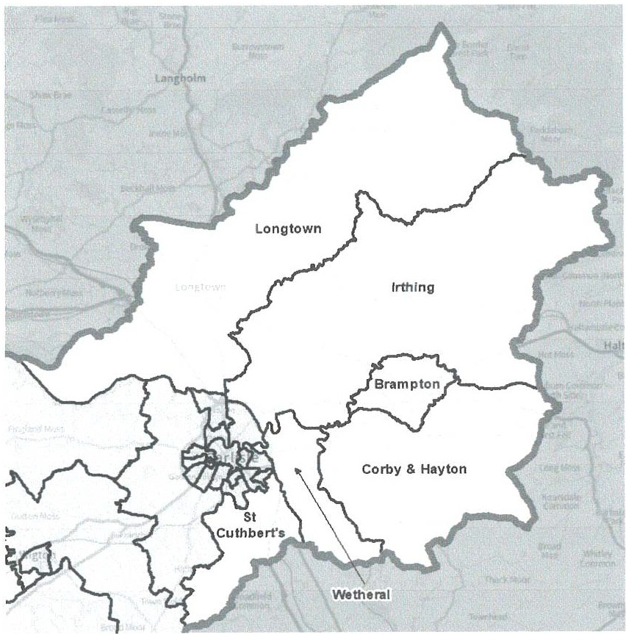

Ward name  Brampton | Number of councI ors | Variance 2030  -1%
Corby & Hayton |  | 0%
lrthing |  | -12%
Longtown |  | 3%
St Cuthbert's |  | -7%
Wetheral |  | 0%

Brampton
11
- In addition to the district-wide proposals, we received submissions from the Green Group and some residents about Brampton ward.

9

Currently, Brampton parish is included in a ward with six smaller parishes to its
northeast.

The Council and Liberal Democrats both proposed a Brampton ward coterminous with Brampton parish boundaries. The Council stated that this preserved this market town as a single ward with capaclty for the development expected in future years. The Green Group expressed broad support for the Liberal Democrats' proposed ward in this area.

The Conservatives' proposals split Brampton town and parish across two wards. They acknowledged that based on 2030 forecast figures, Brampton parish could form a district ward. However, In their view splitting the parish across two district wards would prevent the creation of a doughnut ward completely surrounding Brampton or a geographically large ward comprising the rural parishes either side of
the perish.

- A resident stated that the River Eden was a natural boundary In the east, for Brampton ward. A resldant of Talkin village advocated to be in Brampton ward instead of Corby & Hayton, as at present. They also felt Talkin should be in Castle Carrock parish and not Hayton, for community identity reasons.

A resident of lrthington also advocated to be placed in Brampton ward because
it was the nearest town to lrthington.

- We considered the different viewpoints carefully. We note that due to the rural nature of most of Cumberland, there will be some geographically large wards in some area of the district - as proposed by all the district-wide schemes that we received. Therefore, we were not persuaded to split Brampton town just to avoid the creation of a large ward elsewhere. We considered that keeping Brampton town in a single ward better reflected the community Identity and would facilitate effective and convenient local government in Brampton.
- While we noted the comments about lrthington and Talkin villages being close to Brampton, we consider that within any warding pattern, there will always be villages close to towns that will be in different wards,

- Accordingly, we have adopted the proposals submitted by the Council and the

Liberal Democrats as part of our draft recommendations.

- Brampton ward is forecast to have good electoral equality by 2030.

- On Talkin village being in Hayton parish and not Castle Carrock parish, this Is a

matter for Cumberland Council and outside the scope of our electoral review.

10

Corby & Hayton
- In addition to the district-wide proposals, we received submissions from the Green Group and Councillor Dobson.

- The district-wide submissions all advocated for the retention of the existing ward. This was also supported by the Green Group.

- The Liberal Democrats described the existing ward as being made up of the villages south of Brampton with the River Eden as a natural boundary to the west.

- Councillor Dobson was also of the view that there was no compelling need to change the existing ward. He pointed out that the existing ward was forecast to have very good electoral equality by 2030, and that all the parishes within the ward had shared issues around road, bus and rail transport services.

- We considered these comments and note that in addition to these shared issues, this ward has clearly identifiable boundaries: River Eden to the west and the district boundary to the south and east. We also note the consensus by all those who wrote in to us. Accordingly, we are content to adopt it as part of our draft recommendations.

- Corby & Hayton ward is forecast to have good electoral equality by 2030.

lrthing & Longtown
- We received submissions from Councillor Pickstone and a resident in addition to the district-wide proposals for this area.

- The Council's and Liberal Democrats' proposals for Longtown ward were similar. While the Liberal Democrats retained the boundaries of the existing ward, the Council excluded Harker village from its proposed ward.

- Their proposals for the parishes between Longtown and Brampton wards had a few more differences. The Liberal Democrats included the entire area in its lrthing ward which had the M6 as its western boundary. The Council's Houghton & Walton ward included most of the same area but included more of Stanwix Rural parish and placed lrthington parish in a ward to the south. The Liberal Democrats say that the River lrthing runs through most of their proposed lrthing ward, and that it represents the rural villages north of Brampton.

- The Conservatives excluded Bewcastle and Solport parishes from their proposed Longtown ward and had included them in their proposals for the Brampton area. We consider that our proposed wards in Brampton are a good reflection of our statutory criteria, and we do not consider we should move away from them to adopt their proposal here.

11

- Councillor Pickstone advocated for the retention of the existing Longtown ward. ward. He stated that this ward was unique because it was made up of the entirety of northwest England's border with Scotland. This created shared issues with the eastern villages in the area using health services in Scotland.

- He was of the view that all the villages looked to Longtown village for most of their amenities, and that there were good community and transport links between most of the villages.

- As mentioned in the section on Brampton, a resident wanted lrthington included in Brampton ward due to its proximity to Brampton town.
- After careful consideration, we have been persuaded to retain the boundaries of the existing Longtown ward as part of our draft recommendations. At the same time, we have not been persuaded to move lrthington into a ward to the south of this area.

- Furthermore, we have been persuaded that the M6 is a strong identifiable boundary. Accordingly, we have adopted the Liberal Democrats' proposals for lrthing ward as part of our draft recommendations, with one modification in the south of the ward. There do not appear to be any direct crossings between Aglionby and Warwick-on-Eden in the south and the rest of the Liberal Democrats' proposed ward. Therefore, we have moved the southern boundary of this ward so that it runs from the MS along the River Eden, which is the boundary between Stanwix Rural and Wetheral parishes.

- This reduces the size of this geographically large rural ward and it now has slightly fewer electors per councillor than we would normally recommend. Nevertheless, we consider this the best balance of our statutory criteria.

- lrthing ward is forecast to have 12% fewer electors than the average for the district. Longtown ward is forecast to have 3% more electors than the average for Cumberland, by 2030.

St Cuthbert's and Wetheral
- In addition to the district-wide proposals, we received a submission from the Green Group and some residents. The Green Group expressed broad support for the Liberal Democrats' proposals on the southern outskirts of Carlisle.

- The district-wide proposals were very different here.

- The Council proposed a Garlands & Durdar ward and a Wetheral ward. Its Wetheral ward included an area of Scotby, south of the railway line just north of Parkett Hill. It said that the new Garlands & Durdar ward capitalised on the increased

12

connectivity across the southern edge of Carlisle. The rest of Scotby was included in a Carlisle-facing ward to the west. The southern boundary of this ward was north of Cotehill and Low Cotehill which it included with most of St Cuthbert Without parish in its Garlands & Durdar ward.

- The Conservatives also proposed two wards in the area: St Cuthbert's and Wetheral & Scotby. Like the Council, they excluded Cotehill and Low Cotehill villages from Wetheral ward and included them in St Cuthbert's. Unlike the Council, they included all of Scotby village in one ward. They say that this ward utilises the River Eden as a natural boundary to the north. Their proposed St Cuthbert's ward did not include the Garlands area of St Cuthbert Without parish, but it included Blackwell and also Raughton Head in Dalston parish.

- The Liberal Democrats created a Dalston ward comprising Dalston parish and a significant part of St Cuthbert Without parish. However, they excluded Blackwell from this ward. Their proposals for Wetheral ward excluded the Garlands area of St Cuthbert Without parish but included the Carleton area.

- We carefully considered the proposals presented to us. We were not persuaded to split the Scotby community across district wards as proposed by the Council. As mentioned in the previous section, neither were we persuaded to exclude Aglionby and Warwick-on-Eden from wards in this area and include them in lrthing ward to the north.

- At the same time, we were not convinced that Cotehill and Low Cotehill had good road connections within Cumberland district with St Cuthbert Without parish.

- Therefore, after very careful consideration, including what will facilitate a good warding pattern in Carlisle, we have based our draft recommendation wards in this area on aspects of all the three district-wide schemes.

- Wetheral ward comprises Wetheral parish with the exception of Durranhill and Great Corby parish wards. This ward is bounded by the River Eden, the district boundary and parish boundaries.

- St Cuthbert's western boundary is based on the Conservatives' proposal while its northern and most of the eastern boundary is based on the Council's proposal and also on aspects of the Liberal Democrats' proposed ward.

- We welcome comments with community evidence on whether we should rename the wards St Cuthbert's & Garlands and Wetheral and Scotby as part of our final recommendations.

13

- St Cuthbert's and Wetheral wards are both forecast to have good electoral equality by 2030.

- A resident requested that Barley Edge be moved from Wetheral parish. Another resident also mentioned that Wetheral parish crossed the M6 and that Barley Edge and other neighbouring roads should be part of Botcherby ward. This area is currently in Botcherby ward and we propose retaining it there.

- At the same time we recognise that the streets in questions are in Wetheral parish. However, changing parish boundaries is outside the scope of an electoral review like this one. Modifying parish boundaries is the responsibility of Cumberland Council after carrying out a Community Governance Review.

14

Carlisle and Houghton
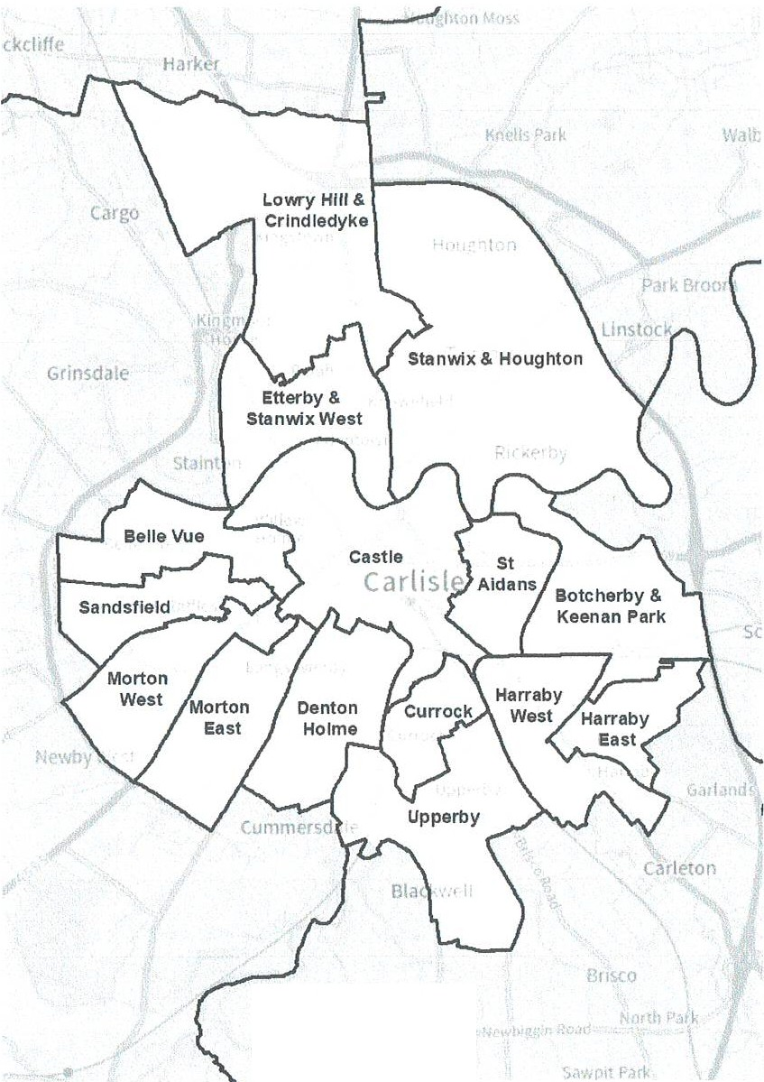
Ourdar

15

Number of
Ward name | councillors | Variance 2030
Belle Vue |  | -2%
Botcherby & Keenan Park |  | -8%
Castle |  | -10%
Currock |  | -2%
Denton Holme |  | -7%
Etterby & Stanwix West | 1 | -2%
Harraby East | 1 | -10%
Harraby West |  | -6%
Lowry Hill & Crindledyke |  | 9%
Morton East |  | 7%
Morton West |  | 8%
Sandsfield |  | 3%
StAidans |  | 3%
Stanwix & Houghton |  | 0%
Upperby |  | -1%

- The district-wide proposals we received for Carlisle were very different in most places. Nevertheless, all of them used the River Eden as a boundary between the wards to the north and those in the south of Carlisle.

- In addition to these we received submissions from the Green Group and some residents. These additional comments helped us decide between the different boundaries.

- The Green Group was of the view that the Liberal Democrats' proposed wards for Carlisle better reflected the communities in the city.

- A few residents pointed out that the area around Windsor Way and Raisbeck Close, called Windsor Park, was currently split across three existing wards. They advocated for this entire area, including any nearby new developments, be united in a single district ward.

- Two residents questioned why the Ascot Way/Newbury Way area of Carlisle was in Wetheral ward when residents looked to Carlisle for all their community.

- Other comments we heard included that the Castle community did not extend as far east as the Cumberland Infirmary, that Raffles Estate was split across the existing wards and that part of Currock was currently in Upperby ward.

- On careful consideration of these comments and looking at the different proposed boundaries, we considered that the industrial estate at the north of Currock

16

Road was a 'boundary' between the Currock community to its south and those residents to the north. We were persuaded to use the River Petteril as a strong boundary between Botcherby and the community to its west. We were also persuaded to include the Newbury Way area in a Carlisle-facing ward. Furthermore, we considered the boundaries of the proposed St Aidans ward very strong and identifiable and that it was unlikely that Botcherby extended as far west as the alternative proposal suggested.

- Accordingly, we have based our draft recommendations for Carlisle broadly on the Conservatives' proposals to the north of the River Eden, the Liberal Democrats' proposals to the west and south, and the Council's proposals to the east. We modified these proposals to better reflect our statutory criteria. We welcome comments with evidence on the names as well as the boundaries of these wards

- Another resident wanted the wards to align with Integrated Care Communities. However, they did not give details of how this will meet our three statutory criteria.

Etterby & Stanwix West, Lowry Hill & Crindledyke and Stanwix & Houghton
- The proposals we received for this area all placed the Windsor Park area in a single district ward, even though the makeup of the proposed wards were different.

- The Council's proposed Stanwix ward extended from just south of the M6 all the way south to the River Eden, while excluding Knowe Park Avenue. It also utilised a parish boundary which split Greymoor Way across district wards. We considered that residents on the eastern end of Greymoor Way would have little in common with those of Cargo village. We were not persuaded that this split reflected the community identity in the area. Accordingly, we did not adopt this proposal more so as there were other options available to us. Furthermore, these residents would have to cross into Stanwix ward to access the rest of their ward, which is not ideal.

- The Liberal Democrats' proposed Belah and Stanwix wards were based on the existing wards with some modifications. Their proposed Houghton & Kingstown ward was forecast to have 15% fewer electors than the district average by 2030, but more importantly did not have motor access within the ward between Houghton and the rest of the ward to the west.

- The Conservatives proposed a Lowry Hill & Crindledyke ward comprising communities which they say have similar issues on planning and schooling. They also state that Houghton and Stanwix have a number of shared services, e.g., GP services and schools. They point to the new developments in the area which they believe are bringing the communities closer together. Their proposals also include an Etterby & Stanwix West ward.

17

- After careful consideration of the evidence we received, we have based our draft recommendations on the Conservatives' proposals with some modifications to the eastern boundary of Stanwix & Houghton ward, which we move to the M6.

- We consider that our draft recommendation wards have good boundaries and reflect communities in the area.

- Ellerby & Stanwix West, Lowry Hill & Crindledyke and Stanwix & Houghton wards are forecast to have good electoral equality by 2030.

Botcherby & Keenan Park and St Aidans
- The Council's proposed St Aidans ward and the Conservatives' Brunton Park ward were near identical, the only difference being that the Conservatives united residents of Rydal Street in this ward while the Council used Rydal Street as a boundary. Both of them state that their proposed ward reflects the community in the area and the Conservatives add that the ward uses Melbourne Park as a recognisable boundary to the west.

- Both proposals also propose a ward in Botcherby with many shared boundaries although different. The Council includes part of Scotby here while the Conservatives include an area south of the railway line instead. The Conservatives explain that this area around Keenan Park which has been included here is accessible by road through travel by Eastern Way and Pennine Way and has an established footpath access underneath the rail line.

- The Liberal Democrats proposed a Botcherby ward which straddles the River Petteril with the area west of Brook Street and Greystone Road in a different ward to the west. They also include a larger area south of the railway line in a ward with residents to the north of it.

- We considered the different proposals and note the identifiable boundaries of the St Aidans/Brunton Park ward proposed by the Council and Conservatives, and we have been persuaded to adopt this as part of our draft recommendations in light of these strong boundaries.

- We have placed both sides of Rydal Street in the same ward but welcome comments about this. We have adopted St Aidans as the name of this ward because we are not sure if the community there will identify with Brunton Park. We welcome comments on this.

- In the section on Wetheral we explained that we were not persuaded to split Scotby across wards. Accordingly, we did not adopt the entirety of the Council's proposal. Instead, we have adopted the Conservatives' proposal for a Botcherby & Keenan Park ward. We considered using the railway line as a boundary but this

18

produced wards with poor electoral equality e.g., a Botcherby ward forecast to have 15% fewer electors than the average for the district. We note that there are road connections between Keenan Park and Botcherby to the north, and we are content that this reflects our statutory criteria. We did not include a wider area south of the railway line as proposed by the Liberal Democrats as not doing this facilitates a ward with good electoral equality in Harraby.

- Botcherby & Keenan Park and St Aidans wards are both forecast to have good electoral equality by 2030.

Currock and Upperby
- The southern boundary for Currock ward was identical in all the district-wide proposals which all placed Lund Crescent and the Currock Community Centre on Lediard Avenue in this ward. We heard that Lund Crescent and Lediard Avenue areas are traditionally considered part of Currock and not Upperby where they currently sit.
- The Council and Conservatives proposed an identical Currock ward which extended past Carlisle station in the north, while the Liberal Democrats utilised the trading estate at the northern end of Currock Road as a boundary between this ward and Castle ward to the north.

- The Council and the Liberal Democrats proposed an identical Upperby ward which included the Newbury Way area. The Council stated that this ward covers the whole of Upperby Park. The Conservatives' proposed ward retained the Newbury Way area in a St Cuthbert Without parish-based ward. Their proposed Upperby & Petteril Bank ward utilised the road connections between the two communities in this ward.
- We note that the Council's and Liberal Democrats' Upperby ward reflects the community identity expressed by residents of the Newbury Way area. While we acknowledge the road connection between Upperby and Petteril Bank, we also note that the railway line is a more identifiable boundary. Accordingly, we are adopting the identical Upperby ward proposed by the Council and Liberal Democrats.

- With regards to Currock ward, we note that the trading estate at the northern end of Currock Road appears to split the area into two and forms an identifiable boundary between residents to the south and those to the north. We have not been persuaded that the Currock community extends all the way past Carlisle train station.

- We have therefore adopted the ward proposed by the Liberal Democrats.

- Currock and Upperby wards are both forecast to have good electoral equality by 2030.

19

- We note that the Conservatives mention that the Council's Upperby ward includes a 'polling district which can only be reached by driving through two other divisions to reach it'. As mentioned elsewhere in this report, we do not consider polling districts as reflecting communities. They are administrative areas created by the Council to facilitate elections. Following this electoral review, the Council will need to carry out a polling district review.

Harraby East and Harraby West
- The Conservatives and Liberal Democrats included the Garlands area in their warding arrangement while the Council excluded it due to its growing size.

- The Conservatives' proposals for this area excluded Petteril Bank, which we have not included in our Upperby ward to the west. We consider that Petteril Bank looks east rather than west and is more appropriately included here.

- The Liberal Democrats included a lot more of the area around Keenan Park in Botcherby ward, which we have not done. Nevertheless, we considered including the Garlands area in a Harraby ward but because of the level of development in the area, the wards had poor electoral equality. We even considered creating a two­ councillor Harraby ward here if it would improve the electoral equality. However, it produced a ward with 25% more electors than the average for the local authority.

- Accordingly, we have based our draft recommendations for the Harraby area on the Council's proposals, with some modifications. The Council used the eastern section of Cumwhinton Road as a boundary, but to the west of Edgehill Road, they unite both sides of the road in Harraby West. However, we have run the boundary along Cumwhinton Road all the way to London Road (A6). We consider this more identifiable. It also facilitates a ward with good electoral equality because of decisions we have made in the Keenan Park area.

- We note that all the proposals used the parish boundary which cut across Settle Close and therefore placed those at the eastern end in St Cuthbert's ward. We could not identify an alternative pattern which would not create an unviable parish ward in the area and therefore our wards utilise this boundary. We are content that this is the best balance of our statutory criteria.

- Harraby East and Harraby West wards are both forecast to have good electoral equality by 2030.

Castle
- We have based our draft recommendations for Castle ward broadly on the Conservatives' proposal taking account of the boundaries proposed by the Council and Liberal Democrats, and making a number of modifications.

20

- The Council retained much of the eastern boundary, which included the Cumberland Infirmary, in this ward. The Conservatives and Liberal Democrats, while proposing different boundaries in that area, excluded the hospital from their proposed ward. This reflected comments we heard from elsewhere which suggested that this community did not extend that far to the west of Carlisle. Instead, we considered that the Caldewgate area was more central and closer to other parts of the proposed Castle ward. Therefore, we have included much of it here.

- We have moved the boundary proposed by the Conservatives and Liberal Democrats from Wastwater Close and Abbots Road to run behind the properties on Buttermere Close to reflect the access of those residents. We also exclude Carlisle Dental Centre, which we include with the hospital in a ward to the west. Granville Road and Peel Street are not included in this ward in line with the Liberal Democrats' proposals and because it facilitates good electoral equality in this ward.

- As mentioned in the section on Currock, we have included Carlisle train station in this ward. We have retained the name Castle for the ward but welcome comments on whether Castle & Cathedral is a better reflection of the community in the area.

- Castle ward is forecast to have good electoral equality by 2030.

Denton Holme, Morton East and Morton West
- The Council's Denton Holme ward was confined to an area just south of Castle ward. It explained that its proposal sought to create a ward around the Denton Holme Estate with the Denton Holme Community Centre at its heart.

- The Council say that its Morton Park ward includes the estate of the same name together with Longsowerby Estate across the Dalston Road. It also explains that its Morton ward is a collection of communities which look towards each other and share facilities like shops and pubs. The proposed ward sits mostly north of its Morton Park ward.

- The Conservatives' Morton ward has a different footprint and is located in the south of the area. Its Chances Park ward covers some of the same area as the Council's Morton ward but ex1ends further to the south.

- Both the Conservatives and Liberal Democrats proposed a Denton Holme ward which extends south past the cemetery to the Cummersdale parish boundary. The Liberal Democrats also create Morton East and Morton West wards which for the most part use Orton Road and Wigton Road as boundaries.

- On careful consideration we note that the Council retains the use of a section of a parish boundary which splits the Garden Village residential area across district wards. We also note that ii did not provide any detailed evidence that Morton Park

21

Estate and Longsowerby Estate further north along Dalston Road have any shared

community between them.

- We consider that the boundaries proposed by the Conservatives and Liberal Democrats with regards to most of Denton Holme are more identifiable than the Council's boundary. Furthermore, without additional community evidence, we are not persuaded that the Council's boundary does not split a community. Accordingly, we are adopting the Conservatives' proposal for Denton Holme as part of our draft recommendations. This is similar to the Liberal Democrats' proposal except for where we have made a decision fn the north with regards to Caldewgate.

- Furthermore, we are adopting the Liberal Democrats' proposals for Morton East and Morton West wards. They have stronger and more identifiable boundaries than the east to west boundaries proposed by the Council and Conservatives between their wards in this area, west of Denton Holme ward. We note that Morton East ward shares some slmilarlties with the existing Morton division. Nevertheless, we welcome comments on whether including Dale Meadows in the south of Denton Holme in Morton East ward instead would better reflect the community Identity of the residents there.

- Denton Holme, Morton East and Morton West wards are all forecast to have good electoral equality by 2030.

Belle Vue and Sendslleld

Due to decisions made in Morton, we have based our draft recommendations for these wards on the Liberal Democrats' proposals.

- Belle Vue ward has Newtown Road as its spine and includes the Cumberland Infirmary, reflecting comments from a resident about this area being more appropriately excluded from Castle ward to the east. Sandsfield ward spans the area around Parham Drive, Parham Grove and Yewdale Road. We welcome comments on the boundary between these two wards

- We make one modification to the Liberal Democrats' proposals to facilitate a Castle ward with good electoral equality, by excluding Caldew Lea School and the and the area around Canal Court from Belle Vue ward.

- Belle Vue and Sandsfield wards are forecast to have good electoral equality by 2030.

22

Fells & Selway
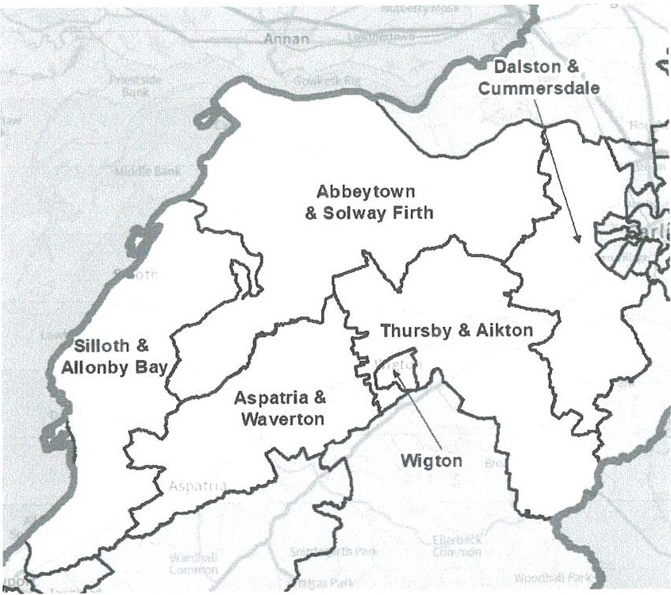
Mumber of
Ward name | councillors | Variance 2030
Abbeytown & Solway Firth |  | -6%
Aspatria & Waverton |  | -7%
Dalston & Cummersdale | 1 | -8%
Silloth & Allonby Bay | 1 | 11%
Thursby & Aikton | 1 | -13%
Wigton |  | 6%

- As mentioned earlier, the district-wide schemes we received for Cumberland utilised very different boundaries most of the time. This was the case in this area of the authority. Therefore, we could only adopt one scheme here, while noting the boundaries used by the others and modifying where appropriate.

- Because of decisions we had made in north and south Carlisle, and to facilitate a coherent warding pattern across Cumberland, we have adopted the Conservatives'

23

proposals for this area. We believe these proposals reflect the challenges in warding a large rural area, and while two of the wards have variances outside of what we would normally recommend, we are content that they reflect our statutory criteria.
- Furthermore, the Liberal Democrats proposed splitting Bowness parish in a way that meant that there was no road access from Bowness-on-Solway and Cardurnock to the rest of their ward without going out of it.

Dalston & Cummersdale
- In addition to the district-wide schemes, we received submissions from the Green Group, Beaumont Parish Council and Dalston Parish Council.

- The Green Group expressed support for the Council's Dalston & Caldbeck ward.
- Beaumont Parish Council's submission was about modifying the parish boundaries. This is outside the scope of an electoral review or our powers. This is something that Cumberland Council could do after carrying out a Community Governance Review.

- We also received a submission from Dalston Parish Council which appeared to suggest that the existing Dalston & Burgh district ward was too big for a single councillor. It might be helpful to explain that we are required by law to achieve a similar number of electors per councillor in each ward. This electoral equality is what determines the relative size of each ward in terms of numbers. However, we recognise that where these electors are spread out in rural areas, the geographical size of each ward will differ greatly.

- Nevertheless, our draft recommendations for Dalston & Cummersdale ward has a smaller footprint than the existing Dalston & Burgh ward as ii excludes Burgh By Sands parish and part of Dalston parish.

- We note that the Conservatives point to the Northern Bypass as connecting the ward from north to south. We considered that this ward uses mostly well-recognised boundaries and comprises communities that look to Carlisle and are used to working together.

- Dalston & Cummersdale is forecast to have good electoral equality by 2030.

Abbeytown & So/way Firth and Silloth & Al/onby Bay
- We note that while the Council's proposed Silloth & Allonby does not extend as far south to Maryport as the Conservatives', and its Burgh & Bowness ward differs slightly from the Conservatives' Abbeytown & Selway Firth, their proposals included
many of the same parishes.

24

- The Conservatives stated the view that its Abbeytown & Solway Firth ward combines the Solway Firth communities. Both the Council and Conservatives point to the shared coastal and economic links within their Silloth & Allonby wards. We note that the 85300 traverses the length of the Conservatives' longer ward. We consider that the additional parishes of Crosscanonby, Hayton & Mealo and Allerby village are likely to have similar issues and interests as the ones included in the Council's smaller ward. So while we note that Silloth & Allonby is forecast to have slightly more electors per councillor than we would normally recommend, we are content to do so to create a strong coastal ward. We make one modification to include Biglands settlement in Abbeytown & Solway Firth to avoid creating a parish ward in Aikton parish with too few electors.

- Abbeytown & Solway Firth and Silloth & Allonby Bay are forecast to have 6% fewer and 11% more electors respectively than the average for the local authority area by 2030.

Wigton
- Wigton parish has too many electors for a single-councillor ward if we are to provide for a good level of electoral equality. Therefore, to retain a single-councillor ward, a part of the parish will have to be included in another ward.

- The Council and Conservatives proposed that the Station Hill area of Wigton be included in a different ward. The Liberal Democrats, on the other hand, exclude the Western Bank area from this ward.

- The Council explained that ii had sought to include the 'old' town of Wigton in this ward and use the A596 bypass as an identifiable boundary, putting the newer Station Hill development in a separate ward.
- After due consideration we have been persuaded by the Council's rationale for which area to exclude from this ward, and have adopted its proposal. It is Identical to the one proposed by the Conservatives.
- Wigton ward is forecast to have good electoral equality by 2030.

Aspatria & Waverton and Thursby & Aikton
- Aspatria & Waverton ward has the A596 linking most of the parishes within it. The main difference from the existing ward is the exclusion of the coastal parishes and inclusion of Waverton parish.

- Thursby & Aikton is also linked in part by the A596 as well as the A505. The Conservatives tell us that it is made up of parishes which look to either Wigton or Dalston.

25

- We note that Thursby & Aikton is forecast to have 13% fewer electors than the average for the district and we considered merging it with Wigton ward for electoral equality reasons. However, we have not done so as part of our draft recommendations because we do not think that that merging a largely rural ward with an urban one would necessarily reflect community identities. We welcome comments on this.
- Aspatrta & Waverton and Thursby & Aikton wards are forecast to have 7% fewer and 13% fewer electors per councillor than the average for Cumberland local authortty area by 2030.

26

Workington & Seaton
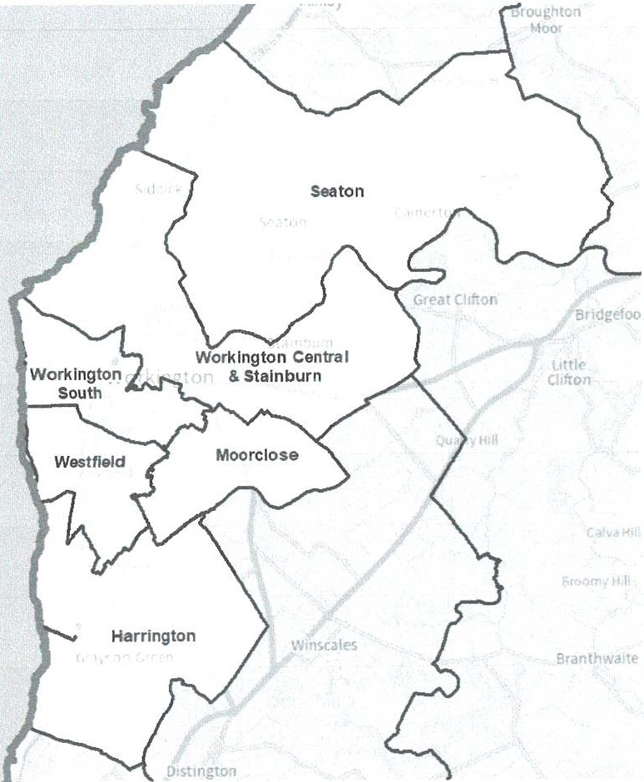
Number of
Ward name  Harrington | councillors | Variance 2030  4%
Moorclose |  | -3%
Seaton |  | 9%
Westfield |  | 0%
Workington Central & Stainburn |  | -4%
Workington South |  | 4%

27

- In addition to the distrlct wide submissions, we received submissions from Josh MacAlister MP and some residents who expressed support for the proposals put forward by Whitehaven & Workington Labour. We also received a submission from Workington Town Council who advocated that the existing wards are retained.

- On careful consideration of the submissions we received, we noted that the Council's warding proposals split the High Harrington area. We considered that while splitting the densely populated centre of Workington town was unavoidable, we were not persuaded to split what appeared to be a discrete settlement if we dld not have to.

- We were also not persuaded by the Conservatives" proposed Northside & Vulcan Park ward and the southern section of its proposed Moss Bay & St Michael's ward. In the case of the latter ward, we considered that the southern and northern sections of that ward might not share the same community interests and Identity.

- We were not persuaded by the Liberal Democrats' proposals for its St John's ward, particularly because it isolated residents north of Fisher Street, South William Street and Finkle Street. We considered that it also extended too far to the south around Banklands and Mason Street. Furthermore, we were not persuaded to adopt their proposals for Seaton ward because Camerton parish, which they excluded from this ward, most likely looks west to Seaton for its amenities and not east or south, based on the road layout and proximity.

- Furthermore, we are unable to retain the existing wards because the number of councillors representing Cumberland wHI increase and therefore we have to create new wards to flt the new councll size.

- Our draft recommendations for Workington are based on the proposals put forward by Whitehaven & Workington Labour. However, we note that In some cases they are identical or share similarities with the other proposals.

Seaton
- Our draft recommendations for Seaton ward are based on the identical proposals from the Council, Conservatives and Whitehaven & Workington Labour. They proposed a ward made up of the neighbouring parishes of Camerton and Seaton. The Conservatives mention that Camerton is closer to Seaton than to Great Broughton to the east and give that as one reason for the proposed warding pattern.

- We make one modification as part of our draft recommendations. We move the southern boundary of this ward to run along River Derwent south of Meadow Edge. This unites the area along Galva Brow and Workington Road and also ensures that we are not using a defaced parish boundary In this area.

28

- Seaton ward is forecast to have good electoral equality by 2030.

29

Workington Central & Stainbum and Workington South
- Whitehaven & Workington Labour told us that its proposed Workington Central & Stainbum ward combines Stainbum and the centre of Workington with communities on the north side of the river which look to Workington for their services and amenities, and which are a natural extension of the town centre. They point out that these areas are connected by a footbridge, roads, bus and rail services. It states that its Workington South ward brings together the south and west of Workington.

- We note that there are similarities between these proposals and those of the Liberal Democrats, which suggests some consensus around the communities and boundaries.

- Accordingly, we are basing our draft recommendations on these proposals.

173 We considered moving the proposed boundary between the two Workington wards to run straight along Jane Street, Oxford Street and Station Road, which we consider is a clearer and more identifiable boundary than the one proposed. We noted that doing this would keep the Workington Community Hospital and the roads either side of it in the same ward which would potentially facilitate more convenient and effective local government. While we have not adopted this road as a boundary at this stage we do consider it has considerable merit and we welcome comments and community evidence on whether we should adopt this stronger boundary as part of our final recommendations. This would result in Workington Central & Stainbum and Workington South wards forecast to have slightly poorer electoral equality with 11% fewer and 11% more electors respectively than the average for the district by 2030.
- We gave some consideration to combining the two Workington wards to form a two-councillor ward, and we also welcome comments on this option.

- Workington Central & Stainburn and Workington South wards are both forecast to have good electoral equality by 2030.

Moorclose and Westfield
- We are adopting the identical proposals submitted by the Liberal Democrats and Whitehaven & Workington Labour for Moorclose as part of our draft recommendations. For Westfield, we are adopting the Whitehaven & Workington Labour proposal while noting the similarities with the Liberal Democrats' proposed ward. Both wards share some boundaries with the Council and Conservative proposals.

- Whitehaven & Workington Labour states that the Moorclose and Westfield wards split and expand the current Mossbay and Moorclose ward into the Mossbay and Westfield communities, maintaining important community ties.

30

- We are adopting its proposals as part of our draft recommendations with three minor modifications. Firstly, we unite the Industrial Estate on Moorclose Road in a different ward. We also move one property on Pearl Road into Westfield ward with the rest of the road. Finally, we move three properties at the junction of Weiher Riggs Road and Wordsworth View out of Westfield Road to place them in the same ward with their neighbours.
- Moorclose and Westfield wards are both forecast to have good electoral equality by 2030.

Harrington
- The Conservatives retain most of the boundaries of the existing ward which includes Winscales parish. Whitehaven & Workington Labour say that its proposed Harrington ward includes the distinct and well-established communities of Harrington and Salterbeck. It excludes Winscales parish from this ward, as do the Liberal Democrats.

- On careful consideration of submissions, we note that the main road routes from Winscales are along the A595 and A596 and lead to Distington. We also note that the Council reflected this in its proposals.

- Accordingly, we have decided to exclude Winscales parish from this ward. We are therefore adopting the ward proposed by Whitehaven & Workington Labour as part of our draft recommendations.

- Harrington ward is forecast to have good electoral equality by 2030.

31

Whitehaven and neighbouring parishes
Ward name  Bransty & Lowca |  | councillors | Variance 2030  7%
Corkickle & Harras Park |  |  | -8%
Hensingham |  |  | 7%
Kells & Harbour |  |  | 1%
Mirehouse & Greenbank |  |  | 11%
Moresby, Distington & Arlecdon |  |  | 5%
 | 32

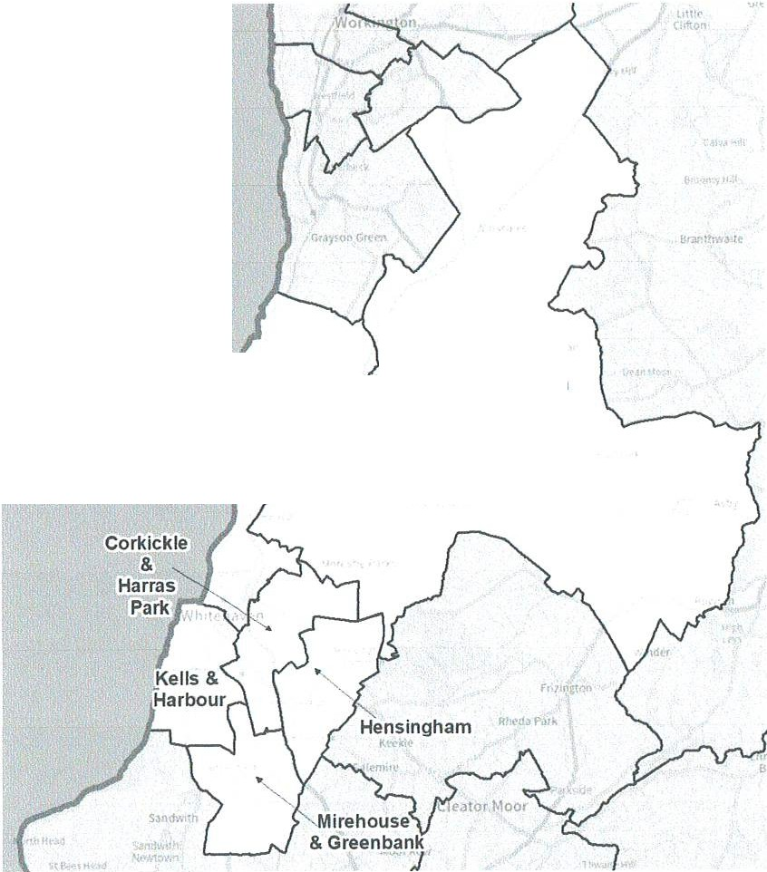
Bransty
& Lowca
Moresby, Distington &Arlecdon
Number of

- In addition to the district-wide schemes and the one from Whitehaven & Workington Labour, we received a submission from a resident with regards to Whitehaven.

- The Council told us that its proposals for Whitehaven built on existing ward structures and historical communities and that the changes it proposed were to better reflect elector distribution and natural boundaries. We did not receive any more detailed information about the communities here.

- With regards to the proposals by Whitehaven & Workington Labour, we have not been persuaded based on the limited community information provided that Kells extends as far south as Clarendon Drive and Clyde Way.

- The proposals we received utilised different boundaries. Therefore, due to decisions we have made elsewhere in the district, particularly in Cleator Moor, St Bees and Sandwith, it was not possible to adopt different proposals in this area. For' this reason and some others which we highlight below, we are basing our draft recommendations for Whitehaven on the Conservatives' proposals. These wards also facilitate a good warding pattern across the rest of the district, especially to the east.

Hensingham and Mirehouse & GreenbanR
- With the exception of the Liberal Democrats, all the other proposals united Mirehouse East and Mirehouse West communities in a single Mirehouse ward on community identity grounds.

- The Council included part of Corkickle in its ward while Whitehaven & Workington Labour included a part of Hensingham in this ward. The Conservatives placed the Greenbank area here instead.

- The Conservatives state that their proposed Hensingham ward is made up of an established area and has good transport links. Furthermore, they say their proposals for Mirehouse include the Greenbank area of Whitehaven using Meadow Road, Mlrehouse Road and the B5345 to provide a coherent road link through the area. Whitehaven & Workington Labour say that its proposal brings the whole Mirehouse estate together with the areas of Hensingham that are in the current Mirehouse ward.

- On carefully considering the proposals, we were persuaded to unite Mirehouse in the same ward to reflect the community identity of residents in this area. However, we were not persuaded by the Council's proposal to place the Park Drive and Leathwaite areas in a separate ward from Corkickle without any detailed community evidence to support it. We note that Whitehaven & Workington Labour appeared to split Hensingham across wards right in the centre along the main street. This might

33

be necessary in urban areas, but we considered that the Conservatives' boundaries around Woodhouse Road and south of Hillcrest Avenue more identifiable.

- Accordingly, we have adopted the Conservatives' proposal as part of our draft recommendations for these two wards. We make two modifications to their proposals. Firstly, we include all of Meadow Road in Mirehouse & Greenbank ward. We also move the boundary along a section of Highfields to run behind the properties on The Crest to reflect their access.

- We note that Mirehouse & Greenbank is forecast to have 11% more electors per councillor than the average for the district, slightly higher than we would normally recommend. However, we are content that it is a good balance of our statutory criteria.

- Hensingham ward is forecast to have good electoral equality by 2030.

Kells & Harbour and Corkickle & Harras Park
- Our draft recommendations for these two wards are based on the Conservatives' proposals.

- The Conservatives say that Kells & Harbour ward includes most of the main services within the Whitehaven area. In their view, Kells is well-linked to the harbour by the existing road network and by public transport. They also explain that this ward unites the harbour area which has similar issues such as shop vacancy and harbour pollution.

- We note that this ward shares some similarities with the Liberal Democrats' Lowther ward who have also based their ward on the harbour, the town centre and the Kells area to the west.

- The Conservatives also state that Corkickle & Harras Park ward is centred around Harras Wood and has good transport links between it. While we note that the ward is made up of two communities on either side of Harras Wood, we do consider that they will have shared issues and interests relating to the woods. We also sometimes include two separate communities within a single ward if it facilitates a good warding pattern elsewhere in the local authority area. We note that the new developments north of Standings Rise will bring the two areas closer.

- We made one modification to the proposed boundaries by moving St Begh's Catholic Junior School and Whitehaven Castle into Corkickle & Harras Park ward to improve the electoral equality of that ward.

- Kells & Harbour and Corkickle & Harras Park wards are both forecast to have good electoral equality by 2030.

34

Bransty & Lowca and Moresby, Distington & Arfecdon
- The Council placed the parishes of Lowca, Moresby and Parton in a single ward together with an area south of Hensingham Common in the heart of Whitehaven and a fair distance away from the rest of the ward. We were not persuaded by this warding arrangement. It created a second ward comprising the parishes of Great Clifton, Little Clifton and Winscales, and part of Distington and Greysouthen parishes.

- A resident told us that the parishes of Lowca, Moresby and Parton have long­ standing associations and that more recently they have worked with Distington Parish Council. They acknowledged that it would be difficult to include all these areas in the same ward without impacting on Whitehaven town, and expressed support for the Whitehaven & Workington Labour proposal which created a Bransty & Parton ward and a Howgate ward. Bransty & Parton ward was made up of the Bransty area and Parton parish. Howgate included the parishes of Distington, Moresby, Winscales and part of Weddicar. However, as mentioned elsewhere in this report, we have included Weddicar parish in a different ward to the east.

- The Liberal Democrats split Distington and Moresby parishes across its wards in this area. Their proposals also included Frizington village which we have included elsewhere.
- It is clear that it is difficult to include all four parishes in a single ward while reflecting our statutory criteria. Even keeping Lowca, Moresby and Parton together necessitates splitting two other parishes across district wards and including an additional area within the ward.

- Accordingly, we have based our draft recommendations for Bransty & Lowca ward on the Conservatives' proposals. This ward comprises the parishes of Lowca and Parton, and the Bransty area of Whitehaven. We make a slight modification to run the southern boundary along George Street. We welcome comments on this.

- Our draft recommendations for Moresby, Distington & Arlecdon ward are based in part on the proposals from the Conservatives and Whitehaven & Workington Labour. This ward includes Winscales parish and Arlecdon village. It does not include the parish of Lowca.
- Bransty & Lowca and Moresby, Distington & Arlecdon wards are both forecast to have good electoral equality by 2030.

35

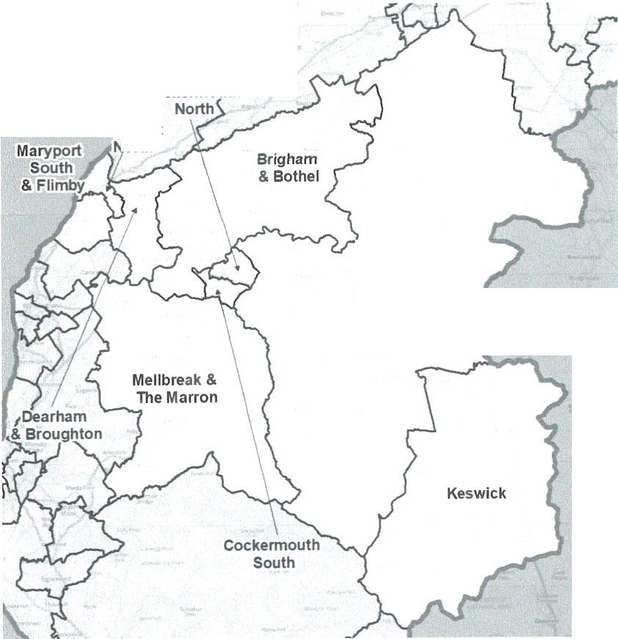
11
Midwest and Central Cumberland and Maryport
y
Cockennouth
Maryport
-orth
j
Buttennere, Bassenthwaite & Caldbeck

Ward name |  | Number of | Variance 2030
Brigham & Bethel |  | counc1 ors | -5%
Buttennere, Bassenthwaite & Caldbeck |  |  | -6%
Cockermouth North |  |  | -2%
Cockermouth South |  |  | -8%
Dearham & Broughton |  |  | 5%
Keswick |  |  | 7%
Maryport North |  |  | 9%
Maryport South & Flimby |  |  | -2%
Mellbreak & The Marron |  |  | -9%
 | 36

Cockermouth North and Cockermouth South
- We received submissions from Penrith & Selway Constituency Labour Party (Cockermouth Branch), Cockermouth Town Council and some residents in addition to the district-wide proposals.

- The Council and the Liberal Democrats both included Papcastle in its warding arrangements for Cockermouth. The Conservatives proposed two wards which together were coterminous with Cockermouth parish boundaries.

- Cockermouth Town Council advocated for a two-councillor ward to be created for its parish boundaries based on the similarity of issues that were faced across the town. A resident also felt that the existing Cockermouth South ward, which comprises rural parishes together with part of Cockermouth, did not work well, and that Cockermouth town itself was now big enough to form wards without the inclusion of any rural parishes.
- Penrith & Selway Constituency Labour Party (Cockermouth Branch) advocated for three wards in Cockermouth. However, the number of electors in Cockermouth does not support three councillors and this would result in wards with poor electoral equality. It would also impact on the number of councillors in the rest of the local authority area. Accordingly, we did not adopt this proposal.

- After careful consideration, we have decided to exclude the rural parishes from our warding pattern for Cockermouth and adopt the Conservatives' proposal. Although this creates two single-councillor wards across Cockermouth parish, we welcome wider comments on whether we should create a two-councillor ward in line with the town council's wishes.

- Cockermouth North and Cockermouth South wards are both forecast to have good electoral equality by 2030.

Dearham & Broughton, Maryport North and Maryport South & Flimby
- The district-wide schemes were the only proposals we received for boundaries in the Maryport parish area.

- The Council's and the Conservatives' wards in this area were similar. They proposed two wards which together were coterminous with Maryport parish boundaries and one that was made up of Broughton, Broughton Moor and Dearham parishes. The main difference between the proposals was that the Council included Ellenfoot Drive and Moorslde Drive, and the streets off them, in its Maryport South ward while the Conservatives place them in Maryport North ward.

- The Liberal Democrats proposed different boundaries for their Maryport North and South wards. They placed Ellenfoot Drive and Moorside Drive, and the streets

37

off them, in a ward with Dearham parish to the east of this area. They did not provide us with any community evidence why these few roads were included in a rural ward to the east of Maryport.

- Accordingly, we have been persuaded to base our draft recommendations on the similar proposals from the Council and the Conservatives. We include Ellenfoot Drive and Moorside Drive, and the streets off them, in Maryport North and we use Church Road as a more identifiable boundary. We welcome comments and community interest evidence on whether these roads should be included in Maryport South ward.
- Dearham & Broughton, Maryport North and Maryport South & Flimby are all forecast to have good electoral equality by 2030.

Brigham & Bothe/, Buttermere, Bassenthwaite & Caldbeck and Mel/break & The Marron
- These wards encompass the large rural area around Cockermouth parish, east
of Workington and Maryport. We note that each scheme presented a different configuration of these and other parishes in this area, but there is a significant overlap between them.
- Whitehaven & Workington Labour's proposals only extended as far east as Dean and Lamplugh parishes and did not encompass the entire area. We were unable to make their limited proposals work with any of the others and we did not adopt them.

- To facilitate our proposals elsewhere in the district, we have based our draft recommendations on the Conservatives' scheme and not the proposals from the Council and Liberal Democrats. We welcome comments on the boundaries and names of these wards.

- We note that Brigham & Bothel is a ward with the A595 as its spine. The Conservatives say that most of the ward has farming as its predominant industry. We consider that these communities will therefore have some shared issues and interests.

- The Conservatives tell us that Buttermere, Bassenthwaite & Caldbeck ward is an area that also relies extensively on farming and tourism as its main economic industries. We note that it includes many of the parishes in the existing Bethel & Wharrels ward and those links will be maintained here.

- We note that the parishes that make-up Mellbreak & The Marron ward are connected by the A5086 and the roads coming off it. We understand that most of

38

these parishes have previously been included in the same division and share some commonalities.

- Brigham & Bothel, Buttermore, Bassenthwalte & Caldbeck and Mellbreak & The Marron are all forecast to have good electoral equality by 2030.

Keswick

We received a submission from Keswick Town Council and a resident tn addition to the district-wide submissions.

- The Council and Conservatives proposed an ldentlcal ward comprising Borrowdale, Keswick and St John's, Cast\erlgg & Wythburn parishes. The Conservatives state that Calvert Way, Which Is now being added to the existing Keswlck ward under these proposals, is more aligned to Keswick than to Undersklddaw to the north.

- The Liberal Democrats' Keswlck ward Included Keswick parish, a northern section of St John's, Castlerigg & Wythburn parish and Underskiddaw parish to the north of the A66. They placed most of St John's, Castlerigg & Wythburn parish and Borrowdale parish fn a Derwent ward which extends as far east as Loweswater parish and to Setmurthy parish In the north. They state that almost all these parishes are within the Lake District National Park, and are well connected by bus services. They include Underskiddaw parish Jn Keswlck ward because Keswick parish is too small to form a ward on its own.

- Keswick Town Council advocated for Calvert Way to be included in Keswick ward so that the boundary aligned with the perish boundary. It also expressed the view that It needed two councl\lors to deal with the workload.

A resident was of the view that Borrowdale had a strong connection to Keswick which was its main local support town, and that this connection ought to be maintained.

While we note the rationale behind the warding pattern for a Derwent ward as expressed by the Liberal Democrats, we have not been persuaded to include Keswlck In a ward with Undersklddaw parish. We note that Keswick and Borrowdale share issues around the demand for affordable housing .as expressed by the Conservatives. We also note the comments made by the resident about Borrowdale looking to Keswick for Its services.

- Accordingly, we are adopting the identical ward proposed by the Council and

Conservatives as part of our draft recommendations.

- Keswick ward is forecast to good electoral equality by 2030.

39

- With regards to the number of councillors, this is determined by the number of forecast electors in any given area. If Keswick were to have two councillors it would be forecast to have 46% fewer electors than the average for Cumberland Council. This ls very poor electoral equality and we are not minded to create such a ward especially as electoral equality is one of our statutory criteria.

40

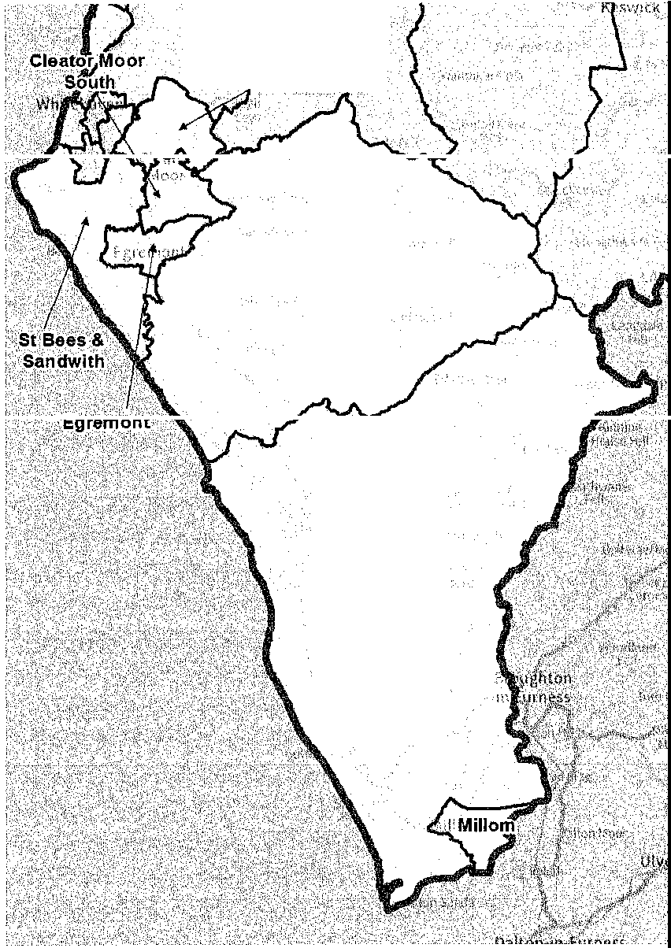
South Cumberland
:i. •
or oor Nori &Frizington .
Goslorth
Millom Without

41

Ward name  Cleator Moor North & Frizington | Number of councillors | .  Variance 2030  5%
Cleator Moor South |  | -8%
Egremont |  | 18%
Gosforth |  | -3%
Millom |  | 10%
Millom Without |  | -1%
St Bees & Sandwlth |  | 7%

Millam and Millam Without
- In addition to the district-wide proposals, we received submissions from Bootle Parish Council, Millom Without Parish Council, Whicham Parish Council and residents. Although Whitehaven & Workington Labour's proposals do not include most of this area, it does include two parishes in the north of the area.

- The Council and Conservatives retained the boundaries of the existing divisions for these two wards. The Council is of the view that this arrangement retains a compact ward centred on the town of Millom that reflects the urban nature of the town and a Millom Without ward which reflects the rural geography and economy of the area between Millom and Egremont. Millom ward is forecast to have 12% more electors per councillor than the average for Cumberland Council area, by 2030.

- To address the slightly high electoral variance, the Liberal Democrats moved an area around Queen's Park and Palmers Lane into Millom Without ward. They also proposed that Drigg & Carleton and lrton with Santon parishes move into a ward to the north of the area. Whitehaven & Workington Labour also includes these two parishes in its proposals to the north.

- The parish councils that wrote to us stated that the existing Millom Without division was geographically too large with one councillor being responsible for 11 parishes. They wanted us to consider the geographical spread and not just elector numbers when creating wards. Millom Without Parish Council advocated that it be split into two separate wards with one councillor being responsible for each of them.

- A resident of Muncaster also stated that Millom Without ward was too large. They felt more aligned to Seascale, Origg and Gosforth and not the other parishes further south.
- Another resident who lived in Drigg & Carleton parish felt that the parish was like rest of rural Millom Without ward with similar industry, services and

42

infrastructure, and faced similar needs and problems. They felt that Drigg & Carlton parish would not 'relate' to the parishes to its north.

- We note the comments about the size of Millom Without ward. However, we are required by law to take account of the number of electors per councillor. The geographical spread of wards is a common feature of rural areas.
- We have been persuaded by the resident who explained how Drigg & Carleton parish fit in with the other rural parishes in the south of Cumberland to retain this parish in Millom Without ward. We have not been persuaded to split Millom in the way the Liberal Democrats suggest just to get the numbers down.

- Accordingly, we are basing our draft recommendations on the proposals submitted by the Council and Conservatives. Nevertheless, we do improve the variance by moving a few electors on the outskirts of Millom into Millom Without ward.

- Millom and Millom Without wards are both forecast to have good electoral by 2030.
- We note that the Conservatives proposed renaming Millom Without ward Black Combe & Scawfell. We welcome comments on whether this name better reflects the communities in that area.

Gosforth and St Bees & Sandwith
- In addition to the district-wide proposals and the proposal from Whitehaven & Workington Labour, we received submissions from two residents.

- The Council addressed the poor forecast electoral equality in the existing Gosforth ward by moving Lowside Quarter parish into its proposed St Bees ward. It proposed that St Bees should include an area of Whitehaven between James Pit Road and extending north to Woodhouse and the area just south of Ennerdale Terrace.
- Although they did not propose identical wards, the Conservatives and Whitehaven & Workington Labour both included Ennerdale & Kinniside parish in Gosforth ward, and Sandwith in a ward with St Bees. In the Conservatives' view the inclusion of Ennerdale & Kinniside parish in Gosforth ward 'complements rural Wasdale'. Whitehaven & Workington Labour say that bringing the Ennerdale and Wasdale valleys together brings the Western Fells and western stretch of the Lake District National Park together into one ward.

43

- Whitehaven & Workington Labour included Drigg & Carleton and lrton with Santon parishes in Its Gosforth ward. As explained in the section on Mlllom Without, we have included these parishes elsewhere.
- The Liberal Democrats suggested a Gosforth ward not too dissimilar from the Council's but which also Included Drigg & Carleton and Irion with Santon parishes. Their proposed Egremont South & St Bees ward is forecast to have 36% fewer electors than the average for the Cumberland Council area, by 2030. We were not minded to create a ward with such poor electoral equality, and we did not adopt these proposals.
- One resident felt that Sandwith village would be better placed with the similarly rural St Bees parish rather than retained in a ward with Kells in Whitehaven. The other resident stated that Thornhill village should be within Egremont and not Gosforth.
- On careful consideration, we have not been persuaded to include the area between Wilson Pit Road and Ennerdale Terrace in a ward with St Bees, as proposed by the Council. We have not received any evidence to suggest that residents here look south for their community, and we are not convinced that they do. At the same time we are content to include Sandwlth in a ward with St Bees, as proposed by the Conservatives, Whitehaven & Workington Labour and a resident. This retains much of the eastern boundary of the existing ward in the area. We also consider that Ennerdale & Kinniside and Wasdale parishes will have shared issues.
- Accordingly, we have based our draft recommendations for these wards on the Conservatives' boundaries with a slight modification around Woodend in Egremont parish. We exclude all of Woodend from the wards in this area. We also retain the name Gosforth for one of the wards although we note that the Conservatives proposed renaming It Seascale & Beckermet after two of the coastal parishes to the east of the ward. All the other proposals retained Gosforth as the name and we have done so. We welcome comments on this.
- Gosforth and St Bees and Sandwith wards are both forecast to have good electoral equality by 2030.

Egremont
- The district-wide proposals and those from Whitehaven & Workington Labour were the only ones we received for this area.

- The town of Egremont will have significantly more electors than the average If this area is contained by itself in a single-member ward. To improve on this level of electoral equality the Council and Conservatives split it across two wards. They proposed identical boundaries for their respective Egremont and Egremont Ehen &

44

Orgill wards. Their Egremont ward would have a good level of electoral equality. Under this proposal an area of Egremont east of Croadalla Avenue and north of St Mary's Church is moved Into a ward with part of Cleator Moor parish. The Conservatives explain that they have allocated the 'northernmost polling district' into a ward to the north.
- The Liberal Democrats proposed an Egremont ward which shared the same boundaries as the whole of Egremont parish. This includes the built up part of Egremont town plus the surrounding rural part of the parish to the north. A ward based on the entire parish would have a forecast variance of 36%. We considered this too high and did not adopt this proposal.
- Whitehaven & Workington Labour stated that it was important to keep Egremont town in a single ward and its proposed ward reflected that. In its view, the town has its own very distinct Identity and community ties. The northern boundary of the proposed ward extended to just south of Dalzell Street In Woodend, and the ward was forecast to have 19% more electors per councillor than the average for Cumberland district, by 2030.
- We considered the different proposals and conducted a virtual tour of the area. We note that while the ward proposed by the Council and Conservatives had good electoral equality, the boundary was not easily identifiable or strong, neither was the split of the town based on any community identity and interests. We looked at other ways to split the town, for example placing the area between the A595 and River Ehen into a ward with Cleator Moor. However, wh[1e this will undoubtedly Improve

the electoral variance of the ward, we considered that Egremont was a town that was
clearly bounded on the east by the A595 and River Ehen and that those residents

may not share any community interests with those in Cleator Moor.

- Accordingly, we have decided that adopting a ward with a high variance as proposed by Whitehaven & Workington Labour, while retaining identifiable boundaries and community interests and identities, is the best balance of our statutory criteria In this instance. While this high level of electoral inequality is not something that we would normally recommend, we consider that splitting the built-up area of Egremont will not reflect the community identity in the area. We have made one modification to Whitehaven & Workington Labour's proposal. We were not persuaded that urban Egremont extended as far north as Woodend. We considered that the proposed boundary actually split the Woodend area. As part of our

draft recommendations we have therefore excluded that entire area from
Egremont ward.

Our proposed Egremont ward is forecast to have 18% more electors per
councillor than the average for the dlst ct, by 2030.

45

C/eator Moor North & Frizington and Cleator Moor South
- In addition to the district-wide proposals and the one from Whitehaven & Workington Labour, we received a submission from a resident.

- Cleator Moor town has too many electors for one councillor and too few for two if ii is to have a good level of electoral equality. Therefore, it has to be split across two wards and warded with other communities.

- The Council stated that the way ii split the town reflects the natural communities within the town. As mentioned above it includes an area of Egremont in its warding for the area, as did the Conservatives. However, while the Council excluded Frizington village from its warding in this area, the Conservatives proposed a Frizington & Cleator Moor North ward which shared many similarities with Whitehaven & Workington Labour's Cleator Moor West & Frizington ward.

- Whitehaven & Workington Labour was of the view that Frizington naturally connected to the west of Cleator Moor via Bowthom Road. It felt that this was the best place to split Cleator Moor, and that ii kept Frizington village in a single ward. It also stated that its proposed Cleator East kept the main communities of Cleator Moor and Cleator in one ward.

- The Liberal Democrats state that its Cleator Moor North ward consisted of a third of Cleator Moor itself and the immediately adjacent communities of Moor Road, Galemire, Keekle and Rheda Park. Its Cleator Moor South comprises the southern two-thirds of Cleator Moor itself, the adjacent community of Cleator, and the more rural Ennerdale Kinniside parish.

- The resident was of the view that Cleator Moor ought to include Keekle and Parkside, and that the entire area should be split into two wards. We are not sure if the first part of this proposal refers to making changes to Cleator Moor parish boundaries to include areas currently in other parishes. If so, this is out of scope of this electoral review. Changes to parish boundaries can only be made by Cumberland Council after conducting a Community Governance Review.

- On considering the submissions we received, we have been persuaded by the explanation given by Whitehaven & Workington Labour for how they split Cleator Moor town and kept its main community together in a ward with Cleator. We note that the Liberal Democrats also use this boundary. We have also been persuaded of the good connection between Frizington and Cleator Moor and are content to create a ward reflecting this.

- Without supporting community evidence, we were not persuaded to split Frizington and Rheda Park villages across wards as proposed by the Liberal Democrats due to their close proximity. We explain in the section on Gosforth that

46

we have included Ennerdale & Kinniside and Wasdale parishes in the same ward due to their shared geography and issues. Accordingly, we have not adopted the Liberal Democrats' proposal which includes Ennerdale & Kinnlside parish In a Cleator Moor ward. We have also not adopted the Council's proposal which excludes Frizington and places It In a ward with Ennerdale & Kinniside parish, We consider that Frizington looks more towards Cleator Moor than Ennerdale & Kinnlside parish.

Accordingly, our draft recommendations are mainly based on the other two proposals - with modifications to reflect decisions made earner and facilitate effective and convenient local government. We note that some of the individual boundaries were also proposed by the Council and Liberal Democrats.

- Our draft recommendations are for a Cleator Moor North & Frizington ward and a Cleator Moor South ward. Bigrigg village is excluded from these wards but Woodend Is included in Cleator Moor South ward. To facilitate a Cleator Moor South ward with good electoral equality after making changes elsewhere, we have moved part of the boundary in Cleator Moor slightly west of St John's Church and Crossfield Road. Finally, we Include all of Weddicar parish In Cleator Moor North & Frlzlngton ward to avoid creating a parish ward with too few electors in the north of the parish.

- Cleator Moor North & Frlzington and Cleator Moor South wards are forecast to have good electoral equality by 2030

47

Conclusions
- The table below provides a summary as to the impact of our draft recommendations on electoral equality in Cumberland, referencing the 2024 and 2030 electorate figures against the proposed number of councillors and wards. A full list of wards, names and their corresponding electoral variances can be found in Appendix A to the back of this report. An outline map of the wards is provided in Appendix B.

Summary of electoral arrangements
Draft recommendations

 | 2024 | 2030
Number of councillors | 55 | 55
Number of electoral wards | 55 | 55
Average number of electors per councillor | 3,938 | 3,900
Number of wards with a variance more than 10% 8 7
from the average
Number of wards with a variance more than 20% 0 0
from the average
Draft recommendations
Cumberland Council should be made up of 55 councillors serving 55 single­ councillor wards. The details and names are shown in Appendix A and illustrated on the large maps accompanying this report.

Mapping
Sheet 1, Map 1 shows the proposed wards for Cumberland Council.
You can also view our draft recommendations for Cumberland Council on our interactive maps at www.lqbce.orq.uk

Parish electoral arrangements
- As part of an electoral review, we are required to have regard to the statutory criteria set out in Schedule 2 to the Local Democracy, Economic Development and Construction Act 2009 (the 2009 Act). The Schedule provides that if a parish is to be divided between different wards it must also be divided into parish wards, so that each parish ward lies wholly within a single ward. We cannot recommend changes to the external boundaries of parishes as part of an electoral review.

48

- Under the 2009 Act we only have the power to make changes to parish electoral arrangements where these are as a direct consequence of our recommendations for principal authority warding arrangements. However, Cumberland Council has powers under the Local Government and Public Involvement in Health Act 2007 to conduct community governance reviews to effect changes to parish electoral arrangements.

- As a result of our proposed ward boundaries and having regard to the statutory criteria set out in schedule 2 to the 2009 Act, we are providing revised parish electoral arrangements for Aikton, Allhallows, Arlecdon & Frizington, Beckermet, Boltons, Cleator Moor, Cockermouth, Dalston, Egremont, Kingmoor, Maryport, Millom, Oughterside & Allerby, St Cuthbert Without, Stanwix Rural, Westward, Whitehaven, Wigton and Workington.

- We are providing revised parish electoral arrangements for Aikton parish.

Draft recommendations
Aikton Parish Council should comprise 10 councillors, as at present, representing two wards:
Parish ward Number of parish councillors
Aikton & Wiggonby 8
Biglands & Whitrigglees 2
- We are providing revised parish electoral arrangements for Allhallows parish.
Draft recommendations
Allhallows Parish Council should comprise eight councillors, as at present, representing two wards:
Parish ward Number of parish councillors
Baggrow 2
Fletchertown 6
- We are providing revised parish electoral arrangements for Arlecdon & Frizington parish.
Draft recommendations
Arlecdon & Frizington Parish Council should comprise nine councillors, as at present, representing two wards:
Parish ward Number of parish councillors
Arlecdon 3
Frizington 6
49

- We are providing revised parish electoral arrangements for Beckermet parish.
Draft recommendations
Beckerrnet Parish Council should comprise 12 councillors, as at present, representing two wards:
Parish ward Number of parish counc1llors
Beckerrnet 5
Thornhill 7
- We are providing revised parish electoral arrangements for Boltons parish.
Draft recommendations
Boltons Parish Council should comprise 10 councillors, as at present, representing two wards:
Parish ward Number of parish counc1llors
Boltongate 8
Mealsgate 2
- We are providing revised parish electoral arrangements for Cleator Moor parish.
Draft recommendations
Cleator Moor Town Council should comprise 12 councillors, as at present, representing two wards:
Parish ward Number of parish councillors
Cleator Moor North 4
Cleator Moor South 8
- We are providing revised parish electoral arrangements for Cockermouth parish.

Draft recommendations
Cockermouth Town Council should comprise 12 councillors, as at present, representing four wards:
Parish ward | Number of parish councillors
All Saints | 4
Christchurch | 2
Double Mills | 3
Fitz | 1
South Lodge | 2

50

- We are providing revised parish electoral arrangements for Dalston parish.

Draft recommendations
Dalston Parish Council should comprise 15 councillors, as at present, representing two wards:
Number of p,insh councillors
Dalston 13
Raughton & Stockdalewath 2
- We are providing revised parish electoral arrangements for Egremont parish.
Draft recommendations
Egremont Town Council should comprise 10 councillors, as at present, representing four wards:
Parish ward Number of parish councillors
Bigrigg & Moor Row 2
East
South & Central 6
Woodend
- We are providing revised parish electoral arrangements for Kingmoor parish.

Draft recommendations
Kingmoor Parish Council should comprise eight councillors, as at present, representing two wards:
Parish ward Number of parish councillors
Cargo 3
Fenwick 5

- We are providing revised parish electoral arrangements for Maryport parish.

Draft recommendations
Maryport Town Council should comprise 18 councillors, as at present, representing four wards:
Parish ward  Ellenborough | Number of parish councillors  5
Ewanrigg & Glasson | 6
Flimby | 3
Netherhall | 4

51

- We are providing revised parish electoral arrangements for Millam parish.

Draft recommendalions
Millam Town Council should comprise 15 councillors, as at present, representing three wards:
Parish ward  Haverigg | Number of parish councillors  3
Holborn Hill | 5
New Town | 7

- We are providing revised parish electoral arrangements for Oughterside & Allerby parish.

Draft recommendations
Oughterside & Allerby Parish Council should comprise nine councillors, as at present, representing two wards:
Parish ward Number of parish councillors
Allerby 2
Oughterside 7
- We are providing revised parish electoral arrangements for St Cuthbert Without parish.

Draft recommendations
St Cuthbert Without Parish Council should comprise 15 councillors, as at present, representing four wards:
Parish ward  Parklands | Number of pansh councillors  7
Speckled Wood
St Cuthbert Without | 3
Upperby | 4

52

- We are providing revised parish electoral arrangements for Stanwix Rural parish.

Draft recommendations
Stanwix Rural Parish Council should comprise 15 councillors, as at present, representing three wards:
Parish ward  Crosby & Linstock | Number of parish councillors  4
Houghton | 8
Windsor Park | 3

- We are providing revised parish electoral arrangements for Westward parish.

Draft recommendations
Westward Parish Council should comprise 10 councillors, as at present, representing two wards:
Parish ward Number of parish councillors
West Curthwaite 6
Westward 4
- We are providing revised parish electoral arrangements for Whitehaven parish.

Draft recommendations
Whitehaven Town Council should comprise 12 councillors, as at present, representing 10 wards:
Parish ward Number of pansh councillors Corkickle
Greenbank Harras Park Hillcrest Kells
Mirehouse 2
Sandwith Snekyeat

Whitehaven Central North 2

Whitehaven Central South

- We are providing revised parish electoral arrangements for Wigton parish.

Draft recommendations

53

Wigton Town Council should comprise 15 councillors, as at present, representing two wards:
Parish ward Number of parish councillors
Station Hill 2
Wigton 13
- We are providing revised parish electoral arrangements for Workington parish.

Draft recommendations
Workington Town Council should comprise 25 councillors, as at present, representing 12 wards:
Parish ward  Harrington | Number of parish councillors  3
Moorclose | 3
Northside
Poole Road | 2
Salterbeck | 2
Seaton | 1
St John's | 2
St Joseph's | 2
St Michael's | 1
Stainburn | 2
Westfield | 3
Workington South | 3

54

55

Have your say
- The Commission has an open mind about its draft recommendations. Every representation we receive will be considered, regardless of who it is from or whether it relates to the whole district or just a part of it.

- If you agree with our recommendations, please let us know. If you don't think our recommendations are right for Cumberland, we want to hear alternative proposals for a different pattern of wards.

- Our website is the best way to keep up to date with progress on the review and to have your say www.lgbce.orq.uk

- Each review has its own page with details of the timetable for the review, information about its different stages and interactive mapping.

- Submissions can also be made by emailing reviews@lgbce.orq.uk or by writing to:

Review Officer (Cumberland) LGBCE
7th Floor
3 Bunhill Row London
EC1Y 8YZ

- The Commission aims to propose a pattern of wards for Cumberland Council which delivers:

  - Electoral equality: each local councillor represents a similar number of electors.
  - Community identity: reflects the identity and interests of local communities.
  - Effective and convenient local government: helping your council discharge its responsibilities effectively.

- A good pattern of wards should:

  - Provide good electoral equality, with each councillor representing, as closely as possible, the same number of electors.
  - Reflect community interests and identities and include evidence of community links.
  - Be based on strong, easily identifiable boundaries.
  - Help the council deliver effective and convenient local government.

56

- Electoral equality:

  - Does your proposal mean that councillors would represent roughly the same number of electors as elsewhere in Cumberland?

- Community identity:

  - Community groups: is there a parish council, residents' association or other group that represents the area?
  - Interests: what issues bind the community together or separate it from other parts of your area?
  - Identifiable boundaries: are there natural or constructed features which make strong boundaries for your proposals?

- Effective local government:

  - Are any of the proposed wards too large or small to be represented effectively?
  - Are the proposed names of the wards appropriate?
  - Are there good links across your proposed wards? Is there any form of public transport?

- Please note that the consultation stages of an electoral review are public consultations. In the interests of openness and transparency, we make available for public inspection full copies of all representations the Commission takes into account as part of a review. Accordingly, copies of all representations will be placed on deposit at our offices and on our website at www.lgbce.org.uk A list of respondents will be available from us on request after the end of the consultation period.

- If you are a member of the public and not writing on behalf of a council or organisation we will remove any personal identifiers. This includes your name, postal or email addresses, signatures or phone numbers from your submission before ii is made public. We will remove signatures from all letters, no matter who they are from.

- In the light of representations received, we will review our draft recommendationsand consider whether they should be altered. As indicated earlier, it is therefore important that all interested parties let us have their views and evidence, whether or not they agree with the draft recommendations. We will then publish our final recommendations.

- After the publication of our final recommendations, the changes we have proposed must be approved by Parliament. An Order - the legal document which brings into force our recommendations- will be laid in draft in Parliament. The draft

57

Order will provide for new electoral arrangements to be implemented at the all-out elections for Cumberland Council in 2027.

58

59

Equalities
31O The Commission is satisfied that it complies with its legal obligations under the Equality Act and that no adverse equality Impacts will arise as a result of the outcome of the review.

60

61

Appendices

Appendix A

Draft recommendations for Cumberland Council
Number of Electorate Number of Variance Electorate Number of Variance Ward name councillors (2024) elector per from (2030) elector per from
councillor average% councillor average%

 |  | Abbeytown &  Salway Firth | 1 | 3,751 | 3,751 | -5% | 3,664 | 3,664 | -6%
2 |  | Aspalria &  Waverton | 1 | 3,595 | 3,595 | -9% | 3,616 | 3,616 | -7%
3 |  | Belle Vue | 1 | 3,968 | 3,968 | 1% | 3,830 | 3,830 | -2%
4 |  | Botcherby & | 1 | 3,710 | 3,710 | -6% | 3,598 | 3,598 | -8%
 | Keenan Park
 | 5 Brampton |  | 1 | 3,859 | 3,859 | -2% | 3,862 | 3,862 | -1%
 | 6 Bransty & Lowca |  | 1 | 4,303 | 4,303 | 9% | 4,171 | 4,171 | 7%
 | 7 Brigham & Bothe! |  | 1 | 3,818 | 3,818 | -3% | 3,688 | 3,688 | -5%
 | Buttermere,
 | 8 Bassenthwaite & |  | 1 | 3,790 | 3,790 | -4% | 3,663 | 3,663 | -6%
Caldbeck
9 |  | Castle | 1 | 3,854 | 3,854 | -2% | 3,499 | 3,499 | -10%
10 |  | Cleator Moor North & Frizington | 1 | 4,119 | 4,119 | 5% | 4,112 | 4,112 | 5%

62

Number of Electorate Ward name councillors (2024)
1
Number of Variance
electors per
from
Number of Variance e ector per

councillor average % councillor average %
Electorate (2030)
from

11 Cleator Moor 1 3,659 3,659 -7% 3,604 3,604 -8%
-S-outh

12 Cockermouth 1 3,891 3,891 -1% 3,821 3,821 -2%
North
South

13 Cockermouth 1 3,667 3,667 -7% 3,586 3,586 -8%

14 Corby & Hayton 1 4,043 4,043 3% 3,881 3,881 0%

15 Corkickle & 1 3,404 3,404 -14% 3,574 3,574 -8%
Broughton
Harras Park
Cummersdale

16 Currock 1 3,,993 3,993 1% 3,835 3,835 -2%

17 Dalston & 1 3439 3,439 -13% 3,585 3,585 -8%

18 Dearham & 1 4,047 4,047 3% 4,093 4,093 5%

19 Denton Holme 1 3,826 3,826 -3% 3,,636 3636 -7%

20 Egremont 1 4,615 4,615 17% 4,611 4,611 18%

21 Etterby & Stanwix 1 3,887 3,887 -1% 3,831 3,831 -2%

22 Gosforth 1 3,889 3,889 -1% 3,781 3,781 -3%

23 Harraby East 1 3,644 3,,644 -7% 3,502 3,502 -10%

63
West

Num er of Electorate
b
Number of
Ward name councillors (2024) electors per
Variance

from
Number of Variance electors per

councillor average% councillor average%
Electorate (2030)
from

24 | Harraby West | 1 | 3,800 | 3800 | -4% | 3,682 | 3,682 | -6%
25 | Harrington | 1 | 4,097 | 4,097 | 4% | 4,052 | 4,052 | 4%
26 | Hensingham | 1 | 4,206 | 4,206 | 7% | 4,171 | 4,171 | 7%

Crindledyke
32 |  | Maryport North | 1 | 4,369 | 4,369 | 11% | 4,265 | 4,265 | 9%
33 Maryport South & |  |  | 1 | 3,781 | 3,781 | -4% | 3,829 | 3,829 | -2%
34 |  | Mellbreak & The | 1 | 3,665 | 3,665 | -7% | 3532 | 3,532 | -9%
 |  | Marron
 | 35 | Millom | 1 | 4,296 | 4,296 | 9% | 4,275 | 4,275 | 10%
 | 36 | Millom Without | 1 | 3,861 | 3,861 | -2% | 3,869 | 3,869 | -1%

27 | lrthing | 1 | 3,520 | 3,520 | -11% | 3,416 | 3,416 | -12%
28 | Kells & Harbour | 1 | 4,032 | 4,032 | 2% | 3,941 | 3,941 | 1%
29 | Keswick | 1 | 4,310 | 4,310 | 9% | 4,188 | 4,188 | 7%
30 Longtown  --- |  | 1 | 4,130 | 4,130 | 5% | 4,033 | 4,033 | 3%
31 Lowry Hill & |  | 1 | 4,135 | 4,135 | 5% | 4,248 | 4,248 | 9%

Flimby

64

Number of
Electorate (2024)
Variance El ectorate
Number of Variance

Ward name councillors
Number of
elector per
(2030) elector per

councillor average % councillor average %
from
from

37 Mirehouse & 1 4,235 4,235 8% 4,335 4,335 11%
Greenbank
38 Moorclose 1 3,567 3,567 -9% 3,785 3,785 -3%

Moresby,
39 Distington & 1 4,163 4,163 6% 4,086 4,086 5%
Arlecdon
40 Morton East 1 4,249 4,249 8% 4,177 4,177 7%

41 Morton West 1 4,257 4257 8% 4,228 4,228 8%

42 Sandsfield 1 4,187 4,187 6% 4,027 4,027 3%

43 Seaton 1 4,198 4.,198 7% 4,252 4,252 9%

44 Silloth & Allonby 1 4,414 4,414 12% 4,324 4,324 11%
Bay
45 StAidans 1 4,294 4,294 9% 4,014 4,014 3%

46 St Bees & 1 4,225 4,225 7% 4,180 4,180 7%
Sandwith
47 St Cuthbert's 1 3,241 3,241 -18% 3,619 3,619 -7%

48 Stanwix& 1 4,008 4,008 2% 3,918 3,918 0%
Houghton
49 Thursby & Aikton 1 3,343 3,343 -15% 3,391 3,391 -13%
65

Number of Electorate Number of Variance Electorate Number of Variance Ward name councillors (2024) elector per from (2030) elector per from
councillor average % councillor average%

50 Upperby 1 3,673 3,673 -7% 3,862 3,862 -1%
51 Westfield 1 3,749 3,749 -5% 3,903 3,903 0%

52 Wetheral 1 3,860 3,860 -2% 3,894 3,894 0%

53 Wigton 1 4,050 4,050 3% 4,140 4,140 6%

Workington
54 Central & 1 3,798 3,798 -4% 3,730 3,730 -4%
Stainburn
55 Workington South 1 4,108 4,108 4% 4,073 4,073 4%

Totals 55 216,592 - - 214,482 - -

Averages - - 3,938 - - 3,900 -

Source: Electorate figures are based on information provided by Cumberland Council.

Note: The 'variance from average' column shows by how far, in percentage terms, the number of electors per councillor in each electoral ward varies from the average for the authority. The minus symbol(-) denotes a lower than average number of electors. Figures have been rounded to the nearest whole number.

66

Appendix B

Outline map
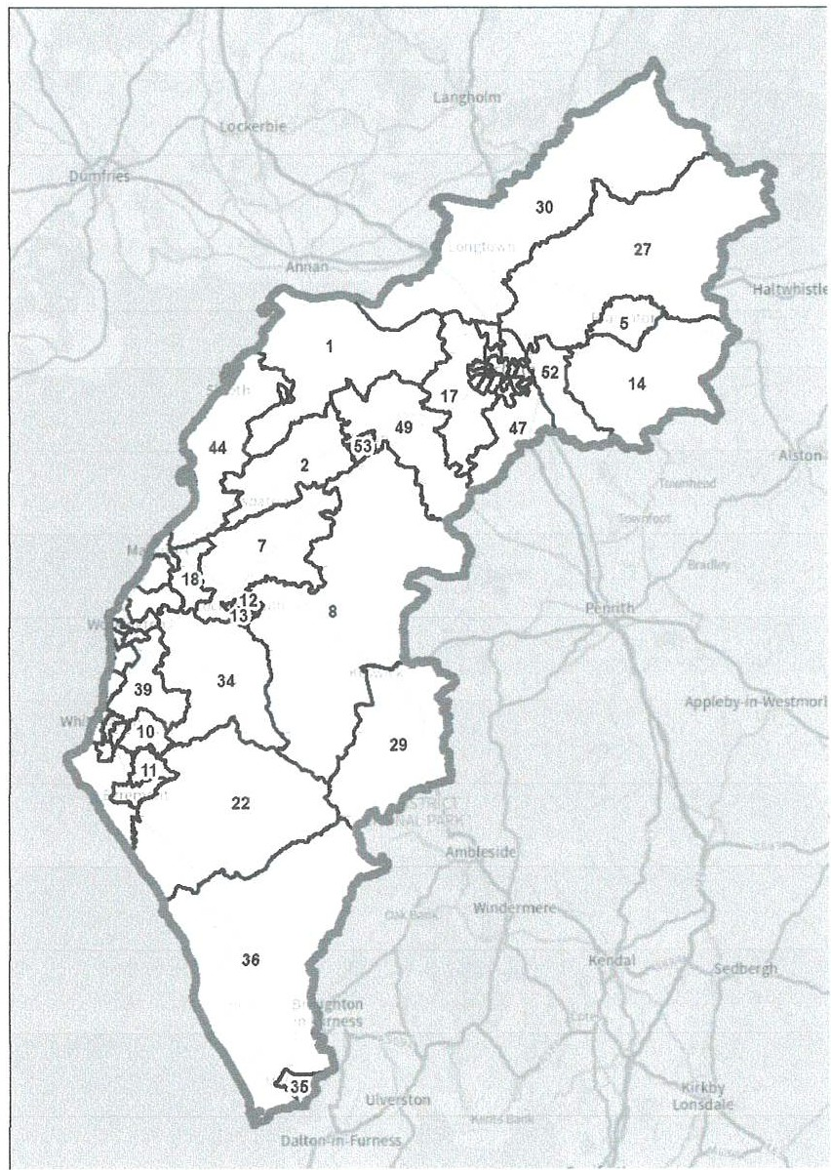

67

Carlisle and Houghton
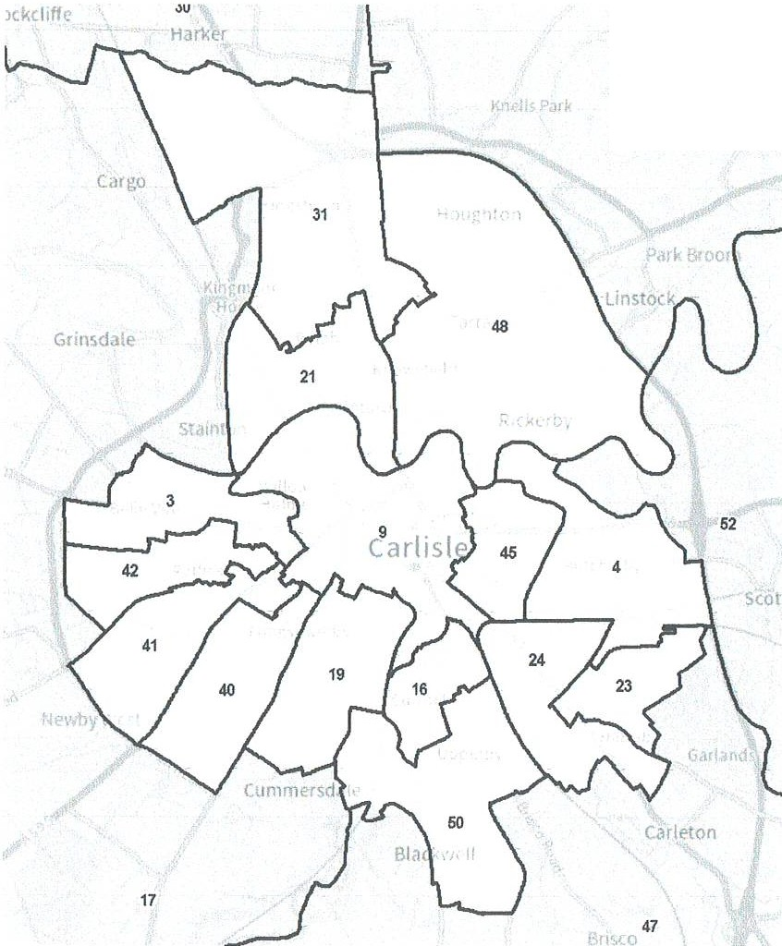
27

68

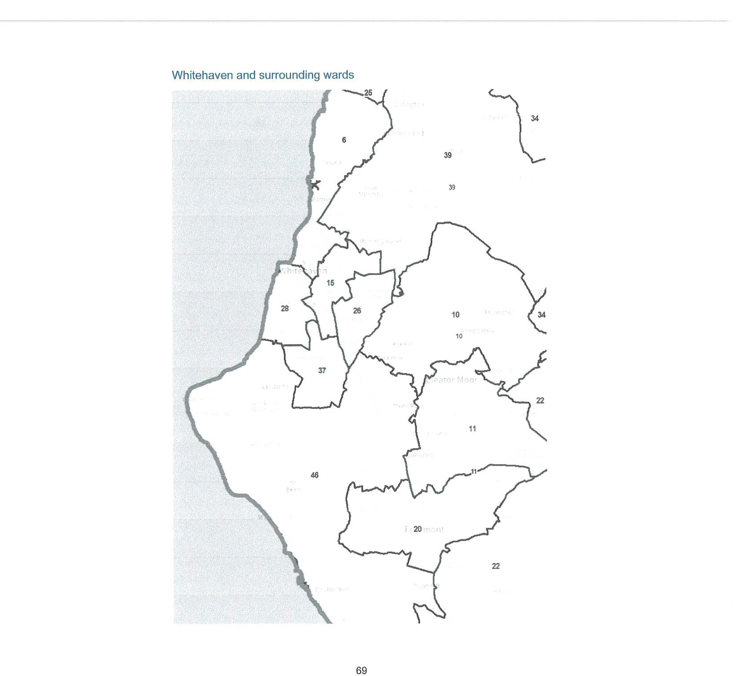

Workington and surrounding wards
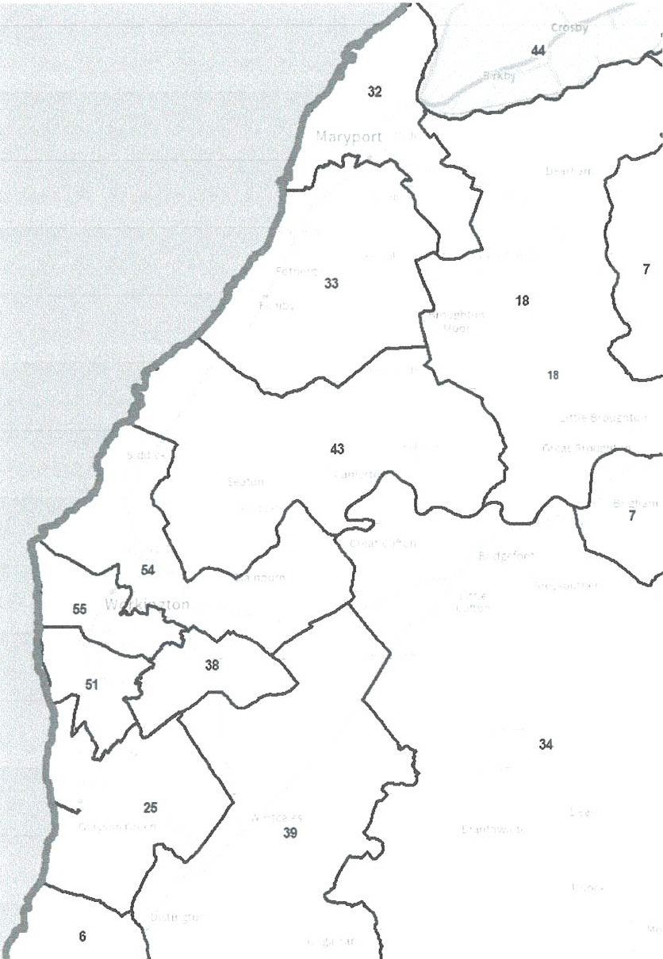

70

Number Ward name
Abbeytown & Solway Firth
- Aspatria & Waverton
- Belle Vue
- Botcherby & Keenan Park
- Brampton
- Bransty & Lowca
- Brigham & Bothe!
- Buttermere, Bassenthwaite & Caldbeck
- Castle
- Cleator Moor North & Frizington
- Cleator Moor South
- Cockermouth North
- Cockermouth South
- Corby & Hayton
- Corkickle & Harras Park
- Currock
- Dalston & Cummersdale
- Dearham & Broughton
- Denton Holme
- Egremont
- Etterby & Stanwix West
- Gosforth
- Harraby East
- Harraby West
- Harrington
- Hensingham
- lrthing
- Kells & Harbour
- Keswick
- Longtown
- Lowry Hill & Crindledyke
- Maryport North
- Maryport South & Flimby
- Mellbreak & The Marron
- Millom
- Millom Without
- Mirehouse & Greenbank
- Moorclose
- Moresby, Distington & Arlecdon
- Morton East
41 Morton West

71

- Sandsfield
- Seaton
- Silloth & Allonby Bay
- St Aidans
- St Bees & Sandwith

- St Cuthbert's
- Stanwix & Houghton

- Thursby & Aikton
- Upperby
- Westfield
- Wetheral
- Wigton
- Workington Central & Stainbum
- Workington South

A more detailed version of this map can be seen on the large map accompanying this report, or on our website: www.lgbce.orq.uk/all-reviews/cumberland

72

Appendix C
Submissions received
All submissions received can also be viewed on our website at: www.lgbce.org.uk/all-reviews/cumberland

Local Authority

- Cumberland Council

Political Groups

- Cumberland Conservatives Associations
- Cumberland Council Green Group
- Cumberland Liberal Democrats & Cumberland Council Liberal Democrats Group
- Penrith & Solway Constituency Labour Party (Cockermouth Branch)
- Whitehaven & Workington Labour Party

Member of Parliament

- Josh MacAlister MP (Whitehaven & Workingham)

Councillors

- Councillor R. Dobson (Cumberland Council)
- Councillor M. Greaves (Brigham Parish Council)
- Councillor T. Norman (Gosforth Parish Council & Ponsonby Parish Council)
- Councillor J. Perry (Cumberland Council)
- Councillor T. Pickstone (Cumberland Council)
- Councillor G. Sewell (Moresby Parish Council)
- Councillor R. Watson (Cockermouth Town Council)

Parish and Town Councils

- Beaumont Parish Council
- Bootle Parish Council
- Cockermouth Town Council
- Dalston Parish Council
- Keswick Town Council
- Millom Without Parish Council

73

- Stanwlx Rural Parish Council
- Whlcham Parish Council
- Workington Town Council

Local residents

- 59 local residents

74

Appendix D
Glossary and abbreviations
Council size
The number of councillors elected to serve on a council
A legal document which implements changes to the electoral arrangements of a local authority
A specific area of a county, defined for electoral, administrative and representational purposes. Eligible electors can vote in whichever division they are registered for the candidate or candidates they wish to represent them on the county council
Where there is a difference between the number of electors represented by a councillor and the average for the local authority
People in the authority who are registered to vote in elections. We only take account of electors registered specifically for local elections during our reviews.
The total number of electors in a local authority divided by the number of councillors
Where there are fewer electors per councillor in a ward or division than the average
A specific and defined area of land within a single local authority enclosed within a parish boundary. There are over 10,000 parishes in England, which provide the first tier of representation to their local residents

Electoral Change Order (or Order)

Division

Electoral inequality

Electorate

Number of electors per councillor

Over-represented

Parish

75

Parish council
A body elected by electors in the parish which serves and represents the area defined by the parish boundaries. See also 'Town council'
The total number of councillors on any one parish or town council; the number, names and boundaries of parish wards; and the number of councillors for each ward
A particular area of a parish, defined for electoral, administrative and representational purposes. Eligible electors can vote in whichever parish ward they live for candidate or candidates they wish to represent them on the parish council
A parish council which has been given ceremonial 'town' status. More information on achieving such status can be found at www.nalc.qov.uk
Where there are more electors per councillor in a ward or division than the average
How far the number of electors per councillor in a ward or division varies in percentage terms from the average
A specific area of a district or borough, defined for electoral, administrative and representational purposes. Eligible electors can vote in whichever ward they are registered for the candidate or candidates they wish to represent them on the district or borough council

Parish (or town) council electoral arrangements

Pansh ward

Town council

Under-represented

Variance (or elecioral variance)

Ward

76



T
Local Government Boundary Commission

The Local Government Boundary Commission for England (LGBCE) was set up by Parliament, independent of Government and political parties. It is directly accountable to Parliament through a committee chaired by the Speaker of the House of Commons. It is responsible for conducting boundary, electoral and structural reviews of local government.
Local Government Boundary Commission for England
7th Floor. 3 Bunhill Row. London.
EC1Y 8YZ

Telephone: 0330 500 1525 Email: reviews@lgbce.org.uk Online: www.lgbce.org.uk
X: @LGBCE

WTC 26/06/25
Item 10

ALLOTMENT UPDATE REPORT

Purpose of Report and Recommendation

To consider a report on the present position with regards to Allotments

1.0 INTRODUCTION

  - Further to Minute 2769/25 the position with regards to the Council's Allotment Sites is as follows-

Cartgate Allotment Site

    - There is only one half allotment plot vacant on Cartgate and there is an appointment for a potential tenant to view it at the end of the week.
    - Following reports from the Site Representative letters have been sent to 2 tenants for breach of their Allotment Agreements and since receiving the letters there have been no further complaints
    - No further issues have been raised by the site representative

Crow Park Allotment Site

    - There are 2 vacant plots on Crow Park Allotment Site and there is an appointment at the end of the week for a potential tenant to view one of them. The remaining vacant plot is at the bottom of the site co-extensive with the woodland and may prove difficult to let
    - Four access paths on the Allotment Site have been resurfaced and hand rails installed on one of them following a site meeting between the Allotments Advisory Group and the Site Representative who agreed the work to be carried out. The Contractor used a recycled material from an environment agency

    - licensed site which was totally appropriate for that use and that using new aggregate would not only be more expensive but would be environmentally insensitive. The Contractor said he was aware that the Site Representative was not happy with the material put on the 4 pathways and said he had some very fine material being delivered for another project and was planning to take some to the allotment site and top over the paths with it.
    - The Contractor said he did not have enough stock to replace all the chicken mesh but had some on order and would do it as soon as it was received.

Midgey Allotment Site

      - There are no vacancies on Midgey Allotment Site

Sneckyeat Allotment Site

      - There are no vacancies on Sneckyeat Allotment Site

  - There are no outstanding reported repairs from the Site representatives and a Meeting will be arranged on Zoom between the Allotments Advisory Group and the Site Representatives in the near future
  - RECOMMENDATION

  - It is recommended that the above report be noted and that a Zoom Meeting be arranged

WTC 26/06/25
Item 11

TO NOMINATE A REPRESENTATIVE TO BECOME A TRUSTEE ON THE WHITEHAVEN RELIEF IN NEED CIOMMITTEE

Purpose of Report and Recommendation

To nominate a representative to become a trustee on the Whitehaven Relief in Need Committee

1.0 INTRODUCTION

  - The Vicar of St Nicholas Church the Reverend Alison Dobell has asked if the Council would nominate a representative (not necessarily a Council Member) to become a Trustee on the Whitehaven Relief In Need Committee which is a Charity.

  - 1.2 Attached at Appendix 1 are details of the Charity.

  - RECOMMENDATION

  - It is recommended that the Council considers who to nominate to become a Trustee of this Charity and then pass the information to the Reverend Dobell

'
I- - , ---------- .,i, ., ··----·
The Revd Alison Dobell
The Rectory, Harras Road CA28 6SG
Tel: 01946 63937 Email: rector.whitehaven@gmail.com

beia,< IV\ 0 ,f)
'
r1 wvi ,JCV\. ask, r' JCwn G::,vrn L

Y\Or'V\/i , YlelE.":>Sa<½ 0.. CQ,\11C \ N-Mbr.,,
.}i ku>rr-t. (A .,..,- rU (7(\. en
lk4 )r- /)<RJ Cwnm ,
,--eq6'td1.
m,./{c;f,1 l) tl

·
-R;
lJi
-i
=
V\

l.QgJnt.Q..Q.oline services (b.llps.Jlmy-cirn.ri.ty .a.Qco®.t!.:had.lycommissjon.gm:'...U.lsL)
Search Q.

Charity overview
Whfil, who, b.m:Y,...wbfile.
Governance Trustees Financial history
Accounts and annual returns Governing document Contact information
What the charity does: General Charitable Purposes Disability
The Prevention Or Relief Of Poverty

Who the charity helps:
Children/young People Elderly/old People People With Disabilities
How the charity helps:
Makes Grants To Individuals Makes Grants To Organisations
Where the charity operates:
Cumbria

tl4 Print charitY. details

.LQg io to oolioe services (hllRsJlmy..:mar.i.ty-accounLcharitycommission gO)[JJJsl)
Search Q.

Charity overview
What, who, how, where Governance
Trustees
Financial history
Accounts and annual returns Governing document Contact information
Trustees are the people responsible for controlling the work, management and administration of the charity on behalf of its beneficiaries. Generally trustees are treasurer, chair, board member etc. The trustees are responsible for keeping this list up to date and can do this by updating their details as they happen through the online service
3 Trustee(s)
Name Role Date of Other trusteeships Reporting status of other appointment trusteeships
- --

Rev Alison | Trustee | 20 November | THE PAROCHIAL CHURCH |  | Received: On time
Jane Dobell |  | 2023 | CQUNCIL QE Tl::JE
 |  |  | ECCLESl8SIIC8L P8BISt:l
 |  |  | OF WHITEHAVEN, ST. JAMES
Alan Webb | Trustee | 21 February | THE PARQCHIAL CHURCH |  | Received: On time
 |  | 2022 | CQUNCIL QE Tt:JE
 |  |  | ECCLESIASIIC8L EABISH
 |  |  | QE WtllJEtlAVEN, ST. J8MES
DOROTHY | Trustee | 07 September | THE PARQCHIAL CHURCH |  | Received: On time
GRAHAM |  | 2011 | CQUNCIL OF THE
 |  |  | ECGLESI8SIICAL EABIStl
 |  |  | QF Wt:JIIEtlAVEN, SI JAMES

llt Print charitY. details

Log in to oolioe services (bltRS.JLrny.=.maray-account.charitycommissjongQY.J.llsl)
SearchQ

Charity overview
What, who, how, where Governance
Trustees Financial history
Accounts and annual returns
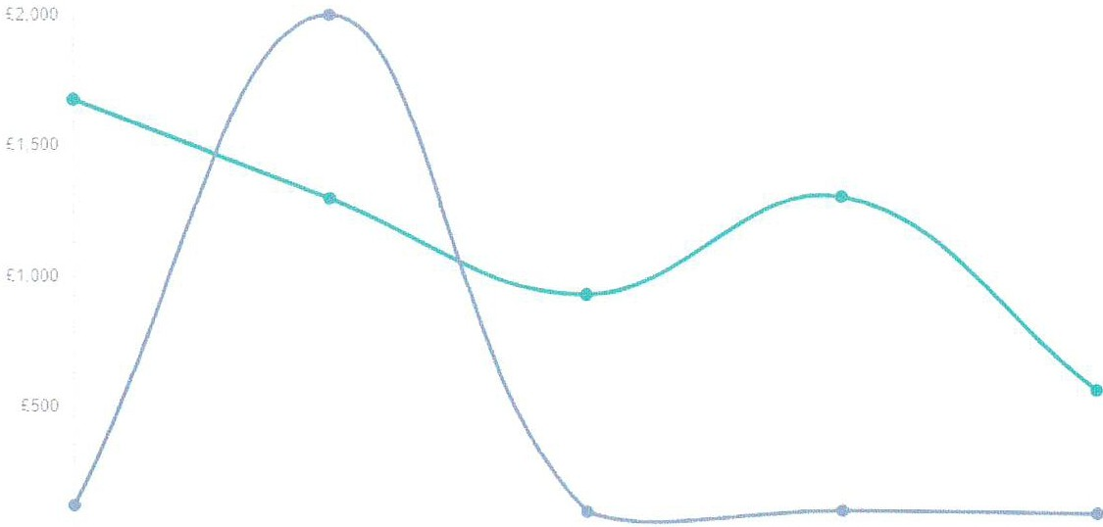
Governing document Contact information
£.O
3' ·2.2:,19 3'1 12 201t) 3 ·2202· 3"' ,2,2022 5• ◄ 2 2023

Financial period end date

 |  | Income I Expenditure | 31/12/2019 | 31/12/2020 | 31/12/2021 | 31/12/2022 | 31/12/2023
 |  |  |  |  |  |  | ---
g |  | Total gross income | £128 | £2.00k | £94 | £94 | £79
g |  | Total expenditure | £1.68k | £1.30k | £923 | £1.29k | £550
g |  | Income from government contracts | N/A | N/A | N/A | N/A | N/A
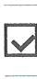
Income from government grants N/A N/A N/A N/A N/A

tit Print charitY.details

