c□p(dpr in t
.,
SOLUTIONS
O(}
j

Mac L11e costs:

lx New Toshiba E-Studio 251SAC
Purchase Cost - £2,395 ex VAT 3yr lease - £75.44 per month ex VAT 5yr lease - £49.58 per month ex VAT

Full Service Costs
Includes toners, parts, labour and maintenance Colour - £0.025* per page (£25 per 1,000)
M ono - £0.0025* per page (£2.50 per 1,000)
*Fixed for contract term

* No minimum billing
* We employ our own engineers
* Delivery, installation and training included
* Remote support via Teamviewer

CJ,

c□p'=Jpr in t
SOLUTIONS

O<)
0)
)

lx Fully Refurbished Toshiba e-studio
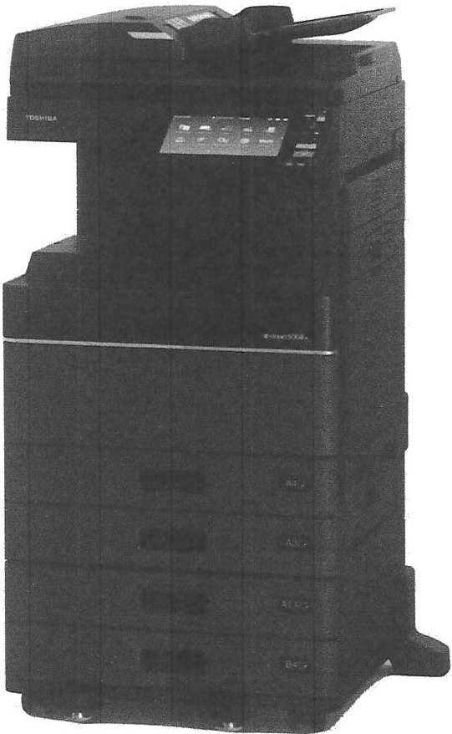
4505AC

- 45 pages per minute in colour and mono
- 100 sheet reversing document feeder
- AS-SRA3 paper {52-300gsm)
- Postscript enabled
- 50 sheet internal staple finisher
- 1,200 x 1,200 dpi
- 2 x 550 sheet paper trays
- 1 x 2,000 sheet tandem deck
- 1 x 100 sheet multi bypass
- 320 GB Secure HOD
•4GB RAM
- Mobile desk unit
- Cloud enabled

c □p(dp r in t
.,
SOLUTIONS

0()

Machine costs:

lx Fully Refurbished Toshiba E-Studio 4505AC
Purchase Cost - £1, 250 ex VAT 3yr lease- £41.63 per month ex VAT Syr lease - £27.75 per month ex VAT

Full Service Costs
Includ es toners, parts, labour and maintenance Colour - £0.028* per page (£28 per 1,000} Mono - £0.0028* per page (£2.80 per 1,000}
*Fixed for contract term

* No minimum billing
* We employ our own engineers
* Delivery, installation and training included
* Remote support via Teamviewer

c□pldp r in t
C,

SOLUTIONS
::t--
0()

About Us

Address - Unit 3, Block C, The Courts, Trafford Park, M17 lSF Website - www.copyprintsolutions.co.uk
Phone - 0161 876 0187
Company Registration number- 10317766 VAT Number- 252345030

TOSHIBA

TOSHIBA
Leading Innovation »>

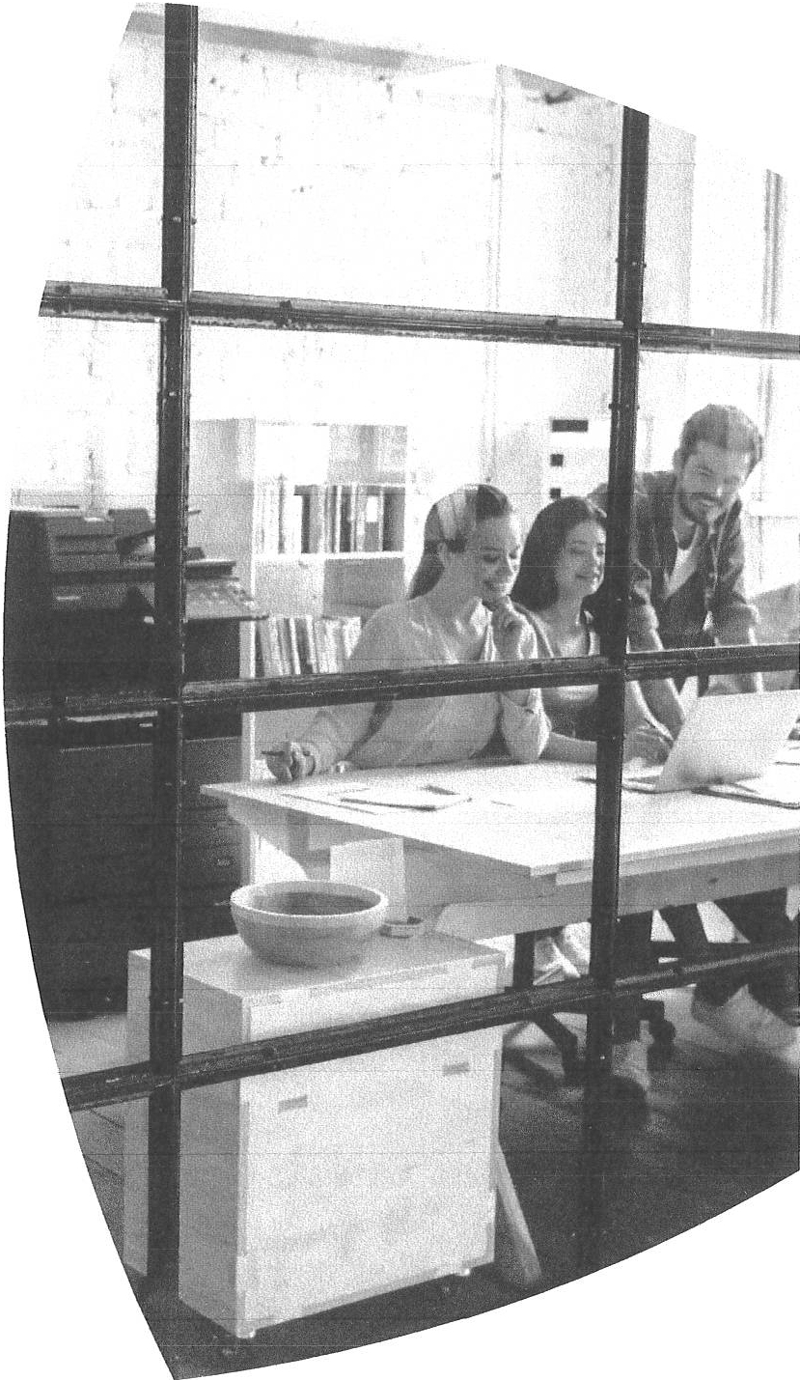
-SIUDI0 2 5 15AC
-SIUD0I 3 0 15AC
-SIUDI0 3 5 15AC
- SIUD0I 4 5 l5AC
- SIUD0I 5 0 15AC

Product brochure

  - Tosh iba's A3 colour systems impr ess with an outstanding document output at a speed of up to 50 pages per minute.
  - Enhance your efficiency with tailor-made workflows, easily accessible via the
fully customisable user interface.
  - All models easily integrate into modern business environments and support cloud and mobile printing.

AGETHER
INFORMATION
p°':?f 5

2 e-STUDI0 2 515 Ac/ 3015A c/ 3 515 Ac/ 45 1 5A c/ 50 15 Ac

CONNECT. INTEGRATE. SIMPLIFY.

Technolog y for every office, delivering advanced funct ionalit y, ease of use and peace of mind.
Every business is unique. That's why Toshiba offers the latest customisable solutions that can be tailored to meet your needs. Toshiba solutions help you simplify complex tasks while managing diverse information - efficiently and safely to maximise your productivity.

Toshiba's latest series delivers on our promise ofTogether Information - our commitment to collaborate with clientsto provide tailored, cost-effective solutions that meet your print, document management and content needs while helping you to meet your green objectives.
Super ior docume nt workflows with impressive colour output.
Don't restrict yourself. Colour can make all the difference and with Toshiba's e-STUDIO5015Ac ser ies youcan expect high image quality. Combine this with advanced features and you have a multifunction system which cove rs even the most demanding needs.

- Advanced Toshiba a-BRIDGENext controller technology for easy integration into IT environmentsand customisation of document workflows.
- Impeccab le, high-quality output with a resolution of up to 1,200 x 1,200 dpi.
- H igh-vo lu me cons istency of colour across small and large print jobs.

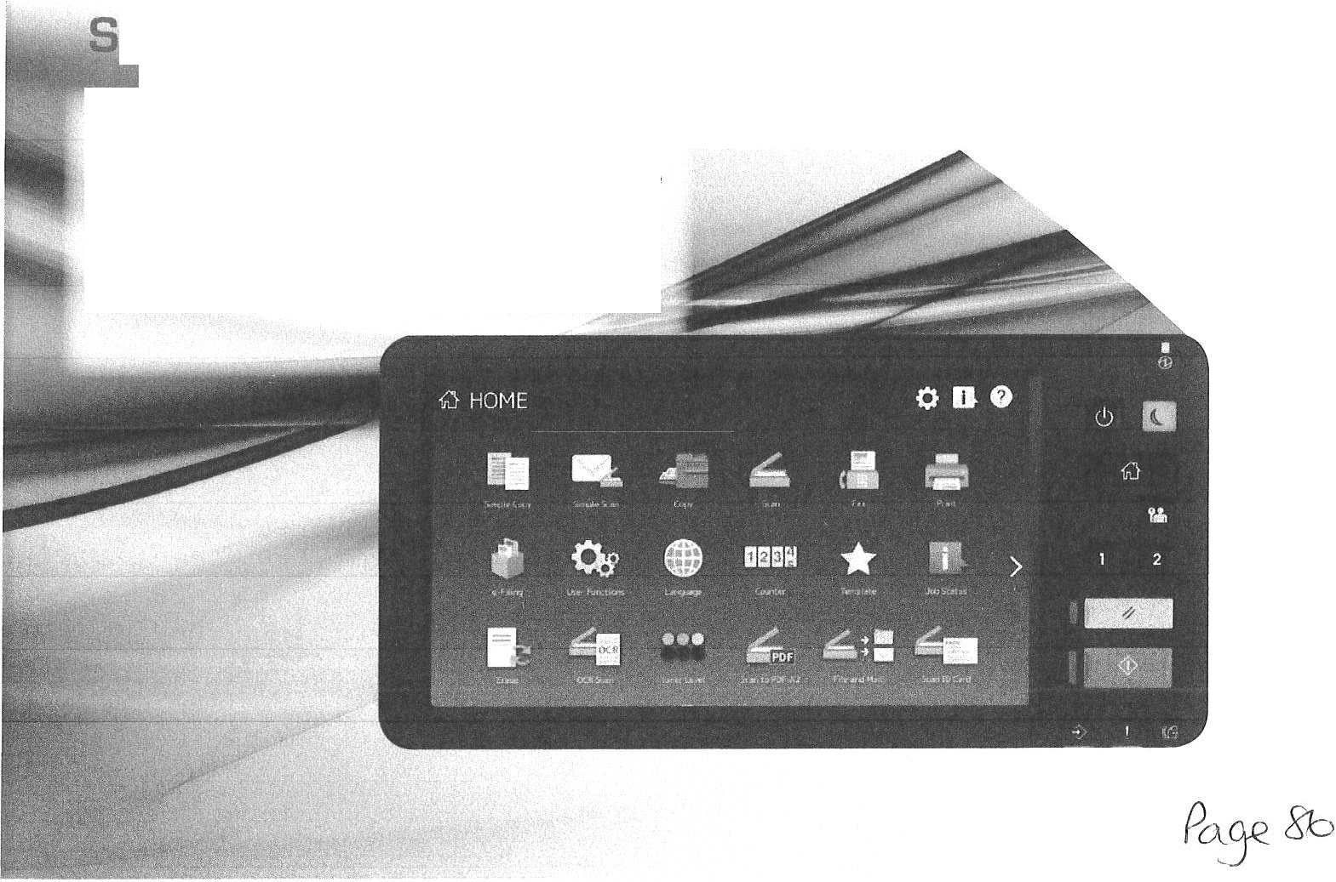
impleJ smart and stylish.
Toshiba has designed the e-STUDIO5015Ac ser ies to ensure utmost user experience. Via the 26 cm (10.1"}, tablet-style multi-touch screen, which is fully customisable, the sytems are intuitive to use and increase your productivity and efficiency.

Complicated multi-step processes can be turned into
one-touch functions and willhelp streamline your document workflows.

3

ADVANCED TECHNOLOGY

FOR MORE EFFICIENCY.

Businesses require a great amount of flexibility and the possibility to access information and data anytime from anywhere - the e-STUDIO5015Acseries is ready for this.

Flexible integration with third-party applications, an embedded web browser and the support of cloud and mobile printing are just some of the features, which will enhance your efficiency and boost your productivity.

As each company has different ways of storing and sharing data, the colour systems can be equipped with apps, which meet your individual requirements or preferences. Whether you wish to connect to cloud services or local applications, we have the solution.

Cloud solution apps
  - a-BRIDGE Plus for Box
  - a-BRIDGE Plus for Dropbox
  - a-BRIDGE Plus for Google Cloud Print
  - a-BRIDGE Plus for Google Drive
  - e-BRIDGE Plus for OneDrive
  - e-BRIDGE Plus for OneDrive for Business¹
>
Security for your business
Protecting your business' data is at the top of our minds while designing our products and we offer a large range of built-in and optional features to help enhance your security and aid GDPR compliance:

- The self-encrypting Toshiba Secure HOD provides top level security and makes unauthorised access to the data virtually impossible.
- Card readers not only provide an extra layerof security but also give direct access to the user's print jobs.
We offer a large choice of card readers with different features to ensure your needs are covered.
- By adding optional security functions the systems conform with HCD-PP v1.0 and are Common Criteria certified.

  - a-BRIDGE Plus for SharePoint Online1l
  - a-BRIDGE Plus for Exchange Online1l
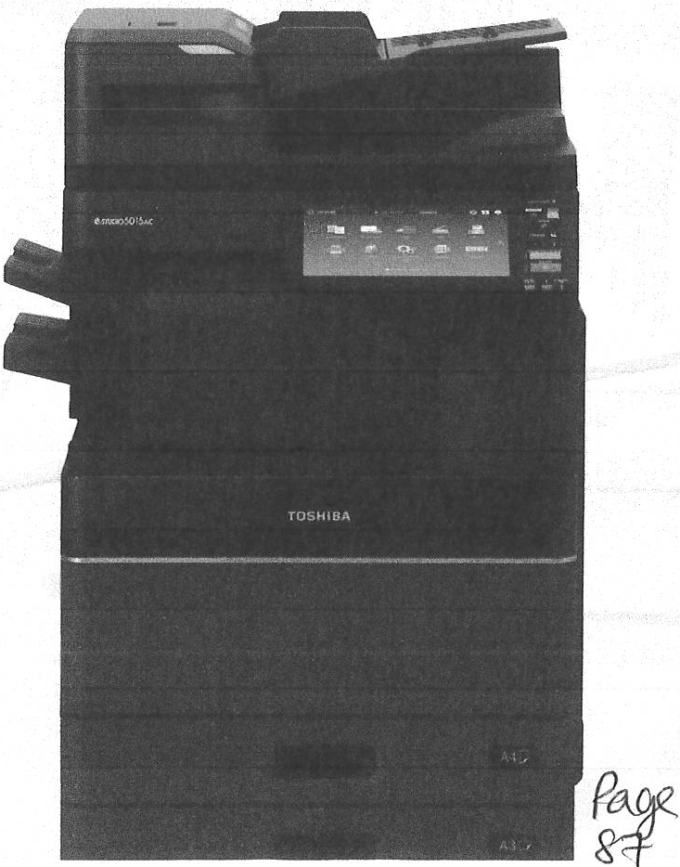
Workflow solution apps
  - a-BRIDGE Plus for Barcode Scan
  - a-BRIDGE Plus for USB Storage

Environmental Protection
Protecting the environment is embedded in our corporate philosophy and we ensure that our products comply to the highest environmental standards. With ENERGY STAR certification,these devices help you to save money and protect the environment through their energy efficiencies. In addition, our devices arrive with youcarbon neutral as all the carbon from procurement, production and shipping is offset by carbon reduction projects around the world as part of our Carbon Zero Scheme.

'1Embedded app for Microsoft Office365

4 e-STUDI02515Ac/3015Ac/3515Ac/4515Ac/5015Ac

COMPACT AND FULLY

CUSTOMISABLE

The e-STUDIO5015Ac series comes with a small footprint packed with industry-leadingtechnology and innovations. Designed to help workgroups connect, integrate and simplify processes the systems have an unparalleled set of features.

Auto Calibration ensures perfect image quality with consistentcolours and crystal-clearlines from the first to the last page.

RGB Colour Substitutionallows accurate colours with office applications so that your documents are printed exactly the way you want.

Multi Station Print Solution allows you to send print jobs from your desktop and retrievethem at up to 50 different MFPs by authenticating at that device, e.g. by simply swiping your badge.

Embedded Optical Character Recognition (OCR) simplifies the creation of searchable PDFs and editable document formats such as Microsoft Word.
Scan and Fax Preview allows you to review, rotate and modify your scanned documents or incoming faxes before saving or printing them.

Scan to USB is great for working with your documents when on the go. Plus, with the option to create PDF/A-2 files your documents are ready for long-termarchiving.

Print from USB for quick and easy printouts. If necessary, the MFP will automatica lly scale your documents to fit the available paper size.

E-ma il Direct Print ing can automatica lly print attached documents from e-mails sent to the MFP.

Barcode Printing allows you to send print data from your ERP system direct ly to the MFP. The barcode sequence is automatically processed and printed without the need of additional middleware.

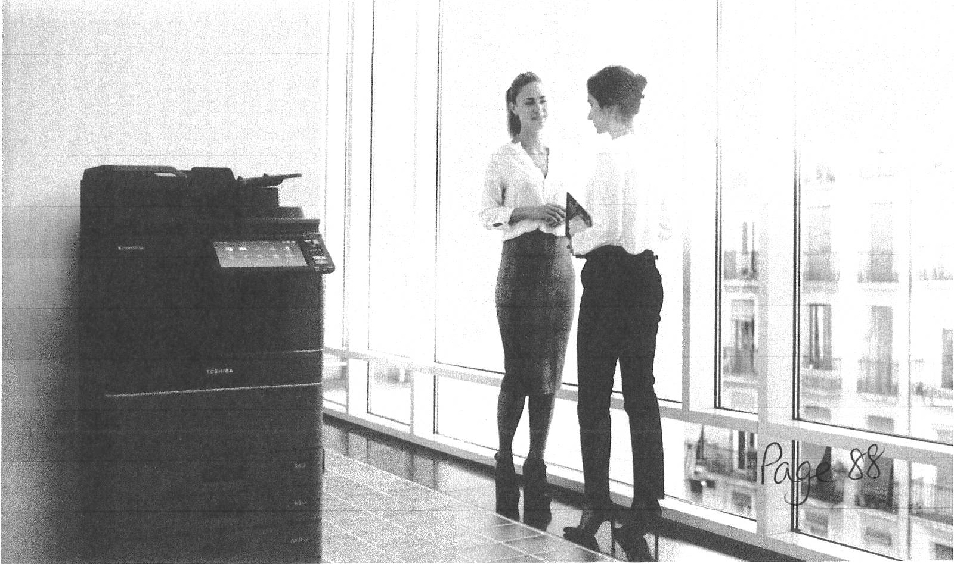

5

CONFIGURATION

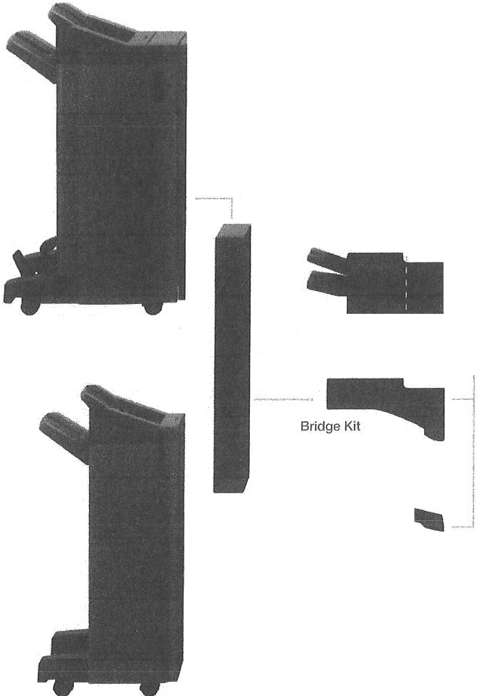Dual Scan Document Feeder

Reversing Automatic Document Feeder

Platen Cover

Hole Punch Unit
l----------1 J

Saddle-Stitch Finisher

Inner Finisher
HolePunch Unit j
r· ,.,,-
, CJ Accessible Arm

II
i -- Work Tray

j l
Accessory Tray
I Panel Ten-Key

l

Job Separator

Paper Feed Pedestal

I
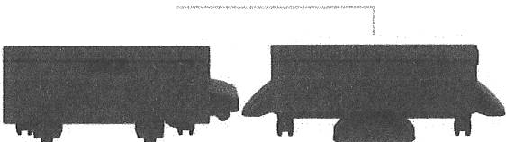
r 1'. _
! -

M anua l Poc k et

Multi-Staple Finisher

Large Capacity Feeder

Desk

Envelope Drawer Drawer Module

HIGHLIGHTS

M obile Print ing
Easily connect to these systems with your mobile devices via AirPrint, Google Cloud Print or the Mopria Print Service. By adding the optional Wi- Fi module you can unleash even more mobile print and scan features.
Uniq ue User Exper ience
The large and fully customisable user interface makesthe MFP intuitive to use. Simply swipe through the menu and select the feature or function you need and modify the screen to suit your individual preferences.
Dual Scan Document Feeder
An option which holds an amazing 300 originals and boasts an impressive 240 images per minute (ipm) by scanning both sides of the page in a single pass.

6 e-STUDI0 2515Ac/ 3015 Ac/ 35 1 5 Ac/ 45 1 5A c/ 5015 AC

SPECIFICATIONS

General
Print & Copy Speed

Wann-up Time Paper Size & Weight

Paper Capacity

Inner Output Tray Automatic Duplex Controller Type Control Panel

25/30/35/45/50 ppm (A4)
15/16/18/22/25 ppm (A3)
Approx . 12 seconds from low power mode Cassette 1: A5R-A3, 60-256 gsm
Cassette 2: A5R-320 x 460 mm, 60-256 gsm
Bypass: 100 x 148 mm-320 x 460 mm, 52-280 gsm, banner paper (up to 305 x 1,200 mm, 90-163 gsm)
2x 550 sheets (Cassettes), 1x 100 sheets (Bypass)
Maximum 3,200 sheets 400-sheet capacity
ASR-305 x 457 mm, 60-256 gsm
Toshiba a-BRIDGENext
26 cm (10.1") Multi-Touch Colour Panel
Copy
Resolution Scan: 600 x 600 dpi
Print: 600 x 600 dpi,5 bit, equiv. 2,400 x 600 dpi with smoothing (monochrome only)
First Copy Output Time Colour: Approx. 7.8/7.8/7.8/5.7/5.7 seconds
Monochrome: Approx. 5.9/5.9/5.9/4.4/4.4 seconds
Zoom 25-400% (Platen),25-200% (RADF/DSDF)l'
Copy Modes Text, Text/Photo, Photo, Printed Image, Map, Image Smoothing
Colour Modes Auto-Colour (ACS), Full Colour, Twin Colour,
Mono Colour, Monochrome
Colour Settings Hue, Saturation, Colour Balance, RGB adjustment, 5 one-touch modes
Copy Functions Electronic Sort, Rotate Sort, ID Card Copy,
Edge Erase, 2-in-1 / 4-in-1 mode

Memory Toshiba Secure HOD 320 GB'l, 4 GB RAM

Interface

Dimensions& Weight

Print
1OBase-T/1OOBase-TX/1OOOBase-T,
High Speed USB 2.0, WLAN2l QEEE802.11b/g/n) , Bluetooth 2l, Wi-Fi Direct'l
585 x 641 x 787 mm fN x D x H), - 78 kg
Fax21
Communication Transmission Speed Compression
Fax Memory

Super G3, G3 - (opt. 2°• line), Internet Fax T.37 Approx. 3 seconds per page
JBIG, MMR, MR, MH
1 GB Transmission/Reception

Resolution

Page Description Language
Supported Systems

Network Protocols

Colour Modes Colour Settings

Mobile Printing Print Functions

Scan
Resolution Scan Speed

Scan Modes File Formats

Scan Functions

600 x 600 dpi,5 bit,
1,200 x 1,200 dpi, 2 brt (equiv. 3,600 x 1,200 dpQ with Postscript driver only
PCL5e, PCL5c, PCL6 (PCL XL), XPS, PDF and
Postscript 3 compatible
Windows 10/8.117/Server 2008 (32/64 brt), Windows Server 2016/Server 2012 R2/Server 2012/ Server 2008 R2 (64 bit), Mac OS X 10.6.8-10.13,
Linux/Unix, Citrix, Novell SLES, SAP, AS/400
TCP/IP QPv4/IPv6), IPX/SPX,EtherTalk, NetBios over TCP/IP
Auto-Colour (ACS), Colour, Twin Colour, Monochrome
ICC profile colour management, RGB subsmution, Brightness, Saturation, Contrast, Colour Balance
a-BRIDGE Print & Capture, AirPrint, Mopria Print Service, Google Cloud Print
Universal Printer Driver, Driver Templates, Driver plug-ins2l, Print from USB, Hold print,
Tandem printing, E-mail direct printing

Maximum 600 x 600 dpi
Reversing Automatic Document Feeder'l:
up to 73 ipm (300 dp0 in colour and monochrome
Dual Scan Document Feeder'l:
up to 240 ipm (300 dpi) in colour and monochrome Auto-Colour (ACS), Colour, Grayscale, Monochrome
JPEG, Mufti/Single Page TIFF/XPS/PDF,
Secure PDF, Slim PDF, PDF/A, PDF/A-2, Searchable PDP (and other formats like DOCX, XLSX)2l
WS Scan, Scan to USB, Scan to E-Mail, Scan to File (SMB, FTP, FTPS, IPX/SPX, Local), Meta Scan21, OCR scan2l, Scan to Box (a-Filing), WIA, TWAIN
Network-Fax Driver for Windows 10/8.1/7/Server 2008 (32/64 bit),
Windows Server 2016/Server 2012 R2/Server 2012/ Server 2008 R2 (64 bit)
IncomingFax Routing To shared folders (SMB, FTP, IPX/SPX), E-Mail,
a-Filing

System & Security
Device Management Top Access for remote administration and configuration
System Features a-Filing document server for secure storage,
Document distribution and Print-on-Demand
(1 public box, 200 user boxes). 12,060 one-touch templates for storage of personalised settings
or workflows, Scan/Fax Preview, Rip-while­ Print, a-BRIDGE Open Platform, Embedded Web Browser, Job Skip, PCL Barcode printing, e-BRIDGE Plus embedded apps
Accounting & Security Role Based Access, LDAP support, 1,000
department & 10,000 user codes, Card Reader''. Private print, Standard data encryption with ToshibaSecure HOD, Data Overwrite Enabler2l, IP and MAC address filter, Port filter, Support of SSL and 1Pse c2l protocols, IEEE802.1x support, CC certified (ISO/IEC15408)with HCD-PP v1.0 . Scan to Secure PDF, Pull-printing

7

OPTIONS

REVERSING AUTOMATIC 100-sheet capacity, A5R-A3, 35-157 gsm
DOCUMENT FEEDER
DUAL SCAN 300-sheet capacity, A5R-A3, 35-209 gsm
DOCUMENT FEEDER
PAPER FEED PEDESTAL 550-sheet capacity (1 Cassette),
A5R-320 x 460 mm, 60-256 gsm
DRAWER MODULE For Paper Feed Pedestal
550-sheet capacity (1 Cassette) A5R-320 x 460 mm, 60-256 gsm
ENVELOPE DRAWER For Paper Feed Pedestal or 2"" cassette
Envelopes: 50-envelope capacity,
100 x 162 mm-240 x 380 mm, 60-85 gsm Paper: 550-sheet capacity (1 Cassette), A5R-A4R, 60-256 gsm
LARGE CAPACITY FEEDER 2,000-sheets capacity, A4, 64-105 gsm
INNER FINISHER 2 trays, 600-sheet capacity
50-sheet multi-position stapling
A4R-A3, 60-105 gsm (stapling mode)
MULTI-STAPLE FINISHER 2 trays, 2,250-sheet capacity
50-sheet multi-positionstapling
A4R-A3, 60-105 gsm (stapling mode)
SADDLE- STITCH FINISHER 2 trays, 3,250-sheet capacity
50-sheet multi-position stapling 5-sheet centre folding
Saddle-stitched booklets of up to 60 pages A4R-A3, 60-105 gsm (stapling mode)
PLATEN COVER DESK
JOB SEPARATOR FAX BOARD
WIRELESS LAN/ BLUETOOTH MODULE (incl. Wi-Fi Direct)
e•BRIDGE ID- GATE
HARD DISK DRIVE 320 GB'' ACCESSORY TRAY
PANEL TEN-KEY OPTION WORK TRAY
DATA OVERWRITE ENABLER IPsec ENABLER
EMBEDDED OCR ENABLER
MULTI STATION PRINT ENABLER HARD COPY SECURITY KIT META SCAN ENABLER UNICODE FONT ENABLER ACCESSIBLE ARM

HOLE PUNCH UNIT Available in 2 holes (E), 4 ho les (F)

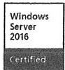
Bli g
mmm'Jm1 t
O® ._. ,.-.. .-..,-,_-.
--

li'11a=i j

'' 1 GB = 1 billionbytes; the actual formatted capacity
is less . Available capacity will also be less if software

{ y- CElnlFIED mopn-cr
applications are pre-insteJl ed.
- Optional
P 9I

e-SUTDI02515Ac/ 3015Ac/ 3 5 1 5A c/ 45 15 Ac/ 5015Ac

About Toshiba TEC UK

Toshiba TEC UK Imaging Systems LTD is part of the globally operating Toshiba TEC Corporation, active in various high-tech industrial sectors.

Toshiba TEC Corporat ion is a leading provider of information technology, operating across multiple industries. With headquarters in Japan and over 80 subsidiaries worldwide, Toshiba TEC Corporation helps organisations transform the way they create, record, share, manage and display information.

For more information please contact us:

TOSHIBA TEC UK IMAGING SYSTEMS LTD
Abbey Cloisters, Abbey Green, Chertsey, Surrey KT16 8RB
Telephone
+44 (0)843 2244944
Email
info@toshibatec.co.uk
Website
www.toshibatec .co.uk

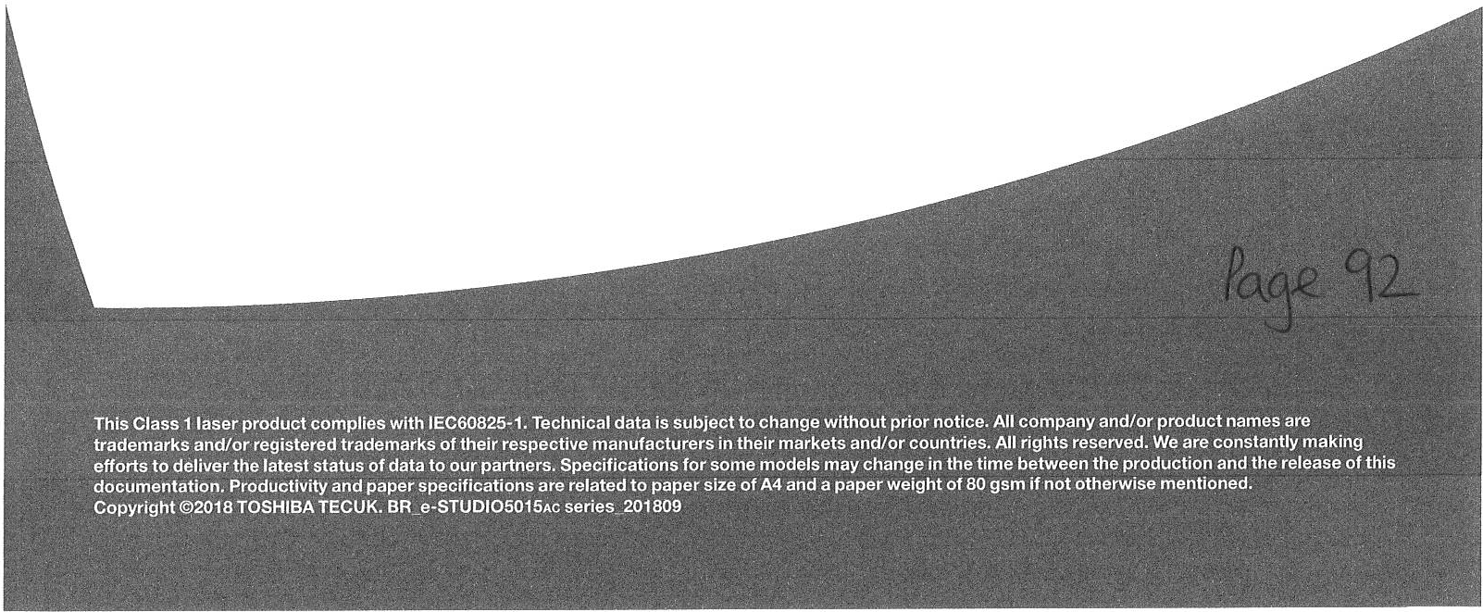

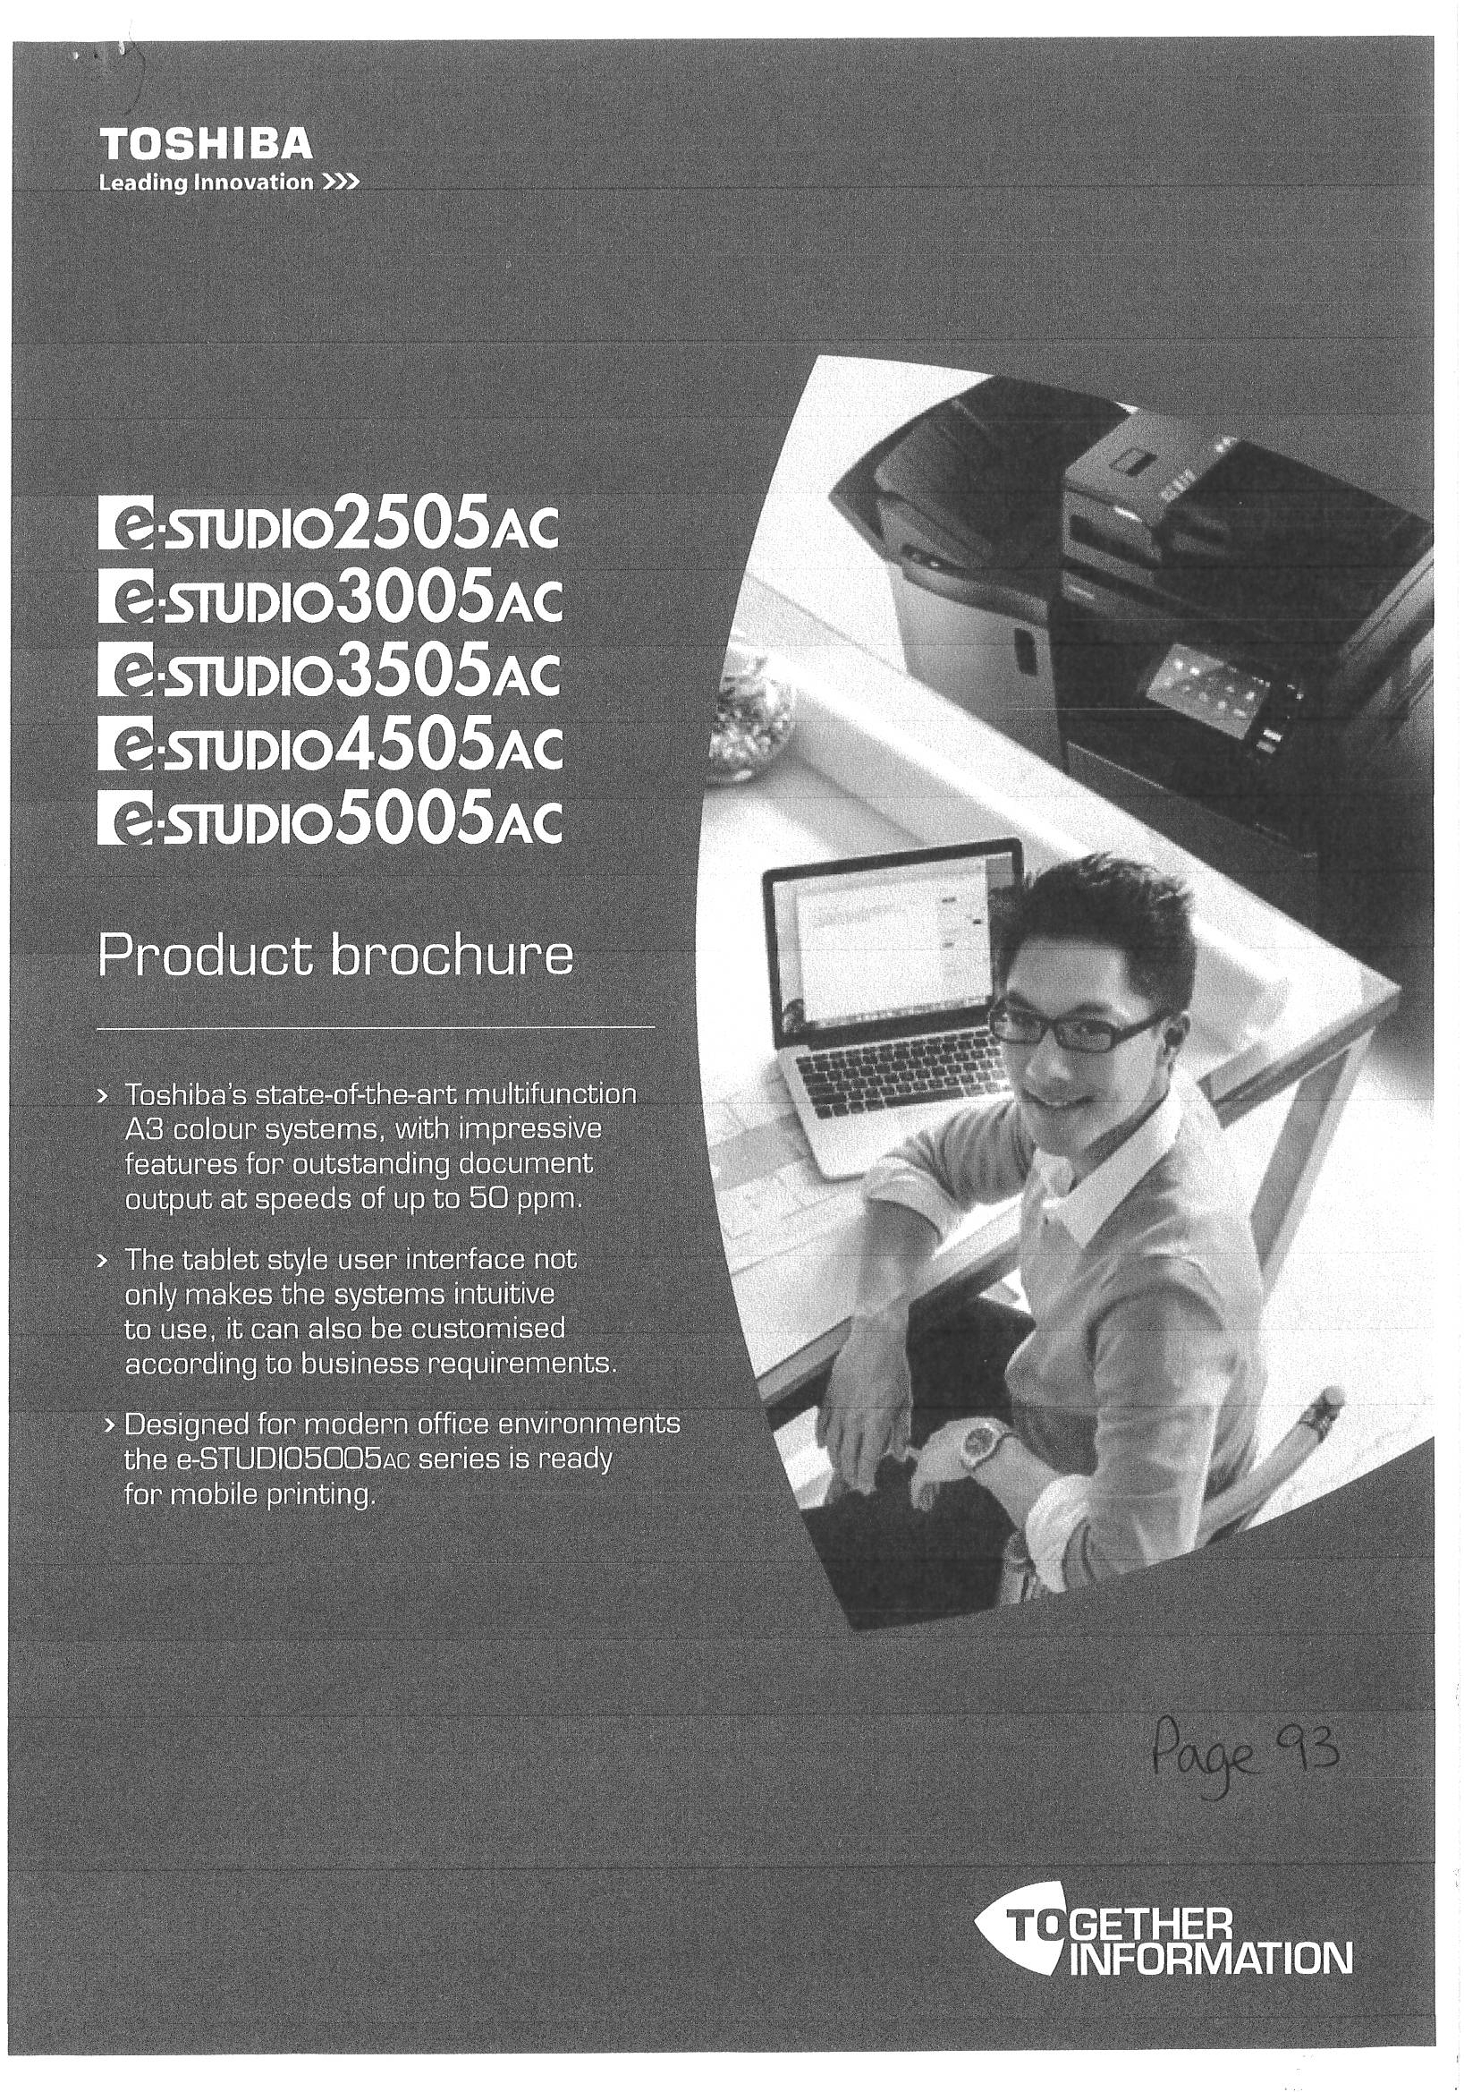

2 e-STUDI02505Ac/3005Ac/3505Ac/4505Ac/5005AC

CONNECT. INTEGRATE. SIMPLIFY.

Technology for ever y office, delivering advanced functionality, ease of use and peace of mind.
Every industry has unique workflow needs. Toshiba has developed customisable MFPs to make your job easier. Intuitive and smartly integrated, our products simplify complex tasks and give youcontrol while providing the reliability Toshiba is known for.

Toshiba's latest series delivers on our promise of Together Information - our commitment to collaborate with clients in order to provide tailored, cost-effective solutions to meet specific print, document management and content needs while helping you to meet your green objectives.
Colour commands attention. Technology makes it possible.
It'simportant that an MFP is powerful, reliable, and efficient. Combine this with brilliant colours and you have even more ways to make your documents impactful.

- Advanced Toshiba a-BRIDGE controller technology for high-quality document output in colour and monochrome
- RGB substitution allows accurate colours with office applications
- Auto-calibration ensures consistency of colour across small and large print jobs

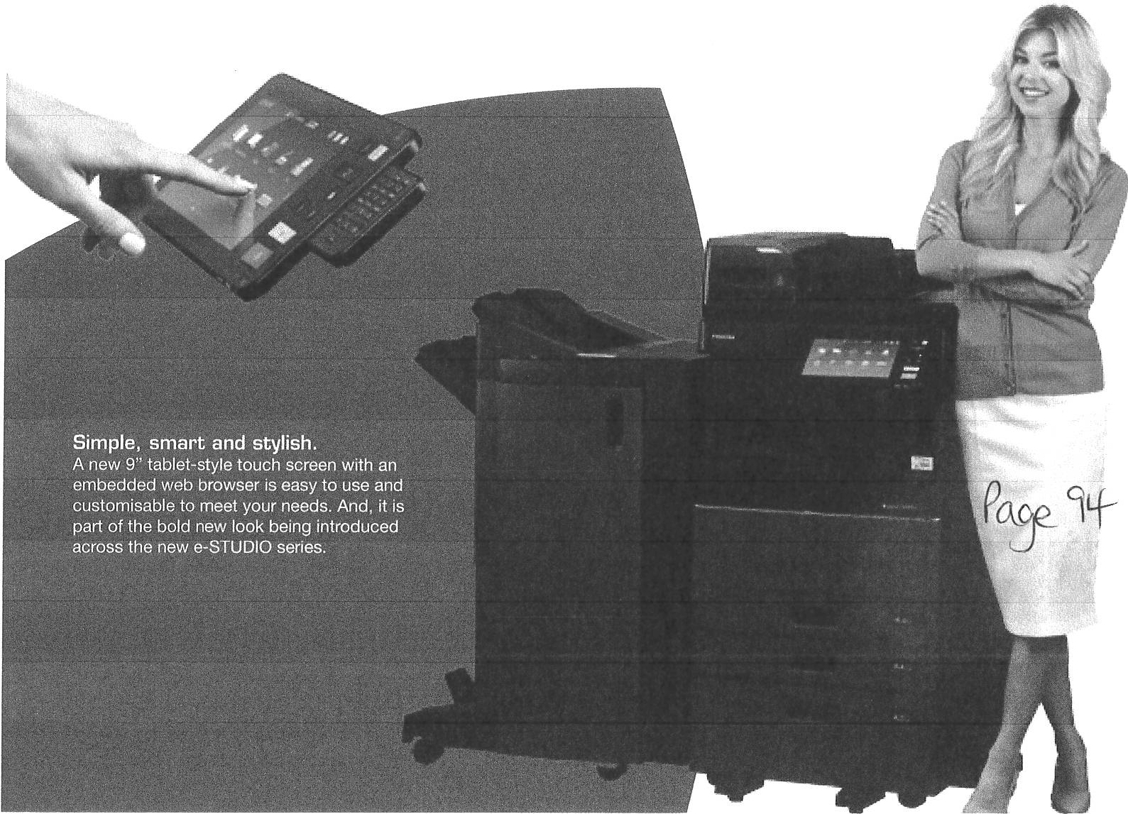

3

TOSHIBA TECHNOLOGY NEVER LOOKED BETTER.

Keeping medium to large workgroups in mind,the
e-STUDIO5005Ac series is easily integrated, customisable and solutions ready, with its open platform architecture.

Flexible integration with third-party solutions applications, an embedded web browser brings the workflow to one location.

Toshiba's exclusive e-BRIDGE Print & Capture application enables you to use your mobile device to take advantage of the broad feature set of our MFPs - whether in
the office or on the go.

The universal driver provides fast and easy connectivity and works on all Toshiba a-BRIDGEmodels. Youcan choose from a variety of time-saving, function-addingplug-ins that enable productivity from the driver. For instance:
  - e-BR IDGE Job Point
Quickly split up large jobs with up to 10 Toshiba MFPs
  - a-BRIDGE Job Replicator
Use multi-part form replacement (3 prints)
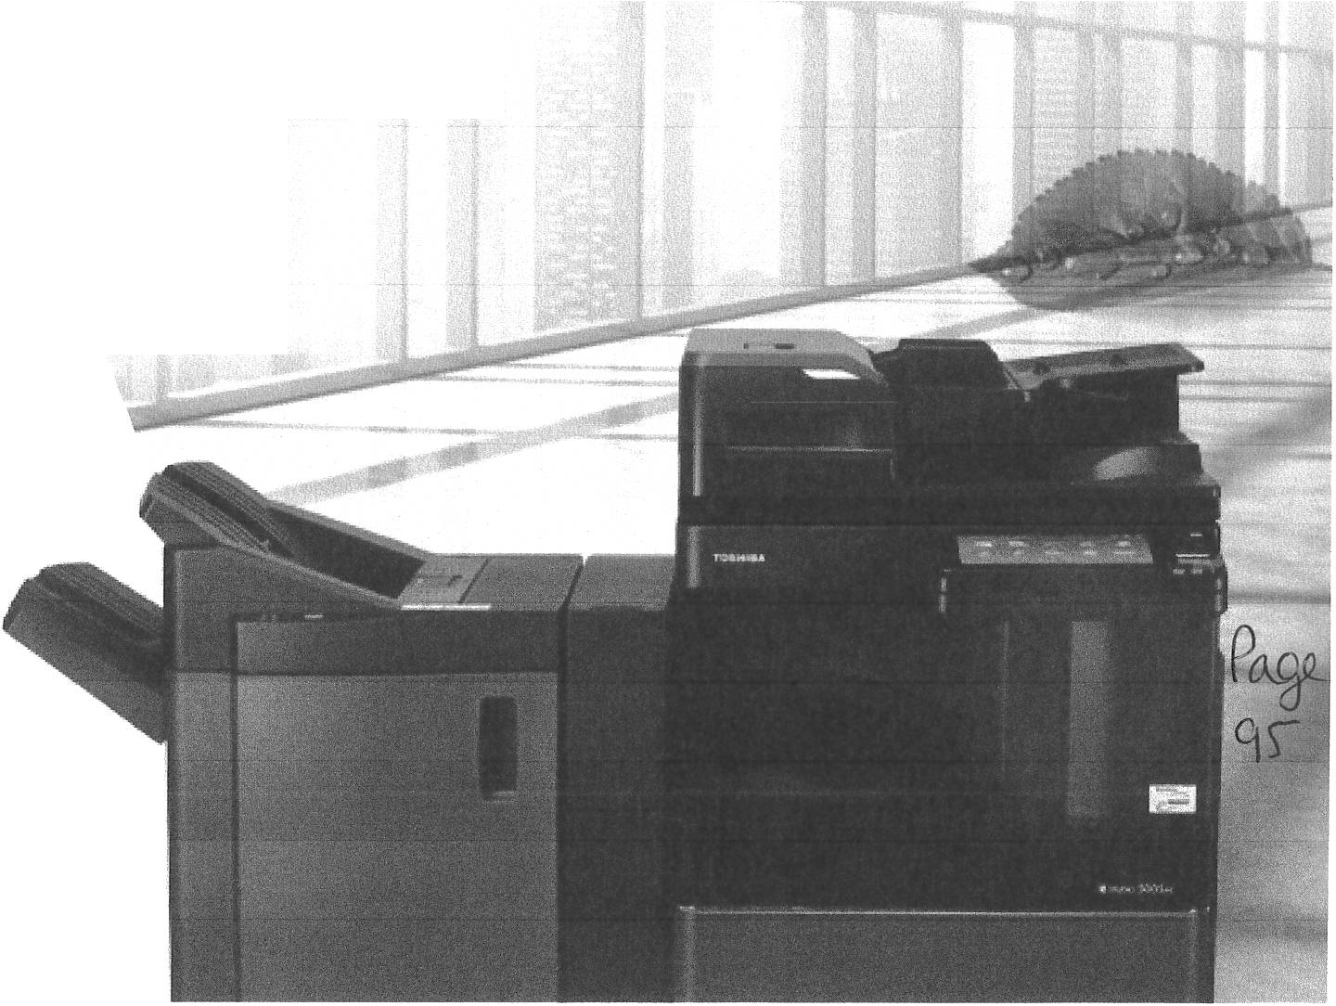
  - a-BR IDGE Job Separator
Perform batch printing easily using any Microsoft Office programme
  - e-BR I DGE Job Build
Conveniently print different document types all together as a single job
Industry-Leading Securit y
Along with all of the new and innovative Toshiba technologies, we ensure that the security of your business is a priority.

- The se lf-encryp ting Toshiba Secure HDD provides top level security
- By adding optional security functions the systems become compliant with IEEE2600.1 and meet the EAL3 Common Criteria requirements
- IPsec is available to securely encrypt data sent to and from the MFP

World-LeadingEnvir onmental Standards Our innovative approach makes certain that our environmentis part of the equation.

- RoHS compliant; use of recycled plastics and a low-power Super Sleep Mode to save resources
- Being ENERGY STAR Tier 2 compliant means the systems meet the latest, most stringent environmental requirements

4 e-STUDI0 250 5Ac/ 300 5Ac/ 350 5A c/ 4 50 5Ac/ 50 05 Ac

COMPACT, STYLISH
AND FULLY CUSTOMISABLE
The e-STUD1O5005Ac ser ies is packed with industry-leading technologyand innovations designed to help workgroups connect, integrate and simplify all within a compact footprint.

Dual Scan Document Feeder is an option which holds an amazing 300 originals and boasts an impressive 240 images per minute (ipm) by scann ing both sidesof the page in a single pass.

Multi Station Print Solution* allows you to send print jobs from your desktop and retrieve them at any convenient MFP by authenticatingat that device, e.g. by simply swiping an ID card.

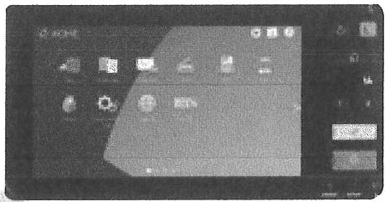
Print Around eliminates printing bottlenecks by allowingother print jobs to go around one job that's held-up due to requiring a specific paper size or type.

Job Reservation will queue up multiple copy or print jobs so users can send jobs whenever.

Embedded Optical Character Recognition* (OCR) simplifies the creation of searchable PDFs or prepares for editable document formats such as Microsoft Word.

Saddle/Fold Capabilities offer saddle-stitch finishing and the option to fold without stapling.

Large Paper Formats from the Cassette provide the ability to also print SRA3 and upto a maximumsize of 320 x 460 mm.

Scan to and Print fromUSBletsyouprint straight from your USB drive or scan documents to it.

Mobile Printing connects these systems with your mobile devices via AirPrint, Google Cloud Printorthe Mopria Print Service.
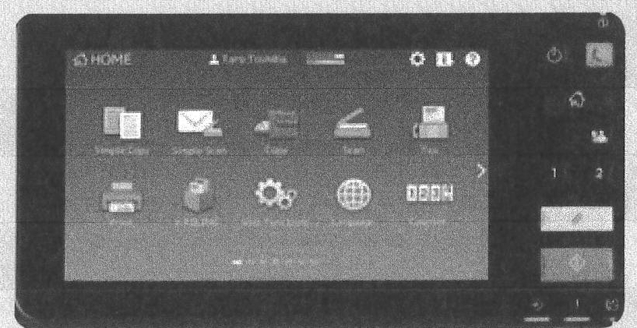

With a large touch screen document handling hes never been easier. Size and order of icons as well as the background image can be customised. Enjoy the unique experience of working with a system t:het understands what you want.
I

Customised to display up to 18 icons per page and with a different background

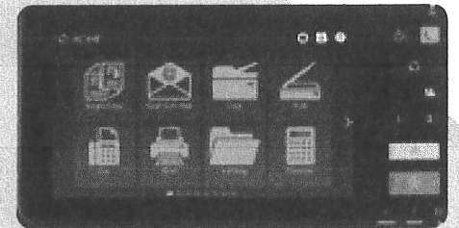

Display icons as buttons to easily access functions
or start workflows.

"Optional

5

CONFIGURATION

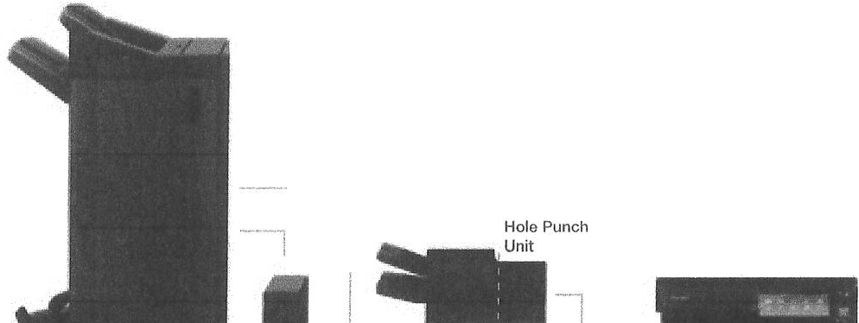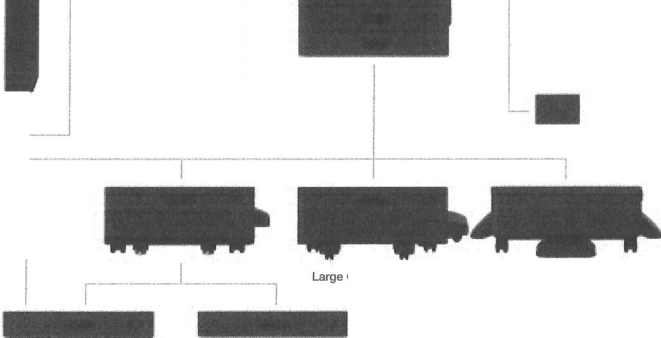
Saddle-Stitch Finisher
Dual Scan Document Feeder
Reversing Automatic Document Feeder
Platen Cover
I
Inner Finisher
7
Hole Punch Unit
'------•
··-· I
Work Tray
Accessory Tray

Panel Ten-Key
Job Separator "' )
_j
Manua l Pocket
Paper Feed Pedestal
Desk
Staple Finisher
Envelope Drawer Drawer Module

HIGHLIGHTS

Advanced e-BRIDGE Technology Toshibas' next-generationa-BRIDGE architecture features an embedded web browser, 4 GBRAM and the Toshiba secure hard disk drive enabling the MFP to easily drive Toshiba's internally developed solutions as
well as third-party applications.
Embedded Apps
The optionale-BRIDGEPlus connectors for Microsoft OneDrive, Google Drive and Dropbox let you send your documents directly to or print from these cloud services via the MFP.
Card Readers
A choice of optional card readers not only gives you fast and convenient access to your print jobs but
alsoincreases datasecurity.

6 e-STUD lO 2 5O5Ac/ 3 OO5Ac/ 3 5 O5 Ac/ 4 5O5 Ac/ 50 O5 Ac

SPECIFICATIONS

General
Print & Copy Speed

Warm-up Time Paper Size & Weight

Paper Capacity

Inner Output Tray Automatic Duplex Controller Type Control Panel Memory
Interface

Dimensions & Weight

25/30/35/45/50ppm (A4)
15/16/18/22/25 ppm (A3)
Approx. 12 seconds from low power mode Cassette 1: A5R-A3, 60-256 gsm
Cassette 2: A5R·320 x 460 mm, 60-256 gsm
Bypass: 100 x 148 mm-320 x 460 mm, 52-280 gsm,
banner paper (up to 305 x 1,200 mm, 90-163 gsm)
2x 550 sheets (Cassettes), 1x 100 sheets (Bypass) Maximum 3,200 sheets
400-sheet capacity A5R-A3, 60-256 gsm
Toshiba a-BRIDGE
22.8 cm (9") Multi-Touch Colour Panel Toshiba Secure HOD 320 GB'1, 4 GB RAM 10Base-T/100Base-TX/1000Base-T,
High Speed USS 2.0, WLAN21 (IEEE802. 1 1 b/g/n), Bluetooth2l, WiFi Direct2l
585 x 640 x 787 mm CM x D x H), - 75.5 kg
Copy
Resolution Scan: 600 x 600 dpi
Print: 600 x 600 dpi, 2,400 x 600 dpl with smoothing
First Copy Output Time Colour: Approx. 7.8/7.8/7.8/5.7/5.7 seconds
Monochrome: Approx. 5.9/5.9/5.9/4.4/4.4 seconds
Zoom 25-400% (Platen), 25-200% (RADF/DSDF)21
Copy Modes Text, Text/Photo, Photo, Printed Image, Map, Image Smoothing
Colour Modes Auto-Colour (ACS), Full Colour, Twin Colour,
Mono Colour, Monochrome
Colour Settings Hue, Saturation, Colour Balance, RGB adjustment 5 one-touch modes
Copy Functions Electronic Sort, Rotate Sort, ID Card Copy,
Edge Erase, 2-in-1 / 4-in·1 mode

Fax21
Communication Super G3, G3 - (opt. 2"" line), Internet Fax T.37
Transmission Speed Approx. 3 seconds per page

Print
Resolution

Page Description

600 x 600 dpi,
1,200 x 1,200 dpi (2 bit, Postscript driver only), 3,600 x 1,200 dpi with smoothing (Postscript driver only, monochrome)
PCL5e, PCL5c, PCL6 (PCL XL), XPS and
Compression Fax Memory Network-Fax

Incoming Fax Routing
JBIG, MMR, MR, MH
1 GB Transmission/Reception
Driver for Windows 10/8/7N ista/Server2008 (32/64 bit),Server 2012/Server 2008 R2 (64 b )
To shared folders (SMB, FTP, IPX/SPX), E-Mai l, e-Fil ing

Language
Supported Systems
PostScript 3 compatible
Windows 10/8/7Msta/Server 2008(32/64 bit),
System & Securit y

Network Protocols

Colour Modes Colour Settings

Mobile Printing Print Functions

Scan
Resolution Scan Speed

Scan Modes File Formats

Scan Functions
Windows Server 2012/Server 2008 R2 (64 bit), Mac OS X 10.6.8-10.11, Linux/Unix, Citrix, Novell NetWare (NDPS), SAP, AS/400
TCP/IP (IPv4/lPv6), IPX/SPX, EtherTakl , NetBios over TCP/IP
Auto-Colour (ACS), Colou r, TwinColour, Monochrome
ICC profile colour management, RGB substitution, Brightness, Saturation, Contrast, Colour Balance
e-BRIDGE Print & Capture, AirPrlnt, Mopria Print Service, Google Cloud Print
UniversalPrinter Driver, Driver Templates, Driver
plug-ins21, Print from USB, Hold print, Tandem printing

Maximum 600 x 600 dpi
Reversing Automatic Document Feeder'l:
up to 73 ipm (300 dpijin colour and monochrome
Dual Scan Document Feeder'l:
up to 240 ipm (300 dpi) in colour and monochrome Auto-Colour (ACS), Colour, Grayscale, Monochrome
JPEG, MultVSingle Page TIFF/XPS/PDF,
Secure PDF, Slim PDF, PDF/A, Searchable PDP 1
(and other formats like DOCX, XLSX, RTF, T)(T)21
WS Scan, Scan to USS, Scan to E-Mail, Scan to File (SMB, FTP, FTPS, IPX/SPX, Local), Meta Scan21, OCR scan", Scan to Box (a-Filing}, WIA, TWAIN
Device Management System Features

Accounting & Security
a-BRIDGE Fleet Management System21, Top Access for remote administration and configuration
a-Filing document server for secure storage,
Document distribution and Print-on-Demand
(1 public box, 200 user boxes), 12,060 one-touch templates for storage of personalised settings or workflows, Scan/Fax Preview, Rip-while-Print.
e-BRIDGEOpen Platform'1, Embedded Web
Browser, Job Skip
Role Based Access, LOAP support, 1,000 department & 10,000 user codes, Card Reader'', Private print, Standard data encryption with Toshiba Secure HOD, Data Overwrite Enabler'l, IP and MAC address filter, Port filter. Support of SSL and IPsec" protocols, IEEE802.1x support, IEEE2600.1compliant21, Scan to Secure PDF

7

OPTIONS

REVERSING AUTOMATIC 100-sneet capacity, A5R-A3, 35-157 gsm
DOCUMENT FEEDER
DUAL SCAN 300-sheet capacity, A5A-A3, 35-209 gsm
DOCUMENT FEEDER
PAPER FEED PEDESTAL 550-sheet capacity (1 Cassette),
ASR-320 x 460 mm, 60-256 gsm
DRAWER MODULE For Paper Feed Pedestal
550-sheet capacity (1 Cassette) ASR-320 x 460 mm, 60-256 gsm
ENVELOPE DRAWER For Paper Feed Pedestal or 2"" cassette
Envelopes: SO-envelope capacity,
100 x 162 mm-240 x 380 mm, 60-85 gsm Paper: 550-sheet capacity (1 Cassette), A5R-A4R, 60-256 gsm
LARGE CAPACITY FEEDER 2,000-sheets capacity, A4, 64-105 gsm
INNER FINISHER 2 trays, 600-sheet capacity
50-sheet multi-position stapling
A4A-A3, 64-105 gsm (stapling mode)
MULTI-STAPLE FINISHER 2 trays, 2,250-sheet capacity
SO-sheet mufti-positionstapling
A4R-A3, 60-105 gsm (stapling mode)
SADDLE-STITCH FINISHER 2 trays, 3,250-sheet capacity
50-sheet multi-position stapling 5-sheet center folding
Saddle-stitched booklets of up to 60 pages A4R-A3, 60-105 gsm (stapling mode)
PLATEN COVER DESK
JOB SEPARATOR FAX BOARD
WIRELESS LAN/ BLUETOOTH MODULE (incl. WiFi Direct)
a-BRIDGEID-GATE ACCESSORY TRAY PANEL TEN-KEY OPTION WORK TRAY
DATA OVERWRITE ENABLER IPsec ENABLER
EMBEDDED OCR ENABLER MULTI STATION PRINT ENABLER HARD COPY SECURITY KIT META SCAN ENABLER UNICODE FONT ENABLER e•BRIOGE RE-RITE
ACCESSIBLE ARM

HOLE PUNCH UNIT
Available in 2 holes (E), 4 holes (F)

••

AlrPrlnt
w••
■
Servt,2012

TOSHJBA
CARBON
YE
......
ZERO

mopna-
·"®
QIIITIAI!)

'' 1 GB= 1 billion bytes; the actual formatted capacity is less. Available capacity will alsc be less ff softw are applications arep,e-installed.
- Optional

e-STUDI0 2505 Ac/ 300 5Ac/ 3 505Ac/ 450 5Ac/ 500 5AC

About Toshiba TEC
Toshiba TEC UK Imaging Systems LTD is part of theglobally operating Toshiba TEC Corporation, active in various high-tech industrial sectors.

Toshiba TEC Corporat ion is a leading provider of information technology, operating across multiple industries. With headquarters in Japan and over 80 subsidiaries worldwide, Toshiba TEC Corp orat ion helps organisations transform the way they create, record, share, manage and display information.

For more information please contact us:

TOSHIBA TEC UK IMAGING SYSTEMS LTD
Abbey Cloisters, Abbey Green, Chertsey, Surrey KT16 SRB
Telephone
+44 (0)843 2244944
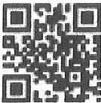
Email
info@toshibatec.co.uk

Website
www.toshibatec.co.uk
t rma

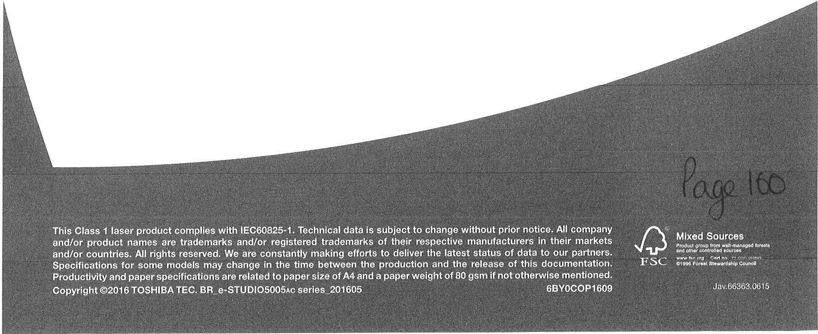

Whitehaven Town Council

From: Sent:
To:
Subject: Attachments :

Importance:
Mitou Miah <Mitou.Miah@pb.com> 18 March 2021 16:22
Whitehaven Town Council
FAO Mar lene- HP Printer/ Copier Proposal (Pitney Bowes) HP E77422DV Brochure.pdf

High

Hi Marlene

Thank you for your enquiry regarding the print er/ copier ©

I am delighted to propose our HP E77422DV based on your requirements. We currently have an amazing promotion running where the first 3 months is FREE on our lease offering.

My recommendation is absolutely suited to your needs as is has all the functionalities you require and I have provided you with different leasing/ purchase options. It is a world class product, truly 'best in class', environmentally friendly and is ideal for your current needs but also very future proof should your needs change .

Pitney Bowes are the official partner of Samsung/HP and the market leader for mailroom solutions , all equipment is brand new with the highest level of service in the market. Everything is under one umbrella and direct with no 3rd party involvement ©

We also offer an optional service package with the machine which is called cost per copy (optional). This is an optional service plan where all toner/inks along with all -in clusive service and maintenance cover are included (all parts, labour, engineer call outs & brand new replacement machines).

Please see new device/cost info rmat ion below - based on the information provided (Brochure is attached along with formal proposal attachment)

Pitney Bowes will provide the finance - no 3rd party lenders

There are NO UPFRONT COSTS - delivery and installation included

Meeting your requirements:

- A fully functioning machine with an all inclusive maintenance plan.
- This wil l give you the lat est technology with modern day equivalents and increased speci ficat ion to maximize your productivity.
- Excellent printing quality with printing speeds
- The new printer will help you achieve all your business objectives with the printing technology and the most cost eff ective running costs.
- Pitney Bowes provide all finance for new customers
- Service costs remain fixed for the contract duration - no increases

New HP Laser Jet Colour E77422DV

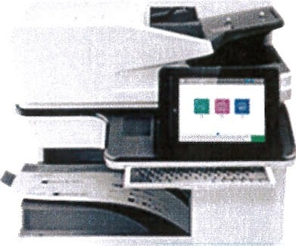

'

Specifications

22 Pages per Minute (Colour/Mono) A3/A4/A5 Freestanding machine Colour Touch-Panel Screen USB/Network Ready
Ful l Colour Network Printing Duplex, Network
Print, Scan, Copy
2 GB Standard Memory 2 Paper Trays & Cab inet

3 year (paid by direct debit) (1st Quarter Free)
£65 + VAT per Month
PB In clusive Service cover included

5 year (paid by direct debit) (1st Quarter Free)
£45 + VAT per Month
PB Inc lusive Service cover included

OR you can...
2

Purchase
£1910 + VAT outright (Normally this machine is £8,271 so a HUGE discount has been applied)

***Please note for the purchase opt ion, NO payments are needed now- after the machine has been delivered and installed would you then receive th e invoice which you would have 30 days to pay* * *

Service Solution

The Pitney Bowes service and care package provided offers the following benefits: Full customer support
All emergency call outs All spare parts as required Toner inclusive
Delivery, inst allation and conn ect ion
No M inimum Billing - Just pay as you print

Cost per copy plan (optional)

Billed on a mont hly basis prices are fixed @ £0.003 per mono print and £0.035p per colour print - Includes all Inclusive Service & Maintenance, part s, call out s and TONER - Fix ed for agreement term and avai lable on purchase option too.

* example - 1000 mono prints @ £0.003 = £3.00

If you can make a decision by the 24th March 2021- we can also offer some extra freebies if you decide to move forward with us

- p t Quarter free on all machines if you opt for 5 year lease (payment deferred)
- 5 Boxes of Paper (25 reams)
- Free Engineer Installation & Training

I look forward to hearing from you ©

Kind Regards, Mitou Miah
Client Manager & Competitive Specialist UK & ROI

T +44 (0)333 999 4359
3

F +44 (0)333 999 4304
mit ou.miah@pb.co m pitneybowes.com/uk (pitneybowes.coml

Pitney Bowes Limited
Langlands House
130 Sandringham Avenue Harlow
CM19 5QA
I
pitney bowes

[ m y Linked m, p ro felt lr lin ke d in.com l

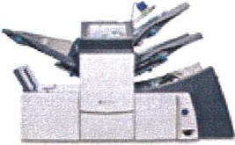
(pitneybowes.coml

Package Tracking Visitor Tracking Asset Management
E - Invoicing
Print Management Document Archiving
Folding/ Inserting Mailing Auditing
Document Integrity

Pitney Bowes Limited: Registered Office: Building 5 Trident Place. Hatfield Business Park, Mosquito Way, Hatfield, Hertfordshire AL10 9UJ, United Kingdom, Registered in England No: 182037.
Pitney Bowes Finance Limited: Registered office: Building 5 Trident Place, Hatfield Business Park, Mosquito Way, Hatfield, Hertfordshire AL1O 9 UJ, United
Kingdom,

*******************************************************************************************************************
*****************************

This message may contain confidential information . If you are not the intendedrecipientplease inform the sender that you have received the message in error before deleting it.
Please do not disclose, copy or distribute information in this e-mail or take any action in reliance on its contents:
to do so is strictly prohibited and may be unlawful. Thank you for your co-operation.
NHSmail is the secure email and directory service available for all NHS staff in England and Scotland
NHSmail is approved for exchanging patient data and other sensitive information with NHSmail and GSi recipients NHSmail provides an email address for your career in the NHS and can be accessed anywhere

******* ** ****** ************* ** *************** **** ********** ******** ** ************ ** ******* ** ********** ******** *** **
*********** **** *************

4

Data sheet

HP Color LaserJet Managed MFP E77422-E77428 series
Premium color value, maximum uptime, and the strongest security¹ from a streamlinedMFP.
HP Managed MFPs and printers are optimized for managed environments. Offe ring increased monthly page volumes and fewer interventions, this portfolio of products can help reduce printing and copying costs. See your HP Authorized Reseller for detalis.

-----3!:t

HP Color LaserJet ManagedMFP E77422dn
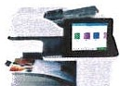

HP ColorLaserJet Managed MFP E77428dn

Big color. Small cost.
- Print premium, professional-quality documen ts with vivid color images and graphics for a low cost.
- Get consistent, professionalquality and performance you count on with Origin al HP tonercartr idgesand drums.
Minimal interrupotins. Maximum uptim.e
- Avoid interruptions with an HP LaserJet Managed MFP designed to be streamlined for maximum productivit y.
- Tailor this MFP to the needs of your business with a wide rangeof paper-handlingaccessories.
- Scan files directly to Microsoft® Off ice and SharePoint, plus email, USB, and network folders.2
The world's most secure printing¹
- Each printer in your fleet checks it s operating code and repairs itself from attacks.
- Your printe r's outgoingnetwork connections are inspected to stop
suspicious requests and thwart malware.
- Memory activityis monitored to continually detectand stop attacks.
- Firmware is automatically checked durin g startup to determine if it's authentic code-digitally signed by HP.

Dynamic security enabled printer. Only intended to beused withcartridges using an HP origina l chip.Cartridgesusing a non -HPchip may not work, and those that work todaymay not work in the future.
http://www.hp.com/go/learn aboutsuppiles

¹BasedonHP reviewof 2018publishedsecurity features of compeittivein•c!ass primers. OnlyHP offers a combinationof secunty featuresthat can monitor toderect and automatciallystop an attack then self•validate softwarein!egrtyina reboot. For a list of printers. visit 'lp.corn/go/PrnitersThatProtect.For moreinformation:np.cam/go/pnntersecurityclaims.
z Requiresanlriternet connectionto tt·eprinter. Services may requre regrstr3tion.App availaiblityvar'es by c0t.ntry. ·.anguag.eandagreements. For ;1etails. see http;//t-pcoflnecte.dcom
l Measured using 150 / l t:C2A73 .excludsefirst set of test documents. For moreinformation, seehp.com/go/pr1nter<la1m.sExact speedvariesdependingon me system configuration.softwareappl1cat1on.dnver. and document complexity.
-1HP Web Jetadmin tsavailable for download at no additionaclharge athp.com/go/webjetadmin.

Datasheet I HP Color LaserJet Managed MFP E77422-E77428 series

Product walkaround

- Hardware Integration Pocket1 (for connecting accessory and third-partydevices)
- Easy-accessUSB por t 2
- 500-sheet output bin
- Front door (access to toner cartridges and imaging drums)
- Slot for cable-typesecurity lock. 2 Hi-Speed USB 2.0 Host ports, Hi-SpeedUSB 2.0 device port,GigabitEthernet port
- 1DO- sheet automatic document feeder (ADFI with reverse duplex copying and scanning
- Flatbedscanner supports mediasizes up to 11 x 17 inches (A3)
- 8.0-,nch (20.3 cm) color touchscreen
- Right door (access to the print path)
- . 1OD-sheet multipurpose tray 1 supports media sizesup to 11 x 17 inches (A3) 1 1. Automatic two - sidedprinting
12. 520-sheet trays 2, 3 support media sizes up to 11 x 1 I inches (A3)

Series at a glance

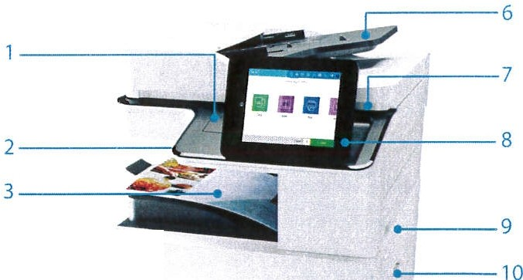5- - - - -
4- - - - - -

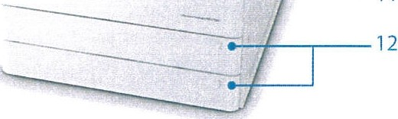
- - - 11

Model | HP Color LaserJetManaged MFPE77422dn | I | HPColor LaserJet Managed MFP E77428dn
Functions | Print, copy, scan. optional fax (both models)
Print speed (letter and A4, black and color³) | Up to 22 pagesper minute (ppm) | I | Up to 28 ppm
Automatic two-sided printing
Scan speed(black andcolor)⁴ | Simplex: Up to 43/46ppm(letter/M l Duplex: Up to 19 image'sSimpl ex:Up to 45/47 ppm (letter/Ml Duplex: Up to 19 images per minute lipm) (letter and M) per minute (ipm) (letter and A4)
Scanning | 100-sheet ADF with reverse duplex scanning(bothmodels)
1OD-sheet multipurpose tray 1, 520-sheet tray 2, 520-sheet tray 3 | ,/
Optional 2x520-sheet paper tray and stand
Optional 500-sheet Inner finisher
Input capacity | 1,1 40/2,180 sheets (standard/maximums ) (both models)
Control panel | 8.0-inch (20.3 cm) color touchscreen (both models)
RMPv6 | Up to 20,000 pages (bothmodels)
Managed Cartridge yields⁷ | Black:· 25,000 pages; Color: · 20,000pages (both models)
Optional wireless networking⁸/NFC touch-to-prlnt/BLE•⁹

¹ Solutionsdeployed1hrough the HardwareIntegration Pocket (HIP)may require adaitianal purchase.
2 Anadministrator mt.st enable the easy-accessUSB port Jeforeuse.
3 Me asuredusing ISO/IE( 24734. excludes first set of test documents. For more information.seehp.com/go/prni terclaims.Exact speea varies depending on the systemconfi,;uration. software applicatio,n driver. and
dornment complexity.
4 Scan soeedmeasured from AOF at default300dpi (black-and-white. grayscale. andcolor). Actual processing speedsmay vary dependingon scan resolution,network conditions, computerperformance,andapplication
software.
>Selection of optionalpaper-handilng accessoriesrequired to reach ma ximuminputcapaoty.
6 Recommended Monthly Page Volume (RMPV:)HPrecommendsthat the number of printedDages per monthbewithin the statedrange for optimum device performance, based on factors incluelmg supplies replacement
intervals anddevKelif e over an e><tended \•1 ar ra n t yperiod.
7 Avefageblack declaredyieldsbased on150/IEC 19 7 52and ccnt,nuous print ng.Average color composite (C/M /Yl declaredyie!dsbased on 150/IEC 19798and continuous printir g. Actual y0eldsvary ccns,derably based on imagesprinted and other factors. HP ManagedCartridges are not included1n pr int erpurchase: purchase separately.For details. seehp.com/go/tearnaboutsupplies
- The E77422 /28series moaels can addwirelessnetworkingwithselection of theoplional HP Jetdirect 2900nw Pnnt Server (J803l Al.If selected,youcannot also select the HP Jetdirect 3l 00\0, BLE/NFC/Wireless
Accessory(3 N69A). Wire·ess Jer formarceis dependent on:Jhysical erv'ronmenl and disrance from accesspoim andmay be limited1urini;ac:iveVDN connections.
- Bluetoolhi, andNFC t01..,Ch -to - pr1nt capab1lit1esare opt1onal andcan be added to the E77422/2'8 senesmodelsby selectni g theoptional HP Jeldirect 31OOw BLE/ NFC/WiretessAccessory (3JN69A). It selected. youcannot also select theHP Jetdirec1 2900nw Print Server (J8031A).Mobile device mu st supporl "lear-Field Communciation(NFC)- en abledprinting. For mo,e information,see hp.com /go/bus1nessmob!iepnnring. Bluetooth isa trademarkowned byits proprietor andused byHPInc.under license.

\

Whitehaven Town Council

From:
Sent:
To:
Subject: Attachments:
Cassie Briggs <cassie.briggs@xbmltd.com>
17 March 202111:18
Whitehaven Town Council A3 A4 Quote
A3 A4 Quote Whitehaven Town Council.pdf

Good Morning Marlene

Please find attached a copy of the A3 A4 copi er printer device as you requested. I have added both new and Refurbished options on there for you to look over.

Let me know your thoughts Kind Regards

Cassie Briggs
Busin ess Development M anager

xbm
_.OM wtl'""°"'
Photocopiers Supplier of the Year - UK

Head Office: | 0113 2533342
Newcastle: | 0191 2736966
Birm in gham: | 0121 3140320
Manchest er: | 0161 8265355

· lcoVID19 Aware...

XBM has put strict measures in place following the governments guidelines to make sure our staff and customers are protected from the spread of Corona Virus.
0 Twitter
0 Facebook
www.xbm ltd.comI www.photocopiers-manchester .com I www .photo copiers-newcastle.comI www .photocopiers-
wake field.comI www.photocopiers-durham.com I www.photocopiers -brad ford .comI www.photocopiers-sunderland.com I www .photocopiers­ leeds.com

SHARP RICOH EPSON DEVELOP
euo YOUR 'it$i0.."

Ji Please consider the environment - do you really need to print this e-mail?
The information in th is email is confide ntial and m ay be legally privileged.
It is intend ed solely for the addressee. Accessto this email by anyone else is unauthorised.

2005 - 2015

MFD Quote

For

Whitehaven Town Council

17 March 2021

About Us

XBM is a specialist provider of print and photocopier solutions for all types of businesses and professions which include private, public and corporate sectors across the UK.

With over 25 years experience working with print customers, XBM is a leading independent print management company with a mission "To be the most successful, customer focused and forward thinking Xerox and Sharp reseller in the UK"

We have signifi cant experience in providing 'cradle to grave' print solutions along with providing a complete financial package.This can include a single photocopier lease or purchase through to the supply and funding of an entire multi function device, bespoke solution including desk top and remote software solutions, p-counter and project management.

What We Do?

We offer the full range of Sharp products from simple desktop laser printer through to workgroup product ion devices delivering key document production for departments and key functions within the business. In addition we offer a full suit e of software solutions to support the document lifecycle process from scanning and forms product ion through to document storage and retrieval systems.

Although we exclusively supply and service Sharp equipment we are aware that the best fit for a particular solution may be by another manufacturer, software or service provider. We are therefore happy to source and provide other equipment when needed.

Our service support is structured to provide service on a hos t of other manufacturer's equipment. We are able to provide a true open and unbiased technology and service solution which we deliver to the highest possible standard.

Our proven document outsourcing and services can help transform your enterprise and lower costs.
Optimise your office printing environment to improve productivity and reduce costs. Derive maximum value from your document management processes.
Cut the complexity of customer account management with an agile, digital approach. Str eamlin e your business proces ses for immediate access to your financial informatio n. Digitise and manage documents for fast access to business -critical information.

SHARP RICOH
EPSON
EXCEED YOUR VISION

Why choose XBM ?
COVID19 Aware...
XBM has put strict measures in place following the governments guidelines to make sure our staff and customers are protected from the spread of Corona Virus.

We have adapted our engineers to do the following...

- Sales people can demo devices and do meetings via video calls
- Work will be allocated to engineers via the phone, reducing the need to come into the office
- If engineers need to collect parts, they will have time slots to avoid unnecessary contact with others
- Installs can be done remotely via splashtop remote software.
- Machines will be wiped down before and after being worked on
- Job completion sheets all done electronically to reduce spread via paperwork
- We have video tutorial content on our website to allow people to receive help without us visiting site

All of this has been put in place so XBM can continue its unbeatable pricing and service delivery.

Where we cover?

XBM has national coverage with our Head Office in Leeds, with offices in North East, North West and The Midlands.

We work to 4 hour call outs and only use manufacturer's parts and toners and have a strict no tolerance policy to compatible parts.

Price Promise - FREE Machine!

XBM knows most of our deals are unbeatable, however, if you find a 'like for like' quote that is better than ours, let us know! If XBM cannot beat it, we will give you the machine for FREE!

Customer Re quirement s

Po_i R_ 110

Option 1-Refurbished Sharp MX2614N {Full Warranty as Brand New)

MX2614N - High Spec Colou r MFD allows you to print at 26pm B&W and 26ppm Colour.

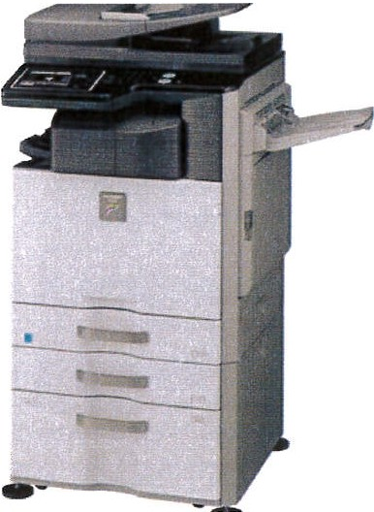
M achine Spec
High Spec Colour M ult ifu nctio nal Device 26ppm Colou r/ 26ppm B&W
2 Trays
3GB Memory/160GB HOD Networked
Auto Doc Feeder Duplex Print/ Scan
- .1" Finger Swipe Touch Screen (Like Ipad) Print/ Co py/ Scan (Scan to Net work & Em ail) Sort/Collate
A4 &A3
1200 x 1200 dpi

Pricing M ainte nance Costs

3 year@ £29 per month+ VAT 5 year @ £19 per month + VAT
B&W Per Print Colou r Per Print
0.004

0.04

Or

Purchase Outright@ £999 + VAT

Includes

Delivery, Install and Staff Training FREE! All Toner, Part s, Labour and Call outs FREE!

Option 2 - Refurbished Sharp MX4140N (Full Warranty as Brand New)

MX4140N - High Spec Colour MFD allows you to print at 41pm B&W and 41ppm Colo ur.

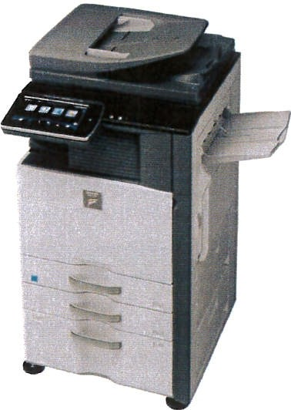
Machine Spec
High Spec Colour Multifun ctional Device 41ppm Colour/41ppm B&W
2 Trays / A3/A4/A5
4GB Memory/320GB HDD Networked
Aut o Doc Feeder/ 1200 x 1200 dpi Duplex Print/Scan
  - " Fin ger Swipe Touch Screen (Like Ipad) Print / Copy/ Scan (Scan to Network & Email) Sort / Colla t e
Wifi
PS

Pricing | Maintenance Costs
3 year@ £37 per month+ VAT | B&W Per Print | 0.0035
5 year@ £24 per month+ VAT | Colour Per Print | 0.035

Or

Purchase Outright@ £1,100 + VAT

Includes

Delivery, Install and Staff Training FREE! All Toner, Parts, Labour and Call outs FREE!

Option 3 - Brand New Epson WF-878RDTW

WF-87 8RDTWF - High Spec Colour MFD allow s you to print at 20 ppm B&W and 20 ppm Colour.

Machine Spec
High Spec Colour Multifunctional Device World's First Business In kjet
20ppm Mono (Settings Dependant) 20ppm Colour (Settings Dependant) 60 Sheet Auto Doc Feeder
2 Trays+ Bypass Networked/ Sort/Collate Duplex Print/Scan
Print/Copy/Scan (Scan to Network & Email)/Fax A3/AS/A4
600 x 600dp i to 1200 x 4800dpi Up to 80,000 pages per ink set
Use 80% less Power Consum pt ion than laser pr int ers Wifi / Wifi Direct/ Airprint
Postscript Photo Print ing
3.5 times Increase Productivity 99% reduction on waste

t sq

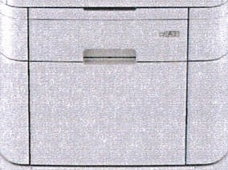

Pricing Maintenance Costs

3 year@ £68 per month+ VAT S year@ £43 per month + VAT
B&W Per Print Colour Per Print
0.003

0.03

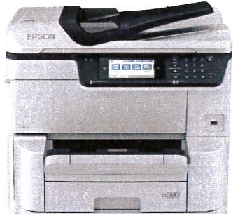

Or

Purchase Outright@ £2,050 + VAT

Includes

Delivery, Install and Staff Training FREE!

PU! e.. 11

All Toner, Parts, Labour and Call outs FREE!

Option 4 - Brand New Ricoh IMC2000SP (A4/A3 Special Offer

IMC2000 - High Spec Colour MFD allows you to print at 20ppm B&W and 20ppm Colour.

Machine Spec
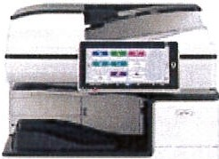
High Spec Colour Multifunctional Device 20ppm Colour & B&W
2 Trays & Cab 2 GB Memory
250GB Hard Drive Networked Duplex Print/Scan
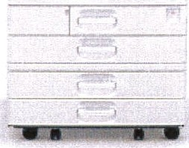
Print/Copy/Scan (Scan to Network & Email) Sort/Collate
A4/A3
10" Android Screen 100 page Doc Feeder Postscript

Pricing Maintenance Costs

3 year@ £81 per month+ VAT 5 year@ £52 per month+ VAT
B&W Per Print Colour Per Prin t
0.003

0.03

Or

Purchase Outright@ £2,499 + VAT

Includes

Delivery, Install and Staff Training FREE! All Toner, Parts, Labour and Call outs FREE!

Maintenance Contract

All of our machines are backed by our fully inclusive maintenance plans. We offer fast call outs using only cert ified parts.

Our plans include the following: Toner
Parts Maintenance
Call outs (Within 4 hours) Ongoing support
The above is inclusive in the 'Per Print' price.

XBM Contacts

Jade Carter
Account Manager cassie.briggs@xbm lt d.com 0113 2533 342

Simon Earith
Service Manager
si mon.ear it h@xbmlt d.com
07535 231 623

Sales Support
cust omer@xbm lt d.com
01132 533 342

WTC 29/04/2021

Item 11

REMOTE ACCESS FOR HOMEWORKING

To allow the Council's IT Provider to transfer files to Microsoft OneDrive to enable staff remote access when working from home.
  - INTRODUCTION

  - Following the outbreak of the Coronavirus Pandemic and subsequent lockdowns, staff have been increasingly working from home.

  - For business continuity working files were downloaded to USB sticks.

  - Whilst this worked well initially, a USB stick would no longer function as it required formatting and to format the USB stick would have meant the loss of files stored on it and also access to the files was denied due to the USB stick requiring formatting.

  - Attempts are ongoing to recover the data.

  - To prevent this from happening in the future enquiries have been made with our I.T provider Westcom, to see if there was any way in which files stored on the server could be accessed remotely.

  - Attached at Appendix 1 is the recommendations of our I.T provider. They recommend using Microsoft One Drive to store data so that it can be accessed remotely. The cost to do this work is £180.00 with additional ongoing charges of £11.40 per month for 3 x Office 365 Licences.

  - RECOMMENDATION

  - It is recommended that authorisation is given for Westcom to commence work to enable staff to access files remotely to ensure business continuity.

Whitehaven Town Coun cil

From: Sent: To: Subject:

Westcom Support <Support @west -com.co.uk> 01 April 2021 13:59
Whitehaven Town Council Onedrive Quote
v-J1'L 2 9 /04- / 2.02..I
e cx I II
bV\{JI ¥ I .

Attac hments:
WQ3245 - Whitehaven Town Counc il OnedriveQuote.pdf

Dear Vanessa,
we recommend using Microsoft One Drive to store your data in to access remotely.
The plan is to t emporari ly disconnect your Machines at the office from the data, move it on the server and reconnect the machines. There will be minimum down time while this happens.
While that is happening we will configure the server with its own Office 365 account. This will take many days depending on your internet speed, but the machines in the office will still be able to access data as no rmally. Then we will configure your laptops to use the new onedrive and show you how to use it. To begin with there will not be much data to access but as each file is uploaded to the cloud, it becomes available to all computers.
You Need a t otal of 3 licenses for Office 365 Em ail. One for the server and one for each user. You should not really have two people using the same license and it will not work at all with the One Drive. Each user needs their own email address and password.
Thanks

Ben Hawle y
Sen ior Co mpu te r Eng ineer

WESTCOM
Com p u tin g Solu tions fo r We st Cumbria
Low ther Road. Clay Fla tts. Worki ng to n. CA 14 2TQ Tel 01900 870455
Shop opening hours - Mon to Fri. 9a m to 5pm www.west-cof'1 .CO.vk

-

N': STCO M ; s o tr-:Jdir g norre of P•.;r'ield Solutions Lif'1ited. UK Regist ra tion 4.583 961
UK rs gis: ered ;)hce. 4 Swinside C!ose Cock ermouth. CA I 3 9A3. UK VA r regi strotion no 80 4 73G8 43

111111 -,f- Westcom
11
111111 IT Solutions

Dear Vanessa,
Westcom Lowther Road Workington CA14 2TQ
0 1 900 870455
sup p ort @west-c om.c o .uk

l April 2021 Re feren c e: WQ3245

Thank you for your enquiry. We are pleased to quote as follows. Please refer to the quotation number in any future correspondence. If you would like to discuss this or any other matter, please contact us a t the above address.

Item Qty Desc rip tion
3 Office 365 Lic en ses for Server & users

2 Transfer of Data to cloud and recofiguration of Se rver and Laptops to access Cloud data. Estimate 3 Hours Work at your contract rate.
Pric e Each

£3.80 Per Month

£180
Total

£1 1.40
Per Month
£180

All products sold to the Purchaser will remain the property of Westcom until such times as the appropriate invoice has been paid in full. All prices exclude vAT which will be charged at the rate current on the date of invoic e.
This q uo ta tion is valid for a p eriod of 30 days from the date of issue . A vailability is usually 30 working days.
Please refer to the q uo ta tion number in any future correspondence. If you would like to discuss this or any other matter, please contac t us at the above address.
Best Regards Ben Hawley

Page 1 of I
Westcom is the trading name of Purfield Solurions Limited . Registration ro. 4583961

WTC 29/04/2021

Item 12

ALLOTMENT REPORT

Purpose of the Report

To update Members on Whitehaven Town Council owned allotments and to approve the recommendations contained within the report.
1.0 INTRODUCTION

The Town Council own and manage 4 Allotment Sites within the Parish of Whitehaven.

  - PRESENT POSITION

  - Due to the Coronavirus pandemic, the Town Council have not held an Allotment Advisory Group meeting with the Site Reps or the sitting Councillors on the group (Councillors Rayson, Gill and E Dinsdale), however the Site Reps have been able to contact the staff by e-mail or telephone.

  - Invoices for Annual Rent were sent out week commencing 1st March 2021.

  - At the time of writing this report we currently have one full plot at Midgey Ghyll, one full and one-half plot at Crow Park and one full plot at Sneckyeat vacant.

  - We are actively seeking new tenants to take on these plots.

  - There are currently 55 people on the waiting list with an average waiting time of 2+ years.

  - A request has been received from a tenant of Crow Park seeking permission to install a polytunnel. The polytunnel will not exceed the permitted dimensions. As per the Allotment Tenancy Agreement permission must be sought from Council before a polytunnel can be erected

This request was emailed to members of the Allotment Advisory Group on 14/04/2021. All 3 Councillors responded to say they had no objection to this request.

  - The Town Council has provided skips twice yearly for the past 3 years.

It is recommended that 12 cubic yard skips be provided for October 2021 and March 2022. Quotes have been sought from 4 Skip Hire Companies and at the time of writing this report 1 company had provided a quote of £240 + VAT. If any further quotes are received, they will be reported at the meeting

RECOMMENDATION

    - Members are asked to note the information contained within the report, and approve the requests at 2.6 and 2.7.

