WHITEHAVEN TOWN COUNCIL

Clerk and Responsible Financial Officer: Marlene Jewell
Telephone: 01946 67366
Chairman: Councillor C Maudling

To: Members of Whitehaven Town Council

You are duly SUMMONED to attend a MEETING of WHITEHAVEN TOWN COUNCIL which will be held in THE BEACON PORTAL at THE BEACON, WHITEHAVEN on THURSDAY 28th July 2022 at 6:00pm

Signed.. --- -- Dated .4. Marlene Jewell, Clerk and Responsible Financial Officer

AGENDA

- Apologies for Absence

- Declarations of Interest
-;. --- l,

To receive declarations of interest by elected Members in respect of Agenda items.

If a Member requires any advice on any item involving a possible declaration of interest which could affect his/her ability to speak and/or vote he/she is advised to contact the Clerk at least 24 hours in advance of the meeting.

- Public Participation

- Minutes of the Council Meeting held on 30th June 2022

- Planning Applications

- Finance Report

- Asbestos on Midgey Allotments

- Office Accommodation Quotes for Fire Engineering Review

- Local Cycling and Walking Infrastructure Plan
Pc e I

- Council Representative at Nuclear Strategic Energy Board and other Nuclear Stakeholder Groups - Councillor E Dinsdale to report

- Councillor Ward Matters

- Date, Time and Place of Next Council Meeting IN PRIVATE
That prior to the following items of business the Chairman will move the following resolution:

That in view of the special or confidential nature of the business about to be transacted it is advisable in the public interest that the public and or press be instructed to withdraw.

- Grant Application - WTG

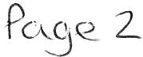

WHITEHAVEN TOWN COUNCIL

Minutes of the Council Meeting held on the 30th June 2022

Present: Councillor C Maudling (Chairman); Councillor E Dinsdale; Councillor J Carr; Councillor G Dinsdale; Councillor R Gill; Councillor C Hayes; Councillor J Rayson; Councillor R Redmond; Councillor G Roberts; Councillor G Stevens

M. Jewell, Clerk and Responsible Financial Office

V. Gorley, Assistant Clerk Member of the Public Member of the Press
2037/22 Apologies for Absence

Apologies for absence were received from:-

Councillor B O'Kane Councillor C Walmsley
On Holiday
Family Commitment

It was proposed by Councillor Gill and seconded by Councillor Hayes that the apologies for absence be accepted and noted. A vote was held and it was unanimously

RESOLVED - That the apologies for absence be accepted and noted

2038/22 Declarations of Interest

Councillor Maudling declared an interest in Item 5 as he was a member of CBC's Planning Panel
Councillor Roberts declared an interest that he was a member of CCC

2039/22 Minutes of the Annual Council Meeting held on 26th May 2022

It was proposed by Councillor Gill and seconded by Councillor Roberts that the Minutes of the Annual Council Meeting held on 26th May 2022 be approved and signed by the Chairman as a correct record. A vote was held and it was unanimously
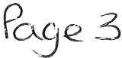

RESOLVED - That the Minutes of the Annual Council Meeting held on 26th May 2022 be approved and signed by the Chairman as a correct record

2040/22 Public Participation

There was no public participation

2041/22 Planning Applications

The Council considered a list of Planning Applications received from CBC and shown at Appendix 1.
Councillor Rayson referred to the Harras Moor Planning Applications and said she had just the usual concerns which had previously been mentioned - infrastructure etc.
Councillor Roberts referred to the Barras Moor Planning Applications and said he had given the Clerk and Deputy Clerk some guidance notes on this but that he had concerns about:-
- The infrastructure
- The local plan
- The lack of it
- Access
- The scale in relation to the curtilage of the land
- Drainage

- Councillor Gill said that as a matter of record it was important that as a Council they agreed with the views of the local Councillors and it was proposed by Councillor Gill and seconded by Councillor Stevens that the Clerk takes up this matter with CBC on behalf of the local Councillors and submits the above comments and notes as the Council's representations to the Harras Moor Planning Applications to CBC. A vote was held and it was unanimously

RESOLVED - that the Clerk takes up this matter with CBC on behalf of the local Councillors and submits the above comments and notes as the Council's representations to the Harras Moor Planning Applications to CBC.
- It was proposed by Councillor Gill and seconded by Councillor Hayes that CBC be informed that following consideration of the remainder of the planning applications on Appendix 1 there were no further representations.
RESOLVED - That CBC be informed that following consideration of the remainder of the Planning Applications on Appendix 1, there were no further representations.

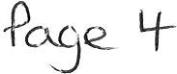

2042/22 Finance Report

The Council considered a Finance Report.
1. Appendix 1 - The Assistant Clerk reported that there was 1extra invoice to consider namely:

Cumbria Media £148.00 for uploading to website

It was proposed by Councillor Gill and seconded by Councillor CatT
that the invoices on Appendix l plus the 1 additional invoice listed above be approved and paid. A vote was held and it was unanimously

RESOLVED - That the invoices on Appendix 1 plus the 1 additional invoice listed above be approved and paid.
11. Appendices 2 and 3 - the Council considered Appendices 2 and 3 and it was proposed by Councillor Hayes and seconded by Councillor Gill that these be approved and noted. A vote was held and it was unanimously
RESOLVED - That Appendices 2 and 3 be approved and noted.
2043/22 Christmas Lights
The Council considered a report on a quote of £24,400.00 plus VAT received from the Council's preferred supplier for the erection, maintenance, dismantling and repair of the Council's Christmas Lights and considered whether to suspend Financial Regulations in order to accept the quote and also the reasons for suspension and the risks.
It was proposed by Councillor Gill and seconded by Councillor Maudling (i) that the Council makes a Resolution to suspend Regulation 11 to allow CCC to erect, maintain, dismantle and repair the Christmas Lights and having made the Resolution (ii) that in accordance with Financial Regulation 18 the reasons for suspension and also the assessment of the risks stated in the Report be accepted and approved and that CCC undertake the work at a cost of £24,400.00

RESOLVED - That (i) the Council makes a Resolution to suspend Regulation 11 to allow CCC to erect, maintain, dismantle and repair the Christmas Lights and having made the
Resolution
(ii) that in accordance with Financial Regulation 18 the reasons for suspension and also the assessment of the risks stated in the Report be accepted and approved and that CCC undertake the work at a cost of £24,400.00

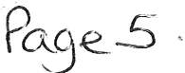

2044/22 Winter Bedding Plants
The Council considered a report on a quote of £3,162.54 plus VAT received from the Council's preferred supplier for winter bedding plants and considered whether to suspend Financial Regulations in order to accept the quote and also the reasons for suspension and the assessment of the risks.
- It was proposed by Councillor G Dinsdale and seconded by Councillor Gill that the Council makes a Resolution to suspend Financial Regulation 11 to allow the winter bedding plants to be purchased from the preferred supplier. A vote was held and it was unanimously

RESOLVED - That Council makes a Resolution to suspend Financial Regulation 11 and the winter bedding plants be purchased from the preferred Supplier
- It was proposed by Councillor Hayes and seconded by Councillor Gill that having made the Resolution in (i) above that the reasons for the suspension and also the assessment of the risks contained in the Report be accepted and approved and that the quote of £3,162.54 plus VAT be accepted.
RESOLVED - That the reasons for the suspension and also the assessment of the risks contained in the Report be accepted and approved and that the quote of
£3,162.54 plus VAT be accepted.
2045/22 Concerns about the level of service provided to the people of Whitehaven by GP Practices

Councillor Gill gave a verbal report on concerns about the level of service provided to the people of Whitehaven by GP Practices. He made the following points:-
  - He was concerned that every day more and more he was seeing people having problems about being able to see their GP
  - He said that he had had problems and that the Government was pressurising GPs to do more
  - He said at his GPs Receptionist Staff were being trained to deal with people's ailments but that he didn't think that people had much confidence in this and that this was not only over this town but over the country
  - That in his practice there were the same number of doctors there now after covid but that things didn't seem to have opened up again
  - He said people were ringing up at 8.00 o'clock in the morning, sometimes sitting for 20-25 minutes on the telephone only to find that all the appointments have gone
  - That this problem was all over the Town and the country but that he was really concerned about the level of service being provided by all the GP practices in Whitehaven
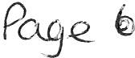

  - Councillor Gill thought that the Council should be trying to do something even if it turned out to be unsuccessful
  - That he didn't know what the answer was but that the least the Council could do was to write to the Cumbria County Health and Scrutiny Committee.
  - He said what he could not understand was that there were the same number of doctors at the surgeries that there were before covid and that when he went into the doctor's surgery when he eventually got an appointment there was no one in there
  - He said people were going to Cuedoc or A and Eat West Cumberland Hospital and it was heaving because people couldn't see their doctor and that this was putting the NHS at the hospital under pressure.
Councillor Stevens asked for a rider to be put to any proposal to the CCC Health and Scrutiny Committee that dental services in Whitehaven be included. It was proposed by Councillor Gill and seconded by Councillor Maudling that the Council write to the CCC Health and Scrutiny Committee to ask them to
have an investigation into the provision of doctors and dentists in Whitehaven. A vote was held and it was unanimously

RESOLVED - That the Council write to the CCC Health and Scrutiny Committee to ask them to have an investigation into the provision of doctors and dentists in Whitehaven.

2046/22 Councillor Ward Matters
- Councillor Stevens said that she had been trying to track down who owned the broken bench at Sandwith. Councillor Gill said it was owned by St Bees School
11. Councillor Rayson referred to the grass at the top of St Benedicts going to the Golf Club and said it was a really bad junction and the grass was high on both sides. Councillor G Dinsdale said it was on the CCC cutting regime
111. Councillor Carr said that Mirehouse Community Centre had a play park
behind it and Councillor Walmsley had said that they were going to be getting a new play park provided by Well Whitehaven. He said the grass was overgrown and Councillor Walmsley had contacted several people trying to get it cut down to make it useable through the summer.
1v. Councillor E Dinsdale referred to the grass cutting at Bransty which the CCC said they would do and said he had received a text from the resident to say it still had not been done. The Clerk said she would send a reminder to CCC.
- Councillor E Dinsdale referred to road surfacing issues and lack of lighting at Maple Grove at Valley park. The Clerk said that she had contacted Brian Holmes the CCC Lighting Manager. He said that he had done a survey of all the lighting columns in Copeland and as a result some had been found to be unsafe and had been condemned and removed and
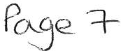

the street light on Maple Grove was one of them. He said the new lighting columns had been ordered but there was a 12 week lead in time and CCC was in the process of obtaining tenders from outside contractors to install the new lighting columns. As regards the road surfacing problems the Clerk said she had sent an email to Craig Mccarron at CCC and asked when this would be carried out.
v1. Councillor E Dinsdale said that the Magnox reprocessing comes to an end on 29th July 2022 which follows on from the Thorpe reprocessing which ended on 20/08/ l 9 and that we must be the most reliant area on the nuclear industry in the whole of the UK. He made the following points
  - With the direction that the nuclear industly is going a lot of jobs were based around these 2 main streams of reprocessing and asked should the Council not have someone representing the 23,000 people that it represents with all the stakeholders involved who could then feed back to the Council because he was concerned for the town around the direction that the nuclear industry was going
  - Eve1ything in the Town was underpinned by the nuclear industry and ultimately the Council needed to know what the strategy is
  - What is going to be there to mitigate the thousands of jobs that are going to go within the next so many years
  - What impact is that going to have on the people that the Council represents
  - We need somebody to represent the Council and to lead on these key points of strategy and delivery
  - There were quarterly stakeholder meetings being held at Cleator Moor Civic Hall
  - Meetings were taking place at BEC
  - There was a Strategic Nuclear Energy Board
Councillor Gill said we should write and ask for a place on that
Board so that the people of Whitehaven knew what was going on. The Clerk said she would write to the Board to ask for a representative of WTC to sit on the Board and Councillor E Dinsdale agreed to give the Clerk a list of the stakeholders so that we could write to them. Councillor Rayson said that the MP should be copied into this.
v11. Councillor Carr said it was 19 years since he had worked at Sellafield but that everytime you go down you see it's always changing but is it really getting that bad that there's nothing new job wise happening. Are the new buildings on there creating jobs or is it getting to the point where people will not be transferred anywhere and there will be redundancies.
Councillor G Dinsdale said certain places do need more staff and were working with less staff than they need. At the moment some people were doing 2/3 people's jobs.
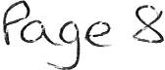
v111. Councillor Maudling thanked Councillor E Dinsdale for standing in for him when he was away. He also thanked the Clerk and Assistant Clerk for the wonderful Jubilee weekend.

1x. Councillor Maudling referred to Schoolhouse Lane and the hedge going across to the Westminster Cafe and said it was right on the pavement and that people were stepping out when there could be a car there and asked if anything could be done to cut the hedge back. The Assistant Clerk said there could be nesting birds in the hedge and the hedge would not be cut down during that time.
x. Councillor Gill referred to the state of the roads in Hensingham and said he was working with County Councillor Mike Hawkins on this and that he was doing his best.
x1. Councillor Hayes said that the 3 Councillors on Kells were going to have a chat with locals because there had been a lot of vandalism, graffiti etc and they were going to t1y and sort this out with the police
x11. Councillor G Dinsdale said there had been a few highway issues but she had reported them.
x111. Councillor Rayson referred to the path from Inkerman Terrace to Tower Hill and said that although nobody had complained to her about this she had walked up it a couple of weeks ago and it was covered and you couldn't get up it. Councillor G Dinsdale said that this came under CCC and that she would put a report into them about it.

2047/22 Date Time and Place of next Meeting

The next Council Meeting would be on 28th July 2022 at 6.00pm at the Beacon Portal, Whitehaven.

IN PRIVATE
2048/22 That prior to the following items of business the Chairman moved the following resolution: -

That in view of the special or confidential nature of the business about to be transacted it is advisable in the public interest that the public and or press be instructed to withdraw from the meeting.
Councillor Hayes proposed this and Councillor Maudling seconded it. A vote was held and it was unanimously

RESOLVED - That in view of the special or confidential nature of the business about to be transacted it is advisable in the public interest that the public and press be instructed to withdraw from the Meeting. All
members of the public and press then left the Meeting.

2049/22 Grant Application - GCC

Councillor Maudling declared an interest in this item
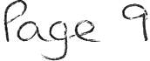

The Council considered a Grant Application from GCC for a grant of
£1,000.00. It was proposed by Councillor Rayson and seconded by Councillor Roberts that a Grant of £1,000.00 be awarded to GCC. A vote was held and it was unanimously

RESOLVED-That a Grant of £1,000.00 be awarded to GCC

2050/22 Grant Application - WTG

The Council considered a Grant Application from WTG for a Grant of
£1,000.00. Following a discussion it was proposed by Councillor Gill and seconded by Councillor E Dinsdale that a Grant of £1,000.00 be awarded to WTG. A vote was held and 6 Councillors voted for the proposal and 4 Councillors voted against

RESOLVED - That a Grant of£ 1,000.00 be awarded to WTG

2051/22 Queen's Platinum Jubilee Events

The Council considered a report on the Queen's Platinum Jubilee Events organised by the Council which contained commercially sensitive information.
It was proposed by Councillor Roberts and seconded by Councillor Hayes that
the report be approved and noted. A vote was held and it was unanimously

RESOLVED -That the report be approved and noted

2052/22 Office Accommodation and Quotes

The Council considered a report on the Office Accommodation and quotes that had been received for necessary works to the building which had been requested by the Architects. It was proposed by Councillor Gill and seconded by Councillor Roberts that (i) the quote of £550.00 for the Refurbishment and Demolition Asbestos Survey be accepted and the work carried out and (ii) that the quote of £950.00 for the opening up/investigation work be accepted and the work carried out. A vote was held and it was unanimously

RESOLVED - That (i) the quote of £550.00 for the Refurbishment and Demolition Asbestos Survey be accepted and the work carried out and (ii) that the quote of £950.00 for the opening up/investigation work be accepted and the work carried out.

2053/22 Social Media Policy

The Chairman raised an issue over certain comments made on social media that
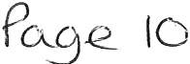

he had received complaints about and a discussion on this followed during which it was stated that the only way to deal with it was to use the Code of Conduct and refer it to the Monitoring Officer.
There was no decision made on this as it was for information/discussion only. Councillor Rayson apologised as she had to leave the meeting and did not return.
2054/22 Sand Sculpture for HarbourFest

The Clerk reported that the Council had been informed that a sand sculptor (RS) was available to attend the HarbourFest event on Saturday 2nd July2022 at a cost of £400.00 and that the Harbour Commissioners were happy for him to attend. It was proposed by Councillor Maudling and seconded by Councillor G Dinsdale that the sand sculptor be booked for the HarbourFest event at a cost of £400.00. A vote was held and it was unanimously

RESOLVED - That the sand sculptor (RS)be booked for the HarbourFest event at a cost of £400.00.

2055/22 Cumbria in Bloom

The Clerk reported that CBC had entered the Cumbria in Bloom competition for Whitehaven including the Harbour and Hensingham.

This was an information item only and no decisions were made on this and comments made were noted.

The Meeting closed at 7.35pm

Chairman

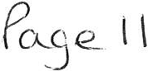

WTC 28/07/2022
Item 5

Planning Application for Consideration by Whitehaven Town Council

Application Number 4/21/2489/0Fl

4/22/2135/0Fl

4/22/2217/0Fl

4/22/2233/0Fl

4/22/2269/0Fl
Detail
Consultation on Additional and Amended Information: RESIDENTIAL DEVELOPMENT OF 37 DWELLINGS LAND WEST OF CLEATOR MOOR ROAD, WHITEHAVEN

Consultation on Additional and Amended Information: PROPOSED RESIDENTIAL DEVELOPMENT FOR 23 DWELLINGS INCLUDING ASSOCIATED INFRASTRUCTURE AND LANDSCAPING
LAND AT HARRAS ROAD, HARRAS PARK, WHITEHAVEN

Consultation on Additional and Amended Information: IMPORTATION & DEPOSIT OF EARTH MATERIAL TO REPROFILE EXISTING GROUND LEVELS/CONTOURS; INSTALLATION OF SURFACE WATER DRAINAGE INFRASTRUCTURE INCLUDING INSTALLATION OF FOUL WATER DRAINAGE INFRASTRUCTURE
LAND TO THE WEST OF VALLEY VIEW ROAD, WHITEHAVEN

Consultation on Amended Description: SINGLE STOREY REAR EXTENSION WITH FIRST FLOOR BALCONY
31 WATERS EDGE CLOSE, WHITEHAVEN

REPLACE CORRUGATED GARAGE WITH CONCRETE GARAGE WITH TILED ROOF AND UP AND OVER DOOR
PLOT 13, OVEREND ROAD GARAGE SITE, OVEREND ROAD, WHITEHAVEN

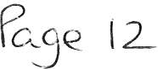

Application Number Detail

4/22/2278/0Fl ERECTION OF A TWO BED BUNGALOW
DALELANDS, SANDWITH

4/22/2286/0Fl SINGLE STOREY STORAGE BUILDING AND 2.4M
HIGH PALISADE SECURITY FENCE EXTENSION WOODHOUSE STORES, WOODHOUSE ROAD, WHITEHAVEN

4/22/2287/0Fl SINGLE STOREY EXTENSION AT REAR TO FORM
NEW LOUNGE
3 GILL CLOSE, WHITEHAVEN

4/22/2293/0Fl CONVERSION OF FIRST AND SECOND FLOORS
FROM FORMER OFFICES INTO FOUR RESIDENTIAL APARTMENTS
34 LOWTHER STREET, WHITEHAVEN

4/22/2297/0Fl CONVERSION & ALTERATIONS TO THE FORMER
MEDICAL SURGERY TO CREATE 3 NO. NEW RESIDENTIAL APARTMENTS; DEMOLITION OF EXISTING GARAGE TO THE REAR & THE ERECTION OF A NEW DWELLING ON SITE OF THE DEMOLISHED GARAGE ALONG WITH ASSOCIATED CARPARKING AREA AND GARDENS;
TRINITY HOUSE SURGERY, 17 IRISH STREET,
WHITEHAVEN

4/22/2298/0Ll LISTED BUILDING CONSENT FOR WORKS
ASSOCIATED WITH THE CONVERSION AND ALTERATIONS TO THE FORMER MEDICAL SURGERY TO CREATE 3 NO. RESIDENTIAL APARTMENTS; DEMOLITION OF EXISTING GARAGE TO THE REAR & THE ERECTION OF A NEW DWELLING ON SITE OF DEMOLISHED GARAGE ALONG WITH ASSOCIATED CAR PARKING AND GARDENS;

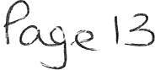

Application Number

4/22/2309/0Fl
Detail

TRINITY HOUSE SURGERY, 17 IRISH STREET, WHITEHAVEN

INSTALLATION OF VEHICLE ACCESS AND DRIVEWAY FROM EXISTING GARDEN AREA AT THE FRONT OF THE PROPERTY
5 VICTORIA VILLAS, EGREMONT ROAD, WHITEHAVEN

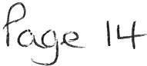

WTC 28/07/2022

Item 6

FINANCIAL REPORT

Purpose of the Report

Members are asked to consider a list of invoices for authorisation and payment as shown at Appendix 1 and approve the recommendations in paragraphs 3.1 and 3.2.

1.0 INTRODUCTION

  - Authorise the payment of all invoices as listed in Appendix 1.

  - The Council is asked to note the cashbook as reconciled with the bank account as shown at Appendix 2 together with income and expenditure at Appendix 3.

- 0 FINANCIAL POSITION

  - The bank reconciliation was carried out on 21st July 2022. This shows a balance of £478,707.98. There currently payments totalling £19. l O waiting to be cleared.

  - The balance in the deposit account is £453,327.71.

- 0 RECOMMENDATION

3.1 The invoices listed and shown in Appendix 1 be approved and authorised for payment.

3.2 The Cashbook (Appendix 2) and the Income and Expenditure (Appendix 3) be noted.

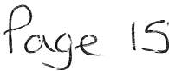

28/07/2022

Appendix 1

Invoices for Consideration by Whitehaven Town Council

Date | Supplier | Category | Detail | Total | Amount | Power |  | Columnl
01/01/2022 | Copeland Borough Council | Premises | Commercial Waste collection (01.01.2022 - 31.03.2022) | £ | 15.93 | slllLGA 1972
25/06/2022 | Eden Springs (UK) Ltd | Supplies & Services | Environmental Levy for water coolers (July 2022) - 6 x 18.51water | £ | 37.22 | slllLGA 1972
01/07/2022 | AJ-Securitv (North) Ltd | Events | Provision of 2 x securitv personnel for 5 nights | £ | 2,772.00 | sl44 LGA 1972
01/07/2022 | Deborah McKenna Ltd | Events | Final 50%fee for Stefan Gates | £ | 1,S00.00 | s144 LGA 1972
04/07/2022 | Lockhart Leisure Ltd | Events | Suooly of marauee,flooring and chairs for event held on 23-24 June 2022 | £ | 2,028.00 | s144 LGA 1972
07/07/2022 | Sharp Business Systems UK PLC | Supplies & Services | Photocopier Charges - minimum charge for June 2022 | £ | 30.00 | slllLGA 1972
08/07/2022 | Cooeland BorouRh Council | 3rd Partv | Grass Cutting Contract-July 2022 | £ | 2,045.51 | slllLGA 1972
08/07/2022 | Copeland Borough Council | 3rd Party | Allotment and Pigeon Loft Maintenance Contract - July 2022 | £ | 720.80 | slllLGA 1972
08/07/2022 | Copeland Borough Council | 3rd Party | Ranger Contract - July 2022 | £ | 3,500.59 | slllLGA 1972
08/07/2022 | Copeland Borough Council | 3rd Party | Assistant Ranger Contract - July 2022 | £ | 2,227.00 | slllLGA 1972
13/07/2022 | Copeland Borough Council | Premises | Commercial Waste collection (01.07.2022 - 30.09.2022) | £ | 15.93 | slllLGA 1972
16/07/2022 | Mrs V Gorley | Supplies & Services | Coffee | £ | 4.49 | slllLGA 1972
18/07/2022 | Cleator Moor Brass | Events | Jubilee Event Performance - Whitehaven Harbour - 03.07.2022 | £ | 200.00 | s144 LGA 1972
18/07/2022 | Mr CE Maudling | Employees/Allowances | Mileage Claim for return trip on 03.07.2022 from Coulderton to Tithe Barn Carlisle | £ | 49.00 | slllLGA 1972
18/07/2022 | Mr CE Maudling | Emolovees/Allowances | Mileage Claim for return trio on17.07.2022 from Coulderton to Wigton Methodist Church | £ | 35.50 | slllLGA 1972
19/07/2022 | Mrs V Gorley | Supplies & Services | Adobe Acrobat Export PDF subscription 19.08.2022 - 18.08.2023 | £ | 21.14 | slllLGA 1972

£ 15,203.11

c_g
(0

er

WHITEHAVEN TOWN COUNCIL CASH BOOK FROM 1 APRIL 2022

APPENDIX 2

Date
April-2022
01.04.2022
01.04.2022
01.04.2022
4 01.04.2022
5 01.04.2022
6 01.04.2022
7 01.04.2022
8 01.04.2022

Ref

BAC5 BACS 1080
1081
1082
BACS BACS BACS

Payee

Eden Springs UK Ltd
Sharp Business Systems UK Pk Copeland Borough Council Copeland Borough Council Copeland Borough Council Mrs VGorley
MrsVGorley
Westcom IT

Employees/ Supplies/
Allowances Premises Services 3rd Party

1.80
51.35

7.65
7.65
270.00

Grants Allotmts Market

597.85

Community Ground Plan Maint

Civic
Hospitality Ranger/SO W.I.B

1832.52
2771.20

Ward
Grants Elections

Environmental
Improvements Events Contingencies

Reserves Net Total VAT

£ 1.80 £
51.35
£ 597.85
£ 1,832.52 £
£ 2,771.20 £
E 7.65
7.65
270.00

Total

0.36 £
10.27 £
119.57 £
366.50 E
554.24 E
£

54.00

2.16
61.62
717.42
2,199.02
3,325.44
7.65
7.65
324.00

Min. Ref.

1973/22 (i)
1973/22 (i)
1973/22 (i)
1973/22 (i)
1973/22 (i)
1973/22 (i)
1973/22 (i)
1973/22 (i)

9 01.04.2022
10 01.04.2022
11 01.04.2022
12 01.04.2022
13 01.04.2022
14 01.04.2022
15 01.04.2022
1083
BACS BACS BACS BACS BACS BACS
Copeland Borough Council
CALC
Viking
Mrs V Gorley Mrs VGorley Mrs VGorley
CALC

20.00

184.44
15.15
99.79
20.00
10603.75

60.72
E 10,603.75
£ 20.00
£ 60.72
£ 184.44
E 15.15
99.79
20.00
E 10,603.75
E 20.00
12.14 E 72.86
184.44
15.15
99.79
20.00
1973/22 (i)
1973/22 (i)
1973/22 (i)
1973/22 (i)
1973/22 (i)
1973/22 (i)
1973/22 (i)

16 06.04.2022
17 06.04.2022
18 06.04.2022
19 12.04.2022
20 13.04.2022
14.04.2022
14.04.2022
14.04.2022
21 19.04.2022
22 19.04.2022
May-2022
23 04.05.2022
24 04.05.2022
25 04.05.2022
26 04.05.2022
27 04.05.2022
28 04.05.2022
29 04.05.2022
30 04.05.2022
31 04.05.2022
32 04.05.2022
33 04.05.2022
34 04.05.2022
35 04.05.2022
36 09.05.2022
13.05.2022
13.05.2022
13.05.2022
37 16.05.2022
38 17.05.2022
39 19.05.2022
40 28.05.2022
41 28.05.2022
42 28.05.2022
43 31.05.2022
44 31.05.2022
45 31.05.2022
46 31.05.2022
47 31.05.2022
48 31.05.2022
49 31.05.2022
so 31.05.2022
51 31.05.2022
52 31.05.2022
53 31.05.2022
54 31.05.2022
55 31.05.2022
56 31.05.2022
57 31.05.2022
58 31.05.2022
59 31.05.2022
60 31.05.2022
61 31.05.2022
62 31.05.2022
63 31.05.2022
64 31.05.2022
65 31.05.2022
66 31.05.2022
67 31.05.2022
68 31.05.2022
69 31.05.2022
70 31.05.2022
June-2022
BACS BACS BACS OD BACS BACS
BACS BACS
OD DO

BACS BACS BACS BACS BACS BACS BACS 1084
1085
1086
1087
1088
BACS BACS BACS BACS BACS DO
1089
OD OD DD
DD BACS BACS BACS BACS BACS BACS 1090
1091
1092
1093
1094
BACS BACS BACS BACS BACS BACS BACS BACS BACS BACS BACS BACS BACS BACS BACS BACS BACS
The Fairly Famous Family Ltd
Whitehaven and District Amateur Operatic Society The Georgian House Hotel
Water Plus
Newsquest Media Group
Staff HMRC
Cumbria LGPS BT Group Crown Gas & Oil

Eden Springs UK Ltd
Sharp Business Systems UK Pie Thomas Graham & Sons Limited Viking
Viking
CALC
Cumbria Media
Copeland Borough Council Copeland Borough Council Copeland Borough Council Copeland Borough Council Copeland Borough Council
Zurich Municipal Gifts 2 Impress Ltd Staff
HMRC
Cumbria LGPS Crown Gas & Oil
Copeland Borough Council BT Group
Water Plus Water Plus Water Plus
Eden Springs UK Ltd
Cumbria Loos
Derwent Recycling Services Ltd Derwent Recycling Services Ltd Derwent Recycling Services Ltd Derwent Recycling Services Ltd
Mrs Julie Hartley - VOID
Copeland Borough Council Copeland Borough Council Copeland Borough Council Copeland Borough Council Sharp Business Systems UK Pie Support Warehouse limited
Mrs VGorley Mrs VGorley Mrs VGorley Mrs VGorley Mr CJ Hayes
Mr CJ Hayes
Mr CJ Hayes Mr CJ Hayes Viking
Cumbria Media PHP Architects Ltd
POD (North West) Ltd
The Community Centre · Red Lonning Bee Unique
The Community Centre RedLanning

5012.77
2020.75
768.14

5012.16
2021.36
768.14

34.20
1.35
3.60
2.70

500.00

329.41

420.00

259.71

81.36

159.00

3391.00

73.43

1.80
44.56

32.90
44.90
1914.98
68.00

3157.29

72.81

1.80

49.04
87.20

94.30
68.00

179.00

1000.00

931.90

221.23

600.67

53.05

13.34

240.00
240.00
240.00
240.00

600.67

1704.59

1704.59

2917.16
1855.83

2917.16

2917.16
1855.83

250.00
1350.00

100.00

219.00

661.60

349.00

12.56
7.24
20.33

500.00
1,350.00 E
£ 1,000.00
£ 100.00 £
221.23
219.00
5,012.77
2,020.75
768.14
73.43
329.41

1.80
44.56 £
179.00
32.90
44.90
1,914.98
68.00
1,704.59 £
600.67
2,917.16
1,855.83 £
420.00 £
3,157.29
661.60 £
5,012.16
2,021.36
768.14
259.71
£ 2,917.16
£ 72.81
E 53.05
E 81.36
£ 13.34
E 1.80
£ 349.00 £
240.00 E
240.00
240.00
240.00

1,704.59
600.67 E
2,917.16 E
1,855.83 £
49.04 E
87.20 £
12.56
7.24
20.33
159.00
34.20
1.35
3.60
2.70
£ 94.30 E
£ 68.00
£ 3,391.00
£ SOO.DO
£ 250.00
500.00
931.90
270.00 E
£
20.00 £
£
43.80 E E E
£
14.69 £
65.88 E

0.36 E
8.91
35.80
6.58
8.98
E
£
340.92 £
120.13
583.43 £
371.17 £
84.00 E
£
132.32

51.94
583.43
14.56

2.67

0.36
69.80 £
48.00 E
48.00 £
48.00 E
48.00 £

340.92
120.13
583.43
371.17
9.81 £
17.44 E
£ E E
£
£
£
E
£
9.36 E

678.20
100.00 £
1,620.00
1,000.00
120.00
221.23
262.80
5,012.77
2,020.75
768.14
88.12
395.29

2.16
53.47
214.80
39.48
53.88
1,914.98
68.00
2,045.51
720.80
3,500.59
2,227.00
504.00
3,157.29
793.92
5,012.16
2,021.36
768.14
311.65
3,500.59
87.37
53.05
84.03
13.34
2.16
418.80
288.00
288.00
288.00
288.00

2,045.51
720.80
3,500.59
2,227.00
58.85
104.64
12.56
7.24
20.33
159.00
34.20
1.35
3.60
2.70
103.66
68.00
4,069.20
600.00
250.00
500.00
931.90
1960/22 (2)
1985/22
1980/22 (iv)
Contract
1979/22
1931/21 (i) HMRC 6317/17 (ii)
Contract Contract

1997/22 (i)
1997/22 (i)
1997/22 (i)
1997/22 (i)
1997/22 {i)
2000/22
1997/22 (i)
1997/22 {i)
1997/22 {i)
1997/22 {i)
1997/22 (i)
1997/22 {i)
1998/22
1997/22 (i)
1931/21 (i) HMRC 6317/17 {ii)
Contract
1997/22 (i)
Contract Contract Contract Contract 2014/22 (i)
2014/22 (i)
2014/22 (i)
2014/22 (i)
2014/22 (i)
2014/22 {i)

2014/22 (i)
2014/22 (i)
2014/22 {i)
2014/22 (i)
2014/22 {i)
2014/22 (i)
2014/22 (i)
2014/22 (i)
2014/22 (i)
2014/22 (i)
2014/22 (i)
2014/22 (i)
2014/22 (i)
2014/22 (i)
2014/22 (i)
2014/22 (i)
2014/22 (i)
2014/22 {i)
Ward Grant Mayors Allowance Grant

71 12.06.2022
72 13.06.2022
BACS Water Plus
BACS Whitehaven Harbour Commissioners Car Park
51.12

2500.00
51.12
2,500.00
51.12
£ 2,500.00
Contract

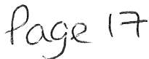

5,012.56 5,012.56 1931/21 (i)
 | 15.06.2022 | BACS | Staff | 5012.56
 | 15.06.2022 | BACS | HMRC | 2020.96
 | 15.06.2022 | BACS | Cumbria LGPS | 768.14
73 | 17.06.2022 | BACS | Mrs Julie Hartley |  |  |  | 250.00
74 | 18.06.2022 | OD | Crown Gas & Oil |  | 154.59
75 | 19.06.2022 | 00 | BT Group |  |  | 43.95
76 | 22.06.2022 | 00 | Water Plus |  | 41.34
77 | 22.06.2022 | OD | Water Plus |  |  |  |  |  | 6.72
 | July-2022
78 | 05.o?.2022 | BACS | Quality Cleaning & Contracting Ltd
79 | 05.07.2022 | BACS | Al-Security (North) Ltd
80 | 05.o?.2022 | BACS | Hampshire Flag Company
81 | 05.07.2022 | BACS | Carlisle City Fire Protection |  | 50.00
82 | OS.07.2022 | 1095 | Copeland Borough Council |  |  | 15.93
83 | 05.07.2022 | BACS | Eden Springs UK Ltd |  |  | 1.80
84 | 01.07.2022 | 1096 | David Callow
85 | 05.07.2022 | 8ACS | Mrs M Jewell
86 | 05.07.2022 | BACS | Mr CJ Hayes
87 | 05.07.2022 | BACS | Al-Security (North) Ltd
88 | 05.o?.2022 | BACS | Lockhart Leisure Ltd
89 | 05.07.2022 | BACS | Quality Cleaning & Contracting Ltd
90 | 05.07.2022 | BACS | Sharp Business Systems UK Pie |  |  | 42.66
91 | 01.07.2022 | 1097 | Copeland Borough Council |  |  |  |  |  |  | 1704.59
92 | 01.07.2022 | 1098 | Copeland Borough Council |  |  |  |  |  | 600.67
93 | 01.07.2022 | 1099 | Copeland Borough Council |  |  |  |  |  |  |  | 2917.16
94 | 01.07.2022 | 1100 | Copeland Borough Council |  |  |  |  |  |  |  | 1855.83
95 | 01.07.2022 | 1101 | J & R Bennett |  |  |  |  |  |  |  |  | 4269.70
96 | 01.07.2022 | 1102 | J & R Bennett |  |  |  |  |  |  |  |  | 3030.00
97 | 01.07.2022 | 1103 | J & R Bennett |  |  |  |  |  |  |  |  | 85.80
98 | 05.07.2022 | BACS | Fluid Productions Limited
99 | 05.07.2022 | BACS | Mrs VGorley |  |  | 6.98
100 | 05.07.2022 | BACS | Cumbria Media |  |  | 148.00
101 | 05.07.2022 | BACS | Whitehaven Heritage Action Group |  |  |  |  | 1000.00
102 | 05.07.2022 | BACS | West Coast Surveys Ltd |  | 550.00

£ 2,020.96 2,020.96 HMRC
£ 768.14 £ 768.14 6317/17 (ii)
250.00 £ 250.00 replacement
£ 154.59 £ 7.73 162.32 Contract
£ 43.95 £ 8.79 52.74 Contract
£ 41.34 1.34 42.68 Contract
£ 6.72 £ 6.72 Contract

585.00 585.00 117.00 702.00
385.00 385.00 £ 77.00 £ 462.00
350.74 350.74 70.15 £ 420.89
£ 50.00 10.00 60.00
£ 15.93 £ 15.93
1.80 0.36 £ 2.16
19.10 £ 19.10 19.10
125.90 £ 125.90 £ 125.90

23.22
945.00
£ 23.22 £ 23.22
£ 945.00 £ 189.00 1,134.00

2615.00 £ 2,615.00 £ 523.00 3,138.00
480.00 £ 480.00 96.00 576.00
£ 42.66 8.53 £ 51.19
£ 1,704.59 340.92 2,045.51
£ 600.67 120.13 £ 720.80
£ 2,917.16 583.43 £ 3,500.59
£ 1,855.83 371.17 £ 2,227.00
£ 4,269.70 £ 853.94 £ 5,123.64
£ 3,030.00 £ 606.00 3,636.00
£ 85.80 17.16 102.96

1586.40
£ 1,586.40 317.28 £ 1,903.68
6.98 £ 6.98
£ 148.00 £ 148.00
£ 1,000.00 1,000.00
£ S50.00 £ 110.00 660.00
£ 83.00 £ 83.00

 |  |  |  |  | £ 52.99 |  | 52.99
 |  |  |  |  | £ 5,041.99 |  | 5,041.99 | 1931/21 (i)
 |  |  |  |  | £ 1,991.53 |  | 1,991.53 | HMRC
 |  |  |  |  | £ 768.14 |  | £ 768.14 | 6317/17 (i)
 |  |  |  |  | £ 115.93 | 5.80 | £ 121.73 | Contract
 |  |  |  |  | £ 123.31 | 24.66 | £ 147.97 | Contract

32103.17 16156.09 6477.51 429.00
103 05.o?.2022  13.07.2022 | BACS  00 | ZMCD Claims Recoveries Account Water Plus |  |  |  | 52.99 | 83.00
15.07.2022 | BACS | Staff | 5041.99
15.07.2022 | 8ACS | HMRC | 1991.53
15.07.2022 | BACS | Cumbria LGPS | 768.14
16.07.2022 | OD | Crown Gas & Oil |  | 115.93
19.07.2022 | 00 | BT Group |  |  | 123.31

2931.90 3758.31 0.00 0.00 5113.77 0.00

21839.85 7385.50 250.00 0.00 0.00 12835.09
0.00 0.00 109,363.19 £ 10,828.66 £ 120,191.85

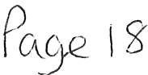

WHITEHAVEN TOWN COUNCIL Appendix 3

INCOME 2022-2023
Date | Item | Precept | Interest | Other
01.04.2022 | Allotment Rents 2022/2023 |  |  | 3318.33
 | Zurich Insurance (Claim for damaged bus
12.04.2022 | shelter) |  |  | 83.00
13.04.2022 | HMRC - VAT Refund (March)  Zurich Insurance (Claim for damaged bus |  |  | 8862.83
20.04.2022 | shelter) |  |  | 83.00
21.04.2022 | Allotment Rents 2022/2023 |  |  | 977.50
22.04.2022 | Precept 2022/2023 | 455593.93
04.05.2022 | Allotment Rents 2022/2023 |  |  | 260.00
09.05.2022 | Allotment Rents 2022/2023 |  |  | 20.00
11.05.2022 | Thomas Graham credit returned |  |  | 156.55
16.05.2022 | Cheque 1086 returned |  |  | 3500.59
06.06.2022 | Donation from Taylors Fair |  |  | 2500.00
17.06.2022 | HMRC - VAT Refund (May) |  |  | 2711.44
27.06.2022 | HMRC - VAT Refund (April) |  |  | 1974.65
20.07.2022 | Allotment Rents 2022/2023 |  |  | 153.00

455593.93 0.00 I 24600.89 1480194.s2 I

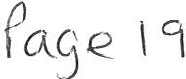

 |  |  |  | Expenditure Net |  | Invoices not yet
WHITEHAVEN TOWN COUNCIL |  |  |  | of VAT |  | processed | Budget
SUMMARISED INCOME& EXPENDITURE STATEMENT
FINANCIAL YEAR 2022-2023
BANK BALANCES BROUGHT FORWARD CBS 53905917 (01.04.2022) |  | 118,685.91
CBS 53906216 (01.04.2022) |  | 453,327.71
TOTALOPENING BALANCE |  | £ 572,013.62
INCOME:
Precept |  | 455,593.93
Interest (Deposit)
Other Income |  | 24,600.89
TOTALINCOME |  | £ 480,194.82
EXPENDITURE
Employees & Allowances |  |  |  | 32103.17
Premises |  |  |  | 16156.09
Supplies/Services |  |  |  | 6477.51
3rd Party |  |  |  | 429.00
Grants |  |  |  | 2931.90
Allotments |  |  |  | 3758.31
Markets |  |  |  | 0.00
Community Plan |  |  |  | 0.00
Ground Maintenance |  |  |  | 5113.77
Civic Hospitality |  |  |  | 0.00
Ranger |  |  |  | 21839.85
Whitehaven In Bloom |  |  |  | 7385.50
Ward Grants |  |  |  | 250.00
Elections |  |  |  | 0.00
Environmental Improvements |  |  |  | 0.00
Events |  |  |  | 12835.09
Contingencies |  |  |  | 0.00
Reserves |  |  |  | 0.00
VAT (to be reclaimed) |  |  |  | 10828.66
TOTAL EXPENDITURE |  |  |  | £ 120,191.85
CASH BOOK BALANCE
Brought forward |  |  |  | £ 572,013.62
Income |  |  |  | £ 480,194.82
Expenditure |  |  |  | £ 120,191.85
Town Council Funds | 1£ |  |  |  | 932,016.59 1
BANK BALANCES
CBS 53905917 (21/07/2022) |  |  |  |  | 478,707.98

CBS 53906216 (21/07/2022)

Unpresented Cheques 2022/2023

FINANCIAL POSITION
453,327.71
1£ 932,035.69 1
19.10

1£ 932,016.59 I

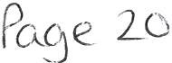

WTC 28/07/2022

Item 7

Asbestos on Allotments

Purpose of the Report

To inform Members of a recent discovery of possible asbestos material and the actions being taken.

1.0 INTRODUCTION

  - During a recent viewing with a new tenant at Midgey Allotments it was highlighted that a number of fence panels could contain asbestos.

  - In view of this and the possibility that there may be other potential sources of asbestos we have requested that our Ranger and Assistant Ranger conduct a survey of all the plots on Midgey, Crow Park and Sneckyeat. The Site Rep at Cartgate has reported that there is nothing on any of the plots on their site which could contain asbestos but has said that the roof on the garage that is used to store equipment could possibly contain asbestos.

  - Once the survey has been conducted it will be forwarded to a specialist company to obtain a quote for removal which will be reported to Full Council for authorisation.

- 0 RECOMMENDATION

  - To note the contents of the report and to agree for quotes to be sought from specialist companies who deal with the safe disposal of asbestos waste.

WTC 28/07/22
Item 8

OFFICE ACCOMMODATION QUOTES FOR FIRE ENGINEERING REVIEW

Purpose of Report and Recommendation

To inform Members of the quotes being sought for a Fire Engineering Review of the Council's building at 148 Queen Street, Whitehaven and to agree a course of action in the event of an urgent decision being required.

1.0 INTRODUCTION

  - The Council's Architect has been seeking quotes from contractors to carry out a Fire Engineering Review of our Offices at 148 Queen Street.

  - Very briefly a Fire Engineering Review is a process used to identify significant fire risk hazards and most likely scenarios so that the required level of quantified safety design can be established.

  - It may seem expensive in the early stages of a project. However it can be a very valuable exercise which can identify problems early and potentially help to reduce project cost and risk.

  - Our Architect was asked for a detailed description of what a Fire Engineering Review is and his reply is shown at Appendix 1 together with the one quote he has received although he is contacting alternative companies. The contractors who submitted the quote have requested a further meeting with our Architect to firm things up.

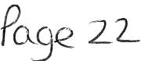

  - RECOMMENDATION

  - That Members consider the situation and make a
decision on how this should be progressed in the event of an urgent decision being required in respect of a quote for this work if there is no time to take it to Full Council
and in those circumstances Members are asked to consider delegating this decision to the Clerk (Proper Officer) in consultation with Councillors and thereafter ratified by Full Council.

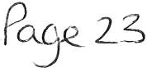

Whitehaven Town Council
WTC ;;;;18/, /z2-

I-zEl'v1 8

.A-P.P 5bA.,)( (

From:
Sent:
To:
Subject: Attachments:
Paul Morton <p.morton@phparchitects.co.uk> 20 July 2022 10:22
Whitehaven Town Council
RE: Fire engineer
Estimate PHP Cumbria.pdf

Hi Marlene,

In response to your request RE a Fire Engineer. We are looking to commission a RIBA Stage 4 Fire Strategy, including existing condition review.

This basically entails a full assessment of the existing building and the proposals to understand the functional objectives of the development and form a systematic approach to addressing the 'hazard and consequence of fire' to achieve risk to that of an acceptable level.

They will assess fire load densities, site conditions, construction type, sources of ignition, escape routes, compartmentation, fire suppression, smoke control requirements (if any) and fire detection measures in conjunction with the design team.

Essentially the report will be project specific and be in accordance with current Building Regulations/ Standards to ensure the finished premise is both operationally functional to the end users and offers suitable safety protection of its occupants and users.

The phasing of the proposals will be of particular importance as this will include a hybrid of new compliant construction and the fire engineer can help determine the extent of remedial and required upgrades to any existing fabric/ doors etc to ensure the upper floors can be utilised and protected in terms of fire/ smoke and evacuation as required.

The following fire safety measures are to typically to be addressed and given full consideration:
- Adequacy of means of preventing fire.
- Means of fire detection and raising the alarm (providing early warning).
- Design provisions for means of escape and progressive horizontal evacuation (PHE).
- Provision and requirement if any for smoke control.
- Control of the rate of fire growth.
- Structural resistance to the effects of fire.
- Degree of fire containment.
- Fire separation between various parts of the building (compartmentation).
- Standard of active measures for fire extinction or control.
- Facilities to assist the Fire and Rescue Service.
- Quality of premises management.

We have received a response from your contact at Carlisle City Fire Protection and they have advised this is not a service they can provide at present.

We are therefore struggling a little to obtain alternative quotations from others for comparison purposes. The companies we have contacted and generally use are either already too busy or are more commercially and generally only deal with multi-million pound schemes. I've put the feelers out to a couple of alternative companies we haven't previously used but as yet I haven't heard anything back.

I've attached the previously sourced fee estimate but this is subject to further firming up with requested a further meeting to discuss and agree extent of works etc.
as they

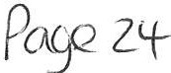

Estimate PHP Cumbria

Date of estimate: 17/03/2022 Reference number: 3388248
Client:
PHP Partnership Architects
Your reference/contact: Paul Morton
Premises:
146 Queen St Whitehaven Cumbria
Services:
- Provide Fire Engineering services for the above named project, working within the design team, providing solutions, guidance, and alternative ways to achieve compliance up to and including RIBA4

- Provide a written fire strategy to RIBA 4 Technical design for submission to the Responsible Authorities.

*Not included CFO modelling or smoke calculation /modelling which is outsourced and passed to the client at cost. This is not expected on this project

Fee: £9350.00 subject to VAT at current rate

ChrLstllt\e Mo-rsho..LL Business accounts manager

The Institution
of Fire Engineers
ID
I1-J.:.,

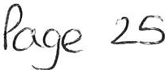

WTC 28/07/2022

Item 9

THE WHITEHAVEN LOCAL CYCLING AND WALKING INFRASTRUCTURE PLAN

Purpose of the Report and Recommendation

To inform Members of a The Whitehaven Local Cycling and Walking Infrastructure Plan and to endorse the document

1.0 INTRODUCTION

  - The Whitehaven Local Cycling and Walking Infrastructure Plan (LCWIP) was prepared to bring about a coherent list of cycling and walking investment priorities.

  - Attached at Appendix 1 are 2 plans showing the proposed LCWIP Whitehaven walking network and the cycling network and 1 showing the LCWIP Prioritised cycling network together with the Whitehaven Local Cycling and Walking Infrastructure Plan 2022-2037

  - This Plan is being taken for approval at the CCC Local Committee on 20th July 2022 and attached at Appendix 2 is a copy of the Report to the Local Committee.

  - The CCC are asking the Council to consider the LCWIP and to endorse the document.

2.0 RECOMMENDATION

2.1 That the Council endorses the LCWIP

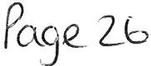

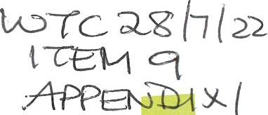
I I QUALITY CORNER
I
I
I
I
,I

Whitehaven LCWIP Walking Network

I I I I
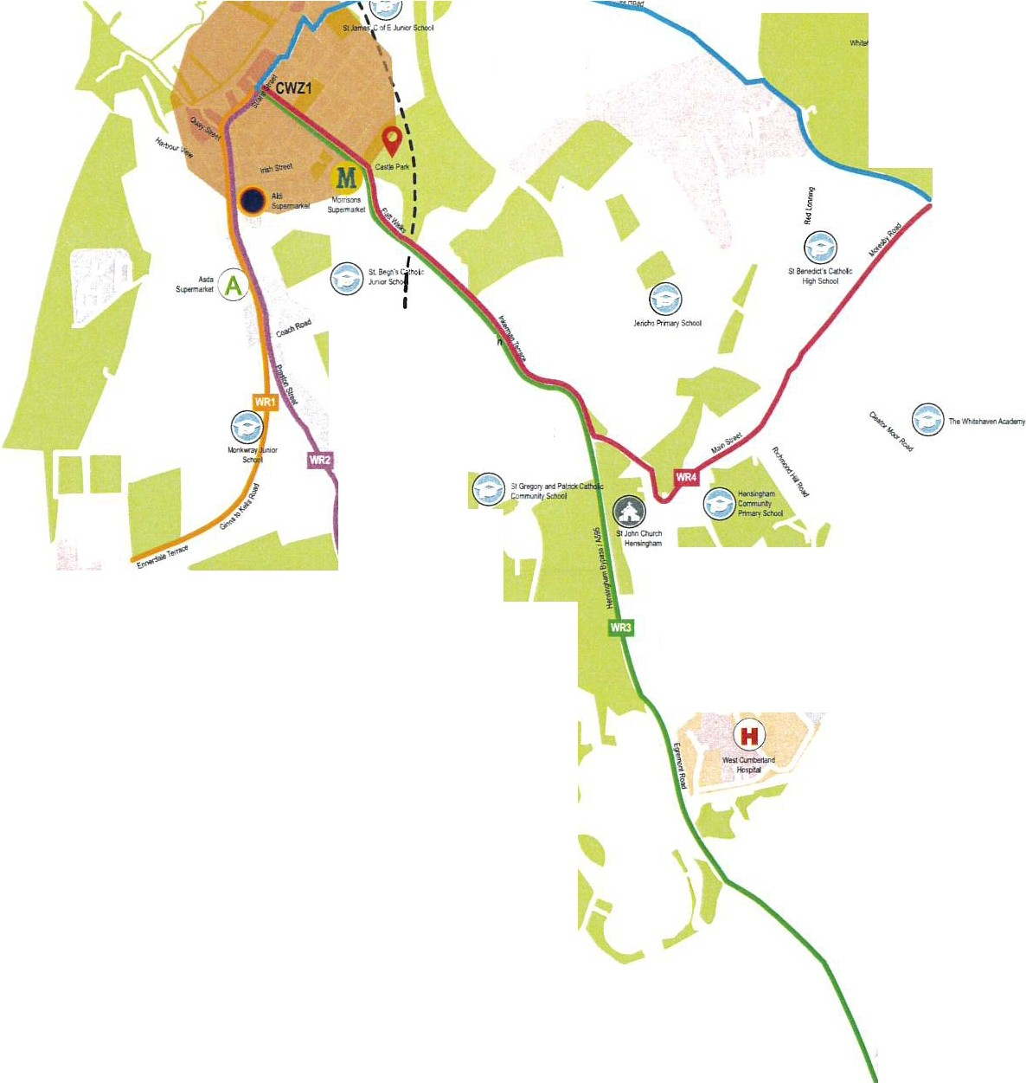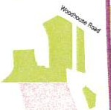\
\
I I I
\ BRANSTY
I
--,.,

MORESBY PARKS

,.,....,.., ,_,
-=(I) ,, I
' ' J
9

HARRAS MOOR

eCorklck Statio
9 '
-L-apFQO!WCU I \

''' ;
'
\

CORKICKLE

MIREHOUSE
'I
'I ''''
l
\ '''' J
' l
''
'
''

.....9
J J HENSINGHAM,

SANOWITH

KEY
',..,._,,_

'.0
''''
''''
''''
''''',,.,,,,,,,,,.
'''
'I
I I I I
e

GOOSE BUTTS

LocalPlan Draft Housing Allocalions Green Space

LocalPlan Draft Er1]ploymenl and Opportunily SileAllocations
Railway Slalion

Schools I Colleges
River

Railway Line

- WR1 Ginns toKells Road
- WR2 B5345 / LowRoad
- WR3 A595 / Egrnmonl Road
WR4 Main Street
- WRS Harras Road
a
CWZ1 Core Walking Zone (c.400m)

I
I

Version I • 13/06122

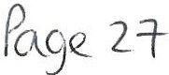
I I
.I I

/
Route 15 Parton to Lowca ,?, :\

Whitehaven LCWIP Cycling Network

A595 --=o
(

QUALITY CORNER
MORESBY

- l

MORESBY PARKS

9
HARRAS MOOR j
i
f

\
Cortkk.leStalior1·\,

\
MIREHOUSE

-...­..

11
GOOSE BUTTS

, ,,..

SANOWITH
Route 16 continues to St Bees \

NCN

KEY

local Plan Draft Housing Allocations
e

local Plan Draft Employment and Opportunity Site Allocations

Green Space Railway Slalion

Schools/ Colleges

Rai ayLine

River

NCN 7 Nalional Cycle Nelwork

- New infrastructure tobe providedwithinthe highway boundary ,.. Existingcycle route(improvementplanned to comply with guidance)

- 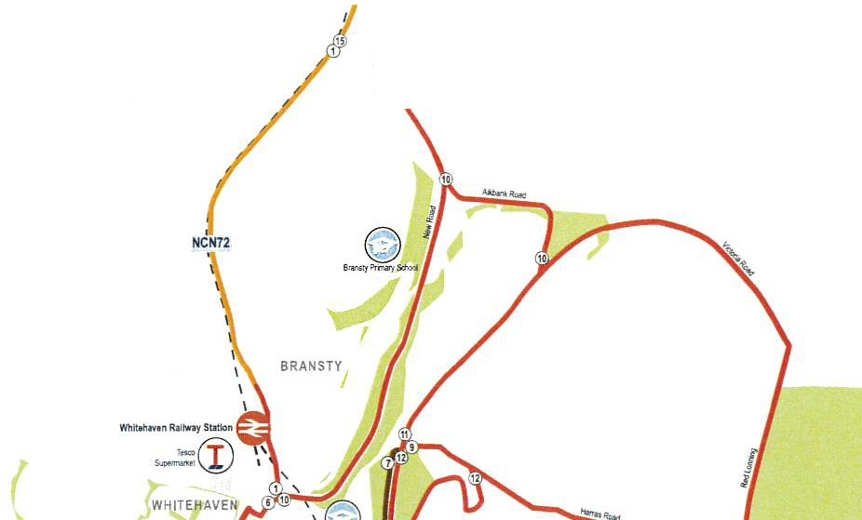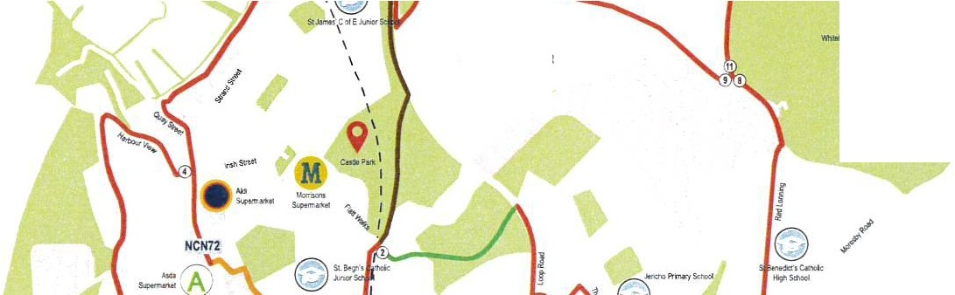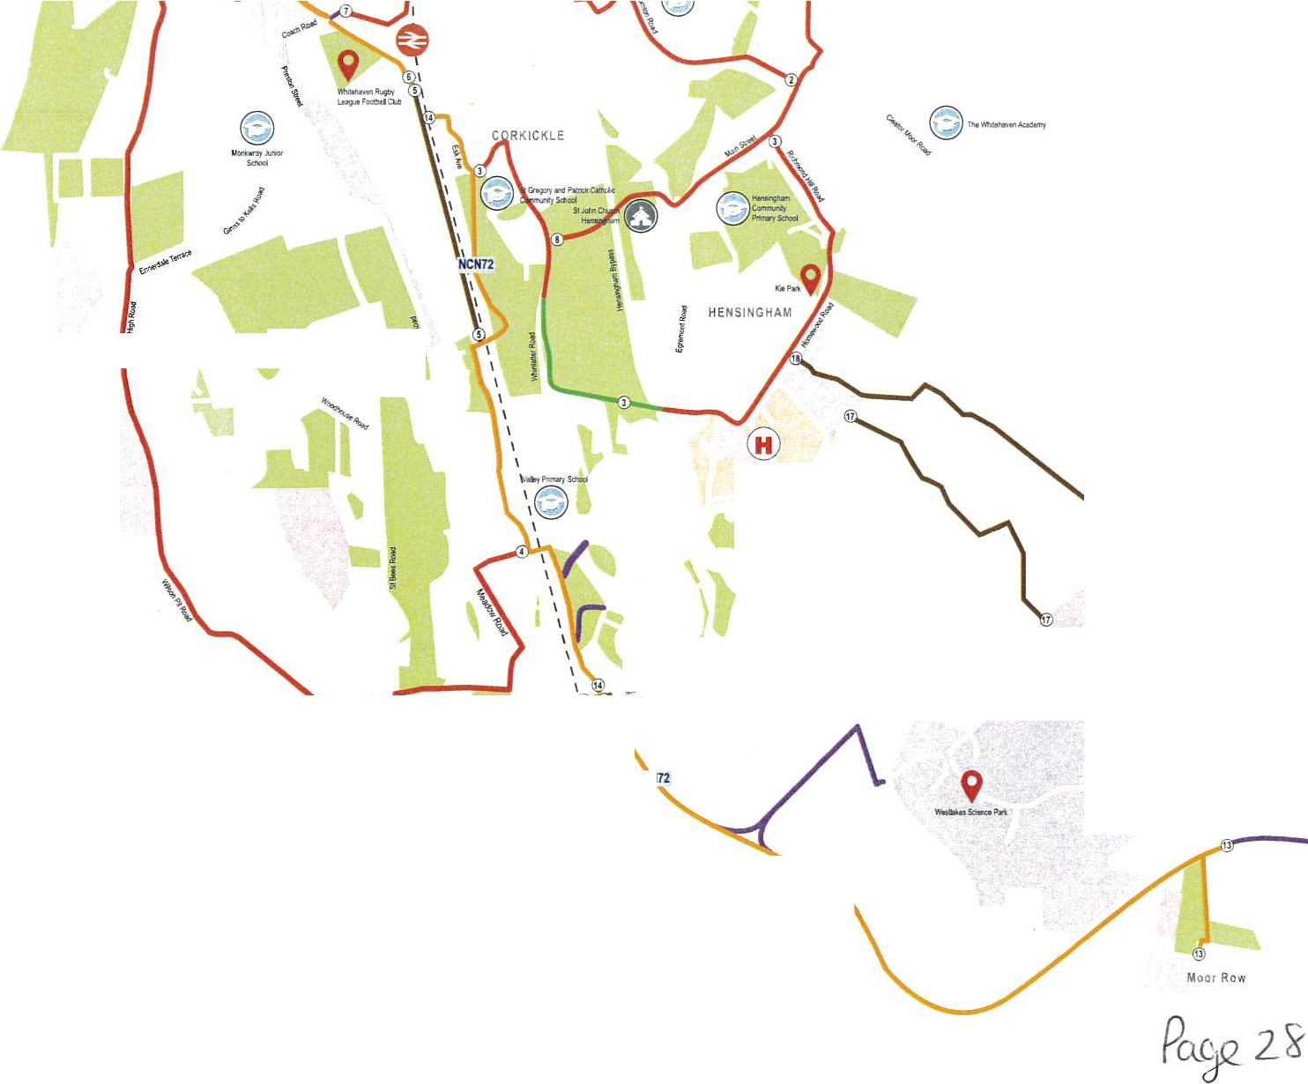Exisling cycle route (noimprovement planned)
- Existingbridleway
- New infrastructure to beprovidedonlh1rdparty land

Version1 - 09106122

7
Route 15 Parton to Lowca ,,;,, :\

Whitehaven LCWIP Prioritised Cycling Network

o QUALITY CORNER
A595 ""-=o
(
MORESBY

PRIORITISATION

Priority Target Years Target Timescale (Subject to Funding) (Subject to Funding)

Priority Group I Within5 Years 2026 I 2027
Priority Group2 Within8 Years 202912030
Priority Group3 8+ Years Post 2029 / 2030

9
HARRAS MOOR

1 1
\
,

MIREHOUSE
....

'

GOOSE BUTTS"

Route 16 continues to St Bees \,

SANOWITH

KEY

Local Plan Draft Housing Alk>cations

Local PlanDraft Employment and Opportunity Sile Allocations
Green Space
0 Railway Station
Schools I Colleges

Raitv.iay line
River

NCN 7 National Cycle Network

- New infrastructure to be provided 1\ithin the highway boundary - Existingcycle route (improvement planned locomply withguidance)

- 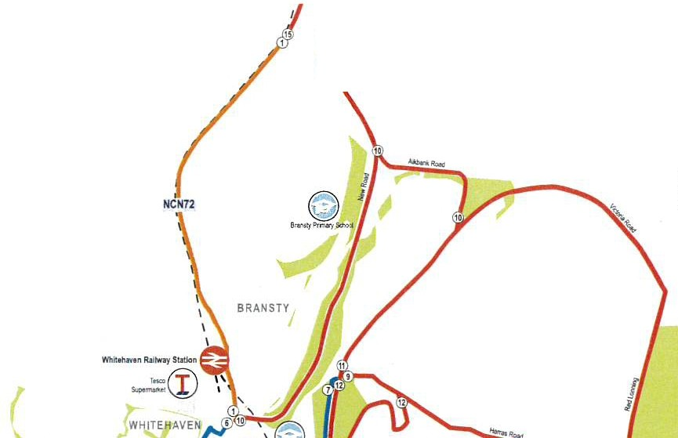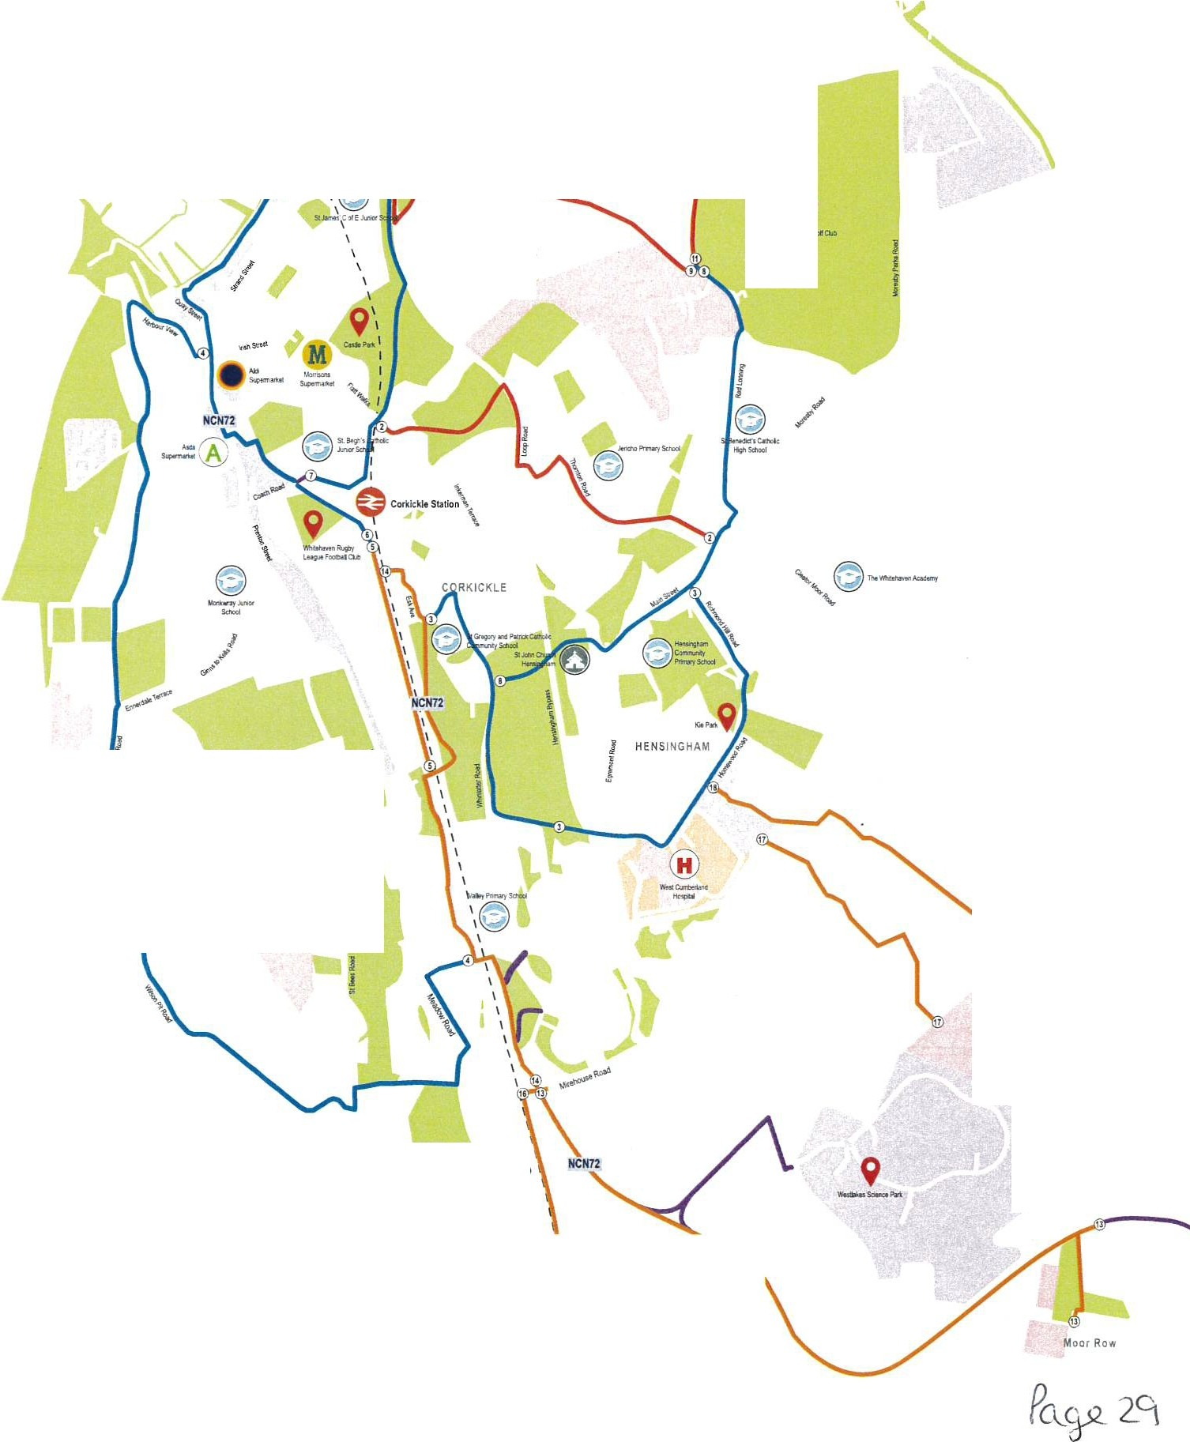Existing cycle route (no improvement planned)
- Existing bridleway
- New infrastructure to be provided on third party land

Version1- 13106122

N N 0 N
Q)
C:
::I
"'")

"'C
C:
co
C:

cCo:
a.
-

I'-

(1) en en (1) ..-. M
>co
C:
C:
L,., a. 0

.c:
·-- ·-
..:..:.l, - N

..(..1.,) >,.- 0 I
0

·- (.) co
..:..:.l,
(.) N

.c: -co

L,.,
u,
.._..J N
lh,
0

0 co N •.:,t, ·;:;
-
L,., ,I.l.l.',: =C:

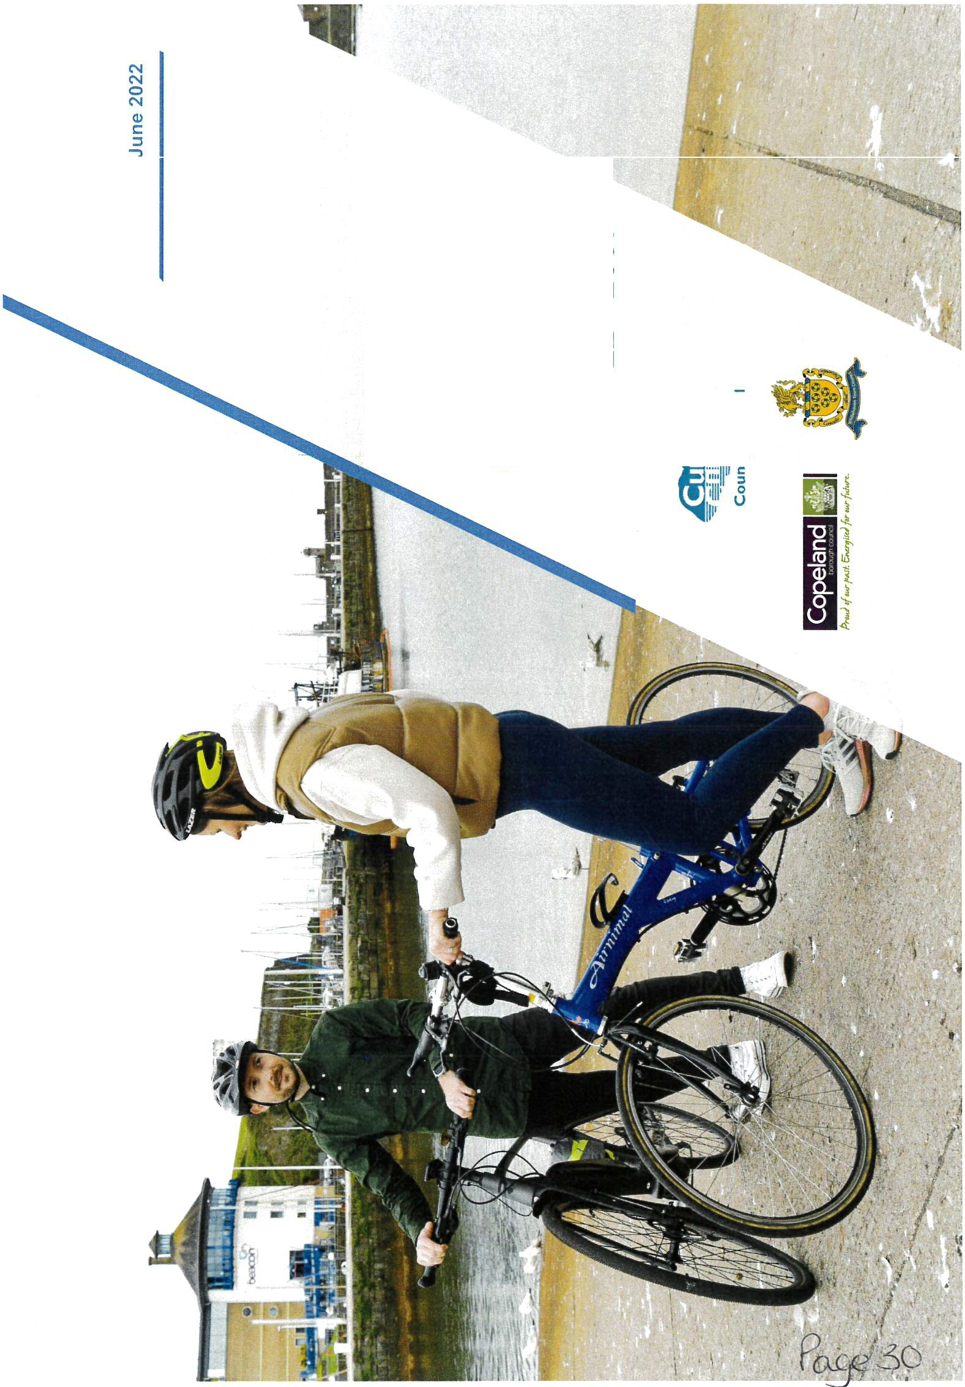0 'to-
..J C:
. ^{·1};::¹::llf
'illl· 5
1,,, u

Whitehaven Local Cycling and Walking Infrastructure Plan (2022 - 2037)

Contents

Foreword
- Vision and Aim
What is a Local Cycling and Walking Infrastructure Plan?
Why is an LCWIP important for Whitehaven?

- Existing Context
National policy context Local policy context
Transport and placemaking schemes
How to people currently make local journeys? Potential for more walking and cycling

Page 2
Page 3-5

Page 6-9

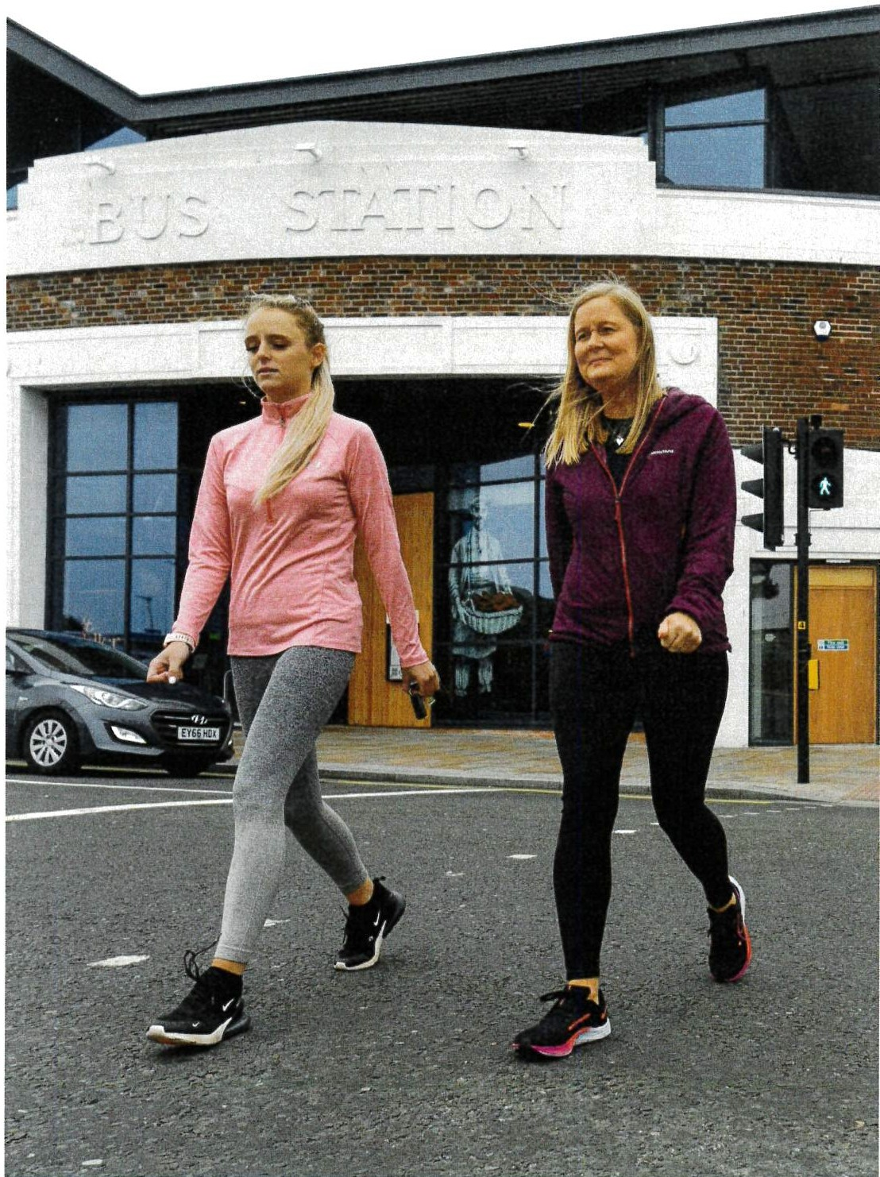

n
'O
p
lN
- Cycling and Walking Infrastructure
Developing the LCWIP
Engagement and public consultation Infrastructure improvements
Cycling infrastructure improvements Walking infrastructure improvements Cycling network
Walking network Prioritisation

- Conclusion and Next Steps
Page 10-17

Page 18

Whitehaven Local Cycling and Walking Infrastructure Plan (2022 - 2037)

Foreword To insert
I am pleased to introduce Cumbria County Council's Local Cycling and Walking Infrastructure Plan (LCWIP) for Whitehaven, which outlines the proposed network of key cycling and walking routes in the district. The plan will work in conjunction with our wider infrastructure plans, including the Cumbria Transport Infrastructure Plan to support transport and connectivity, which will help Cumbria to become one of the best­ connected rural geographies in the UK, whilst also incorporating the growth of Cumbria and responding to climate change.

The LCWIP identifies cycling and walking improvements at a local community level and is designed to facilitate a long-term approach to developing cycling and walking networks. Encouraging people to adopt a more active lifestyle will benefit their health, but collectively this will have a positive impact on net zero carbon emissions.

This document gives a summary of the county council's goals and objectives, while sharing more specific information about the communities that we have consulted with in Whitehaven.

I'd like to thank all the residents, businesses, and visitors for their support and feedback on engagement and consultations to date.

N
{?
r'5
y:;

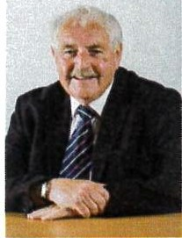
Cllr Keith Little
Cumbria County Council Cabinet Member for Highways and Transport
Cllr Keith Hitchen
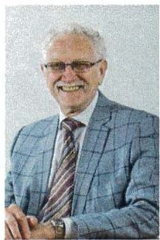
Cumbria County Council Chair of Copeland Local Committee

Whitehaven Local Cycling and Walking Infrastructure Plan (2022 - 2037)

Vision and aim
The LCWIP covers Whitehaven, with a focus on the urban centre but including links to surrounding communities such as Distington and St Bees.

What is a Local Cycling and Walking Infrastructure Plan?
A Local Cycling and Walking Infrastructure Plan (LCWIP) is a document that identifies and prioritises cycling and walking improvements at a local level. It sets out an approach for developing prioritised routes over the period of the Plan (2022-2037), with the aim of encouraging more people to make journeys on foot or by bike.

The focus of the LCWIP is the improvement of routes used for everyday shorter journeys, such as to work, school or the shops. It aims to identify good quality infrastructure that connects the places people need to get to, in a coherent, direct, safe and attractive way. Recognising that it is not always possible to connect everywhere and that funding for delivery needs to be secured, the LCWIP aims to prioritise future investment where the most benefits can be realised. The LCWIP is a not a funded plan. However, having an LCWIP in place will put the Council in the best possible position to secure future funding for the delivery of improvements.

(Y)

<;) !I:.
(_b
(v

lN
l)J
The LCWIP has been developed using principles set out in the Government's first Cycling and Walking Investment Strategy, 2017. This Strategy sets out the ambition"to make walking and cycling the natural choices for shorter journeys or as part of a longer journey''. Government guidance outlining a recommended approach for developing LCWIPs has also been followed.

The LCWIP is based on data and evidence of existing and future potential need and demand. It has also been guided throughout by effective engagement with partners, stakeholders and the public.

The LCWIP provides:
- Plans showing the most important routes for development
- Priorities and timescales'for development
- A detailed evidence base to support future delivery funding bids
- A basis for securing government funding or developer contributions

Whitehaven Local Cycling and Walking Infrastructure Plan (2022 - 2037)

"'""

\..b [:_
(Q
{fa
--f
Why is an LCWIP important for Whitehaven?

Creating attractive places to live and work

Copeland District employs approximately 27,400 people, which accounts for 13% of all employment in Cumbria. The nuclear sector and its supply chain are a major employer within the area, accounting for 59% of jobs. The coastal town of Whitehaven is the administrative seat of Copeland. Built on shipping and mining, both industries have now declined however, Whitehaven retains a rich cultural heritage with over 250 listed buildings.

Investment in the streets where people live or work can create more attractive and desirable places. Improvements to the street scape can encourage more people to walking and interact with their surroundings, promoting journeys on foot, generating a greater sense of pride in their town and increasing wellbeing.

Responding to the climate crisis

Cumbria has set itself an ambitious challenge to be the first carbon-neutral county in the UK by 2037 (Cumbria Zero Carbon Partnership, 2021). De-carbonising transport is key to achieving this goal. Cycling and walking has a much lower carbon footprint compared to other forms of transport and undertaking more journeys on foot or by bike will help to tackle climate change. The LCWIP for Whitehaven focusses on everyday short journeys such as those to work, school and the shops, where there is the greatest potential for change.
Q?,;-oJ
Transport.accounts
for27-% of the
gas emlsslons -
61 %·of(thls is from
·cars_arid taxis
(DrTTranepart lorGrllll Brtllln
2021)
UKs,greenhouse

Supporting health, wellbeing and access for all

Active travel can play a crucial role in supporting public health and wellbeing. It is one of the simplest and most effective ways of enabling adults and children to meet the recommended levels of physical activity. The LCWIP for Whitehaven has an important role to play in promoting behavioural change. By setting out well planned networks that connect people to the places they want to go and focussing on inclusive design that ensures access for all, the LCWIP presents a real opportunity for behavioural change that will last for generations to come.
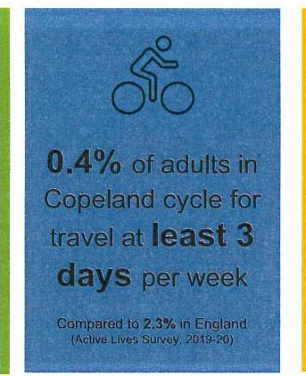
0
11.5% of adults in Copeland walk for travel at least 3 days per week
Compared to 15.1%in England
(Active lives Survey, 2019-20)
Qo
Q
25.9'% of.people
in Copela_nd(16+)
area'irt'ac.fiv&

Compared to 27.5%tnEngland
(Actiwa.-SUrvey 10,2021,
The health cost of inactivity to Copeland is £1,300,000 every year
(Sport England Local Sport Prom,,)

Whitehaven Local Cycling and Walking Infrastructure Plan (2022 - 2037)

Improving accessibility and social inclusion

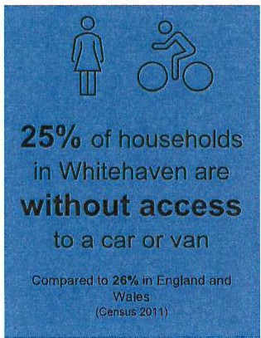
Households who struggle to access employment and education opportunities, key services and facilities due to transport poverty can suffer from social exclusion. Cycling and walking are generally affordable modes of transport, accessible to most people.
Enabling people to walk or cycle to the places they want to travel to can facilitate social inclusion. The LCWIP for Whitehaven aims to connect people to jobs, education and each other, which is especially important when other modes of transport are not available.

Improving the tourism offer

Whitehaven is an attractive Georgian coastal town and one of the 51 Gem Towns in England, chosen by the Council for British Archaeology for being 'particularly splendid and precious'. It is a key gateway for the visitor economy in the western Lakes, with a number of attractions such as The Beacon Museum, The Rum Story, Rosehill Theatre, and the harbour - which was once the third largest in the UK with trade links all over the world.

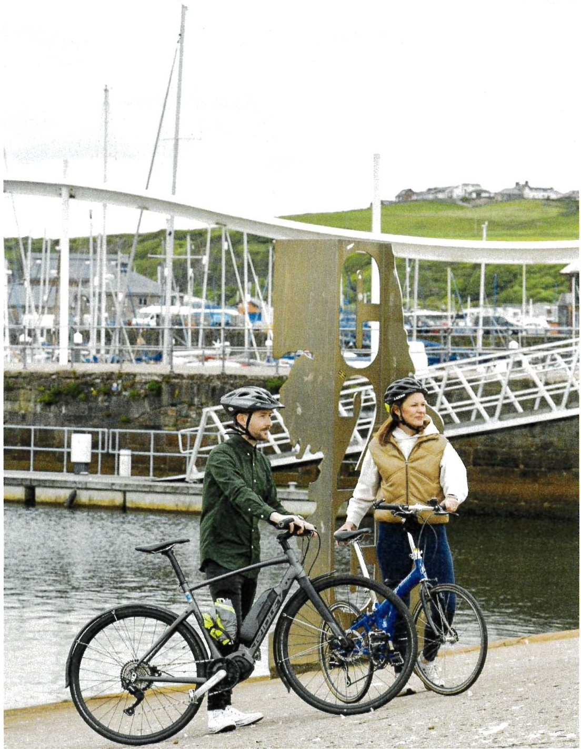

L[)
ff

t))
Whitehaven's location on the west coast makes the town well placed for access to the western Lake District and coastal landscapes, with fantastic leisure cycling and walking opportunities. Whitehaven is one of two potential starting points for the 'Sea to Sea' (C2C) cycle route, one of the UK's most popular challenge routes, ending in either Tynemouth or Sunderland on the east coast. The Hadrian's Cycleway, a 174 mile route from Ravenglass to South Shields in Tyne and Wear, also runs through the town. The LCWIP network builds on these established longer distance links and aims to consolidate Whitehaven's
position as a premier cycling and walking town.

Whitehaven Local Cycling and Walking Infrastructure Plan (2022 - 2037)

Existing Context

National policy context
Gear Change: A bold vision for cycling and walking (DfT, 2020)[11

UK Net Zero Target (2020) 161
National and local policy has guided and shaped the development of the Whitehaven LCWIP. The Plan supports key environmental, health, social, economic and sustainable mobility goals to better connect people and places.

l.O
l6
(\)

lN
l}"
Sets out the governments vision for the delivery of far higher quality cycling infrastructure. Accompanied by Local Transport Note 1/20 with new ambitious cycle design standards.
Cycling and Walking Investment Strategy (DfT, 2017) [²1
Aims to make active modes of transport the natural choice by 2040. Sets out the need for LCWIP to inform locally targeted investments.
Future of Mobility: Urban Strategy (DfT, 2019)1³1
Includes the principle that 'walking, cycling and active travel must remain the best option for short urban journeys'.
Clean Air Strategy (DEFRA, 2019) [⁴1
A change to more sustainable modes of transport is key to delivering a reduction in emissions.
Decarbonising Transport: A Better, Greener Britain (DfT, 2021)1⁵1 Sets out the government's commitments and actions needed to decarbonise the UK's transport system.

Key Local Policy documents include:
o ;Cumbria Transport Infrastructure Plan, 2022-2037 181
Cumbria Local Industrial Strategy, 2019 1101
'Cumbria.Cycilng Strategy, 2017-2022 1111
:o.fCopeland.L 6al Plan, 2021-2038 (draft) 191
g onomic Recovery Plan, 2020 1121
i? nation Bprd rlands and the Borderlands
:.arowth
Deal:2021-203111s1
- :·;;bumbrlaRu; , and Visitor Economy Growth Plan,
20171141
National target to bring all greenhouse gas emissions to net zero by 2050
Inclusive Transport Strategy (DfT, 2019) 1⁷1
A need for inclusive infrastructure with streetscapes designed to meet the needs of all travellers.
Local policy context
There are strong levels of support for cycling and walking in existing local policy.
The Cumbria Transport Infrastructure Plan (CTIP)l81recognises the role that active travel schemes can play in improving health, access to education, employment and services and supporting the local economy. The CTIP places active travel centrally in the aim to develop a 'Clean and Healthy Cumbria'.
The Copeland Local Plan, 2021-2038[⁹1(publication draft) cites cycling and walking as key mechanisms to achieve the goals outlined in several policies including:
- Policy DS6PU - Design and Development Standards
- Policy T2PU - Coastal Development along the Developed Coast
- Policy H6PU - New Housing Development
- Policy C02PU - Priorities for Improving Transport Networks within Copeland
- Policy C04PU - Sustainable Travel
- Policy C05PU - Transport Hierarchy

Whitehaven Local Cycling and Walking Infrastructure Plan (2022 - 2037)

The Copeland Local Plan also sets out a number of housing and employment growth areas in the borough which need to be considered when developing the active travel network. The main locations for housing growth within the Whitehaven LCWIP area are:
  - Land at the West Cumberland Hospital (127 dwellings),
  - Red Lanning and Harras Moor (370 dwellings),
  - Former Marchan site (532 dwellings),
  - Land at Edgehill Park Phase 4 (120 dwellings),
  - Land to south-west of Summergrove (80 dwellings),
  - Land adjacent to Abbots Court (58 dwellings), and
  - Land south and west of St Mary's School (60 dwellings).

an attractive place to live, work, study, visit and invest. They may also feature improvements to connectivity by sustainable and active modes of travel. Schemes include:
Levelling Up Fund (LUF)
- Copeland Borough Council are currently preparing a bid to the Government's Levelling Up Fund.
- The bid includes elements of cycling and walking which align closely to proposals in the LCWIP.
- Funding for delivery is subject to the bid being successful.

(E
(\)
(J\)

-+J

r---...
OJ
i
Employment land is allocated at:
- 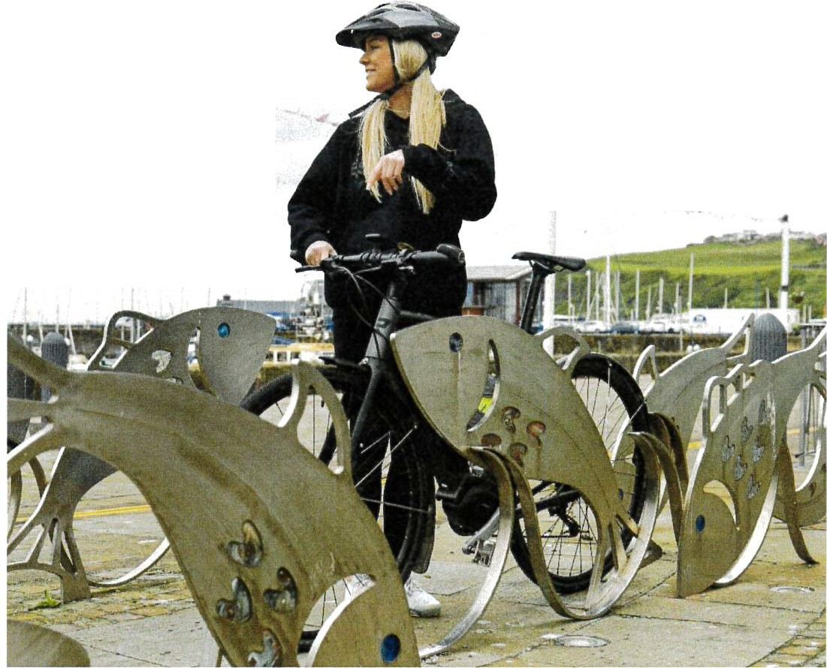Whitehaven Commercial Park (11ha)
..... ..
.,,,
" "'. "
-,,, ....
· .
.,-
- Sneckyear Road (1.1ha)
- Red Lanning (0.6ha) and,
- Furnace Row, Distington (3.1ha)

The Copeland Infrastructure Delivery Plan, 2020 identifies sustainable transport schemes required to support the delivery of the Copeland Local Plan.
The West Cumbria Corridor Travel Plan, 2016 identifies sustainable transport measures which could be developed or improved to enable and encourage visitors and residents to travel to work and leisure purposes without the use of a car.
Transport and placemaking schemes
Cumbria County Council and Copeland Borough Council are exploring opportunities for government funding to deliver active travel and place­ based schemes. These schemes aim to improve the Borough's offer as

Whitehaven Local Cycling and Walking Infrastructure Plan (2022 - 2037)

How do people currently make local journeys?
National travel to work data from 2011r¹⁵1shows high levels of

6%
(7%)°
<1%
(9%)**
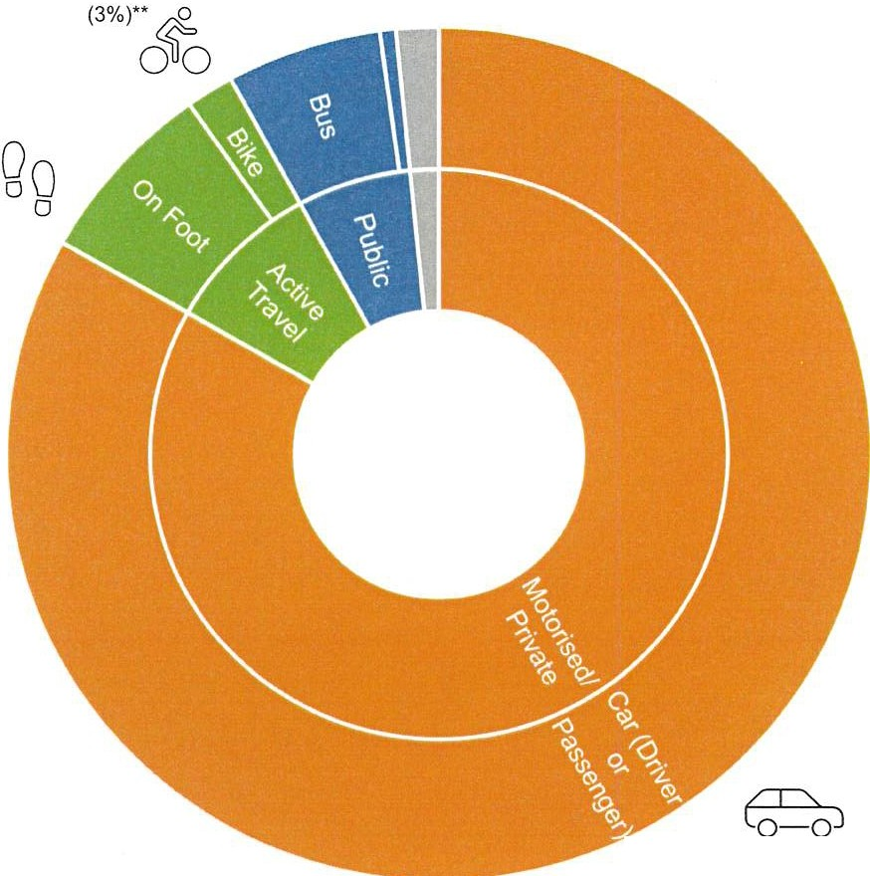g How people
7%
(10%)*•
(60%)° 83%

containment with 78% of residents within the Whitehaven LCWIP area, also working within Copeland. Only 22% of residents travel outside of Copeland for work with neighbouring Allerdale being the work destination for the majority (16%).
Despite short commuting distances there is a high level of car dependency with around 83% of trips using this mode of travel. Only 2% of journeys to work were found to be made by cycling and 7% by walking.
Travel to school r¹s1data indicates 19% of children in Copeland walk to school, whilst <1% cycle. Private motorised transport as a means of getting to school accounted for 16% of journeys.
The most popular cycle routes 1¹⁷1 for travel to work journeys are typically linear connections to the south of Whitehaven. The link between Whitehaven and Bigrigg consisting of Loop Road South and Egremont Road is particularly popular.

How children travel to school
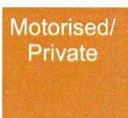
Public Active Travel
2% [ _{I} g
travel to work

[ I g 63% (32%)*
er
00 g 0% (2%)*
Based on Copeland Borough average v * County average.
Qo 19% Co='oJ 16%
0 (35%)* (28%)*
0
<1%
0 0 (2%)*

CX)
Data taken from School Travel Demand Surveys 2021, providing an indication of travel modes to/from schools in Copeland Borough pre-COVID. Statistics are based on 2089 respondents countywide and 206 respondents for schools in Copeland Borough.
Based on averages within LSOA relevant to the Whitehaven LCWIP area v •· England average. Data taken from 2001 Census. Method of Travel to Work.

Whitehaven Local Cycling and Walking Infrastructure Plan (2022 - 2037)

74% of respondents said improvements to cycling and walking routes would encourage them to walk and/or cycle more often than they do currently.

Potential for more walking and cycling

Fo='o)
83%
·rt y,(toworkare pt£1,1ate·mptorised JfljtfWhitehaven
.CWlfiarea
however..

{,
35%
of journeys to work are
<5km11a1
18%
of journeys to work are
<2km11a1

but did you know...
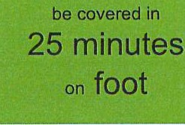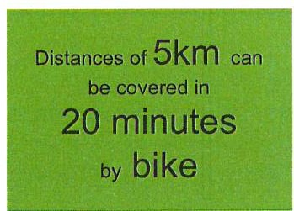 (I)
Distances of 2km can
0
Oo
0 00
l!

Levels of cycling and walking in Whitehaven increased during the COVID-19 lockdown in Spring/Summer 2020. This was in part because roads were less busy and quieter, offering more desirable conditions for cycling and walking. The reduction in traffic emissions also led to improvements in air quality. As people returned back to places of work and to school, levels of cycling and walking reduced. This demonstrates that the potential for cycling and walking exists if the right conditions are put in place. Improvements to active travel infrastructure will form part of this.
Despite high levels of car dependency across the Whitehaven LCWIP area, a high proportion of everyday journeys to work, school or the shops are within a distance which is easily achievable either on bike or on foot
An initial round of public consultation on the Whitehaven LCWIP undertaken in July/August 2021, asked for feedback on what would encourage people to change to cycling and walking for short journeys. Findings were consistent with national data whereby, a large proportion (71%) of respondents identified they currently make journeys by car to places that were within cycling and walking distance. Journeys to the shops, to/from leisure activities and transporting children or other people were the main reasons given.

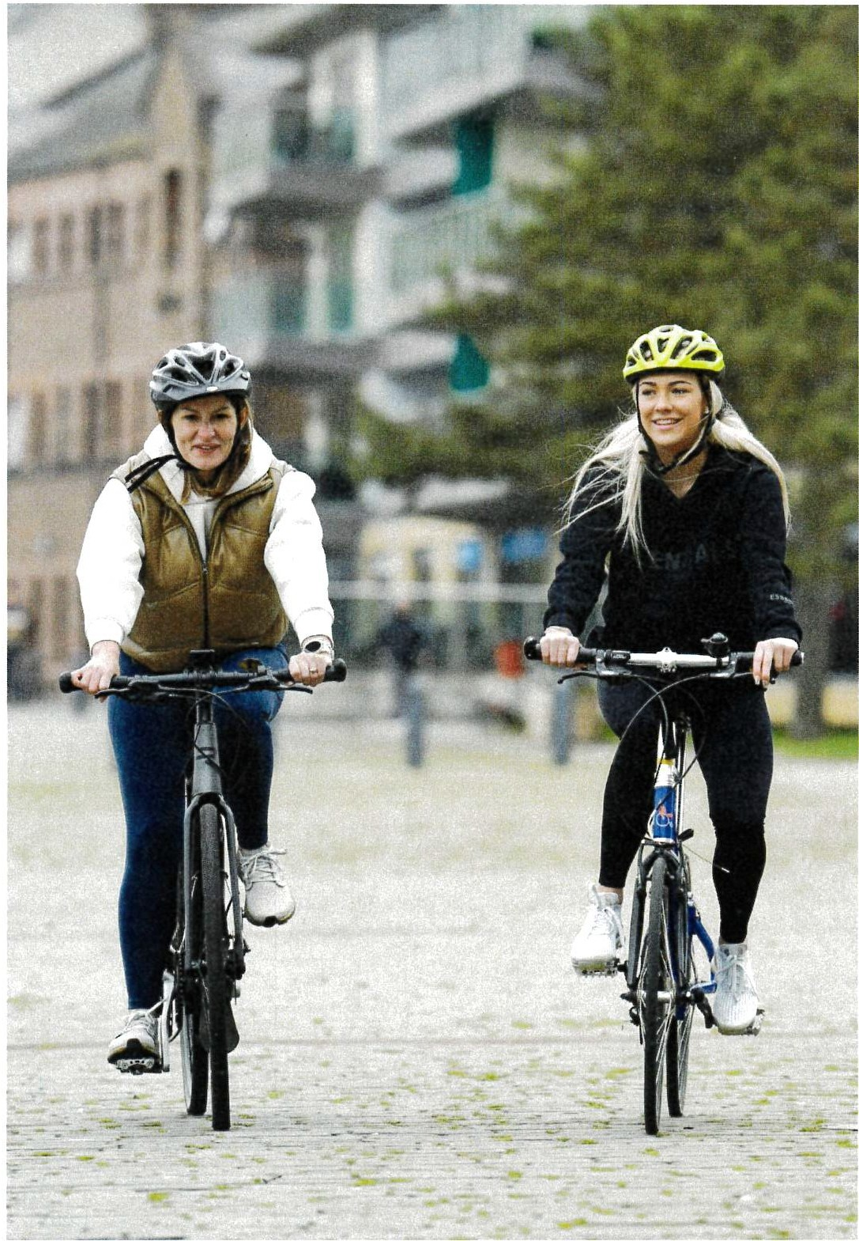

0._.,
cf

t
Whitehaven Local Cycling and Walking Infrastructure Plan (2022 - 2037)

Cycling and walking infrastructure

Developing the LCWIP
The LCWIP for Whitehaven has been developed in accordance with government guidance and has followed a six stage process.

- Stage 1: Determine the scope - establish the geographical context and arrangements for governing and preparing the plan.
- Stage 2: Gathering information - identify existing walking and cycling patterns and potential new journeys. Review existing conditions and identify barriers to walking and cycling. Review related transport and land use policies and programme.
- Stage 3: Network planning for cycling - identify origin and destination points and cycle flows. Convert flows into a network of routes and determine the improvements required.
- Stage 4: Network planning for walking - identify key trip generators, core walking zones and routes, audit existing provision and determine the improvements required.
- Stage 5: Prioritising improvements - prioritise improvements to develop a phased programme for future investment.
- Stage 6: Integration and application - integrate outputs into local planning and transport policies, strategies and delivery plans.

Whitehaven Local Cycling and Walking Infrastructure Plan (2022 - 2037)

Engagement and public consultation
Public consultation and stakeholder engagement have played a key part in the development of the Whitehaven LCWIP with an initial public consultation undertaken in July/August 2021 and a follow up in February 2022. In addition, regular workshops have been undertaken with key stakeholders throughout.
The initial public consultation focused on gaining an understanding of:
  - Current travel behaviour - cycling and walking journeys and why these are undertaken;
  - Public opinion on the current active travel provision in Whitehaven;
  - Any barriers on active travel routes that may prevent cycling and walking;
  - What would encourage modal shift to cycling or walking for short journeys; and,
  - Feedback on the emerging priority cycling network.
A total of 316 responses were received for this consultation.
The follow up consultation offered a second opportunity to comment on proposals prior to finalising the Whitehaven LCWIP. This consultation focused on:
  - Gauging the level of support for the draft prioritised cycling and walking network plans;
  - Whether the network and interventions proposed would encourage the respondent to use active modes more often; and,
  - Whether there was support for reduced space for cars to prioritise
rl active modes.
rl
QJ A total of 215 responses were received for this consultation.
� l
:E

The results of the consultation exercise demonstrate a desire for future investment in cycling and walking infrastructure. Responses emphasised the importance of providing safe, segregated routes that provide direct connections to the places people want to get to. The need to provide routes that were separate from other modes of travel was a common theme in the responses and was identified as a key measure for encouraging more cycling and walking. The creation of more direct cycling and walking routes, and better maintained routes were also supported, along with lower speed limits and greater priority for cyclists at junctions.
The main perceived barriers to cycling and walking were:
- Busy roads
- Quality of routes
- Feeling unsafe
- Indirect routes
- Unsuitable terrain/geography
The draft priority cycling and walking networks presented received a high level of support and the majority of respondents felt that the proposals would encourage them to cycle or walk more often.

"Many people·are wanting to be healthier and are more conscious about protecting our environment and living a greener, more sustainable life. If cycle paths are put into our infrastructure, many more people would use them as they would feel safer, anct it
would become more part of everyday life like it is in cities and towns all over the world."
a local resident, open ended question response,
February 2022

Whitehaven Local Cycling and Walking Infrastructure Plan (2022 - 2037)

Existing cycling and walking routes

45% felt the existing cycling routes do not connect to the places they want to go

24% felt the existing walking routes do not connect to the places they want to go

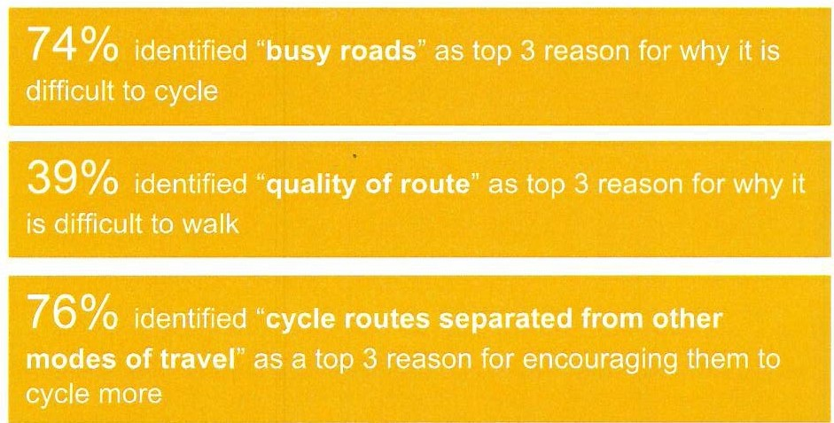
Cycling and walking barriers and opportunities
"I think the cycle path would help us all to be more active... It would give us more places to walk to rather than using the car. It would also be great for young children to use to ride their bikes safely off the road while keeping fit and active at the same time."
A local resident, open ended question response, July/August 2021
Support for proposals
93% welcomed more money being spent on cycling and walking in Wllitehaven
91% said they would support
cycling and walking improvements even when this could mean less space for other road traffic

94% strongly agreed or agreed with the routes prioritised in the draft Whitehaven LCWIP cycling network

L¹ .LI)
r6
rE

N_,
ro
CL

58% identified ';better maintained pavements/footways"
as a lop 3 reason for encouraging them to walk more

"We need to [be] encouraging more environmentally friendly forms of transport, going back to how transport was before cars took over."
A local resident, open ended question response, July/August 2021
89% strongly agreed or agreed with the improvements identified in the draft Whitehaven LCWIP walking network

86% felt the proposals in the Whitehaven LCWIP would encourage them to cycle or walk more often

iJ Appendix C for copies of the Consultation Reports
See Whitehaven LCWIP Technical Report

Whitehaven Local Cycling and Walking Infrastructure Plan (2022 - 2037)

Cycling infrastructure improvements

funding and further development.

The Whitehaven LCWIP broadly identifies the types of improvements that could be implemented. All improvements are subject to

On-Highway Fully Segregated Cycleways
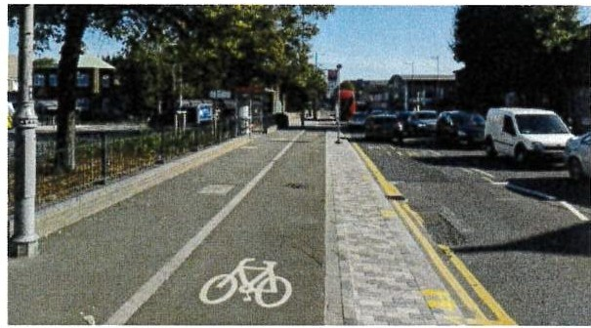
Segregated cycleways offering separation from pedestrians and motor vehicles.
Photo shows a stepped cycle track.

Upgrades to Existing Facilities
On-Highway Lightly Segregated Cycleways
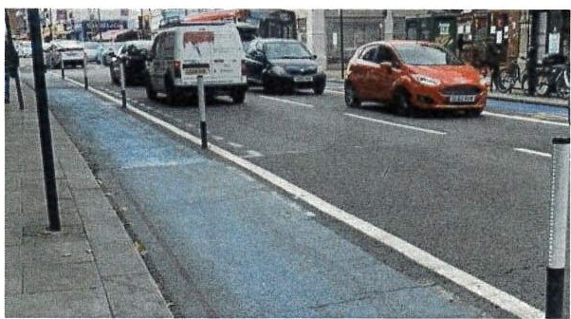
Light segregation providing a protected space.
Photo shows light segregation using 'wands'.

Road Crossings and Junctions
Off-Road Cycleways
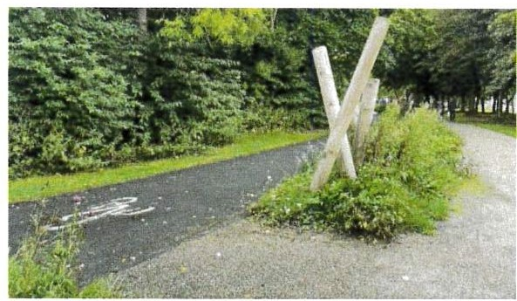
Greenways providing rural connections. Shared use paths where pedestrian number are low.
Photo shows a greenway with segregated facilities.

Secure Cycle Parking

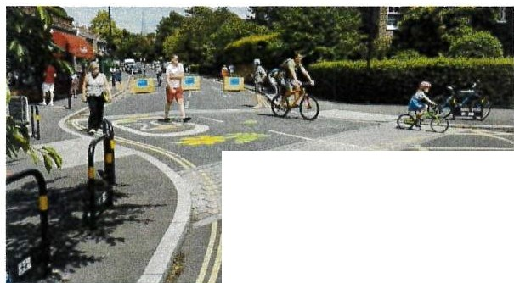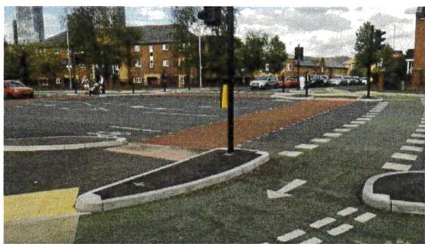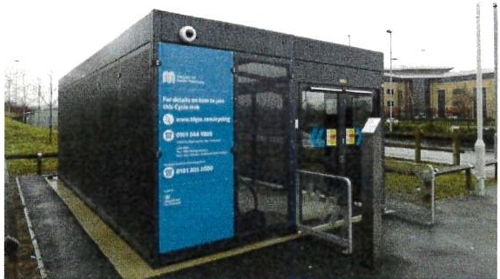
· ...

::D
f
Removal of through-traffic to create Low Traffic Neighbourhoods. Slowing traffic i.e. 20mph zones.
Photo shows a Low Traffic Neighbourhood.
Strong visual priority for cyclists and walkers on side junctions. Crossings and junctions offering separation and improved safety.
Photo shows a 'CYCLOPS' junction.
Short stay and long stay solutions that are secure and positioned at strategic locations.
Photo shows a secure cycle hub.

Whitehaven Local Cycling and Walking Infrastructure Plan (2022 - 2037)

Walking infrastructure improvements

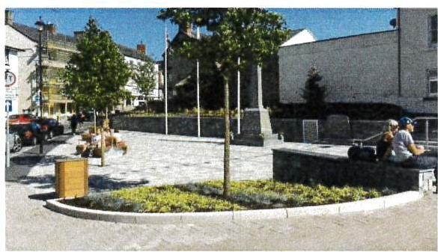
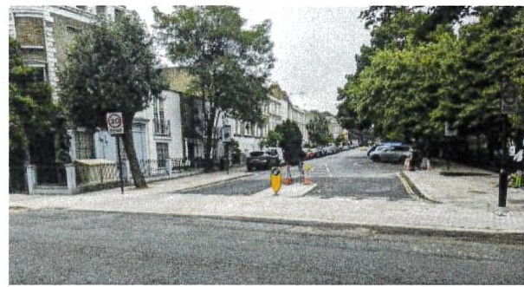
Public Realm Blended Footways
Maintenance
Short term maintenance to bring a route up to standard or planning for longer term maintenance.

Increased Surveillance
Improving sightlines, additional access points or installing CCTV.

Footway Widening
Proving adequate footway widths.

Speed Reduction
Through physical traffic calming measures, enforcement cameras or public realm.

Dropped Kerbs and Tactile Paving Improving access for pedestrians with limited mobility or sight impairments.

Reduced Kerb Radii
Limiting the speed of motor vehicles at junctions to allow pedestrians to cross more safely

Enhancing the look and feel of an area through, planting, paving, seating, and street art.
Photo shows public realm improvements.

Road Crossings
Continuing footways across junctions to enforce pedestrian priority.
Photo shows a blended footway.

Wayfinding

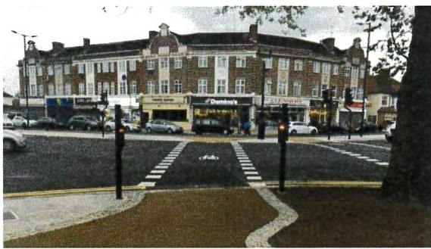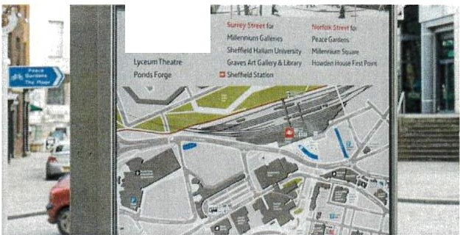
...".t.l.lf,f,,.S..,_..._.."""""
Cl'IA&iltlhu•.,.

<:::j"
rl
(_£ ii:
(0
-F
-\=
Widening refuges, improving timings, signals and markings.
Photo shows an improved signalised junction.
Providing simple directional signage, larger maps or interactive screens
Photo shows information and wayfinding signage.

Whitehaven Local Cycling and Walking Infrastructure Plan (2022 - 2037)

Cycling network
The Priority Cycling Network reflects the importance of connectivity across the city to increase active travel and reduce car journeys. Key aspects of the network include:
- The Hadrian's Cycleway (NCN72) as a core spine to the network;
- Connections to the town centre and railway station;
- Links to education sites including Whitehaven Academy, St Benedict's Catholic High School and Hensingham Community Primary School;
- Links to Westlakes Science and Technology Park;
- Links to surrounding villages including Parton, Lowca, and Moor Row;
- Link to St Bees; and,
- Access to allocated housing and employment sites.
Recognising that it is not possible to connect everywhere, the LCWIP focuses on the most important routes to secure funding for. Support for walking and cycling infrastructure usually increases further once it is built and people are using it. Over time these priorities can be built on to deliver a more extensive network to encourage and support a step change in the numbers of people cycling and walking.

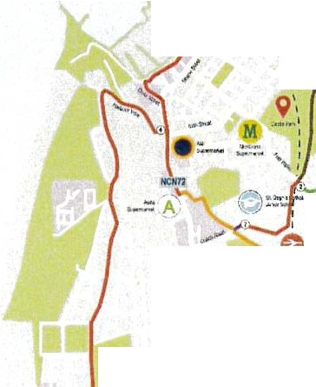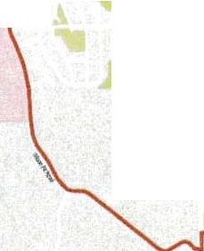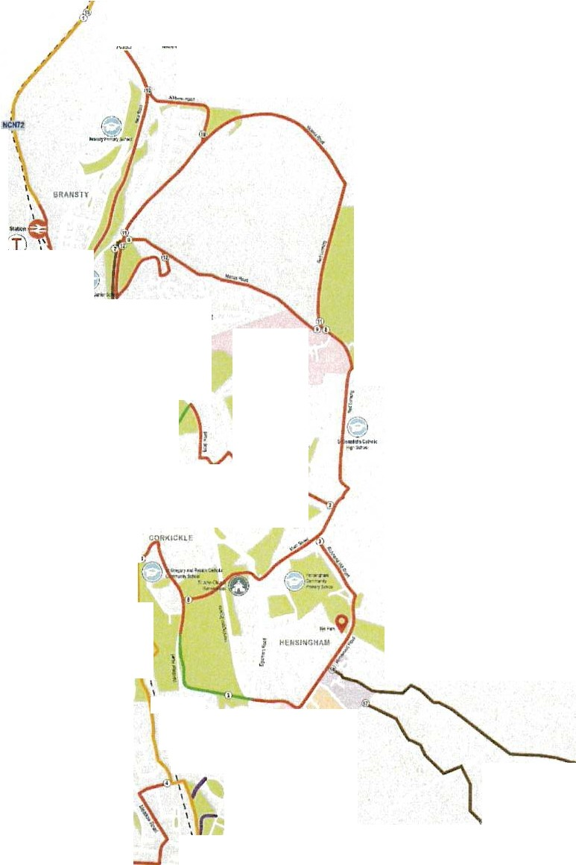[iJ
1/ (
UOIH:::iliT
OUAllrT CORNt:K

- - --Aw
•
\ •om•"""
<
--
(
---"=·Cl,
"""?"''".
.i.'&.t.
\
\
\
9
WAIUIIAI MOOR
,,.,
\\U _
\ 9,...,, \
.
...,/
'
(,•'l\
.'::-!,..
--Cl•
1"'\.
--'!! •;_\ \
'"' ,...
,..\
,' ,"..".,' --­
.........
·-·
I
\
,
...
'>
't
I
I
MUtfHOUIE
'
I I
(\
I
I
\:A
\
I
-
-,^{1_}=^{H}:/.....
.,,.
fiOOll:. IUITI
I
\lr
'
I
.,..-
_,.
SA,,.DWn"
....'"""" ·-·"'"\ '
'
Q
See Whitehaven LCWIP Technical Report Appendix
Route 15 Parton to Lowca ,,;, r
Whitehaven LCWIP Cycling Network

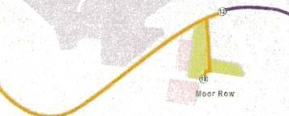
A for a copy of the Cycling Network Map

Th KEY
ro
CL
The n twork ircorporates new cycHng rcn,i es and improvements to e_xistir,·grot.Jtes,.alongside existing '.ptbvisionfo.provide a coherent,
:direct,-s fe;·comfortable, and
attractive·cycle network for 'Whitehaven.

ux::a1P'la'I o,anHouuijj

Gnw,n Ill ·rl' Sc:nooii,I Colegts:. - R1.v

Ltca1PlanOranE.A-Ji!O'flMl'II,_., Rat. yS'tltal
Opp)'-""'Y SiieA.locato'$ 'v
--- R!f Lhe
NCH7 "'""""""'""m \

-t:ewlnlraSlNCuetobe wh'IV".e f - Exi Cvder(MGcll'l ptarro:!t. tti n.;e)

- Elo$ ngc,dtro.l\e(no pktnnod)
-Ewingbnr:teway
- NewfflaS elo prC\1deidonrir00irt," "ll:I

et.

1-0i-o&22

, , I
,
,
,'

- w---·wA

OUAllfY COR'4Elt

The walking network map shows Primary

Whitehaven LCWIP Walking Network
I -
and Secondary routes to Whitehaven Town Centre Core Walking Zone.

I ...'
I
I
I
I
·,..
\ •o•uey ••m
<.
Throughout the lifespan of the LCWIP a more complete walking network will be

I
I
\ BRAHSTY
I
established by identifying routes and

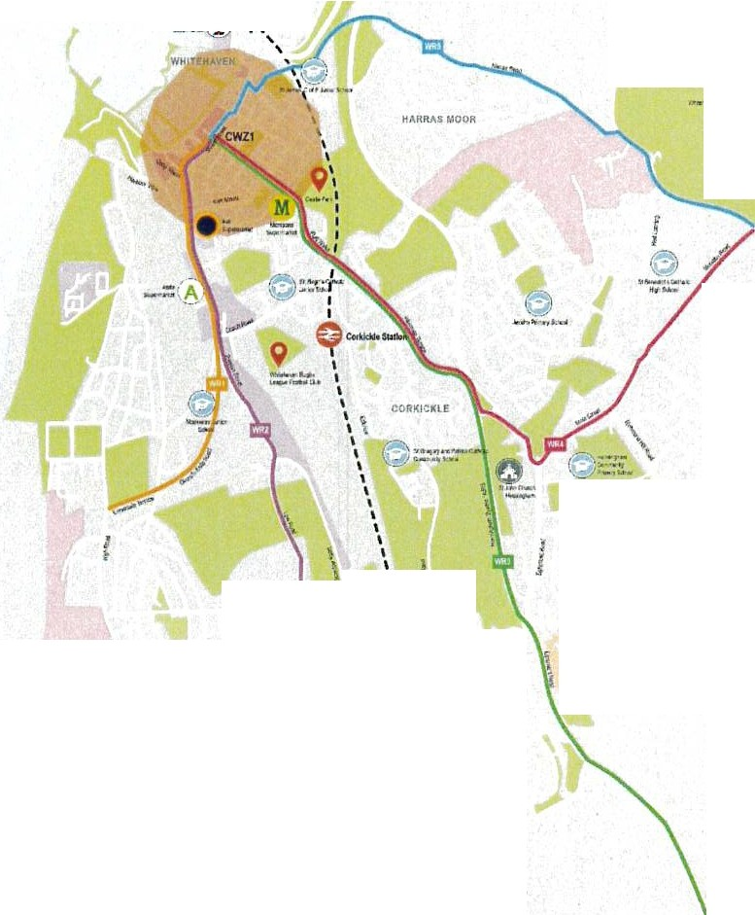----=-CQu .,

I
9
Walking network
improvements for other Core Walking
Zones.

tll"UOUH
,
....

'
\

I
I I I
I
I
I
Ir.·--
,,y,
I I I

...9
H[ltSl'tGHA#
/

( it)
. ..,

' .n... .--­

GOOH. II.Ins
As part of the LCWIP, we have identified Core Walking Zones across the study area, along with primary and secondary routes linking into those Core Walking Zones.
- Core Walking Zones are areas with the highest potential for footfall such as town centres and employment sites.
- Primary routes are those routes that are generally the most direct and have the highest usage.
- Secondary routes are alternative routes that are generally less direct but quieter
The LCWIP identifies potential improvements within the Core Walking Zones and along the primary routes which, could include: new or enhanced road crossings; better quality public spaces and paths; and the provision of dedicated and separated space for walkers.
Improvements have been identified for the Whitehaven Town Centre

\.

UNDiVITH
\ \
\ I I
I

I
I
I
I
I
II,......... I
I
I

- - 9
Walking Zone (CWZ1) and connecting primary routes. These are shown on the plan adjacent and further detail is provided in the LCWIP Technical Report.
Throughout the lifespan of the LCWIP, improvements will be identified for the remaining Core Walking Zones and connecting primary routes

(\)

KEY

loca!PlanOc;iii .Allrx:abcn; Green
I
I I I
t
o
l
R.ltMl)'S!aliOrl
e Sdx;ds;ICi;i;i.g.s

- ""''
across the LCWIP area.

9
See Whitehaven LCWIP Technical Report Appendix A for a copy of the Walking Network Map

# Pl,riOr.t.t andSrl(iAlicea
-WIU G.\."1.t.toi(.a&Road
-WR2 SSMStt.owR.oeie
- WR) A!iQSIEgrlmOl'ltROIKI
- WR,& Mu,5:rMl
- Wft!I Ma'TtiRoa-l
- CWZI CcnW&il.ngbloe1c.40CmJ
--- R,t1,11 Ule iJ

1.'!Dlenl•IY.:6'22

I I
I
_,I

Whitehaven Local Cycling and Walking Infrastructure Plan (2022 - 2037)
Route 15 Pa,tan ta Lawca _,, {r
Whitehaven LCWIP Prioritised Cycling Network
I ( .
li/.OftUBT
QUAUIY COll'IU:.R
w-::::o

PRIORITISATION

Prioritisation

Pr1ortty Targcl Years Target Tlmuca!e (Subject to Funding) (Subject to Funding)

In developing the LCWIP, government guidance setting out a recommended approach to prioritising networks of walking and cycling routes, has been followed. The guidance recommends that priority should be given to areas which have the greatest potential for increasing cycling and walking trips and offer the greatest value for money.

The delivery of all improvements identified in the Whitehaven LCWIP is subject to securing funding. Routes for delivery have been prioritised using a framework that assesses:

I

''
'
, 9,.'.,.I
...-' M :

Pl-101'1'/Gloup I
"P"no"n"ly'"C'.°..o"u'2p3

....,9_,._,.,.

- \W.hnSY ,u
- Wi:r.nBYt-in
-a..vears

2026!20J1
2029/2030
P«,1202912tl30

- Effectiveness - the potential to generate cycling trips
- Alignment with policy objectives - such as those in the CTIP
- Economic factors - scheme cost, value for money and likelihood of attracting funding
- Deliverability - engineering constraints, land ownership and
- _;:..

\
.a..:. , :,
/

,11.w.--._\

stakeholder support
( 1. :! ) ,

.:t.. \\ '. i
.,. \. \ l

'V,"-"' _.._
',.
'

r ­
rl
The cycling routes have been prioritised as shown on the adjacent plan. The routes have then been categorised according to the targeted timescale for delivery:
- Funded: These will be delivered in line with the timescales of the funding source
- Priority 1: Delivery within 5 years (2026/27), subject to funding
- Priority 2: Delivery within 8 years (by 2029/30), subject to funding
- Priority 3: Delivery 8 years plus (post 2029/30), subject to funding.

i See Whitehaven LCWIP Technical Report Appendix B
,.,.,...,..., .l
...., 'I.
- 1 n I
""' \
1
\
\ J
,IIIIEKOU.U.
\
'

COOS!: IIJTU"

lbt:.
(\)
for a copy of the Prioritised Cycling Network Plan

KEY

,A•U>W'lfte

l,xal PI.anO:'all Hou 'loaluor.s °'""'""""
e
LOCIII P!,1111 Dl'lll E,rpoyment S10 RI S!ioon
,ysr..
9

Sct100ti1Cokigos - Rou

R.11:W.tylne HCH1 tw.ioN!CyciliNPtv.'Olt

-
-M:wmlmtruc=.re10bepramedlli:l!'ll'!Uet - E cyde-rc.a(llrf)'O',«r,e,'t "'l!l'l nce)
-Emzlnge)'d&rouTei(nolTIFO'- plam.a) - Nc,,,:,ti etooe on ;i,artyliln::i

IIOllr Ro"

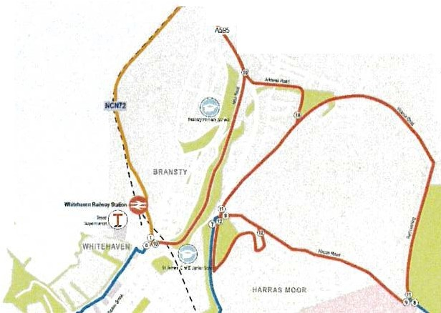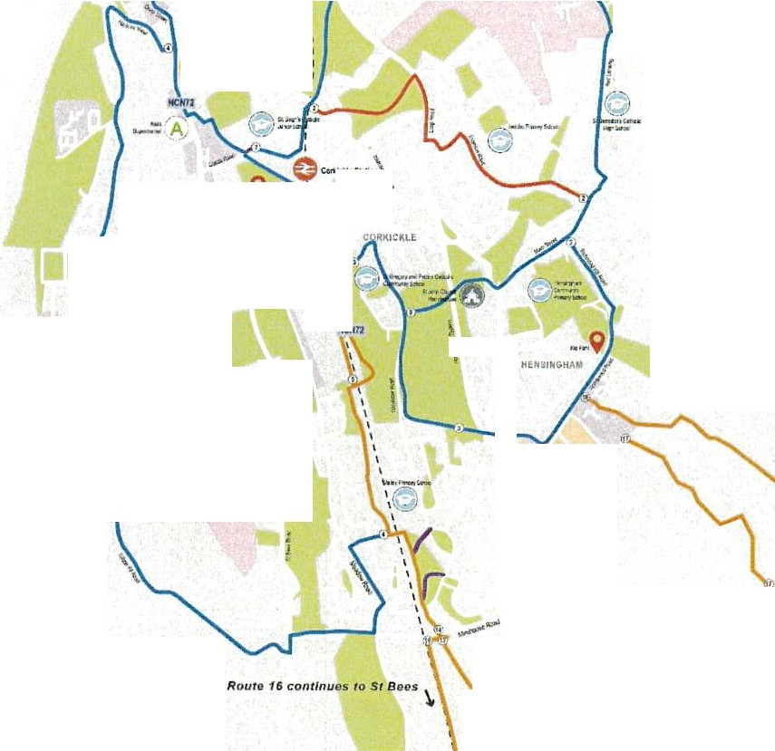-EmlmQ
1-13.0022
;t

Whitehaven Local Cycling and Walking Infrastructure Plan (2022 - 2037)

Thank you for reading this document

Conclusion and next steps
The Whitehaven LCWIP provides a prioritised investment plan for cycling and walking in Whitehaven over the next 15 years.
The LCWIP takes into account the overlaps and synergies with other plans, schemes and strategies. This means the network priorities will be reviewed and updated periodically, particularly if there are any significant changes in local circumstances, such as the publication of new policies or strategies, new development sites, if funding bids are successful and as walking and cycling networks mature and expand.
The LCWIP for Whitehaven is a live document that will be regularly reviewed to ensure the most appropriate routes for cycling and walking are identified and prioritised for future delivery.
The document will be used to assist in securing funding for the delivery of the identified improvements.
Further information
For further information please refer to our webpage for accompanying reports:
www.cumbria.gov.uk/cyclingandwalking
- Whitehaven LCWIP Technical Report
  - Appendix A - Cycling Network Plan and Walking Network Plan
  - Appendix B - Cycling Prioritised Network Plan
  - Appendix C - Supporting Information
00 ■ Consultation Reports
rl

References

- Gear Change: A bold vision for cycling and walking. Department for Transport (2020) https://www.gov.uk/governmenUpublications/cycling-and-walking-plan-for-england
- Cycling and Walking Investment Strategy. Department for Transport (2017) https://www.qov.uk/governmenUpublications/cycling-and-walking-investment-strategy
- Future of Mobility: Urban Strategy. Department for Transport (2019) https://www.gov.uk/governmenUpublications/future-of-mobility
- Clean Air Strategy. DEFRA (2019)
https://www.gov.uk/governmenUpublications/clean-air-strategy-2019
- Decarbonising Transport: A Better, Greener Britain. Department for Transport (2021) https://www.gov.uk/governmenUpublications/transport-decarbonisation-plan
- UK Net Zero Target (2020) https://www.qov.uk/governmenUpublications/net-zero-strategy
- Inclusive Transport Strategy. Department for Transport (2019) https://www.qov.uk/governmenUpublications/inclusive-transport-strateqy
- Cumbria Transport Infrastructure Plan. Cumbria County Council (2021) https://www.cumbria.qov.uk/planninq-environmenUinfrastructureplanninq/strategicplans.asp
- Copeland Local Plan 2021-2038, Copeland Borough Council (2022) Publication draft. https://www.copeland.qov.uk/contenUlocal-plan-2021-2038-publication-draft-consultation [1OJ Cumbria Local Industrial Strategy, Cumbria Local Enterprise Partnership (2019) https://www.thecumbrialep.eo.uk/strategies-and-plans/
- Cumbria Cycling Strategy, Cumbria Cycling Partnership 2017-2022 https://www.cumbria.qov.uk/planning-environmenUcyclingandwalking/
- Economic Recovery Plan, 2020
- Destination Borderlands and the Borderlands Growth Deal, 2021-2031
- Cumbria Rural and Visitor Economy Growth Plan, Cumbria Local Enterprise Partnership 2017
- National Census 2011. Dataset WU03UK (Commuting destinations). Dataset WU03EW (Internal Journeys to Work: Modal Split) data filtered to consider on trips internal to relevant LSOA for the Whitehaven LCWIP area.
- School Travel Demand Surveys, 2021. Community Data Cooperative
- Propensity to Cycle Tool: An open source online system for sustainable transport planning.
Lovelace, R. et al. (2017) https://www.pct.bike/
- National Census 2011. Dataset QS702EW (Distance travelled to work).

(0

­

L,...:, Tc. '2.-<{ I, ( 22.­
t TB--1 9
APP a "=b-,l x: ..2..

COUNTY COUNCIL LOCAL COMMITTEE FOR COPELAND
Meeting date: 20th July 2022
From: Angela Jones, Executive Director, Economy and Infrastructure

WHITEHAVEN LOCAL CYCLING AND WALKING
INFRASTRUCTURE PLAN

  - EXECUTIVE SUMMARY

  - The purpose of this report is to seek approval of the Local Cycling and Walking Infrastructure Plan (LCWIP) for Whitehaven.

  - STRATEGIC PLANNING AND EQUALITY IMPLICATIONS

  - By preparing an LCWIP for Whitehaven and working to achieve the delivery of the findings, the Council will be meeting the following Council Plan priorities:
    - To safeguard children, and ensure that Cumbria is a great place to be a child and grow up
    - To enable communities to live safely and shape services locally
    - To promote health and wellbeing, and tackle poverty
    - To protect and enhance Cumbria's world class environment
    - To provide safe and well-maintained roads and an effective transport network
    - To promote sustainable economic growth, and create jobs
    - To support older and vulnerable people to live independent and healthy lives

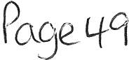

  - RECOMMENDATION

  - It is recommended that Members approve the LCWIP for Whitehaven as attached at Appendix 1.

  - It is recommended that Members delegate authority to the Executive Director - Economy and Infrastructure in consultation with the Chair and Vice Chair of the Local Committee to make any necessary minor amendments to the Whitehaven LCWIP prior to its publication.

  - BACKGROUND

  - The Cumbria Transport Infrastructure Plan (2022 - 2037) sets out the strategy for Active Travel in Cumbria and the development of LCWIPs are a key part of this. The Council has committed to the development of a series of LCWIPs. The methodology for LCWIPs has been developed by the Department for Transport (DfT) as part of the national Cycling and Walking Investment Plan. DfT funding for local cycling and walking schemes will be dependent upon the schemes inclusion in a LCWIP, with infrastructure to be designed in line with the DfT Cycle Infrastructure Design guide issued in July 2020.

  - The LCWIP for Whitehaven, outlines the network of key cycling and walking routes in the district. The focus of the Whitehaven LCWIP is the improvement of routes used for everyday shorter journeys, such as to work, school or the shops. It aims to identify good quality infrastructure that connects the places people need to get to, in a coherent, direct, safe and attractive way.

  - Recognising that it is not always possible to connect everywhere and that funding for delivery needs to be secured, the Whitehaven LCWIP focuses on the routes where the most benefits can be realised. Support for walking and cycling infrastructure usually increases further once it is built and people are using it. Over time these priorities can be built on to deliver a more extensive network to encourage and support a step change in the number of people cycling and walking.

  - The Whitehaven LCWIP is a not a funded plan however, having an LCWIP in place will put the Council in the best possible position to secure future funding for the delivery of improvements.

  - Public consultation on the draft LCWIP proposals was undertaken in July and August 2021. During this consultation the draft priority network for cycling was presented. Feedback was sought on the existing barriers to cycling and walking and what improvements could be made to encourage more everyday short journeys to be undertaken by active travel. The consultation received a total of 316 questionnaire responses. Through the consultation it was established that 93% of respondents welcomed more money being spent on cycling and walking in Whitehaven and 86% felt the proposals in the Whitehaven LCWIP would encourage them to cycle or walk more often.

  - A second round of public consultation took place in February 2022, presenting the updated priority cycling and walking networks reflecting the feedback received in the first consultation. 215 responses were received, showing the same strong desire for future investment in cycling and walking infrastructure.

  - The Whitehaven Local Cycling and Walking Infrastructure Plan (2022 - 2037) is included in Appendix 1.

  - OPTIONS

  - That Members approve the Whitehaven Local Cycling and Walking Infrastructure Plan.

  - That Members approve the Whitehaven Local Cycling and Walking Infrastructure Plan with recommended changes.

  - That Members do not approve the Whitehaven Local Cycling and Walking Infrastructure Plan.

  - RESOURCE AND VALUE FOR MONEY IMPLICATIONS

  - There are no direct resource implications arising from the recommendations in this report.

  - Should the Council be successful in obtaining funding for the LCWIP from the DfT, there may be future maintenance requirements that would have to be met from the local committee budget (SEA 22/06/2022).

  - LEGAL IMPLICATIONS

  - There are no direct legal implications if Members approve the Whitehaven

LCWIP as it stands or with recommended changes. Likewise there are no direct legal implications if Members do not approve the Plan.

  - In the event the Plan is approved as it stands or with recommended changes the Scheme of Delegation in Part 3A of the Constitution allows delegation of authority to the Executive Director of Economy and Infrastructure in consultation with the Chair and Vice Chair of the Local Committee to make any necessary minor amendments to the Plan prior to its publication. In law any such amendments to the Plan are the decision of the Executive Director alone notwithstanding the requirement to consult.

  - CONCLUSION

  - The Whitehaven LCWIP provides a prioritised investment plan for cycling and walking in Whitehaven area over the next 15 years.

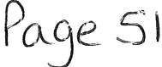

  - The LCWIP considers the overlaps and synergies with other plans, schemes and strategies. This means the network priorities will be reviewed and updated periodically, particularly if there are any significant changes in local circumstances, such as the publication of new policies or strategies, new development sites, if funding bids are successful and as walking and cycling networks mature and expand.

  - The LCWIP is a live document that will be regularly reviewed to ensure the most appropriate routes for cycling and walking are identified and prioritised for future delivery.

Angela Jones
Executive Director Economy and Infrastructure

30^{1h} June 2022

APPENDICES

Appendix 1: Whitehaven Local Cycling and Walking Infrastructure Plan (2022 - 2037)

Electoral Division(s): All in Whitehaven Town Divisions

Executive Decision No

Key Decision No

If a Key Decision, is the proposal published in the current Forward Plan? |  | N/A
Is the decision exempt from call-in on grounds of urgency? | No
If exempt from call-in, has the agreement of the Chair of the relevant |  | N/A
Overview and Scrutiny Committee been sought or obtained?

Has this matter been considered by Overview and Scrutiny? If so, give details below.
Has an environmental or sustainability impact assessment been undertaken?
Has an equality impact assessment been undertaken?
I No

I N/A

I N/A

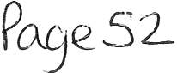

PREVIOUS RELEVANT COUNCIL OR EXECUTIVE DECISIONS

The County Council Committee for Copeland approved a recommendation for
£15,830 to allow the development of a Whitehaven LCWIP on 13th September 2021.

CONSIDERATION BY OVERVIEW AND SCRUTINY

Not considered by Overview and Scrutiny.

BACKGROUND PAPERS

No background papers.

REPORT AUTHOR

Contact: Nicola Parker, Senior Programme Manager Cycling and Walking Email: nicola.parker@cumbria.gov.uk

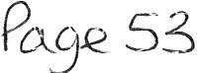

'\] -ic.. - 2 8 ·O-=·t 2022...

Whitehaven Town Council

From: Sent: To: Subject:

edwindinsdale1@sky.com 21 July 2022 14:26
Whitehaven Town Council; Charles Maudling Proposed Agenda Item
AGENM -:r-fc'fv'\ 10

Hello Marlene/Charlie
As we previously discussed, we agreed at the last meeting that the Town Council should have a nuclear representative roll.

The proposed terms of reference for the roll are...
For the roll holder to engage with all aspects of the nuclear community that has an effect on the residents and Town of Whitehaven.

As a Town Council we represent over 23,000 residents. Our town is reliant on the nuclear industry for jobs and funding and we regard Whitehaven Town Council as a key nuclear stakeholder.

The roll holder will attend nuclear stakeholder meetings & events on behalf of the Town Council and report back to the Town Council updates and key points from meetings & events that they have attend.

The meetings & events will include...
Copeland Borough Council Strategic Nuclear & Energy Board meetings. Sellafield site Stakeholder meetings.
Sellafield Ltd Stakeholder meetings.
Nuclear Decommissioning Authority stakeholder meetings. British Energy Coast stakeholder meeting.
British Energy Coast Business Cluster Stakeholder meetings. Office of Nuclear Regulation stakeholder meetings.
Civil Nuclear Constabulary stakeholder meetings.
Tier 2 & contract companies within the nuclear industry. Geological Disposal Facility stakeholder meetings.
Any other direct or indirect nuclear stakeholder.

Proposed title of the elected or appointed roll Head of Nuclear Strategy and Delivery

It is important that Whitehaven Town Council plays a part in how the nuclear industry moves forward from a strategic point of view, it is also important that this strategy is delivering for the residents and town of Whitehaven.

Kind regards Edwin

