WHITEHAVEN TOWN COUNCIL

Clerk and Responsible Financial Officer: Chairman:
Marlene Jewell Telephone: 01946 67366 Councillor Chris Hayes

To: Members of Whitehaven Town Council

You are duly SUMMONED to attend a MEETING of WHITEHAVEN TOWN COUNCIL which will be held in THE HARBOUR GALLERY at THE BEACON, WHITEHAVEN on THURSDAY 30th SEPTEMBER 2021 at 6:00pm

Signed... .. ... ... .... Dated:.)_. . 2D2l
Marlene Jewell, Clerk and Responsible Financial Officer

AGENDA

- Apologies for Absence

- Declarations of Interest

To receive declarations of interest by elected Members in respect of Agenda items.

If a Member requires any advice on any item involving a possible declarationof interest which could affect his/her ability to speak and/or vote he/she is advised to contact the Clerk at least 24 hours in advance of the meeting.

- Public Participation

- Minutes of the Council Meeting held on 26TH August 2021

- Planning Applications

- Finance Report

- Annual Governance & Accountability Return - External Auditors Report for Year Ended 31 March 2021

- Christmas Lights

- Events Expenditure

- Summer Plants 2022

- Replacement of Defibrillator Electrode Pads

- Remembrance Sunday
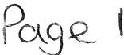

- Grass Cutting Contract

- Allotment and Pigeon Loft Maintenance Contract 15.Code of Conduct
- Copeland Local Plan 2021 - 2038: Additional Focused Pre-Publication Draft Consultation on Potential Changes to the Local Plan

- Councillor Ward Matters

- Date and Time of Next Meeting IN PRIVATE
That prior to the following items of business the Chairman will move the following resolution:

That in view of the special or confidential nature of the business about to be transacted it is advisable in the public interest that the public and or press be instructed to withdraw.

- Councillor Ward Grant - CVG

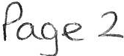

WHITEHAVEN TOWN COUNCIL

Minutes of the Council Meeting held on 26th August 2021

Present: Councillor C Hayes (Chairman); Councillor C Arrighi; Councillor E Dinsdale ; Councillor G Dinsdale; Councillor R Gill; Councillor C Maudling; Councillor B O'Kane; Councillor J Rayson; Councillor G Roberts;

M. Jewell, Clerk and Responsible Financial Officer Press Representative

1856/21 Apologies for Absence

An apology for absence was received from Councillor R Redmond

1857/21 Declarations of Interest

Councillor Maudling declared an interest in Item 5 he was a member of CBC's Planning Panel.

1858/21
Public Participation

A member of the public attended (MG) and read out the statement below:

"Thank you for all o win g me to address the Town Counc i l. I would appreciate any help you can give me in th e ongoing saga re la tin g to 9 self buil ds on Han as Moo r. My conce rns ,yet agai n, are that when this appli catio n was granted
Outli ne Planning pe1111iss io n it was for and I quote from a docum ent explainin g condit ions attached to th e applic ation "Th e Desig n and Access Statement
s ubmi tted indic ates the properties will be self builds II It then follows on to say "th e reg is ter ind icates that there is a healthy requirement for se lf build
detached prope rties in Whitehaven Area and I would therefore suggest the case officer can give reasonable weight to the proposal in this res pect. If the case officer is s atisfied that the proposa l deli vers significant and demonstrable
e c onomic , soc ial and environm ental benefits then the applica tio n meets with C riteria 1 of the IHP Po lic y SS3". I have asked the case officer for he r
inte rpre tatio n of self builds and her reply was as follows "the outli ne
appli catio n was indicated to be for se lf builds with each plot owner build ing out thei r own d wellin g." My concerns now are that a developer has taken over the plannin g applic ation which is presently before the plannin g departme nt, and

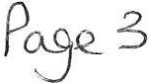

which Nick Ha yhurst has sub seque nt ly passed by dele gated decis ion , the appearance and landscapin g of plot one which one wo uld assum e to be a show house. Could I respectively ask therefore if the cou nc il wou ld make a req ues t that this application goes befo re the full planning panel? lt is obvious that these 9 plots are now not up for sa le so therefore are not going to be self builds as what was originally granted. This application doesn't meet the criteria presented to the plannin g panel so if the deve lo per wants to proceed he should sure ly now need to rea pply.' '

Councillor O'Kane said delegated planning decisions were not public facing and something of this nature should be in front of a Panel. He said any panel Member can ask for it to go to the Panel and be heard in front of the Panel. He said he was not being critical but he was concerned about the system.
Councillor Gill proposed that CBC be asked that this matter go before
CBC's Planning Panel and that the member of the public's statement be read out at the Planning Panel Meeting. This was seconded by Councillor Rayson. A vote was held and 7 Councillors voted for the proposal and 1 Councillor abstained.

RESOLVED - That the Clerk write to CBC to ask that the matter go before CBC' s Planning Panel and that the members of the public' s statement be read out at the Planning Panel Meeting.

1859/21

1860/21

Minutes of the Meeting held on 10th August 2021

It was proposed by Councillor Gill and seconded by Councillor O'Kane that the Minutes of the Meeting held on 10th August 2021 be approved and signed by the Chairman as a correct record. A vote was held and 6 Councillors voted for the proposal and 2 Councillors abstained .

RESOLVED -That the Minutes of the Meeting held on 10 ^{th} August 2021be approved and signed by the Chairman as a correct record

Councillor G Dinsdale entered the Meeting

Planning Applications

The Council considered a report on Planning Applications received and shown at Appendix 1.
- Councillor O' Kane said he had spent a lot of time on CBC's website trying to get details on planning applications without much success. He asked if the Council could have a bit more information like we used to get from CBC previously to see if there was something the Council wanted to look at in detail because at the moment all the Council received was a description. The Clerk said she had previously sent an email about this

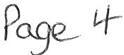

with no result. The Clerk was asked to send another email asking for a reply and that this be copied into the Chief Executive.
11. Councillor Rayson referred to dwellings to be erected on the former Romar factory site at Hensingham and said her concern was that due to the infrastructure there had been flooding on the road where there had been developments in the past and with the junctions of Richmond Hill Road/Spar junction, the one onto Horsefield Close and Thornton Road and the other where the emergency Services come out all being within 100 yards of each other.
The Council considered all the planning Applications on Appendix 1 and had no further comments/representations to make and that CBC be informed accordingly.

1861/21 Finance Report

The Council considered a Finance report.

1. Appendix1 - It was proposed by Councillor Gill and seconded by Councillor Roberts that the Invoices shown at Appendix 1 be approved and paid. A vote was taken and it was unanimously

RESOLVED - That the Invoices shown on Appendix 1 be approved and paid.

11. Appendices 2 and 3 - It was proposed by Councillor Gill and seconded by Councillor Roberts that Appendices 2 and 3 be approved and noted. A vote was held and it was unanimously
RESOLVED - That Appendices 2 and 3 be approved and noted.

1862/21 Town Council Apologies

The Council considered an email from CALC regarding the recording of apologies. Following a discussion it was proposed by Councillor Gill and seconded by Councillor Roberts that in future the Minutes will state that any apology for absence is noted and accepted and the reason for the apology recorded. A vote was held and it was unanimously

RESOLVED - That in future the Minutes will state that any apology for absence is noted and accepted and the reason for the apology recorded

1863/21 Repairs to Office Building

The Council considered a report on repairs necessary to the Council's Offices
1. Due to heavy rainfall on 6th August 2021 it was discovered that the main roof and the kitchen roof in the Council Offices were leaking. The leak to
Po- e s

the kitchen roof was stopped after the gutter was cleaned out by a Copeland operative. Numerous contractors were contacted to give quotes to repair the leaking main roof but only one replied and submitted a quote after an inspection. The quote was for£1,450.00 plus VAT. It was proposed by Councillor Maudling and seconded by Councillor Roberts that the repairs to the roof be approved and the expenditure of£ 1,450.00 be authorised. A vote was held and it was unanimously

RESOLVED - Thatthe repairs to the roof be approved and the expenditure of£ 1,450.00 be authorised.
11. Following the Legionella Risk Assessment being carried out (Minute 1820/21 refers) there was a recommendation in the Risk Assessment Report that the combination water heater header tank located in the old photo booth on the first floor should be cleaned and chlorinated and the tank inspected annually. It was proposed by Councillor Roberts and seconded by Councillor Maudling that works to the combination water heater tank be authorised and expenditure for this be authorised after Council consideration of quotes received. A vote was held and it was unanimously

RESOLVED - That works to the combination water heater header tank be authorised and expenditure for this be authorised after Council consideration of quotes received.

1864/21 Recommendations from Events Advisory Group

  - The Council considered the recommendations made by the Events Advisory Group at their meeting on 19/08/21 which were as follows:-

Gazebo Pegs
When the last Traders Market took place the Assistant Ranger reported a back injury caused by the amount of lifting and moving the weights for the market gazebos across distances in St Nicholas Gardens. So alternatives had been explored and a set of tent pegs had been produced by a local firm and successfully tested on a gazebo on site. It was unanimously recommended that
That 110 pegs be purchased at a cost of£ 150 and these would be trialled at the next market but
11 A few weights would also be kept at hand just in case
m The new gazebos that the Council had got a grant for come with weighted bags with handles and these would be used

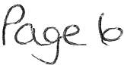

Using Marquees for the Markets
It was unanimously recommended that the Council reduces the number of CBC gazebos and trials the Christmas Market by hiring 2 marque es and that quotes be sought for these.

Continental Market

It was unanimously recommended that the Council would organise and be responsible for the cost of the June 2022 Continental Market

Next Year's Markets
It was unanimously recommended that the Traders Markets for next year follow the same format as the December Traders Market if the trial is successful ie 2 marquees and a smaller number of Council gazebos.

Ukelele Group
Gerard Richardson said he had been approached by a local Ukelele Group who had asked if the Council could hire them for events. Following a discussion the Group had said that they were happy to come to the Christmas Market if they could put a hat/collection tin out. He suggested that the Christmas Traders Market was infilled by a couple of school choirs and on the same basis as there was no cost to this. The Advisory Group recommended unanimous approval to this.

Church Fete

The Rev Robert Jackson had been supportive of the Council Markets in St Nicholas Gardens and it was suggested that the Council make a gesture to budget a few hundred pounds to suppo rt an old- fashioned church fete/garden party using our own gazebos with some entertainment. The Advisory Group recommended unanimous approval for this suggestion.

Banner

It was unanimously recommended that a 4m x l m banner costing approx.
£l 00.00 be purchased to be attached to a marquee

Leyland Bus Anniversary

It was reported that it was the 50th Anniversary of the Leyland Bus and that a 2 day event on l ^{st} and 2nd May 2022 was to be held with 17 or 18 vintage buses parked on the Marina and an open -topped one going around the town. The group is a non profit making group. Security would
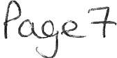

be required for the 2 day event (2 nights) and if the Council was interested costs and details for the provision of security would be obtained.
The Events Advisory Group unanimously recommended an indication of support be given subject to costings being obtained and reported.

Town Crier
The position of Town Crier had been running for 25 years and it was an independent body but a civic position. Gerard Richardson said that in 18 months Copeland Borough Council was going to be non­ existent and that an option would be for the Town Crier
position to go to the new authority or it could go to the Town Council. It was unanimously recommended that the position of Town Crier be included with the Town Council.

Tables for Gazebos
It was reported that the Council had agreed to purchase 20 folding tables for use in gazebos at a cost of £799.00 plus£100 delivery charge but that due to transportation difficulties it had not been possible to purchase them. It was unanimously recommended
that enquiries be made of other suppliers to see if the Council could get them at the same price or if that was not possible to get them at a reasonable price.

It was proposed by Councillor Gill and seconded by Councillor O'Kane that the above recommendations be approved and actioned . A vote was held and it was unanimously

RESOLVED - That the above recommendations be approved and actioned. Councillor Arrighi left the Meeting and did not return

1865/21 Whitehaven in Bloom

The Council considered a report on winter planting and considered quotes received for the purchase of additional planters and barrier baskets.

Provision of Winter Plants in 2021. The Council received a quote of
£2,116.80 from the preferred supplier for 8 hexagonal planter bases, 20 barrels, 12 cast iron planters, 5 aluminium planters, 6 plastic planters, Trinity bed, Pelican bed, Corkickle badge bed, the Hensingham ship and Wilkinsons window boxes. In order to purchase the winter plants from the preferred supplier Financial Regulation 11 req uire s the Council to make a Resolution to do so and having made a Resolution that the Council then makes a resolution to record the reaso ns for suspension and consider the assessment of risks drawn up and presented and approve the same. It was
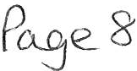

proposed by Councillor Ro be1is and seconded by Councillor O'Kane that the Co uncil makes a Resolution to suspend Financial Regulation 11 to allow the Council to purchase the winter plants for 2021 at a cost of
£2,116.80 plus VAT from the preferred supplier. A vote was taken and it was unanimously
RESOL VED - That the Financial Regulation 11 be suspended to allow the Council to purchas e the winter plants for 2021 from the prefe rr ed supplie r at a cost of £2,116.80 plu s VAT.

LI Having made the Resolution in i above it was proposed by Councillor Gill and seconded by Councillor O' Kane that the Council resolve to record the reasons for suspe nsion and consider the assessment of the risks drawn up and prese nted and approve the same. A vote was held and it was unanimously

RESOLVED - That the Council record the reasons for suspension and
consider the assess me nt of the risks drawn up and prese nted and approve thes ame.
m Councillor O'Kane proposed that the Council purchase winter plants for the wooden barrels on the Harbour which the Council had recently supplied (Minute 1846/21 refers) and that the amount of £2,116.80 authorised in i and ii above be increased to £2,500.00 to provide this. This was seconded by Councillor Roberts. A vote was taken and it was unanimously

RESOLVED - That the amount of £2,116.80 authorised in i and ii above be increased to £2,500.00 to provide winter plants for the barrels which the Council had placed on the harbour.

iv Purchase of Additional 3 Tier Planters and Barrier Baskets. Quotes had been received for the purchase 2x 3-tier planters and 4 barrier baskets as follows:­ Supplier A - £1505.20 plus VAT
Supplier B - £1523.84 plus VAT Supplier C - £2072.90 plus VAT
It was proposed by Councillor Maudling and seconded by Councillor
E Dinsda le that the 2x3 tier planters and the 4 barrier baskets be purchased from Supplier A at a cost of £1505.20 plus VAT. A vote was taken and it was unanim ously

RESOLVED - That the 2x3 tier planters and the 4 barrier baskets be purchased from Supplier A at a cost of£ 1505.20 plus VAT.

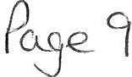

1866/21 Councillor Ward Matters

- Councillor Gemma Dinsdale said a drain had been removed which had left a massive sink hole at the bottom of Valley Park Hill and that this was a CCC matter.

11. Councillor G Dinsdale said she had asked residents to put in complaints about weeds to CCC but they were coming back and saying that a generic reply was coming back saying it was not available right now and that it would be at least 12 months before work could start. She said there was a problem with weeds blocking pathways and although she knew it was not our issue as such she didn' t know what could be done about it. The Chairman said that irrespective of this the matter had to be noted.
u1. Councillor Edwin Dinsdale thanked the Clerk for the updates on the bins that were going to be put on the cycle path and the bus shelter.
1v. Councillor Maudling said the Police were doing a good job although the problems had moved to other areas. He said there had been a lot of compliments about the Council's flowers in the town.
v. Councillor Maudling said that some businesses were leaving their seagull bags tied to lamp posts all night and that this was detracting away from what we want to achieve with the flower beds. He said seagulls were still getting in the bags because they may be left half empty and they're just left out every night and asked that when people get a seagull bag that we ask them not to leave them out all night. The Clerk said that this was being done.
v1. Councillor Rayson said she had been contacted about an ongoing issue that the lights in Market Place/James Street were not working and that a lot of the lights were missing. She said she had emailed CBC Councillors and had been informed that it was someone at Copeland called Emanuel
who was dealing with it and that he was going out that night to have a look as it was an ongoing legal issue and that it would be costly to get the residents to agree to the rewiring being done for the lights that weren't working. She said she thought out of 12 lights only 2 were working.
Councillor O'Kane said this had been an ongoing issue for 3 months and that he had sent Copeland a long letter on the health and safety issues as the lights had not been working for approximately 13 years and the officer mentioned said guaranteed that they were being being fixed and said the vast majority of the lights were supposed to have been completed by now.
v11. Councillor Rayson referred to the rat problem and said some residents had been issued with letters about rats coming up from the ghyll and a lot of residents on Hillcrest had been asking why everyone hadn't got them because the rats were everywhere at the moment. She said people were being asked not to encourage the rats into their gardens by feeding the birds or action would be taken against those people who were doing things that make it difficult to control the rats. Councillor Rayson said there were a lot coming up from Jericho Park on Highfields and around that area of
Pa_se_ I 0

Hillcrest. She said there had been some more work done at Jericho School recently and the seagulls on the roof. Councillor Rayson said trees had been cut down on part of the ghyll coming down Thornton Road and Springfields so that had disturbed a lot and they were everywhere. She said it might be worth getting in touch with Environmental Health about it. But she said people were still putting food out in their gardens to feed the seagulls/birds and that this was also attracting rats.
v111. Councillor Rayson said she had been round the allotments with other Councillors and the Allotment Site Reps and a few issues had been brought up and it had been suggested that a meeting of the Allotment Advisory Group be set up consisting of Councillors only. Councillor Gill said he had asked the Clerk to do this.
1x. Councillor O'Kane said that he was delighted that the hedges had been cut on Victoria Road.
- Councillor O' Kane said there were problems with parking at Sunnyhill on Sundays when it becomes almost gridlocked and the difficulty was that if you want to support businesses and then people are reported to the Police then you affect the businesses.
- Councillor O'Kane asked if an update could be given on the bus shelter at Bransty and the Clerk said it had now been determined that the land belonged to CBC.
x11. Councillor O' Kane referred to the weeds problem and said people were quite rightly complaining about the weeds that were all over the place and asked if the Council should be asking CBC/CCC to do something.
x111. Councillor Edwin Dinsdale said there had been weedkiller put down on an area in Corkickle so on a positive note that was an improvement but that there was still a long way to go.
- Councillor Roberts said there was a problem with weeds and also with the use of chemicals to control them and said he had been onto CCC about this and suggested that they try flame wands which were better for the environment.
- Councillor Hayes said things had been quiet on Kells and that he attended a health and wellbeing event at Whitehaven Rugby League and it had been really good.

1867/21 Date and Time and Venue of Next Meeting

The Clerk referred to an email previously circulated to Councillors about the costs and conditions of the hire of the Harbour Gallery at the Beacon for Council Meetings.
Following a discussion on various alternatives Councillors agreed that they would look at other venues and get costings and pass these onto the Clerk and it would then be put on the Agenda for the next Council Meeting but that the next Council Meeting would be held in the Harbour Gallery at the Beacon on 30th September 2021 at 6.00pm.

RESOLVED - That Councillors would look at other venues and get costings
P e_ 1 1

and pass these onto the Clerk and it would then be put on the Agenda for the next Council Meeting but that the next Council Meeting would be held in the Harbour Gallery on 30th September 2021 at 6.00pm.

Councillor Rayson left the Meeting and did not return

IN PRIVATE
1868/21 That prior to the following item of business the Chairman moved the following resolution: -

That in view of the special or confidential nature of the business about to be transacted it is advisable in the public interest that the public and or press be instructed to withdraw from the meeting.
Councillor Roberts proposed this and Councillor Gill seconded it. A vote was held and it was unanimously.

RESOLVED - That in view of the special or confidential nature of the business about to be transacted it is advisable in the public interest that the public and press be instructed to withdraw from the Meeting. All
members of the public and press then left the Meeting.

1869/21 Councillor Ward Grant- CVG

Further to Minute 1853/21 it was reported that a letter had been sent requesting full details of expenditure in respect of the £1,000.00 Ward Grant but no reply had been received. Following a discussion it was proposed by Councillor
0 'Kane and seconded by Councillor Maudling that a letter be sent to all members of the CVG to ask if they knew what had happened in respect of the
£1,000.00 Ward Grant and to request payment of the unspent part of the Grant. A vote was held and 5 Councillors voted for and 2 Councillors abstained.

RESOLVED - That that a letter be sent to all members of the CVG to ask if they knew what had happened in respect of the £1,000.00 Ward Grant and to request payment of the unspent part of the Grant.

1870/21 Application for Grant- WAU16

Further to Minute 1845/21 The Clerk reported that the Applicant had stated that they had obtained sponsorship from elsewhere and therefore no longer required the Grant and thanked the Council for their consideration of this.
No decision was required for this and the matter was noted.

The Meeting closed at 7.35pm

Chairman
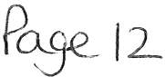

WTC 30/09/2021
Item 5

Planning Application for Consideration by Whitehaven Town Council

Application Number 4/21/2139/0F1

4/21/2140/0L1

4/21/2313/0F1

4/21/2364/0L1

4/21/2365/0F1

4/21/2373/0F1

4/21/2375/0F1

4/21/2379/0F1
Detail

INSTALLATION OF NEW WINDOWS & DOORS TO PRINCIPAL ELEVATION, ERECTION OF FIRST FLOOR SIDE EXTENSION WITH REAR DORMER ALONG WITH INTERNAL ALTERATIONS (DEMOLITION WORKS AND NEW CONSTRUCTION) TO FACILITATE CHANGE OF USE OF BUILDING TO FORM 6 FLATS - REVISION TO SCHEME APPROVED UNDER REFERENCE 4/19/2115/0F1
3 CATHERINE STREET, WHITEHAVEN

Consultation on Additional and Amended Details: LISTED BUILDING CONSENT FOR CONVERSION OF BUILDING TO A RESIDENTIAL USE INCLUDING INTERNAL ALTERATIONS, REAR DORMER EXTENSION AT FIRST FLOOR, PRESERVATION OF PROTECTED INTERNAL FEATURES (FIREPLACES & PANELLING) - REVISION TO PREVIOUSLY APPROVED SCHEME UNDER REFERENCE 4/19/2263/0L1
3 CATHERINE STREET, WHITEHAVEN

Consultation on Additional and Amended Details: ERECTION OF DECKING IN THE REAR GARDEN (PART-RETROSPECTIVE) 28 WASDALE CLOSE, WHITEHAVEN

INTERNAL AND EXTERNAL ALTERATIONS TO REFURBISH EXISTING LISTED BUILDING
6-8 DUKE STREET, WHITEHAVEN

ALTERATIONS/REFURBISHMENT AND CHANGE OF USE OF VACANT FORMER WHITTLES FURNITURE STORE TO FORM A COMMUNITY DIGITAL HUB AND CAFE INCLUDING THE CREATION OF A ROOF TERRACE
6-8 DUKE STREET, WHITEHAVEN

NEW BUILD GARAGE
12 WEST ROW, WHITEHAVEN

PRIOR APPROVAL FOR THE CHANGE OF USE FROM AN AGRICULTURAL BUILDING INTO A DWELLING
LANE HEAD GARDENS, LANE HEAD, SANDWITH, WHITEHAVEN

ERECTION OF PORCH TO FRONT OF PROPERTY
7 HAIG AVENUE, WHITEHAVEN

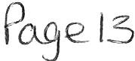

Application Number

4/21/2381/0F1

4/21/2387/0F1

4/21/2397/0F1

4/21/2399/0F1

4/21/2406/0F1

4/21/2408/0F1

4/21/2410/0F1

4/21/2412/0F1

4/21/2413/0B1
EXISTING TELECOMS INSTALLATION UPGRADE INVOLVING THE REMOVAL AND REPLACEMENT OF 3 NO. ANTENNAS

ONTO EXISTING POLES, THE RE-LOCATION OF 1 NO. EXISTING 0.3M MICROWAVE DISH AT A LOWER HEIGHT BY 500MM, THE INSTALLATION OF 1 NO. NEW CABINET ONTO A NEW CONCRETE BASE (HAVING DIMENSIONS OF 1900 X 600 X 1752), THE REMOVAL AND REPLACEMENT OF 1 NO. EXISTING CABINET TOGETHER WITH THE INSTALLATION OF ANCILLARY EQUIPMENT . THE CUMULATIVE VOLUME OF ALL CABINETS INSTALLED DOES NOT EXCEED 90M3.
ALBION STREET, WHITEHAVEN

DEMOLITION OF EXISTING SINGLE STOREY GARAGE AND CONSTRUCTION OF TWO STOREY SIDE EXTENSION
57 VALLEY PARK, WHITEHAVEN

PROPOSED RELOCATION OF GARAGE AND SINGLE STOREY SIDE EXTENSION TO HOUSE
5 GAMERIGGS ROAD, WHITEHAVEN

DEMOLITION OF EXISTING FLAT ROOF EXTENSION & CONSTRUCTION OF NEW SINGLE STOREY EXTENSION TO SIDE/REAR OF EXISTING DWELLING
5 OAKFIELD COURT, WHITEHAVEN

SINGLE STOREY EXTENSIONS TO SIDE AND REAR
188 HIGH ROAD, WHITEHAVEN

SINGLE STOREY EXTENSION TO SIDE OF PROPERTY
- HARTFIELD CLOSE, WHITEHAVEN

EXTENSION & NEW AUTOMATIC OPENING DOOR TO PORCH TO MAKE IT FULLY WHEELCHAIR AND STRETCHER ACCESSIBLE
BETHSHAN NURSING HOME, YEWBARROW CLOSE, WHITEHAVEN

APPLICATION FOR PERMISSION FOR DEMOLITION & SITE CLEARANCE IN A CONSERVATION AREA - FORMER MAGISTRATES COURT BUILDING
FORMER MAGISTRATES COURT, CATHERINE STREET, WHITEHAVEN

VARIATION OF CONDITION 2 (PLANS) OF PLANNING APPROVAL 4/21/2148/0F1 DEMOLITION OF SIDE GARAGE AND ERECTION OF A SINGLE STOREY EXTENSION - THE

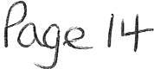

Application Number

PROPOSED ROOF TO HAVE A DIFFERENT PROFILE TO THAT APPROVED
10 AIKBANK ROAD, WHITEHAVEN

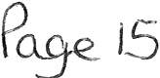

WTC 30/09/2021

Item 6

FINANCIAL REPORT

Purpose of the Report

Members are asked to consider a list of invoices for authorisation and payment as shown at Appendix 1 and approve the recommendations in paragraphs 3.1 and 3.2.

  - INTRODUCTION

  - Authorise the payment of all invoices as listed in Appendix 1.

  - The Council is asked to note the cashbook as reconciled with the bank account as shown at Appendix 2 together with income and expenditure at Appendix 3.

FINANCIAL POSITION

  - The bank reconciliation was carried out on 22nd September 2021. This shows a balance of £353,029.52. There are no cheques waiting to be presented and cleared.

  - The balance in the deposit account is £450,400.11.

RECOMMENDATION

  - The invoices listed and shown in Appendix 1 be approved and authorised for payment.

  - The Cashbook (Appendix 2) and the Income and Expenditure (Appendix 3) be noted.

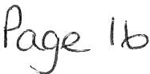

30/ 09/ 2021

Appendi x 1

Invoices for Consideration by Whitehave.o Town Council

Date | Supplier | Category | Detail |  | Total Amount |  | Power | Columnl
23/07/2021 | Thomson Electrical | Premises | To carry out EICRon 148 Queen Street and PAT test ing eQuipment/appl | iances | £ | 840.00 | Health and Safety at Work Act 1974
15/08/2021 | Chris Hayes | Employees & Allowances | Mileage from home address to Workington for Mayor of Workington TC Civic Services |  | £ | 6.50 | slllLGA 1972
16/08/2021 | The Guide Media Group (Easby Orwell Ltd) | Events | Video advertising |  | £ | 700.00 | sl44 LGA 1972
19/08/ 2021 | Westcom | Supplies & Serv ices | Webroot Antivirus Licence 18.09.2021 - 17.09.2022 |  | £ | 86.40 | slllLGA 1972
25/08/2021 | Eden Sorinis (UK) Ltd | Suoolies & Services | Environmental Levv for water coolers(September) |  | £ | 2.16 | slllLGA 1972
01/09/ 2021 | Water Plus Ltd | Premises | Water and Wastewater bill 15.06.2021- 28.08.2021 |  | £ | 101.74 | slllLGA 1972
01/09/2021 | Cooeland Borough Council | 3rd Partv | Assistant Ranger Contract - September 2021 |  | £ | 2,199.02 | slllLGA 1972
01/09/2021 | Copeland Borough Council | 3rd Party | GrassCutti ng Contract - September 2021 |  | £ | 1,995.62 | slllLGA 1972
01/09/2021 | Cooeland Borouih Council | 3rd Party | Parks & Ooen Soaces Ranier Contract - September 2021 |  | £ | 3,325.44 | slllLGA 1972
01/09/2021 | Copeland Borough Council | 3rd Party | Allotment Maintena nce Contr act - September 2021 |  | £ | 717.42 | s23 Sma ll Holdings Allotments Act 1908
08/09/2021 | Weir & Carmichael Ltd | 3rd Party | 500 gull proof bags olus bulk deliveryto CA28 7AW |  | £ | 1,944.00 | ss5 Litter Act 1983
09/09/2021 | Copeland Borough Council | Premises | Hire of Harbour Gallery for Council meetings held on 10.06.21,10.08.21 and 26.08.21 |  | £ | 288.00 | slllLGA 1972
10/09/2021 | Discount Disolavs | Events | 10 x gazebo's and 32 sandbags plus bulk delivery to CA28 7AW |  | £ | 4,077.60 | s144 LGA 1972
15/09/2021 | Nisbets | Events | 20 x 6ft fold ing tables for market events |  | £ | 1,127.76 | sl44 LGA 1972
16/09/2021 | PKF Llttleiohn | Suoolies & Services | Professional services rendered in connection with the Limited Assurance Review of Annual Governance & Accountability Return for year ended 31 March 2021 |  | £ | 1,200.00 | slllLGA 1972
17/09/2021 | Chris Hayes | Employees & Allowances | Tickets to JJ Parker testimonial |  | £ | SO.OD | sl44 LGA 1972
20/09/2021 | Cumbria Media | Suoolies & Services | Website maintenance Job No's 389 - 392, meeting support |  | £ | 224.25 | slllLGA 1972
21/09/2021 | Water Plus Ltd | 3rd Party | Water Bill for Midgey Allotme nts 16.06.2021 - 16.09.2021 |  | £ | 280.46 | s23 Small Holdings Allotmen ts Act 1908

£ 19,166.37

+i

WHITEHAVEN TOWN COUNCIL CASH BOOK FROM 1 APRIL 2021
APPENDIX 2
Employees/ Supplies/ Community Ground
Civic |  |  | Ward |  | Environmental
Hospitali ty | Ra nger/SO | W.1.8 | Grants | Elections | Improvements | Events | Contingencies | Reserves | Net Total | VAT | Total

Date Ref Payee Allowances Premises Services 3rd Party Grants Allotmts Market Plan Maint
Min. Ref.

 | Aprll-2021  01/04/2021 | 991 | Copeland Borough Council |  | 10603.75 |  |  |  |  |  |  |  |  |  | 10603.75 |  | 10603.75 | 1723/21 (i)
 | 15/04/2021 | 992 | HMRC | 2155 .02 |  |  |  |  |  |  |  |  |  |  | 2155.02 |  | 215S.02 | HMRC
 | 15/04/2021 | BACS | Staff | 4364.68 |  |  |  |  |  |  |  |  |  |  | 4364.68 |  | 4364.68 | 1666/20
 | 15/04/2021 | SACS | Cumbria LGPS | 1825. 02 |  |  |  |  |  |  |  |  |  |  | 1825.02 |  | 1825.02 | 6317/17 Iii)
 | 19/04/2021 | DD | Crown Gas & Oil |  | 251.05 |  |  |  |  |  |  |  |  |  | 251.05 | 50.21 | 301.26 | Contract
3 | 20/04/ 2021 | DD | BTGroup |  | 70.42 |  |  |  |  |  |  |  |  |  | 70.42 | 14.08 | 84.50 | Contract
4 | 30/04/2021 | BACS | Vultur e Club |  |  |  |  | 1000.00 |  |  |  |  |  |  | 1000.00 |  | 1000.00 | 1733/21
 | 30/04/2021 | 993 | Copeland Borough Council |  |  |  |  |  | 70.83 |  |  |  |  |  | 70.83 | 14.17 | 85.00 | 1161/21 Iii
 | 30/04/2021 | SACS | Eden Springs (UK) Ltd |  | 1 .8 0 |  |  |  |  |  |  |  |  |  | 1.80 | 0.36 | 2.16 | 1161/21 Ii)
7 | 30/04/2021 | BACS | Clyde & Co |  |  |  |  |  |  |  |  |  |  | 232.30 |  | 232.30 | 232.30 | 1761/21 Ii)
8 | 30/04/2021 | BACS | Derwent Recycling Services Ltd |  |  |  |  |  | 240.00 |  |  |  |  |  | 240.00 | 48.00 | 288.00 | 1761/21 Ii)
9 | 30/04/2021 | BACS | Derwent Recycling Services Ltd |  |  |  |  |  | 240.00 |  |  |  |  |  | 240.00 | 48.00 | 288.00 | 1761/21 Ii)
10 | 30/04/2021 | SACS | Derwent Recycling Services Ltd |  |  |  |  |  | 240.00 |  |  |  |  |  | 240.00 | 48.00 | 288.00 | 1761/21 Ii)
11 | 30/04/2021 | 994 | Copeland Borough Council |  |  |  |  |  |  | 1663 .0 2 |  |  |  |  | 1663.02 | 332.60 | 1995.62 | 1761/21 Ii)
12 | 30/04/2021 | 995 | Copeland Borough Council |  |  |  |  |  | 597.85 |  |  |  |  |  | 597.85 | 119.57 | 717.42 | 1161/21 Ii)
13 | 30/04/2021 | 996 | Copeland Borough Council |  |  |  |  |  |  |  | 2771.20 |  |  |  | 2771.20 | 554.24 | 3325.44 | 1761/21 (i)
14 | 30/04/2021 | 997 | Copeland Borough Council |  |  |  |  |  |  |  | 1832.52 |  |  |  | 1832.52 | 366.50 | 2199.02 | 1761/21 (i)
15 | 30/04/2021 | 998 | Copeland Borough Council |  | 15.20 |  |  |  |  |  |  |  |  |  | 15.20 |  | 15.20 | 1761/21 Ii)
16 | 30/04/2021 | BACS | Water Plus limited |  |  |  |  |  | 27.11 |  |  |  |  |  | 27.11 |  | 27.11 | 1761/21 (i)
17 | 30/04/2021 | BACS | Water Plus limited |  |  |  |  |  | 54.42 |  |  |  |  |  | 54.42 |  | 54.42 | 1761/21 (i)
18 | 30/04/2021 | SACS | Whitehaven Gas & Plumbing |  | 209.68 |  |  |  |  |  |  |  |  |  | 209.68 | 41.94 | 251.62 | 1761/21 (i)
19 | 30/0 4/ 2021 | BACS | Cumbria Media |  |  | 356.00 |  |  |  |  |  |  |  |  | 356.00 |  | 356.00 | 1761/21 (i)
20 | 30/04/2021 | 999 | Viking |  |  | 173.80 |  |  |  |  |  |  |  |  | 173.80 | 4.56 | 178.36 | 1761/21 (i)
21 | 30/04/2021  May-2021 | 1000 | Mrs VGorley | 8.48 |  | 21.51 |  |  |  |  |  |  |  |  | 29.99 |  | 29.99 | 1761/ 21 Ii)
 | 14/05/2021 | BACS | Staff | 4771.51 |  |  |  |  |  |  |  |  |  |  | 4771.51 |  | 4771.51 | 1666/20
 | 14/05/2021 | 1001 | HMRC | 2256.63 |  |  |  |  |  |  |  |  |  |  | 2256.63 |  | 2256.63 | HMRC
 | 14/05/2021 | SACS | Cumbria LGPS | 1 64.94 |  |  |  |  |  |  |  |  |  |  | 16 4.94 |  | 164.94 | 6317/17 (ii)
22 | 14/05/2021 | SACS | Im per ative Training Limited |  |  | 120.00 |  |  |  |  |  |  |  |  | 120.00 | 24.00 | 144.00
23 | 17/05/2021 | DD | Crown Gas & Oil |  | 238.33 |  |  |  |  |  |  |  |  |  | 238.33 | 47.66 | 285.99 | Contract
24 | 19/05/2021 | DD | BTGroup |  |  | 67.21 |  |  |  |  |  |  |  |  | 67.21 | 13.44 | 80.65 | Contract
25 | 25/05/2021 | BACS | Friends of St JINS |  |  |  |  |  |  |  |  | 500.00 |  |  | 500.00 |  | SOD.OD | W ar d G r a n t
26 | 25/05/2021 | BACS | Rosehill Youth Theatre |  |  |  |  | 1000.00 |  |  |  |  |  |  | 1000.00 |  | 1000.00
27 | 25/05/2021 | BACS | Deborah McKenna Ltd |  |  |  |  |  |  |  |  |  | 1000.00 |  | 1000.00 | 200.00 | 1200.00
28 | 27/05/2021 | BACS | POD !No rt h West) Lt d | 800.00 |  |  |  |  |  |  |  |  |  |  | 800.00 | 160.00 | 960.00 | Mayors Allowance
 | June-2021
29 | 03/06/2021 | BACS | Eden Springs (UK) ltd |  | 19.80 |  |  |  |  |  |  |  |  |  | 19.80 | 3.96 | 23.76 | 1794/21 (i)
30 | 03/06/2021 | BACS | Derwent Recycling Services Ltd |  |  |  |  |  | 240.00 |  |  |  |  |  | 240.00 | 48.00 | 288.00 | 1794/21 Iii
31 | 03/06/ 2021 | 1003 | Copeland Borough Council |  |  |  |  |  |  |  | 1832.52 |  |  |  | 1832.52 | 366.50 | 2199.02 | 1794/21 Ii)
32 | 03/06/2021 | 1004 | Copeland Borough Council |  |  |  |  |  |  | 1663.02 |  |  |  |  | 1663.02 | 332.60 | 1995.62 | 1794/21 (i)
33 | 03/06/2021 | 1005 | Copeland Borough Council |  |  |  |  |  |  |  | 2771.20 |  |  |  | 2771.20 | 554.24 | 3325.44 | 1794/21 (i)
34 | 03/06/2021 | 1006 | Copeland Borough Council |  |  |  |  |  | 597.85 |  |  |  |  |  | 597.85 | 119.57 | 717.42 | 1794/21(i)
35 | 03/06/2021 | 1007 | Mrs J Hart ley |  |  |  | 250.00 |  |  |  |  |  |  |  | 250.00 |  | 250.00 | 1794/21 (i)
36 | 03/06/2021 | BACS | Cumbria Medi a |  |  | 349.58 |  |  |  |  |  |  |  |  | 349.58 |  | 349.58 | 1794/21 Ii)
37 | 03/06/2021 | 1008 | Sharp Business Systems |  |  | 144.79 |  |  |  |  |  |  |  |  | 144.79 | 28.96 | 173.75 | 1794/21 Ii)
38 | 03/06/2021 | 1009 | Westcom IT |  |  | 214.19 |  |  |  |  |  |  |  |  | 214.19 | 42.84 | 257.03 | 1764/ 21
39 | 03/06/2021 | SACS | Mrs VGorley |  | 159.00 |  |  |  |  |  |  |  |  |  | 159.00 |  | 159.00 | 1794/21 Ii)
40 | 03/06/2021 | BACS | Zurich Municipal |  |  | 3233.79 |  |  |  |  |  |  |  |  | 3233.79 |  | 3233.79 | 1794/21 (i)
41 | 03/06/2021 | BACS | CALC |  |  | 18 78 .49 |  |  |  |  |  |  |  |  | 1878.49 |  | 1878.49 | 1794/21 Ii)
42 | 03/06/2021 | BACS | Sharp Business Systems |  |  | 2700.00 |  |  |  |  |  |  |  |  | 2700.00 | 540.00 | 3240.00 | 1763/21
43 | 03/06/2021 | BACS | Mrs V Gorley | 7.98 |  |  |  |  |  |  |  |  |  |  | 7.98 |  | 7.98 | 1794/21 (i)
44 | 03/06/2021 | BACS | Mrs M Jewell |  |  |  |  |  |  |  |  |  | 59.40 |  | 59.40 | 11.88 | 71.28 | 1794/21 (i)
45 | 03/06/2021 | SACS | Tradeprin t |  |  |  |  |  |  |  |  |  | 340.68 |  | 340.68 | 68.14 | 408.82 | 1794/21 (i)
 | 15/06/2021 | 1010 | HMRC | 2257.03 |  |  |  |  |  |  |  |  |  |  | 2257.03 |  | 2257.03 | HMRC
 | 15/06/2021 | BACS | Cumbria LGPS | 210.12 |  |  |  |  |  |  |  |  |  |  | 210.12 |  | 210.12 | 6317/17 (ii)
 | 15/06/2021 | SACS | Staff | 4516.89 |  |  |  |  |  |  |  |  |  |  | 4516.89 |  | 4516.89 | 1666/20
46 | 17/06/2021 | DD | Crown Gas & Oil |  | 192.98 |  |  |  |  |  |  |  |  |  | 192.98 | 9.65 | 202.63 | Contract
47 | 21/06/2021 | DD | BTGroup |  |  | 71.71 |  |  |  |  |  |  |  |  | 71.71 | 14.34 | 86.05 | Contract
48 | 28/ 06/2021 | BACS | Eden Springs (UK) Ltd |  | 1.80 |  |  |  |  |  |  |  |  |  | 1.80 | 0.36 | 2.16
49 | 28/06/2021 | BACS | Carlisle City Fire Protection |  | 38.25 |  |  |  |  |  |  |  |  |  | 38.25 | 7.65 | 45.90
50 | 28/06/2021 | 1011 | Cope land Borough Council |  |  |  |  |  |  |  | 1832.52 |  |  |  | 1832.52 | 366.50 | 2199.02
51 | 28/06/2021 | 1012 | Copeland Borough Council |  |  |  |  |  |  | 1663.02 |  |  |  |  | 1663.02 | 332.60 | 1995.62
52 | 28/06/2021 | 1013 | Copeland Borough Council |  |  |  |  |  |  |  | 2771.20 |  |  |  | 2771.20 | 554.24 | 3325.44
53 | 28/06/2021 | 1014 | Copeland Borough Council |  |  |  |  |  | 597 .85 |  |  |  |  |  | 597.85 | 119.57 | 717.42
54 | 28/06/ 2021 | 1015 | Viking |  |  | 32.48 |  |  |  |  |  |  |  |  | 32.48 | 6.50 | 38.98
55 | 28/06/2021 | 1016 | Water Plus limited |  |  |  |  |  | 18.98 |  |  |  |  |  | 18.98 |  | 18.98
56 | 28/06/2021 | 1017 | Water Plus limited |  |  |  |  |  | 117.50 |  |  |  |  |  | 117.50 |  | 117.50
57 | 28/06/2021 | 1018 | Water Plus limited |  | 194.80 |  |  |  |  |  |  |  |  |  | 194.80 | 10.71 | 205.51
58 | 28/06/ 2021 | BACS | Cumbria Media |  |  | 170.00 |  |  |  |  |  |  |  |  | 170.00 |  | 170.00
59 | 28/06/2021 | 1019 | Beck Bottom Community Garden Group - VOID
 | July-2021
60 | 17/07/20 21 | DD | Crown Gas & Oil |  | 77.54 |  |  |  |  |  |  |  |  |  | 77.54 | 3.88 | 81.42 | Contract
61 | 19/07/20 21 | 1020 | Fledglings (replaces chq no 990) |  |  |  |  |  |  |  |  | 200.00 |  |  | 200.00 |  | 200.00 | Ward Grant
 | 19/07/2021 | 1021 | HMRC | 2256.82 |  |  |  |  |  |  |  |  |  |  | 2256.82 |  | 2256.82 | HMRC
 | 19/07/2021 | BACS | Staff | 4517.10 |  |  |  |  |  |  |  |  |  |  | 4517. 10 |  | 4517.10 | 1666/20
 | 19/07/2021 | SACS | Cumbria LGPS | 733.36 |  |  |  |  |  |  |  |  |  |  | 733.36 |  | 733.36 | 6317/17 liil
62 | 20/07/2021 | DD | BT Group |  |  | 68.59 |  |  |  |  |  |  |  |  | 68.59 | 13.72 | 82.31
63 | 30/07/2021 | BACS | Eden Springs !UK) Ltd |  | 1.80 |  |  |  |  |  |  |  |  |  | 1.80 | 0.36 | 2.16

Po.9e IS

100.00
64 | 30/07/2021 | SACS | Rosehill Youth Theatre | 100.00 |  |  |  | 100.00
65 | 30/07/2021 | SACS | Copeland Borough Council |  |  | 20.00 |  | 20.00
66 | 30/07/2021 | SACS | Bauer Radio ltd |  |  |  |  |  |  |  |  |  |  | 1687.75 | 1687.75
67 | 30/07/2021 | 1022 | Copeland Borough Council | 20.73 |  |  |  |  |  |  |  |  |  |  | 20.73
68 | 30/07/2021 | 1023 | Copeland Borough Council |  |  |  |  |  |  | 1832.52 |  |  |  |  | 1832.52
69 | 30/07/2021 | 1024 | Copeland Borou gh Council |  |  |  |  |  | 1663 .02 |  |  |  |  |  | 1663.02
70 | 30/07/2021 | 1025 | Copeland Borough Council |  |  |  |  |  |  | 2771.20 |  |  |  |  | 2771.20
71 | 30/07/2021 | 1026 | Copeland Borough Council |  |  | 597.85 |  |  |  |  |  |  |  |  | 597.85
72 | 30/07/2021 | 1027 | Mr Alan Clements |  |  |  |  |  |  |  | 22.52 |  |  |  | 22.52
73 | 30/07/2021 | SACS | Lockhart Leisure Ltd |  |  |  |  |  |  |  |  |  |  | 595.00 | 595.00
74 | 30/07/2021 | SACS | Whitehaven Gas & Plumbing | 110.00 |  |  |  |  |  |  |  |  |  |  | 110.00
75 | 30/07/2021 | SACS | Glasdon UK Ltd |  |  |  |  |  |  |  |  |  | 2554.08 |  | 2554.08
76 | 30/07/2021 | SACS | Beck Bottom Community Garden Group - replaces chq no 1019 |  |  |  |  |  |  |  |  | 100.00 |  |  | 100.00
77 | 30/07/2021 | SACS | Beck Bottom Community Garden Group |  |  |  |  |  |  |  |  | 80.00 |  |  | 80.00
 | Aug-21
 | 13/08/2021 | SACS | Cumbria LGPS | 733. 36 |  |  |  |  |  |  |  | 733.36
 | 13/08/2021 | SACS | Staff | 4516.89 |  |  |  |  |  |  |  | 4516.89
 | 13/08/2021 | 1028 | HMRC | 2257 .03 |  |  |  |  |  |  |  | 2257.03
78 | 20/08/2021 | DD | BTGroup |  |  | 67.99 |  |  |  |  |  | 67.99
79 | 21/08/2021 | DD | Crown Gas & Oil |  | 62.40 |  |  |  |  |  |  | 62.40
80 | 27/08/2021 | 1029 | J & R Bennett |  |  |  | 3310.00 |  |  |  |  | 3310.00
81 | 27/08/2021 | 1030 | J & R Bennett |  |  |  |  |  |  |  | 390.00 | 390.00
82 | 27/08/2021 | 1031 | J & R Ben nett |  |  |  |  |  |  |  | 2622.70 | 2622.70
83 | 27/08/2021 | 1032 | Viking | 38.48 |  |  |  |  |  |  |  | 38.48
84 | 27/08/2021 | 1033 | Copeland Borough Council |  |  |  |  |  |  | 1832.52 |  | 1832.52
85 | 27/08/2021 | 1034 | Copeland Borough Council |  |  |  |  |  | 1663 .02 |  |  | 1663.02
86 | 27/08/2021 | 1035 | Copeland Borough Council |  |  |  |  |  |  | 2771.20 |  | 2771.20
87 | 27/08/2021 | 1036 | Copeland Borough Council |  |  |  | 597.85 |  |  |  |  | 597.85
88 | 27/08/2021 | 1037 | Graham Roberts | 3.75 |  |  |  |  |  |  |  | 3.75
 | Sept-21

20.00
337.55 2025.30
20.73
366.50 2199.02
332.60 1995.62
554.24 3325.44
119.57 717.42
22.52
119.00 714.00
22.00 132.00
510.81 3064.89
100.00 Ward Grant
80.00 Ward Grant

733.36 631/17 Iii)
4516.89 1666/20
2257.03 HMRC
13.60 81.59
3.12 65.52
662.00 3972.00
78.00 468.00
524.54 3147.24
7.70 46.18
366.50 2199.02
332.60 1995.62
554.24 3325.44
119.57 717.42
3.75

7.56
89 | 01/09/2021 | SACS | Eden Springs (UK) Ltd |  |  | 6.30 |  | 6.30 | 1.26
90 | 01/09/2021 | SACS | Solway Water Management Ltd |  | 250.00 |  |  | 250.00 | 50.00
91 | 01/09/2021 | BACS | Cumbria Media |  |  | 138.00 |  | 138.00
92 | 10/09/2021 | 1038 | Jeans Flower Boutique | 30.00 |  |  |  | 30.00
93 | 15/09/2021 | SACS | Mrs L & Mr DP Kelly T/A Corner House B&B |  |  |  | 85.00 | 85.00
94 | 15/09/2021 | BACS | J O Dixon Jeweller Ltd | 12.50 |  |  |  | 12.50
 | 15/09/2021 | BACS | Staff | 4517 .09 |  |  |  | 4517.09
 | 15/09/2021 | BACS | Cumbria LGPS | 733.36 |  |  |  | 733.36

300.00
138.00
30.00
85.00
12.50
4517.09
733.36
15/09/2021 1039 HMRC 2256.83 2256.83 2256.83
20/09/202 1 DD BT Group 70.15 70.15 14.03 84.18
20/09/2021 | DD | Crown Gas & Oil | 66.56 |  |  |  |  |  |  |  |  |  | 66.56 | 3.33 69.89
 |  |  | 45902.64 12685.89 9926.81 | 270.00 | 2000.00 4238.09 0.00 | 0.00 8315.10 | 0.00 | 23018.60 | 6345.22 880.00 | 0.00 | 2554.08 | 3767.83 | 232.30 119904.26 | 10969.16 £130,873.42

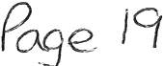

WHITEHAVEN TOWN COUNCIL Append ix 3

INCOM E 2020-2021  Date | Item | Precept | Interest | Other
01.04.2021 | Allot ment Rents 2021/2022 |  |  | 2460.00
14.04.2021 | Allotment Rents 2021/2022 |  |  | 470.00
15.04.2021 | Allotment Rents 2021/2022 |  |  | 100.00
15.04.2021 | HMRC - VAT Refund - March 2021 |  |  | 2339.13
19.04.2021 | All otment Rents 2021/2022 |  |  | 100.00
30.04.2021 | 2021-2022 Pr ecept | 433573.86
30.04.2021 | Allotment Rents 2021/2022 |  |  | 260.00
04.06.2021 | CBC - Refund |  |  | 24.60
07.06.2021 | All otment Rents 2021/2022 |  |  | 450.00
11.06.2021 | HMRC - VAT Refund - May 2021 |  |  | 2496.39
14.06.2021 | HMRC -VAT Refund - April 2021 |  |  | 1860.36
14.06.2021 | Allotment Rents 2021/2022 |  |  | 40.00
23.06.2021 | Sell afield Sponsorship |  |  | 3000.00
28.06.2021 | All ot ment Rents 2021/2022 |  |  | 291.00
30.07.2021 | All ot ment Rents 2021/2022 |  |  | 310.00
13.08.2021 | All ot ment Rents 2021/2022 |  |  | 90.00
16.08.2021 | HMRC - VAT Refund - Ju n e & July |  |  | 3815.79
24.08.2021 | Cumbria Count y Cou ncil Grant |  |  | 3290.00
03.09.2021 | Cumbria County Council Grant |  |  | 3737.00
17.09.2021 | Refund - CBC r ent from former office |  |  | 81.74
17.09.2021 | HMRC - VAT Refund - August |  |  | 1439.63
20.09.2021 | Refund - Viking |  |  | 308.48

433573.86 0.00 26964.12 146 0 537.98 1

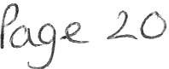

 |  |  |  | Expenditure Net |  | Invoicesnot yet
WHITEHAVEN TOWN COUNCIL |  |  |  | of VAT |  | processed | Budget
SUMMARISED INCOM E & EXPE NDITURE STATEMENT
FINANCIAL YEAR 2021-2022
BANK BALANCESBROUGHT FORWARD
CBS 53905917 (01.04.2021) |  | 23,364.96
CBS 53906216 (01.04.2021) |  | 450,400.11
TOTAL OPEN ING BALANCE |  | £ 473,765.07
INCOM E:
Precept |  | 433,573.86
Int erest (Deposit)
Other Income |  | 26,964.12
TOTAL INCOME |  | £ 460,537.98
EXPENDITURE
Employees & Allowances |  |  |  | 45902.64
Premises |  |  |  | 12685.89
Suppl i es/ Services |  |  |  | 9926.81
3rd Party |  |  |  | 270.00
Grants |  |  |  | 2000.00
Allot men ts |  |  |  | 4238.09
Markets |  |  |  | 0.00
Community Plan |  |  |  | 0.00
Ground Maintenance |  |  |  | 8315.10
Civic Hospitality |  |  |  | 0.00
Ranger |  |  |  | 23018.60
Whitehaven In Bloom |  |  |  | 6345.22
Ward Grants |  |  |  | 880.00
Elections |  |  |  | 0.00
Environmental Improvements |  |  |  | 2554.08
Events |  |  |  | 3767.83
Contingencies
Reserves |  |  |  | 232.30
VAT (to be reclaimed)  TOTAL EXPENDITURE | £ |  |  |  | 10969.16  130,873.42
CASH BOOK BALANCE
Brought forward | £ |  |  |  | 473,765.07
Income | £ |  |  |  | 460,537.98
Expendit ure | £ 130,873.42
Town Council Funds | I £ so3,429.63 1
BANK BALANCES
CBS 53905917 (22/09/2021) | 353,029.52
CBS 53906216 (22/09/2021) | 450,400.11
 | 1 £ |  |  |  | so3,429.63 I
Unpresented Cheques 2021/2022
FINANCIAL POSITION | 1 £ |  |  |  | s o3,429 .63 I

WTC 30/09/2021
Item 7

External Governance and Accountability Return - Annual External Auditor Report and Certificate for 2020/21
Purpose of the Report and Recommendation

To inform Councillors of the Final External Auditor Report and Certificate for 2020/21 and to approve and note it

INTRODUCTION

  - The Council's External Auditors, PKF Littlejohn LLP have issued their Report and Certificate for 2020/21 which is attached at Appendix 1.

  - Councillors will see from the External Auditor Report that the Council has been given a clean bill of health.

  - The Notice of Conclusion of the Audit has in accordance with Regulations been published on the Council's website and a copy has been displayed in the window of the Council Offices.

RECOMMENDATION

  - That the Council approve and note the External Auditor Report and Certificate for 2020/21

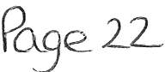

Sectio n 1 - Annual Governance Statement 2020/21
LO'TC. 3 0 (9 l;2.-,f
I
MPENhlx l

We acknowledge as the members of:

our responsibility for ensuring that there is a sound system of internal control, including arrangements for the preparation of the Accounting Statements. We confirm, to the best of our knowledge and belief, with respect to the Accounting Statements for the year ended 31 March 2021, tha t:

Agreed
Yes No' 'Yes' means that thisauthor,ty.

f. We have put in place arrangements for e ffective financial  management during the year, and for the preparation of  the accounting statements. | / | prepared its accounting statements in accordance  with the Accounts and Audit Regulations.  made proper arrangements and accepted responsibility for safeguarding the public money and resources in  its charge.  has only done what it has the legal power to do and has c :;:;:ope sin
2. We maintained an adequate system of internal control including measures designed to prevent and detect fraud and corruption and reviewed its effectiveness.
3. We took all reasonable steps to assure ourselves that there are no matters of actual or potential non-compliancewith laws, regulations and Proper
Practices that could have a significant financial effect on the ability of this authority to conduct its
business or manage its finances.
.We provided proper opportunity during the year for /  the exercise of electors' rights in accordance with the  requirements of the Accounts and Audit Regulations. |  | during the year gave all persons interested the opportunity to inspect and ask questions about this authority's accounts.
5. We carried out an assessment of the risks facing this /  authority and took appropriate steps to manage those  risks, including the introduction of internal controls and/or external insurance cover where required. |  | considered and documented the financial and other risks it faces and dealt with them property.
6 We maintained throughout the year an adequate and effective system of intern al audit of the accounti ng records and control systems. |  | arranged for a competent person, independent of the financial controls and procedures. to give an objective view on whether internal controls meet the needs of this smaller authority.
7. We took appropriate action on all matters raised in reports from internal and external audit. |  | responded to matters brought to its attention byintemal and external audit.
8 We considered whether any litigation, liabilities or commitments, events or transactions, occurring either during or after the year .end , have a financial impact on this authority and, where appropriate, have included them  in the accounting statements. | I | disclosed everything it should have about its business activity during the year including events taking place after the year end if relevant.
9. (For local counclis only) Trust funds including charitable. In our capacity as the sole managing trustee we discharged our accountability responsibi lities for the fund(s)/assets, including financial reporting and, if required, independent examination or audit. | has met all of its responsibilities where, as a body corporate, it is a sole managing trustee of a focal trust or trusts.
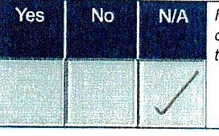
' Please provide explanations to the external auditor on a separate sheet for each 'No' response and describe how the authority will address the weaknesses identified. These sheets must be published with the Annual Governance Statement.

This Annual Governance Statement was approved at a meeting of the authority on:

t2 / os /2 1
and recorded as minute reference:
Signed by the Chairman and Clerk of the meeting where approval was given:

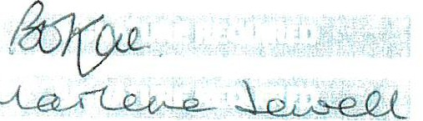
Chairman

I ::}::=.Jb·
/ 21 4-. to)

Clerk

Annual Governance and Accountability Return 2020/21 Part 3
Local Councils, Internal Drainage Boards and other Smaller Authorities*
Page 4 of 6

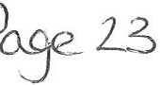

Sectio n 2 - Accoun tin g Statements 2020/21 for
WHITEHAVEN TOWN COUNCIL

Year ending Notes and guidance ·
31 Marth 31 March Please round all figures to neare:,t £1. Do not leave any
1
2020 2021 boxes blank and report £0 or Nil balances All figures m11st
. £ £ agreeto.underlying financial records.
1. Balances brought  forward | 404,162 | 355,334 | Total balances and reserves af the beginning of the year  as recorded in !he financial records. Value must agree lo  Box 7 of previous year.
2. (+)Preceptor Rates and L evies | 442 , 558 | 437,769 | Total amount of precept (or for IOBs rates and levies/  received or receivable in the year. Exclude any grants received.
l . (+) Total other receipts | 45,193 | 55,783 | Total income or receipts as recorded in the cashbook less  the precept or rates/levies received (line 2). Include any grants received.
4. (·) Staff costs | 85,172 | 87,769 | Total expenditure or payments made to and on behalf of all employees. Include gross salaries and wages. employers NI contributions, employers pension  contributions. gratuities and severance payments.
5. (·) Loan interest/capital repayments | 0 |  | Total expenditure or payments of capital and interest
 |  | 0 made during the year on the authority's borrowings (if any/.
6. (·) All other payments | 451,407 | 285,97 | Total expenditure or payments as recorded in the cash- book less staff costs (line 4) and loan interest/capital  repayments (line 5).
7. (=) Balancescarried forward | 355,334 | 475,142 | Total balances and reserves at the end of the year. Musi equal (1+2+3/ - ( 4+5+6 /.

8. Total value of cash and short term investments | 353,854 | 471,050 | The sum of all current and deposit bank accounts. cash holdings and short term investments held as at 31 March - To agree wi th bank reconcili ation.
9. Total fixed assets plus long term investments and asse ts | 221,058 | 286,613 | The value of all the property the authority owns - it is made up of all its fixed assets and long term investments as al  31 March.
10. Total borrowings | 0 |  | The outstanding capital balance as at 31 March of all loans
 |  | 0 from third parties (including PWLBJ.
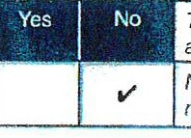
The Council, as a body corporate, acts as sole trustee for and is responsible for managing Trust funds or assets.
N.B. The (,gures in the accounting statements above do not include any Trust transactions.
11 . ( F or L oc al Councils Only) Disclosure note re Trust funds (including charitable)

I certi fy tha t for the year ended 31 March 2021 the Accounting Stat eme nts in this Annual Governance and Accountability Return have been prepared on either a receip ts and payments or income and expenditure basis following the guidance in Governance and Accountability for Smaller Authorities - a Practitioners' Guide to Proper Practices and present fairly the financial position of this authority.
Signed by Responsible Financial Officer before being
I confirm that these Accounting Statemen ts were approved by this authority on this date:
1 2- /os I 2..1
as reco r ded in min u te reference :
1 -=t-=tb /2 1 4- 1 C i·1)

presented to the authority for approval

_ .t,,.-UL
-e S i gned by C h ai r man of the meeting where the Accounting
S tatme eo i .

Date
- t- J :t o l

Ann ual Governance and Accountability Return 2020/21 Part 3
Local Councils, Internal Drainage Boards and other Smaller Authorities•
Page 5 of 6

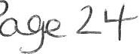

Section 3 - External Auditor Report and Certificate 2020/21
In respec t of Whitehaven Town Council - CU0268

Respective responsibilities of the body and the auditor
This authority is responsible for ensuring that its financial management is adequate and effective and that it has a sound system of internal control. The authority prepares an Annual Governance and Accountability Return in accordance with Proper Practices which:
  - summarises the accounting records for the year ended 31 March 2021; and
  - confirms and provides assurance on those matters that are relevant to our duties and responsibilitiesas external auditors.
Our responsibility is to review Sections 1 and 2 of the Annual Governance and Accountability Return in accordance with guidance issued by the National Audit Office (NAO) on behalf of the Comptroller and Auditor General (see note below). Our work does not constitute an audit carried out in accordance with International Standards on Auditing (UK & Ireland) and does not provide the same level of assurance that such an audit would do.

External auditor report 2020/21
On the basis of our review of Sections 1 and 2 of the Annual Governance and Accountability Return (AGAR), in our opinion the information in Sections 1 and 2 of the AGAR is in accordance with Proper Practices and no other matters have come to our attention giving cause for concern that relevantlegislation and regulatory requirements have not been met.

Other matters not affecitng our opinion which we draw to the attention of the authority:

The annual internal audit report focuses on a series of internal control objectives cover ing an authority's key financial and accounting systems and concludes whether, in all significant respects, the internal control objectives were being achieved throughout the financial year to a standard adequate to meet the needs of the authority. We note that the internal auditor has not provided a conclusion on internal control objective C in respect of risk assessment . The annual internal audit report will inform the authority's response to assertions 2 and 6 in the annual governance statement. As a result, the authority must ensure that assurance that has not been provided via these control objectives has been sought elsewhere.[
- External auditor certificate 2020/21
We certify that we have completed our review of Sections 1 and 2 of the Annual Governance and Accountability Return, and discharged our responsibilities under the Local Audit and Accountability Act 2014, for the year ended 31 March 2021.
External Auditor Name

External Auditor Signature
PKF LITTLEJOHN LLP
PJL+.- utf joAtt Ld' Date 15/09/2 021

* Note: the N AO issue d gu idanc e ap pli cab le to externa l au ditors ' wo rk on limit ed assura nce re views in Au ditor Gu idance Note AGN/02. The AGN is available from the NAO website (www.nao.org.uk)

Annual Governance and Accountability Return 2020/21 Part 3 Page 6 of 6
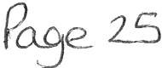

WTC 30/09/2021

Item 8

CHRISTMAS LIGHTS
Purpose of the Report and Recommendation

To inform Members of a quote received for the erection, maintenance dismantling and repair of the Christmas Lights for 2021 and to consider whether to suspend Financial Regulations in order that the estimate be accepted and to consider the risks and recommendations at 2.1.
  - INTRODUCTION

  - Attached at Appendix 1 is a quote for the erection, maintenance, dismantling and repair of the Christmas Lights for 2021 from Cumbria County Council Highways Lighting Department. The quote is for
£24,400.00 + VAT. For the past 3 years, CCC has not increased their price.

  - The lights are currently stored in the Whitehaven Civic Hall and also at the Council offices in Queen Street. CCC Highways Lighting Department has erected, maintained, dismantled and repaired the Christmas lights for the past few years.

In order for the lights to be erected, maintained, dismantled and repaired by the Council's preferred supplier the Council will have to consider suspending Financial Regulation 11 to permit this. In order to suspend Financial Regulation 11, Financial Regulation 18 states that "The Council may by resolution of the Council duly notified prior to the relevant meeting of Council, suspend any part of these Financial Regulations provided that reasons for the suspension are recorded and that an assessment of the risks arising has been drawn up and presented in advance to members of the Council".

  - The reasons for suspension are as follows:

    - CCC is a trusted and efficient contractor;
    - It is a value for money, quality service;
    - All faults reported are rectified as soon as possible - usually if reported during a working day they are repaired that day and certainly within 24 hours;
    - All required highway permissions to carry out works on the highway are submitted by CCC on the Council's behalf;
    - CCC has insurance, risk assessments and method statements for all work carried out using trained operatives;
    - CCC has all necessary machinery and equipment to carry out the work;
    - CCC erects and dismantles the Christmas lights during early morning at weekends so as to cause minimal disturbance to traffic;

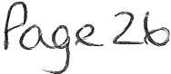

    - CCC completes the seasonal illuminations inventory unmetered supplies giving the location, type of lighting, number of hours in use, total number of lamps and the wattage per lamp and switch on and switch off date for submission to Electricity North West so that electricity charges can be calculated.

Risks:

    - There is a risk that the work could be done cheaper by another contractor but it is a very small risk. CCC has not increased its charges for the past 3 years.

2.0 RECOMMENDATION

  - It is recommended that the Council considers making a resolution to suspend the Financial Regulation 11 to allow CCC to erect, maintain, dismantle and repair the Christmas lights and if making the resolution

  - In accordance with Financial Regulation 18, agree to the reasons for the suspension which will be recorded and also that the assessment above of the risks provided be accepted and approved, so that CCC can undertake the work at a cost of £24,400.00 + VAT.

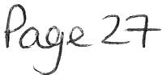

WHITEHAVEN TOWN COUNCIL
CHRISTMAS LIGHTING
QUOTATION
2021 /2022 season

INSTALLATION & MAINTENANCE+ REMOVEL OF LIGHTING

£24,400.00

CCC WILL HAVE A 24 HOUR CALL OUTS TO BE CHARGED AT TIME+ 15% ALL MATERIALS TO BE CHARGED AT COST+ 15%
THIS DOSE NOT INCLUDE VAT ON ANY COSTS

ALL CATENARY WIRES WILL BE VISUALY CHECK ON INSTALLATION OF FITTINGS AND CCC CAN NOT BE HELD RESPONSIBLE IF THEY FAIL.

(_£
i -\ '5"

3
l
- ' DQ UJ
0
-
j)
t5

(\J

WTC 30/09/2021

Events Expenditure
Item 9

Purpose of the Report and Recommendation

For Members to consider and authorise expenditure for and in connection with Council events

INTRODUCTION

  - At the Council Meeting on 26th August 2021, it was resolved
that as it had not been possible to obtain 20 folding tables for the gazebos from the supplier who had supplied the successful quote that enquiries be made of other suppliers to see if the Council could get them at the same price or if that was not possible to get them at a reasonable price (Minute 1864/21 refers).

  - The original supplier had quoted £799.00 plus £100 delivery charge for 20 folding tables. After a search a supplier was found who could supply 20 folding tables for £939.80 plus VAT to be delivered after 17/11/21 and with no delivery charge. The tables have been ordered.

  - At the Council Meeting on 26th August 2021, it was resolved that the Council reduces the number of gazebos and that a trial run be done at the Christmas Market using 2 marquees and that quotes be sought for the provision of these. (Minute 1864/21 refers). We are still in the process of obtaining quotes from suppliers and will present them at the Full Council meeting.

  - At the Extraordinary Council Meeting on 10th June 2021, it was resolved that the Council would authorise £700 to cover the shortfall for the Fartology Science Show. Included in this shortfall was the presenters' travelling expenses which had been estimated at £250.00. However, we have received notification from the presenter's agent that the price of his rail fare is £135.00 each way from London to Whitehaven and we will also need to account for taxi fares.

RECOMMENDATION

  - That the Council notes and approves the action taken in 1.2 above.

  - That the Council considers the quotes received for the 2 marquees and

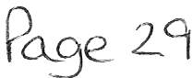

decides which quote to accept.

  - That the Council authorise an additional £70.00 to cover the increased rail fare and taxi fare for the presenter of the science show.

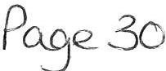

WTC 30/09/2021

Item 10

SUMMER PLANTING FOR 2022

Purpose of the Report and Recommendation

To inform Members of a quote received for summer planting in Whitehaven 2022 and to consider whether to suspend Financial Regulations in order that the estimate be accepted.

  - INTRODUCTION

  - The Council's preferred supplier for flowers has submitted a quote for the provision of flowers for the hanging baskets, hexagonal planters, barrier baskets, barrels, cast iron planters, half-moon baskets, aluminium planters, plastic planters, Trinity bed and the Pelican bed in the sum of £6,889.55 excluding VAT (Appendix 1). This quote also includes the additional 3 tier planters and barrier baskets purchased recently as well as hanging baskets and tubs on the harbour.

  - The quote received has been brought before the Council now as the Council's preferred supplier has to put their main bulk order in for flowers next year as soon as possible. The quote is for 5,093 plants plus the compost required.

The quote for last year was for £6,368.10 + VAT for 5,038 plants.

  - In order to continue to purchase flowers from the Council's preferred supplier the Council will have to consider suspending Financial Regulation 11 to permit this. In order to suspend Financial Regulation 11, Financial Regulation 18 states that "The Council may by resolution of the Council duly notified prior to the relevant meeting of Council, suspend any part of these Financial Regulations provided that reasons for the suspension are recorded and that an assessment of the risks arising has been drawn up and presented in advance to members of the Council".

  - The reasons for suspension are as follows:

    - It is a value for money service;
    - It is a quality service - the Council is constantly asked who provides the flowers;
    - The preferred supplier is very community orientated, has pride in the flowers they provide and even helps with the planting of them in town.

Risks:

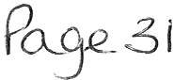

    - There is a risk that the flowers could be obtained cheaper by another supplier but this is a very small risk as the cost per plant is very low and the quality is very high.

RECOMMENDATION

  - It is recommended that the Council considers making a resolution to suspend the Financial Regulation 11 to allow the flowers to be purchased from the preferred supplier and if making the resolution

  - Agree to the reasons for the suspension which will be recorded and also that the assessment above of the risks provided be accepted and approved.

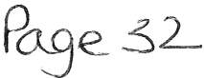

hSTC: 30/ '1 }202.\

1 10
d,'x /,.

R. B en n e tt
Brook House Dislinglon Workington Cumbria CA14 5YA tel. (01946)834140
Mobile 07512353137

QUOTE: Whitehaven Town Council Summer Bedding for 2022

WHERE PLANTS PACK QUANTITY £
TOTAL(£)

BARRELS x34 Yellow Antirrhirum 3, Vanilla Nemesia 2,
red geranium 1, cineraria 1, non stops - peaches? 4,
ALL AREAS | Non-Slop Begonia | 4 | 450 | 1.85 | 832.50
 | Trailing Begonia | 4 | 300 | 1.85 | 555.00
 | Antirrhirum | 6 | 250 | 1.30 | 325.00
 | Cinerara | 6 | 40 | 1.30 | 52.00
 |  |  |  | TOTAL | 1764.50
BARRELS | Nemesia (Vanilla. White) |  | 68 | 0.70 | 47.60
(x34) | Geranium (Red) |  | 34 | 0.85 | 28.90
CAST IRONS | Canna (red or green) |  | 12 | 3.00 | 36.00
(x 12) | Osteospermum (Orange) |  | 60 | 0.85 | 51.00
 | Peach (Semi Trailing) Begonia |  | 120 | 1.05 | 126.00
 | Nemesia (Vanilla) |  | 36 | 0.70 | 25.20
 | Nemesia (Yellow) |  | 36 | 0.70 | 25.20
 | Geranium Ivy Leaf (Pink) |  | 60 | 0.85 | 51.00
 | Surfinia (Pink) |  | 144 | 0.70 | 100.80
CIVIC HALL | Canna |  | 5 | 3.00 | 15.00
(x 5) | Geranium (Red) |  | 30 | 0.85 | 25.50
 | Geranium (Pink) |  | 30 | 0.85 | 25.50
 | lpomea (Sweet Caroline) |  | 20 | 0.95 | 19.00
PLASTIC SQUARE | Osteospermum (Orange) |  | 15 | 0.85 | 12.75

trailing begonias a

CAST IRONS x12 - Canna 12,Vanilla and yellowNemesia 6, pink sufinia 12, pink ivygeranium S, peach semi traili ng begon ia 10, osteospe rmum {orange) 5, few non stops-
peach? 4

CIVIC HALL xS • Canna 1, separate coloured antirrhirum 10, red geraniums 12, non stops mixed 12,trailing begonias 12, ipomea 4

Plastic Square xS • Antirrhirum (Yellow) S, Orange surfinias 10, Vanilla nemesia 6, osteospermum or ange and pink 6, Bacopa 4, non stops S, trailingbegonias 10

Tiers xlO • Red/pink Ivyleaf Geraniums (Topand Bottom) 7, Bacopa {Top, Middle) 10, PeachSemi-trailing begonia (2nd,bottom) 15, Nonstops (Bottom ) S, tpomea (Middle) S,nemesia (2nd,middle) 8, orange,pink surfinias(2nd, Middle) 8, trailing begonia 4

Wilkosx4- Bacopa 3, osteospermum (orang,e pink} 4, peach semi trailing 6, antirrhirum (mixed) 6, lpomea 2, non stops 2

BadgeBed · Marigolds 150, osteospermum 40, sanvitalia 100, anttrrhirum (mixed) 15. smallpinks/reds begonia 100

Hensingham Ship • Pink, orange surfinias 15, antirrhirum (Mixed) S,trailing begonia S,non stops 6

(x 5) Osteospermum (Pink) 15 0.85
Surfinia (Orange/Yellow) 50 0.70

12.75
35.00

Roper Street • Antir rhirum (mixed) 9, cineraria 4, osteospermum (orange,pink) 21, non stops 60, marigolds 20, pink, orange surfinias 21,

Pelican · Antirrhirum (mixed)30,large red, pink begonias

 | Nemesia (Vanilla) |  |  | 30 | 0.70 | 21.00 | 30, marigolds 40, non stops SO
 | Bacopa |  |  | 20 | 0.70 | 14.00
TIERS | Geranium Ivy Leaf (pink & red) |  |  | 70 | 0.85 | 59 .50
(x 10) | Bacopa |  |  | 100 | 0.70 | 70.00
 | Nemesia ( Mix of colours) |  |  | 80 | 0.70 | 56.00
 | Peach Semi Trailing Begonia |  |  | 150 | 1.05 | 157.50
 | lpomea (Ivy Leaf) |  |  | 50 | 0.95 | 47.50
 | Surfinias (Orange/Pink) |  |  | 80 | 0.70 | 56.00
WILKOS | Osteospermum (Pink/Orange) |  |  | 16 | 0.85 | 13.60
(WindowBoxes x 4) | Semi Trailing Peach Begonia |  |  | 24 | 1.05 | 25.20
 | Bacopa |  |  | 12 | 0.70 | 8.40
 | lpomea (Sweet Caroline) |  |  | 8 | 0.95 | 7.60
Pelican Bed | Large Begonia (Red) |  |  | 15 | 0.80 | 15.00
 | Large Begonia (Pink) |  |  | 15 | 0.80 | 15.00
 | Marigold | 6 |  | 40 | 1.30
Badge Bed | Marigold |  | 6 | 150 | 1.30 | 195.00
 | Sanvilalia |  |  | 100 | 0.70 | 70.00
 | Osteospermum(orange. pink) |  |  | 40 | 0.85 | 34.00
 | Small Begonia (Pink/red) |  | 6 | 100 | 1.30 | 130.00
Hensingham Ship | Surfinias (Orange) |  |  | 7 | 0.70 | 4.90
 | Surfinias (Pink) |  |  | 8 | 0.70 | 5.60
Roper St Bed | Surfinias (Orange) |  |  | 10 | 0.70 | 7.00
 | Surfinias (Pink) |  |  | 11 | 0.70 | 7.70
 | Osleospermum (Orange/Pink) |  |  | 21 | 0.85 | 17.85
 | Marigolds |  |  | 20 | 1.30 | 26.00

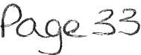

 |  | Quantity | Price(£) |  | Total (£)
Plants: | Nemesia | 250 | £0.65 |  | £162.50
 | Geranium | 224 | £0.85 |  | £190.40
 | Canna | 17 | £3.00 |  | £51.00
 | Osteopsermum | 167 | £0.85 |  | £141.95
 | Semi Trailing Peach Begonia | 294 | £1.05 |  | £308.70
 | Surfinia | 310 | £0.70 |  | £217.00
 | lpomea | 78 | £0.95 |  | £74.10
 | Bacopa | 132 | £0.70 |  | £92.40
 | Large Begonia | 30 | £0.80 |  | £24.00
 | Marigold | 210 | £1.30 |  | £273.00
 | Sanvita lia | 100 | £0.70 |  | £70.00
 | Small Begonia | 100 | £1.30 |  | £130.00
 |  |  |  | TOTAL | £1 , 735.05
Bas kets etc. | Hanging Baskets | 178 | £15.00 |  | £2,670.00
 | Barrier Baskets | 36 | £7.50 |  | £270.00
 | 1/2 Moon Baskets | 12 | £10.00 |  | £120.00
 | Compost | 3 | £110.00 |  | £330.00
 |  |  |  | TOTAL | £3,390.00
 |  |  |  | Bedding | £1,764.50
 |  |  |  | Other Plants | £1,735.05
 |  |  |  | Baskets etc. | £3,390.00
 |  |  |  |  | £6,889.55

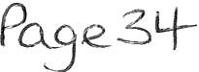

WTC 30/09/2021

Item 11

Replacement Electrode Pads for Council Owned Defibrillators

Purpose of the Report

To inform Members of the need and cost to replace Electrode Pads in the Council owned defibrillators and for Members to decide which supplier to purchase them from.

INTRODUCTION

  - Members may recall that they agreed to purchase 7 defibrillators and to have them installed in various locations in Whitehaven. Part of the report that was presented to Council informed Members that there would be ongoing costs including replacing the electrode pads after every use or every 2 years. Council approved the purchase and the ongoing costs involved (minute ref 1130/18 (ii) refers).

  - The expiry date on the electrode pads is November 2021. To enable the defibrillators to remain in service, 13 replacement pads must be purchased.

  - Quotes for replacement electrode pads have been sought from 3 suppliers and are as follows:

    - Supplier A - £52.99 each+ VAT
    - Supplier B - £36.00 each+ £9.95 delivery+ VAT
    - Supplier C - £69.99 each+ VAT

RECOMMENDATION

  - It is recommended that Council purchase 13 replacement electrode pads and to decide which supplier to purchase them from.

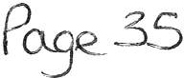

WTC 30/09/2021

Remembrance Sunday 14th November 2021
Item 12

Purpose of the Report and Recommendation

To inform Members of the preparations for Remembrance Sunday on 14th
November 2021 and to authorise expenditure

INTRODUCTION

  - This year's Remembrance Sunday is on 14th November 2021.
Essentially the organisation for the parade and the Service follows the same format every year. A meeting has been held with the various Services, the RBL, the Rev Robert Jackson and the Mayor to discuss who was doing what.

  - Preparations are now well under way and Members will be informed when they have been finalised.

  - The Whitehaven Brass Band will be in attendance for the service in Castle Park but it is not known at the moment whether or not they will be able to march through the town to the United Reformed Church. It is not known at the time of writing the report the cost of the band but Council will be informed at the meeting.

  - In 2019 following the Remembrance Day Service in the United Reformed Church the Council provided pie and peas in Whitehaven Civic Hall. Quotes have been sought for the provision of pies and these are as follows

Quote A - £32 per tray of any variety
Quote B - £28.14 per tray of meat & potato, £34.26 per tray of steak and
£14.43 per tray of cheese & potato pie Quote C - £34 per tray of any variety

In addition to this will be a cost for peas and gravy estimated to be
£30.00.

  - It is suggested that the Council purchase 5 poppy wreaths (so that we have at least one spare) at a cost of approximately £25-£30 per wreath

RECOMMENDATION

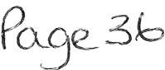

  - That the Council approve the cost for the Whitehaven Brass Band

  - That the Council decide whether or not to provide pie and peas after the Church Service and if so to decide which quote to accept and also authorise the cost of the peas

  - That the Council decides how many poppy wreaths to order at a cost of approximately £25-£30

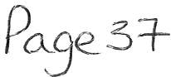

WTC 30/09/2021

Grass Cutting
Item 13

Purpose of the Report and Recommendation

To inform Members of the existing grass cutting contract with Copeland Borough Council and to consider the list of areas being cut and whether or not the list be extended to cover other areas before quotations are sought for 2022

INTRODUCTION

  - The Council has a contract with CBC to cut those areas of grass listed on Appendix 1 attached hereto on 12 occasions from April 2021 to September 2021.

  - Every year the Council asks for quotations from local contractors to carry out this work. All quotations received are reported to Council for decision.

RECOMMENDATION

  - Before quotations are sought members are asked to consider if there are any areas that should be included on the list before quotations are sought and having considered this to recommend that quotations are sought from local contractors to provide this service.

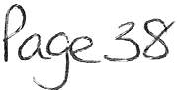

Whitehaven Town Council - Grass Cutting 2020/2021 Area
Verge from Firestation to Alma Bank Road
Carlton Drive to Thornton Road End Of Carlton Drive
Thornton Road Entrance Verges along Thornton Road Greenlands Avenue
Ashleigh Place Hillcrest Avenue Tower Hill
Victoria Road verge Rannerdale Drive junctions Crossfield Road, Bransty verges
Area next to St Gregorys and St Patricks school Verges along Whinlatter Road
Yewbarrow Close - Bank Whinlatter road - Large Bank Wastwater Road entrance
Monkwray Bungalows, junction of Monkwray Brow Verge next to Monkwray Cott ages
Corner Harbour View/High Road Mirehouse Road verge Sandwith Village Green
Toll Bar
Toll Bar to Pelican verge Pocket Park , Bransty
Highfield Road - opposite Jericho play area Cleator Moor Road Verge - Whitehaven Corner at start of Foxhouses Road Springfield Avenue (Highfi eld Court) Springbank Junction
Wordworth Road Junction Richmond Hill to Homewood verge Bottom of Lincoln Road junction Station Road - Coach Road junction
Corner of Winston Drive off Main Street Hensingham Substation at junction of Homewood and Sneckyeat Road Cambridge Road - Garage Site
Victoria Road left side up to junction with Elizabeth Crescent Banks near Bransty School overlooking New Road
Far end of Jubilee Road (on to Red Lanning) Jubilee Road beside Rascals nursery
Balmoral Road - top end where the foorpath is Balmoral Road - in front of No's 135 & 169
Carlton Drive - next to no 33 where the beck leads to Thornton Road Verges on Cro ss Lane
Cross Lane/Jericho Road corners
\.A-)LC, s.0/<1 I 2,,1
l --r-Efv1 1 3
AP .P t

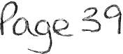

Jericho Road car park Verges on Highfields
Corner of Highfields/Woodlands Avenue Area outside no 5 Lansdowne Grove Verges at Standings Rise
Area outside St Gregory and St Patrick's School Top of Castle Park next to Castle Park Lodge Outside Valley School near the Cattle Arch
Bleng Avenue for the end of Foxhouses Road and ending at the junction with Esk Avenue Footpath leading to Maple Grove behind the verge at Bleng Avenue
Footpath leading from Bleng Avenue to Calder Avenue
Footpath to the left after going through the Cattle Arch and leading to Valley Junior School entrance Verge opposite South Row, Kells from the shop to the bottom
Land adjacent to Greenbank Community Centre Football field at Victoria Road

Pase 4-0

WTC 30/09//2021

Item 14

Contract for Maintenance of Allotments and Pigeon Loft Sites
Purpose of the Report and Recommendation

To inform Members of the Contract for the maintenance of allotment and pigeon loft sites and to recommend that quotations are sought for the provision of this service in 2022/2023

INTRODUCTION

  - The Council has a contract with CBC for 2021/2022 for the maintenance of allotments and pigeon loft sites. The services carried out are shown at Appendix1.

  - Every year the Council invites quotes from local contractors for the provision of this service. All quotations received are reported to Council for decision.

RECOMMENDATION

  - That Members recommend that quotations are sought from local contractors for the maintenance of allotments and pigeon loft sites based on Appendix 1 for the year 2022/2023

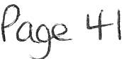

wr - c so/9 lb l

APPENDIX 1
l TEfv1 i 4-
A--PP 7::v{X. I

The list of services required to be undertaken at the allotment sites and pigeon loft sites are: -

    - Carry out pathway maintenance four times yearly to ensure good access for tenants such maintenance to include grass cutting provided that this obligation shall not require the Service Provider to put the pathways into a better condition that they are at the date of the agreement;
    - Carry out hedge maintenance annually;
    - Carry out ongoing reactive and preventative maintenance to maintain/improve allotments to a desired standard provided that this obligation shall not require the Service Provider to put the allotments or pigeon lofts into a better condition than they are at the date of the agreement;
    - Maintain perimeter fencing and site security in its existing condition at the date hereof;
    - Repair water supplies as and when necessary;
    - Maintain access/parking areas in their condition at the date hereof;
    - Removal of any fly tipping on site;
    - Removal of any compost (leaf mould) on site;
    - Maintain any signage on site in its existing condition at the date hereof;
    - Provide a schedule of works clearly itemizing when works would be carried out;
    - Provide monthly reports to Whitehaven Town Council to include Health and Safety

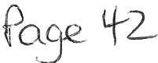

lrJ T C 3 0 ) 9 12 0 2-. 1
A3 QY\do J.t0'V\ 15 .

COPELAND BOROUGH COUNCIL

STANDARDS AND ETHICS COMMITTEE-17 September 2021

Notice of decision to complaint concerning Whitehaven Town Councillor Carla Arrighi

- Decision on whether the hearing should be in private and anonymity.

  - The Committee agreed that members of the press and public should be excluded from the hearing under paragraph 1 of part 1 of schedule 12A of the Local Government Act 1972. This was on the basis that the hearing will be considering information relating to individual s and the business affairs of the Borough Council and that, in this case, it would not be in the public interest to consider such information in public.

  - It was noted that no application for anonymity had been made.

- Attendances

  - The following persons were present at the hearing:

Members of the Committee:
Councillor Joan Hully (Chair) Councillor Jackie Bowman Councillor Hugh Branney Councillor Ged McGrath Councillor Russell Studholme

Independent Person: Complainant:
Subject Member:

Legal Offi cer:

Democratic Services Represent ative:
Mr Henry Holmes

Mrs Marlene Jewell and Mrs Vanessa Gorley Councillor Carla Arrighi
Clinton Boyce, Solicitor

Stephanie Shaw, Electoral & Democratic Services Manager , Clive Willoughby, Democratic Services Offi cer

- Preliminary issues

  - In accordan ce with paragraph 12 of the procedure adopted by Council on the 11t ^{h} September 2018 (amend ed on 17 Jun e 2021) for dealing with complaints, th e Chair commenced the hearing by reading out the procedure which was to be followed.

  - In accordance with paragraph 12 of th e said procedure, the Commit tee decided that t he matt er should continue to be held in private.

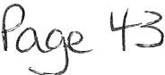

  - The Councils Solicitor then presented the report, setting out the detail of the com plaint and the evidence provided, which can be sum marised as follows:

On 23 November 2020, a member of the public posted a comment on the Copeland Politics Facebook page, which stated: "Just heard this lady called Marlene is on £52K per year. She's actually getting paid more that Mike Starkie and he is the Mayor of Copeland. Plus there ' s another drain on Public funds in WTC in the form of Vanessa. She's on £38K. And please can someone tell me what are we, the public getting for our money. By the looks of things not very much. But I forgot they are OKanes little nodding dogs and an important part of his circus"

In direct response to this comment, Subject Member replied "Totally agree Richard".

  - The evidence provided comprised of screen shots of the Facebook post and the comments made.

  - The Committee agreed that no further evidence was likely to be required, it was not necessary to appoint an extern al investigator and no further witnesses were to be called .

  - The fi nal Prelim inary issues for the committee to consider was whether the Subj e ct Member was acting in a capacity of a counci ll or at the time of the alleged breach and that the code of conduct applied to them at that time.

  - Hearing

  - The Committee considered the complaint togeth er with the evidence provided. The Committee heard from both the Comp lainants. The Subject Member did not attend the hearing, nor did they submit any written represen t at ion to the Committee in advance.

  - The Solicitor set out to the Committee the case law for 'acting in capacity' and that on the comment made there was no reference to the Sub ject Member being a councillor. The complainants argued that whilst they acknow ledged the point made by the solicitor, the Subject Member was well known for being a Whitehaven Town Council lor.

  - Decision

  - The Committee unanimously agreed that based on the evidence present ed, the Subject Member had breached the Code of Conduct.

  - It was agreed that the following sections of Whit ehaven Town Council' s Code of Conduct had been breached:

(5) You must not bring your office or your Council into disrepute.

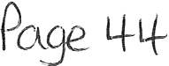

6) You must not act in such a way which a reasonable person would regard as bullying or intimidatory and behave in such a way that a reasonable person would regard as respectful and promote equality by not discriminating unlawfully against any person, and by treating people with respect, regardless of their sex, race, age, religion, gender, sexual orientation or disability. You should respect the impartiality and integrity of the Council's statutory officers and its other employees.
(12) You must promote and support high standards of conduct when serving your office.

  - Reasons

  - The Committee members accepted that the member did not post under the name of Councillor, however, the Committee agreed that by making the comment the Subject Member had shown disrespect. As a member of Whitehaven Town Council and therefore the employer of the staff members involved in the complaint, the Subject Member had a duty of care to the complainants and shou ld not have commented on such a post.

  - Sanctions

  - In accordance with paragraph 13(i) of the adopted procedure for dealing with Code of Conduct compla.int s the Committee considered, and agreed, that the following sanction is necessary:

  - That the Subject Member be issued with a conditional warning in respect of future behaviour for a period of two years from the date of this notice. This shall mean that if a further complaint is received against the Subject Member which is substantiated that any sanction imposed for that breach will take into account the present breach as well.

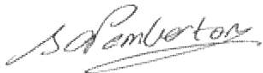
Signed:
Sarah Pemberton, Monitoring Officer, Copeland Borough Council

Date: 21 September 2021

Right of Appeal:

There is no right of appeal against the decision of the Standards and Ethics Committee.

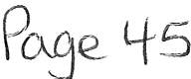

Co p e la nd B o ro u g h Co un c i l
Market Hall,
Market Place , Whitehaven,
Cum bria, CA28 7JG
t el: 01946 59 83 00
email: info o copelanc! gov uk w eb : www co p ela nd gov uk
t w i tt e r : a copelanc!bc
w,c.. 30 (0 9 /2-0 2- (
Asendcx1 16

Dear Parish Clerk,

Copeland Local Plan 2021-2038: Additional Focused Pre- Publication Draft Consultation on Potential Changes to the Local Plan

This letter is to inform you that Copeland Borough Council is beginning a five week public
consult at ion focused on the most significant changes the Council is considering to make to the draft Copeland Local Plan. The consultat ion will run from Monday 13th September 2021until Sunday 17th
October 2021.

The Council consult ed on the Preferred Options Draft of the Local Plan between September and November 2020. Since this time the Counci l has considered the responses received and updated elements of the evidence base that informs the Local Plan in order to identify the likely changes that are needed to the emerging Plan.

There have been a number of minor changes identified that will update and improve the Local Plan which can easily be incorporated. In addition to this there has also been a number of potential changes that could be more significant. These include new or significantly amended policies as well as draft allocations and boundary extensions that are proposed to be.added or removed.

It is important that these potential changes are properly considered and understood before the Council decides whether or not to include them in the final draft of the Local Plan . As such, the
Coun cil is holding this add iti onal focused consu lt ation on these significant potential changes in order to gather the views of st akeholders and the public before deciding which changes are incorporated in the Local Plan.

The Focused Consultation document highlights the significant changes that are being proposed from the Preferred Options draft in order to gather feedback before the Local Plan is finalised. Any Preferred Options policy or sit e not included in this consult at ion document will largely remain unchanged or proposed changes are minor/continue to be proposed for allocation. All responses to this Focused Consultation will be taken into account and the final, Publication Draft, of the Local Plan will be availabl e for comment as part of a six week public consultatio n in early 2022.

The draft Focused Con sult ation document is available on the Copeland Borough Council websit e: www .copeland.gov. uk/ cont ent / copeland-local-plan.

We are aware that this slight ly shorter and focused consultation may mean that you do not have a scheduled parish meeting during the consultation period, and as such are happy to receive informal comm ent s/ comments from individual councillors if that helps. We are also happy to discuss our attendance at your standard parish council meeting or bespoke meeting/drop in session that you

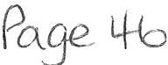

may wish to arrange to discuss any matters in the consult at ion document that affec t your parish's se t tlem ents. This sh ort er timescale will enable us to produce the final version of th e Local Plan in time for further consultation at the start of 2022.

I have also att ached a paper copy of the consult at ion document and a poster to promote it locall y if you wish.

If you have any comments on proposed changes in the draft consultation document, please complete the questionnaire online at the link above. Alt ern at ive ly you can find a hard copy of our response form on our website. Please return all completed forms to Copeland Borough Coun cil at t he following address:

St r at egic Planning Team Cop eland Borough Council The Market Hall
M arket Place Whit ehaven
Cumb ri a CA28 7JG

Or by email t o: Localplanconsu lt at ion @copel and.gov.uk

For fur th er information or advice, please cont act the St rategic Planning Team on
localplanconsult at ion@copeland.gov.uk or call 01946 598300. Pl ease return all responses no later than midnight on Sunday 17 th October 2021.

Yours Fait hfull y,

Chri s Hoban
St r at egic Planning M anager

Privacy Notice
A copy of the Counc il's priva cy statement can be viewed
at https://www.copeland .gov.uk/sites/defa ult/fi!es/att achments/ privacy_noticel .pdf. Further info rmat ion is also available by cont acting the council' s Data Protection Offi cer at info@copland.go v.uk or by callin g 019 46 598300 and asking to speak to the Data Protection Off icer .

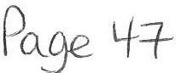

Your chance to get involved in the Copeland Local Plan.
See what changes we are proposing and have your say!
Copeland Borough Council is carrying out a focused Public consultation which outlines the most significant changes the Council is considering to the Local Plan Preferred Options Draft, which was consulted on in September 2020.

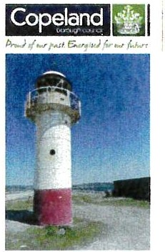The changes include elements such as additional and deleted site allocations, amendments to settlement boundaries and new policies.
'
,

Copeland Local Plan
2021- 2038
Foc use d P re - Publication Draft Cons ultati on
S• ptember 2021

The Consultation runs from Monday 13th September 2021until Sunday 17th October 2021
For more information please

Visit: ww w.co pelan d.gov. uk/ content/copeland -local-plan or

Email: loca lplan consu lt ati on @cop eland.gov.uk

Call: 01946 598300
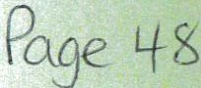

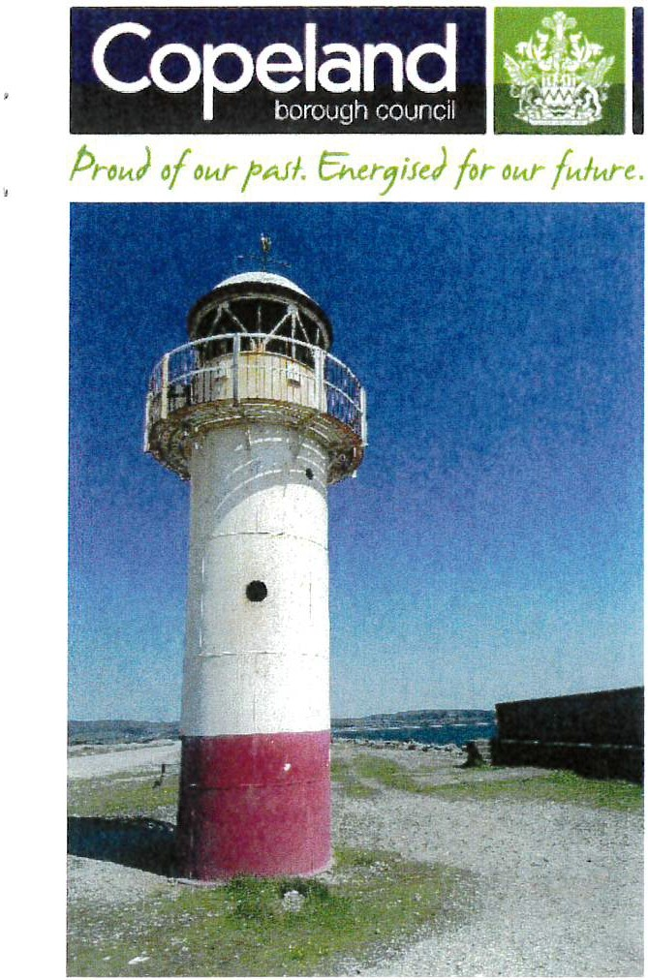
Copeland Local Plan
2021-2038
Focused Pre- Publication Draft Changes Consultation

September 2021

Focused Pre-Publication Draft Changes consultation document for public comment
This consultation document is available for comment until 15th October 2021. To view and download an electronic copy of this Copeland Local Plan 2021-2038: Focused Pre-Publication Draft Changes Document please visit the Copeland Borough Council website: www.copeland.gov.uk.

This document highlights key changes from the Preferred Options draft that are considered by the Council following feedback at the Preferred Options stage and also updates to the Local Plan evidence base.

The feedback from this consultation will inform the Publication Draft of the Copeland Local Plan, which will be made available for a six week public consultation in January 2022.

Please make any comments on the accompanying response form and return it no later than Sunday 17th October to:
Strategic Planning Copeland Borough Council Market Hall
Market Place Whitehaven Cumbria CA28 7JG

Email: localplanconsultation@copeland.gov.uk Telephone: 01946 598300
There is also an online form available to provide comments on the Council's website.

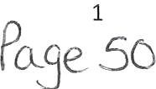

Contents
Focused Pre-Publication Draft Changes consultation document for public comment 1
  - Introduction 4
    - Copeland Local Plan 2021-2038 4
    - Focused Pre-Publication Draft Changes Consultation 4
    - How to use this document. 5
  - Changes to the Development Strategy Chapter 7
    - Strategic Development Priority Projects 7
    - Settlement Hierarchy 8
    - Settlement Boundaries 10
    - Strategic Development Principles 12
  - Changes to the Development Standards Chapter 13
    - Soils and Contamination 13
    - Air Quality 14
  - Changes to Copeland 's Economy Chapter. 15
    - Employment allocations 15
    - Cleator Moor Innovation Quarter 16
  - Changes to the Climate Change and Clean Energy chapter 19
    - Climate Change 19
    - Nuclear Deve lopment at Sellafield 20
  - Changes to the Retail Chapter 22
    - Key Service Centres 22
    - Local Service Centres, Sustainable Rural Villages and Other Rural Villages 23
  - Changes to the Tourism Chapter 26
    - Tourism 26
  - Changes to Copeland's Communities Chapter 27
    - Distribution of Housing 27
    - Housing Allocations 29
    - Affordable Housing 32
  - Changes to the Health, Sport and Community Facilities Chapter 33
    - Health and Well-being 33
    - Impact of new development on sports facilities 33
  - Changes to the Copeland's Places Chapter 35
    - Heritage Coast 35
    - Protection of Watercourses 35
    - Community Growing Spaces 36
    - Green Infrastructure 36
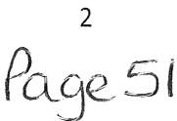

  - Changes to the Copeland's Connectivity Chapter 38
    - Sustainable Transport 38
    - Electric Vehicles 39
  - Appendices 40
    - Appendix A: Land proposed for inclusion within Settlement Boundaries 40
    - Appendix B: Land to be removed from Settlement Boundaries 42
    - Appendix C: Changes to Employment Allocations 46
    - Appendix D: Additional Housing Allocations 47
    - Appendix E: Housing Allocations proposed to be removed or reduced in size 49

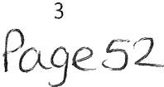

Introduction

Copeland Local Plan 2021-2038
    - Copeland Borough Council are in the process of developing a new Local Plan, covering the period of 2021-2038. Once adopted, this will become the Borough's Development Plan, replacing the current Copeland Local Plan 2013-2028 Core Strategy and Development Management Policies , (the Core Strategy), which was adopted in December 2013, and Saved Policies from the Copeland Local Plan 2001-2016.
    - The Local Plan has already undergone several stages. The most recent draft of the Local Plan, the Preferred Options Draft, was consulted on between September and November 2020. A full copy of the Preferred Options Draft can be seen on the Council's website¹.
    - The timetable and process for taking the Local Plan forward towards adoption can be viewed below.

Issues and Options Draft Nov 2019
Preferred Options Draft Sept 2020
Focused Pre­ Publication Draft Sept 2021
Publication Draft January 2022

Submission Spring 2022

Examination Autumn/ Winter 2022

Adoption
Spring 2023

Focused Pre-PublicationDraft Changes Consultation
    - The Council consulted on the Preferred Options Draft of the Local Plan between September and November 2020. Since this time the Council has considered the responses received and updated elements of the evidence base that informs the Local Plan in order to identify the likely changes that are needed to the emerging Plan.
    - There have been a number of minor changes identified that will update and improve the Local Plan which can easily be incorporated. In addition to this there has also been a number of potential changes that could be more significant. These include new or significanlty amended policies as well as draft allocations and boundary extensions that are proposed to be added or removed.
    - It is important that key Stakeholders and members of the public have enough opportunity to view and comment on these proposed changes to ensure that effective

1 Loca l Plan Pre ferred Opt ions I Copeland Boro ugh Council

4
Pccge 53

public engagement has been carried out, and that the draft plan is as robust as possible. For more information on how we engage the public in the planning process, please see our Statement of Community lnvolvement ².
    - As such, the Council is holding this additional five week focused consultation on the significant potential changes in order to gather the views of stakeholders and the public before deciding which potential changes are incorporated in the Local Plan.
    - This consultation document contains all of the significant changes that are being proposed within the emerging Local Plan at present. These are changes which have been made since the Preferred Options Consultation, which was carried out between September and November 2020. Significant changes can include:
      - Changes to the development strategy and settlement hierarchy
      - New policies
      - Deletion of a Preferred Options policy
      - Significant changes to a Preferred Options policy (e.g. those that may put additional requirements onto a developer)
      - New site allocations
      - Removal of Preferred Options allocations
      - Revisions to settlement boundaries

    - A number of other changes to the Plan are proposed in light of comments received to the Preferred Options draft. These are primarily more minor changes to the wording of policies and supporting text. These changes have not been included in this consultation document, and the Council will not be accepting comments unrelated to the content of this report at this time. They will be reflected in the final draft of the Local Plan (the Publication Draft).
    - The Council will consider all responses received to this focused consultation, and the draft Local Plan will be updated accordingly. The full amended version will form the Publication Draft that will be produced under Regulation 19 of the Town and Country Planning (Local Planning) Regulations 2012. This will be subject to a full 6 week public consultation in early 2022.

How to use this document
    - This document sets out all of the significant changes from the Preferred Options being proposed within the Local Plan. Policies are set out according to their chapter within the Local Plan Preferred Options document, and each one has an explanation of our proposed changes and the justification for this.
    - The changes have been shown as follows:
Key

+e wiU1 a stFiketRFel::l§R | This shows text that we are proposing to delete from the Local Plan Preferred Options draft
Red Text | This shows text that we are proposing to add to the Local Plan.

2 Statement of Commun ity Involvement I Cop eland Borough Council

5
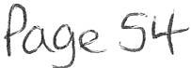

    - The policy numbering system shown in this report is an interim system. This is because of the addition of new policies, which fit between existing ones shown at the Preferred Options Consultation. The Publication Draft will contain a full list of policies and their superseded references to make the document easier to understand.
    - We welcome feedback on the proposed significant changes set out in this document. Please refer to page 1 for information on how to get involved in the consultation process.
    - The remainder of this document highlights the significant proposed changes from the Preferred Options draft that are being considered.

6
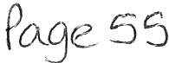

Changes to the Development Strategy Chapter
  - St r at egic Development Pri ority Pro jec t s
Proposed Change
We propose to delete policy DS4PO below from the draft Local Plan and move the supporting text from the Development Strategy chapter and into the Spatial Portrait chapter.
Justification
This policy sets out the Strategic Development Priority projects section of the Local Plan. Howeve r it is worded as a statement rather than a policy and has the potential to become dated relatively quickly as key developments are delivered.
The list of Strategic Development Priority Projects and their details is currently included in the Development Strategy chapter. It is considered that the policy should be removed and the list and descriptions should be moved into the Spatial Portrait chapter that describes the challenges and opportunities facing the borough. This ensures that the information is at the forefront of the plan, and clarifies our strategic development priorities.

Polisy DS4PO: Stratogis 0 01, olopmont Priority Projosts

The follo•,t.iing de¥elopments are strategio priority projects that will help transform oblr
Boro blgh , sblpport economio grovAh and di1.iersificationand impro¥e sooial and commblnity infrastr blotblre.

- De1.ielopment that sblpports the Energy Coast brand, pro¥ides opportblnities for training and edblcation and helps establish the Boroblgh as a Plaoe for lnno1.iation and Centre for Nblclear E>Ecellence and Clean Energy in particbllar :
  - The de¥elopment of V\lestlakes Science Park as strategio hblb for science and engineering e>Epertise and research and de•.ielopment indblstries
  - The oreation of an Enterprise Campbls and lnno¥ation Flblb
  - The de1.ielopmentof the North Shore lnno1.iation Zone in Whiteha1.ien
  - The de1.ielopment of a Clean Energy Park
o The de¥elopment of a new strategio employment site on the Eastern Fringes of
1Nh iteha¥en

- De¥elopment that helps establish the Lake District Coast brand and enhances the e>Eperienoe economy and oblr natblral and bblilt en¥iron ment, in partiobllar:
  - The impro1.iement of linkages between VVhiteha i.1en toi.•m centre and the Harboblrside
  - The Establishment of "E>Eperience '.'Vhiteha1.ien" inolblding the oreation of new aroades and hblbs in Whiteha¥en Town Centre
o The establishment of a Sports and Leisblre Qblarter in East Whiteha¥en
o The impro1.iement of the sports and leisblre offer in Millam
o De1.ielopment that enhanoes Oblr offer to blsers of national oyole robltes , promotes oblr location on Cblmbria's Hidden Coast and helps aohie¥e oblr amb ition to de 1•1elop a coastal oyoling roblte

- De1.ielopment that improi1.es the Boroblgh's residential offer in order to meet needs and aspirations, in partiobllar
  - The de1.ielopment of large, key regeneration sites
  - Town Centre renewal schemes in Cleator Moor, Egremont, Millam and
\"lhiteha¥en

7
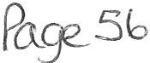

  - Settlement Hierarchy

- Infrastructure development which improves physical and digital connectivity within Copeland and bet\¥een the Borough and surrounding districts, in particular:
o The development of a new growth corridor to the East of VVhitehaven
- lmproi.1ements to the rail line and local stations
- lmpro1.ied Connectivity between Whitehaven Station and the Town Centre
o The de1.ielopmentof a Digital Grid in VVhitehaven to1A1n centre and improi1.ementsto digital connectii1.ity within Cleator Moor, Egremont and Millam
Proposed Change
Changes to the Settlement Hierarchy are shown in revised Policy DS2PO in light of the latest village services survey. Extra text will also be added to the policy to clarify that there are a number of villages within the National Park area of Copeland that fall outside the remit of the Local Plan.
Justification
Copeland Borough Council carry out an annual Village Services Survey, which looks at the key services contained within each settlement in the borough and highlights where there have been changes. The latest survey was carried out in June 2021 and indicates that a number of settlements have more or less services than when the previous Settlement Hierarchy was produced for the Preferred Options Draft of the Local Plan. This means that they now fall within a different tier of the hierarchy.
The revised hierarchy shows that Bigrigg and Calderbridge have both moved down a tier and Lowca has moved up a tier. Two settlements, Nethertown and The Hill no longer have sufficient services to maintain a position in the Other Villages tier of the hierarchy and will therefore be classed as being within the open countryside.
The Development Strategy Paper, available on the Council's website, explains the methodology behind the hierarchy, and the criteria that must be met for a settlement to be placed in a specific tier.
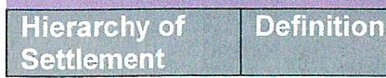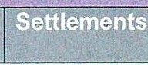

Policy DS3PU QS2PO: Settlement Hierarchy

The Council will support development within the settlements specifically listed below. Development must be proporticmate in terms of nature and scale to the role and function of the settlement, unless it has been specifically identified within the Plan to meet the strategic growth needs of the Borough.

The amount of development (housing, retail and leisure, employment) pportioned to each tier of the hierarchy is identified within the relevant chapter. Delivery will be closely monitored against these figures.

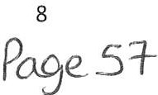

Principal Town | The largest settlement in terms of population by a considerable margin with the broadest range of day-to-day services including the West Cumberland Hospital, a number of secondary schools and an extensive choice of convenience and comparison goods stores and employment opportunities. Well connected to neighbouring Boroughs by public transport. | Whitehaven
Key Service Centres | The Borough's towns are self-sufficient providing a wide range of services, including convenience and comparison stores, employment opportunities, schools and healthcare. They also act as service hubs for  nearby villages. | Cleator Moor
 |  | Egremont
 |  | Millom
Local Service Centres | These centres have a supporting role to the Borough's towns containing a broad range of services. Settlements operate independently to meet day to day needs or as a well-connected cluster, linked to a neighbouring town or villag e of a similar scale by a frequent public transport service and/or safe pedestrian routes a mile or less in length.  Villages that scored 15 points or more in the Village Services Survey June 2021 | Arlecdon & Rowrah
 |  | Bi§Fi§§
 |  | Cleator
Distington &
Common End
 |  | Drigg & Holmrook
 |  | Frizington
 |  | Haverigg
 |  | Seascale
 |  | St Bees
 |  | Thornhill
Sustainable Rural Villages | Settlements which offer a limited number of services but which could support a limited amount of growth to maintain sustainable communities.  Vi llages that scored between 10 and 14 points in the Village Services Survey June 2021 | Beckermet
 |  | Bigrigg
 |  | GalEleFeFiEl§e
 |  | Ennerdale Bridge
 |  | Moresby Parks
 |  | MoorRow
 |  | Lowca
 |  | Parton
OtherRt:ffeal Villages | Smaller settlements which offer one or two key services but which are physically separated from settlements within a higher tier. Public transport and pedestrian links are poor therefore reliance is likely to be on the private vehicle. Limited development would enable future housing needs to be met and support existing local services.  Villages that scored between 5 and 9 points in the Village Services Survey June 2021 | Calderbridge
 |  | Hallthwaites
 |  | Keekle
 |  | Kirkland
 |  | Kirksanton
 |  | Lowca
 |  | Summergrove

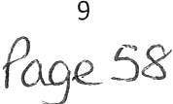

 |  | The Green
 |  | +Ae l=lill ³
 |  | Netl=ieFtowA
Open Countryside | Remaining parts of the Copeland Local Plan  Area Boreugl:1 including smaller settlements or areas of sparse development not listed above.
Rural Service Centres in Copeland under the jurisdiction of  LDNPA | Settlements within Copeland but outside the jurisdiction of the Copeland Local Plan. Please see the Lake District National Park Local Plan for further information regarding these | Bootle Remaining part of Ennerdale Bridge Gosforth

  - Sett lem ent Boundaries
Proposed Change

Amend the proposed settlement boundaries as shown in Appendices A and B and described in Tables 1 and 2 below. This includes the addition of three areas and the removal of seven areas. Recent evidence has shown that we would be unlikely to support windfall development on the removed areas.
Justification

This is to account for additional information received since the Local Plan Preferred Options Draft, including site information from statutory consultees and Cumbria County Council's Highways and Lead Local Flood Authority departments.
Individual justification for the proposed addition or removal of sites has been provided in the tables below.
Please note, any additional developments granted planning permission prior to the Publication Draft of the local Plan will also be brought into the Settlement Boundary, where applicable. Please also see changes to policy H5PO to see proposed changes to draft housing allocations .
Table 1: Areas Brought into Settlement Boundary
Please see Appendix A for maps showing these areas.

Area name | Settlement | Reasoning | Map number
Land south of Derwentwater Close | Millom | This land was missing in error from the settlement boundary shown in the Preferred Options Draft.  It should be noted that this land is currently being considered as part of Millom's flood and drainage alleviation project and may not be suitable for development, and may be removed  from the settlement boundary as a result. | 1

³ The Hill and Net hert own have been removed from the Set t leme nt Hierarchy du e to their low settleme nt service score, and are now classified as Open Coun t rys id e. Please see the Development St r ategy and Hierarchy paper fo r more info rmat ion

10
P°8es 9

Area name | Settlement | Reasoning | Map  number
Crook Field | Millam | This land was previously considered as undevelopable due to flood risk issues, but has recently been promoted by the landowner. The latest evidence from the Strategic Flood Risk Assessment (SFRA) suggests that flooding issues at the site have now been overcome.  It should be noted that this land is currently being considered as part of Millom's flood and drainage alleviation project and may not be suitable for development, and may be removed  from the settlement boundary as a result. | 2
Land south of Fairladies | St Bees | Site has been proposed as a draft allocation (HSB3) and therefore will be included within the settlement boundary if the site is allocated. See  changes to H5PO for more information. | 3

Table 2: Areas removed from Settlement Boundary

Please see Appendix B for maps showing these areas.

Area name | Settlement | Reasoning | Map number
Land south Baybarrow Road | Egremont | Objection received from Cumbria County Council (CCC) Highways Department due to unsatisfactory access. Development would also  be considered as backland. | 4
Land north Back Bay View | Millam | Access is considered to be unsatisfactory. There is also uncertainty surrounding the availability of the land, landscape impacts and  the issue of backland development. | 5
Land to rear Hound Inn | Arlecdon/ Rowrah | Landscape and visual impacts | 6
Land north Wray Head | Drigg/ Holmrook | Impacts on the character of the village, unacceptable encroachment into the countryside and uncertainty surrounding the  availability of the land. | 7
Land north west Holme Forge | Beckermet | Objection received from Cumbria County Council (CCC) Highways Department due to unsatisfactory access. Development would also be considered as backland and would result in  visual and landscape impacts. | 8
Land at Moor Row | Moor Row | Potential issues with access into the field. There is also an issue with the scale of the land compared with its position within the settlement  hierarchy. | 9
Land behind Vicarage Lane Ennerdale  Bridge | Ennerdale Bridge | Ecological constraints. | 10

11
Po.ge_ 60

  - Strategic Developm ent Principles
Proposed Change
Delete Policy DS5PO from the draft Local Plan and incorporate criteria into other policies.
Justi fication
This action has been proposed to avoid repetition within the Local Plan. The criteria listed in the policy are or will all be included within other specific policies in the Local Plan. For example, the Climate Change criteria will be included within revised policy CC1PO and criteria addressing the natural and built environment and design will be incorporated into the design policy in the Development Standards chapter.
A new health policy will be added to the Local Plan within the Communities chapter to replace the health section in policy DS5PO. This policy is therefore no longer needed. This change will help to keep the Local Plan concise, ensuring that all information relating to each section within DS5PO is kept together for greater clarity.

Policy DS5PO: Development Principles
In order to achieve sustainable development in the Borough and meet Local Plan objectives, development must, where possible:
Mitigation of and adaption to climate change
- Minimise carbon emissions, maximise energy efficiency and help us to mitigate and adapt to the effects of climate change
- Be located on sites where there is no risk of flooding and where the development does not increase the risk of flooding else\\<here
- Protect, enhance and create new areas of green infrastructure, recognising the important role that the natural environment and healthy ecosystems have to play in the future social and economic, as v.ei ll as eni.1ironmental sustainabliity of Copeland
- Make the most efficient use of land by building at appropriate densities and reusing existing buildings and previously developed land
- Minimise waste, maximise opportunities for recycling and use sustainable construction methods, taking into account circular economy principles⁴
- Be located on sites which minimise the need to travel, with good, safe pedestrian links to services and facilities

Protection, enhancement and restoration of the Borough's valued natural and cultural assets
Protect and enhance areas, sites, species and features of biodiversity or geodiversity value, important landscapes and the undeveloped coast including valued landscapes which form a setting to the Lake District National Park and areas of Heritage Coast.
- Conserve and enhance the Borough's cultural and heritage assets and their settings
- Provide and enhance recreational opportunities for the Borough's residents and its visitors, protecting existing provision where possible and ensuring that future development meets appropriate standards in terms of quantity and quality
- Protect the Borough's best and most versatile agricultural land from development

⁴ This involves keeping resources in use for as long as possib le, extracting the maximum value from them whilst in use, then recovering and regenerating products and materials at the end of each service life (wrap.org.uk). Fo r example through the reuse of building materials on site.

12
P09e_ 6,

- Support the reclamation and redevelopment or restoration of the Borough's vacant or derelict sites, whilst taking account of landscape , biodiversity and historic environment objectives
- Minimise air, ground and water pollution, ensuring that development does not have a negative impact upon water quality (including waterbodies and bathing •.t.•aters)

Creation and retention of quality plaGes
- Be of high quality in terms of design so that it retains and enhances locally distinctive places and raises aspirations
- Provide or safeguard good levels of residential amenity and security, reducing the fear of crime and minimising the opportunities for crime and anti social behaviour
- Be supported by the relevant infrastructure, ensuring it can accommodate traffic and access arrangements in ways that make it safe and convenient for pedestrians and cyclists to move around
- Address land contamination with appropriate remediation measures

Healttw Communities
- Adopt dementia friendly design principles⁶
- Provide opportunities for food growing
- Contribute to the creation of mix:ed communities, helping to reduce social isolation and create community resilience
- Retain and enhance valuable community facilities (including healthcare, cultural and education facilities)
- Include community energy generation to provide lo1N carbon heat and/or power and address energy poverty
- Enhance local pedestrian links to promote physical activity

Changes to the Development Standards Chapter
  - Soils and Con t am inat ion
Proposed Change
We propose adding additional text to Policy 0S11PO as shown below.
Justification
The additional wording proposed was put forward by a statutory body during the consultation on the Preferred Options Draft. This improves compliance with the NPPF and helps provide further clarity regarding what we require from developers in terms of remediating contaminated land.

Policy D51OPU DS11PO: Soils and Contamination

- The Council will produce a Supplementary Plann ing Document relating to design wh ich to support this Policy. This will provide further guidance for developers on issues such as how to incorporate dementia-fr iendly principles into their developments.

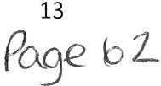

The Council will proactively work with developers and other partners to identify opportunities to remediate contaminated sites.
Sustainable construction measures should be used to conserve good quality soils, protect soils from contamination and avoid soil compaction around root protection areas.
Development should not result in the loss of best and most versatile agricultural land.

In accordance with the NPPF, development sites likely to have caused detriment to land quality will need to be risk assessed. Some sites will be more sensitive due to the location of sensitive environmental and human health receptors e.g. flood risk areas, surface waters, vulnerable aquifers, housing, schools, hospitals, children's play areas.

It is the developer's responsibility to secure safe development and provide the necessary information at the time of the planning application. The minimum information that should be provided by an applicant is the report of a Preliminary Investigation (desk study, site reconnaissance and preliminary risk assessment.) The findings of this will determine if further investigation is needed.

Where contamination issues are identified, development proposals should incorporate appropriate remediation and subsequent management measures to remove unacceptable risks. Full implementationof remediation measures would be secured via planning conditions and these measures are likely to be required prior to the first occupation of the proposed development.

  - Air Quality
Proposed Change
Add the new policy below to the Local Plan's Development Standards chapter.
Justification
The Sustainability Appraisal (SA) has recommended that a policy relating to air quality is added to the plan to help maintain good air quality in the borough. Natural England have suggested that the policy contains reference to reducing ammonia emissions. The Government's Code of Good Agricultural Practice shows that around 88% of ammonia emissions in the UK come from agriculture and the policy will help the government meet its target of reducing such emissions by 16% in 2030, compared to 2005 levels.

Policy 0S11PU: Protecting Air Quality
The Council will continue to monitor air quality in the borough and will introduce Air Quality Management Areas as necessary.
Development proposals will only be granted planning permission where they will not give rise to unacceptable levels of air pollution.
Applications for new or extended farming developments involving new animal housing or livestock manure storage must include details of measures to reduce ammonia emissions.

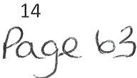

.4 Changes to Copeland's Economy Chapter
  - Em ploym e nt allo cat ion s
·Proposed Change
Amend Policy E4PO as shown below to remove the proposed hierarchy of sites and also add existing employment sites at Red Lanning, Energy Coast Business Park at Haile, and Haverigg Industrial Estate.
Justification
The evidence from the Economic Development Needs Assessment (EDNA) has identified a level of need that can currently be met from the existing Employment sites.
The accompanying Employment Land Availability Study (ELAS) suggests that there was no need for a new strategic site at Hensingham Common at present (although it may be required if the major projects at Moorside/the Cumbria Clean Energy Park happen). As such it is proposed to remove Hensingham Common from the hierarchy, although it will be retained as a longer term direction for future employment growth in the borough when the demand arises.
In addition to this, Leconfield has been identified as the location for a business cluster to maximise the economic potential from the supply chain at Sellafield. As such, it is proposed that this site has its own policy to reflect its importance (see Policy E4PU for further details below).
The remaining sites can then be grouped together in a more simple policy as outlined below.

Policy E5PU E4PO: Employment Sites and Allocations
i
Development within the boundaries of the following employment sites and allocations will be supported where criteria set out in policies E1PO and E2PO is met.
Development is restricted to B4- E(g) , B2 and B8 Use Classes.
Site | Total Site Size Approx. (ha)
Whitehaven Commercial Park, Moresby Parks | 12ha
Sneckyeat Rd, Whitehaven | 4.9ha
Haig Business Park, Whitehaven | 2.6ha
Red Lanning, Whitehaven | 1.7ha
Bridge End, Egremont | 12.Sha
Furnace Row, Distington | 3.1ha
Frizington Rd, Frizington | 1.6ha

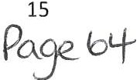

Energy Coast Business Park, Haile | 3.6ha
Seascale Rural Workshops | 1.4ha
Devonshire Rd, Millam | 5.9ha
Mainsgate Rd, Millam | 3.4ha
Haverigg Industrial Estate, Haverigg | 2.6ha
 | Mt@
Strategie ER:iployR'leRt Site | Hensingham Common, 1,A,thit eha1o1en *
 | beeonl:ielEl lnEli:JStFial Estate
M ajor ER:iployR:ieRt Sites | Whit ehaven CoR:im eFEial PaFI(, MoFesl3y Parl(s
 | BFiage En El, EgFemont
boeal ER=11'llo1yFRe Rt Sites | neEl(yeat Ra, l,1\lhitehaven
 | Haig 81:Jsiness PaFI(, V>.thitehaven
 | Fi:JFnaee Row, Qistington
 | FFi ington REl, FFi i n gton
 | liieasEale Ri:JFal WoFl(sho13s
 | QevonshiFe REl, M ill am
 | Mainsgate REl, Millam

  - Cleator Moor Innovat ion Qua rt er
Proposed Change
The creation of new policy relating to the development of the Cleator Moor Innovation Quarter, which will be centred around the existing Leconfield Industrial Estate and future expansion land. As it is a strategic site for the borough it is proposed that it has its own policy in a similar way to Westlakes Science Park.
Justification
The Cleator Moor Innovation Quarter (CMIQ) is aimed at leveraging the economic growth potential of the Sellafield supply chain, through a cluster approach to growing and diversifying the West Cumbria economy. Included within this is the creation of an Industrial Solutions Hub ("ISH") which will provide bespoke accommodation that will be a focus for collaboration, innovation and diversification across the Cumbrian nuclear and engineering sectors. The CMIQ lays the foundations for change, via improvements to connectivity, commun ity fac ilities and creating the Industrial Solutions Hub to support businessesto diversify beyond nuclear and to grow exports.
The CMIQ will provide opportunities for the supply chain in west Cumbria to grow and broaden their markets, exporting skills, processes and technologies developed in west Cumbria to the rest of the UK and other world markets.

16
P°'9e_65

T h e policy and some initial supporting text for the new policy are included below:

There are three areas that can form the CMIQ at Leconfield, which are shown in Figure 1 below:
- Area 1 - the existing Leconfield Industrial Estate (14.4ha)
- Area 2 - land to the east towards Heather Bank and Cleator Moor Medical Centre (4ha approx.)
- Area 3 - expansion land to the north (14ha approx.)
Figure 1: Cleator Moor Innovation Quarter at Leconfield - Areas for Development
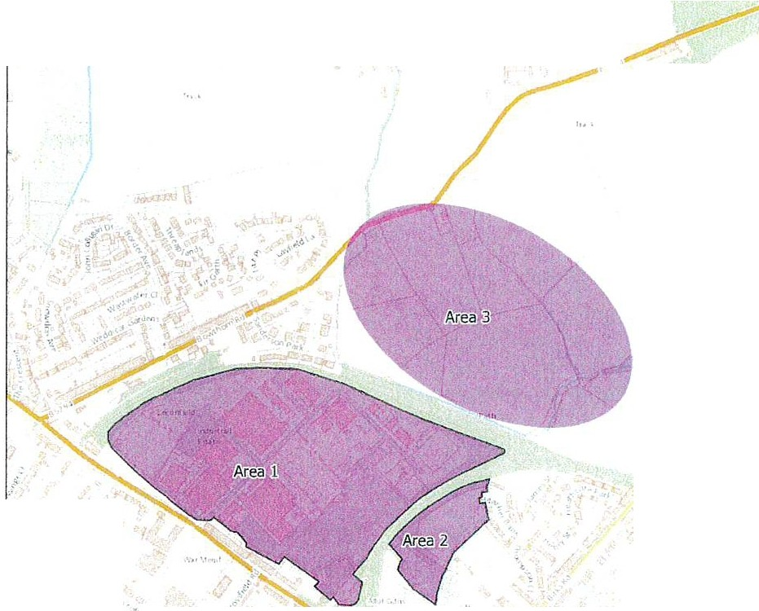
, •
Ordn a nco survey cf."lta @:.·C r'3Wn copy right Jnd d.i.l:i -.se righ1 .oll .:
. : 1 00010994.'.

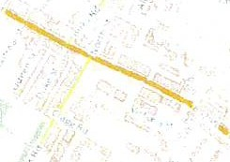
It is expected that development will be brought forward in accordance with an approved masterplan and site-wide outline planning application, which will outline matters such as design and sustainability requirements, scale and massing, phasing, and connections

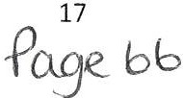

through and to through the site to integrate it with the wider community. This will enable a comprehensive and coordinated approach to site development and infrastructure provision, and ensure that each phase of development is sustainable.

New Policy E4PU: Cleator Moor Innovation Quarter at Leconfield

Leconfield Industrial Estate and Associated Growth Areas will be redeveloped to create the Cleator Moor Innovation Quarter as the location to attract new businesses and investment, develop new markets and increase collaboration and economic clustering. The boundary of the existing allocated site and future Associated Growth Areas are outlined in Figure 1.

Existing Leconfield Industrial Estate {Area 1)

The primary uses on the Cleator Moor Innovation Quarter development will be limited to Use Class 82, Use Class 88 and Use Class E(g) only

Community infrastructure. community facilities and secondary uses to support to the primary uses on the development will be supported within a single building or small cluster of buildings within the development to act as a focal point for the development and local community.

Any development will be required to demonstrate how it retains and where possible enhances existing connections and linkages through the site and to the wider settlement of Cleator Moor.

Associated Growth Areas (Areas 2 and 3)

It is expected that developmentwill initially be focussed on the existing Leconfield Industria l Estate. However. the development of the Associated Growth Areas as an extension of the Cleator Moor Innovation Quarter will be supported when one of the following can be demonstrated:

  - The Existing Leconfield Industrial Estate has been fully redeveloped· or
  - It can be demonstrated that the requirements of the businesses seeking to occupy the Cleator Moor Innovation Quarter cannot be met on the Existing Leconfield Industrial Estate.

The primary uses on Growth Area 2 will be limited to Use Class E(g) and student accommodatio n linked to the site.

The primary uses on Growth Area 3 will be limited to Use Class 82 Use Class 88 and Use Class E(g) only.

Any development will be required to demonstrate how it links to the redevelopment of the existing Leconfield Industrial Estate and retains and where possible enhances existing connections to the wider settlement of Cleator Moor.

PC>Be b+
18

5 Changes to the Climate Change and Clean Energy chapter
  - Clim at e Change
Proposed Change
Delete climate change policy CC1PO and replace it with the revised policy below, which will be at the forefront of the Local Plan after the Presumption in Favour of Sustainable Development policy.
Just ification
Addressing climate change is one of the most challenging issues that we currently face. Locating the policy at the front of the Plan highlights the Council's commitment to addressing the impacts of climate change and achieving the Cumbria wide target of net zero carbon by 2037 .
The replacement policy includes a greater number of actions that can be taken to reduce the impacts of development on climate change and sets out the reasoning why this is important.

Polisy CC1PO: Rec:lusing the impast& of Ele¥elopment on slimate shange

To reduce the impact of de•,elopFnent on cliFnate change developeFS are encouraged to:

- Use energy efficient censtruciion Fnethods and locally sourced, recycled Fnaterials;
- Incorporate renewable energy production equipment, such as photovoltaics, hydrogen energy;
- lncoF13orate loY.' carbon or decentralised energy schemes appropriate to the scale and location;
- Ma:iEimises the design of building(s), to ensure layout, design and materials are as energy efficient as possible, incorporating Passi•,haus principles
- Incorporates measures to reduce the consumption of energy , water and other resources post completion
- Steering new development a1,¥ayfrom areas at highest risk of flooding
- Incorporates space to park cycles and charge electrical vel=licles
- Includes measures that incenti•,ise local, sustainable travel, tl=lat also benefits l=lealth including; provision of walking and cycling routes and good access to public transport

Policy DS2PU: Reducing the impacts of development on Climate Change

The Council will support development proposals where they make a positive contribution towards achieving the Cumbria wide goal of net zero carbon by 2037, where this accords with the development plan. This includes but is not limited to the following
- High quality design techniques, including the incorporation of Passivhaus principles and maximising the design and layout of buildings to improve energy efficienc

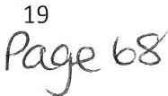

- Supporting measures to avoid fossil fuel usage for transport, heating and power generation and offsetting any carbon intensive energy usage over full lifetime of development
- Promoting active and low carbon travel in line with the transport hierarchy in COSPO and encouraging the increased use of Electric Vehicles
- Increasing resilience to the effects of climate change through elements such as reducing deforestation, providing SUDs and avoiding development in areas with high flood risk
- Making sustainable use of resources, energy and water over the full lifecycle - moving higher up the materials/waste hierarchy towards circular economy principles.
- Making the most efficient use of land by building at appropriate densities and encouraging the reuse of existing buildings and previously developed land
- Promoting sustainable land use management, forestry and farming practices and encouraging agri-environmental schemes
- Contribution towards environmental benefits, including but not limited to provision and enhancement of local green spaces, contributing to the creation of new woodlands, preserving existing woodlands, peatland restoration and preservation, provision of green roofs and walls, and native species preservation.
- Contributing towards Local Nature Recovery Networks.
- Requiring biodiversity net gain as part of all appropriate developments

Additional aspects of sustainable design and development which contribute towards a reduced carbon footprint will also be looked at favourably by the Council.

  - Nuclear Development at Sellafi eld
Proposed Change
Amend policy CC6PU as shown below.
Justification
This change is anticipated to provide greater clarity surrounding the requirements we expect from development at Sellafield Ltd. The additional criterion recognises the fact that Sellafield is Copeland's largest employer and that they have a role to play in meeting Cumbria's carbon reduction targets.

Policy CCGPU CC7PO, Nuclear Sester Development at Sellafield

The Council's approach to dealing with proposals for nuclear development including those related to decommissioning, site remediation and radioactive material management in the Borough is to work with operators of the facilities at the Sellafield licensed nuclear site and Cumbria County Council to ensure that:

    - All nuclear development proposals align with the Council's appro1.ied "Nuclear Position Statements" unless material planning considerations indicate otherwise
- All nuclear development (other than monitoring, maintenance and investigatory work necessarily done off-site) shall be sited within existing designated Sellafield site boundary unless Criterion 6* b) applies.
- Where any proposed development is outside the designated boundary at Sellafield it shall be sited on a designated employment site or on suitable sites within

20
P<>-9-e. 6 9

settlement boundaries in accordance with the principles set out in Policies DS2PO and 0 S3PO, or otherwise accompanied by a justifiable exceptional need case⁶.
- With the exception of irradiated fuel and nuclear materials, no radioactive material is imported for treatment or storage on the Sellafield licensed site unless the proposal represents the best practical environmental option and is an interim proposal pending agreement on a national disposal route.
- Proposals for any new development are submitted with include long term management plans te setting out how operations will be co-ordinated to minimise any harmful effects and mitigate or compensate for physical environmental
impacts.
- Proposals include provision for adequate infrastructure to support the new development.
- Proposals involve and secure the support of the local community and stakeholders where relevant.
- Proposals include measures to mitigate any adverse effects of the proposed development and provide a positive local social impact by enhancing the social, environmental and economic wellbeing of the community.
- Proposals shall include satisfactory measures for carbon offsetting via off site/ other agreed compensatory means where it has been demonstrated that they cannot be achieved on site.

⁶ A development proposal which is supp orted by a statement out lining t he special ' site specific' circumstances that demonstrat e the need / r eason for that deve lo pment on planning grounds to be on that particular site (as opposed to elsewhere)and which just ify the proposal in that location as an exception to est ablished plann ing pol icies.

21
Po.se_1-o

Changes to the Retail Chapter
  - 1 Key Service Cent res
Proposed Change
Merge the three policies into one clearer, more streamlined policy which covers all three Key Service Centres.
Justification
The existing three policies are quite repetitive, this change will make the wording more clear and streamlined. Care has been taken to ensure all criteria have been reflected, and settlement specific information will be incorporated into the supporting text. Wording changes have also been made in accordance with recommendations from Statutory Consultees .
Policy R7aPO: Gloater Moor Toi.\•n Centre
Development that provides opportunities to reduce the high level of vacancy rates, improve the viability, vitality and community spirit of Cleator Moor, Town Centre will be encouraged and supported 'A'here it accords with the Development Plan and:
    - Pro¥ides opportunities that encourages residents, visitors and tourists to i.•isit the Market Square and town centre;
    - Diversifies the offer to meet needs of both residents and visitors;
    - Results in the repair, regeneration and refurbishment of derelict buildings within the centre;
    - Strengthens and di1.iersifies the towns offer;
    - Improves pedestrian safety, reduces on street parking and pro1.«ide s new appropriate parking provision.

Policy R7bPO: Egremont Town Centre
De¥elopment that pro1.«ides opportunities to reduce the high level of '.'acancy rates, improve the viability, vitality and lack of investment in the TO'.vn Centre will be encouraged and supported where it accords with the Development Plan and:
- Pro¥ides opportunities for new leisure pro1.«ision that encourages residents and ¥isitors to the town centre;
- Builds upon the independent and community offer of the centre and supports additional
use of the market hall;
- Provides impro1.«ements to public realm and signage;
- Results in the repair and renovation of derelict buildings ; and
- ln1.iol¥es the repair and renovation of vacant units in the gatei.•.•ays to the town.
- Strengthens and diversifies the tovms offer.

Policy R7cPO: Millam Town Centre
Dei.•elopment that proi.1ides opportunities to decrease the need to shop on line, reduces the high lei1.el of vacancy rates, and improves the viability and ¥itality in the Town Centre
•Nill be encouraged and supported where it accords with the Development Plan and:
- Pro1.«id es impro1.«ements to public realm across the town as well as a focus on Market Square;
- Results in the regeneration of historic buildings;
- Results in the repair and reno1.«ation of derelict buildings; d) Builds on the 11,•ider retail and leisure offer;
- Improves transport and pedestrian links from the train station into the heart of the town centre;
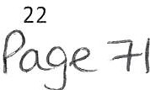

- Results in improved town centre ooherenoe; g) Improves oar parking provision;
- Strengthens and diversifies the tovms offer

New Policy R7PU: The Key Service Centres

Development that supports the roles of Cleator Moor, Egremont and Millom as the Key Service Centres, strengthens and diversifies their offer and improves vitality and viability will be encouraged, particularly where it builds upon the strengths and opportunities identified above and helps address the list of challenges. Development will be supported where it:

  - Is located within the Town Centre boundaries of the Key Service Centres
  - Builds upon and addresses the strengths, opportunities and challenges associated with each town, as set out in table***
  - Provides convenience and comparison shopping, or range of other services, including leisure provision to serve the settlement and surrounding communities
  - Encourages evening and night time uses that contribute to the vibrancy, inclusiveness and economic vitality of the centres
  - Diversifies the range of residential accommodation in the key service centres, including the re-use of vacant floors over shops;
  - Provides improvements to public realm and signage
  - Provides enhanced connectivity and town centre coherence, including providing active travel links to public transport hubs
  - Provides or enhances car parking provision where appropriate
  - Promotes the reuse of Brownfield Land
  - Results in the repair and renovation of derelict and historic buildings, particularly those that are sited in prominent positions within the town centre and those that form part of a gateway into the town centre.

  - Local Se rvice Cent res , Sustainable Rural Villages and Other Ru ra l Vill age s
Proposed Change
To remove Policy R9PO and R13PO and incorporate them into policy R8PO under a new name. Two amendments have also been made to the policy. Firstly , a criteria has been added to define what is meant by 'small scale' in the context of development in the open countryside. Secondly , a criteria has been added to state that 'appropriate marketing' of retail and services in rural settlements should be over a 12 month period.
Justification
There was a level of overlap between policy R8PO, R9PO and R13PO. A single policy relating to supporting existing provision as a means of maintaining the viability of smaller, rural centres is considered to be a more streamlined approach. This was advised by consultants producing the Retail Study to support the Local Plan and should provide clarity over what we expect within rural settlements.
A figure of 150sqm has been included as our threshold for 'small scale development' in the open countryside. This is designed to provide greater clarity surrounding the development we will support in principle in the open countryside. This figure has been suggested by the consultants producing the Retail Study Update to support the emerging Local Plan based on

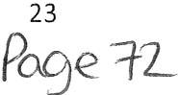

their previous experience. The 150sqm figure is considered to be adequate size for a modest farm shop or small office development, for example.
The criteria to market village services over a 12 month period has been included to further improve clarity. It also reflects the period of time required for a community asset transfer, which could help to prevent the loss of these services in the future.

Policy R13PO: Loss of Village Shops, Post Offices and Public Houses

The loss of existing village shops, post offices and public houses through ne•N development requiring planning permission will only be permitted where it can be clearly demonstrated, to the satisfaction of the Council, that:

    - Its continued use as a village shop, post office or public house is no longer feasible, having had regard to appropriate marketing (over an appropriate period of time and at a price which reflects its use, condition and local market values), the demand for the use of the site or premises , its usability and the identification of a potential future occupier; or
    - There is sufficient provision of such facilities in the area; or
    - That sufficient alternative provision has been, or will be made elsewhere which is equally accessible and of the same quality or better than the facility being lost.

Policy R8PU RiPO: Local Services Centres, Sustainable Villages and Other Rural Villages Retail and service provision in rural areas

Local SeNice Centres, Sustainable Villages and Other Rural Villages
Development will be encouraged where it provides small scale retail and service provision that will support and strengthen sustainability and local community viability and is appropriate in scale to its location in accordance with Policy R2PO. Strong emphasis will be placed on the retention of existing provision. and any proposal for loss of retail or service use will need to be robustly justified.

Open Countryside

Small scale farm diversification, retail and leisure schemes (150sqm or less) will be considered where they meet the requirements of national policy the NPPF and where:

- The development respects the character of its setting and the countryside
- There are sustainable transport links
- The development would not lead to unacceptable harm to biodiversity interest assets
- It can be robustly justified that there is need for an open countryside location.

Loss of retail and services in rural settlements
The loss of existing village shops, post offices and public houses through new development requiring planning permission will only be permitted where it can be clearly demonstrated, to the satisfaction of the Council, that:

- Its continued use as a village shop, post office or public house is no longer feasible, having had regard to appropriate marketing (over twelve months and at a

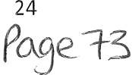

price which reflects its use, condition and local market values), the demand for the use of the site or premises, its usability and the identification of a potential future occupier; or
- Sufficient alternative provision is, or will be as part of the proposal, made elsewhere which is equally accessible and of the same quality or better than the facility being lost.

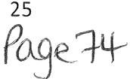

Changes to the Tourism Chapter
7.1 Tour ism
Proposed Change
The deletion of Policy T1PO below and moving the wording into supporting text
Justification
Policy T1PO acts as a statement rather than a policy. The policy is not necessary as tourism is covered under a number of other policies within this chapter. The wording will still be included in the Local Plan as text to support the other tourism policies.
Policy T1PO: Strengthening the Tourism Offer
The Borough's tourism offer 1t•ill be strengthened and mmdmised through a sustainable
m1
1
and proactive approach to enhance Copeland's role as a high quality and attractive destination for day visitors and longer stay tourists. The Council will
¥.'Ork positively and pr::oactively wi th the Lake District National Park Authority,
Cumbria Tourism, National Trust, Forestry England and other touFism organisations and developers in marketing, coordinating and managir.:1g the
development of the Borough's offer and to maximise the 'Lake District Coast' brand.

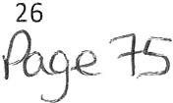

Changes to Copeland's Communities Chapter
  - Dist r ib u t i on of Housin g
Proposed Change

Amend the housing figures (housing requirement and growth figure) based on the latest draft SHMA and the revised plan period. The SHMA suggests a housing requirement of 149 dwellings per year and a growth figure of 200 dwellings per year. Amend the policy to bring it in line with the new settlement hierarchy and revise the proportion of dwellings directed to Local Service Centres and Sustainable Rural Villages.
Note that the final column previously showed the additional growth required above the baseline housing requirement. This has been amended so that the column now shows the total figure which incorporates the baseline requirement.
Justification

The amended housing figure reflects the most up-to-date evidence as set out in the draft Strategic Housing Market Assessment (SHMA) 2021. The proportion of housing directed to each tier of the hierarchy reflects changes made within the hierarchy, namely that the number of Sustainable Rural Villages has grown and the number of Local Service Centres has fallen, and is designed to keep the balance of development across the tiers broadly consistent with the Preferred Options.

Policy H4PU M4PO: Distribution of H0using

ifhe distribution of housing in the Borough will me bmadly in line with the settlement hierarchy set out below. Additional housing will be supported within the Principal Town tGwRs, Key Service Centres and Local Service Centres wher;e it accords with the Development Plan.
The amount of housing identified witlilin the Sustainable Villages and Other RYfal Villages, required to support economic growth, is limited to the amount shown below.

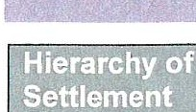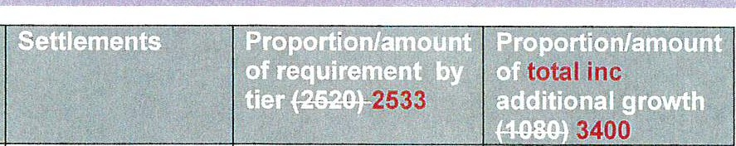Principal Town

Key Service Centres

Local Service Centres

Whitehaven 40% 40%
1008 dwellings 432 d1n ellings 1014 dwellings R9in iFfH:Hfl
1360 dwellings minimum
Cleator Moor 30% 30%
E remont 756 dwellings 324 dwellings Millam 760 dwellings R9iniR91::1R9
1 020 dwell i ngs mi n imum
Arlecdon & 19% 19%
Rowrah 504 d'l.iellings 216 dwellings
Cleator 482 dwellings R9iniR91::1m
D istington & 646 dwellings
Common End minimum

27
Pa_ge'¾

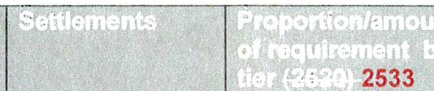
J total inc
---; . .
Drigg & Holmrook Frizington Haverigg Seascale
St Bees
Thornhill Bigrigg
Sustainable Rural Villages
Beckermet
-7%--8%
1 i 177 dwellings
1B- gi r_gi g_ ---i 203 dwellings Ennerdale Bridge
Moresby Parks Moor Row Lowca
Parton
-7-.9/4 8%
76 d1Nellings maximum 272 dwellings maximum

 | Calderbridge
Other Rural Villages | C alderbridge |  | 3% |  | 3%
 | ,_-Ha _l -lt_hw_ a _i te- s | _, | 76 | dwellings | 102 dwellings  maximum
 | Keekle
 | Kirkland
 | Kirksanton
 | Summergrove
 | The Green
 | Lowca
 | Nethertown⁷
 | The Hill

7 The Hill an d Nethertown have been removed from the Set tlement Hierarchy due to their low sett lement servicescore, and are now within the Open Countrysid e. Pleasesee the Develop ment St rat egy and Hierarchy paper for more info rmat ion
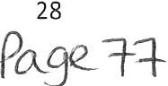

  - Housing All ocat ions
Proposed Change
Change plan period from 2017-2035 to 2021-2038 and delete or amend draft allocations where evidence shows the site is no longer deliverable or where full planning permission has been granted as shown in Tables 3 and 4 below. We have also reordered the table according to the new settlement hierarchy positions. Indicative yield for Site HDl2 has been reduced to enable incorporation of open space.
Justification
These changes have been proposed to ensure the Local Plan covers a 15 year period from adoption as required by the NPPF. It also ensures that housing needs can be met by identifying a supply of deliverable allocations. The policy has been updated in light of the latest settlement hierarchy.
Justification for removing or adding individual sites can be seen in Tables 3 and 4 respectively. Maps showing each of these sites can be seen in Appendices 4 and 5.
Table 3: Allocations brought into the Local Plan

Allocation Ref | Settlement | Reasoning | Map number
HDH3⁸ | Drigg/ Holmrook | This has been brought in following the removal of allocation HDH1. It is considered more suitable as it provides a more even split of allocations between the two settlements of Driaa and Holmrook | 13
HSE3 | Seascale | This allocation has been brought in following the removal of HSE1 | 14
HSB3 | St Bees | This allocation has been brought in following the removal of HSB2 | 15

Table 4: Allocations removed/amended in the Local Plan

Allocation ref | Settlement | Reasoning | Map number
HWH1 | Whitehaven | Section marked as Ws008a on the map will be deleted from draft housing allocation, with the remaining allocation only comprising of Ws013. This is because WS00S now has full planning permission. | 16
HAR2 | Arlecdon/ Rowrah | The site has been granted planning permission since the Preferred options was published | 17
HDH1 | Drigg/ Holmrook | Issues surrounding landscape character and surface water | 18
HFR1 | Frizington | Access issues and topography of site. It is proposed to keep the land within the settlement boundary should an acceptable and deliverable scheme be  developed. | 19
HSB2 | St Bees | Objection from CCC Highways Department surrounding difficulty accessing site. | 20

⁸ Pleasenote we are awaiting confirmation of availability of Hill Farm, Holmrook (HDH3}. This may result in removal of the site if it is not available.
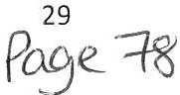

Allocation ref | Settlement | Reasoning | Map number
HSE1 | Seascale | Objection from Lead Local Flood Authority. In close  proximity to waste water treatment works and development would be backland. | 21
HBl1 | Bigrigg | Draft allocation HBl3 has been proposed for deletion as Bigrigg now sits within a lower tier in the hierarchy than previously and there is therefore no need for the site to be allocated within this Local  Plan. | 22

Policy H5PU MiPO: Housing Allocations

The following sites are allocated for housing over the Plan period 2021-2038 2017 2035. The yields idemtified are indicative only and alternative yields will be accepted where appropriate in accordance with Policy H7PO. ·

Settlement | Site Ref (SHLAA reference is shown in brackets⁹) | Address | Indicative Yield (dwellings - based on 25dph unless otheiwise  stated)
Towns
Whitehaven | HWH1 (WE032 &  WE001) | Land at West Cumberland Hospital and Snekveat Rd | 127
 | HWH2 (WH011a) | Red Lonnino and Harras Moor* | 370¹⁰
 | HWH3 (VVS00Ba  & WS0 13) | Land at Edgehill Park (former  Marchan Car Park) | &1-0-1 20
 | HWH4 (WW018/WW022) | Land south and west of St Mary's School | 98
 | HWH5 (WW014) | Former Marchan Site North* | 532
 | HWH6 (WW019a) | Land South of Waters Edoe Close | 35
Cleator Moor | HCM1 (CM028 &  CM038) | Land at Jacktrees Road | 127
 | HCM2 (CM082a) | Land north of Dent Road | 96
 | HCM3 (CM008b) | Former Ehenside School | 40
 | HCM4 (CM025a) | Land at Mill Hill | 81
Egremont | HEG1 (EG014, EG036 & EG050) | Land north of Ashlea Road | 108
 | HEG2 (EG008, EG025 & EG032) | Land at Gulley Flatts | 170
 | HEG3 (EG007) | Land to south of Daleview Gardens | 141
Millam | HMl1 (MI001) | Land west of Grammerscroft | 107
 | HMl2 (MI022 &  Ml026) | Moor Farm | 195
Local Service Centres

9 Please not e, on ly part of the SHLAA site may form part of the allocated sit e. Please r efer to the SHLAA for further details.
¹⁰ Based on planni ng application subm itte d
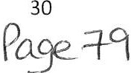

Arlecdon & Rowrah |  | HAR01 (AR009 & AR020) |  | Land East of Arlecdon Road |  | 37
 |  | HARQ2 (AR Q g) |  | PaFk ReaEI |  | g
BigFigg |  | HB I | (BIQQ ) | baAEI ASR:R ef S13FiAgfielEI GaFEleAs |  | 00
 |  | HB l2 (B IQQ2a ) |  | baAEI west ef d1:1eilee GaFEleAs |  | 4-Q
 |  | HBld (BIQQ9a) |  | S13FiAgfielEI F a F!fl |  | 44
Distingt | on | HDl1  (0 I013a) |  | Land south of Prospect Works |  | 30
 |  | HDl2 (01033) |  | Land south west of Rectory Place |  | e4 30
Drigg & Holmrook |  | HQH | (QHQQ4 ) | baAEI A0R:R ef MeaE10weF00k
 |  | HDH2 (DH012) |  | Wray Head, Station Road |  | 22
 |  | HDH3 (DH007) |  | Hill Farm, Holmrook |  | 40
Frizington |  | Hi;:R (i;:RQ4d) |  | baAEI at GFiffiA Giese
St Bees |  | HSB1 (SB001) |  | Land adjacent Abbots Court |  | 58
 |  | HSB2 (SBQQ5)  HSB3 (Part  SB018 Part SB028) |  | I -..l .-l-h ---L J\1..1..- | r-, .., | Jg  30
 |  |  |  | , - -  Fairladies Extension | ---
Seascale |  | HSE (SEGdG) |  | baAEI te west ef SaAteA V¥ay- |  | 4a
 |  | H SE2 | (SE024) | Fairways Extension |  | 22
 |  | HSE3 (SE006) |  | Town End Farm East |  | 10
+R0FARill |  | H+ H | (+ GQQ2a | b a AEI te s0 1:1t l=1 ef + R0 FARi ll |  | w
Sustainable Rural Villages
Beckermet |  | HBE1 (BE003 & BE023) |  | Land north of Crofthouse Farm |  | 46
 |  | HBE2 (BE006) |  | Land adjacent to Mill Fields |  | 27
Bigrigg |  | HBI1 (BI001) |  | Land north of Springfield Gardens |  | 65
 |  | HBl2 (BI002a,  BI018 plus small section to east) |  | Land west of Jubilee Gardens |  | 19
 |  | HBl d (BIQQQa ) |  | S 13FiAgfie lEI FaF!fl |  | 44
Moor Row |  | HMR1 (M0009) |  | Land to north of social club |  | 37
 |  | HMR2 (M0 006a) |  | Land to south of Scalegill Road |  | 41
Thornhill |  | HTH1 (T0002a) |  | Land to south of Thornhill |  | 69
Lowca |  | HL01 (L0004) |  | Solway Road |  | 22
Other Rural Villages
bewea |  | HbG (bGQQ 4 |  | S0 l1.vay- ReaEI
Summ ergrove |  | HSU 1 (M0 028 ) |  | Land to South West of Summergrove |  | 80

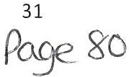

  - Affo rd abl e Housing
Proposed Change
Amend Policy H8PO to include a new requirement for 25% of affordable home ownership to be First Time Homes
Just ification
As recommended in the draft SHMA, to bring the Policy in line with the latest NPPF (2021). Please note that the draft SHMA recommends alternative affordable housing requirements of 20% and 25% are assessed through the Viability Study. The findings may result in a higher proportion of affordable housing being taken forward into the Publication Draft of the Local Plan.

Policy H8PU MiPO: Affordable housing

On sites of 10 units or more (or of 0.5ha or more in size), or on sites of 5 units or more within the Whitehaven Rural sub-area¹¹, at least 10% of the homes provided should be affordable as defined in the NPPF 2Q4.S 2021 (or any document that replaces it) unless:

- this would exceed the level of affordable housing required in the area as identified in the Housing Needs Study; or
- The development falls into an exemption category listed in the NPPF

Where the proposal involves the re-use or redevelopment of vacant buildings, a proportionate reduction in the affordable home contribution, equivalent to the existing gross floorspace of existing buildings, will be supported.

The following tenure split should be applied to affordable housing developments:

- 40% discounted market sales housing, starter homes or other affordable home ownership routes¹² (25% of these must meet the definition of First Homes)
- 60% affordable or social rented.

A financial contribution may be accepted in lieu of on-site affordable housing provision, to secure the equivalent provision off site where this is justified and helps create mixed and balanced communities. Where the number of empty homes within the settlement is above the national average, this contribution may be used to improve the standard of empty properties within that settlement and bring them back into use as affordable housing.

A lower proportion of affordable housing or an alternative tenure split will only be accepted in exceptional circumstances. In such cases developers must be able to demonstrate, to the Council's satisfaction, why the current site specific circumstances mean that meeting the requirements of this policy would render the development unviable. This should be in the form of a clear, bespoke viability assessment that will be subject to independent assessment by the Council.

11 As id ent ifi ed in the Housing Needs St ud y 2020
12 As de fi ned in the NPPF Glossary

32
Pa.9e gi

Changes to the Health, Sport and Community Facilities Chapter
  - Healt h and Well-being
Proposed Change
Incorporation of a new Health and Wellbeing policy into the Local Plan's Communities chapter.
Justification
The Council recognises the issues surrounding health and wellbeing in the borough, and understands the importance of planning in contributing to improving this. Previously, health and wellbeing was an overarching theme of the Plan, but this policy clearly outlines the Council's commitment to improving health in the borough. A link to the design policy in the Development Standards chapter will be made in the supporting text to highlight the importance of high quality, inclusive design.

Policy SC1PU: Health and Well-being.

The Council will promote and support health and well-being in the borough by:

- Producing a Health Impact Assessment and Equalities Impact Assessment to support the Local Plan which identifies the impacts of the policies within it on health and inequality;
- Implementing the policies within the Local Plan to help deliver high quality, safe developments and enhance our natural environment, improving air and water quality;
- Implementing the policies within the Local Plan that promote active travel and protect or deliver new open spaces, sports, cultural and community facilities or seek developer contributions for such facilities;
- Implementing policies within the Local Plan that support access to open spaces and the countryside;
- Supporting local strategies to improve health, social and cultural well-being;
- Supporting local communities to create spaces for food growing;
- Supporting the opening up of educational facilities for communtiy use and securing such use through Community Use Agreements where appropriate;
- Contributing to the creation of mixed communities through new or improved developments that are located in areas with access to key services to reduce social isolation and create community resilience.

  - Impact of new deve lopm ent on spo r t s fa cilit ies
Proposed Change
Incorporation of a new policy into the Local Plan's Communities chapter that ensures new development (e.g. housing) does not have a prejudicial impact on existing sporting facilities and uses.

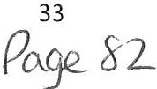

Justification
This reflects a suggestion made through the Preferred Options consultation by Sport England. It is designed to help ensure new development, particularly housing, does not prejudice existing sporting sport facilities, for example through the impacts of ball strike, noise and disturbance.

Policy SC4PU: Impact of new development on sporting facilities

New development must not prejudice the use of existing sports facilities within the vicinity of the development site. Potential impacts such as ball strike, noise and disturbance, impacts upon parking and access must be considered at an early stage when drawing up proposals to avoid or minimise complaints from future occupiers of the new development.

Where potential harm is identified, mitigation measures must be agreed with the Council and Sport England. This may be in the form of acoustic fencing, landscaped bunds, ball strike zones etc and the exact measures will be dependent upon the specific development.

Where ball strike zones are required opportunities should be taken to create multi-purpose spaces where appropriate which can act as spaces for biodiversity, drainage areas etc.

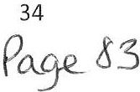

Changes to the Copeland's Places Chapter
  - Herit age Co ast
Proposed Change
Incorporation of a new policy into the Local Plan's Places chapter that helps to conserve, protect and enhance the Heritage Coast.
Justification
This modification was suggested by statutory bodies during the consultation on the Preferred Options Draft of the Local Plan. It sets out the Council's commitment to ensure that new development does not harm the Heritage Coast or its setting.

Policy N7PU: St Bees Heritage Coast

New development within, or that affects views into or the setting of, the St Bees Heritage Coast must preserve, protect and enhance the Heritage Coast and its setting and take opportunities to encourage the public to enjoy and understand the area by improving public access for all, and interpretation where possible.

Developers should demonstrate that they have taken into consideration the features that contribute to the special character of the area and the importance of its conservation.

  - Protection of Watercourses
Proposed Change
Incorporation of a new policy into the Local Plan's Places chapter that helps to protect Copeland's watercourses.
Justification
This modification was suggested by a statutory consultee during the consultation on the Local Plan Preferred Options Draft. It sets out the Council's commitment to help protect or improve the quality of the Borough's surface and groundwater water resources.

Policy N5PU: Protection of watercourses

New development must seek to protect or improve the quality of surface and groundwater water resources, including designated coastal Bathing Waters and Shellfish Waters downstream. Proposals should follow the hierarchy for wastewater treatment with foul drainage connected to mains sewer wherever possible.

The possibility of contamination from former uses on any application site and its effects on the water environment and human health needs to be consideredand remediated where it is present.

Proposals will be required to support the objectives of the Water Framework Directive, including the objectives for Protected Areas (such as Bathing Waters and Shellfish Waters) as set out in the North West River Basin Management Plan.

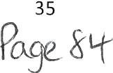

New development should ensure there is sufficient water resource available to meet current and future needs, without putting the environment at risk. Wherever possible development should include water efficiency and saving measures.

  - Community Gro wing Spaces
Proposed Change
Incorporation of a new policy into the Local Plan's Places chapter that encourages the provision of new community growing spaces.
Justification
This policy is designed to support health and well-being in the borough and provides opportunities for social improvements and community cohesion. This is related to the Health and Wellbeing policy within the Health, Sport and Community Facilities Chapter

Policy N14PU- Community Growing Spaces

The Council will support opportunities for the creation of community-led growing spaces (including allotments and urban orchards) on disused sites where such spaces are to be managed and maintainedby town or parish councils or community groups. Spaces must not have a detrimental impact upon the street-scene through inappropriate fencing or paraphernalia and adequate levels of parking for users should be available in close proximity to the site.

  - Green Infrastructure
Proposed Change
Incorporation of a new policy into the Local Plan's Places chapter that emphasises the need to protect and enhance Green Infrastructure networks.
Justification
The Local Plan currently contains policies relating to specific types of Green Infrastructure but at present does not contain an overarching policy relating to it. Responses from statutory consultees at Preferred Options stage have requested such a policy is included to clarify the importance of Green Infrastructure. The following policy will demonstrate the Council's commitment to protecting and enhancing GI in the borough.

Policy N9PU- Green Infrastructure

A comprehensive, high quality network of green infrastructure will be identified through a Green Infrastructure Strategy for the Copeland Local Plan Area. This network will connect our towns and villages to the more rural parts of the borough and the coastline and will be formed of a variety of Green Infrastructure types including open countryside, green wedges, protected green spaces, local green spaces, rivers, ponds, grass verges, woodlands and trees, private gardens, green walls and green roofs.

The amount of Green Infrastructure on the developmentsite should be maximised and developers should take opportunities to create new connections, expand networks and

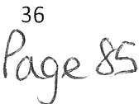

enhance existing Green Infrastructure to support the movement of plants and animals. Green Infrastructureshould be multi-functional where possible and should be considered at the start of the design process.

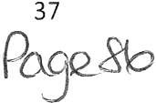

Changes to the Copeland's Connectivity Chapter
  - Su st ainab le Tr anspor t
Proposed Change
Include a new section in the Sustainable Transport Policy relating to the protection of disused rail infrastructure
Justification
This addition to the policy is designed to protect disused rail infrastructure. This ensures that development does not prevent future reuse of this infrastructure, and can improve opportunities for new active travel routes in the future. This shows our commitment to providing high quality and cohesive active travel links within the borough.
Policy C04PU C04PO: Sustainable Travel
i
The Council will support developments which encourage the use of sustainable modes of transport. In particular, the following will be encouraged:
- Proposals that have safe and direct connections to rnutes that promote active travel, such as walking and cycling, and those that provide access to regular public transport services.
- Proposals that encourage the sustainable movement of freight.
- Proposals that make provision for electric vehicles in line with policy CO?PO

- Proposals for the integration of eleGtric 1.iehiclecharging infrastruGture into new de¥elopments. This 11.iill h a1•1e different requirements dependent on the scale of dei.•elopment.

The Council will seek opportunities to use disused rail track beds to widen sustainable transport choices, encourage active travel within the borough and provide spaces for biodiversity.

New development that would prejudice the future use of disused railway lines that are well connected either to settlements, other sustainable travel routes or key tourist facilities within the open countryside for this purpose will only be considered in exceptional circumstances.
Devel0pm,ents that are likely to generate a large arnount of movement will be required to be supported by a Transport Assessllilent and Travel Plan. The criteria for these requirements will be 0utlined in Appendix X.

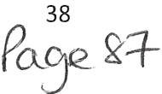

11. 2 Elect r ic Vehi cles
Proposed Change
To include a new section in the Parking Standards Policy which relates to the provision of Electric Vehicle Charging Infrastructure
Justification
To set out the expectations we have surrounding the provision of electric vehicle charging infrastructure, following comments received through the Preferred Options Draft consultation. This reflects the goal of achieving the Cumbria target of net zero carbon by 2037, as well as the expectation that all vehicles will be electric in the future. Previously this was included as a brief point in the Sustainable transport policy, but it did not set out our expectations clearly enough .

Policy C07PU C0 7PO: Parking Standards and Electric Vehicle Charging Infrastructure

Proposals for new development will be required to provide adequate parking provision in accordance with the Cumbria Development Design Guide or any document that supersedes it, where appropriate. Where there is satisfactory evidence that this cannot be provided, sufficient on street parking will be required without detriment to the street scene or residential amenity. There will also be a requirement for the provision of secure cycle parking in all new car parks as well as accessible parking bays and associated development.

Development will be supported where it accords with the Whitehaven Parking Strategy or any document that supersedes it. Proposals that provide new or improved Park and Ride Facilities for local employment and development sites will be supported where they will provide demonstrable benefits and will be situated in appropriate locations.

The following new developments should integrate new Electric Vehicle Charging Infrastructure as follows:

- For new residential development (excluding extensions and conversions), one charging point must be provided per dwelling with off street parking. Where off street parking is not provided, a commuted sum will be required to provide charging facilities in the immediate locality.
- For major non-residential development, at least one charging point must be provided per 10 spaces and the infrastructure to enable future installation of charging points in every parking bay where possible and viable. Consideration should be given to grouping parking bays to optimise provision of charging infrastructure. Where off street parking is not provided as part of the proposal (e.g. due to a town centre location), the applicant must provide a commuted sum towards the alternative provision of Electric Vehicle Charging Infrastructure.

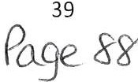

Appendices
  - Appendix A: Land proposed for inclus ion wi t hin Set t lem ent Boundarie s
This appendix sets out the areas of land which we are proposing to bring into the settlement boundaries. Please refer to Table 1 for more information on each site and the reasons for the decisions.
Map 1: Land south Derwentwater Close, Millom
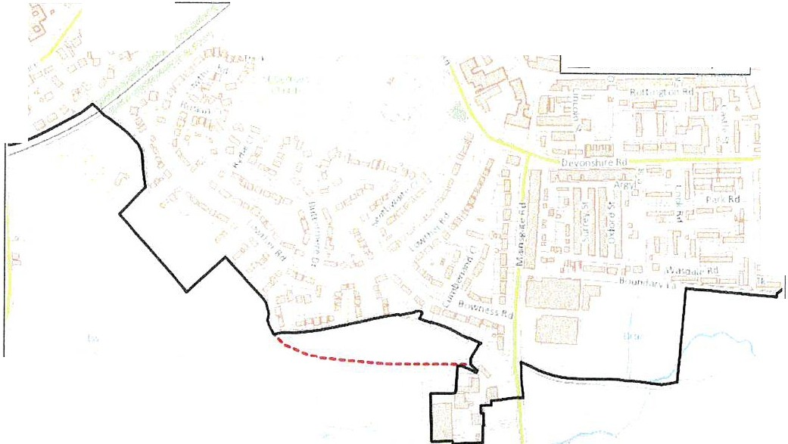
Legend
i:.!Draft Settlement Boundary Exten!ilof\
c=J CurrentSettlement Boundary

,.,...

f ,, ,

Map 2: Crook Field, Millom
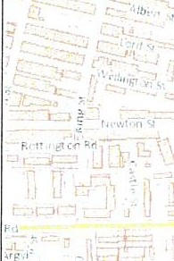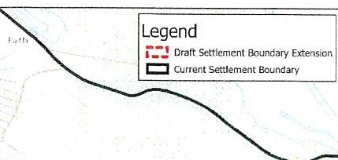
',,
' '
- , ,. I I' ,:.-,1
. ""
1, V
r ---- -.J'-----
-.L-------
--- - - - -1

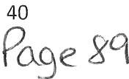

Map 3: Land south of Fairladies, St Bees (Allocation HSB3)

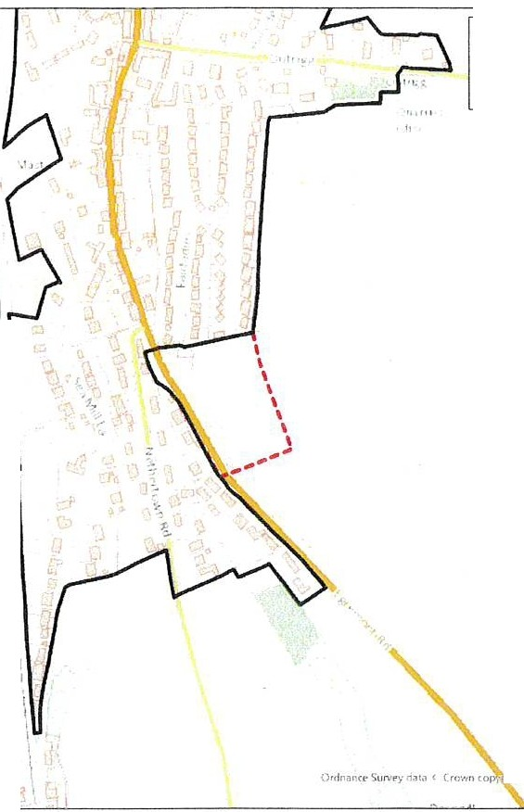Legend
c::] Current Selttement Boundar y
i-:!Draft Settlement Boundary Extension

- 'r . ..

I
I

1 th \

, qh,t m<l e1,111l!,h .H ... ,,. 11i1:.>un O'io HiC(B(lq\)l.

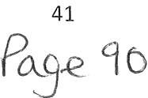

  - Appendix B: Land t o be removed from Settlement Boundaries
This Appendix sets out the land which we are proposing to remove from the settlement boundaries. Please refer to Table 2 for more information on each site and the reasons for the decisions.
Map 4: Land south Baybarrow Road, Egremont
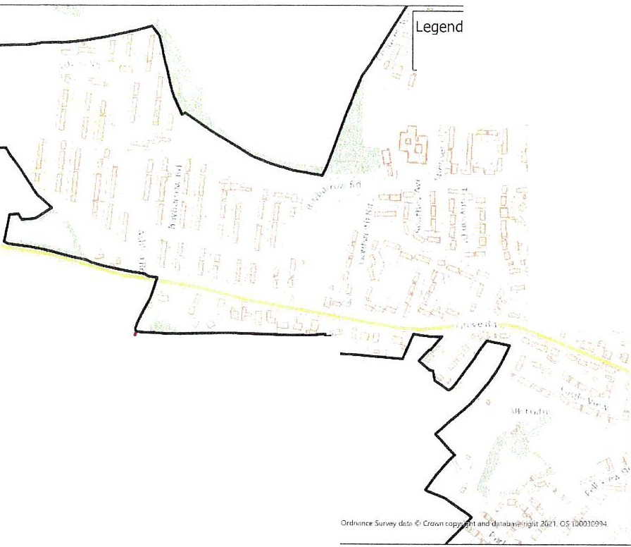
t, J Remo,i,1! ol Ora SettleemnlBcundary Exteru.ron
CJ Curr e-it Senle nt Bouridary
',1,1
I
I
I - - - - - • •- , • - - • • - • • "'
I
I

Map 5: Land north Back Bay View, Millom
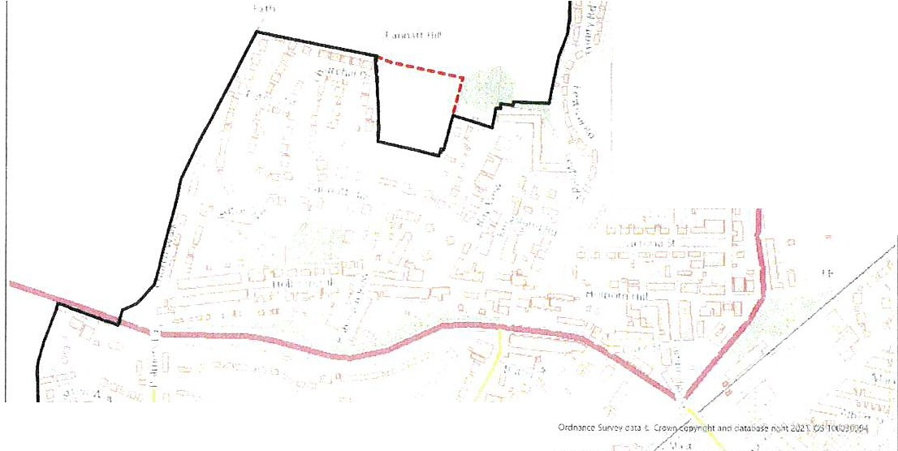
,lh
- 1f.·,,,.,,,.,,·,·1/,(
- 1UI
"'V, '.

,./ ·
'1 l ., ,:,,
; 11 :...
tr
r i..., t..-,
r
lt\ , ,'
j
Legend
t. : 1 Removal of Draft Settlement Boundar y E!rteMiori
c:::]Current Settleme nt Boundary

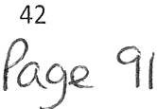

Map 6: Land to rear Hound Inn, Arlecdon and Rowrah
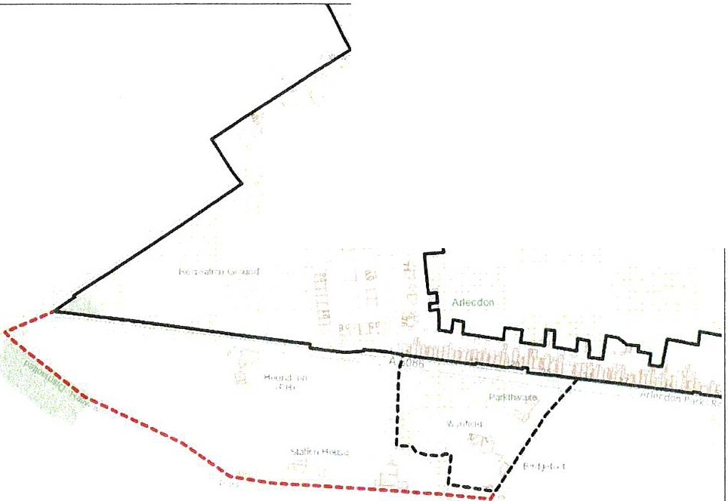
r, ·,1 I
r ,, , ,, .. 1•
"'
Legend
-=.4, Rcmoval of Draft Scttlcmc-nt Bounda ry Exums:on
C CUrr enr Settlement Bol.ll"Aary
,:_. Orart Settlement 8oundc1;y Extcnsmn

Map 7: Land north Wray Head, Drigg and Holmrook

Legend
t : 1 Removal of Draft Settlement Boundary Extensio n
c::::I Proposed Settlement Boundary
/
•
I
I

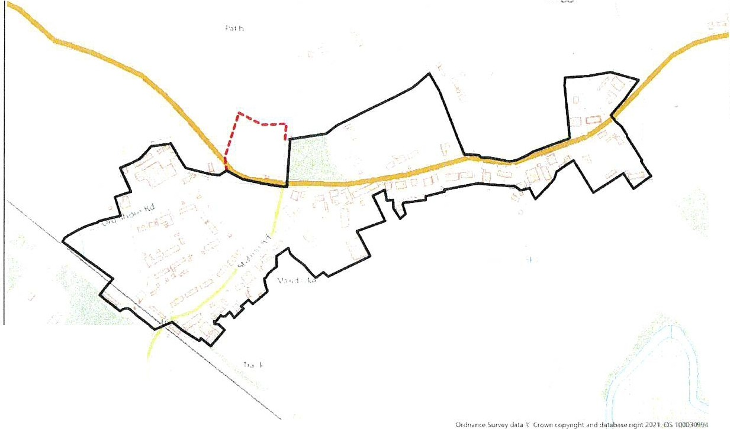
43
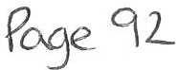

Map 8: Land north west Holme Forge, Beckermet
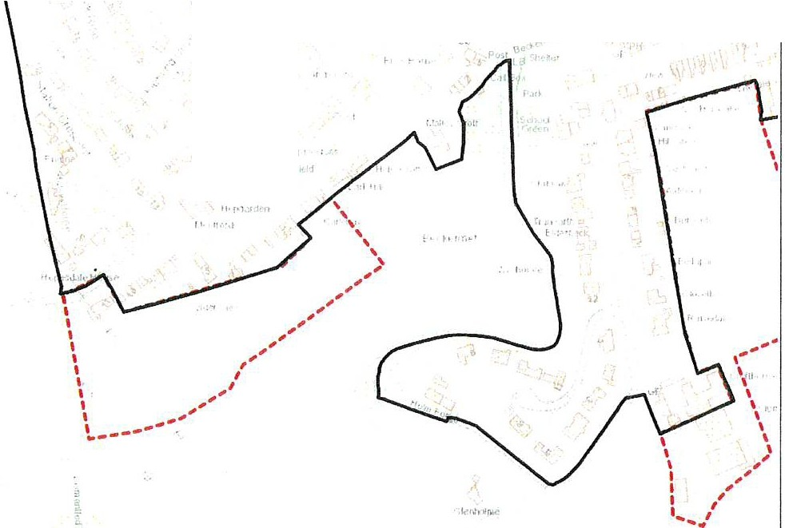
' I I I
•1· 1 ,1
Ordn1 nce Su \litta Crown copyright and database ught 20ll OS 100(B09':14
' u '
Legend
t, : 1 Removal of Dtoft Settlement Boundary Extension
c::J Current Settlement Boundary

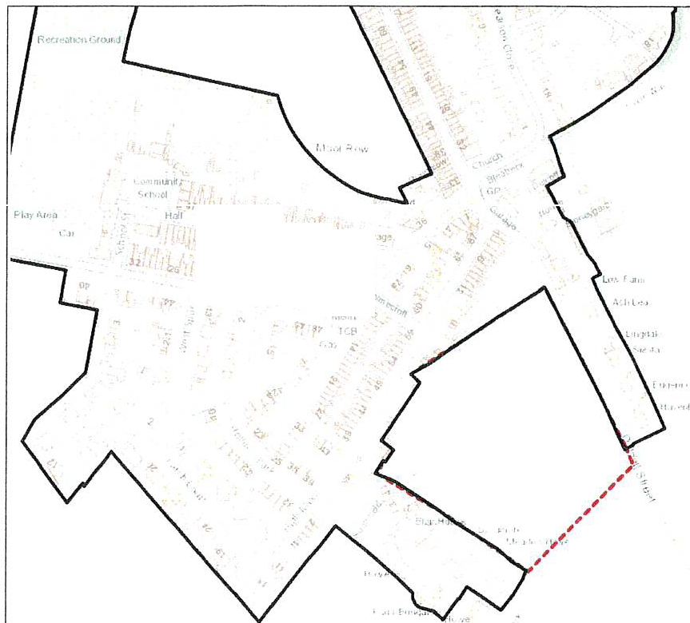
Map 9: Land at Moor Row, Moor Row

" | Legend  t,:,1 Re moval of Draft Settlement Boundary Extension  c::J Current Settlemen t Boundary
_,,. .,.
.,,,., ,,J ,_
F<l, "' ow ;,
3( -i! -Ji ,., < ,;. "-,
ll I, ,. ,, a
•'
,, ., I ,,. > ' ,.
, '"..
" " {
,.,

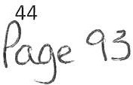

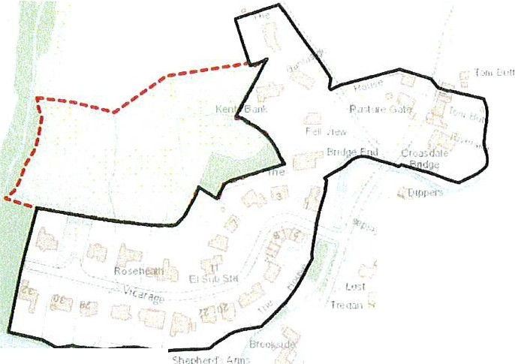Map 10: Land behind Vicarage Lane, Ennerdale Bridge

Legend
': : 1 Removal of Draft Settlement Boundary Extension
l::J Current Settl1?mcn t Bou ndary
I "

.. l 'J'"i' i
-.,1.·,,

f• , 1: JuTII,
I ll f, 11
>i lc-r•
Th,m[•,+•

IU..t1

\,r1vey..-d l)!r, ,i r,m., S4J1V Wltil C1ow1\coµy,19htaodc:lat•bf ngtit 2021. OS10003099-1. Lil.
W.xM,eml f-1u n 11 I· I

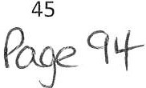

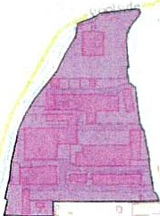
Appendix C: Changes to Employment Allocations
This appendix shows the additional sites that have been brought into proposed Policy E5PU in the employmentchapter as existing employmentsites.
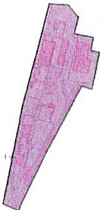
Map 11: Energy Coast Business Park
Legend
l:.:] AddlUonal Employment Allocation
J
!

Map 12: Haverigg Industrial Estate
t 'llllJ"
Legend
E:) AddrUonal Employmnet Allocation
H,w rigg
,, ,,I ,.
,11,1
11, "'
II' ' '
:itcn ar>o::cS r ,t; :I :.>. ';r ,:>·1, n Ct? i '--;; '. _,,,,d d <1tJ b J <: righ: Wi'.1 0 !::x>'.':L'g'µ
. ' ' 1,.

46
P°"_se crs

  - Appe n dix D: Addit iona l Hous in g All ocat ions
This appendix shows the additional housing allocations that we are proposing to include within the Local Plan. Please refer to Table 3 for more information
Map 13: HDH3, Hill Farm, Holmrook
Legend
r_-J Draft Settlement Boundary Extension
I::]Proposed New Housing Al\ocat10n
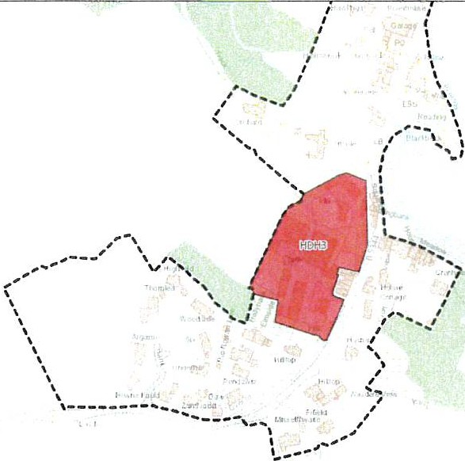 ,,,,....

Map 14: HSE3, Town End Farm East, Seascale

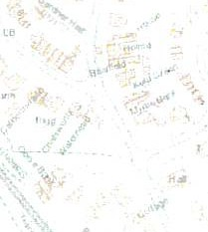
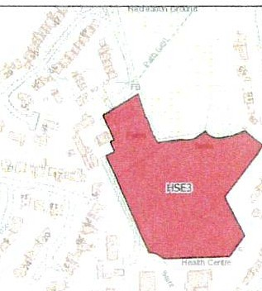.
Legend
E::J Proposed New Housmg Allocation
I
\
L, ..
..

47
Pcxge 96

Map 15: HSB3, Land south of Fairladies, St Bees

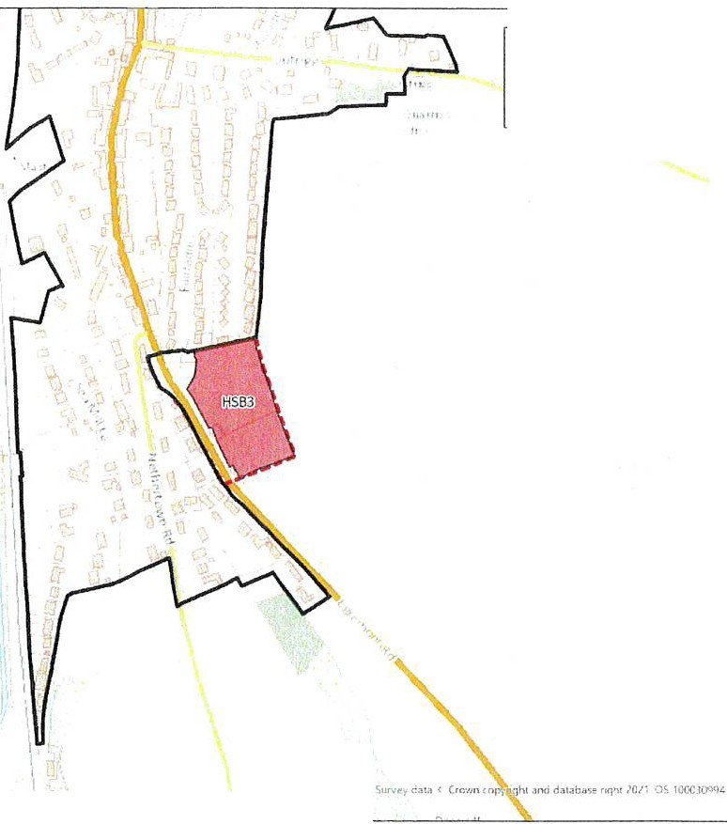I
Legend
r_-. Drah Sen/£:rr-ent BcJndary[ 11te ns 1on
0 Propcsec: New Housing Allocahoo
c:::::I Current Settlement Soundary
....
,,
I Jth
Outran

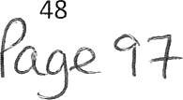

  - Appe nd ix E: Ho usin g Allo cat ion s prop ose d to b e rem oved or reduced in size
This appendix shows the housing allocations that we are proposing to remove from the plan or reduce in size. Please refer to Table 4 for more information
Map 16: HWH3, Whitehaven
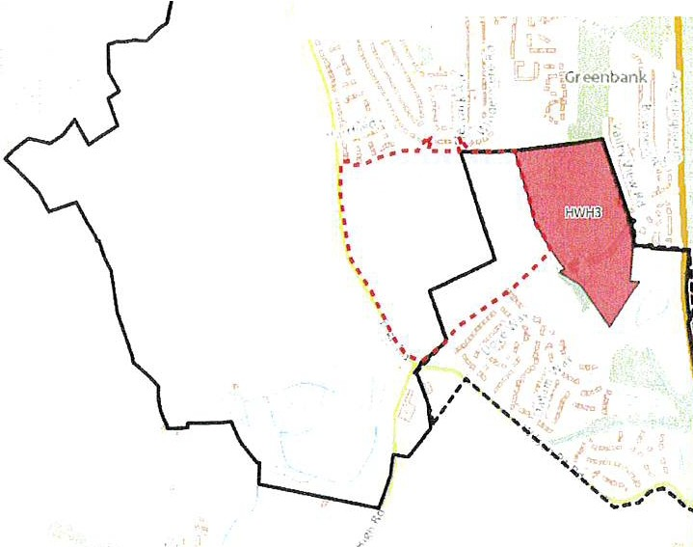
,·
'
\ \'Voodh o us<>
.,.
M i r e h o u se
E•st
Mis'ehOu se

Wes t
\
\
i
I
t -'!1,' I Q<,; li)R1if1911\
Lege n d
.:::I L•• ..,_ '>c:!ll.:".11<:"' 0.,.,•c,;ry
r-.:, O,r<,i:11-,1\o,,. r,t• ,:...;in
CJ, ,,·i!.'<:He,,ur.'<1:.l :.1a n
r .• •,, J>,r,, _,. ,.,, ., ,,o.il, n :.-.,#.'" ·"

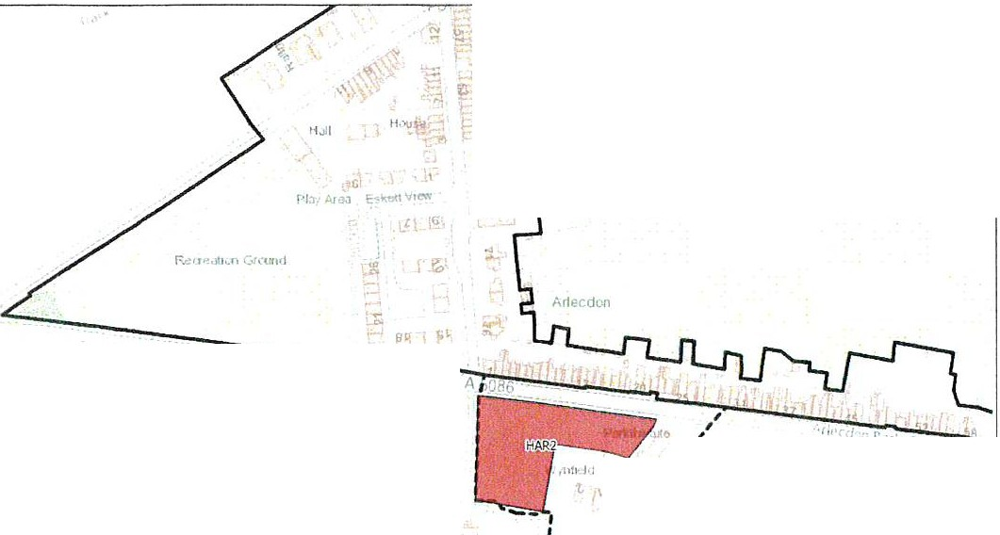Map 17: HAR2, Arlecdon and Rowrah
tf' II j,u, I ,1,
, ,
,,I
,,
, t .. II I
,I
I
,'I
Legend
c::]OJ tSct!.ltff'l:!"ll i'!,o,rlc: ry
r_-,Craft Settte t ecund,y ensron
0 R.ttn ova l cJ aft Alocaorio
11i,j>J /
r,, ,,

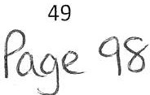

Map 18: HDH1, Drigg and Holmrook

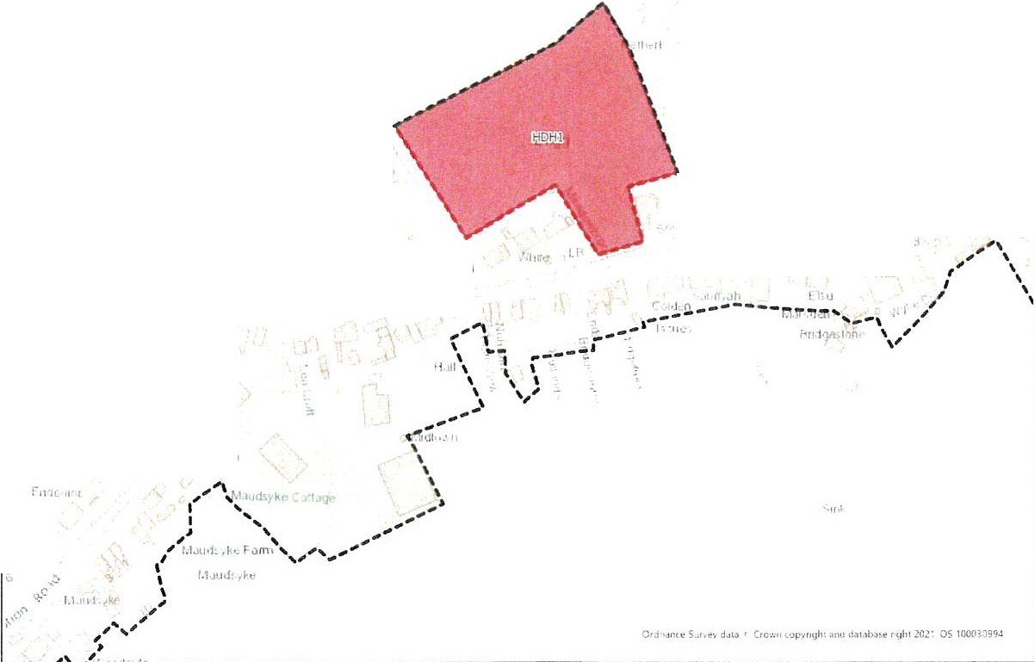,
Legend
r_-, Or.ill SelUement 8<:a.nd.iry
D Reino•ial of D1dft 0.1ocJt 1t1n
r_-, RE',IS<!d Sett,erne1. 1 8ou 11d ary
1
"
l 1 .I '
I ' ,
,....
I
I ' 1
,,'
, -----
I
; '
,,
I I I I
I
I
,,
I
I I
t ...
-- -
I•
\
I'
\ \
-
I
I
I
\
- - - , _ _
, ..
....
..
, ...........
, )
I
_ _ _ _ ..,,"" r.t
I I . ,
l ,r I
ff
f H ll l
'I

Map 19: HFR1, Frizington
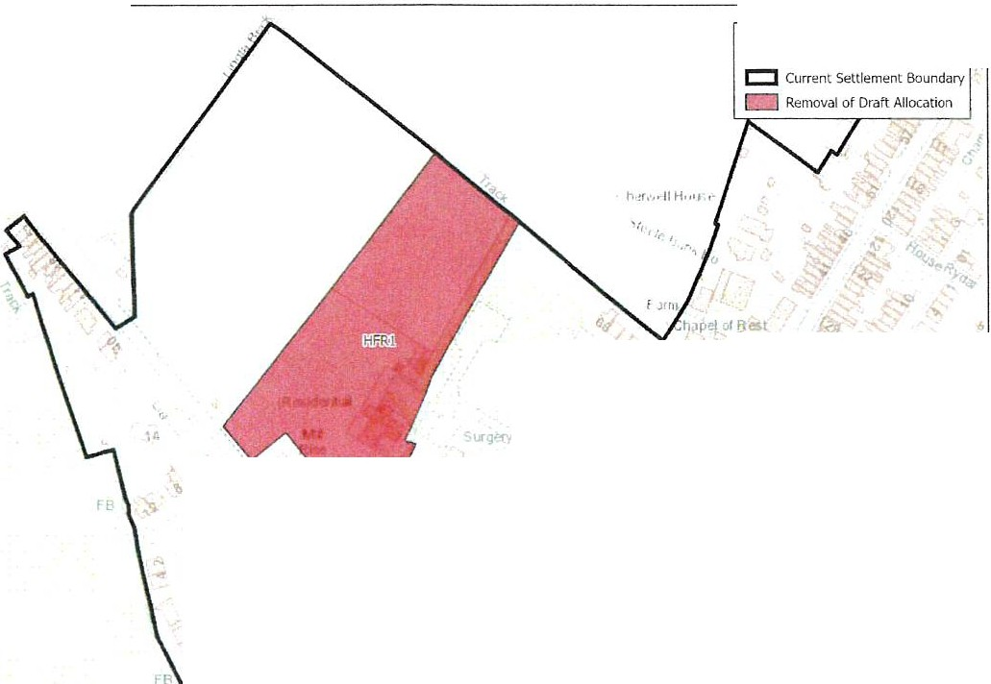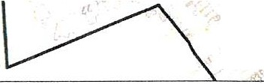
Legend
I flell
lo
L ''!'
..
l
't
Club
:.•
f
i ◄
,:
l:
/!
t;t;
zy
r ,,ror^{J}s^{t} ^{J}
I .Cd
L
..,
,;,
,
, ..
i-,
/;
J.-u,.,
n l t•Jl'/!111
I'< l h ,, ll'•J t,;/1_
'1
','
t
,,,,'
f,,;
fl, 1

; I
r,
•·"!!. •
'",
::,
:-/ "'
" l t L-' ol f •o ,11 · r,.1>rn ,;,,lt1 ,wet it! •l ' IC'') ll 'fl/1 C'i- l lllCI [tq,>,:
'

P e cn
so

Map 20: HSB2, St Bees
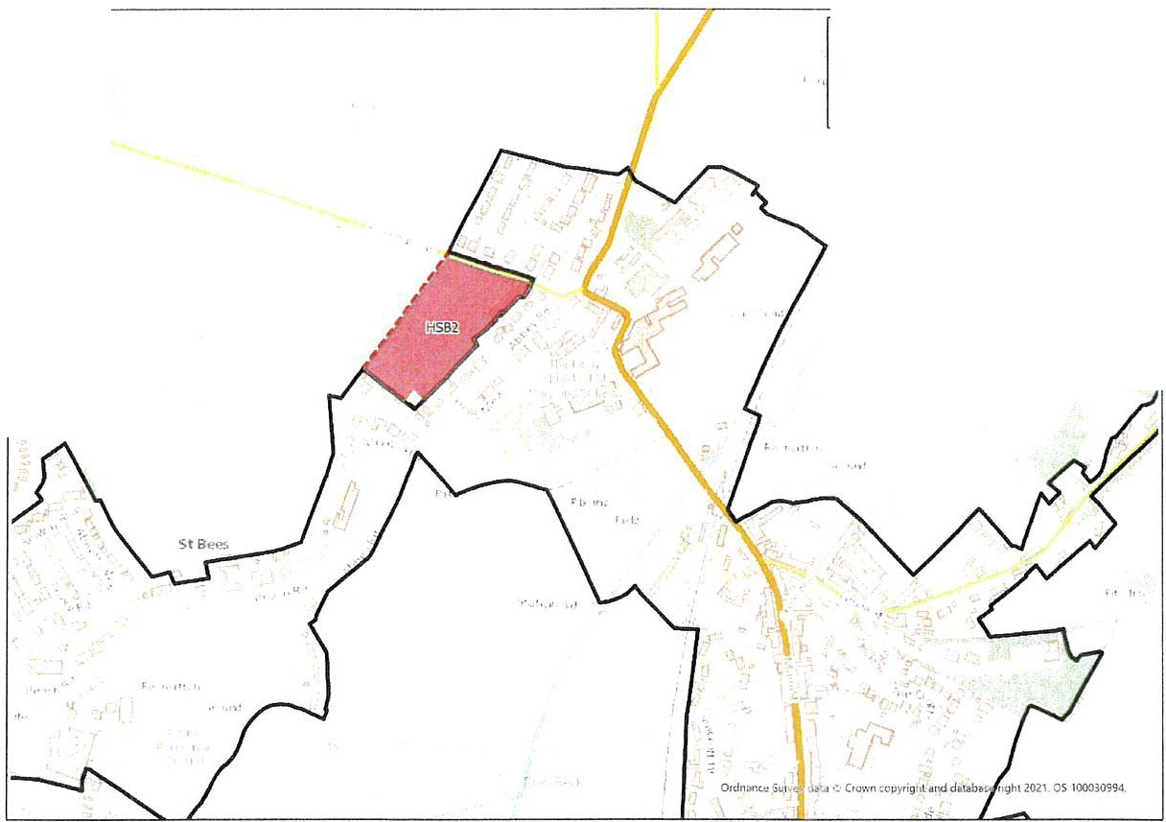
)
l
Legend
t,: 1 Removal of Draft Settlement Boundary Extension
c:::J Current Settlement Boundary
-
Removal of Draft Allocat1on

Map 21: HSE1, Seascale
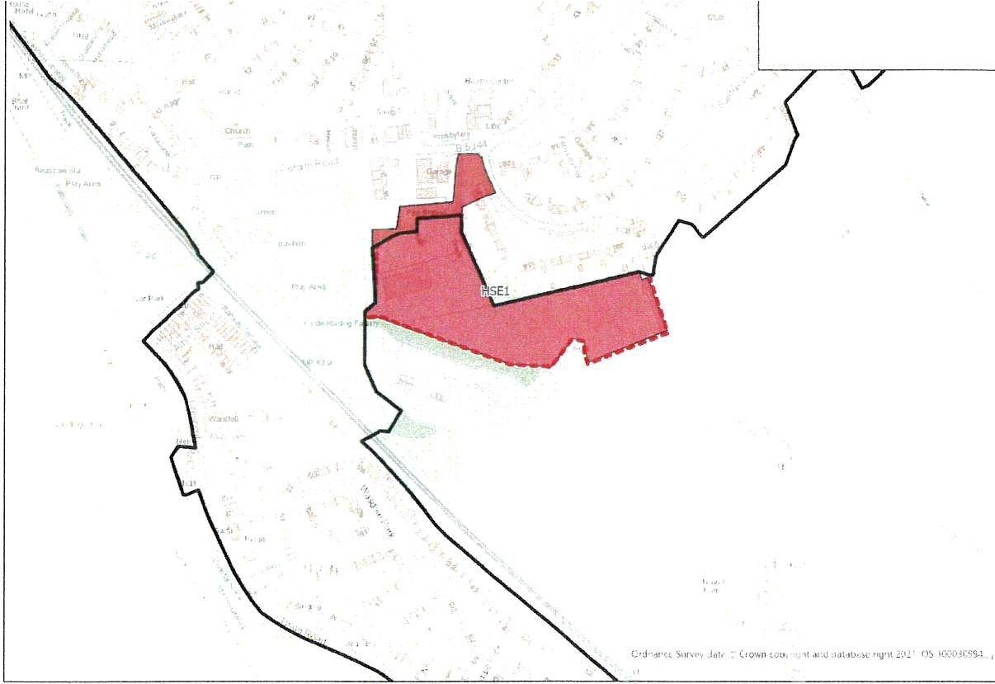
Legend
C Current Scnlcmcm Sou'W.ir,,
t::J lb!•nova!of l)iaft A!locat1on
,:. • Remova1of Dr.ifl Se.riemen1 Ooundar, hrens,on

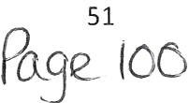

Map 22: HBl3, Bigrigg
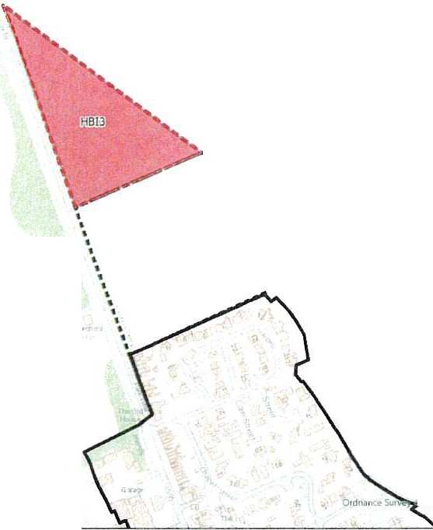
........
••...
•.
,... r-",
IIUI fl Crown copyrtqhl llnd <l.it ab ,m· •19h1 20 21. OS 1000.lM':M
Legend
:1 Removal of Draft Settlement Boundary Extension
c::JcurrentSettlement Boundary
- Removal of Draft Allocation
: : ) Proposed Settlement Boundary

