WHITEHAVEN TOWN COUNCIL

Clerk to the Council: Chairman:
Marlene Jewell Telephone: 01946 67366 Councillor Chris Hayes

To: Members of the Whitehaven Town Council

You are duly SUMMONED to attend an MEETING of WHITEHAVEN TOWN COUNCIL which will be held in the SOLWAY HALL, WHITEHAVEN CIVIC HALL, LOWTHER STREET, WHITEHAVEN

Date: 24th June 2021 Time: 6.00pm
Signed....K .... .............Dated.J < t . ?-0 2- {
Marlene Jewell, Clerk and Responsible Financial Officer

AGENDA

Apologies for Absence

To receive apologies for absence

Declarations of Interest

To receive declarations of interests by elected members in respect of Agenda items

If a Member requires any advice on any item involving a possible declaration of interest which could affect his/her ability to speak and/or vote he/she is advised to contact the Clerk at least 24 hours in advance of the meeting.

- Public Participation

- Minutes of Annual Meeting held on 27th May 2021

- Minutes of Extraordinary Council Meeting held on 10 ^{th} June 2021

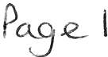
- Planning Applications

- Finance Report

- Advertising for Council Events

- Request for Sponsorship/Support

- Bus Shelter at Bransty

- Request to Lease the former Editor's Office in the Council Offices

- Recommendations from Events Advisory Group- To follow

- Venue for Council Meetings

- Councillor Ward Matters

- Date and Time of Next Meeting

IN PRIVATE

That prior to the following items of business the Chairman will move the following resolution:-

That in view of the special or confidential nature of the business about to be transacted it is advisable in the public interest that the public and or press be instructed to withdraw.

15. Councillor Ward Grant - CVG

WHITEHAVEN TOWN COUNCIL

Minutes of the Annual Council Meeting held on the 27th May 2021

Present: Councillor B O' Kane; Councillor J Rayson; Councillor E Dinsdale; Councillor G Dinsdale; Councillor R Gill; Councillor C Hayes; Councillor C Maudling; Councillor R Redmond; Councillor G Roberts

M. Jewell, Clerk and Responsible Financial Officer

- Gorley, Assistant Clerk Members of the Public Member of the Press

1785/21 Introduction

The Chairman welcomed everyone to the Annual Meeting of Whitehaven Town Council and said it was a special meeting as officers would be changing. The Chairman expressed gratitude to and thanked all his colleagues for all their help throughout the past two years and said that the last year had been unbelievably difficult and thanked everyone for their positivity and expressed gratitude to The Clerk, The Assistant Clerk and Luke Johnson for all their help. He said it was an honour to be Mayor of our Town and gave his best wishes to the person who would be taking over.

1786/21 Appointment of Chairman ( Mayor) for 2021/22

Councillor O'Kane asked for nominations for the position of Chairman (Mayor) for 2021/22.
The following nominations were received:
  - Councillor R Gill nominated Councillor C Hayes Councillor G Roberts seconded the nomination
2. Councillor J Rayson nominated Councillor C Maudling
There was no seconder for this and Councillor Rayson with Councillor Maudling's agreement withdrew the nomination
Although not necessary Councillor O' Kane requested a vote on this and it was unanimously

RESOLVED - That Councillor C Hayes be appointed Chairman (Mayor) for
P0--..9-e 3

2021/22. Councillor Hayes took the Chair and signed the Declaration of Acceptance of Office.

Councillor Hayes then thanked Councillor O'Kane for the past two years with the last year being very hard for everyone.

1787/21 Appointment of Vice Chairman (Deputy Mayor) for 2021/22

The Chairman asked for nominations for the position of Vice-Chairman (Deputy Mayor) for 2021/2022.
The following nominations were received:-

- Councillor J Rayson nominated Councillor C Maudling. This was not seconded
- Councillor Hayes nominated Councillor R Gill This was seconded by Councillor G Roberts
A vote was held and it was unanimously

RESOLVED - That Councillor Gill be appointed Vice Chairman (Deputy Mayor) for 2021/22 and he signed the Declaration of Acceptance of Office.

1788/21 Apologies for Absence

Apologies for absence were received from Councillor C Arrighi, Councillor C Walmsley and Councillor L Walmsley

1789/21 Declarations of Interest

There were no Declarations of Interest

1790/21 Minutes of the Council Meeting held on 29th April 2021

It was proposed by Councillor Maudling and seconded by Councillor Hayes that the Minutes of the Council Meeting held on 29th April 2021 be approved and signed by the Chairman as a correct record. A vote was held and 6 Councillors voted for and Councillor Gill did not vote as he had not been present.

RESOLVED - That the Minutes of the Council Meeting held on 29th April 2021 be approved and signed by the Chairman as a correct record

1791/21 Minutes of the Extraordinary Council Meeting held on 12th May 2021

Councillor E Dinsdale and Councillor G Dinsdale entered the Meeting during this item.
It was proposed by Councillor Gill and seconded by Councillor Hayes that
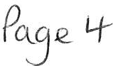

the Minutes of the Extraordinary Meeting held on 12th May 2021 be approved and signed by the Chairman as a correct record. A vote was taken and 7 Councillors voted for the proposal and 2 Councillors abstained.

RESOLVED - That the Minutes of the Extraordinary Council Meeting held on 12th May 2021 be approved and signed by the chairman as a correct record

1792/21 Public Participation

MH congratulated Councillor Hayes on becoming Mayor of Whitehaven Town Council and wished him all the success for the coming year and said he would be an asset to the Town.
GC said they were 2 good appointments, well deserved and congratulated Councillor Hayes and Councillor Gill.

1793/21 Planning Applications

Councillor Maudling declared an interest as he was on CBC's Planning Panel Councillor O' Kane said he would not be declaring an interest as he was no longer on CBC's Planning Panel.

The Council considered a list of Planning Applications received from CBC and shown at Appendix 1.
Councillor O'Kane raised concerns about two Planning Applications namely CH/4/21/2195/0R l and CH/4/2/2196/0O1 - Barras Dyke Farm and land at Barras Road. He said that both these applications must go before the full Planning Panel of CBC and to ensure that this took place the Council had to object to the applications. Councillor O'Kane then proposed that a request be made to CBC that both of these applications go before the full Planning Panel of CBC. This was seconded by Councillor Gill. A vote was held and 6 Councillors voted for this proposal and 3 Councillors abstained

RESOLVED-That CBC be informed that following consideration of the Planning Applications on Appendix 1, that planning Applications CH/4/21/2195/0R1 and CH/4/2/2196/0O1 - Barras Dyke Farm and land at Barras Road go before the full Planning Panel of Copeland Borough Council.

1794/21 Finance Report

The Council considered a Finance Report.
1. Appendix 1 - The Assistant Clerk reported that there were 5 extra invoices to consider namely:

  - V Gorley
  - M Jewell
  - Westcom
£7.98 toilet rolls and batteries
£71.28 for handi hoops litter
£257.03 for transferring files
Pog-e.5

  - Sharp
  - Tradeprint
£2700.00 New photocopier
£408.82 feathered flags

It was proposed by Councillor Gill and seconded by Councillor Hayes that the invoices on Appendix 1 plus the 5 additional invoices
listed above be approved and paid. A vote was held and 8 Councillors voted for the proposal and 1 Councillor abstained

1795/21
RESOLVED - That the invoices on Appendix 1 plus the 5 additional invoices listed above be approved and paid.
11. Appendices 2 and 3 - the Council considered Appendices 2 and 3 and it was proposed by Councillor Gill and seconded by Councillor O'Kane that these be approved and noted. A vote was held and 8 Councillors voted for the proposal and 1 Councillor abstained
RESOLVED - That Appendices 2 and 3 be approved and noted

Consideration of Recommendations made by a Committee
The Council considered a report on recommendations made by the Policy and Resources and Finance Committee in regard to Councillor Ward Grants.
- It was proposed by Councillor O'Kane and seconded by Councillor Gill that the recommendations be accepted and that the rationale for the distribution of the grants for the next financial year 2022/23 be examined. A vote was held and it was unanimously

RESOLVED - That the recommendations be accepted and that the rationale for the distribution of the grants for the next financial year 2022/23 be examined.

- It was proposed by Councillor E Dinsdale and seconded by Councillor G Dinsdale that the Wording in the Guidelines for Councillor Ward Grants be changed from "funding to support Community Groups in their Wards" to "funding that benefits the residents in their Wards" A vote was held and 4 Councillors voted for the proposal, 4 Councillors voted against and 1 Councillor abstained. The Chairman exercised his casting vote and voted against the proposal.
RESOLVED - That there be no change to the wording of the Guidelines for Councillor Ward Grants.

1796/21 Mayor/Chairman's Allowance

The Council considered a report on the Mayor's (Chairman's) Allowance for 2021/22. It was proposed by Councillor E Dinsdale and seconded by Councillor Gill that the Mayors Allowance of £3,063 be approved as stated in paragraph 1.6 of the report and that it is administered through the Office and the Mayor is reimbursed on production of a receipt for the expenditure. A vote was held and

it was unanimously

RESOLVED - That the Mayor ' s (Cha irman' s) Allowance of £3,063 be approved as stated in paragraph 1.6 of the report and that it is administered through the Office and the Mayor (Chairman) is reimbursed on production of a receipt for the expenditure.

1797/21
Council's Bank Account

The Council considered a report on the Council' s Bank Account and the 4 authorised signatories. It was proposed by Councillor Dinsdale and seconded by Councillor Rayson that the Chairman and Vice Chairman should be authorised signatories together with 2 others and Councillor O'Kane and Councillor Roberts said they were prepared to carry on. A vote was held and it was unanimously

RESOLVED - That the Chairman and Vice Chairman should be authorised signatories together with 2 others namely Councillor O'Kane and Councillor Roberts.

1798/21 Review and Adoption of Model Standing Orders

The Council considered a report on the review and adoption of Model Standing Orders which contained amendments made by NALC.
It was proposed by Councillor O'Kane and seconded by Councillor
Roberts that the Model Standing Orders be approved with the amendments made by NALC and adopted and that they be further reviewed at the next Annual Meeting in May 2022 unless in the meanwhile amendments are made by NALC in which case they will be referred to Council at that time.
A vote was held and it was unanimously

RESOLVED - That the Model Standing Orders be approved with the amendments made by NALC and adopted and that they be further reviewed at the next Annual Meeting in May 2022 unless in the meanwhile amendments are made by NALC in which case they will be referred to Council at that time.

1799/21 Review and Adoption of Financial Regulations

The Council considered a report on the review and adoption of Model Financial Regulations which were last approved by the Council in May 2019. No amendments had been made by NALC since that time. It was proposed by Councillor O' Kane and seconded by Councillor Hayes that the Model Financial Regulations be approved and adopted and that they be further reviewed at the next Annual Meeting in May 2022 unless in the meanwhile amendments are made by NALC in which case they will be referred back to Council at that time. A vote was held and it was unanimously

RESOLVED - that the Model Financial Regulations be approved and adopted and that they be further reviewed at the next Annual Meeting in May 2022 unless in the meanwhile amendments are made by NALC in which case they will be referred back to Council at that time.

1800/21 Review and Adoption of Code of Conduct

The Council considered a report on the Code of Conduct shown at Appendix 1 to the report which had been last reviewed and adopted on 15th May 2019. It was proposed by Councillor Gill and seconded by Councillor Hayes that the Code of Conduct shown at Appendix 1 of the report be approved and adopted. A vote was held and it was unanimously

RESOLVED - That the Code of Conduct shown at Appendix lofthe report be approved and adopted.

1801/21 Review of Social Media Policy

The Council considered a report on its Social Media Policy as shown at Appendix 1 of the report which was approved and adopted by the Council on 7th August 2020. Councillor E Dinsdale said he was strongly against the Policy and said it was an attempt to try and gag certain Councillors around their online activities. He said Councillors were already covered from a Copeland point of view. Following a discussion it was proposed by Councillor
O' Kane and seconded by Councillor Gill that the Social Media Policy shown at Appendix 1 of the report be approved and adopted. A vote was held and 6 Councillors voted for the proposal and 3 Councillors voted against.

RESOLVED-That the Social Media Policy shown at Appendix 1 of the report be approved and adopted.

1802/21 Review and Adoption of Terms of Reference for Committees

The Council considered a report showing at Appendix 1 the Terms of Reference for the Staffing Committee and the Policy and Resources and Finance Committee. It was proposed by Councillor Roberts and seconded by Councillor O' Kane that the Terms of Reference for the Staffing Committee and the Policy and Resources and Finance Committees shown at Appendix 1 of the report be approved. A vote was held and it was unanimously

RESOLVED-That the Terms of Reference for the Staffing Committee and the Policy and Resources and Finance Committees shown at Appendix 1 of the report be approved.

1803/21 Appointments to Committees

The Council considered a report on appointments to the two standing Committees of the Council. The Clerk asked for volunteers and the following Councillors put their names forward:-

Staffing Committee: Councillor E Dinsdale Councillor C Hayes Councillor J Rayson Councillor O'Kane Councillor G Roberts

Policy and Resources and Finance Committee:
Councillor Hayes Councillor E Dinsdale Councillor R Gill Councillor B O'Kane Councillor G Roberts

RESOLVED - That the Councillors named above be appointed to sit on the Standing Committees.

1804/21 Appointment to Advisory Groups

The Council considered a report on appointments to the Council's various Advisory Groups and approval of the Terms of Reference for the Advisory Groups which had last been approved by the Council in May 2019 It was proposed by Councillor Gill and seconded by Councillor Hayes that the Terms of Reference for Advisory Groups be approved. A vote was held and it was unanimously

RESOLVED - that the Terms of Reference for Advisory Groups be approved.

11 The Clerk asked for volunteers to sit on the Advisory Groups and the following put their names forward:-

Whitehaven in Bloom Advisory Group Councillor E Dinsdale
Councillor Maudling Councillor O'Kane Councillor Hayes

Events Advisory Group
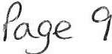

Councillor E Dinsdale Councillor Gemma Dinsdale Councillor Maudling Councillor Rayson Councillor Hayes

Allotments Advisory Group Councillor Gill
Councillor Rayson Councillor G Dinsdale Councillor E Dinsdale

Steering Group on Office Accommodation Councillor Gill
Councillor O'Kane Councillor Robe11s Councillor Hayes Councillor E Dinsdale

RESOLVED - That the Councillors named above be appointed to sit on the Advisory Groups.

1805/21 Review of Representation on or work with External Bodies and Arrangements for reporting back

The Council had recently decided that the Chairman should be appointed to sit on the Harbour Users Group and that the first meeting had been held on 24th May 2021. It was proposed by Councillor Gill and seconded by Councillor Hayes that whenever the Chairman attends the Harbour Users Group Meetings he reports back to the next full Council Meeting. A vote was held and it was unanimously

RESOLVED - That whenever the Chairman attends the Harbour Users Group Meetings he reports back to the next full Council Meeting.

1806/21 Confirmation of Insurance Cover

The Council considered a report confirming the Council's Insurance Cover. It was proposed by Councillor Gill and seconded by Councillor Hayes that the Insurance Policy be noted and approved. A vote was held and it was unanimously

RESOLVED - That the Insurance Policy be noted and approved.

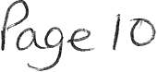

1807/21 Review of Subscriptions to Other Bodies

The Council considered a report on Subscriptions to Other Bodies
giving details of the subscription to CALC. It was proposed by Councillor Roberts and seconded by Councillor Gill that the position regarding the subscription to other bodies be noted and approved and the subscription of
£1,878.49 to CALC for 2021/22 be paid.

RESOLVED - That that the position regarding the subscription to other bodies be noted and approved and the subscription of£ 1,878.49 to CALC for 2021/22 be paid.

1808/21 Health and Safety

The Council considered a report on a combined Health and Safety Policy and Risk Assessment. The documents were shown at Appendix 1. It was proposed by Councillor Gill and seconded by Councillor Hayes that the Health and Safety Policy and the Risk Assessment at Appendix 1 of the report be approved and Signed. A vote was held and it was unanimously

RESOLVED - That the Health and Safety Policy and the Risk Assessment at Appendix 1 of the report be approved and signed.

1809/21 Financial Risks Assessment

The Council considered a report on Risk Assessment and Management (Financial and Operational) shown at Appendix 1 which had been amended in accordance with the Internal Auditor's recommendations it was proposed by Councillor Gill and seconded by Councillor Roberts that the amended Risk Assessment Policy shown at Appendix 1 of the report be approved. A vote was taken and it was unanimously

RESOLVED - That the amended Risk Assessment Policy shown at Appendix 1 of the report be approved.

1810/21 Review of Asset Register

The Council considered a report on the Asset Register shown at Appendix 1 of the report which was last approved on 15 ^{th} May 2019. It was proposed by Councillor Gill and seconded by Councillor Hayes that the Asset Register shown at Appendix 1 of the report be approved and be further reviewed at the Annual Meeting in 2022. A vote was held and it was unanimously

RESOLVED - That the Asset Register shown at Appendix 1 of the report be approved and be further reviewed at the Annual Meeting in 2022.

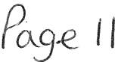

1811/21 Review of s137 Expenditure

The Council considered a report on Section 137 expenditure which was shown at Appendix l to the report. It was proposed by Councillor Gill and seconded by Councillor Roberts that the S137 expenditure shown at Appendix 1 to the report be approved. A vote was held and 7 Councillors voted for the proposal and 2 Councillors voted against

RESOLVED - That the S137 expenditure shown at Appendix 1 to the report be approved.

1812/21 Time and Place of ordinary Council Meetings up to and including the next Annual Meeting

The Council considered a list of the times and place for ordinary Council meetings up to and including the next Annual Meeting. It was proposed by Councillor Rayson and seconded by Councillor Hayes that the list be approved except that the Council Meetings should commence at 6.00pm instead of 6.30pm. A vote was taken and it was unanimously

RESOLVED - That the list be approved except that the Council Meetings should commence at 6.00pm instead of 6.30pm.

IN PRIVATE
1813/21 That prior to the following item of business the Chairman moved the following resolution: -

That in view of the special or confidential nature of the business about to be transacted it is advisable in the public interest that the public and or press be instructed to withdraw from the meeting.
Councillor Hayes proposed this and Councillor Roberts seconded it. A vote was held and it was unanimously

RESOLVED-That in view of the special or confidential nature of the business about to be transacted it is advisable in the public interest that the public and press be instructed to withdraw from the Meeting. All
members of the public and press then left the Meeting.
Councillor E Dinsdale and Councillors G Dinsdale also left the Meeting and did not return.

IN PRIVATE

1814/21 Grant Application - GCA

Councillor Maudling declared an interest in this item as it was a family member

The Council considered an application for a grant of£ 1,000.00 from GCA. Councillor Gill said it was regretful that this was not being taken out of the Ward Counc illor ' s Ward Grant.
It was proposed by Councillor Gill and seconded by Councillor Hayes that a grant of£ 1,000.00 be awarded to GCA A vote was taken and 6 Councillors voted for the proposal and 1 Councillor abstained

RESOLVED - Thata grant of £1,000.00 be awarded to GCA

The Meeting closed at 7.42

Chairman

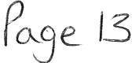

WHITEHAVEN TOWN COUNCIL

Minutes of the Extraordinary Council Meeting held on 10th June 2021

Present: Councillor C Hayes (Chairman); Councillor R Gill; Councillor C Maudling; Councillor B O' Kane; Councillor J Rayson; Councillor G Roberts;

M. Jewell, Clerk and Responsible Financial Officer

V. Gorley, Assistant Clerk

Jenny Brumby, CBC Business Liaison Officer

1815/21 Apologies for Absence

Apologies for absence were received from Councillor E Dinsdale, Councillor G Dinsdale, Councillor Redmond, Councillor C Walmsley, Councillor L Walmsley

1816/21 Declarations of Interest

Councillor Maudling declared an interest in item 5 as he had a shop on King Street.

1817/21 Public Participation

There was no public participation

1818/21 Expenditure for Events

The Clerk asked for the Council' s permission to add a further two items in addition to that on the Agenda to authorise expenditure for two other Council events. The Council gave permission for this to be done.

- The Council considered a report on extra expenditure required for the hire of a Marquee for an event in St Nicholas Gardens on 25th June 2021. This was due to the demand for stalls and it was necessary to hire a marquee to hold the antiques market. Quotes had been requested for the hire of the marquee and two had been received for £691.00 plus VAT and £595.00 plus VAT. It was proposed by Councillor Gill and seconded by Councillor Roberts that the quote from Contractor B in the sum of
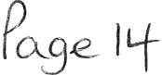

£595.00 plus VAT be accepted. A vote was held and it was unanimously

RESOLVED -That the quote from Contractor Bin the sum of £595.00 plus VAT be accepted.

- The Clerk reported that the Viking re -enactment which had been postponed from 2020 due to covid would be taking place in St Nicholas Gardens in August. The company had been paid for the event in 2020 and had confirmed the event could be postponed to a later date at the same fee However the Council had also authorised payment of £270.00 plus VAT for a security firm for the event which had been in the2020/2 l budget and therefore this needed to be authorised from the 2021/22 budget. It was proposed by Councillor Roberts and seconded by Councillor Hayes that the amount of £270.00 for the security firm for the Viking re-enactment be authorised and paid. A vote was held and 5 Councillors voted for and l Councillor abstained.

RESOLVED - That that the amount of £270.00 plus VAT for the security firm for the Viking re-enactment be authorised and paid.

- The Clerk reported on expenditure for the Fartology Science Show taking place in St Nicholas Gardens on 25th June 2021. The total expenditure was
£4,861.40. The Sellafield sponsorship was £3000.00 and the Council had already authorised £1200.00 for Fluid Productions leaving a balance of
£661.40. The Clerk asked if the Council would authorise £700.00 to cover the shortfall plus a small amount for any incidentals. It was proposed by Councillor Gill and seconded by Councillor Hayes that an amount of £700 be authorised to cover the shortfall and a small amount for any incidentals. A vote was held and it was unanimously

RESOLVED - that an amount of £700 be authorised to cover the shortfall and a small amount for any incidentals.
Councillor O'Kane asked the Chairman's permission to give an information report that would not need a vote. The Chairman agreed. Councillor O'Kane said that last year the Council had agreed to authorise expenditure for the
La' al Big Band for a function in Whitehaven which had had to be postponed due to covid. He said the Council still held a reservation with the band and at one stage it was proposed that the Council try and do something round the harbour on Yd July 2021 but that everything was now up in the air. Councillor O'Kane said the band had rung him earlier in the day and said they wanted to honour their booking in the future so the deposit the Council had paid would still stand until some time in the future and that the matter may come back to the Council in the future to authorise some kind of event on the harbour.

1819/21

1820/21

Sponsorship for Young Entrepreneurs Market

The Council considered a report containing a request received from CBC asking if the Council wished to sponsor the Young Entrepreneurs Market to be held in Whitehaven each month. The Clerk read out the costings for the market and identified those items where the Council had no powers to expend money and said that Councillors may wish to consider giving a sum of money for sponsorship in general rather than for individual items.
Councillor Gill said he was opposed to this as it had been advertised widely as a Copeland event and that Copeland should pay for it. It was proposed by Councillor Gill and seconded by Councillor Roberts that no sponsorship be Given.
A discussion then took place during which Jenny Brumby gave a short presentation and answered any questions.
Councillor Rayson proposed a counter proposal that sponsorship of £2,626.00 be given and this was seconded by Councillor O'Kane.
A vote was held on the counter proposal and 2 Councillors voted for the Proposal, 3 Councillors voted against and 1 Councillor did not vote

RESOLVED - That sponsorship of £2,626 be not awarded

The Council then considered the original proposal and a vote was held and
3 Councillors voted for the proposal and 2 Councillors voted against it and 1 Councillor did not vote.

RESOLVED - That no sponsorship be given.

Council Building Inspections

Minute 1778/21 authorised the Clerk to have all necessary checks to the Council's building carried out with 3 quotes being obtained where possible and all certificates renewed. The Clerk reported as follows:-

1. Fire Safety - The contractor that fitted new fire extinguishers in the building last year was contacted and gave a quote of £45.90 for checking the fire extinguishers, the fire alarm and issuing a certificate and that this could be done the next day. In view of the amount of money and the service the Council had had previously from the contractor the quote was accepted and the work has been carried out. It was proposed by Councillor Roberts and seconded by Councillor O'Kane that this be approved. A vote was held and it was unanimously

RESOLVED - That the action taken by the Clerk be approved.

ii. Gas Safety Certificate - The Clerk reported that 5 contractors had been contacted and 4 quotes had been received

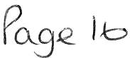

£110 plus VAT
£85 plus VAT
£60 plus VAT
£80 plus VAT

The Clerk reported that the quote of£ 110 was the highest and was from the contractor who can-ied out the work last year and who had given excellent service. It was proposed by Councillor Gill and seconded by Councillor Roberts that the quote of £110.00 plus VAT be accepted. A vote was held and it was unanimously

RESOLVED - Thatthe quote of £110.00 plus VAT be accepted.

111. Electrical Safety Checks - The Clerk reported that 5 quotes had been sought and 2 quotes had been received for £620 plus VAT and £666 plus VAT. The quote of £666 plus VAT although slightly higher was from the contractor who carried out the work to the Council's building last year and who had given an efficient service. It was proposed by Councillor Hayes and seconded by Councillor Roberts that the quote of £666.00 plus VAT be accepted. A vote was held and 5 Councillors voted for and 1 Councillor abstained as he knew the Contractor.

RESOLVED - That the quote of £666.00 plus VAT be accepted

1v. Legionella Risk Assessment - The Clerk reported that quotes had been sought and 2 quotes had been received for £595 plus VAT and £250 plus VAT. It was proposed by Councillor Gill and seconded by Councillor Hayes that the quote of £250.00plus VAT be accepted. A vote was held and it was unanimously

RESOLVED - That the quote of £250.00 plus VAT be accepted.

The Meeting closed at 6.35pm

Chairman

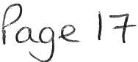

WTC 24/06/2021
Item 6

Planning Application for Consideration by Whitehaven Town Council

Application Number

4/21/2195/OR1

4/21/2196/0R1

CH/4/21/2226/0F1

CH/4/21/2231/0F1

CH/4/21/2232/0F1
Consultation on Additional and Updated Information showing an updated red and blue line: APPLICATION FOR THE APPROVAL OF RESERVED MATTERS FOR ACCESS, APPEARANCE, LANDSCAPING , LAYOUT AND SCALE FOR 85 DWELLINGS FOLLOWING OUTLINE PLANNING APPROVAL 4/16/2415/00 1. HARRAS DYKE FARM, HARRAS DYKE, WHITEHAVEN

Consultation on Additional and Updated Information showing an updated red and blue line: APPLICATION FOR APPROVAL OF RESERVED MATTERS FOR ACCESS, APPEARANCE, LANDSCAPING, LAYOUT AND SCALE FOR 5 DWELLINGS FOLLOWING OUTLINE PLANNING APPROVAL 4/16/2416/00 1 LAND AT HARRAS ROAD, HARRAS MOOR, WHITEHAVEN

THE DEVELOPMENT IS THE CONSTRUCTION OF A SINGLE STOREY MODULAR CABIN WHICH WOULD SERVE AS AN EXTENSION AND PROVIDE ADDITIONAL SPACE TO THE EXISTING A & E DEPARTMENT BUILDING. THE MODULAR BUILDING HAS BEEN ERECTED UNDER THE PROVISIONS OD SCHEDULE 2, PART 12A, CLASS A OF THE TOWN AND COUNTRY PLANNING (GENERAL PERMITTED DEVELOPMENT) (ENGLAND) ORDER 2015 (AS AMENDED) AND THIS APPLICATION SEEKS FULL PLANNING PERMISSION FOR THE RETENTION OF THE BUILDING BEYOND THE 31sr DECEMBER 2021, THAT BEING THE DATE FOR THE CESSATION OF THE USE UNDER THE PROVISIONS OF SCHEDULE 2, PART 12A, CLASS A. THE PLANNING APPLICATION SEEKS PERMISSION FOR THE RETENTION OF THE BUILDING PAST THE DATE AS MENTIONED ABOVE. WEST CUMBERLAND HOSPITAL, HOMEWOOD ROAD, WHITEHAVEN

CHANGE OF USE OF CONTRACTORS PLANT HIRE DEPOT TO BUILDERS MERCHANTS (SUI GENERIS) WITH ASSOCIATED OPERATIONAL DEVELOPMENT OF DEMOLITION AND ALTERATIONS.
HEWDEN PLANT HIRE, MEADOW ROAD, WHITEHAVEN

PROVISION OF A 20FT STORAGE CONTAINER TO THE REAR OF THE SITE TO HOUSE MATERIALS AND EQUIPMENT TO SUPPORT THE LOCAL TELECOMS INFRASTRUCTURE . BRITISH TELECOM, THE GINNS, WHITEHAVEN

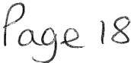

Application Number

CH/4/21/2233/0F1

CH/4/21/2238/0G1

CH/4/21/2250/0F1

CH/4/21/2251/0F1

CH/4/21/2256/0F1

CH/4/21/2262/0F1

CH/4/21/2271/0F1

CH/4/21/2272/0L1

CH/4/21/2276/0F1

CH/4/21/2279/TPO
Detail

ERECTION OF THREE BUSINESS/INDUSTRIAL BUILDINGS TO PROVIDE 12 SELF CONTAINED UNITS (USE CLASSES 82, BS AND CLASSES E(G)(I), E(G)(II) AND E(G)(III), CAR PARKING, ACCESS AND ASSOCIATED WORKS.
SNECKYEAT INDUSTRIAL ESTATE, WHITEHAVEN

REMOVAL OF CONDITION 3 (RELATING TO LATH & PLASTER) & CONDITION 6 (RELATING TO CORNICING) OF PLANNING APPROVAL 4/20/2470/0L1
6 CHURCH STREET, WHITEHAVEN

DEMOLITION OF GARAGE & CONSERVATORY & REPLACEMENT WITH TWO STOREY SIDE & SINGLE STOREY REAR EXTENSION & SINGLE STOREY EXTENSION TO FRONT
16 CORONATION DRIVE, WHITEHAVEN

SINGLE STOREY SIDE EXTENSION
90 HOLLY BANK, WHITEHAVEN

ERECTION OF A CONSERVATORY TO FRONT OF PROPERTY
3 MELBREAK CLOSE, WHITEHAVEN

DEMOLITION OF CONSERVATORY TO SIDE AND ERECTION OF SINGLE STOREY EXTENSION
17 HENSINGHAM ROAD, WHITEHAVEN

DEMOLISH EXISTING GARAGE & ERECT A SINGLE STOREY EXTENSION TO SIDE (CONTAINING A LIVING ROOM , UTILITY ROOM & SECOND BATHROOM)
42 HILLCREST AVENUE, WHITEHAVEN

LISTED BUILDING CONSENT TO ADD A FEATURE FIREPLACE IN A BEDROOM (ORIGINAL FIREPLACE HAD BEEN REMOVED AND BRICKED UP), ADDING GLAZED DOUBLE DOORS BETWEEN LIVING ROOM AND DINING ROOM, REPLACE FRONT STEPS AT ENTRANCE TO PROPERTY (IN KEEPING WITH THE ORIGINAL STEPS)
6 FOXHOUSES ROAD, WHITEHAVEN

SINGLE STOREY REAR EXTENSION
61 HILL TOP ROAD, WHITEHAVEN

WORKS TO SIX ALDER TREES SITUATED WITHIN A CONSERVATION AREA
STRAND STREET, WHITEHAVEN

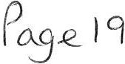

Application Number

CH/4/21/2280/TPO

CH/4/21/2282/0F1
WORKS TO TWO TREES SITUATED WITHIN A CONSERVATION AREA
QUEEN STREET, WHITEHAVEN

CHANGE USE OF BUILDING FROM STORAGE TO RETAIL (SALE OF FISHING EQUIPMENT)
GROUND FLOOR WORKSHOP, FISH HANDLING HALL, NORTH SHORE, WHITEHAVEN

WTC 24/06/2021

Item 7

FINANCIAL REPORT

Purpose of the Report

Members are asked to consider a list of invoices for authorisation and payment as shown at Appendix 1 and approve the recommendations in paragraphs 3.1 and 3.2.

  - INTRODUCTION

  - Authorise the payment of all invoices as listed in Appendix 1.

  - The Council is asked to note the cashbook as reconciled with the bank account as shown at Appendix 2 together with income and expenditure at Appendix 3.

  - FINANCIAL POSITION

  - The bank reconciliation was carried out on 16th June 2021. This shows a balance of £400,661.73. There are however cheques to the value of £1,757.03 still to be presented and cleared.

  - The balance in the deposit account is £450,400.11.

  - RECOMMENDATION

  - The invoices listed and shown in Appendix 1 be approved and authorised for payment.

  - The Cashbook (Appendix 2) and the Income and Expenditure (Appendix 3) be noted.

24/06/2021

Appendi x 1

Invoices for Consid_er aJ i on by Whitehaven Town Council

Date | Supplier | Category | Detail | Total Amount | Power | Columnl
25/05/2021 | Eden Springs (UK) Ltd | Suppli es & Services | Environmental Levy for water coolers (June) | £ 2.16 | sl ll LGA 1972
25/05/2021 | Carlisle City Fire Protection | Premises | Annual Servicing of Fire Extinguishers within 148 Queen Stree t | £ 45.90 | slll LGA1972
01/06/ 2021 | Copeland Borough Council | 3rd Party | Assistant Ranger Contract - June 2021 | £ 2,199.02 | slllLGA1972
01/06/2021 | Copeland Borough Council | 3rd Party | Grass Cutting Contract - Jun e 2021 | £ 1,995.62 | slllLGA 1972
01/06/2021 | Cop eland Borough Coun cil | 3rd Party | Parks & Open Spaces Ramrer Contract - June 2021 | £ 3, 325.44 | slllLGA 1972
01/06/2021 | Cope lan d Borough Counci l | 3rd Party | Allotment Maintenance Contract - June 2021 | £ 717.42 | s23 Small Holdings Allotments Act 1908
01/06/2021 | Viking | Supplies & Services | Copier Paper and highlig hters | £ 38.98 | slllLGA 1972
15/06/ 2021 | Water Plus | 3rd Party | Water Bill - Overend Pigeon Lofts - 31.03.2021 - 12.06.2021 | £ 18.98 | s23 Small Holdings Allotments Act 1908
18/06/2021 | Water Plus | 3rd Party | Water Bill - MidgeyAllotments - 01.04.2021 - 15.06.2021 | £ 117.50 | s23 Small Holdings Allotments Act 1908
18/06/2021 | Water Plus | Premises | Water Bill - 148 Queen Stree t - 27.02.2021 - 15.06.2021 | £ 205.51 | sl ll LGA 1972

£ 8,666.53

lb

WHITEHAVENTOWN COUNCIL CASH BOOK FRO M 1 APRIL 2021

APPENDIX 2

Date Ref Payee
Apr il-2021

Employees/ Supplies/ Community Ground Civic Ward Environmental
Allowances Premises Services 3rd Party Grants Allotmts Market Plan Ma int Hospitality Ranger/SO W.I.B Grants Elections Improvements

Events Contingencies Reserves Net Total VAT Total Min. Ref.

01/04/2021 991 Copeland Borough Counci l 10603.7S 15/04/2021 992 HMRC 2155 .0 2
15/04/2021 BACS Sta ff 4364 .68
15/0 4/2021 BACS Cumbria LGPS 1825.02
2 19/04/2021 DD Crown Gas & Oil 251.05
3 20/04/2021 DD BT Group 70.42
4 30/04/2021 BACS Vulture Club 1000.00
- 30/04/2021 993 Copeland Borough Council 70.83
- 30/04/2021 BACS Eden Springs (UK) Ltd 1.80
- 30/04/2021 BACS Clyde & Co
- 30/04/2021 BACS Derwent Recycling Serv ices Ltd 240.00
- 30/04/2021 BACS Derwent Recy cling Services Ltd 240.00
- 30/04/2021 BACS Derwent Recycling Serv ices Ltd 240.00
- 30/04/2021 994 Copeland Borough Council 1663.02
10603.7S 10603.7S 1723/21(i)
2155.02 2155.02 HMRC
4364.68 4364.68 1666/20
182S.02 1825.02 6317/17 (ii)
251.05 50.21 301.26 Contract
70.42 14.08 84.50 Contract 1000.00 1000.00 1733/21
70.83 14.17 85.00 1761/21 (i)
1.80 0.36 2.16 1761/21 (i)
232.30 232.30 232.30 1761/21 (i)
240.00 48.00 288.00 1761/21(i)
240.00 48.00 288.00 1761/21(i)
240.00 48.00 288.00 1761/21(i)
1663.02 332.60 1995.62 1761/21(i)

- 30/04/2021 995 Copeland Borough Council 597.85
597 .85
119.57 717.42 1761/21 (i)

- 30/04/2021 996 Copeland Borough Council
2771.20
2771.20 554.24 3325.44 1761/21(i)

- 30/04/2021 997 Copeland Borough Council
- 30/04/2021 998 Copeland Borough Council 15.20
- 30/04/2021 BACS Water Plus limited 27.11
- 30/04/2021 BACS Water Plus limited 54.42
- 30/04/2021 BACS Whitehaven Gas & Plumbing 209.68
19 30/04/2021 BACS Cumbria Media 356.00
20 30/04/2021 999 Viking 173 .80
21 30/04/2021 1000 Mrs V Gorley 8.48 21.51
M ay-2021
14/0S/2021 BACS Staff 4771.5 1
14/05/2021 1001 HMRC 2256.63
1 4/05/ 20 21 BACS Cumbr ia LGPS 16 4.94
22 14/05/2021 BACS Imperative Training limited 120.00
23 17/05/2021 DD Crown Gas & Oil 238.33
24 19/05/2021 DD BTGroup 67.21
1832.52 1832.52 366.50 2199.02 1761/21(i)
15 .20 15.20 1761/21 (i)
27.11 27.11 1761/21(i)
54.42 54.42 1761/21(i)
209.68 41.94 251.62 1761/21 (i)
356.00 356.00 1761/21(i)
173.80 4.56 178.36 1761/21(i)
29.99 29.99 1761/21 (i)

4771.51 4771.51 1666/20
2256.63 2256.63 HMRC
164.94 164.94 6317/17 (ii)
1 20.00 24.00 144.00
238.33 47.66 285.99 Contract
67.21 13.44 80.65 Contract

- 25/05/2021 BACS Friends of St JINS
- 25/05/2021 BACS Rosehill Youth Theatre 1000.00
- 25/05/2021 BACS Deborah McKenna Ltd
- 27/05/2021 BACS POD (North West) Ltd 800.00
Ju ne-202 1
- 03/06/2021 BACS Eden Springs (UK) Ltd 19.80
- 03/06/ 2021 BACS Derwent Recycling Services Ltd 240. 00
- 03/06/2021 1003 Copeland Boro ugh Council
- 03/06/2021 1004 Copeland Borough Council 1663.02
- 03/06/2021 1005 Copeland Borough Council
- 03/06/2021 1006 Cop e land Borough Council 597.85
35 03/06/ 2021 1007 Mrs J Hartley 250.00
36 03/06/2021 BACS Cumbria Media 349.58
37 03/06/ 2021 1008 Sharp Business Systems 144.79
38 03/06/2021 1009 Westcom IT 214.19
39 03/06/2021 BACS Mrs V Gorley 159.00
40 03/06/2021 BACS Zurich Municipal 3233 .79
41 03/06/2021 BACS CALC 1878.49
42 03/06/2021 BACS Sharp Business Systems 2700.00
43 03/06/2021 BACS Mrs V Gorley 7.98

1832.52

2771.20
500.00

1000.00
500.00 500.00 Ward Grant
1000.00 1000.00
1000.00 200.00 1200.00
800 .00 160.00 960.00 Mayo rs Allowance

19.8 0 3.96 23.76
240.00 48.00 288.00
1832.52 366.50 2199.02
1663.02 332.60 1995.62
2771.20 554.24 3325 .44
597.85 119.57 717.42
250.00 250.00
349.58 349.58
144.79 28.96 173.75
214.19 42.84 257.03 1764/21
159.00 159.00
3233.79 3233.79
1878.49 1878.49
2700.00 540.00 3240.00 1763/21
7.98 7.98

- 03/06/2021 BACS Mrs M Jewell
- 03/06/2021 BACS Tradeprint
15/06/2021 1010 HMRC 2257.03
15/06/ 2021 BACS Cumbria LGPS 210 .12
15/06/2021 BACS Staff 4S16 .89
23338.30 11569.03 9259.36 250.00 2000.00 2308.06 0.00 0.00
59.40 59.40 11.88 71.28
340.68 340.68 68.14 408.82
2257.03 2257.03 HMRC
210.12 210.12 6317/17 (ii)
4516 .89 4516.89 1666/20

3326 .04 0.00 9207.44 0.00 500.00 0.00 0.00 1400.08 0.00 232.30 63158.31 4436.32 £67,594.63

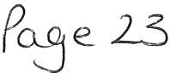

WHITEHAVEN TOWN COUNCIL Appendix 3

INCOME 2020-2021

Date Item Precept Interest Other

01.04.2021 | Allotment Rents 2021/2022 |  | 2460.00
14.04.2021 | Allotment Rents 2021/2022 |  | 470.00
15.04.2021 | Allotment Rents 2021/2022 |  | 100.00
15.04.2021 | HMRC-VAT Refund - March 2021 |  | 2339.13
19.04.2021 | Allotment Rents 2021/2022 |  | 100.00
30.04.2021 | 2021-2022 Precept | 433573.86
30.04.2021 | Allotment Rents 2021/2022 |  | 260.00
04.06.2021 | CBC - Refund |  | 24.60
07.06.2021 | Allotment Rents 2021/2022 |  | 450.00
11.06.2021 | HMRC- VAT Refund - May 2021 |  | 2496.39
14.06.2021 | HMRC - VAT Refund - April 2021 |  | 1860.36

433573.86 0.00 10560.48 1444134 .34 1

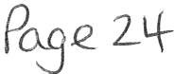

 |  |  |  | Expenditure Net | Invoices not yet
WHITEHAVENTOWN COUNCIL  SUMMARISED INCOME & EXPENDITURESTATEMENT |  |  |  | of VAT | processed | Budget
FINANCIAL YEAR 2021-2022
BANK BALANCES BROUGHT FORWARD
CBS 539 0 5917 (0 1.0 4. 202 1 ) |  | 23,364.96
CBS 539 0 6216 (0 1. 0 4 .202 1 ) |  | 450,400.11
TOTAL OPENING BALANCE |  | £ 473,765.07
INCOME:
Precept |  | 433,573.86
Interest (Deposi t)
Other Income |  | 10,560.48
TOTAL INCOME |  | £ 444,134.34
EXPENDITURE
Employees & Allowances |  |  |  | 23338 .30
Prem ises |  |  |  | 11569 .03
Sup pli es/ Serv ices |  |  |  | 9259.36
3rd Par ty |  |  |  | 250.00
Grants |  |  |  | 2000 .00
Allo tm ents |  |  |  | 2308.06
M arkets |  |  |  | 0.00
Communi ty Plan |  |  |  | 0.00
Ground Maint enance |  |  |  | 3326.04
Civic Hospitali ty |  |  |  | 0.00
Ranger |  |  |  | 9207.44
Whit ehaven In Bloo m |  |  |  | 0.00
W ard Grants |  |  |  | 500.00
El ecti o ns |  |  |  | 0.00
Enviro nm en t al Impro vem en ts |  |  |  | 0.00
Events |  |  |  | 1400.08
Conti ngencies |  |  |  | 0.00
Re serves |  |  |  | 232.30
VAT (to be reclaim ed ) |  |  |  | 4436.32
TOTAL EXPENDITURE |  |  |  | £ 67,594.63
CASH BOOK BALANCE
Brought forward |  |  |  | £ 473,765.07
Income |  |  |  | £ 444,134.34
Expenditu re |  |  |  | £ 67,594.63

Town Council Funds

BANK BALANCES
CBS 5 39 0 59 1 7 (16/ 06/ 202 1)
CBS 5 3906 2 16 (1 6/ 06/ 20 2 1)

Unpresented Cheques 2020 / 2021

FINA NCIAL POSITION
1£ s 49,3o4 .s 1 1

40 0,661.73
4 50 ,40 0 .11
1 £ ss1,061.s4 1

1,75 7. 03

1£ 849,3o4.s 1 1

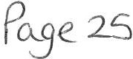

WTC 24/06/21
Item 8

ADVERTISEMENT/PROMOTION PACKAGE FOR COUNCIL EVENTS

To inform the Council of the advertisement/marketing promotions package drawn up for Council events and to seek approval for this.

  - INTRODUCTION

  - At the full Council Meeting on 25th March 2021 it was agreed that Councillor Maudling and Gerard Richardson would liaise together to draw up a costed advertisement/marketing promotion package for the Council's events and report back. (Minute 1727/21 refers)

  - Attached at Appendix 1 is the costed package prepared by Councillor Maudling and Gerard Richardson.

  - The total cost for the package is £2,487.75 exc VAT and the amount remaining in the Events budget is approximately
£1,400.00. The power for this is s144 of the Local Government Act 1972.

2.0 RECOMMENDATION

3.1 It is recommended that the expenditure of £2,487,75 for the advertising/marketing promotion package for Council events be approved

WTc. 21+-( o b /2.,1
I Te1VJ q,
A-PPE:N1>l I

ADVERTISING/MARKETING PROMOTION PACKAGE FOR COUNCIL EVENTS

Recommendationsof Councillor Maudling and Gerard Richardson to go to Full Council for approval.

This is a light touch but it is quite an intensive plan for the first attempt at doing this as a Town Council and coming in at under £3k for the remainder of the year.

This are for the Council's events first and foremost and these events will support jobs in retail of which there are still a few hundred in the town centre, jobs that are hard to replace in these times.

- CFM £1687.75 ex vat which comprises the attached airtime plan plus
£355 production cost.

This has been budgeted for 3 separate weeks with 2 in the summer and 1 near Christmas but these can be moved as appropriate. There are in total 177 adverts. The advantage with radio is that the message is subliminal.

- West Cumbria Guide Media: £700 ex vat to do a pre agreed number of video walkabouts with social media promotions via their pages. This would be done on the basis of 1 for each event plus an extra to promote the antiques fair and another to pre promote whatever is decided for the Christmas lights switch on. The latter can always be just another town promotion for shopping if required. This makes a total of 7. In addition the Editor would be asked a piece in the Guide about events in Whitehaven and how the town is getting it together again. The latter alone would normally cost a few hundred if paid for.

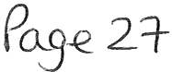

- Facebook: £100 for adverts for each event. We have obviously missed the first one so its 4 in total. That will get us in front of several thousand locals with targeted adverts.

The CFM airtime plan is attached and a separate one will be sent showing their production cost which was included in the body of the email.

Total: £2687.75 ex Vat

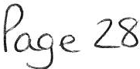

WTC 24/06/21
Item 9

REQUEST FOR SPONSORSHIP/SUPPORT FROM EYES OPEN

To consider a request from Eyes Open for Council sponsorship/support and to determine the request

  - INTRODUCTION

  - A request has been received from an organisation called Eyes Open for sponsorship/support from the Council regarding HIV/AIDS. (see Appendix 1).

  - The request is from The Eyes Open Steering Group and appears to be based at the RVI in Newcastle and you will see that they state that they need funding in Cumbria of £53, 128.75.

  - It appears that this outside the Town Council's powers and that it is for Cumbria as a whole. It also maybe the responsibility of another authority.

2.0 RECOMMENDATION

3.1 It is recommended that the Council considers the request and decides whether or not to sponsor/support Eyes Open.

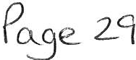

'-0- TC :J-4-\0 b /
( 'TE.jv( 9
MPE'\D f x. f
Eyes Open Steering Group, C/0 Christine Stewart, Treasurer, Social Work Department, 2nd Floor, Peacock Hall, Royal Victoria Infirmary, Queen Victoria Road, Newcastle upon Tyne NE1 4LP

Whitehaven Town Council 148 Queen Street Whitehaven
Cumbria CA28 7AZ

19th May 2021 Dear Trustees
The Eyes Open Steering Group was established in the North East of England in 2003 as a way of regionally pooling resources to widen and strengthen the impact of work at both local and regional levels regarding HIV/AIDS, the objectives of Eyes Open are:

- To guide the delivery of educational initiatives.
- To develop community events to raise awareness in the general population.
- To co-operate and work with individuals, voluntary organisations, and statutory authorities to raise awareness, increase understanding, and reduce onward transmission.

In 2021 the areas involved in the Eyes Open Steering Group are:

- Cumbria: staff from the NHS.
- Blue Sky Trust , charity for people living with HIV Cumbria and the North East region.
- Together We Can Fundraising Limited: support with raising money for the campaign, also some staff members are also living with HIV, based in Cumbria.
- Newcastle: staff from the NHS and Newcastle City Coun cil.
- North Tyneside: staff from the NHS
- Northumberland: staff from the NHS.
- 14 committee members.
- 35% of people on the committee are living with HIV.
In 2019, it was estimated that there were 105,200 people living with HIV in the UK. 94% of these people were diagnosed, and therefore know that they have HIV. This means that around 1 in 16 people living with HIV in the UK do not know that they have the virus. 98% of people diagnosed with HIV in the UK are on treatment, and 97% of those on treatment are virally suppressed which means they can't pass the virus on. Of all the people living with HIV in the UK, 89% are virally suppressed.

In the UK we now have medications that can treat HIV, which allows people to live a near normal life expec tancy , which is so different to the life expectancy peop le were told in the 80's and early 90's, but still today there is a lot of ignorance, stigma and discrimination towards people living with HIV.

If a person adheres to HIV medication, the virus in the blood reduces to undetectable levels. We can now say with complete confidence that people, living with HIV and on effective treatment , can no longer pass on HIV to others, even when sex is unprotected. This is called U=U which stands for Undetectable = Untransmittable. An awareness campaign has been running for a number of years now, but still the message hasn't got to everyone, for more info please visit: https://www.tht.org.uk/our-work/our-campaigns/can-pt ass-it-on

We are supporting the campaign, and on October 20th 2021, Eyes Open are organising a U=U Day to celebrate this. The U=U Day and following marketing campaign will give us an opportunity to raise awareness, get people talking and educate more people about what U=U means today for people living with HIV and use the campaign and this knowledge to finally remove the stigma and discrimination surrounding HIV that still exist today.

Project details:

e U=U Day - 20th October 2021.
- The campaign will run from the Cumbria and North East regions; we will also be promoting the campaign online to reach as many people as we can in the UK and worldwide.
- We have a marketing plan in place highlighted below, and a Covid-19 safe, virtual launch event planned, so we can stream to more people nationally and worldwide through our connections with other HIV charities and organisations.
- We have 200 volunteers involved in the project who are affected by HIV who are volunteering to help to break down stigma and discrimination.
- Our aim is for other UK regions to get involved with our U=U Day from 2022 to make it a national day to celebrate and remember.
- It will work alongside World Aids Day on the 1st December 2021.
Our project brings people together through the passion and experience of the team to develop wide-ranging actions that will:

- Raise awareness of HIV in the community including the U=U message.
- Breakdown stigma and discrimination associated with HIV - myths and truths.
- Develop the confidence and skills of the HIV+ community to make a difference to perceptions of HIV in society.
- Bringing a whole community together: schools, community groups, people living with HIV, volunteers and individuals in the North East and Cumbria region.
- Support the Government campaign to end all new HIV transmissions by 2030 - https://www.tht.org.uk/news/uk-government-commit-ending-new-hiv-transmissions­ england-2030

Our U=U Campaign:

Marketing Details & Budget 2021 | Reach | Costs
Admin and management costs - admin duties and to oversee areas of the campaign |  | £2,000
Promotional materials in key regions: main city/towns/schools/Uni/Colleges/libraries | 20,000+ | £4,500
GP 's/Hospitals/GUM Clinics - TV screens on the day | 10,000+ | N/A
2 weeks social media: Facebook, Twitter, lnstagram, Linkedin - 40 social media sites | 1,000,000+ | £1,000
2 weeks bridqe banners including digital - 20 key areas (@. £500 each | 50,000+ | £10,000
2 weeks on billboards - 20 key areas @ £850 each | 50,000+ | £17,000
2 weeks on digital billboards - 20 key areas(@. £1,700 each | 50,000+ | £34,000
Public transport banners on buses and other transport | 50,000+ | £20,000

2 weeks TV adverts: Reqional Tvne Tees and Border | 200,000+ | £60,000
2 weeks Radio adverts: All North Reqions and Cumbria | 200,000+ | £28,000
2 weeks of kev members from the steerinq qroup - talkinq on local TV and Radio | 50,000+ | N/A
Press releases to local newspapers in all areas | 80,000+ | N/A
Online Virtual event - 20th Oct 2021 - via webinar | 5,000+ | £4,000
Guest speakers |  | £6,000
Entertainment |  | £1,500
Invite packs: postcard, red ribbon, branded U=U condoms, pens x 5000@ £3 each | 5,000+ | £ 15,000
Volunteer costs - 200 volunteers: travel expenses/refreshments/food |  | £3,000
Pin badqes 60p each x 5000 plus £65 desiqn fee |  | £3,065
T shirts x 200 for volunteers@ £15 each plus 20 polo shirts for key members of the  team ® £22.50 |  | £3,450
Cumbrian funding we need |  | £53,128.75
North East fundin!l we need |  | £159,386.25
Total amount needed |  | £212,515

We have quotes for all the above and marketing plans for TV adverts and Radio adverts, available on request. Some reach figures are estimated, although we except it to be much higher than the figures detailed above . We have included VAT on all costs at 20%.

U=U Campaign outcomes:

  - An estimated 2 million plus people will know about U=U and what that means.
  - Decreased stigma and discrimination about living with HIV.
  - Increased knowledge and understanding of HIV.
  - All of the above will lead to improvements in the lives of those living with HIV.
  - We also aim to give information to people to encourage testing - which can save lives, testing early allows you to receive treatment to keep you well and stops it being passed on to sexual partners.

Volunteer Outcomes:

  - 200 people affected by HIV will be able to tell their stories and/or support the campaign in ways they feel they can. This will have a positive impact on confidence, self-esteem, self-stigma associated with living with HIV, better management of mental health difficulties, reduced isolation and that feeling of being accepted in the community.

We are applying to the National Lottery Community Fund and other funders in the Cumbria region and the North East region, if you would like an update at any time, please contact us.

If you were to support us, we will acknowledge your support in our marketing plan, on social media and in the local press, so people in the community are aware that you have supported this campaign.

We are a constituted community group, we have regular board meetings, all governance is in place.

If you would like to make a donation towards our project, please make a cheque payable to Eyes Open, alternatively you can make a BACS payment to: Eyes Open, sort code: 08-92- 99, account number: 65652862.

Many thanks

Christine Stewart Christine.stewart20@nhs.net 07825575987

Facebook: @eyesopenuk Twitter: @EyesOpenHIV lnstagram: @eyesopenuk www.eyesopenart.org

Welfare Rights Officer, HIV specialist working for Newcastle City Council, Newcastle Welfare Rights Service since May 2007, and treasurer for Eyes Open.

Testimonial: I have been a steering group member of Eyes Open since Feb 2014. I applied to become a member after working with HIV positive people and their families as an HIV specialist Welfare Rights officer for Newcastle City Council since 2007. However , in 2014 I had recently discovered that a close member of my family was also HIV positive and acutely unwell at that time. Despite being so very ill the only concern that he had was that me, and other members of our family, did not find out about his HIV status. He was very fearful of being accepted and treated differently.

I truly believed that up to that point I had a great understanding of the stigma and discrimination faced by people living with HIV. My own personal experience changed that. I needed to contribute more and use the experiences and knowledge that I already had. I had feelings and emotions that needed to be channelled in a positive way and so, alongside my paid employment, I have worked for Eyes Open to raise awareness of the challenges HIV positive people face every day of their lives.

My hope for 2021 is that I can continue to work as treasurer for Eyes Open and that we can go ahead with the plans as outlined in our Work Plan. I feel we need to raise the profile of the extraordinarily passionate work that we all currently do in Eyes Open using the U=U campaign message rolled out to a wider audience in as many multi advertising ways as we are able to manage. We need to continue to fight stigma around the HIV diagnosis.

Mark Ellerby-Hedley - Sexual Health Improvement Practitioner, C-Card Co-ordinator, and chairman for Eyes Open. Chairman - I have been an Eyes Open Steering Group member since it started up in 2003 and have been Chair since 2015. I was the HIV+ Men's Support Worker at MESMAC North East so was keen to be involved as I was already delivering HIV Awareness Sessions in Schools across Newcastle. I am also HIV+ so have faced stigma and discrimination because of my status including losing my job in 1998, and thought working in partnership with other health promotion staff across the northeast would be a really good way of improving people's knowledge of HIV.

The campaigns and training Eyes Open have delivered over the last 18 years mean we have engaged with a wide range of people and I'm excited about the work we have planned for 2021, so we can continue to raise awareness in innovative and thought-provoking ways.

Evidence and HIV information regarding stigma and discrimination:

Where it exists, stigma can permeate a person's core beliefs and affect their overall 'quality of life' (Qol ). As highlighted in the recent Positive Voices survey conducted in collaboration with Public Health England the overall utility score for quality of life (EQ5D index) of people with HIV in the UK
was 0.604, compared to 0.856 in the general population of England. The Missing Link- HIV and Mental Health. appg HIV and AIDS, 2019 pg 14

HIV stigma is also well documentedand has been shown to have a detrimental impact on a variety of
health-rela ted outcomes in people with HIV, including mental health. Rueda S, Mitra S, Chen S, et al, 'Examining the associations between HIV-related stigma and health outcomes in people living with HIV/AIDS: a series of meta-analyses', BMJ Open 2016;6:e011453. doi:
10.1136/bmjopen-2016-011453

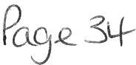

"If we're serious about tackling HIV and achieving the 2030 target of zero transmissionsand we should be, then we need to get really serious about dealing with mental health issues in people with HIV". Dr Ben Spencer, South London, and Maudsley Health Trust - HIV Liaison Service)
The Missing Link - HIV and Mental Health. appg HIV and AIDS, 2019 pg 18

HIV disproportionately affects population groups (LGBT and BAME communities) that are already disproportionately affected by mental health issues. Public Health England 'Progress towards ending
the HIV epidemic in the United Kingdom 2018 report' November 2018

The North East and Cumbria are also involved in the "About J Fast-Track Cities" to help get people
tested https://www.fast-trackcities.org/about

WTC 24/06/2021

Item 10

BUS SHELTERS

Purpose of the Report

To inform Members of the recommendations from the joint Bus Panel and to consider the quotes received for the provision of a new Bus Shelter and to authorise the expenditure thereof.

  - INTRODUCTION

  - A request to install a bus shelter on Bransty Road (as shown at Appendix 1) was received by the Councillor for the ward.

  - As part of the process Cumbria County Council, Cumbria Police and Stagecoach were all consulted on the proposal and no objections were received. The Final Report is Attached at Appendix 2.

  - Enquiries are still being made as to the owner of the land where the bus shelter is to be sited so that permission can be sought to install the shelter.

  - In line with Financial Regulations, 3 quotes have been sought for Bus Shelters with similar specifications and design (Appendix 3).

  - RECOMMENDATION

  - It is recommended that the final report of the Bus Panel be noted and that providing permission to install the shelter is given by the landowner that the request to purchase 1 x Bus Shelters be authorised/approved and for Council to decide which quote to accept.

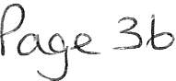

Go gle Maps
t...J IC 2..4 IOb I20 z._'
e.,V\do.. \.\-.e.w\ 10

IV \ ·.
!i!>
:i!

(:)

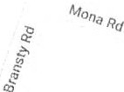

(:)

Go gle

f
"{
!i!>
:i!

Map data ©2021 20 m ... J

Go gle Maps Bransty Rd
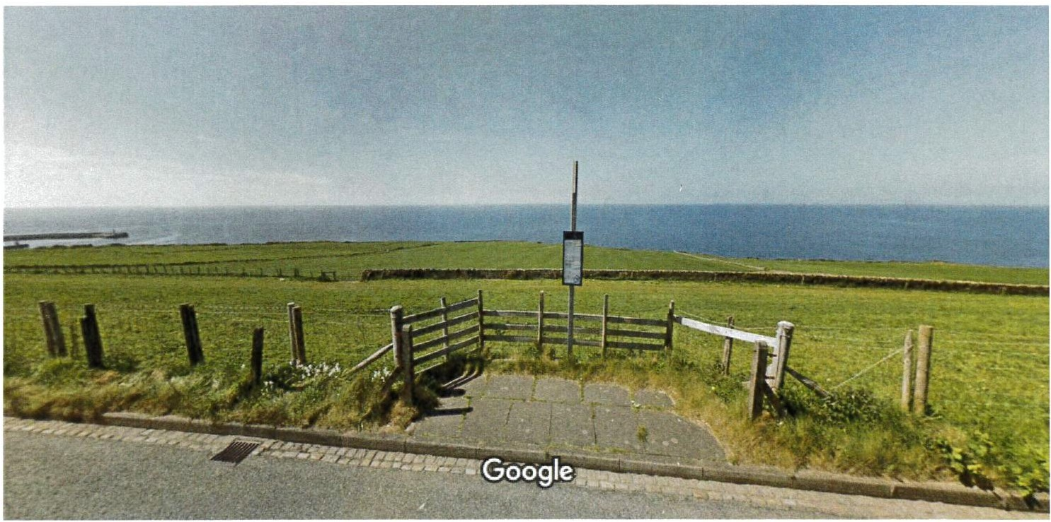
Image capture : May 2017 © 2021 Google

Whitehaven, England

jJ. Google Street View

SPAR Pelican I Service Station
Oles

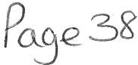

Cumbria County Council
Economy and Infrastructure • Transport Services Team
Parkhouse Building • Baron Way • Kingmoor Park • C arlisle • CA6 4SJ M: 07771 916 847 · E: linda.hardy@cumbr ia.gov.uk

FINAL REPORT
BUS PANEL SITE MEETING
Date: 9th June 2021
Area: Copeland
Location: Bransty Road, Whitehaven
Request: New shelter at existing stop
" ; ·

County Council

h.l1 C : 24 ) ob / 2.DZJ
V\do Irev\A \ o
\'i 2_.

Consultees Vanessa Gorley Leanne Pettit Graham Roberts Peter Bragg Matthew Reeves Linda Hardy

Assistant Clerk
Collision Reduction Officer County Councillor (Bransty) Operations
Traffic Management Officer Bus Infrastructure Officer

Whitehaven Town Council Cumbria Police
Cumbria County Council Stagecoach
Cumbria County Council Cumbria County Council

Site - Bransty Road, Whitehaven

- Source of request

  - Whitehaven Town Council have made the request on behalf of bus services users.

- Funding position

  - The shelter will be provided by Whitehaven Town Council, who will be responsible for on­ going maintenance.

- Location and proposed shelter

  - Bransty Rd - Google Maps

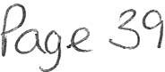

Cumbria County Council
!Jm

County Council

  - The Town Council are proposing a shelter the same as, or similar, to this.

Heritage Bus Shelter - Quarter End Panels - Ace Shelters
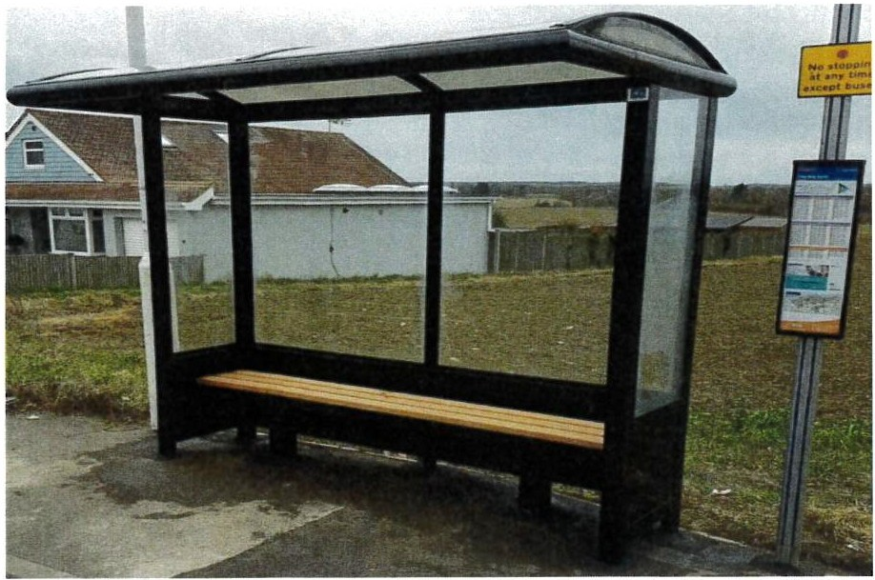

- Consultation with residents

  - In accordance with the Bus Panel process residents close to the proposed stops are being consulted.

- Comments received

  - Matthew Reeves, Traffic Management Team Leader, has confirmed he no issues with the installation of a shelter at this location, but has highlighted the need to maintain a minimum of 50cm from all parts of the shelter (including the roof) and the edge of kerb.

- Comments received after circulation of the Draft Report

  - One of the residents consulted has responded to say that she would have no issue with a shelter, however she has observed that people rarely wait at this stop and usually get off here. These comments have been passed to Whitehaven Town Council.

  - Peter Bragg, Operations Manager at Stagecoach has confirmed he would have no issues with a shelter at this location, as long as distances from the kerb as detailed in 5.1 are observed.

  - Leanne Pettit, Collision Reduction Officer, Cumbria Police has confirmed she has no concerns regarding the proposed shelter.

Cumbria County Council
•!!!- •

County Council

- Recommendation

  - A shelter may be installed at this location.

The decision of Austin Shields (Senior Manager, Transport Services) is as follows:

Agreed with recommendation.

Signed:
Date: 09 June 2021

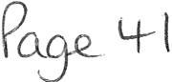

N1C '. 24-/00\202\
A-_9ev\d_a 1:k M \0

d ,--i3 .

SHELTERS
Unit 4B, Swordfish Business Park, Swordfish Close
Burscough, Lancashire, L40 8JW
Tel: 01704 829 404
Email: info@aceshelters.co.uk Web: www.aceshelters.co.uk

FAO: Vanessa Gorley Whitehaven Town Council
Email: clerk@whitehaventowncouncil.co.uk 15th June 2021
Quote ref 6907

Dear Vanessa,

Firstly, thank you for your enquiry. Further to the details received, please find below specifications, images and costings for our Bus Shelters.

All shelters fabricated by Ace Shelters are constructed from high-grade aluminium extrusion BS EN 755 (1-9) that once powder coated BS EN ISO 9002 to your chosen Ral or BS colour will give a long lasting, low maintenance corrosion free finish. The upright stanchions of the shelter will be submerged below the surface within a concrete pocket and top finished in the present surface material to match to ensure a neat installation.

Ace Shelters are accredited with Safe Contractor & Chas. All engineers have been accredited with CSCS courses (health and safety) and Street works city and guilds.

Lead times from date of official purchase order are currently 3 - 4 weeks and time on site will be a single day.

Continued,

sk ill s
Company Reg No. 10187977 - Vat Reg No. 333269994

SHELTERS
Unit 4B, Swordfish Business Park, Swordfish Close
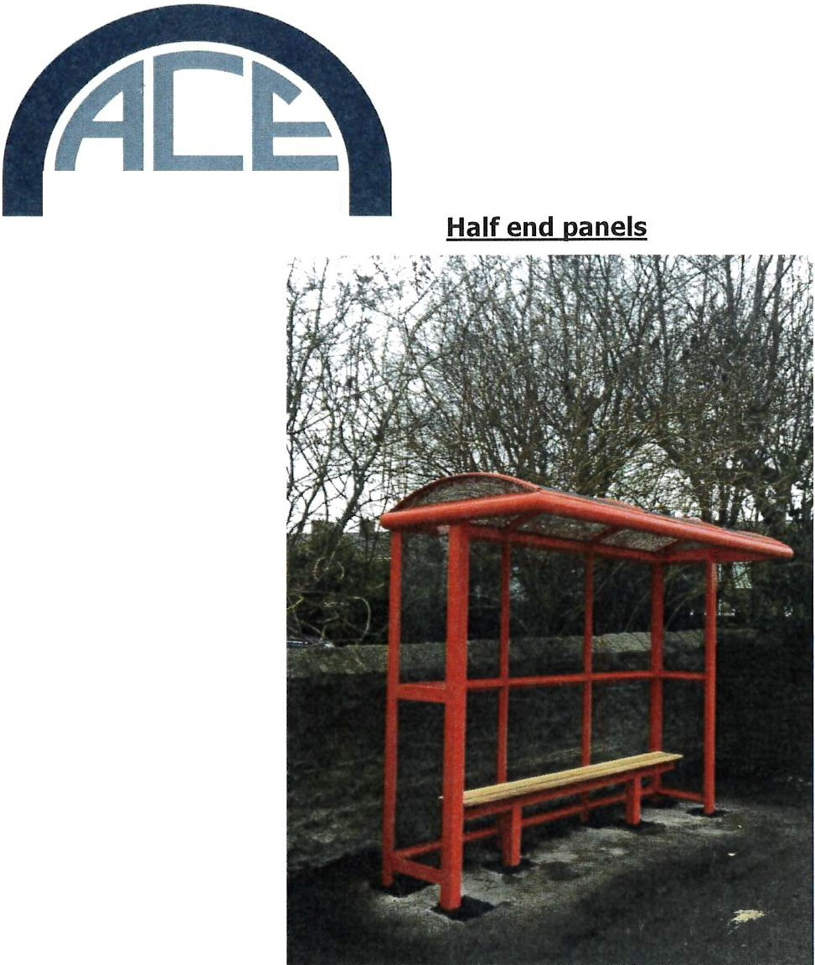
Burscough, Lancashire, L40 8JW
Tel: 01704 829 404
Email: info@aceshelters.co.uk Web: www.aceshelters.co.uk

Specifications

- 3 Bay 3.06Mtr x l.3Mtr Bus Shelter with shallow barrel roof glazed in 4mm THK bronze tinted UV stable polycarbonate. The roof will be constructed from high grade 100.0mm x 50.0mm extruded aluminium D-section, glazing affixed with rubber gasket sealed aluminium capping.

- The main frame of the structure will be constructed from high grade 80.0mm x 80.0mm extruded aluminium section with glazing rebate beaded internally.

- All glazing panels of the Bus Shelter will be of either UV stable polycarbonate or toughened safety glass.

- All metal work will be powder coated to your chosen Ral colour.

skills
Company Reg No. 10187977 - Vat Reg No. 333269994

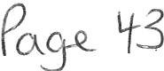

Unit 48, Swordfish Business Park, Swordfish Close

SHELTERS
Burscough, Lancashire, L40 8JW
Tel: 01704 829 404
Email: info@aceshelters.co.uk Web: www.aceshelters.co.uk

Costings:

3 Bay 3.06mtr x 1.3mtr Bus shelter with half end panels £3,500.00 + VAT

Optional Extras

Full length Perch seat:

For a 3 Bay shelter £240.00 +VAT

767mm x 332mm timetable casing £120.00 + VAT

- Please note - Prices are subject to VAT.
- Please note - Price includes Manufacture, Delivery and Installation.
- Payment Terms - 500/o deposit on order, 500/o on completion.

We hope the above is of interest and look forward to discussing in more detail when you have had time to read through the information.

Kind Regards,

Danielle Jenkins Ace Shelters
Tel: 01704 829 404
Email: danielle@aceshelters.co.uk

sk ill s
Company Reg No. 10187977 - Vat Reg No. 333269994

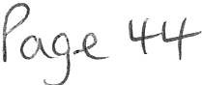

- aus sto

SH E LT E RS
The Old Garage Plantation Road, Burscough, L40 8JT Freephone: 0808 178 2460
Fax: 01704 534387
Email: info@bcshelters.co.uk
www.garrickoutdoor.org.uk

Quote Reference: 8953

13th June 2021

Vanessa Gorley Whitehaven Town Council

Clerk@whitehaventowncounciI.co.uk 07809 142401

Dear Vanessa,

Thank you for your enquiry, please find below the prices and specifications for our range of Bus Shelters, as we manufacture all of our shelters ourselves specific sizes and more bespoke designs are available.

All of our shelters are constructed from high-grade aluminium extrusion BS EN 755 ( 1-9) that once powder coated BS EN ISO 9002 to your chosen RAL or BS colour will give a long lasting, low maintenance corrosion free finish.

All structures will be dug into concrete pockets below the surface and top finished in the present surface material whether it is a flagstone area, tarmac or block paving.

All structures are guaranteed for Ten years and will NOT rust like steel shelters.

BC Shelters have been installing Bus Shelters, Walkways, Canopies, and Jet Wash Screens to various clients nationwide for many years.

Our engineers have been CRB checked and passed both CSCS courses (Health and Safety), Streetworks, and City & Guilds.

B&C Energy Solutions Ltd are certified in accordance with BS EN 1090-2:2008 + Al:2011 up to Execution Class 2 and all of our products will be manufactured to this standard. The harmonised
European Standard applies to all steel & aluminium structural metalwork and it is a criminal offence to supply structural metalwork unless it conforms to the BS EN 1090-2:2008 + Al:2011 standard and carries a legitimate CE mark and may in future affect your insurance.

Lead times from date of official purchase order are currently 3-4 weeks and time on site is normally a single day dependant on ground conditions.

Continued,

Please Note: BC Shelt ers is a trad ing sty le of B&C Energy Solut ions Ltd {Com pa ny Reg No: 08764479)

l;BiSHELTERS
The Old Garage Plantation Road, Burscough, L40 8JT Freephone: 0808 178 2460
Fax: 01704 534387
Email: info@bcshelters.co.uk www.garrickoutdoor.org.uk

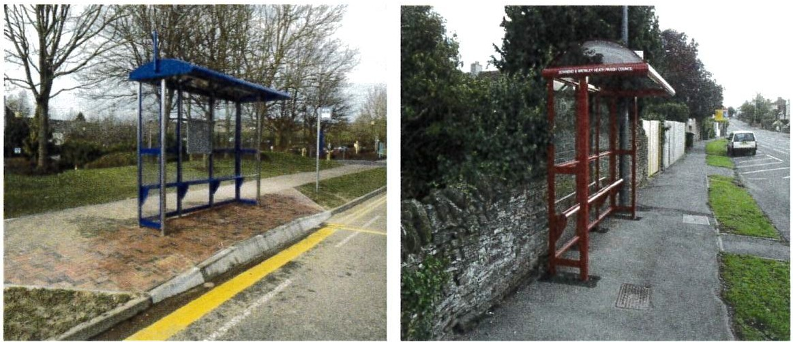

Above are two J bay cant/lever shelter with half glazed end panels & perch seating.

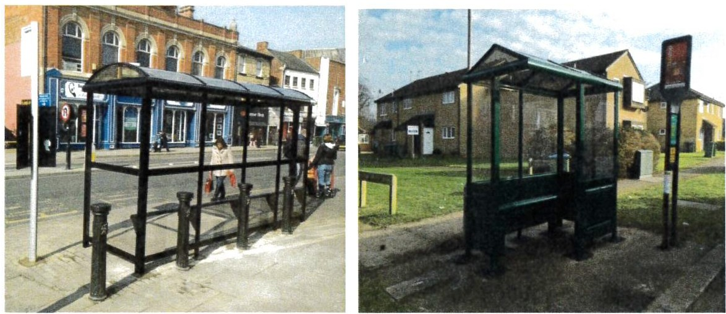
The shelter to the left is a J Bus Shelter with 1 full end panel and 1 quarter end panel and perch seating.

To the right is a picture of a 2 bay enclosed Bus Shelter with an aluminium bench seating and solid lower panels with fret work.

Please Not e: BC She l ter s is a tra ding style of B&C Energy Solut ions Lt d (Company Reg No: 08764479)

SH ELT ERS
The Old Garage Plantation Road, Burscough, L40 8JT Freephone: 0808 178 2460
Fax: 01704 534387
Email: info@bcshelters.co.uk www.garrickoutdoor.org.uk

Customer Testimonials

" Just wanted to say what a great job you completed yesterday, team was on time and had a miserable day in the rain and the wind. Please pass on our thanks to them. I am sure our residents will appreciate having some shelter now the bad weather is here" - Coleby Parish Council

" Brilliant service as usual" - Freston Parish Council

" The fitting team made an excellent job of erecting the shelter, including placing up warning signs.
All in all very helpful and arrived at the arranged time" - Heck Parish Council

"Very efficient and we're very pleased, thank you" - Wainfleet All Saints Town Council

"Very good job, all completed satisfactory" - Chinnor Parish Council

"Good job, well done" - Solutia UK Ltd

"Fitters were really good, very happy with the fit" - Aldi Distribution Centre

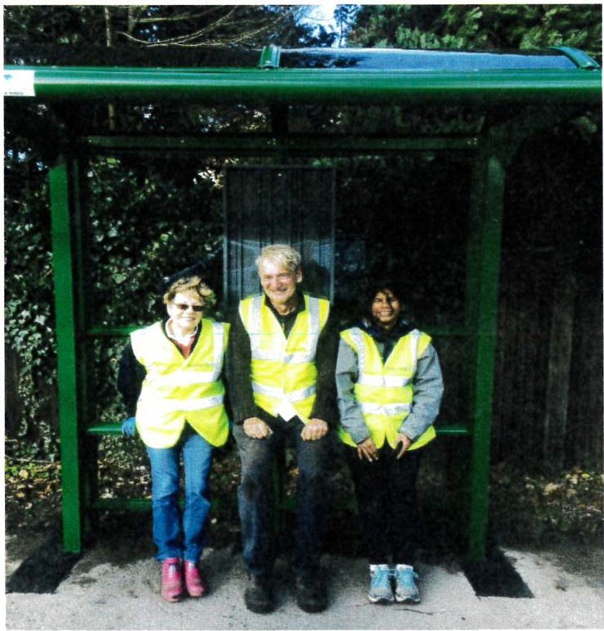
" Brilliant " - St Mary Magdalen's RC Primary School

" Everyt hing was done to an extremely high standard; the fitting team were both very friendly and efficient. A job very well done!" -Sunningdale Parish Council

Sunningdale Parish Councillors enjoying their new shelter.

1111
a pe a '") P£ SM A g1- 'l 111:l l=l
Cons tructionline / iiilmiiiiiiiiimiiilai:mii...,.""""" ,',';;::•;, :-.;:,::, q}}t t :
Please Not e: BC Shelters is a trad ing style of B&C Ene r gy Sol utions Ltd (Company Reg No: 08764479)

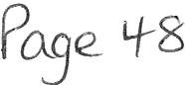

SHELTERS
The Old Garage Plantation Road, Burscough, L40 8JT Freephone: 0808 178 2460
Fax: 01704 534387
Email: info@bcshelters.co.uk www.garrickoutdoor.org.uk

3-Bav Cantilever Bus Shelter with Half End Panels (3.06M x 1.3M Roof Dimension)

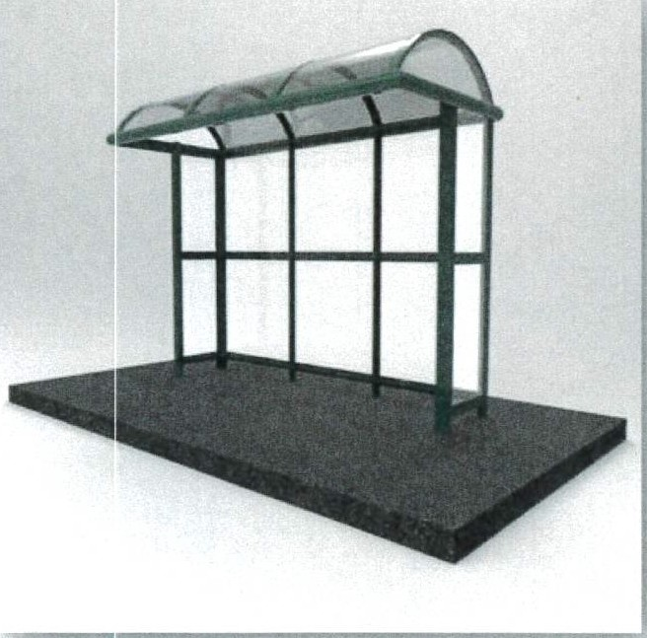

Specification

  - 3.06M x 1.3M Bus Shelter with an Elliptical Roof.

  - The roof will be constructed from high grade 80.0mm x 40.0mm extruded aluminium section and glazed in 4.0mm THK UV Stable Polycarbonate.

  - The main frame of the structure will be constructed from high grade 80.0mm x 50.0mm extruded aluminium section with a polyester powder coated finish. A choice of colours is available.

  - The side glazing panels of the Bus Shelter will utilise either 6.0mm THK toughened glass or 4.0mm THK Polycarbonate for ease of maintenance and safety purposes.

  - The Bus Shelter will be dug into the ground with 300.0mm cubed footings, in order for the Bus Shelter to be stable in all weather conditions.

  - Includes perch seating.

Total Cost: £3,638.80 + VAT
  - Please note - Prices are subject to VAT.
  - Includes installation.

fie- Con W c tionlino ap vP£ SM A ::: :'.·. :-: .::, 1½{$.}lJ 111
=.1 1

Please Not e: BC She lt ers is a t r ading sty le of B&C Ene rgy Solut ions Ltd (Company Reg No: 08764479)

ftf.isHELT ERS
The Old Garage Plantat ion Road, Burscough, L40 8JT Freephone: 0808 178 2460
Fax: 01704 534387
Email: info@bcshe lters.co.uk www.garrickoutdoor.org.uk

Flag Brackets: Timetable Case: Mains Lighting:
Perch Seating "Aluminium":
Optional Extras:

£56.70 (Per Unit) + VAT

£120.00 (Per Unit ) + VAT

£160.00 (Per Unit) + VAT

£62.50 (Per Mtr) + VAT

Bench Seat ing "Aluminium" £92.00 (Per Mtr) + VAT Solar lighting for a 2 bay shelter £1,100.00 (Per unit) + VAT

Solar lighting for a 3 bay shelter Solid lower panels with fret work
£1,450.00 (Per unit) +VAT

£60.00 (Per Unit) + VAT

Th an k you for taking the time to read thr ough the information provided. If you have any questions please do not hesitate to get in touch with me.

Kind Regards, Stacey Porter BCShelters
The Old Garage
Plantation Road Burscough
L40 8JT

e-mail: stacey@bcshe!ters.c.ouk

Tel: 01704 514613
Fax: 01704 534387

Please Note: BC Shelters is a t rad ing style of B&C Energy Sol ution s Lt d (Compa ny Reg No: 08764479)

SHELT ERS
The Old Garage Plantation Road, Burscough, L40 8JT Freephone: 0808 178 2460
Fax: 01704 534387
Email: info@bcshelters.co.uk www.garrickoutdoor.org.uk

BC SHELTERS - TERMS & CONDITIONS (Version 11)

- Delivery: Normally 6-8 weeks from receipt of instructions unless otherwise agreed with the client.

Should structural calculations be required these are available at a separate cost to the client upon request.

Please note that during the order process it may be necessary for further information to be obtained and slow responses could result in delayed installations.
- Fitting: Where prices for fitting are quoted or are inclusive in the price the following conditions apply.

BC Shelters will require your representative to be available when our fitting team arrives to instruct site locations (Also if possible a plan of the intended locations should be included with order), as well as when the installation is finished to complete our sign off form.
On arrival the installation site should be clear of any obstructions and sites should be level, if the client is unsure of the levels we can arrange a site visit to determine this once the order has been placed. Access to site should be unobstructed to allow Plant & Equipment to be used on site (i.e. Telehandler, Genie Lift, Scissor Lift etc)
All necessary permission for fitting shelters must have been obtained by yourselves, with all services clearly marked with

sufficient clearance available to allow foundations to be dug and set. Unforeseen ground conditions may be subject to further costs.
Our fitters will back fill to normal ground level with loose fill materials from site but we do not undertake for re­ instatement with asphalt or other top finishes unless otherwise agreed in writing. We recommend that this work be carried out immediately when our men finish on site.
Where paving stones, etc. are involved the greatest care will be taken when handling however BC Shelters will not be held responsible for any breakages.
BC Shelters requires that the work be undertaken in one visit to the area and that no delays are experienced due to work being unable to proceed after the goods have left our factory, This includes if upon at arrival at site the base is not the required size and we are not able to commence installation.
Should we be unable to carry out the work due to circumstances outside of our control, a minimum charge of £750.00 will apply.
Whilst carrying out an installation any interruptions out of our control will be logged and charged for at our hourly rate of

£48.00 per hour per operative.

Our price is based on there being normal dig conditions and any additional costs incurred, i.e. the provision of compressors, etc. for hard dig conditions will be charged extra.
Please N ot e: BC Shelt ers is a tra ding style of B&C Ener gy Sol ution s Lt d (Com pa ny Reg No : 08764479)

"'5isHELTERS
The Old Garage Plantation Road, Burscough, L40 8JT Freephone: 0808 178 2460
Fax: 01704 534387
Email: info@bcshelt er s.co.uk www. garrickoutdoor .org.uk

Where the removal of a shelter is required which has an electrical supply to them, BC Shelters require this to be disconnectedbefore arriving onsite. If upon arrival an electrical connection is live our installation team will be unable to carry out the works required and an aborted visit charge of £750.00 + VAT will be charged as well as any expenses such as hotels etc. If you are not sure if a supply is connected, your local electr icity company will be able to advise you.
Where shelters are supplied with lights our price includes for internal shelter wiring to a fused connector block only. All exterior electrical work and mains connections are the customer'sresponsibility. Time switchescan be supplied at extra cost.
Our aluminum products are guaranteed for 10 years and steel products are guaranteed for 5 years. This does not apply to the locking doors, both pin coded & key operated along with information panels etc.
The fitters will show you the correct use of locks and we shall be happy to prov ide you with simple maintenance instruc tions along with instructions on how to change your pin number.
It is a requirementof BC Shelters that photographs be taken of the installation once completed, these photographs will be used as part of our ongoing quality management system and may also be used for marketing purposes,if you do not wish for them to be used for our marketing purposesplease inform us at the point of order. I n the case of sensitive sites photog raphs will only be taken for quality purposesand will be destroyed following the inspection of the photographs.
- Installation Dates.

Once an installation dat e has been booked & confirmed, if you require this date to be postponed this must be done no

later than 7 days prior to the installation. All postponeme nts made within 7 days of the installation date will be subject to an administrat ion charge of £500.00 + VAT.
- Deposits.

Please note all orders require a 50% deposit payableon order unless otherwise agreed and alternative arrangements have been made.
- Retentions:

Where retentions are part of a contract a 5% retention will be accepted on the installation element of the order only.

Continued ...

1 , s "' 1111 a pea P' SM. A
C o n s truc tionline / 00

, ,o, 11u, " '' " "' 11,1.
, l l' III M \l!l l'l. 111 • U

Please Note : BC Sh elters is a trading style of B&C Energ y Solu tio ns Lt d (Compa ny Reg No: 08764479)

Pll8e s2.

Ma s H ELT ERS
The Old Garage Plan t atio n Road, Bur scoug h, L40 8JT Freep ho ne : 08 08 178 2460
Fax : 017 04 5343 87
Em ail: inf o @bcshelters .co.uk www .gar ri ckout door .org.uk

- Cancellation:

Should an order be cancelled prior to the commencement of manufactu re, an automat ic admi nistration fee of £50.00 (ex VAT) will be payable. If the ma n uf acture of the order has commenced, we reserve the right to charge up to 75% of the total order value as a cancellation charge dependent upon the stage of manufacture reached at the time of the
cancellation being received by us. If the order is cancelled at short noti ce e. g. the day before/on the day at the clients request, we reserve the right to charge £750.00 ( installat ion cost) if we cannot re-employ our fit ting team with another installation.
On placing an order by fax, post or email you automatica lly accept BC Shelters Terms and Conditions.

TERMS OF PAYMENT- PROFORMA INVOICE, UNLESS OTHERWISE AGREED.

All shelters remain the propert y of BC Shelters until payment has been received and cleared.

- co! ,¹!Lionlienape 9 P£ SM A ,'. .:•:. , :.:!, b\1f,}lJlll J=i
Please Not e: BC She lt ers is a trad ing style of B&C Energy Sol utions Ltd (Company Reg No: 08764479)

helterSolutions

Attn: Mrs Vanessa Gorley Town Clerk
Whitehaven Town Council

Contact No: 0194 667 366
Emailed to: Clerk@whitehaventowncouncil.co.uk REF: 3-Bay Lancashire Dome Roof Bus Shelter 15th June 2021
QUOTE REF: Q-21139AT

Dear Vanessa,

Firstly, thank you for your valued enquiry into our Bus Shelter Solutions. Further to your enquiry today, please find throughout this document my suggestions and specifications for the 3-Bay
Lancashire Dome Bus Shelter as requested. _ - /.
11111Here at Shelter Solutions, we have the distinct advantage over all the other companies as we manufacture all of our shelters to our client's bespoke designs. The Head of our Design and
Development Department will liaise with our surveyors' and yourselves to help you find the right
\ product for you.

All Covered Walkways, Canopies, Bus Shelters, Buggy Parks and Pram Shelters are constructe from high-grade aluminium extrusions (EN 755-9:2008), that once Durateal® coated (BS EN ISQ) 9002) to your chosen RAL or British Standard colour will give a long lasting, low maintenande
/i
1
corrosion free finish for up to fifteen years. .
All structures will be sub-surface fixed below the current ground level, into concr/etJ1/..ad
foundations provided by Shelter Solutions Site Operatives. / /
1
I I
As Shelter Solutions have been installing walkways and covered areas to schools for over !thirty
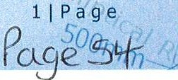years all engineers have passed both SSSTS and CSCS courses (Health and Safety) a d Street Works City and Guilds.

The approximate lead-times from date of official purchase order are currently 3- 4 weeks and time on site is currently listed at 2-3 working days during normal working hours.
II

<1111,1 - ---- ~-- - -
186)

PROPOSAL - 3-Bay Lancashire Dome Bus Shelter C/W Half End Panels
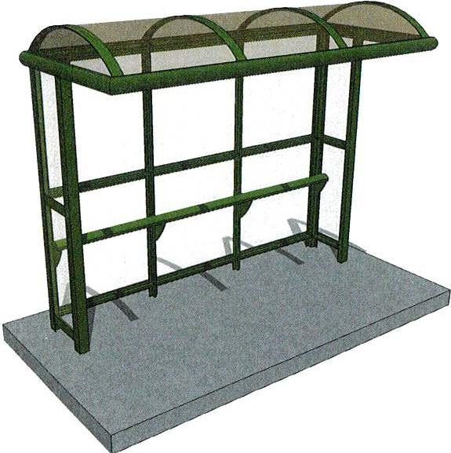

FULL SPECIFICATION:

- To manufacture, deliver and install a 3.00Mtr (L) x 1.30Mtr (W) x 2.45Mtr (H) Lancashire Dome Bus Shelter with Half End Panels.

- The bus shelter will utilise a glazed roof and fully glazed side and rear panels, utilising our own unique aluminium beading section.

The main frame of the bus shelter will be constructed from high grade 80mm x 50mm extruded aluminium sections, whilst the roof purlins will be manufactured from 80mm x 40mm extruded aluminium sections.

- All aluminium extrusions are to be Durateal® coated to a RAL colour of your choice free of charge.
f
- The bus shelter will be supplied in kit form, whilst the roof glazing will be affixed into place using rubber reinforced roof straps and self-drilling screws. The lowest point of the bus shelter will stand at the legally required standard of 2.lOMtrs to comply with current regulations. This will allow for sufficient cover, whilst
not being too intrusive.

- The side and rear glazing panels of the bus shelters will be glazed with either 5mm THK clear polycarbonate or 6mm THK clear toughened safety glass. You can choose either of these options at no extra cost. I

- The glazing material for the roof will consist of 4mm THK bronze tinted UV stable polycarbonate, whl is both easy to maintain and also protects against harmful UV rays from the sun. / /

- Included within my cost I have included one of our standard perch seats, which will be powder coat § to the same RAL colour as the bus shelter.

- The bus shelter will be submerged below the current finished ground level into concrete pad foundations provided by Shelter Solutions Site Engineers. Once the bus shelter has been installed, the localised area will be cleaned to high standard with any refuse brought back to our facility for recycling.

PRICING STRUCTURE:

3-Bay Lancashire Dome Bus Shelter C/W Half End Panels:
*Including Manufacture, Delivery and I nstallation*

Please Note: **VAT will be charged at the standard rate of 20%**
**Prices are subject to the final specifications**

£ 4,269.0 + VAT
//

1862
- - - - - - - - - '-1-)-'/)J ----- ---

,,
I hope all the information supplied here is sufficient, but if you need to discuss this quotation in further detail or would like any further assistance please do not hesitate to contact me.

Kind Regards, Alex Thomas

Solutions Unit 12, CustomComplex Yardley Road
Knowsley Industrial Park
L33 75S

Tel: 01942 625 577
Fax: 01514 470 251
Email: alex@shelter-solutions.co.uk
_{(\} Web: www.shelter-solutions.co.uk

J
CONTRACTORS HEALTH & SAFETY ASSESS MENT sctlEMf
Accredited Contractor
www.chas.gov.uk

Constructionline
Gold Member

11

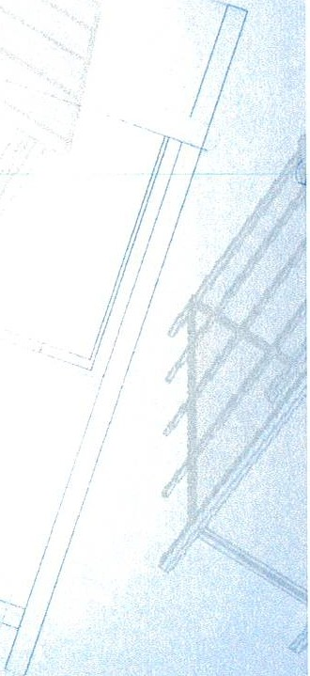185--,
31Page
-
Paj?£,J£ p

- -
-
- - - - - - - - - - - -_ <, f)7 ;_11 - - - -

- - - - - - - -

WTC 24/06/2021
Item 11

REQUEST TO RENT THE FORMER EDITOR'S OFFICE IN THE COUNCIL OFFICES

Purpose of the Report and Recommendation

To inform Members of the terms agreed for the Lease of the former Editor's Room in the Council Offices and to approve these.

  - INTRODUCTION

  - Members will recall that at the Council Meeting in November 2020 it was resolved that the former Editor's Office be rented to Newsquest subject to satisfactory negotiations being concluded and reported to the Council for approval. (Minute 1659/20 refers).

  - Heads ofTerms have been drawn up and submitted to Newsquest for approval (see Appendix 1) who have now asked for a draft Lease to be prepared and sent to them.

  - The Lease will be a standard Lease and will be in the format of the Lease that CBC gave to the Town Council for the Lease of Room 3 in the Civic Hall. The Heads of Terms will be incorporated into the Lease.

  - Each party will be responsible for the payment of their own legal and surveyor's costs in the preparation of the Lease.

  - RECOMMENDATION

  - It is recommended that the Council considers the Heads of Term to be included in a Lease to Newsquest and approves the same and that the draft Lease be sent to Newsquest.

FcJ,,\ :2 4-(0 b ( I
t·rEfvl ( (
APPf3'\ili I'f.-. (
Whitehaven Town Council Room on FirstFloor Heads of Terms

Type of transaction:

Landlord:

Tenant:

Property:

Additional rights:
Lease, excluded from protection under the Landlord and Tenant Act 1954.

Whitehaven Town Council 148 Queen Street Whitehaven
Cumbria
CA28 ?AZ

That part of the 148 Queen Street, Whitehaven, Cumbria Cumbria ('the Building') known as the former Editors Office and shown edged red on the attached plan.

- a right of access to the Property across that part of the Building forming the Reception and stairs to the first floor such access being shown edged green on the attached plan

- a right of access to the toilet areas shown coloured yellow on the attached plan .

- a right to use the toilets referred to in
(b) above.

- a right of access, in the event of an emergency, across other parts of the building designated by the Landlord as emergency exits.

Right reserved to the Landlord and other Building users:

Term:

Termination:

Restricted use:

Opening Hours
- a right to use, in the event of an emergency, any emergency access ways that cross the Property.

- usual rights of access for maintenance of the Building, providing the Services and access to an meters, etc. in the Property.

1 years commencing on the XXXXXXXXX 2021 and ending onthe XXXXXXXXX 2022.

The Landlord or the tenant may determine the lease on either party giving to the other at least 3 months prior written notice

As office accommodation only. No visitors or meetings with any outside bodies to take place on the Property

The Building is open from 8.00am to 4.00pm Monday to Friday (at present due to covid guidance it is only open 3 mornings per Week)

Rent: £1,092.00 per annum based on office space of 168 sq feet at £6.50 per square foot

Water Rates: £80.00 per annum

Energy costs:

The cost of gas is £50 per month recharged separately The cost of electricity is£ 50.00 per month recharged separately
These costs represent a fair and reasonable proportion of the energy costs for the building taking into account the size of the Property and the Common parts used by the Tenant

NNDR: The Property is not rated separately and the Council currently pays £10,603.75for the Building. Based on the size of the property (168sqft) used by the tenant the rechargeable NNDR to the Tenant is £318.11 per annum

Insurance:

Alienation:

Alterations:

Reinstatement:
The Tenant shall be responsible for insuring its own contents.

The Landlord shall be responsible for insuring the Building as a whole subject to the Tenant reimbursing the Landlord a proportion of the cost of such insurance.
For the year 2021/22 the insurance cost of the Building was £10,603.75 and the Tenant's contribution being
£XXXXXX per annum

Sub-letting or assignment of part or whole of the Property is prohibited.

No alterations or additions to the Property are
permitted without prior written consent. Written consent is deemed to have been given for any alterations proposed and agreed to prior to the start of the lease and subject to a specification for such being approved in writing by the Council.

If required to do so by the Council at the end of the Term the Tenant shall remove any alterations made by the Tenant and reinstate any surfaces affected to the condition they were prior to entry and to the Landlord's reasonable satisfaction.

Repairs: The Tenant shall:

- keep the interior of the Property (including the doors, windows, internal or external and the frames thereof and the glass therein, the interior finishes of the walls and ceilings and floor coverings in a clean and tidy condition.

- keep the Landlord's fixtures and fittings in the Property (to be listed and agreed) in an efficient state, in efficient working order and in good repair and condition and compliant will relevant health and safety legislation and if any such items are broken or damaged to repair or replace such to the reasonable satisfaction of the Landor

P03e bO

- keep in good repair and condition the following:

  - the plaster or plasterboard attached to:
    - the interior of the exterior walls of the Property but no other part of the exterior walls;
    - the inner face of any structural supporting column but no other part of such column;
  - the plaster or plasterboard comprising the ceiling of the Property but not the joists beams or cross members to which they are attached;
  - the floor boards concrete floor screeds but not the joists supporting beams or cross members upon which they rest;
  - the entirety of all non-load bearing walls within the Property;
  - the inner half severed medially of any non­
load bearing walls which divide the Property from other parts of the Building;
  - all floor coverings;
  - all internal and external windows and window frames;
  - the doors giving access to the Property and the door frame surrounding it; and
  - all drainage, pipe work and taps, electricity cabling, sockets, switches, light units and bulbs and other similar fittings which exclusively serve the property.
- To keep the Property in a good state of decoration

- Promptly to make good to the satisfaction of the Landlord any wilful or accidental damage to the Property or the Building caused by the Tenant or the Tenant's servants agent licensees or visitors and to indemnify the Landlord in respect of any claims arising from such.

Waste:

VAT:
The Landlord shall provide the repairs stated under Services below.
The Tenant shall arrange for the proper, prompt, regular and adequate disposal of waste produced within the Property and not to form any rubbish or scrap heap on the Property or the Building or to store goods or materials in the open air.

VAT will be chargeable on the Rent and Service Charge as applicable.

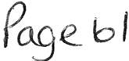

Costs:

Services:
Each party to be responsible for their own surveyor's, legal andother costs incurred in connection with this matter.

In consideration of the Tenant paying the Service Charge the Landlord shall provide the following services:

- Repair & maintenance of building and Property which isnot the responsibility of the Tenant as set out above;
- Hot and cold water to the toilets
- Heating to the Property
- Security to the Building
- Fire alarms and fire extinguishers.

For the avoidance of doubt the following are not included in the Services to be provided by the Landlord:

- Receptionist and reception services
- Furniture, fittings & equipment
- Waste disposal and recycling
Security services (other than as set out above) Porterage services
- Contents insurance
- Office cleaning
- Window cleaning - inside & outside

For the avoidance of doubt the Tenant shall be responsible forthe following matters:

- Occupier fit out works
- ICT connections to the PropertylCT installations New lighting
Power & data containment to desksVoice & data cabling
- Power and data outlets at desks
- Furniture and fittings
- Storage cabinets and pedestals
- Signage
Window blinds or curtainsAccess control
Security system & alarm solely serving the Property
- Removals
- Reimbursement of building insurance costs.

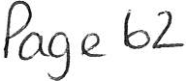

lbilet use: In respect of the shared use of the Toilets shown on the plan the Tenant shall comply with any rules issued, from time to time, by the Landlord to all tenants forthe use thereof.

Better The Tenant shall observe and perform any reasonable management conditions regulations rules and directions as the Landlord may
from time to time publish to govern the mode of use or for the better management and administration of the Building.

Statutory matters: The Tenant shall comply with all statutory requirements, including planning, health and safety and building control, in respect of the occupation and use of the Property.

Security: The landlord is responsible for the security of the building and at the end of the working day will lock and secure the building

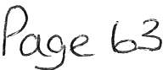

1• $1

Ji<),JNOl:<11'1 (.llf.

I t··-
_J

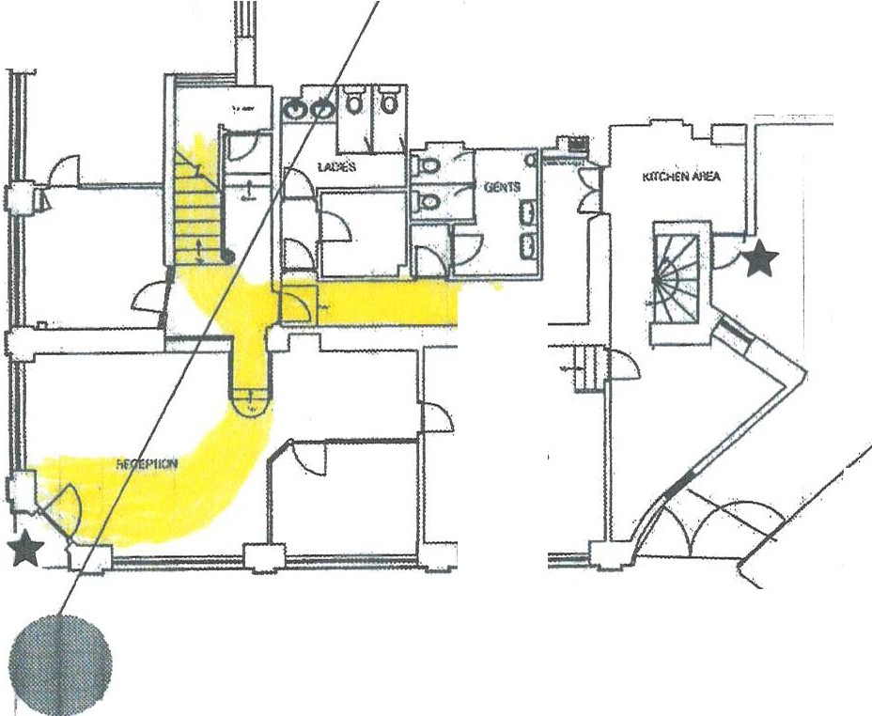EXITS:*
ASSEMBLY POINTS

. ,.:( w..:,:

FIRST FLOOR

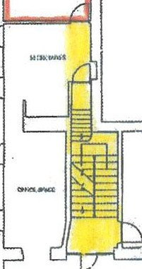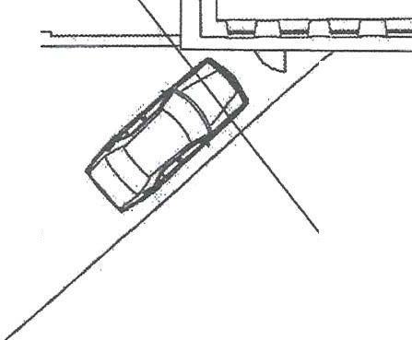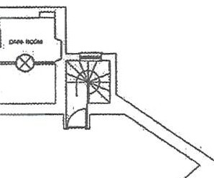f>SBUILi ARST FlOOR Pl.AN
.l""i , ! q £ ! I I

-I"'=-"""!'

flOITTING.C,,lP-
I
·-rrtE P L-·A-N
\.

wimrt:!Jk.G GROUND FLOOR

AS BUilTOROUNO f.LOOR PLAN

lS
('0
o-·
14•1l iI.s·½ I ! !

Corner of Queen Street/Roper Street opposite froht door
I
;
· I I I
· _t.
1J0Metres

Washington Square opposite Bonnars

