WHITEHAVEN TOWN COUNCIL

Clerk and Responsible Financial Officer: Chairman:
Marlene Jewell Telephone: 01946 67366 Councillor Chris Hayes

To: Members of Whitehaven Town Council

You are duly SUMMONED to attend a MEETING of WHITEHAVEN TOWN COUNCIL which will be held in THE HARBOUR GALLERY at THE BEACON, WHITEHAVEN on THURSDAY 28th OCTOBER 2021 at 6:00pm

Signed.... -- ·-············ Dated. Q _ l Marlene Jewell, Clerk and Responsible Financial Officer

AGENDA

- Apologies for Absence

- Declarations of Interest

To receive declarations of interest by elected Members in respect of Agenda items.

If a Member requires any advice on any item involving a possible declaration of interest which could affect his/her ability to speak and/or vote he/she is advised to contact the Clerk at least 24 hours in advance of the meeting.

- Public Participation

- Minutes of the Council Meeting held on 30th September 2021

- Planning Applications

- Finance Report

- Presentation by Andrea Winders (Disruptieve)

- Appointment of Internal Auditor

- Recommendations from Allotments Advisory Group

- Recommendations from Events Advisory Group 11.Recommendations from Policy and Resources and Finance Committee
- Remembrance Sunday
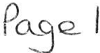

- Christmas Closing 14.Councillor Ward Matters
- Date and Time and Venue of Next Meeting IN PRIVATE
That prior to the following items of business the Chairman will move the following resolution:

That in view of the special or confidential nature of the business about to be transacted it is advisable in the public interest that the public and or press be instructed to withdraw.

- Councillor Ward Grant - CVG

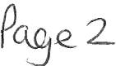

WHITEHAVEN TOWN COUNCIL

Minutes of the Council Meeting held on 30th September 2021

Present: Councillor R Gill (Vice Chairman in the Chair); Councillor E Dinsdale; Councillor B O'Kane; Councillor G Roberts; Councillor R Redmond

M. Jewell, Clerk and Responsible Financial Officer

V. Gorley, Assistant Clerk

The Chairman welcomed Councillor Redmond back and said it was nice to see him fit and well again

The Chairman said he was sorry to hear Councillor Louise Walmsley had resigned and read out her resignation. He proposed that a letter of thanks be sent to Louise Walmsley which was agreed.

The Chairman wished Councillor Hayes a speedy recovery and asked a card be sent to him on behalf of the Council

1871/21 Apologies for Absence

Apologies for absence were received as follows
Councillor C Hayes Recovering from operation
Councillor J Rayson, Work commitments
Councillor C Maudling Flu
Councillor G Dinsdale Ill
Councillor C Walmsley Work commitments
It was proposed by Councillor O'Kane and seconded by Councillor Roberts that the apologies be noted and accepted. A vote was held and it was unanimously

RESOLVED - That the apologies be noted and accepted

1872/21 Declarations of Interest

Councillor G Roberts declared an interest in Item 8 Christmas Lights as he was a member of Cumbria County Council

1873/21 Public Participation

There was no public participation

1874/21 Minutes of the Meeting held on 26th August 2021

It was proposed by Councillor Roberts and seconded by Councillor O'Kane that the Minutes of the Meeting held on 26th August 2021 be approved and signed by the Chairman as a correct record. A vote was held and it was unanimously

RESOLVED -That the Minutes of the Meeting held on 26th August 2021be approved and signed by the Chairman as a correct record.

1875/21 Planning Applications

The Council considered a report on Planning Applications received and shown at Appendix 1.
- Before considering Appendix 1 Councillor O' Kane made a proposal that the CBC' s Planning Officer be requested to explain the procedure regarding delegated decisions and the request to go before the Planning Panel. This was seconded by Councillor Roberts. A vote was held and it was unanimously
RESOLVED - That CBC's Planning Officer be requested to explain the procedure regarding delegated decisions and the request to go before the Planning Panel.
- It was proposed by Councillor Roberts and seconded by Councillor
O' Kane that following consideration of the Planning Application shown at Appendix 1 CBC be informed that the Council had no representations to make. A vote was held and it was unanimously
RESOLVED - That following consideration of the Planning Applications shown at Appendix 1 CBC be informed that the Council had no representations to make.

1876/21 Finance Report

The Council considered a Finance report.
  - Appendix l - The Assistant Clerk reported that there were 6 extra invoices to be considered namely:

Gordon Ellis &Co Cumbria Roofing Lockhart Leisure
£1523.84 plus VAT for 4 barrier baskets 2x3 tier planters and 4 linings
£1400 plus VAT for repairs to Council Office roof
£1475 plus VAT for marquee for Science show

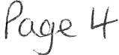

Debra McKenna Cumbria Media
Fluid Productions Ltd
£1000 plus VAT for final 50% fee for Stefan Gates Science show
£104.40 plus VAT for accessibility Software for website
£1046.40 plus VAT for technical Support for Science Show

It was proposed by Councillor Roberts and seconded by Councillor O'Kane that the Invoices shown at Appendix I together with the 6 invoices above be approved and paid. A vote was taken and it was unanimously

RESOLVED - That the Invoices shown on Appendix 1 together with the 6 invoices above be approved and paid.

u. Appendices 2 and 3 - It was proposed by Councillor O'Kane and seconded by Councillor Roberts that Appendices 2 and 3 be approved and noted. A vote was held and it was unanimously
RESOLVED - That Appendices 2 and 3 be approved and noted.

1877/21 Annual Governance & Accountability Return - External Auditors Report for Year Ended 3pt March 2021

The Council considered the Annual Governance & Accountability Return - External Auditors Report for year ended 31st March 2021 received from PFK Littlejohn the External Auditors. The Clerk said that the Council had been given a clean bill of health and the Chairman thanked the Clerk and Assistant Clerk for all their hard work in this. It was proposed by Councillor O'Kane and seconded by Councillor Roberts that the Council note and approve the External Auditor Report and Certificate for 2020/21. A vote was taken and 4 Councillors voted for the proposal and 1 Councillor abstained

RESOLVED - That the Council note and approve the External Auditor Report and Certificate for 2020/21.

Councillor O'Kane asked if the Council could present this as an item to the local media as people needed to know that the Council's accounts were in order.
Councillors indicated agreement and Councillor E Dinsdale asked that in the article it be recorded that 4 Councillors had voted for and 1 Councillor had abstained. The Chairman made a ruling and said this was a quorate meeting of the Council and this matter had been approved by the Council.

1878/21 Christmas Lights

The Council considered a report on Christmas lights for 2021 and the quote of
£24,400.00 plus VAT received from the Council's preferred Contractor, Cumbria County Council Highways Lighting Department for the erection, maintenance, dismantling and repair of the Christmas lights in 2021. The same amount has been charged for the past 3 years.
In order to use the preferred supplier Financial Regulations have to be suspended and the reasons for suspension recorded and that an assessment of the risks has been presented to the council.
1. It was proposed by Councillor O' Kane and seconded by Councillor Roberts that the Council makes a resolution to suspend Financial Regulation 11 to allow CCC to erect, maintain, dismantle and repair the Christmas lights. A vote was held and it was unanimously
RESOLVED - That the Council makes a resolution to suspend Financial Regulation 11 to allow CCC to erect, maintain, dismantle and repair the Christmas lights.
11. Following the making of the resolution in i above it was proposed by Councillor O' Kane and seconded by Councillor Roberts that in accordance with Financial Regulation 18 the reasons for the suspension be recorded and that the assessment of the risks provided be accepted and approved so that CCC can undertake the works at a cost of £24,400.00 plus VAT. A vote was held and it was unanimously
RESOLVED -That following the making of the resolution in i above and in accordance with Financial Regulation 18 the reasons for the suspension be recorded and that the assessment of the risks provided be accepted and approved so that CCC can undertake the works at a cost of
£24,400.00 plus VAT

111. Following a discussion as to when the Christmas lights be switched on it was proposed by Councillor O'Kane and seconded by Councillor Roberts that the Christmas lights be switched on on Saturday 20th November 2021 at 5.00pm by The Mayor, Councillor Chris Hayes. A vote was held and it was unanimously
RESOLVED - That that the Christmas lights be switched on on Saturday 20th
November 2021 at 5.00pm by The Mayor, Councillor Chris Hayes.

1v. It was proposed by Councillor O'Kane and seconded by Councillor Roberts that a letter be sent to Whitehaven Rugby League Club to congratulate them on their successful season this year. A vote was held and it was unanimously
RESOLVED - that a letter be sent to Whitehaven Rugby League Club to

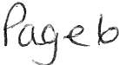

congratulate them on their successful season this year.

1879/21 Events Expenditure

The Council considered a report on expenditure in connection with Council events.
1. It was proposed by Councillor Roberts and seconded by Councillor
0 ' Kane that following Minute 1864/21 the purchase of 20 folding tables for £939.80 plus VAT to be delivered after l 7/11/21 be noted and approved. A vote was held and it was unanimously

RESOLVED- Thatfollowing Minute 1864/21 the purchase of20 folding tables for £939.80 plus VAT to be delivered after 17/11/21 be noted and approved.

n. Further to Minute 1864 /21 quotes had been received to provide 2 marquees one 12 x 6 and one 15 x 9 for the Christmas Market as follows:-

Supplier A Supplier B Supplier C
£1,620.00 plus VAT
£1,550.00 plus VAT
£2,054.24 plus VAT

It was proposed by Councillor O'Kane and seconded by Councillor Roberts that the quote from Supplier A be accepted at a cost of£ 1,620.00. A vote was held and it was unanimously

RESOLVED - That the quote from Supplier A be accepted at a cost of
£1,620.00 plus VAT.

111. It was proposed by Councillor Roberts and seconded by Councillor O'Kane that the Council authorise an additional £70 to cover the increased rail fare and taxi fares for the presenter of the Science Show. A vote was held and it was unanimously
RESOLVED - That the Council authorise an additional £70 to cover the increased rail fare and taxi fares for the presenter of the Science Show.

1880/21 Summer Plants 2022

The Council considered a report on a quote of £6,889.55 excluding VAT received from the Council's preferred supplier for the provision of summer flowers for the hanging baskets, hexagonal planters, barrier baskets, barrels, cast iron planters , Trinity bed and the Pelican bed in 2022. The quote also includes the additional three-tier planters and barrier baskets as well as the Harbour - a total of 5,093 plants. The cost last year was £6,368.10 plus VAT for 5,038 plants. In order to use the preferred supplier Financial Regulations have to be suspended and the reasons for suspension recorded and that an assessment of the
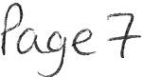

risks has been presented to the council.

1. It was proposed by Councillor O' Kane and seconded by Councillor Roberts that the Council makes a resolution to suspend Financial Regulation 11 to allow the summer plants for 2022 to be purchased from the preferred supplied. A vote was held and it was unanimously
RESOLVED - That the Council makes a resolution to suspend Financial Regulation 11 to allow the summer plants for 2022 to be purchased from the preferred supplier.

- Following the making of the resolution in i above it was proposed by Councillor Roberts and seconded by Councillor O'Kane that that in accordance with Financial Regulation 18 the reasons for the suspension be recorded and that the assessment of the risks provided be accepted and approved so that the summer plants for 2022 can be purchased from the preferred supplier at a cost of £6,889.55 plus VAT. A vote was held and it was unanimously

RESOLVED - That following the making of the resolution in i above and in accordance with Financial Regulation 18 the reasons for the suspension be recorded and that the assessment of the risks provided be accepted and approved so that the summer plants for 2022 can be purchased from the preferred supplier at a cost of £6,889.55 plus VAT

1881/21 Replacement of Defibrillator Electrode Pads

The Council considered a report on the replacement of 13 defibrillator electrode pads in its 7 defibrillators which had an expiry date of November 2021. Three quotes had been received for replacement pads:
  - Supplier A - £52.99 each plus VAT
  - Supplier B - £36.00each plus £9.95 delivery plus VAT
  - Supplier C - £69.99 each plus VAT
Following consideration of the quotes received it was proposed by Councillor Roberts and seconded by Councillor O'Kane that 13 replacement defibrillator electrode pads be purchased from Supplier B. A vote was taken and it was unanimously

RESOLVED - That 13 replacement defibrillator electrode pads be purchased from Supplier B.

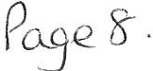

1882/21 Remembrance Sunday

1. The Council considered a report on Remembrance Sunday. The Clerk reported that the Whitehaven Brass Band would be in attendance for the service in Castle Park but it was not known if they would be able to march. There may also be a cost for the Band. This would be reported back.

11. The Assistant Clerk explained that it would not be possible to use the Civic Hall for pie and peas as it had been booked and it had not been possible to find a venue large enough to accommodate the number of people and with the facilities for heating pies. An alternative would be to provide tea, coffee and biscuits and/or sandwiches in the United Church Hall if that was possible. Following a discussion it was proposed by Councillor Roberts and seconded by Councillor O' Kane that consideration of this be left to the next Council Meeting in October.
A vote was held and it was unanimously
RESOLVED - That consideration of this be left to the next Council Meeting in October.
111. It was proposed by Graham Roberts and seconded by Councillor O'Kane that 5 poppy wreaths be ordered at a cost of approximately £25-£30 each. A vote was held and it was unanimously
RESOLVED - That that 5 poppy wreaths be ordered at a cost of approximately £25-£30 each.

1883/21 Grass Cutting Contract

The Council considered a report on the Grass Cutting Contract for 2022. Councillors had been asked if they had any areas in their wards that should be included in the contract. Councillor O'Kane said there was a piece of land at Elizabeth Crescent which had been advertised for sale by the people who owned it and said it had been cut by the Council in the past. He said it was the only piece of grass in the area. Following a discussion it was proposed by Councillor Roberts and seconded by Councillor Gill that the land be included in the Contract and that quotations be sought from local contractors to carry out the grass cutting of those areas in the Contract in 2022. A vote was held and it was unanimously

RESOLVED - That the land be included in the Contract and that quotations be sought from local contractors to carry out the grass cutting of those areas in the contract in 2022.

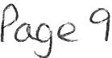

1884/21

1885/21

1886/21
Allotment and Pigeon Loft Maintenance Contract

The Council considered a report on the Allotment and Pigeon Loft Maintenance Contract for 2022/23. It was proposed by Councillor O' Kane and seconded by Councillor Roberts that quotations are sought for the provision of this service for 2022/23. A vote was held and it was unanimously

RESOLVED - That quotations are sought for the provision of this service for 2022/23.

Code of Conduct

The Council considered a Notice of Decision issued following a hearing by Copeland Borough Council's Standards and Ethics Committee into a complaint concerning Whitehaven Town Councillor Carla Arrighi. The Chairman read out the sanction imposed which was that the subject Member be issued with a conditional warning in respect of future behaviour for a period of 2 years from the date of the notice.
No decision was necessary and the Notice of Decision was noted

Copeland Local Plan 2021-2038: Additional Focused Pre-Publication Draft Consultation on Potential Changes to Local Plan

The Clerk informed Members that the consultation on the above document had started on 13t h September 2021 and would end on 12th October 2021.
It was proposed by Councillor Roberts and seconded by Councillor O'Kane that the document be noted and that individual Councillors submit any comments they have direct to CBC. A vote was taken and it was unanimously

RESOLVED - That the document be noted and that individual Councillors submit any comments they have direct to CBC.

1887/21 Councillor Ward Matters

1. Councillor E Dinsdale said there were issues since the last meeting with general waste and recycling collection on Maple Grove at Valley Park. The date for waste collection didn't happen and along with road resurfacing made it difficult for the van to get there. He said letters had been sent to CBC and a response had been from CBC apologising but that while he understood that the pandemic had made it difficult at times this had happened too many times and CBC has got to get a handle on this
- Councillor E Dinsdale referred to Garlieston Court and said the residents there had contacted him about a historic issue around the road resurfacing where the builders had taken a deposit and then left and the residents were still waiting to get the work done

111. Councillor E Dinsdale said there were issues around parking in Garlieston and that people working at Centre Pares were getting picked up there and leaving their cars parked and preventing residents getting a park there. Councillor Dinsdale asked if he could use the Council's zoom for a meeting with the residents and the Clerk confirmed that he could.
1v. Councillor O' Kane referred to Bransty Bus Stop and said that we now know who owns the land.
- Councillor O'Kane referred to Oakbank Avenue and said that frequently the residents there had their waste missed out and that he had made numerous calls to CBC about this but had not been able to speak to a waste officer.
v1. Councillor O' Kane referred to Caldbeck Road and said there was an area of unadopted land where there are 4/5 unadopted street lights that nobody will do anything with. Councillor O'Kane said that the worry was in future at the top of Hensingham there was going to be 6-700 houses up that end of town and no one can tell if the services will be adequate. He said he would like a meeting to look at the plans that CBC has for that area.
v11. Councillor E Dinsdale said that when recycling and waste was left out and not collected plastic and cardboard was blown all over the place.
v111. Councillor Roberts said he had had complaints about people hanging around on the street late at night with cans of diamond white and said that people are getting concerned that the Police are toothless. He said the Police don't act on the PSPOs.
1x. Councillor Gill expressed concern about the length of time it takes to get through to CBC about residents' complaints

1888/21 Date and Time and Venue of Next Meeting

Further to Minute 1867/2 l it was reported that no information had been received on alternative venues and that therefore the next Council Meeting would be held in the Harbour Gallery at the Beacon on 28th October 2021 at 6.00pm.

IN PRIVATE
1889/21 That prior to the following item of business the Chairman moved the following resolution: -

That in view of the special or confidential nature of the business about to be transacted it is advisable in the public interest that the public and or press be instructed to withdraw from the meeting.
Councillor Roberts proposed this and Councillor O'Kane seconded it. A vote was held and it was unanimously .

RESOLVED - That in view of the special or confidential nature of the business about to be transacted it is advisable in the public interest that the
P e II

public and press be instructed to withdraw from the Meeting. All members of the public and press then left the Meeting.

1890/21 Councillor Ward Grant- CVG

Further to Minute 1869/21 was rep01ied that no response had been received from Allan Forster.
Following a discussion it was proposed by Councillor Gill and seconded by Councillor Roberts that after considering the receipts that a letter be sent to Allan Forster asking for the unspent amount of the Councillor Ward Grant to be returned to the Council at the earliest opportunity and that failure to do so would result in further action being taken. A vote was taken and 3 Councillors voted in favour of the proposal, 1 Councillor voted against and 1 Councillor abstained.

RESOLVED - That that a letter be sent to Allan Forster asking for the unspent Amount of the Councillor Ward Grant to be returned to the Council at the earliest opportunity and that failure to do so would result in further action being taken.

The Meeting closed at 7.35pm

Chairman

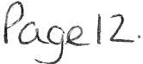

WTC 28/10/2021

Item 5

Planning Application for Consideration by Whitehaven Town Council

Application Number 4/20/2455/0F1
Detail
Consultation on Amended Details - Highways and Drainage - October 2021: RESIDENTIAL DEVELOPMENT OF 40 DWELLINGS
LAND SOUTH OF WATERS EDGE CLOSE, KELLS, WHITEHAVEN

4/21/2294/0F1 Consultation on Additional and Amended Drainage and Parking
Details. Withdrawal of Landscaping Details and Reservation of Subsequent Approval: PROPOSED TWO STOREY EXTENSION WEST CUMBERLAND HOSPITAL, HOMEWOOD ROAD, WHITEHAVEN

4/21/2339/0F1

4/21/2421/0F1

4/21/2427/0B1

4/21/2431/0F1

4/21/2435/0F1

4/21/2440/0E1

4/21/2441/0F1
Consultation on Additional and Amended Information: CONSTRUCTION OF 14 DWELLINGS FOR AFFORDABLE RENT AND ASSOCIATED INFRASTRUCTURE , PARKING AND LANDSCAPING
JEFFERSON PARK, WHITEHAVEN

ERECTION ON A GARAGE ON EXISTING SITE (RETROSPECTIVE)
LAND TO THE REAR OF 31 SOUTH ROW, WHITEHAVEN

VARIATION OF CONDITION 3 (HOURS OF OPERATION) IN RELATION TO PLANNING APPROVAL 4/17/2083/0F1 - CHANGE OF USE FROM STORAGE BUILDING (A1) TO CROSSFIT GYM (D2)
ARGO FITNESS, COACH ROAD, WHITEHAVEN

PROPOSED TWO STOREY EXTENSION
44 WINCHESTER DRIVE, WHITEHAVEN

DEMOLISH EXISTING OUTHOUSE AND CONSTRUCT NEW EXTENSION TO REAR OF THE PROPERTY
5 HERBERT HILL, WELLINGTON ROW, WHITEHAVEN

LAWFUL DEVELOPMENT CERTIFICATE FOR A PROPOSED REAR EXTENSION
46 JUBILEE ROAD, WHITEHAVEN

ERECTION OF ONE PAIR OF SEMI-DETACHED DWELLINGS
LAND ADJOINING 101 WOODHOUSE ROAD, WHITEHAVEN

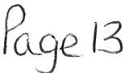

Application Number

4/21/2449/0F1 SINGLE STOREY REAR EXTENSION (AMENDMENT TO
PREVIOUSLY APPROVED 4/21/2139/0F1)
2 BASKET ROAD, KELLS, WHITEHAVEN

WTC 28/10/2021

Item 6

FINANCIAL REPORT

Purpose of the Report

Members are asked to consider a list of invoices for authorisation and payment as shown at Appendix 1 and approve the recommendations in paragraphs 3.1 and 3.2.

  - INTRODUCTION

  - Authorise the payment of all invoices as listed in Appendix 1.

  - The Council is asked to note the cashbook as reconciled with the bank account as shown at Appendix 2 together with income and expenditure at Appendix 3.

  - FINANCIAL POSITION

  - The bank reconciliation was carried out on 20th October 2021. This shows a balance of £318,861.04. There are no cheques waiting to be presented and cleared.

  - The balance in the deposit account is £450,400.11.

  - RECOMMENDATION

  - The invoices listed and shown in Appendix 1 be approved and authorised for payment.

  - The Cashbook (Appendix 2) and the Income and Expenditure (Appendix 3) be noted.

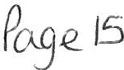

28/10/2021

Appendix 1

Invoices focC1msideration by Whitehaven Town Council

Date | Supplier | Category | Detail | Total Amount |  | Power | Columnl
25/09/2021 | Eden Sprinl!s (UK) Ltd | Supp lie s & Services | 4 x 18.51 water, Environmental Levy for water coolers (October) | £ | 24.43 | slllLGA 1972
30/09/2021 | Copeland Borough Council | Premises | Hire of Harbour Gallery for Council meeting | £ | 96.00 | slllLGA 1972
30/09/2021 | Mrs M Jewell | Supplies & Services | Zoom Standard Pro Annual Licence | £ | 143.88 | slllLGA 1972
30/09/2021 | Bauer Radio Ltd | Even ts | CFM Airtime - ad productions | £ | 583.20 | s144 LGA 1972
01/10/2021 | Cooeland BorouRh Council | 3rd Party | Assistant Ranger Contract - October 2021 | £ | 2,199.02 | slllLGA1972
01/10/ 2021 | Copeland Borough Council | 3rd Party | Grass Cutt ing Contract - October 2021 | £ | 1,995.62 | slllLGA1972
01/10/2021 | Cooeland BorouRh Council | 3rd Party | Parks & Open Spaces Ranger Cont ra ct - Octo b er 2021 | £ | 3,325.44 | slllLGA1972
01/10/2021 | Copeland Borough Council | 3rd Party | Allotment Maintenance Contract - October 2021 | £ | 717.42 | s23 Small Holdings Allotments Act 1908
01/10/2021 | Copela nd BorouRh Council | Premises | Discounted Comme rcial Waste 01.10.21 - 31.12.21 | £ | 20.73 | slllLGA1972
05/10/2021 | Westcom IT Solutions | Supplies & Services | 2 x Azure Rights Management Licence, Office 365 Licence,annual domain hosti ng | £ | 258.72 | slllLGA 1972
07/10/ 2021 | Online Systems | Supplies & Services | ntle purchase of telephone equipment | £ | 60.00 | slllLGA1972
08/10/2021 | Mrs V Gorley | Supplies & Services | Postage for grass cuttingcontract quote letters | £ | 7.32 | slll LGA 1972
18/10/2021 | Viking | Supolies & Services | Copier paper, post it notes, diary and stamps | £ | 133.34 | slllLGA 1972
19/10/2021 | Cumbria Media | Supplies & Services | Website maintenance Job Na's 393 - 396, meeting support | £ | 122.00 | sll l LGA 1972

£ 9,687.12

c%
(0
Cf

WHITEHAVEN TOWN COUNCIL CASH BOOK FROM 1 APRIL 2021

APPENDIX 2

Emp loyees / Supplies/

Community Ground Civic Ward Environmental

Date Ref Payee April-2021
Allowances Premises Services 3rd Party Grants
Allotmts Market Plan Maint Hospita lity Ranger/SO W.I.B Grants Elections
Improvemenst
Events Contingencies Reserves Netlotal VAT
Total Min. Ref.

01/04/2021 991 Copeland Borough Council
15/04/2021 992 HMRC 2155.02
15/04/2021 BACS Staff 4364.68
10603.75
10603.75 10603.75 1723/21 (i)
2155.02 2155.02 HMRC
4364.68 4364.68 1666/20

15/04/2021 BACS Cumbria LG PS 1825.02
19/04/2021 DD Crown Gas & Oil
3 20/04/2021 DD BT Group
251.05
70.42
1825.02
251.05 50.21
70.42 14.08
1825.02 6317/17 (ii)
301.26 Contract
84.50 Contract

- 30/04/202 1 BACS Vulture Club
- 30/04/2021 993 Copeland Borough Council
- 30/04/2021 BACS Eden Springs (UK) Ltd
- 30/04/2021 BACS Clyde & Co
- 30/04/2021 BACS Derwent Recycling Services Ltd
- 30/04/2021 BACS Derwent Recycling Services Ltd
- 30/04/2021 BACS Derwent Recycling Services Ltd
- 30/04/2021 994 Copeland Borough Council
- 30/04/2021 995 Copeland Borough Council
- 30/04/2021 996 Copeland Borough Council
- 30/04/2021 997 Copeland Borough Council
- 30/04/2021 998 Copeland Borough Council 15 . 20
- 30/04/2021 BACS Water Plus li mited
1.80
1000.00

70.83

240.00
240.00
240.00

597.85

27.11

1663.02

2771.20
1832.52
1000 .00 1000.00 1733/21
70.83 14.17 85.00 1761/21 (i)
1.80 0.36 2.16 1161/ 21 Ii)
232.30 232.30 232.30 1761/21 (i)
240.00 48.00 288.00 1761/21 (i)
240.00 48.00 288.00 1761/21 (i)
240.00 48.00 288.00 1761/21 (i)
1663.02 332.60 1995.62 1761/21(i)
597 .85 119 .57 717.42 1761/ 21 (i)
2771.20 554.24 3325.44 1761/21 (i)
1832.52 366.50 2199.02 1761/21 (i)
15.20 15.20 1761/21 (i)
27.11 27.11 1761/21 (i)

17 30/04/2021 BACS Water Plus Limited
54.42
54.42
54.42 1761/21 (i)

- 30/04/2021 BACS Whitehaven Gas & Plumbing
- 30/04/2021 BACS Cumbria Media
20 30/04/2021 999 Viking

356.00
173.80
209.68 209.68 41.94 251.62 1161/ 21 Ii)
356.00 356.00 1761/ 21 (i)
173.80 4.56 178.36 1761/21 (i)

21 30/04/ 2021 1000 Mrs VGorley 8.48
May-2021
21.51
29.99 29.99 1761/21 (i)

14/05/2021 BACS Staff 4771.51
4771.51 4771.51
1666/ 20

14/05/2021 1001 HMRC 2256.63
2256.63 2256.63 HMRC

14/05/2021 BACS Cumbria LGPS 164 .94
- 14/05/2021 BACS Imperative Training Limited 120.00
164.94
120.00 24.00
164.94 6317/17 (ii)
144.00

- 17/05/2021 DD Crown Gas & Oil
238.33
238.33 47.66
285.99 Contract

24 19/05/2021 DD BT Group
67.21
67.21 13.44 80.65
Contract

- 25/05/2021 BACS Friends of St JINS
- 25/05/2021 BAC5 Rosehill Youth Theatre
- 25/05/2021 BACS Deborah McKennaLtd
- 27/05/ 2021 BACS POD (No rt h West) Ltd 800 .00
June-2021

100 0 .00
500.00

1000.00
500 .00 500.00 Ward Grant
1000.00 1000.00 Ward Grant
1000.00 200.00 1200.00
800.00 160.00 960.00 Mayors Allowance

- 03/06/2021 BACS Eden Springs (UK) Ltd
19.80
19.80 3.96
23.76 1794/21(i)

- 03/06/2021 BACS Derwent Recycling Services Ltd
- 03/06/2021 1003 Co p ela nd Borough Council
- 03/06/2021 1004 Copeland Borough Council
- 03/06/2021 1005 Copeland Boro ugh Council
- 03/06/2021 1006 Copeland Borough Council
35 03/06/2021 1007 Mrs J Hartley
- 03/06/2021 BACS Cumbria Media
- 03/06/2021 1008 Sharp BusinessSystems
38 03/06/2021 1009 Westcom IT
- 03/06/2021 BACS Mrs VGorley
- 03/06/2021 BACS Zurich M unicipal
41 03/06/2021 BACS CALC
42 03/06/ 2021 BACS Sharp Business Systems

349.58
144.79
214.19
159 .00
3233.79
1878 .49
2700.00

250.00
240.00

597 .85

1663.02

1832.52

2771 .20
240.00 48.00 288.00 1794/21 (i)
1832.52 366.50 2199.02 1794/21 (i)
1663.02 332.60 1995.62 1794/21 (i)
2771.20 554.24 3325.44 1794/ 21 (i)
597.85 119.57 717.42 1794/21 (i)
250.00 250.00 1794/21 (i)
349.58 349.58 1794/ 21 (i)
144.79 28.96 173.75 1794/21 (i)
214.19 42.84 257.03 1764/21
159.00 159.00 1794/21 Ii)
3233.79 3233.79 1794/21 Ii)
1878.49 1878.49 1794/21 (i)
2700.00 540.00 3240.00 1763/21

43 03/06/2021 BACS Mrs VGorley 7.98
7.98 7.98 1794/21 (i)

44 03/06/2021 BACS Mrs M Jewell
59.40
59.40 11.88 71.28 1794/21 (i)

45 03/06/20 21 BACS Tradepri nt
15/06/2021 1010 HMRC 2257.03
340.68
340.68 68.14
2257.03
408.82 1794/21 (i)
2257.03 HMRC

15/06/2021 BACS Cumbria LGPS
210.12
210.12 210.12 6317/17 (ii)

15/06/2021 BACS Staff
4516.89
4516.89
4516.89 1666/20

46 17/06/2021 DD Crown Gas & Oil 47 21/06/2021 DD BT Group
- 28/06/2021 BACS Eden Springs (UK) Ltd
- 28/06/2021 BACS Carlisle City Fire Protection
- 28/06/ 20 21 1011 Copeland Borough Council
- 28/06/2021 1012 Cope land Borough Council
- 28/06/2021 1013 Copeland Borough Council
- 28/06/2021 1014 Cope land Borough Council 54 28/06/2021 1015 Viking
- 28/06/2021 1016 Water Plus Limited
- 28/06/202 1 101 7 Water Plus limited
- 28/06/2021 1018 Water Plus Limited
- 28/06/2021 BACS Cumbria Media
- 28/ 06/ 2021 1019 Beck Bottom Community Garden Group - VOID July-2021
- 17/07/ 2021 DD Crown Gas & Oil
- 19/07/202 1 1020 Fle dg lings (replaces chq no 990)
19/07/2021 1021 HMRC 2256.82
192.98

194.80

77.54

71.71
1.80

32.48

170.00

597 .85

18 .98
117 .50

1663.02

1832.52

2771.20

200.00
192.98 9.65 202.63 Contract
71.71 14.34 86.05 Contract
1.80 0.36 2.16 1827/21 (i)
38.25 38.25 7.65 45.90 1827/21 (i)
1832.52 366.50 2199.02 1827/2l(i
1663.02 332.60 1995.62 1827/ 21 Ii)
2771.20 554.24 3325.44 1827/21 (i)
597.85 119.57 717.42 1827/21 (i)
32.48 6.50 38.98 1827/21 (i)
18.98 18.98 1827/21 (i)
117.50 117.50 1827/21 (i)
194.80 10.71 205.51 1827/21 Ii)
170.00 170.00 1827/21 Ii)

77.54 3.88 81.42 Contract
200.00 200.00 Ward Grant
2256.82 2256.82 HMRC

19/07/2021 BACS Staff
4517.10
4517.10 4517.10 1666/20

19/07/2021 BACS Cumbria LGPS 733.36
733.36
733.36 6317/17 (ii)

62 20/07/2021 DD BT Group
68.59
68.59 13.72 82.31 Contract

63 30/07/2021 BACS Eden Springs (UK) Ltd
1.80
1.80 0.36 2.16 1843 /21 (i)
PQse I =t-

- 30/07/2021 BACS Rosehill Yout h Theatre 100.00
- 30/07/2021 BACS Copeland Borough Council 20.00
100.00 100.00 1843/21 (i)
20.00 20.00 1843/21 (1)

- 30/07/2021 BACS Bauer Radio Ltd
1687.75
1687 .75
337.55 2025.30 1843/21 (i)

- 30/07/2021 1022 Copeland Borough Councll 20.73
20.73
20.73 1843/21 (ii

- 30/07/2021 1023 Copeland Borough Council
1832.52
1832.52 366.50 2199.02 1843/21 (ii

- 30/07/2021 1024 Copeland Borough Council
1663 .02
1663.02
332.60 1995.62 1843/21 (ii

- 30/07/2021 1025 Copeland Borough Council
- 30/07/2021 1026 Copeland Borough Council
597.85
2771.20
2771.20 554.24 3325.44 1843/21 Ii)
597.85 119.57 717.42 1843/21{ii

72 30/07/2021 1027 Mr Alan Clements
22.52
22.52 22.52 1843/21{ii

73 30/07/2021 BAC5 Lockhart Lei sure Ltd
595.00
595.00 119.00 714.00 1843/21 (ii

- 30/07/2021 BAC5 Whitehaven Gas & Plumbing
110.00 110.00 22.00
132.00 1843/21 (i)

- 30/07/2021 BAC5 Glasdon UK Ltd
- 30/07/2021 BACS Beck Bottom Community Garden Group - replaces chq no 1019
- 30/07/2021 BACS Beck Bottom Community Garden Group
Aug-21
13/08/2021 BACS Cumbria LGP5 733.36
13/08/2021 BACS Staff 4516.89
2554.08

100.00
80.00
2554.08 510.81 3064.89 1843/21 (i)
100.00 100.00 Ward Grant
80.00 80.00 Ward Grant

733.36 733.36 631/17 (ii)
4516.89 4516.89 1666/20

13/08/2021 1028 HMRC 2257 . 03
78 20/08/2021 DD BT Group
67 .99
2257.03
67.99
2257.03 HMRC
13.60 81.S9 Contract

79 21/08/2021
DD Crown Gas & Oil 62.40
62.40
3.12 65.52 Contract

80 27/08/2021 1029 J & R Bennett
3310.00
3310.00 662.00 3972.00 1861/21 (i)

81 27/08/2021 1030 J & R Bennett
390.00
390.00
78.00 468.00 1861/21 (i)

82 27/08/2021 1031 J & R Bennett
83 27/08/2021 1032 Viking
- 27/08/2021 1033 Copeland Borough Council
- 27/08/2021 1034 Copeland Borough Council
- 27/08/2021 1035 Copeland Borough Council
- 27/08/2021 1036 Copeland Borough Council
88 27/08/2021 1037 Graham Roberts
Se pt-21

38.48

3.75

597.85

1663 .02

1832.52

2771.20
2622.70
2622.70 524.54 3147.24 1861/ 21 (i)
38.48 7.70 46.18 1861/21 (i)
1832.52 366.50 2199.02 1861/21 (i)
1663.02 332.60 1995.62 1861/21 (1)
2771.20 554.24 3325.44 1861/21 (i)
597.85 119.57 717.42 1861/21 (i)
3.75 3.75 1861/ 21 (i)

- 01/09/2021 BACS Eden Springs (UK) Ltd 6.30
6.30 1.26 7.56 1861/21 (i)

- 01/09/2021 BACS Salway Water Management Ltd
250.00 250.00 50.00 300.00 1861/21 (i)

- 01/09/2021 BACS Cumbria Media
138.00
138.00 138.00
1861/21 (i)

92 10/09/2021 1038 Jea ns Flower Boutique 30.00
  - 30.00 Mayors Allowance

93 15/09/2021 BACS Mrs L & Mr DP Kelly T/ A Corner House B&B
85.00
85.00 85.00 1832/ 21

94 15/09/2021 BACS J O Dixon Jeweller Ltd 12.50
12.50
12.50 Mayors Allowance

15/09/2021 BACS Staff 4517.09
45 17 .09 4517.09 1666/20

15 / 09/2021 BACS Cumbria LGPS 733.36
733.36
733.36 6317/17 (ii)

15/09/2021 1039 HMRC 2256.83
2256.83 2256.83 HMRC

95 20/09/2021 OD BT Group
70.15
70.15
14.03 84.18 Contract

- 20/09/2021 DD Crown Gas & Oil
Oct-21
- 05/10/2021 BACS M Thomson Electrica l
- 05/10/2021 BACS Mr CJ Hayes
- 05/10/2021 BACS Easby Orwell Ltd
- 05/10/2021 BACS Westcom IT
- 05/10/2021 BACS Eden Springs (UK) Ltd
- 05/10/2021 BACS Water Plus Limited
- 01/10/2021 1040 Copeland Borough Council
- 01/10/2021 1041 Copeland Borough Council
- 01/10/2021 1042 Copeland Borough Council
- 01/10/2021 1043 Copeland Borough Council
- 05/10/2021 BACS Gordon Ellis & Co
- 05/10/2021 BACS Weir & Carmichael
66.56

98.60

72.00
1.80

1620.00

597 .85

1663.02

6.50

1832.52

2771.20

1523.87
66.56 3.33 69.89 Contract

700.00 700.00 140.00 840.00
6.50 6.50
583.33 583.33 116.67 700.00
72.00 14.40 86.40
1 .80 0.36 2.16
98.60 3.14 101.74
1832.52 366.50 2199.02
1663.02 332.60 1995.62
2771.20 554.24 3325.44
597.85 119.57 717.42
1523.87 304.77 1828.71
1620.00 324.00 1944.00

- 01/10/2021 1044 Copeland Borough Council 240.00
240.00 48.00 288.00

- 05/ 10/20 21 BACS Discount Displays
3398.00 3398.00 679.60 4077.60

- 06/10/2021 BACS Nisbets
939.80 939.80 187.96
1127.76

- 06/10/2021 BACS PKF Littlejohn LLP
- 06/10/2021 BACS Mr CJ Hayes
- 06/10/2021 BACS Cumbria Media
- 06/10/2021 BACS Water Plus Limited
- 06/10/2021 BACS Cumbr ia Roofing
- 06/10/2021 BACS Lockhart Leisure Ltd
- 06/10/2021 BACS Deborah McKenna Ltd
- 06/10/2021 BACS Cumbria Media
- 06/10/2021 BACS Flu id Productions Ltd
- 12/10/2021 BACS Water Plus limited
- 15/10/2021 BACS Greenb ank Community Association
15/10/2021 BACS Staff 4516.90
224.25
104.06
1000.00

1000.00

280.46

28.64

50 .00
1000.00 200.00 1200.00
50.00 50.00
224.25 224.25
280.46 280.46
1400.00 1400.00 280.00 1680.00
1475 .00 1475.00 295.00 1770.00
1000.00 1000.00 200.00 1200.00
104.06 104.06
1046.40 1046.40 209.28 1255.68
28.64 28.64
1000.00 1000.00 1814/21
4516.90 4516.90 1666/20

15/10/2021 BACS Cumbria LGPS
733.36
733 .36 733 .36 6317/17 (ii)

15/10/2021 1045 HMRC 2257.02
2257.02
2257.02 HMRC

123 15/10/2021 BACS WELMedical
477.95
477.95 95.59 573.54

124 18/10/2021 DD Crown Gas & Oil
82.57
82.57
4.13 86.70

125 20/10/2021 DD BT Group
72.01
53409.92 12244.51 11153.50 5424.08 3000.00 5145.04 0.00 0.00 9978.12 56.50 27622.32
7869.09 880.00 0.00 0.00
72.01 14.40 86.41
12210.36 2940.23 0.00 151701.37 15459.37 £167,160.81

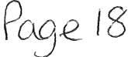

WHITEHAVEN TOWN COUNCIL Appendix 3

INCOME 2020-2021

Date Item Precept Intere st Other

01.04.2021 | Allotment Rents 2021/2022 |  | 2460.00
14.04.2021 | Allotment Rents 2021/2022 |  | 470.00
15.04.2021 | All ot ment Rents 2021/2022 |  | 100.00
15.04.2021 | HMRC - VAT Refund - March 2021 |  | 2339.13
19.04.2021 | All ot ment Rents 2021/2022 |  | 100.00
30.04.2021 | 2021 -2022Precept | 433573.86
30.04.2021 | Allotment Rents 2021/2022 |  | 260.00
04.06.2021 | CBC - Refund |  | 24.60
07.06.2021 | Allotment Rents 2021/2022 |  | 450.00
11.06.2021 | HMRC - VAT Refund - May 2021 |  | 2496.39
14.06.2021 | HMRC - VAT Refund -April 2021 |  | 1860.36
14.06.2021 | All otment Rents 2021/2022 |  | 40.00
23.06.2021 | Sellafi eld Sponsorship |  | 3000.00
28.06.2021 | Allotment Rents 2021/2022 |  | 291.00
30.07.2021 | Allotment Rent s 2021/2022 |  | 310.00
13.08.2021 | Allotment Rents 2021/2022 |  | 90.00
16.08.2021 | HMRC - VAT Refund - June & July |  | 3815.79
24.08.2021 | Cumbr i a County Council Grant |  | 3290.00
03.09.2021 | Cumbria County Council Grant |  | 3737.00
17.09.2021 | Refund - CBC rent from former office |  | 81.74
17.09.2021 | HMRC - VAT Refund - August |  | 1439.63
20.09.2021 | Refund - Viking |  | 308.48
14.10.2021 | HMRC - VAT Refund - September |  | 4118.88

433573.86 0.00 31083.00 1 464656 . 86 1

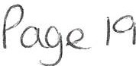

 |  |  |  | Expenditure Net |  | Invoices not yet
W HITEHAVEN TOWN COUNCIL  SUMMARISED INCOME & EXPENDITURE STATEMENT |  |  |  | of VAT |  | processed | Budget
FINANCIAL YEAR 2021-2022
BANK B ALANCESBROUGHT FORWARD
CBS 53905917 (01.04.2021) |  | 21,36 4.9 9
CBS 53906216 (01.04.2021) |  | 450,400.11
TOTAL OPENING BALANCE |  | £ 471,765.10
INCOME:
Prece pt |  | 433,573.86
Interest (Deposit)
Other Income |  | 31,083.00
TOTAL INCOME |  | £ 464,656.86
EXPENDI TURE
Employee s & Allowances |  |  |  | 53409.92
Premises |  |  |  | 12244.51
Suppl ies/ Services |  |  |  | 11153 .50
3rd Party |  |  |  | 5424.08
Grants |  |  |  | 3000.00
Allotments |  |  |  | 5145.04
Markets |  |  |  | 0.00
Community Plan |  |  |  | 0.00
Ground Maintenance |  |  |  | 9978.12
Civic Hospitality |  |  |  | 56.50
Ranger |  |  |  | 27622.32
Whitehaven In Bloom |  |  |  | 7869.09
Ward Grants |  |  |  | 880.00
Ele ctions |  |  |  | 0.00
Environm ental Improvements |  |  |  | 0.00
Events |  |  |  | 12210.36
Contingencies |  |  |  | 2940.23
Reserves |  |  |  | 0.00
VAT (to be reclaimed)  TOTAL EXPENDITURE | £ |  |  |  | 15459.37  167 ,160 .81
CASH BOOK BALANCE
Brought forward | £ |  |  |  | 471,765.10
Income | £ |  |  |  | 464,656.86
Expenditure  Town Council Funds | £  I £ |  |  |  | 167,160.81  769,261.1 s 1

BANK BALANCES
CBS 53905917 (20/ 10/ 2021)
CBS 5390 6216 (20/10/2021)

318,861. 04
450,400.11
1 £ 769,261 . 1s I

Unpresented Chequ es 2021/2022

FINANCIAL POSITION 169 , 261.1s 1

1....r. rc '. 2& I 10/202,
AGEND;C\ T1£M· ·:t •

Whitehaven Town Centre Digital Grid
Creating "smart place" digital infrastructure as a test bed for the UK

The reason for this paper is to request the support of Whitehaven Town Council for the Digital Grid Project in general, and more specifically:

    - Agree that the fibre optic cables for the Digital Grid in King Street and New Street can be situated alongside the existing wiring for Christmas Lights (separate catenary)
    - Agree that the fibre optic cables can access power through some of the same boxes as the Christmas Lights, separately metered, if required
    - Support for the inclusion of St Nicholas Gardens to be included in the digital coverage,
requiring infrastructure to be situated in St Nicholas Tower (separate support and agreement being sought from Church Council)
(Appendix 1- Questions in More Detail)

Delivered by BEC, supported by Copeland BC, and funded by Sellafield Ltd Social Impact Fund, this project is just the start of the creation of a unique "smart place" living test bed for the UK, as part of development of a working town of the future - some examples:

- To attract and retain talented young people to work/live/play in a beautiful, modern town;
- digital opportunities for emerging technology applications to impro ve everyday services;
- attraction of new companies to the area, to diversify the workforce and job opportunities;
- tourism and visitor attractions, to celebrate the past using digital tools (bring our historic buildings to life using augmented reality, for example);
- skills and training for all ages in technology, cyber security, and data science;
- digital in retail, and how that could see the re-imagination of traditional high streets;
- digitisation of existing retail outlets to improve customer experience/increase sales/modernise/sell online/digital marketing
- encourage digital entrepreneurship, to create new companies;
- digital health, and how "place" can be part of the healing, promoting wellness and activity;
- clean, digital energy;
- transport of the future (autonomous vehicles, final mile delivery, etc);
- encourage uni versities to set up external campuses

Whitehaven has already start ed on its journey for change, with the opening of the Bus Station, plans for Whittles, and ambitions for the harbour. The Digital Grid is the next part of that change, and one that will underpin and support other developments, such as RAlco, digital gaming (planned for Whittles).

So, what is the Digital Grid?
Planned to go live Ql 2022, it is a secure, shared, digital infrastructure that will cover most of Whitehaven town centre, as shown in the diagram, below.

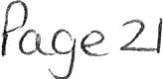

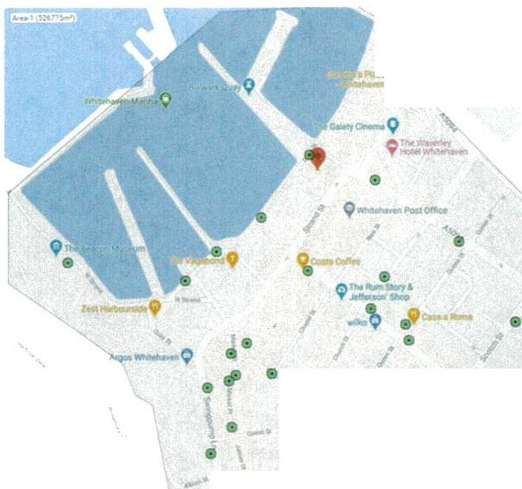Just as roads are the infrastructure and connections for cars/travel/living/places,
- ,.....-_
•
• •
•
a
..._•...,
• •
\
•. the Digital Grid will be the connection for future digital installations (e.g . traffic lights, sensors, way finders, footfall counters, cameras, etc.) that will enable, attract, and modernise life for residents, businesses, visitors, government, and services - all connected and interacting in real time.

Throughout the UK there are examples of smart city projects, but all tend to be small, isolat ed, and time limited. An example is Bird Street, London (Appendix 2) where the pavement was used to produce kinetic energy to power installations and lights.
Bird Street Project was typical of a "smart" application, which tend to be tested in isolation and not replicated beyond the project or minimum viable product, challenged by the fact that a city is too large to test on a larger scale, and legacy digital infrastructure is unconnected and congested, if available at all.

Whitehaven is a perfect place to become the "micro city street lab" to be a test bed for what happens when smart technology is connected in real time, and was chosen for the UK's first Digital Grid because of its:
- City grid-style layout of the town centre;
- Number of residents living in the centre is large enough to be significant, but small enough to control;
- Area attributes (coastal, rural, urban, isolated);
- Lack of existing digital infrastructure and skills/training;
- Potential for tourism/visitor attractions

What will it mean for residents?
Residents will have the choice to engage with the Digital Grid and services, and accordingly the protection of their personal data will be one of the most important early developments - creating a template for the future after GPDR. (Benefits map Appendix 3)

When residents decide to sign onto the Digital Grid they could (just some examples):
- Get access to superfast, safe, free digital wi-fi;
- Have seamless access to services, for example it could be parking (direction to available parking spaces), rewards (instant discounts from local retailers, based on preferences), information (what's on, Council notices, etc);
- Inspiration and opportunities for new digit al t raining/ careers/ entrepreneurs for all ages;
- Participation in smart projects or applications , for example digital, clean energy- how to use intelligence and data with emerging technology and services to improve energy effi ciency, work with the environment, and safe money
- Experience vibrancy from digital art and cultural installations/events
- Parti cipate in digital wellness programmes

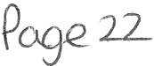

Appendix 1

Questions in More Detail

- Agree that the digital fibre wires for the Digital Grid in King Street and New Street can be situated alongside the existing wiring for Christmas Lights (separate catenary)

- Agree that the digital fibre wires can access power through some of the same boxes as the Christmas Lights, separately metered, if required

The digital infrastructure will be a mix of wired fibre and wireless transmitters/receivers/antennae (example below)

Internet connectivity will start at the Beacon Portal, which will be central control, from there it will be transmitted across the town via the multi-storey cark roof (and other high points); fibre optic cables along the harbour (through existing underground ducting); fibre optic cables along King Street and New street (map below).
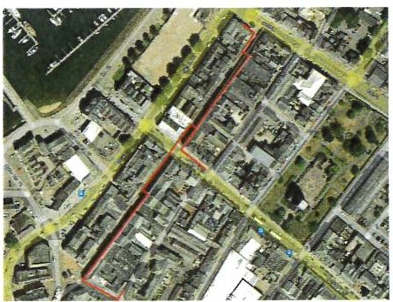
0
vvvv
Wireless transmitter -
30cm in diameter
Proposed fibre route

Notes from the engineer:
The network in King Street will be carried via fibre optic cable running along the building fronts, generally above the shop frontages, alongside existing cable looms. The fibre cables will terminate at locations where mains power is available . The cables will be t ie-wrapped to existing looms. Where we need to cross a street, we will install new catenary wire for sole use by the network. These new catenary wires will be sited above existing, or if new then a minimum of six metres high.
At the termination locations we would install an equipment enclosure, and this would be sized to be as small as possible. We would request power be available at these locations, and this supply should be provided within the enclosur e. The size of the enclosure would be decided by the detailed network design, which would be determined by wider network considerations, including the number and locations of power available in this area.
The precise cable route can be flexible, although the termination points are fi xed.

Wireless antennae/transmitters will need to be installed at each end of this area, to complete connections to the wider network, the precise location to be confirmed.

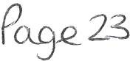

- Support for the inclusion of St Nicholas Gardens to be included in the digital coverage, requiring infrastructure to be situated in St Nicholas Tower (separate support and agreement being sought from Church Council)

St Nicholas Gardens has been identified as an area that could become a suitable events space, or host digital cultural/arts installations (for example, it could be part of a historical trail, where Mildred Gale could be represented in augmented reality, to tell her tale of life in Whitehaven), and as such will require connection to the Digital Grid.

To do this, transmitters will need to be situated on St Nicholas Tower, which of course would be sympathetically placed.

The Church Council has already been contacted, and has responded positively, permitting an engineering visit.

A follow-up meeting is planned for 20th October.

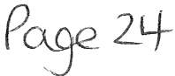

Appendix 2
World's First "Smart Street" in London Turns Movement into Energy

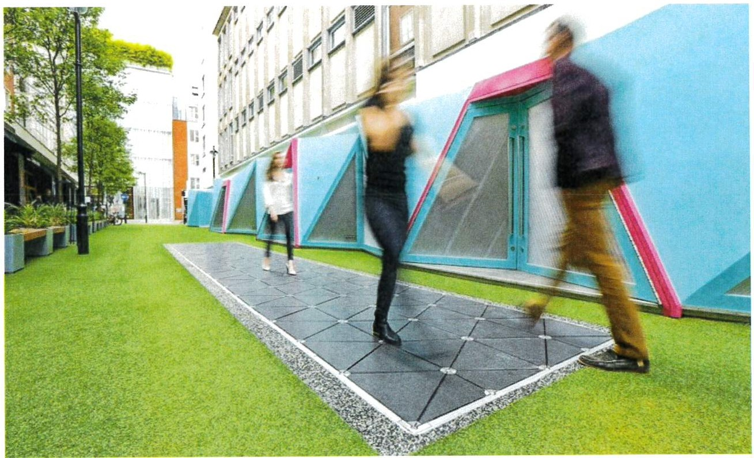
Written by Patrick L) nch July 2017
Technology company Pavegen has unveiled the wor ld' s first "Smart Street" in London 's West End that utilizes the company's unique kinetic paving slabs to generate energy from pedestrians' footsteps. But unlike earlier Pavegen installations deployed in cities like Washin gton DC and Rio de Janeiro (which uses the panels as the foundation for a soccer field), the London Smart Street comes with its very own app - giving visit ors precise information about the power they are generat in g, and encouraging use by off ering up store vouchers in return for steps.
The 107-square foot pavement is located alon g Bird Street, where it produces power for
nearby street lamps, Bluetooth transmitters, and hidden speakers that emit bird sounds int ended to create a soot h in g environment.

P e2s

Appendix 3

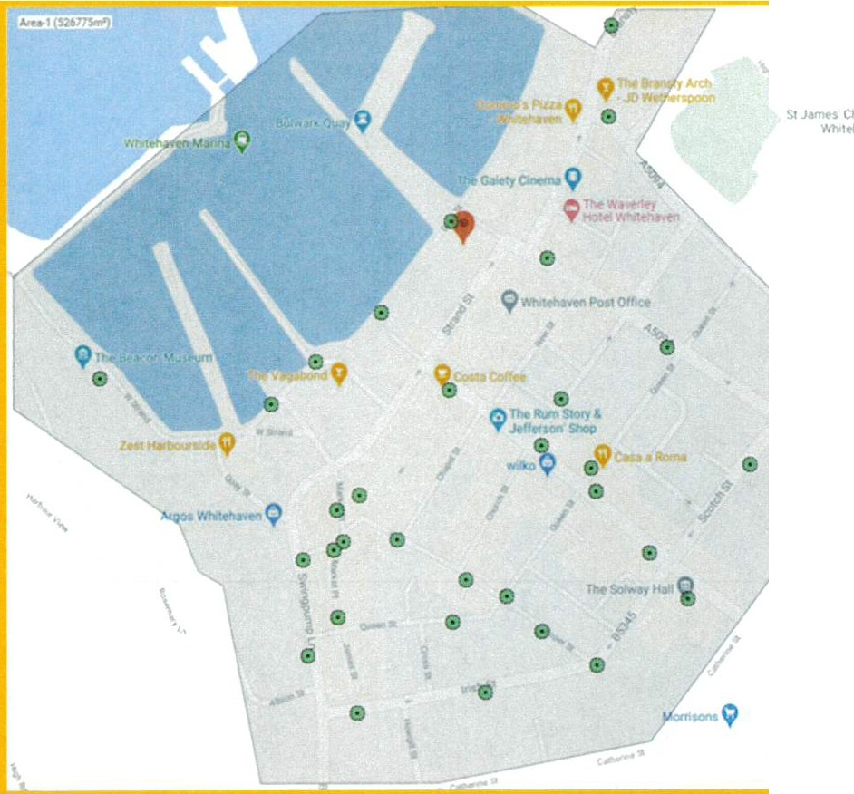I

Whitehaven Digital Grid
Benefits Map
Secure, shared, digital infrastructure
for community, business, education, and tourism

cc
The Old Bo11d of T1ade 8ulld lng, High Stroel , CIH tor Moor, CA25 SAH

PC1_3e2b

The int ere st generated from this work has been added to the original detail, to inform the benefits to be gained from the Digital Grid.

Supetlast connecuvIty pa1t of
1he ll'lnovarlon provision o! Whitehaven to altract re1a,n. and incubate businesses
The F"uture o f
Local Reta>I

lrnpona.nt 1ool 1ncons1drmng 1he luu1re of retail hos1intJ d1g 1t.-.il innO\fOtJOllS
Bi g D ata Campus
\

ProV1S1on of l!ve data to enable developme111 of app'ica11ons/reseruch
a unique aspect tor a data campus

Enabler !or lhe apphc.itmn of
seMces for modem busmcs.sc!;
\ connected 1ravel. green energy,
\ :".'on and suppyl

Senc;ors and reaHm1e connection to create the hOsl lor d1gual lieaong or coohn s Ulions

P ' atfo rm to hos t d1y1tal milfketi,i y and anaJys1s to target -.md improve sales . us1119 Arnfcc1al 1mell1yence .
· nd in tegrated 1echno log1es

\

Enabler to .uvact educa1ors enueprencur,sand ene,gy zom-p-an e-·s 10 1he area

services, to improve user cx.penence

Real. t _brino historical b\1ildmgs10 hie
-
, ,------- ·"'
wh1l1? r e ducmg emissions

, Enabler Md hos1for applications to aid the palt1way 10 ne t zero (transport enm:.sion,s ehn1a1e change , etc)

Superta51, conneclFVJty , fa, delivery of /
1nte 1f1gent !:>e rv1ces , to link places / ! llormlo lmk u a.vel in realt1me. experiences and encourage v1s1tms / :: : :9opportunity to develop to 1.twell autonomous uavel

ii

Energy Visnor Economy T·ansport and movement

Dlgltal Grid as the backbone to connect, support, or enable the provision of services and projects as
o ,rt Q( Whlteha p nsfor 10 lO
Subject | Detail | Benefits | Outputs
Bus Station | Community business centre, for start -ups, entrepreneurs, with digital courses and support. | The Digital Grid will be a factor in attracting busi nesses and entrepreneurs to the Bus Stat ion, as a reflection of Whitehaven as a connected, modern town, and a  platf orm for experimentation with  applications | - More businesses created or new ones  attracted to the area
Ret ail businesses/town centre | Need to modernise, attract new, develop retail as entert ainment , and provide a reason for residents or visitors to be in Whitehaven centre | Ability to measure, track, and digitise existing retail outlets, to improve efficiency, and provide personalised services to customers ; creation of new types of businesses on the high street, such as a digital health, or gaming studios, and digital cultural  installations | - Increased footfall  - Diversified clientele  - Vibrancy in the town centre  - An engaging and attractive place for  ^{1,} younger residents
Big Data Campus | A unique development in the town centre, connecting data and loT in a living smart place situation | The Big Data campus is dependent upon the Digital Grid, and will be a unique offering in the UK to collect data, integrate smart devices, connect geographic locations, and create new applications in real time | - Attract universities to Whitehaven  - Bring new businesses  - Opportun ities for new  skills and learning development  - life-enhancingservices  and applications for residents and visitors

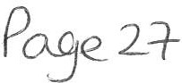

The Future of Local Retail (Levelling Up agenda)

In a post-Covid world it is even more important to stress the need for the provision of digital services as an attraction, moderniser, and part of the entertainment package to develop the future of retail and the town centre in Whitehaven.
The Digital Grid project will be an enabling key element in the future of retail in Whitehaven - the Digital Grid will provide services to existing retailers, such as digital marketing, footfall analysis and customer interactions, The Future of Local Retail (Levelling Up agenda).
Encouraging new retailers to the area, through provision of services, PR, di r ect marketing, vibrancy, and increased reported footfall/visitor dwell.
The development of the town centre, in line with the Levelling Up agenda is supported by BEC and connects to the North Shore Innovation Quarter physicaly, through links to the harbour and Bus Station.

Big Data Campus

A BEC project to create a mixed-use space, as part of the North Shore Innovation Quarter in the town centre, to integrate data, energy, education, and enterprise. The Big Data Campus will be a key customer for the
Digital Grid as well as an init iator of testing for new applications, as part of the live test bed platform, provided by the digital grid.
The R&D and teaching capability that will be offered in the Big Data Campus will generate a pipe line of new and emerging applications from students and commercial businesses alike.
A unique element of the space will be the availability and potentia l interaction of live data in a town environment (that mimics a city) to experiment, create, develop, and test applications and outcomes for replication and scaling in larger conurbations or cities.
Digital Grid is a key component of the Big Data Campus and crucial to the successful attraction of commercial and academic tenants, entrepreneurs, and projects. Without the Digital Grid, the Big Data Campus is simply a building in the town, providing R& D, learning and innovation support, rather than a dynamic contributor to the digital economy and local communities.

Energy

Energy permeates all BEC projects, as our golden thread is that of clean energy. The Digital Grid will be a host for energy applications and will create the ability for the development of digital heating or cooling, linked to climate, as an important part of the journey to net zero.

Additiona lly, the network will enable the linking of electric vehicles (EVs), EV charging, measuring air quality, encouraging walking, reducing emissions (intelligent parking and traffic lights), power grid balancing, energy from renewable sources, and experimentation in energy services.

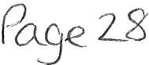

Visitor Attractions

Through the platform and bandwidth availabilit y in public spaces, Whitehaven will have the ab ilit y to apply emerging technology, such as Augmented Reality, to create interactive visitor attractions - for example, the historic buildings or history of th e town could be animated to tell the story of the past.

Transport and Movement

One of the common misconceptions about Whitehaven centre is the lack of parking. As proven in the recently published Parking Study, there is ample parking - the issue is users finding space in their chosen car park or location.

The Digital Grid platform and network would be ab le to host live services, provided by organisations su ch as Just Park or Your Par king Space, to allow driv ers to book or be guided to available parking spaces. In addition , there will be the abilit y to connec t schemes to reward dwell time, encouraging peop le to shop, dine, or use local services in Whitehaven.

The Digital Grid network also provides opportunities to li nk community transport scheme s, whether final mile delivery, e-scooters, personal t rav el, or to encourage walking/cycling.

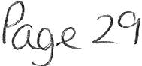

WTC 28/10/21
Item 8

APPOINTMENT OF INTERNAL AUDITOR

PURPOSE OF REPORT AND RECOMMENDATION

To start the process for appointing an Internal Auditor for 2022 and to recommend that 3 quotes be obtained for consideration by the Council.

  - INTRODUCTION
  - The Accounts and Audit Regulations 2015 impose a duty on parish councils to maintain an adequate and effective system of internal audit of its accounting records and of its systems of internal controls. The Internal Auditor is a key part of the Council's internal controls.
  - The Internal Auditor must be both competent and independent from the Council and an Internal audit has to include both financial and procedural controls.
  - A strong internal audit will check that the Council has strong processes and controls not only over money but over all areas to help ensure the Council operates legally and complies with all relevant legislation.
  - A good internal audit will come in 2 parts done at different times of the year.
    - Is usually done part way through the financial year in and is mainly an audit of the Council' s processes and procedure.
    - It may also include an audit of transactions to ensure the completeness of the Council's records.
    - The final audit is done after the year end so that balances within the accounts may be verified and that any problems found at the interim audit have been addressed by the Council.
    - The Internal Auditor reports to the Council and will submit a written report to the Council after both audits.

  - RECOMMENDATION
  - It is recommended that 3 quotes be sought from competent and experienced people for the provision of an Internal Audit Service on the basis of 2 Internal Audits for 2022

WTC 28/10/21

Item 9

RECOMMENDATIONS MADE BY ALLOTMENT ADVISORY GROUP

Purpose of Report and Recommendation

To inform Members of recommendations made at a meeting of the Allotments Advisory Group on 6th October 2021 and to approve the same.

  - INTRODUCTION

  - Following a meeting on the allotment sites between Members of the Allotment Advisory Group and the allotment site representatives it was agreed that a meeting be set up of the members of the Allotment Advisory Group only to discuss issues.

  - A meeting of the Allotment Advisory Group was held on 6th October 2021 and the procedure for non-cultivated plots was discussed. (see Appendix 1).

  - RECOMMENDATION

  - It was recommended that the procedure for dealing with non­ cultivated plots be amended
    - to remove the stage where the tenant is contacted by telephone and issued with an informal warning and given 14 days to make improvements and
    - To move immediately to the non cultivation letter giving 28 days to make improvements and referring to the appropriate clauses in the Allotment Agreement
    - That on the 30th day if no improvements have been made a Notice to Quit will be issued giving one month's notice
    - That when an offer of an allotment is made to someone on the waiting list that a maximum of 7 days be given for the person to accept the allotment site and sign the tenancy agreement and pay the fee.

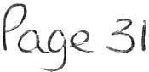

WTC 28/10/21
Item 10

RECOMMENDATIONS FROM THE EVENTS ADVISORY GROUP

To consider the recommendations made by the Events Advisory Group shown at Appendix 1 to this report

  - INTRODUCTION

  - A meeting of the Events Advisory group was held on Monday 11th October 2021 to discuss events for 2022 and the finance required for the events.

  - The Events Advisory Group recommended a series of events for 2022 as shown at Appendix 1 together with costings

RECOMMENDATION

  - That the Council considers the recommendations in paragraphs 1 to 12 of Annex 1 and approves the costings and notes the recommendation in paragraph 13

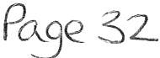

APPENDIX 1 WTC 28/10/21

Item 10

RECOMMENDATIONS MADE BY EVENTS ADVISORY GROUP FOR EVENTS IN 2022 AND THE COSTINGS THEREOF TO GO TO FULL COUNCIL FOR APPROVAL ON 28/10/2021

1st and 2nd May 2022

Leyland Bus Show on Harbour

Continental Market

3rd 4th and 5th June 2022

Queen's Platinum Jubilee

Photo exhibition in St Nicholas Gardens
Security for 2 nights and Toilets -
£2,500

Organised by HC and HC responsible for all costs i. e., toilets and waste

Proposal for events to be held over the Jubilee weekend will be discussed at a separate meeting of the EAG.
The bunting has already been purchased but it was recommended to purchase an extra 100 metres at approx. £125. Also, blue wire to be purchased to attach the bunting on at an
appro x. cost of £300
The bunting to be placed on the existing catena wires on Market Place, King Street, Roper Street, Lowther Street, Duke Street, Tangier Street and Harbourside.

£500
Marquee - approx. £1,000 Security 3 nights - £1,296

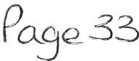

Continental Market on Harbourside Continental Market to be
responsible for provision of toilets.
2 Skips for waste - appro x. £480 +
VAT

3. 27th May 2022
Traders Market in St Nicholas Gardens

2 Marquees approx. £1,700 Security for Marquees - £432

4. 24th June 2022

Science Show in St Nicholas Gardens

Antiques Market in St Nicholas Gardens
Partly sponsored. Exact costings being obtained.

1 Marquee approx. £1,000 Security for Marquee - £432

  - 29th July 2022

Traders Market in St Nicholas 2 Marquees approx. £1,700 Gardens Security for Marquees - £432

  - 26th August 2022

Traders Market in St Nicholas 2 Marquees approx. £1,700 Gardens Security for Marquees - £432

  - 2nd December 2022

Christmas Traders Market 2 Marquees approx. £1,700 St Nicholas Gardens Security for Marquees - £432

  - Viking re-enactment - Date not yet known but it was recommended that this be held on the same weekend as the Queen's Platinum Jubilee in St Nicholas Gardens if possible . This event has been was authorised by the Council but had to be postponed because of the pandemic.

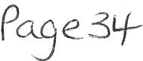

  - It was recommended that, if possible, a Jet Ski Team demonstration over a weekend be arranged. Date not yet determined but approximate cost £3,000.

  - For the Traders' Markets it was recom m ended:

    - that the Council looks at increasing the hours of the markets to 5.00pm;
    - That leaflets are distributed to Sellafield and the NHS to inform people when the markets are being held
    - That Gerard Richardson prepares a pdf and sends it to Councillor Maudling for distribution

  - It was recommended that a marketing budget of £3,000 be agreed to support the events with for example Whitehaven News, CFM and FB

  - It was recommended that the Council asks the Harbour Commissioner to ask the yacht owners to put bunting on their yachts the weekend of the Queen's Platinum Jubilee

  - It was recommended that it be noted that Councillor Maudling had organised 2 Christmas Trees from lggesund for St Nicholas Gardens and that they would arrive sometime in November 2021.

POBe35

WTC 28/10/2021

Item 11

RECOMMENDATIONS FROM POLICY AND RESOURCES AND FINANCE COMMITTEE

Purpose of the Report and Recommendation

To consider the recommendations made by the Policy and Resources and Finance Committee on 13th October 2021.

  - INTRODUCTION

  - At the meeting of the Policy and Resources and Finance Committee on 13th October 2021 the Committee considered a Finance Report including budget monitoring figures and it was proposed by Councillor Roberts and seconded by Councillor Hayes and unanimously agreed that the following recommendation be made to Council:

RECOMMENDATION - That the Finance Report and the Budget Monitoring figures be noted and approved

  - Following a discussion on the contract for the electricity supply to the Council Offices it was proposed by Councillor Roberts and seconded by Councillor Hayes that a three-year contract be entered into at a cost of
£3.099 pa and it was unanimously agreed that the following recommendation be made to full Council:

RECOMMENDATION - That a three-year contract be entered into at a cost of £3.099 pa

  - It was proposed by Councillor Hayes and seconded by Councillor O'Kane that as in previous years a Budget Working Group be set up comprising those on the Policy and Resources and Finance Committee to work on setting the Budget for 2022/23 and make recommendations to full Council and it was unanimously
agreed that the following recommendation be made to full Council:

RECOMMENDATION - That as in previous years a Budget Working Group be set up comprising those on the Policy and

Resources and Finance Committee to work on setting the Budget for 2022/23 and make recommendations to full Council

  - RECOMMENDATION

  - That the council considers the recommendations made in 1.1, 1.2 and 1.3 above for approval.

WTC 28/10/2021

Item 12

REMEMBRANCE SUNDAY

Purpose of the Report and Recommendation

To consider the position with providing refreshments following the church service and to consider the recommendations at 2.1 and 2.2.

  - INTRODUCTION

  - At the last Council meeting on 30th September 2021 it was resolved that the cost of Whitehaven Brass Band be reported back and also that consideration of providing refreshments after the church service in the United Reform Church Hall (minute 1882/21 i and ii refers).

  - The Whitehaven Brass band has informed the Council that they will be in Castle Park as they are not able to march with the procession. They will start playing a marching beat when the parade approaches Castle Park and also when the parade exits the park. They will also play the chosen hymn and The National Anthem. The cost of the Band will be
£205.00.

  - The United Reform Church has said that the Council can use the Hall free of charge but that the Council will have to provide the refreshments and the Council can use their cups etc and that they will help where they can.

  - RECOMMENDATIONS

  - That the cost of the Whitehaven Brass Band be approved.

  - That the Council decides whether or not to provide tea, coffee and biscuits or sandwiches in the United Reform Church Hall at an approximate cost of £50.00 for tea, coffee and biscuits or £130.00 for tea, coffee and sandwiches

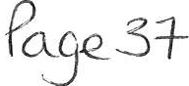

WTC 28/10//2019

Item 13

CHRISTMAS CLOSING

Purpose of the Report and Recommendation

To consider Christmas closing for the Council's Office..

  - INTRODUCTION
  - The Council's Office is normally closed between Christmas and
New Year. This year Christmas day is on a Saturday and Boxing Day in on a Sunday which means that Monday 27th and Tuesday 28th December 202lare substitute days off. Similarly New Year's Day is on a Saturday which means that Monday 3rd January 2022 is a substitute day off.

RECOMMENDATION

  - That the Council Office closes at noon on Friday 24th December 2021 and re-opens on Tuesday 4th January 2022.

