WHITEHAVEN TOWN COUNCIL

Clerk and Responsible Financial Officer: Marlene Jewell
Telephone: 01946 67366
Chairman: Councillor C Hayes

To: Members of Whitehaven Town Council

You are duly SUMMONED to attend a MEETING of WHITEHAVEN TOWN COUNCIL which will be held in THE BEACON PORTAL at THE BEACON, WHITEHAVEN on Thursday 26th October 2023 at 6.00 pm

Signed.... ...;:[ @...... Dated. :..0. -- 3
Marlene Jewell, Clerk and Responsible Financial Officer

AGENDA

Apologies for Absence

- Declarations of Interest

To receive declarations of interest by elected Members in respect of Agenda items.

If a Member requires any advice on any item involving a possible declaration of interest which could affect his/her ability to speak and/or vote he/she is advised to contact the Clerk at least 24 hours in advance of the meeting.

- Public Participation

- Minutes of the Council Meeting held on 28th September 2023

- Planning Applications

- Report from Cumberland Council

- Presentation by the Chief Executive of the Harbour Commissioners

- Finance Report

- Blue Plaque

- Hanging Baskets

- Mayors Christmas Shop Windows Competition

- Remembrance Sunday

- Recommendations from Events Advisory Group - To follow

- Christmas Closing

- Councillor Ward Matters

- Date and Time of Next Meeting

IN PRIVATE

That prior to the following items of business the Chairman will move the following resolution:
That in view of the special or confidential nature of the business about to be transacted it is advisable in the public interest that the public and or press be instructed to withdraw.

- St Nicholas Gardens - Clerk to give a report

- Appointment of Internal Auditor

- Tenders for Grass Cutting

- Tenders for Maintenance of Council Allotments and Pigeon Lofts

- Office Accommodation - Clerk to give a report

- Salaries

WHITEHAVEN TOWN COUNCIL

Minutes of the Council Meeting held on the 28th September 2023

Present: Councillor C Hayes (Chairman); Councillor R Gill; Councillor J Carr; Councillor E Dinsdale; Councillor B O'Kane; Councillor A Pearson;
Councillor G Roberts; Councillor A Spedding; Councillor R Taylor; Councillor R White
M. Jewell, Clerk and Responsible Financial Officer V Gorley, Assistant Clerk
Members of the Public

Cumberland Councillors Emma Williamson and Mike Hawkins Cumberland Officers Michael Barry, Luke Leathers and Emanuel Flecken

2356/23 Apologies for Absence

Apologies for absence were received from:
Councillor G Dinsdale ill

It was proposed by Councillor Gill seconded by Councillor Carr that
the apology for absence be accepted and noted. A vote was held and it was unanimously

RESOLVED - That the apology for absence be accepted and noted.

2357/23 Declarations of Interest

Councillor Hayes declared that he was a member of the Whitehaven Tidy Town Committee and the Harbour Users Group.
Councillor Taylor declared that he was a member of the Red Lonning Community Centre

2358/23 Public Participation

CL said she was a professional Health consultant and Therapist and had lived and worked in this area all her life and had experience in both management and business ownership.

She said she loved this area and felt very fortunate to be a West Cumbrian having easy access to the fells, lakes, and coast; to nature. CL then made the following points:-
- CL said nature was very important for health and wellbeing and that she was concerned about the health and wellbeing of all the constituents of this area. As a Mother she said she had concerns about children and the generations that follow and that Net Zero would impact you, me, everybody.
- Labour Leader Keir Starmer said he preferred to be at Davos than UK Parliament.
- Labour MP Angela Raynor has stated that the ULEZ (Ultra Low Emission Zone) will be extended all over the country.
- CL asked what the intention of Whitehaven Town Council and Cumberland Council was on Net Zero?
- What does Net Zero mean for individuals, public, business, fanners. She said she was interested in the impact both short and long term?
- She asked "What are the 15-minute city/ 15 minute neighbourhood proposals for Cumbria"?
- How will the public be consulted? If Net Zero is going to impact everyone the least you can do is hold a public meeting.
- CL gently reminded the Councils that their responsibility was to us. To our human rights and genuine well-being.
- In photosynthesis Carbon dioxide is plant food; therefore, without it there would be no grass, crops, food, animals, humans. Zero carbon is zero life on Earth.
CL then thanked the Council for their time. And the Chairman thanked CL
AA informed the Council that she had been here for 2 years and really liked the place and she wanted to talk about improving its appearance and appeal and felt there were some really simple things to be done to improve the appearance of the town and there had been some improvements already. She said she had lists and would go through them:-
- AA believed there should be massive improvements to the Train Station as the way it looked was not good
- Driving around Whitehaven - it was really unattractive and perhaps it could be painted to make it a bit nicer. Possibly have some facts about Whitehaven and its history like quotes etc
- Going round the one-way system all the way round some of it looks really grubby and when people come in it doesn't look fantastic
- AA said it was an amazing Georgian town with some unattractive flats and said why couldn't they be brightened up with white paint

- At the weekends the old town was taken over by anti social behaviour which needs sorting out
- She said there were some fantastic indies popping up and we need more of those. We need more pop-up food trucks
- She asked what was the 5-10 year plan and said she totally agreed about net zero
- Bike lock up for Coast to Coast riders and said it was very difficult for cyclists to get into Whitehaven on the train
- Where are the recycling points
- Need more dog poo bins on North Shore
- AA asked where were the electric buses
- She said Whitehaven was an amazing place but it was not being shown off to the best of its ability
SD said he had lived and worked in Whitehaven all his life and wished to reiterate what CL had said about concerns around net zero. He said that he saw on the websites from Copeland Borough that they were talking about planting trees to offset that. He said he had read in that days Whitehaven News that Cumbria was striving to become the first net zero carbon county and he thought the public consultation on this was long overdue and he asked when and where do the public consultations start. SD said we were already seeing the effects of climate change in Cumbria in the form of extreme weather and he wanted to know if anyone could elaborate on these comments at some point.
SD said that he thought net zero was just going to get worse year on year with what was being proposed.

KS said she was Whitehaven born and bred and agreed with what had already been said and wanted to voice her concerns as a mother and grandmother. She said we had not been consulted on what ULEZ means for us in this town. She said that she believed that the Council had signed up for all these changes and said that nobody had been consulted. She said that what she wanted to propose that they go with support to the Council and ask for a special meeting to discuss this in more detail.

2359/23 Minutes of the Council Meeting held on 31st August 2023

It was proposed by Councillor Gill and seconded by Councillor Roberts that the Minutes of the Council Meeting held on 31st August 2023 be approved and signed by the Chairman as a correct record.

RESOLVED -That the Minutes of the Council Meeting held on 31st August 2023 be approved and signed by the Chairman as a correct record.

2360/23 The Chairman said because Cumberland Councillors being present he proposed to move Item 20 up to now so that they didn't have to remain for the whole

Meeting and asked the public to leave for the next 5 minutes. Councillor Gill proposed and Councillor Taylor seconded that the Meeting be moved into private. A vote was held and 8 Councillors voted for the proposal and 1 Councillor voted against

RESOLVED -That the Meeting be moved into private and the Members of the public were requested to leave the room

2361/23 Councillor O'Kane then said that a lot of members of the public had come with genuine concerns and the Council had turned around and turned the Agenda upside down and he didn't think it was appropriate that the Council has an Agenda and the Council should stick to it. Councillor Taylor said it had been done and the Council needed to move on. Councillor Emma Williamson said it was going to be really hard to do this Item in 5 minutes. The Clerk said that in the circumstances if the Council wanted to make another resolution they could do so. It was proposed by Councillor Gill and seconded by Councillor Hayes that the public should be allowed back into the Meeting. A vote was held and it was unanimously

RESOLVED - That the public be allowed back into the Meeting Councillor R White entered the Meeting at this point
2362/23 Planning Applications

The Council considered a list of Planning Applications shown at Appendix 1.

1. It was proposed by Councillor O'Kane and seconded by Councillor Hayes that consideration of 4/23/2258/0F1 which related to internal and external alterations to existing ground floor commercial unit at 49 King Street be deferred until further information on this is available and the Planning Department at Cumberland Council be informed accordingly. A vote was held and it was unanimously
11. RESOLVED-That consideration of planning application 4/23/2258/0Fl
which related to internal and external alterations to existing ground floor commercial unit at 49 King Street be deferred until further information on this is available and the Planning Department at Cumberland Council be informed accordingly.
11 It was proposed by Councillor Roberts and seconded by Councillor Hayes that the Planning Department of Cumberland Council be informed that following consideration of the remaining planning applications on Appendix 1 that the Council had no further representations to make. A vote was held and it was unanimously

RESOLVED - That the Planning Department of Cumberland Council

be informed that following consideration of the remaining planning applications on Appendix 1 that the Council had no further representations to make.

Councillor Taylor asked if Cumberland Council had been informed about the Council's decision on planning application 4/ 23/2221/0Fl and it was confirmed that they had been.

2363/23 Planning Matters Generally

Further to Minute 2334//23 the Clerk reported that a letter had been sent to Councillor Mark Fryer and there was an item on the Agenda for Cumberland Council to give a report and that Cumberland Council were in attendance to Speak to the Council. This was on the Agenda at item 15 but the Chairman was asked if the report could be given now and he confirmed that it could.
Councillor Emma Williamson and Councillor Mike Hawkins informed the Council of what was happening at Cumberland level. Councillor Williamson forwarded a copy of her presentation which is replicated below

Councillor Williamson said Vesting made Cumberland Council 'safe and legal', but the disaggregation requirements of the County Council staff and services meant that much of the base work was still undone at vesting.
This includes critical areas like a pay and grading structure for our staff, and the aggregation work to bring together the former district council services areas - like having a single housing team, working off the same Cumberland policies, etc...
One of these pieces of work well underway is the waste services review - this
looks at everything from staff to services and plans to future proof, for example, considering future requirements over food waste collections
Some of the additional things that would affect the town council areas;
Housing Needs Analysis. Cumberland Council has a statutory duty to understand and plan for the housing needs and aspirations of its people and communities.
The intention is to create a new Housing Strategy for Cumberland, which will encompass all the statutorily required policies such as Homelessness and Rough Sleeping Strategy, Allocations Policy and the new Supported Accommodation Strategy. It is envisaged that the Housing Strategy which will be a pillar corporate document and support other key strategies and policies such as the Local Plan and economic regeneration plans. The first step in developing a new housing strategy is to carry out a housing needs analysis. The scope of this is currently being developed and is likely to include:
- Private sector stock condition survey
- Household needs survey
- Supported Housing needs analysis
- Local Housing Market Analysis. The voice of service users, carers, stakeholder and partners will be central to this large and expansive project.

We would expect our Town Council to be a key stakeholder to feed into these conversations

Early Help and Prevention Work

We have just formed a transformation programme for 0-19 Children and Families Early Help and Prevention Services. Early Help and Prevention Services for children and families have the potential to directly offer wellbeing support to each child born and living in Cumberland, as well as their wider families. With this in mind, it is important that these services (such as the 0-19 Healthy Child Programme and Child & Family Support Service) are as effective as possible. As in many parts of the country, services like these are experiencing challenges due to increased demand and staff recruitment & retention issues. There is now a requirement to significantly change how we deliver these services. At the Executive Committee meeting on the 5th September, the following was agreed in relation to the 0-19

Healthy Child Programme and Child & Family Support Service:

- Service delivery plans would be developed with the providers to ensure ongoing improvement work is taking place throughout the life course of the current contracts.
- The contracts for the services would be extended by 12 months to give the time needed to fully engage with families and partners in order to significantly redesign the services.
Our leader Mark is leading on major opportunities for Cumberland, this will include a town centre regeneration plan for Whitehaven, and he is currently lobbying for SMRs in Cumberland.
The first full round of Community Panels has now taken place with chairs/vice chairs appointed and agreement on governance regarding aspects of grant funding. This is an iterative process and the learning from this first round of Panels will feed into future discussions and panel meetings.
Community Networks have now started to meet and levels of engagement/attendance have been high. Community Networks have been linked to community events and the conversation with the wider community and stakeholders has commenced. This inclusive approach will inform the setting of priorities for each Panel area which will be set out in the respective Neighbourhood Investment Plans. It was great to see two of Whitehaven Town Councillors at the event and your contributions. Along with that of the councillors at St Bees were extremely valuable and we hope you will continue to engage and support us with the creation of our investment plans put the priorities residents have stated are important at the forefront of delivery.
There is money for 750 charging points
Cumberland was putting in a funding bid for electric buses (Zebra funding)

Public Space Protection Orders

Work is starting on the development of new Public Space Protection Orders (PSPOs) for Cumberland. PSPOs are a tool to support communities by prohibiting specific activities, and / or to require certain things to be done by people engaged in particular activities, within a defined public area, for example the consumption of alcohol or anti-social activity. This work
will be subject to consultation and wider engagement as officers begin to develop a consistent approach across Cumberland. But it will be bigger than before

Waste Services

Update Fallowing the announcement of the ending of industrial action by Allerdale Waste Limited (AWSL) from 24th August 2023, it is expected to take several weeks to get the waste operations back to business as usual, with a plan in place this is anticipated to be by 18 September. There is now an opportunity, and requirement, to review the current waste collection services (formerly Carlisle and Copeland) that have come together under the new Cumberland Council alongside those delivered by AWS. There is currently no one unique or identified model to adopt and this requires a detailed piece of work to be undertaken to find the right model for Cumberland under a Waste Review Programme. This needs to take into consideration, residents, employees, trade unions and elected members views, in keeping with the wider Council Plan focus, as well as identify best practice and technology from elsewhere, locally, nationally, and globally.
This project has now started.

Trading Standards Update

Cumberland Council's Trading Standards Service has run a test purchasing operation relating to the selling of vaping materials to under 18 year olds. Overall, a very positive 83 per cent of businesses refused to sell to underage teens, though the results varied across the towns visited:
- Whitehaven - 100 percent.
- Carlisle and Wigton - 92 per cent.
- Workington - 62 percent.
- Maryport - 34 percent. There are strict laws on nicotine vaping products, and it is a criminal offence to sell them to persons under the age of 18 years or purchase them on their behalf. Traders found to be breaking these rules risk being prosecuted and fined up to £2,500.

Councillor Williamson said there were problems with young people vaping. She said Cumberland Council was committed to this community and that she would make sure that everyone has an invite to the next Community Network Meeting

Councillor Taylor said the question was how the Town Council linked in better with Cumberland Council on planning.
Councillor Hawkins said there were 6 Councillors in Whitehaven and the Community Panel was Whitehaven and Coastal. He said the idea was to take their panels round different areas of the town and that was going to be the decision making panel for the £70k investment fund and that elected members would ultimately make the decision on where the money was going based on recommendations and what they got back from the public. He said underneath that there was a network panel which was open to everybody and that was at the United Reformed Church the previous week and two Whitehaven Town Councillors had attended and that was where people could come along for things like net zero or what people would like to see in the town and suggested that for anything to do with Whitehaven people should go to the network panel and get involved that way. He said this was a new way of doing things but that it was more localised.
Councillor E Dinsdale said a resident had raised the problem of recycling and
the resident was in the room and identified herself and said there was no recycling in the old part of town. Councillor Williamson said she would take that up.
Councillor O'Kane said the Council were concerned that there were 12 Cumberland Councillors on the Planning Committee but only 1 from Copeland area so we seem to have lost out. And if the Council objected to something we have to go to Workington or Carlisle. Councillor Williamson said Councillors could not be forced to go on a Committee but that they were reviewing this so that our area is better represented and there is more choice for people to voice their opinions.
Councillor Williamson said she would like to bring Nick Hayhurst to a Council Meeting for a conversation about planning and partnership and to make sure that Cumberland is doing everything it can to involve the Town Council.

2364/23 Annual Governance and Accountability Return for year ending 31st March 2023
The Council considered a report which showed at Appendix 1 the External Auditor's Report and Certificate for year ending 31st March 2023.
The Report showed that the Council's accounts were in order.
The Notice of Conclusion of the Audit would now be published on the Council's website and displayed in the window at the Council Offices.
It was proposed by Councillor Roberts that the External Auditors Report and Certificate for year ending 31st March 2023 be approved and noted.
Councillor Gill added to this in proposing a vote of thanks to the Council's
Officers for the way they handle the Council's finances and the efficient way in which they work and Councillor Hayes seconded this. A vote was held and it was unanimously

RESOLVED - That the External Auditors Report and Certificate for year ending 31st March 2023 be approved and noted and that thanks be given to the Council's Officers for the way they handle the Council's finances and the efficient way in which they work

2365/23 Finance Report

The Council considered a Finance Report.
1. Appendix 1 - The Assistant Clerk reported that there were 6 extra invoices to consider on Appendix 1 namely:-

Cumbria Media

Vanessa Gorley Eden Springs Cumberland Council
Sharp Business Systems Cumberland Council
£310.32 Annual Software Fee and Annual Accessibility Fee and Website Maintenance
£5.60 for cable ties
£9.24 water dispenser hire env levy Oct.
£1200.07 Business rates for storage unit
£18.00 Toner delivery fee
£19.50 Commercial Waste Collection

It was proposed by Councillor Hayes and seconded by Councillor Taylor that the invoices on Appendix 1 plus the 6 additional invoices listed above be approved and paid. A vote was held and it was unanimously
RESOLVED - That the invoices shown at Appendix 1 plus the 6 additional invoices listed above be approved and paid.
ll. Appendices 2 and 3 - the Council considered Appendices 2 and 3 and it was proposed by Councillor Hayes and seconded by Councillor Taylor that these be approved and noted. A vote was held and it was unanimously
RESOLVED - That Appendices 2 and 3 be approved and noted.
2366/23 Fireworks and Lights Donation

The Assistant Clerk reported that last year when the Council had the firework show we asked for volunteer marshalls and the Cumbria Search and Rescue (a voluntary organisation) came with 5 officers. They said they would be delighted to do it again and wondered if the Town Council could donate a small amount of money to their organisation. However they then said that they didn't want a donation anymore as they were community orientated so they were volunteering to do it again for free. It was proposed by Councillor Hayes and seconded by Councillor Carr that a donation of £100 be given to the Cumbria Search and Rescue. A vote was held and it was unanimously
RESOLVED - That that a donation of £100 be given to the Cumbria Search and Rescue

2367/23 Christmas Lights Switch On

The Chairman had authorised this additional item to be added to the Agenda. The Clerk reported that the usual festive event in James Street would not be taking place on the day of the Christmas Lights Switch on (Saturday 18th November 2023) and asked the Council to consider booking Street Entertainment. There were three suggestions, a living snow globe, Elton Wong and Singing Christmas Crackers. It was proposed by Councillor Hayes and seconded by Councillor Gill that the singing Christmas Crackers be booked at a cost of £600.00 plus £20 travelling costs to provide street entertainment during the day. A vote was held and 9 Councillors voted for the proposal and 1 Councillor voted against.
RESOLVED - That the singing Christmas Crackers be booked at a
cost of £600.00 plus £20 travelling costs to provide street entertainment during the day.

2368/23 Remembrance Sunday- RCO and Sandwich costs

The Council considered a report on Remembrance Sunday preparations and Costings and the following recommendations.
- It was reported that for the first time Cumberland Council was charging for the two necessary Road Closure Orders at a total cost of £266 for Remembrance Sunday and that
11. 2 security personnel were required - one at the traffic lights outside Morrisons and one at Scotch Street and then after the service in the Market Place area at a cost of £58.50 plus VAT
u1. Three poppy wreaths were required at a cost of £25.00 per wreath
1v. Last year the Council provided tea, coffee biscuits and sandwiches in the United Reformed Church Hall after the Church Service as many people had travelled to Whitehaven from outside the area and the Council were requested to consider this for this year. Quotes for sandwiches had been sought as follows
- Supplier A- £25.00 (serves 10 people)
- SupplierB - £10.00 (serves 5-6 people)
- Supplier C - £12.50 (serves 5-6 people)
- Supplier D - £12.50 per person
v. The cost of the tea coffee and biscuits would be approximately £40.00
- It was proposed by Councillor O'Kane and seconded by Councillor Hayes that the quote from Supplier A be accepted and 6 platters be purchased. A vote was held and 9 Councillors voted for the proposal and 1 Councillor abstained
RESOLVED - That the quote from Supplier A be accepted and 6 platters be purchased.

- It was proposed by Councillor O'Kane and seconded by Councillor Gill that the remaining expenditure stated above be authorised on the proviso that hopefully Cumberland Council will change their mind on the road closure order. A vote was held and it was unanimously
RESOLVED-That the remaining expenditure stated above be authorised on the proviso that hopefully Cumberland Council will change their mind on the road closure order
2369/23 Wasps Nests

The Council considered a report on the removal of two wasps nests from Council owned allotment sites which had required urgent action at a cost of £60.00 per nest. It was proposed by Councillor Roberts and seconded by Councillor Hayes that the urgent action taken and the cost of removing the two wasps nests
be approved and noted. A vote was held and it was unanimously

RESOLVED -. That the urgent action taken and the cost of removing the two wasps nests be approved and noted

2370/23 Unauthorised Removal of Street Furniture

The Council considered a report about the unauthorised removal of a Council seat and litter bin outside the Salvation Army Shop and Angry Boba on King Street. The seat and bins had just been left further up King Street. The Police were informed and the matter is under investigation. Replacement bolts and fixtures were purchased in the sum of £59.99 and the Clerk informed the Council that the seat and litter bin had now been reinstated in their original positions. It was proposed by Councillor Gill and seconded by Councillor Roberts that the expenditure and action taken be approved and noted. A vote was held and it was unanimously
RESOLVED - That the expenditure and action taken be approved and noted.

2371/23 Quotes for Science Show 2024

The Council considered a report on the suggested date and costings for a Science show for school pupils in Whitehaven in 2024. The show cost was
£2,750.00 plus VAT plus travelling and overnight accommodation costs for the presenter; technical support costs from a local provider of £1,357.40 plus VAT. It was proposed by Councillor O'Kane and seconded by Councillor Hayes that the Science Show be booked at the costs given above and the technical support supplier's the costs for this be also approved. A vote was held and it was unanimously
RESOLVED - That the Science Show be booked at the costs given above and the technical support supplier's costs for this be also approved.

2372/23 WCSSG

Councillor Gill said that at the last Meeting he had told the Council that he had met with Simon Hughes after the WCSSG Meeting and had a discussion with him and Simon Hughes said that he would get Councillor Gill's details from the Secretary Rosina and contact him which he hadn't done. Councillor Gill said that he had tried to phone Rosina but her phone was always off and he couldn't contact her at Sellafield as they wouldn't put him through to her line because he wasn't a Sellafield employee.
. He said he had sent an email to Rosina and asked her to give him details for Simon Hughes so that he could make contact with him.
Councillor Gill said that the Community Partnership Structure was going to be reviewed at the end of the financial year in any event and that he would be there fighting for the Council so that we are included on it.
There was no decision on this as it was for infonnation only.

2373/23 Councillor Ward Matters

  - Councillor White said he and Councillor Hawkins had met with Home Group last evening and gone through a few things and had managed to secure direct contact so that was positive
11. Councillor Spedding said he had no issues on Corkickle but that the day before he had contacted Whitehaven Police about Castle Park and St Nicholas Gardens and that was ongoing
111. Councillor Carr said he had made contact with different Councillors and Home Housing about rats which were a big problem.
IV. Councillor Carr referred to top shop cafe and said they were buying new defibrillator batteries and that we would have to make sure that the defibrillators were properly looked at because one in the top shop cafe had an electrical wire running through into it. The Assistant Clerk said that defibrillator was not one of the Council's and that the Council's defibrillators were checked weekly.
v. Councillor Gill said he had concerns about the junction at Rutland Avenue onto the main Road. He said there was a crossing 50 yards off the junction and if we could get Cumberland Council to close that and put a set of traffic lights on it would solve a lot of problems there.
v1. Councillor Hayes said he was delighted to say the Howgill Centre had now opened on Kells and it was already full
- Councillor Roberts said he had 2 things
  - He had been to the Planning Committee of Cumberland Council regarding Harras Moor where Members voted to defer the matter because although they had had a virtual site inspection they voted for a physical site visit
  - In Whitehaven outside Wilkos 3 ladies had stopped him saying they had waited 3.5 hours for an 02 bus that never arrived and he

thought a letter should be sent to Stagecoach via the integrated Transport Team at Cumberland Council saying that this was not good enough.
v111. Councillor Taylor made the following points:-
    - He said Tamalder Nursery had gone into liquidation and there was a massive demand for that nursery on Kells and just wanted to say well done for pushing that through.
    - Councillor Taylor referred to surface water at Springfield Avenue. He said a bungalow had recently been developed and that was causing surface water draining onto the highway which in winter was going to be a nightmare for ice and people walking
    - Councillor Taylor said the path behind Jubilee Road which he thought was Council owned had a lot of moss and debris on it and that a little girl had slipped on it and asked that this be cleaned up.
    - For the last 2 meetings he had asked for a new litter bin near Jericho School but this had been refused by Cumberland Council but that he had been promised that something would be done and he had given a list of 6 alternatives of different locations which would enable easy collection
    - Councillor Taylor referred to the street sign for Windsor Court and said there had never been one and he had been waiting months for it
    - There had been 7 emails from the residents ofBalmoral Road due to parking nightmares due to Jericho School. He said Windsor Court had a sign up saying that parking was for residents only and there wasn't one on Balmoral cul-de-sac so the problem had shifted one cul-de-sac up to the point where a lady couldn't get her daughter to the hospital as someone had blocked her in. The fire engine had to reverse out of the area because there was no room to turn around due to the number of vehicles parked
    - He thanked United Utilities for action taken. There was a water leak at Balmoral Road which was affecting a number of houses and some people couldn't cut their grass. He had contacted UU about this and as a good will measure they agreed to fix the water leak which had been done the previous week.
1x. Councillor O'Kane said he had a couple of issues ongoing with Home Group and said it was awful the way you could be speaking to one Housing Manager and then a month later that changes and another Housing Manager takes over. He referred to 3 Castles Housing and said he had passed one onto Councillor Joseph Ghayouba as it was housing related and quite difficult to move on with

x. Councillor O'Kane said he had had an enquiry from a family at Bransty about their daughter not being allowed on the St Benedict's school bus and said it was a Cumberland Council decision in terms of who has access to the bus and that he had passed the matter to the relevant Councillor
x1. Councillor O'Kane said he had recently attended the installation of the new Vicar at St James and it was a really lovely service
x11. Councillor Pearson said LC wanted to know if Home Group had something against her because fences were being erected for other people and her fence had been in a state of disrepair for weeks and weeks. She has said that they do things for other people but not for her
x111. Councillor Pearson said on Bowness Road there had been 2 street lights off for months. He said residents had reported it themselves but nothing had been done. He had reported this on 17/09/23 but nobody had been and the problem was that the 2 lights were close together so it was creating an area of total darkness. Highways had told him there was a problem underground and he said they needed to fix it because because these lights have been out for months and the dark nights were commg
- Councillor E Dinsdale said he had attended a public meeting at the miners social club organised by Cumbria Action Group. He said over 120 had attended because of amongst other things concerns around ULEZ and that as Ward Councillor he shared the concerns that the Group had. He said if this goes ahead it could be the death knell for us. £12.50 every time you come into Whitehaven if that was to happen would mean that nobody would come
- Councillor E Dinsdale referred to the Wilko job losses. He suggested that the Council put a public letter out thanking the employers who have come forward and offered employment for the staff who have been made redundant. He thought what would also help would be an appeal from the Council for any other employers to come forward and support where ever they can with job opportunities or training
2374/23 Date and Time of Next Meeting
The next Council Meeting was Thursday 26th October 2023 at 6.00pm at the Beacon Portal

IN PRIVATE

2375/23 That prior to the following item of business the Chairman moved the following Resolution:
That in view of the special or confidential nature of the business about to be transacted it is advisable in the public interest that the public and or press be

instructed to withdraw. Councillor Roberts proposed this and Councillor Taylor seconded it. A vote was held and it was unanimously

RESOLVED - That the public and or press be instructed to withdraw from the Meeting

2376/23 Cumberland Council re Partnership Agreements

Officers from Cumberland Council's Parks and Open Spaces Department and Councillor Williamson attended to give an update on partnership arrangements with the Town Council.

The Council voiced their concerns about
- The state of the Town
- The situation was not good - the Council had set off working in partnership with Copeland for various small things and that partnership worked well but it was not so now and the question was asked as to why it had deteriorated
- It was suggested that everyone should get together to sort things out
- The standard of work was not high enough particularly in St Nicholas Gardens and it appeared there was a lack of proper systems
- The Cumbria in Bloom had been imposed on the Council
- There were areas in the Town that had deteriorated Cumberland responded with the following points:-
- It was good to receive feedback
- Cumberland was a new Council and it was all about how it was managed as they were bringing 4 Councils into 1
- Street cleaning had been reviewed and approved
- There were key areas to prioritise and develop standards
- They were doing Service Reviews and wanted to improve services and build back up the partnership with the Town Council
- Some of the issues were acknowledged and there would be a different format to the previous administration as to how the Parks and Open Spaces Department was managed
- It was suggested that a regular feedback should be given to the Town Council and that a working group should be set up
- They would be doing an asset plan of everything they had to create a strategy get quick wins support and investment
- Councillor Williamson outlined the position with regards to playparks
- Councillor Williamson said that Town Councillors would be invited to section 106 training to be given by Nick Hayhurst

- That Councillor Williamson would send the digital link to report things to the Clerk
There were no decisions made as this item was for discussion and noting only

2377/23 Office Accommodation

Further to Minute 2327/23 the Clerk gave an update on the current Position and said one of the contractors who had expressed an interest had
ceased trading. However they had contacted another Contractor who had asked if they could submit a tender for the renovation work and this was confirmed. At the same time another local contractor made contact and visited the offices with his Team and they said they would be interested in submitting a tender. There was nothing further to report on this. The report from LB had not been received as he had a hospital appointment but this would be forwarded as soon as possible. It was proposed by Councillor Hayes and seconded by Councillor Roberts that this be noted. A vote was held and 9 Councillors voted for the proposal and 1 Councillor abstained and it was

RESOLVED - That this be noted

2378/23 St Nicholas Gardens

Further to Minute 2326/23 and following a discussion it was proposed by Councillor Spedding and seconded by Councillor Hayes that the
the Council invites tenders for the provision of and planting of summer plants, winter bedding plants and all maintenance thereof in 2024/25 and that the Tenders received be reported back to the Council for decision. A vote was held and it was unanimously

RESOLVED - That the Council invites tenders for the provision of and planting of summer plants, winter bedding plants and all maintenance thereof in 2024/25 and that the Tenders received be reported back to the Council for decision.

The Meeting closed at 8.30pm

Chairman

WTC 26/10/2023

Item 5

Planning Application for Consideration by Whitehaven Town Council

Application Number 4/22/2466/0F1

4/22/2486/0Fl

4/23/2258/0Fl

4/23/2269/0Fl

4/23/2272/0Bl
Detail
Consultation on Additional and Amended Information: REDEVELOPMENT OF FORMER BUILDERS YARD INTO NEW HOUSING TO PROVIDE 35 DWELLINGS

LAND ADJACENT TO BORDER YARD, COACH
ROAD, WHITEHAVEN

Consultation on Amended Description: TWO-STOREY REAR AND SIDE EXTENSION AND RAISED DECK TO PROVIDE ADDITIONAL LIVING SPACE WITH RETROSPECTIVE RAISED REAR GARDEN LEVEL 54 VALLEY PARK, WHITEHAVEN

INTERNAL AND EXTERNAL ALTERATIONS TO EXISTING GROUND FLOOR COMMERCIAL UNIT 49 KING STREET, WHITEHAVEN

SMALL DUAL PITCHED GABLE EXTENSION WITH A MONO-PITCHED TIMBER FRAMED PORCH STRUCTURE THAT SPANS ACROSS THE FRONT AND SIDE ELEYATION

13 THE CRESCENT, WHITEHAVEN

VARIATION OF CONDITION 2 OF PLANNING APPLICATION 4/22/2359/0Fl (CHANGE IN FINISHED FLOOR LEVELS AND RELACEMENT OF RETAINING WALLS WITH BANKING TO REAR OF PROPERTIES) - ERECTION OF 40 DWELLINGS COMPRISING 24 NO. TWO BED BUNGALOWS, 4 NO. THREE BED BUNGALOWS AND 12 NO. TWO BED HOUSES AND ASSOCIATED EXTERNAL WORKS

Application Number

4/23/2273/0Fl

4/23/2274/0Fl

4/23/2274/0F1

4/23/2276/TPO

4/23/2285/0Fl

4/23/2289/0El
Detail

LAND AT FELL VIEW AND WINDERMERE AVENUE, WOODHOUSE, WHITEHAVEN

FULL PLANNING APPLICATION FOR THE FORMATION OF A PUBLIC OPEN SPACE LANDSCAPED MOUND IN ASSOCIATION WITH EDGEHILL PARK RESIDENTIAL DEVELOPMENT APPROVED UNDER PLANNING REFERENCES 4/13/2235/001 AND 4/20/2474/0RI

LAND ADJACENT TO HIGH ROAD, WHITEHAVEN

CHANGE OF USE OF GROUND FLOOR FROM A BETTING SHOP (SUi GENERIS) TO A BAR (CLASS E)

54 MARKET PLACE, WHITEHAVEN

Consultation on Additional and Amended Information: CHANGE OF USE OF GROUND FLOOR FROM A BETTING SHOP (SUi GENERIS) TO A BAR (CLASS E)

54 MARKET PLACE, WHITEHAVEN

I.SM CROWN REDUCTION ON A BEECH TREE SITUATED WITHIN A CONSERVATION AREA 7 HIGH STREET, WHITEHAVEN

ERECTION OF A GARAGE

PLOT 10, OVEREND ROAD GARAGE SITE, OVEREND ROAD, WHITEHAVEN

APPLICATION FOR A LAWFUL DEVELOPMENT APPLICATION FOR A PROPOSED USE TO EXTEND THEBOUNDARYOFTHECURRENTBOATYARD LAND AT NORTH SHORE

WTC 26/10/2023

Item 8

FINANCIAL REPORT

Purpose of the Report

Members are asked to consider a list of invoices for authorisation and payment as shown at Appendix 1 and approve the recommendations in paragraphs 3.1 and 3.2.

1.0 INTRODUCTION

    - Authorise the payment of all invoices as listed in Appendix 1.
    - The Council is asked to note the cashbook as reconciled with the bank account as shown at Appendix 2 together with income and expenditure at Appendix 3.

0 FINANCIAL POSITION

    - The bank reconciliation was carried out on 18th October 2023. This shows a balance of £402,862.54. There are no payments waiting to be cleared.

    - The balance in the deposit account is £610,571.03.

0 RECOMMENDATION

    - The invoices listed and shown in Appendix 1 be approved and authorised for payment.
    - The Cashbook (Appendix 2) and the Income and Expenditure (Appendix 3) be noted.

26/10/2023

Appendix 1

Invoices for Consideration by Whitehaven Town Council

Date | Supplier | Category | Detail | Total Amount | Power |  | Columnl
25/08/2022 | Eden Springs UK Ltd | Supplies & Services | Water Dispenser Hire & Environmental Levy for September 2022 | £ 8.16 |  | slllLGA 1972
27/09/2023 | St James Community Centre | Premises | Room Hire - 26.09.2023 | £ 15.00 |  | slll LGA 1972
29/09/2023 | G & AM Lawson | 3rd Party | Plant Hire for removal of pigeon loft | £ 1,602.00
30/09/2023 | Cumbria Waste Recycling Ltd | 3rd Party | Provision of skips and specialist removal fee for disposal of pigeon loft | £ 3,448.80
04/10/2023 | Sharp Business Systems UK PLC | Supplies & Services | Photocopier Charges 30.08.23 • 20.09.23 | £ 30.50 |  | slll LGA1972
05/10/2023 | Cumberland Council | 3rd Party | Ranger and Assistant Ranger Contract and Grass Cutting Contract - October 2023 | £ 8,448.09 |  | slll LGA 1972
10/10/2023 | AJSecurity (North) Ltd | Events | Security | £ 468.00 |  | s144 LGA 1972
18/10/2023 | Cumberland Council | Premises | Room Hire - 31.08.2023 and 28.09.2023 | £ 210.00 |  | slll LGA 1972
18/10/2023 | Vikin• | Supplies & Services | Stamp and punched pockets | £ 49.93 |  | slllLGA 1972

£ 14,280.48

WHITEHAVEN TOWN COUNCIL CASH BOOK FROM 1 APRIL2023

APPENDIX 2

Date
April-2023

Ref

Payee

Unpresented
cheques as of Employees/ Supplies/
31.03.23 Allowances Premises Services 3rd Party

Grants

Ground
Allotmts Maint

Civic
Hospitality Ranger/SO W.I.B

Ward
Grants Elections

Environmental
Improvements Events Contingencies

Reserves Net Total VAT

Total

Min. Ref.

 |  |  | Unpresented cheques b/fwd from 2022/2023 | 2850.31 |  |  |  |  |  |  |  |  |  | 2,850.31 |  |  | 2,850.31 | carried f/wd
 | 01.04.2023 | 1157 | Copeland Borough Council |  |  | 12100.75 |  |  |  |  |  |  |  | 12,100.75 |  |  | 12,100.75 | 2223/23 (i)
 | 06.04.2023 | BACS | Newsquest Media Group |  |  |  |  |  |  |  |  |  | 289.00 | £ 289.00 | 57.80 | £ | 346.80
 | 06.04.2023 | BACS | Hensingham ARLFC Youth |  |  |  |  |  |  |  |  | 1000.00 |  | £ 1,000.00 |  | £ | 1,000.00 | Ward Grant - 2022/23
 | 06.04.2023 | BACS | Hensingham ARLFC Youth |  |  |  |  |  |  |  |  | 750.00 |  | 750.00 |  | £ | 750.00 | Ward Grant - 2022/23
 | 12.04.2023 | DD | Water Plus |  |  |  |  |  |  | 64.51 |  |  |  | 64.51 |  | £ | 64.51 | Contract
 | 14.04.2023 | BACS | Staff |  | 5294.59 |  |  |  |  |  |  |  |  | 5,294.59 |  | £ | 5,294.59 | 2162/22
 | 14.04.2023 | BACS | HMRC |  | 2112.52 |  |  |  |  |  |  |  |  | 2,112.52 |  |  | 2,112.52 | HMRC
 | 14.04.2022 | BACS | Cumbria LGPS |  | 752.33 |  |  |  |  |  |  |  |  | 752.33 |  |  | 752.33 | 6317/17 (ii)
6 | 14.04.2022 | BACS | npower Business Solutions |  |  |  |  | 570.34 |  |  |  |  |  | 570.34 | 28.52 |  | 598.86 | Contract
7 | 14.04.2022 | BACS | Mr D Horner |  |  |  |  |  |  |  | 500.00 |  |  | 500.00 |  | £ | 500.00 | 2223/23 (i)
8 | 17.04.2023 | DO | Crown Gas & Power |  |  | 332.68 |  |  |  |  |  |  |  | 332.68 | 66.53 | £ | 399.21 | Contract
9 | 19.04.2023 | DD | BTGroup |  |  |  | 129.15 |  |  |  |  |  |  | 129.15 | £ 25.83 | £ | 154.98 | Contract
10 | 22.04.2023 | DD | Water Plus |  |  |  |  |  |  | 12.27 |  |  |  | 12.27 |  | £ | 12.27 | Contract
11 | 22.04.2023 | DD | Water Plus |  |  | 41.77 |  |  |  |  |  |  |  | 41.77 | 1.41 | £ | 43.18 | Contract
12 | 28.04.2023 | BACS | Eden Springs UK limited |  |  |  | 7.70 |  |  |  |  |  |  | 7.70 | 1.54 | £ | 9.24 | 2235/23 (1)
13 | 28.04.2023 | BACS | POD (North West) Ltd |  |  |  |  |  |  |  |  |  | 15.00 | 15.00 | £ 3.00 | E | 18.00 | 2235/23 (i)
14 | 28.04.2023 | BACS | Derwent Recycling Services Ltd |  |  |  |  |  |  | 300.00 |  |  |  | £ 300.00 | £ 60.00 | £ | 360.00 | 2235/23 (i)
15 | 28.04.2023 | BACS | Derwent Recycling Services Ltd |  |  |  |  |  |  | 300.00 |  |  |  | £ 300.00 | £ 60.00 |  | 360.00 | 2235/23 (i)
16 | 28.04.2023 | BACS | Mrs V Gorley |  | 4.49 |  |  |  |  |  |  |  |  | £ 4.49 |  |  | 4.49 | 2235/23 (i)
17 | 28.04.2023 | BACS | CALC |  |  |  | 2005.98 |  |  |  |  |  |  | £ 2,005.98 |  |  | 2,005.98 | 2235/23 (i)
18 | 28.04.2023 | BACS | Copeland Borough Council |  |  | 70.00 |  |  |  |  |  |  |  | £ 70.00 | 14.00 |  | 84.00 | 2235/23 (ii
19 | 28.04.2023 | BACS | POD (North West) Ltd |  |  |  |  |  |  |  |  |  | 1000.00 | £ 1,000.00 | £ 200.00 | £ | 1,200.00 | 2235/23 (ii
20 | 28.04.2023 | BACS | Sharp Business Systems UK Pie |  |  |  | 52.98 |  |  |  |  |  |  | £ 52.98 | £ 10.60 | £ | 63.58 | 2235/23 (i)
21 | 28.04.2023 | BACS | Mrs M Jewell |  | 18.50 |  |  |  |  |  |  |  |  | £ 18.50 |  | £ | 18.50 | 2235/23 (i)
22 | 28.04.2023 | BACS | Thomas Graham & Sons Limited |  |  |  |  |  |  |  | 59.57 |  |  | 59.57 | 11.91 | £ | 71.48 | 2235/23 (i)
23 | 28.04.2023 | BACS | Mrs V Gorley |  | 2.48 |  |  |  |  |  |  |  |  | 2.48 |  | £ | 2.48 | 2235/23 (i)
24 | 28.04.2023 | BACS | npower Business Solutions |  |  |  |  | 2013.41 |  |  |  |  |  | 2,013.41 | 100.67 | £ | 2,114.08 | 2235/23 (i)
25 | 28.04.2023 | BACS | Mrs M Jewell |  |  |  |  |  |  |  |  |  | 5.60 | 5.60 |  | £ | 5.60 | 2235/23 (i)
26 | 28.04.2023 | BACS | The Salway Hall |  |  | 120.00 |  |  |  |  |  |  |  | 120.00 | 24.00 | £ | 144.00 | 2235/23 (i)
27 | 28.04.2023 | BACS | Mrs M Jewell |  |  |  |  |  |  |  |  |  | 100.00 | 100.00 |  | £ | 100.00 | 2235/23 (i)
28 | 28.04.2023 | BACS | Mrs V Gorley |  |  |  |  |  |  |  |  |  | 100.00 | 100.00 |  | £ | 100.00 | 2235/23 (i)
29 | 28.04.2023 | BACS | Mr C Maudling |  | 195.40 |  |  |  |  |  |  |  |  | 195.40 |  |  | 195.40 | 2235/23 (i)
30 | 28.04.2023 | BACS | Whitehaven Heritage Action Group |  |  |  |  |  |  |  |  | 1000.00 |  | 1,000.00 |  |  | 1,000.00 | 2235/23 (i)
31 | 28.04.2023 | BACS | Viking |  |  | 49.85 |  |  |  |  |  |  |  | 49.85 | 9.97 | £ | 59.82 | 2235/23 (i)
32 | May-2023  02.05.2023 | BACS | Zurich Municipal |  |  |  | 3497.69 |  |  |  |  |  |  | 3,497.69 |  |  | 3,497.69 | Contract
33 | 15.05.2023 | OD | Crown Gas & Power |  |  | 265.78 |  |  |  |  |  |  |  | 265.78 | £ 53.16 |  | 318.94 | Contract
 | 15.05.2023 | BACS | Cumbria LGPS |  | 752.33 |  |  |  |  |  |  |  |  | 752.33 |  |  | 752.33 | 6317/17 (ii)
 | 15.05.2023 | BACS | HMRC |  | 2112.93 |  |  |  |  |  |  |  |  | 2,112.93 |  |  | 2,112.93 | HMRC
 | 15.05.2023 | BACS | Staff |  | 5294.18 |  |  |  |  |  |  |  |  | 5,294.18 |  | £ | 5,294.18 | 2162/22
34 | 19.05.2023 | DD | BT Group |  |  | 132.91 |  |  |  |  |  |  |  | £ 132.91 | £ 26.58 | E | 159.49 | Contract
35 | 23.05.2023 | DD | Water Plus |  |  | 42.63 |  |  |  |  |  |  |  | £ 42.63 | £ 1.68 | £ | 44.31 | Contract
36 | 23.05.2023 | DD | Water Plus |  |  |  |  |  |  | 14.10 |  |  |  | £ 14.10 |  | £ | 14.10 | Contract
37 | 31.05.2023 | BACS | Whitehaven Community Trust |  |  |  |  |  | 1000.00 |  |  |  |  | £ 1,000.00 |  |  | 1,000.00 | Grant
38 | 31.05.2023 | BACS | Mrs MJewell |  |  |  |  |  |  |  |  |  | 100.00 | £ 100.00 |  | £ | 100.00 | 2279/23 (i)
39 | 31.05.2023 | BACS | Derwent Recycling Services Ltd |  |  |  |  |  |  | 300.00 |  |  |  | £ 300.00 | 60.00 | £ | 360.00 | 2279/23 (i)
40 | 31.05.2023 | BACS | Derwent Recycling Services Ltd |  |  |  |  |  |  | 300.00 |  |  |  | £ 300.00 | 60.00 | £ | 360.00 | 2279/23 (i)
41 | 31.05.2023 | BACS | Newsquest Media Group |  |  |  | 450.00 |  |  |  |  |  |  | £ 450.00 | 90.00 | £ | 540.00 | 2279/23 (i)
42 | 31.05.2023 | BACS | Arborscape |  |  |  |  |  |  | 312.00 |  |  |  | 312.00 | £ 62.40 | £ | 374.40 | 2279/23 (i)
43 | 31.05.2023 | BACS | Mrs VGorley |  |  |  | 10.50 |  |  |  |  |  |  | 10.50 |  | £ | 10.50 | 2279/23 (i)
44 | 31.05.2023 | BACS | Sharp Business Systems UK Pie |  |  |  | 25.00 |  |  |  |  |  |  | 25.00 | 5.00 | £ | 30.00 | 2279/23 (i)
45 | 31.05.2023 | BACS | Rachael Kelly Bookkeeping Services |  |  |  | 250.00 |  |  |  |  |  |  | 250.00 |  | £ | 250.00 | 2279/23 (i)
46 | 31.05.2023 | BACS | Market Place (Europe) Ltd |  |  |  |  |  |  |  |  |  | 480.00 | 480.00 | 96.00 |  | 576.00 | 2279/23 (i)
47 | 31.05.2023 | BACS | Mrs VGorley |  |  |  | 5.80 |  |  |  |  |  |  | 5.80 |  |  | 5.80 | 2279/23 (i)
48 | 31.05.2023 | BACS | Mr CMaudling |  | 110.00 |  |  |  |  |  |  |  |  | 110.00 |  |  | 110.00 | 2279/23 (i)
49 | 31.05.2023 | BACS | Messrs K R Wilson & Sons T/A Cumbria Loos |  |  |  |  |  |  |  |  |  | 349.00 | 349.00 | £ 69.80 |  | 418.80 | 2279/23 (i)
50 | 31.05.2023 | BACS | Cumbria Media |  |  |  | 314.00 |  |  |  |  |  |  | 314.00 |  | £ | 314.00 | 2279/23 (i)
51 | 31.05.2023 | BACS | Carlisle City Fire Protection |  |  | 120.00 |  |  |  |  |  |  |  | 120.00 | 24.00 | £ | 144.00 | 2279/23 (i)
52 | 31.05.2023 | BACS | Starboard Systems limited T/AScribe Accounts |  |  |  | 1994.00 |  |  |  |  |  |  | 1,994.00 | 398.80 | £ | 2,392.80 | 2281/23
53 | June-2023  05.06.2023 | OD | TV licensing |  |  | 159.00 |  |  |  |  |  |  |  | £ 159.00 |  |  | 159.00 | DO
 | 15.06.2023 | BACS | Staff |  | 5294.18 |  |  |  |  |  |  |  |  | £ 5,294.18 |  |  | 5,294.18 | 2162/22
 | 15.06.2023 | BACS | HMRC |  | 2112.93 |  |  |  |  |  |  |  |  | £ 2,112.93 |  |  | 2,112.93 | 631/17 (ii)
 | 15.06.2023 | BACS | Cumbria LGPS |  | 752.33 |  |  |  |  |  |  |  |  | £ 752.33 |  | £ | 752.33 | HMRC
54 | 16.06.2023 | DO | Crown Gas & Power |  |  | 116.63 |  |  |  |  |  |  |  | £ 116.63 | 5.83 | £ | 122.46 | Contract
55 | 16.06.2023 | BACS | Beck Bottom Community Garden Group |  |  |  |  |  |  |  |  | 1029.00 |  | £ 1,029.00 |  | £ | 1,029.00 | Ward Grant
56 | 19.06.2023 | DO | BTGroup |  |  |  | 134.94 |  |  |  |  |  |  | £ 134.94 | £ 26.99 | £ | 161.93 | Contract
57 | 30.06.2023 | OD | Water Plus |  |  |  |  |  |  | 8.59 |  |  |  | £ 8.59 |  | £ | 8.59 | Contract
58 | 30.06.2023 | DO | Water Plus |  |  | 40.74 |  |  |  |  |  |  |  | £ 40.74 | 1.34 |  | 42.08 | Contract
 | Jul-2023
59 | 03.07.2023 | BACS | AJ Security (North) Ltd |  |  |  |  |  |  |  |  |  | 4290.00 | 4,290.00 | 858.00 | £ | 5,148.00
60 | 03.07.2023 | BACS | Lockhart Leisure Ltd |  |  |  |  |  |  |  |  |  | 3410.00 | 3,410.00 | 682.00 |  | 4,092.00
61 | 07.07.2023 | BACS | Eden Springs UK limited |  |  | 7.70 |  |  |  |  |  |  |  | 7.70 | 1.54 |  | 9.24 | 2301/23 (i)
62 | 07.07.2023 | BACS | Mrs V Gorley |  | 2.99 |  |  |  |  |  |  |  |  | 2.99 |  | £ | 2.99 | 2301/23 (i)
63 | 07.07.2023 | BACS | Arborscape |  |  |  |  |  |  | 110.00 |  |  |  | 110.00 | £ 22.00 | £ | 132.00 | 2301/23 (i)
64 | 07.07.2023 | BACS | Newsquest Media Group |  |  |  | 289.00 |  |  |  |  |  |  | 289.00 | £ 57.80 | £ | 346.80 | 2301/23 (i)

65 | 07.07.2023 | 1158 | Cumberland Council |  |  |  |  |  | 1789.82 |  |  |  |  |  | 1,789.82 | £ 357.96 | £ 2,147.78 | 2301/23 (i)
66 | 07.07.2023 | 1159 | Cumberland Council |  |  |  |  |  | 1789.82 |  |  |  |  |  | 1,789.82 | £ 357.96 | 2,147.78 | 2301/23 (i)
67 | 07.07.2023 | 1160 | Cumberland Council |  |  |  |  |  | 1789.82 |  |  |  |  |  | 1,789.82 | £ 357.96 | 2,147.78 | 2301/23 (i)
68 | 07.07.2023 | 1161 | Cumberland Council |  |  |  |  |  |  | 5250.26 |  |  |  |  | 5,250.26 | 1,050.05 | 6,300.31 | 2301/23 (i)
69 | 07.07.2023 | 1162 | Cumberland Council |  |  |  |  |  |  | 5250.26 |  |  |  |  | 5,250.26 | 1,050.05 | 6,300.31 | 2301/23 lil
70 | 07.07.2023 | 1163 | Cumberland Council |  |  |  |  |  |  | 5250.26 |  |  |  |  | 5,250.26 | 1,050.05 | £ 6,300.31 | 2301/23 (i)
71 | 07.07.2023 | BACS | Arborscape |  |  |  |  | 312.00 |  |  |  |  |  | £ | 312.00 | £ 62.40 | £ 374.40 | 2301/23 (i)
72 | 07.07.2023 | BACS | Sharp Business Systems UK Pie |  |  | 95.02 |  |  |  |  |  |  |  | E | 95.02 | £ 19.00 | 114.02 | 2301/23 (i)
73 | 07.07.2023 | BACS | Amberol Ltd |  |  |  |  |  |  |  | 348.98 |  |  | £ | 348.98 | £ 69.80 | £ 418.78 | 2301/23 (i)
74 | 07.07.2023 | BACS | Mrs VGorley |  |  |  |  |  |  |  | 34.00 |  |  | E | 34.00 |  | 34.00 | 2301/23 (i)
75 | 07.07.2023 | 1164 | Cumberland Council |  | 70.00 |  |  |  |  |  |  |  |  | £ | 70.00 | 14.00 | 84.00 | 2301/23 (i)
76 | 07.07.2023 | BACS | Mr CJ Hayes | 38.26 |  |  |  |  |  |  |  |  |  | £ | 38.26 |  | 38.26 | 2301/23 (i)
77 | 07.07.2023 | BACS | Mrs VGorley |  |  |  |  |  |  |  | 51.00 |  |  | £ | 51.00 |  | 51.00 | 2301/23 (i)
78 | 07.07.2023 | BACS | Mrs MJewell |  |  |  |  |  |  |  | 34.00 |  |  | £ | 34.00 |  | 34.00 | 2301/23 (i)
79 | 07.07.2023 | BACS | Eden Springs UK limited |  | 7.70 |  |  |  |  |  |  |  |  |  | 7.70 | 1.54 | 9.24 | 2301/23 (i)
80 | 07.07.2023 | 1165 | J & R Bennett |  |  |  |  |  |  |  | 3909.00 |  |  |  | 3,909.00 | 781.80 | 4,690.80 | 2301/23 (i)
81 | 07.07.2023 | 1166 | J & R Bennett |  |  |  |  |  |  |  | 2831.25 |  |  |  | 2,831.25 | 566.25 | 3,397.50 | 2301/23 (i)
82 | 07.07.2023 | 1167 | J & R Bennett |  |  |  |  |  |  |  | 46.70 |  |  |  | 46.70 | 9.34 | £ 56.04 | 2301/23 (i)
83 | 07.07.2023 | BAC5 | SDEG limited |  |  |  |  |  |  |  |  |  | 378.71 |  | 378.71 | 75.74 | £ 454.45 | 2301/23 (i)
84 | 07.07.2023 | BACS | Mr CJ Hayes | 51.91 |  |  |  |  |  |  |  |  |  |  | 51.91 |  | £ 51.91 | 2301/23 (i)
85 | 07.07.2023 | BACS | AJ Security (North) Ltd |  |  |  |  |  |  |  |  |  | 780.00 |  | 780.00 | 156.00 | 936.00 | 2301/23 (i)
86 | 07.07.2023 | BACS | Deborah McKenna Ltd |  |  |  |  |  |  |  |  |  | 1250.00 |  | 1,250.00 | £ 250.00 | 1,500.00 | 2301/23 (i)
87 | 07.07.2023 | BACS | Mrs V Gorley | 5.49 |  |  |  |  |  |  |  |  |  |  | 5.49 |  | 5.49 | 2301/23 (i)
88 | 07.07.2023 | BACS | PHP Architects Ltd |  | 1588.50 |  |  |  |  |  |  |  |  |  | 1,588.50 | 317.70 | £ 1,906.20 | 2301/23 (i)
 | 14.07.2023 | BACS | Staff | 5294.19 |  |  |  |  |  |  |  |  |  |  | 5,294.19 |  | £ 5,294.19 | 2162/22
 | 14.07.2023 | BACS | HMRC | 2112.92 |  |  |  |  |  |  |  |  |  |  | 2,112.92 |  | £ 2,112.92 | HMRC
 | 14.07.2023 | BACS | Cumbria LGPS | 752.33 |  |  |  |  |  |  |  |  |  |  | 752.33 |  | £ 752.33 | 631/17 (ii)
89 | 16.07.2023 | DO | Crown Gas & Power |  | 70.31 |  |  |  |  |  |  |  |  |  | 70.31 | £ 3.52 | 73.83 | Contract
90 | 19.07.2023 | OD | BTGroup |  |  | 117.87 |  |  |  |  |  |  |  |  | 117.87 | £ 23.57 | £ 141.44 | Contract
91 | 24.07.2023 | OD | Water Plus |  |  |  |  | 12.20 |  |  |  |  |  |  | 12.20 |  | £ 12.20 | Contract
92 | 24.07.2023 | OD | Water Plus |  | 42.63 |  |  |  |  |  |  |  |  |  | 42.63 | 1.68 | £ 44.31 | Contract
93 | Aug-2023  01.08.2023 | BACS | Cumberland Council |  | 70.00 |  |  |  |  |  |  |  |  | £ | 70.00 | 14.00 | £ 84.00
94 | 01.08.2023 | BACS | St James Community Centre |  | 15.00 |  |  |  |  |  |  |  |  | £ | 15.00 |  | £ 15.00
95 | 01.08.2023 | BACS | Arborscape |  |  |  |  | 304.00 |  |  |  |  |  | £ | 304.00 | £ 60.80 | £ 364.80
96 | 01.08.2023 | BACS | Viking |  |  | 150.86 |  |  |  |  |  |  |  | £ | 150.86 | £ 30.17 | £ 181.03
97 | 01.08.2023 | BACS | G &AM Lawson |  |  |  |  |  |  |  |  |  | 194.40 | £ | 194.40 | 38.88 | £ 233.28
98 | 01.08.2023 | 1168 | Cumberland Council |  |  |  |  |  | 1789.82 |  |  |  |  | £ | 1,789.82 | 357.96 | £ 2,147.78
99 | 01.08.2023 | 1169 | Cumberland Council |  |  |  |  |  |  | 5250.26 |  |  |  | £ | 5,250.26 | 1,050.05 | £ 6,300.31
100 | 01.08.2023 | BACS | Sharp BusinessSystems UK Pie |  |  | 42.65 |  |  |  |  |  |  |  |  | 42.65 | 8.53 | £ 51.18
101 | 01.08.2023 | 1170 | Cumberland Council |  | 70.00 |  |  |  |  |  |  |  |  |  | 70.00 | 14.00 | £ 84.00
102 | 01.08.2023 | BACS | Mr E Dinsdale | 3.87 |  |  |  |  |  |  |  |  |  |  | 3.87 |  | £ 3.87
103 | 01.08.2023 | BACS | Mrs VGorley |  |  | 21.14 |  |  |  |  |  |  |  |  | 21.14 |  | £ 21.14
104 | 01.08.2023 | BACS | Whitehaven Harbour Commissioners |  |  |  |  |  |  |  |  |  | 800.00 |  | 800.00 | 160.00 | £ 960.00
105 | 01.08.2023 | BACS | Mr CJ Hayes | 1.90 |  |  |  |  |  |  |  |  |  |  | 1.90 |  | £ 1.90
106 | 01.08.2023 | BACS | Eden Springs UK limited |  | 7.70 |  |  |  |  |  |  |  |  |  | 7.70 | 1.54 | 9.24
107 | 01.08.2023 | BACS | The Fairly Famous Family |  |  |  |  |  |  |  |  |  | 1250.00 |  | 1,250.00 | £ 250.00 | 1,500.00
108 | 03.08.2023 | BACS | Mr E Dinsdale | 10B.63 |  |  |  |  |  |  |  |  |  |  | 108.63 |  | £ 108.63
109 | 14.08.2023 | DO | Crown Gas & Power |  | 85.54 |  |  |  |  |  |  |  |  |  | 85.54 | £ 4.28 | £ 89.82 | Contract
110 | 15.08.2023 | BACS | Top of the Shops |  |  |  |  |  |  |  |  | 650.00 |  |  | 650.00 |  | £ 650.00 | Ward Grant
 | 15.08.2023 | BACS | Staff | 5293.98 |  |  |  |  |  |  |  |  |  |  | 5,293.98 |  | £ 5,293.98 | 2162/22
 | 15.08.2023 | BACS | HMRC | 2113.13 |  |  |  |  |  |  |  |  |  |  | 2,113.13 |  | £ 2,113.13 | HMRC
 | 15.08.2023 | BACS | Cumbria LGPS | 752.33 |  |  |  |  |  |  |  |  |  |  | 752.33 |  | £ 752.33 | 631/17 (ii)
111 | 21.08.2023 | OD | BTGroup |  |  | 138.49 |  |  |  |  |  |  |  |  | 138.49 | £ 27.70 | £ 166.19 | Contract
112 | 22.08.2023 | OD | Water Plus |  | 43.93 |  |  |  |  |  |  |  |  |  | 43.93 | 1.72 | £ 45.65 | Contract
113 | 22.08.2023 | OD | Water Plus |  |  |  |  | 12.40 |  |  |  |  |  |  | 12.40 |  | £ 12.40 | Contract
114 | 29.08.2023 | OD | Bryt Energy |  | 726.37 |  |  |  |  |  |  |  |  |  | 726.37 | 36.32 | £ 762.69 | Contract
115 | 29.08.2023 | OD | Bryt Energy |  | 276.74 |  |  |  |  |  |  |  |  |  | 276.74 | 13.84 | £ 290.58 | Contract
116 | 5ept-2023  04.09.2023 | BACS | Newsquest Media Group |  |  | 999.45 |  |  |  |  |  |  |  | £ | 999.45 | £ 199.89 | £ 1,199.34
117 | 04.09.2023 | BACS | AJSecurity (North) Ltd |  |  |  |  |  |  |  |  |  | 390.00 | £ | 390.00 | £ 78.00 | £ 468.00
118 | 04.09.2023 | BACS | Arborscape |  |  |  |  | 308.00 |  |  |  |  |  | £ | 308.00 | £ 61.60 | 369.60
119 | 04.09.2023 | BACS | Cumberland Council |  |  | 19.50 |  |  |  |  |  |  |  | £ | 19.50 |  | 19.50
120 | 04.09.2023 | BACS | Cumberland Council |  |  | 20.00 |  |  |  |  |  |  |  | £ | 20.00 |  | 20.00
121 | 04.09.2023 | BACS | Sharp Business Systems UK Pie |  |  | 25.00 |  |  |  |  |  |  |  | E | 25.00 | 5.00 | 30.00
122 | 04.09.2023 | BACS | Cumberland Council |  | 70.00 |  |  |  |  |  |  |  |  |  | 70.00 | 14.00 | £ 84.00
123 | 04.09.2023 | BACS | Lockhart leisure Ltd |  |  |  |  |  |  |  |  |  | 5250.00 |  | 5,250.00 | £ 1,050.00 | £ 6,300.00
124 | 04.09.2023 | BACS | Lockhart Leisure Ltd |  |  |  |  |  |  |  |  |  | 288.00 |  | 2B8.00 | £ 57.60 | £ 345.60
125 | 04.09.2023 | BACS | Eden Springs UK Limited |  |  | 7.70 |  |  |  |  |  |  |  |  | 7.10 | £ 1.54 | 9.24
126 | 04.09.2023 | BACS | Mr C Hayes | 34.20 |  |  |  |  |  |  |  |  |  |  | 34.20 |  | 34.20
127 | 04.09.2023 | BACS | Mrs VGorley | 81.00 |  |  |  |  |  |  |  |  |  |  | 81.00 |  | 81.00
128 | 04.09.2023 | BACS | Mrs VGorley | 12.50 |  |  |  |  |  |  |  |  |  |  | 12.50 |  | 12.50
129 | 04.09.2023 | BACS | Proud and Diverse Cumbria |  |  |  | 1000.00 |  |  |  |  |  |  |  | 1,000.00 |  | 1,000.00
130 | 05.09.2023 | BACS | Cumberland Council |  |  |  |  |  | 1789.82 |  |  |  |  |  | 1,789.82 | £ 357.96 | £ 2,147.78
131 | 05.09.2023 | BACS | Cumberland Council |  |  |  |  |  |  | 5250.26 |  |  |  | £ | 5,250.26 | £ 1,050.05 | £ 6,300.31
132 | 05.09.2023 | BACS | Fluid Productions |  |  |  |  |  |  |  |  |  | 1172.00 | £ | 1,172.00 | 234.40 | 1,406.40
133 | 11.09.2023 | BACS | Northern Trust Company Ltd |  |  |  |  |  |  |  |  |  | 1571.74 | £ | 1,571.74 | 115.15 | 1,686.89
134 | 15.09.2023 | BACS | Beck Bottom Community Garden Group |  |  |  |  |  |  |  |  | 229.00 |  | £ | 229.00 |  | £ 229.00
 | 15.09.2023 | BACS | Staff | 5294.58 |  |  |  |  |  |  |  |  |  | £ | 5,294.58 |  | £ 5,294.58
 | 15.09.2023 | BACS | Cumbria LGPS | 752.33 |  |  |  |  |  |  |  |  |  | E | 752.33 |  | £ 752.33
 | 15.09.2023 | BACS | HMRC | 2112.53 |  |  |  |  |  |  |  |  |  | £ | 2,112.53 |  | £ 2,112.53
135 | 18.09.2023 | OD | Crown Gas & Power |  | 79.51 |  |  |  |  |  |  |  |  | £ | 79.51 | £ 3.98 | £ 83.49
136 | 19.09.2023 | OD | Bryt Energy |  | 82.55 |  |  |  |  |  |  |  |  | £ | 82.55 | 4.13 | £ 86.6B
137 | 19.09.2023 | OD | BT Group |  |  | 131.22 |  |  |  |  |  |  |  | £ | 131.22 | 26.24 | £ 157.46
138 | 22.09.2023 | 1171 | Whitehaven Trophies |  |  |  |  |  |  |  |  |  | 172.00 | £ | 172.00 |  | £ 172.00
139 | 22.09.2023 | DO | Water Plus |  | 43.93 |  |  |  |  |  |  |  |  |  | 43.93 | 1.72 | 45.65
140 | 22.09.2023 | OD | Water Plus |  |  |  |  | 12.40 |  |  |  |  |  |  | 12.40 |  | 12.40

139 | Oct-2023  02.10.2023 | BACS | Eden Springs UK Limited |  |  | 7.70 |  |  |  |  |  |  |  |  | 7.70 |  |  | 1.54 | £ 9.24
140 | 02.10.2023 | BACS | Rural Services Partnership limited |  |  | 121.82 |  |  |  |  |  |  |  |  | 121.82 |  |  | £ 24.36 | £ 146.18
141 | 02.10.2023 | BACS | Mrs VGorley | S.49 |  |  |  |  |  |  |  |  |  |  | 5.49 |  |  |  | £ 5.49
142 | 02.10.2023 | BACS | Mr CJ Hayes | 1.53 |  |  |  |  |  |  |  |  |  |  | £ 1.53 |  |  |  | 1.53
143 | 02.10.2023 | BACS | Mr CJ Hayes | 19.08 |  |  |  |  |  |  |  |  |  |  | 19.08 |  |  |  | 19.08
144 | 02.10.2023 | BACS | AJ Security (North) Ltd |  |  |  |  |  |  |  | 390.00 |  |  |  | £ 390.00 |  |  | 78.00 | 468.00
145 | 02.10.2023 | BACS | Deborah McKenna Ltd |  |  |  |  |  |  |  | 170.90 |  |  |  | 170.90 |  |  | 34.18 | £ 205.08
146 | 02.10.2023 | BACS | Sharp Business Systems UK Pie |  |  | 77.00 |  |  |  |  |  |  |  |  | 77.00 |  |  | £ 15.40 | 92.40
147 | 02.10.2023 | BACS | Arborscape |  |  |  |  | 308.00 |  |  |  |  |  |  | £ 308.00 |  |  | 61.60 | 369.60
148 | 02.10.2023 | BACS | BHF Shops Limited |  |  |  |  |  |  |  | 1400.00 |  |  |  | £ 1,400.00 |  |  | 280.00 | 1,680.00
149 | 02.10.2023 | BACS | Glasdon UK limited |  |  |  | 49.98 |  |  |  |  |  |  |  | £ 49.98 |  |  | 10.00 | 59.98
150 | 02.10.2023 | BACS | Mrs VGorley |  |  | 14.75 |  |  |  |  |  |  |  |  | £ 14.75 |  |  |  | 14.75
151 | 02.10.2023 | BACS | Mrs VGorley |  |  |  |  |  |  |  | 15.55 |  |  |  | 15.55 |  |  |  | 15.55
152 | 02.10.2023 | 1172 | Cumberland Council |  |  |  |  |  | 1789.82 | 5250.26 |  |  |  |  | 7,040.08 |  |  | £ 1,408.01 | £ 8,448.09
153 | 02.10.2023 | BACS | Mrs V Gorley |  |  |  |  |  |  |  | 3.98 |  |  |  | 3.98 |  |  |  | £ 3.98
154 | 02.10.2023 | BACS | Moore |  |  |  | 1365.00 |  |  |  |  |  |  |  | 1,36S.OO |  |  | 273.00 | £ 1,638.00
155 | 02.10.2023 | BACS | Cumbria Media |  |  | 310.32 |  |  |  |  |  |  |  |  | £ 310.32 |  |  |  | £ 310.32
156 | 02.10.2023 | BACS | Mrs VGorley |  |  |  |  |  |  |  | 5.60 |  |  |  | £ 5.60 |  |  |  | 5.60
157 | 02.10.2023 | BACS | Eden Springs UK limited |  |  | 7.70 |  |  |  |  |  |  |  |  | £ 7.70 |  |  | 1.54 | 9.24
158 | 02.10.2023 | 1173 | Cumberland Council |  |  |  |  |  |  |  | 1200.07 |  |  |  | 1,200.07 |  |  |  | 1,200.07
159 | 02.10.2023 | BAC5 | Sharp Business Systems UK Pie |  |  | 15.00 |  |  |  |  |  |  |  |  | 15.00 |  |  | 3.00 | 18.00
160 | 02.10.2023 | BACS | Northern Trust Company Ltd |  |  |  |  |  |  |  | 421.74 |  |  |  | 421.74 |  |  | 84.35 | £ 506.09
161 | 02.10.2023 | 1174 | Cumberland Council |  | 19.50 |  |  |  |  |  |  |  |  |  | 19.50 |  |  |  | £ 19.50
162 | 02.10.2023 | BACS | Miss K Magnay | 40.00 |  |  |  |  |  |  |  |  |  |  | 40.00 |  |  |  | £ 40.00
163 | 02.10.2023 | BACS | West Cumbria Search and Rescue | 100.00 |  |  |  |  |  |  |  |  |  |  | £ 100.00 |  |  |  | £ 100.00
164 | 02.10.2023 | BACS | Mrs VGorley |  |  | 119.90 |  |  |  |  |  |  |  |  | £ 119.90 |  |  | 23.98 | £ 143.88
 | 13.10.2023 | BACS | Staff | 5294.19 |  |  |  |  |  |  |  |  |  |  | £ 5,294.19 |  |  |  | 5,294.19
 | 13.10.2023 | BACS | HMRC | 2112.92 |  |  |  |  |  |  |  |  |  |  | £ 2,112.92 |  |  |  | 2,112.92
 | 13.10.2023 | BACS | Cumbria LGPS | 752.33 |  |  |  |  |  |  |  |  |  |  | £ 752.33 |  |  |  | 752.33
165 | 13.10.2023 | BACS | LR Somerfield• West Cumbria Search and Rescue | 100.00 |  |  |  |  |  |  |  |  |  |  | £ 100.00 |  |  |  | 100.00
166 | 16.10.2023 | BACS | Crown Gas & Power |  | 110.01 |  |  |  |  |  |  |  |  |  | £ 110.01 |  |  | 5.50 | llS.51
2850.31 58053.80 |  |  |  |  | 17080.36 11609.83 |  | 3998.73 | 2000.00 2990.47 | 10738.92 | 0.00 31501.56 | 7814.50 | 4658.00 | 0.00 | 0.00 27243.29 | 0.00 | 0.00 | £ 180,539.77 | £ 17,490.58 | £ 198,030.35

WHITEHAVEN TOWN COUNCIL Appendix 3

INCOME 2023-2024
Date | Item | Precept | Interest | Other
03.04.2023 | Allotment Rents 2023/24 |  |  | 3520.00
06.04.2023 | HMRC - VAT Refund (March 2023) |  |  | 3012.02
17.04.2023 | Allotment Rents 2023/24 |  |  | 820.00
27.04.2023 | Allotment Rents 2023/24 |  |  | 200.00
28.04.2023 | Precept 2023/2024 | 495901.48
10.05.2023 | Allotment Rents 2023/24 |  |  | 120.00
11.05.2023 | HMRC - VAT Refund (April 2023) |  |  | 744.28
06.06.2023 | HMRC - VAT Refund (May 2023) |  |  | 885.02
06.06.2023 | Allotment Rents 2023/24 |  |  | 73.00
30.06.2023 | Sellafield - Science Show Sponsorship |  |  | 4500.00
07.07.2023 | Allotment Rents 2023/24 |  |  | 85.00
07.07.2023 | HMRC - VAT Refund (June 2023) |  |  | 7487.48
04.08.2023 | HMRC - VAT Refund (July 2023) |  |  | 2816.14
08.09.2023 | HMRC - VAT Refund (August 2023) |  |  | 3185.35
02.10.2023 | Credit Adjustment |  |  | 100.00
05.10.2023 | HMRC - VAT Refund (September 2023) |  |  | 2331.65

495901.48 0.00 I 29879.94 I s2s181.42 I

WHITEHAVEN TOWN COUNCIL |  |  |  | Expenditure Net  of VAT | Invoices not yet  processed | Budget
SUMMARISED INCOME & EXPENDITURE STATEMENT FINANCIAL YEAR 2023-2024
BANK BALANCESBROUGHT FORWARD
CBS 53905917 {01.04.2023) |  | 225,111.47
CBS 53906216 {01.04.2023) |  | 460,571.03
TOTAL OPENING BALANCE |  | £ 685,682.50
INCOME:
Precept |  | 495,901.48
Interest (Deposit)
Other Income |  | 29,879.94
TOTAL INCOME |  | £ 525,781.42
EXPENDITURE
Unpresented cheques b/fwd from 2022/2023 |  |  |  | 2850.31
Employees & Allowances |  |  |  | 58053.80
Premises |  |  |  | 17080.36
Supplies/Services |  |  |  | 11609.83
3rd Party |  |  |  | 3998.73
Grants |  |  |  | 2000.00
Allotments |  |  |  | 2990.47
Ground Maintenance |  |  |  | 10738.92
Civic Hospitality |  |  |  | 0.00
Ranger |  |  |  | 31501.56
Whitehaven In Bloom |  |  |  | 7814.50
Ward Grants |  |  |  | 4658.00
Elections |  |  |  | 0.00
Environmental Improvements |  |  |  | 0.00
Events |  |  |  | 27243.29
Contingencies |  |  |  | 0.00
Reserves |  |  |  | 0.00
VAT (to be reclaimed) |  |  |  | 17490.58
TOTALEXPENDITURE |  |  |  | £ 198,030.35
CASH BOOK BALANCE
Brought forward |  |  |  | £ 685,682.50
Income |  |  |  | £ 525,781.42
Expenditure |  |  |  | £ 198,030.35
Town Council Funds |  |  |  | !£ 1,013,433.s1 1
BANK BALANCES  CBS 53905917 (20/09/2023) |  |  |  | 402,862.54
CBS 53906216 (20/09/2023) |  |  |  | 610,571.03
 |  |  |  | 1£ 1,013,433.57 1
Less Unpresented Cheques
FINANCIALPOSITION |  |  |  | 1 £ 1,013,433.s1 1

WTC 26/10/2023

Item 9

BLUE PLAQUE
Purpose of the Report

To consider a request from the Whitehaven Heritage Action Group for a Blue Plaque to be placed on the Council's Office Building to mark the fact that the building had been home to the Whitehaven News for 100 years.
1.0 INTRODUCTION

  - At a recent meeting of the Whitehaven Heritage Action Group there was a proposal for a Blue Plaque to be erected on our office building to mark the fact that it had been home to the local paper the Whitehaven News for over 100 years.

  - This would be a Heritage Group Project and it has been suggested that it could be incorporated into the external renovation scheme for the building.

  - The Heritage Action Group have said that the cost of a cast aluminium 400mm diameter plaque is approx. £375 plus VAT and a 500mm diameter plaque is £515 plus VAT. The Heritage Group is not requesting funding for this only the Council's permission to attach it to our building.

  - A suggested wording to go on the plaque is Local Newspaper
THE WHITEHAVEN NEWS
Founded in 1852 Occupied these premises For 160 years until 2017

  - The Secretary of the Whitehaven Heritage Group is drafting out a "potted history" leaflet of the history of the Whitehaven News and there will be several pictures to go with it of former editors, old printers etc. This will be pulled together in a booklet to be kept in our offices for people to see. Attached at Appendix 1 is the draft to date.

0 RECOMMENDATION

  - Members are asked to consider the request to fix a Blue Plaque to the office building relating to the Whitehaven News.

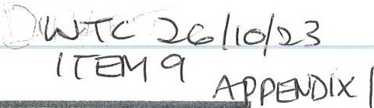
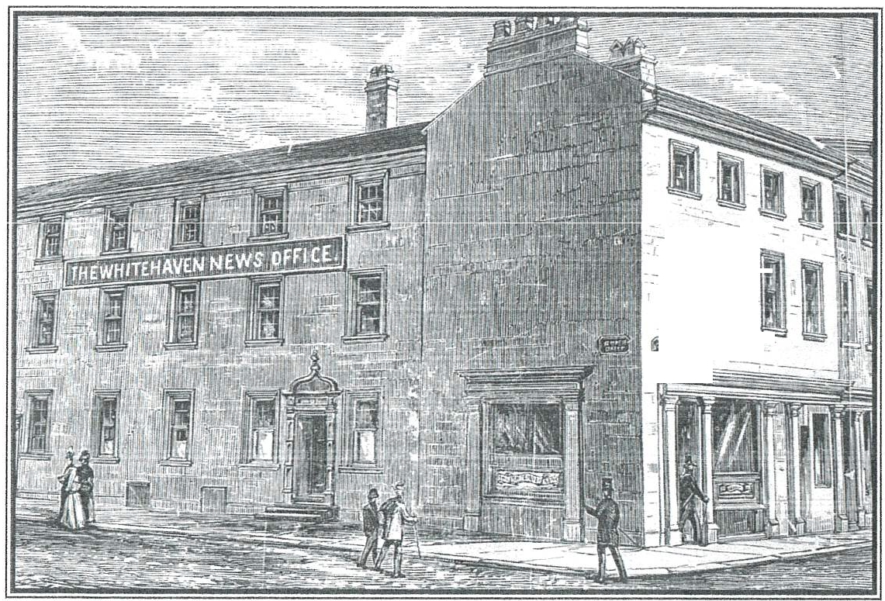
' I

,, ,-
=

A BRIEF HISTORY ABOUT WHITEHAVEN'S TRADITIONAL LOCAL NEWSPAPER.

-- (: :)

.' \,.'.<_ :..: >
. . "·:':'

£:··-- .......
!.- -,.r,.... .S 'rn ,;.· z;-, :
--··.•c-rA .£J
-4. •· ,.L./
,._••.,: \•- •·• I ,. •,. • t,lt •
........,. .....

,.
.. .. J. •.....
......
.·J .

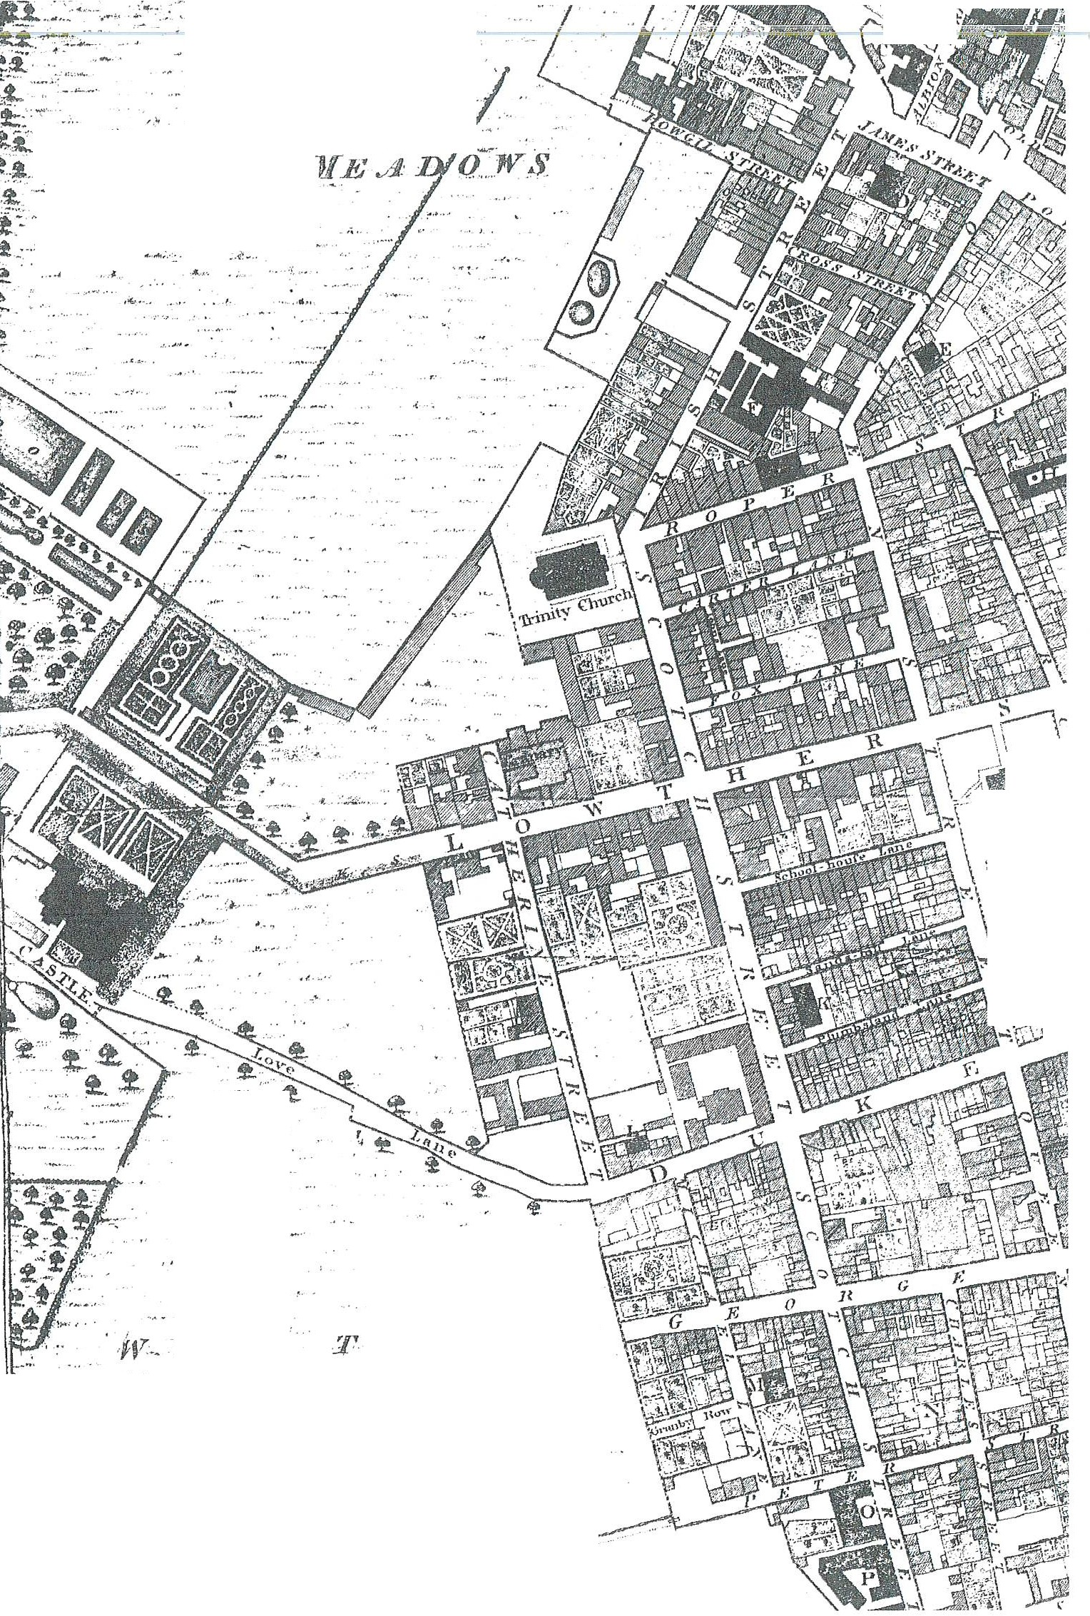

\ t"'
'\
)
\, \.-·-.
:< ;-:•:.-
. '.
.\- \cho\
-:,. ·rn·-.,·l·h
'

.--c'
. t:
.. -·.

.lf. I E-
. •

.&E:f 1{. .w,J,aau.:r,,,;·:: it ' -:.' t:ll ,
, JJr.alf µf .12Chauu-, or 164:,.J:'ordr. , .
/L -#::-
// ,···\·,.:<,:_·

THE WHITEHAVEN NEWS

FOR a town and its people, a local newspaper is not just a source of news and information, but also an essential part of the fabric of a healthy neighbourhood. It plays a crucial role in keeping communities informed and connected, promoting informed debate and in holding local authorities accountable. In today's digital age, with information easily accessible online, the importance of a local paper can be overlooked. However they have a long proud history; local journalists often have a greater understanding of a community's history and culture and their in-depth reporting can provide a catalyst for discussion and interest in local issues. Sadly, modern technology has in many areas of the country sounded the death knell for provincial newspapers. In 2023, The Whitehaven News remains. Though unlikely to reach its former high levels of circulation and household penetration the paper continues to serve its community.

TRADITIONAL local newspaper The Whitehaven News was founded in July 1852 by William Alsop, a bookseller, printer and
A
devout Quaker.
It was developed by his son, also William, who by 1861 had increased its circulation to 4,000 and moved production from his father's small printing shop in King Street to premises at the corner of Roper Street and Queen Street. This building remained the headquarters of The Whitehaven News for 156 years, until 2017.
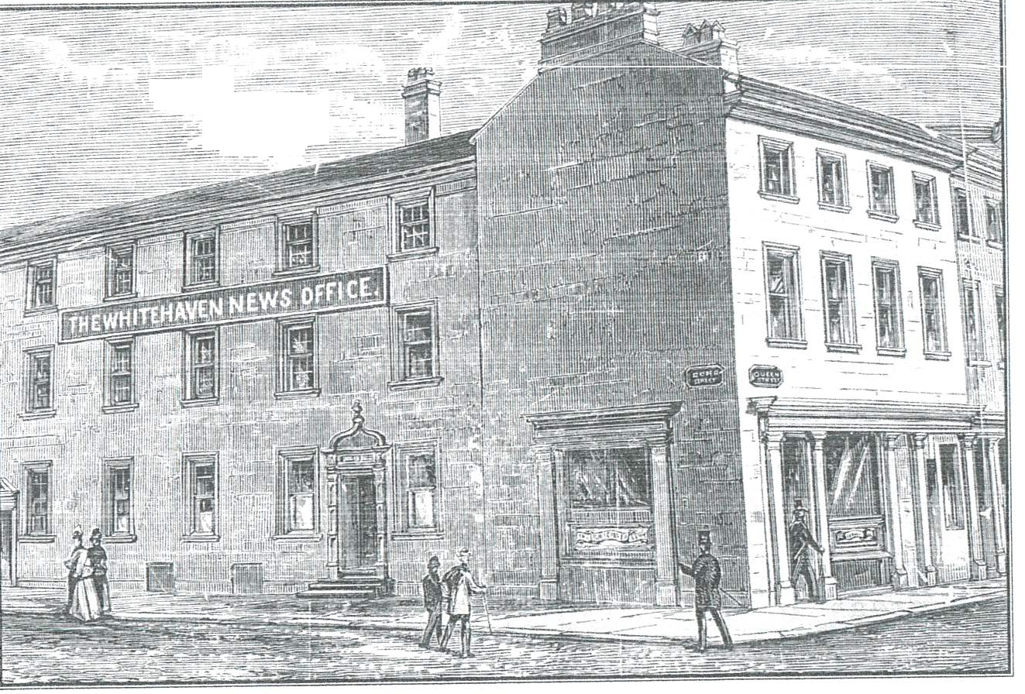
- - -_--i;;:: -- ---
:- - - -; :
-
From an old wood-cut - The original frontage of the Roper-Queen St head office and works in Whitehaven, reconstructed in 1927.

Alsop Jnr sold out in 1878 to Robert Foster who was sole proprietor until 1881 when the paper was registered as a private limited company under its chairman, William McGowan. He was a prominent local businessman, a Liberal and a Congregationalist and was succeeded as principal proprietor and chairman by his son, James McGowan.

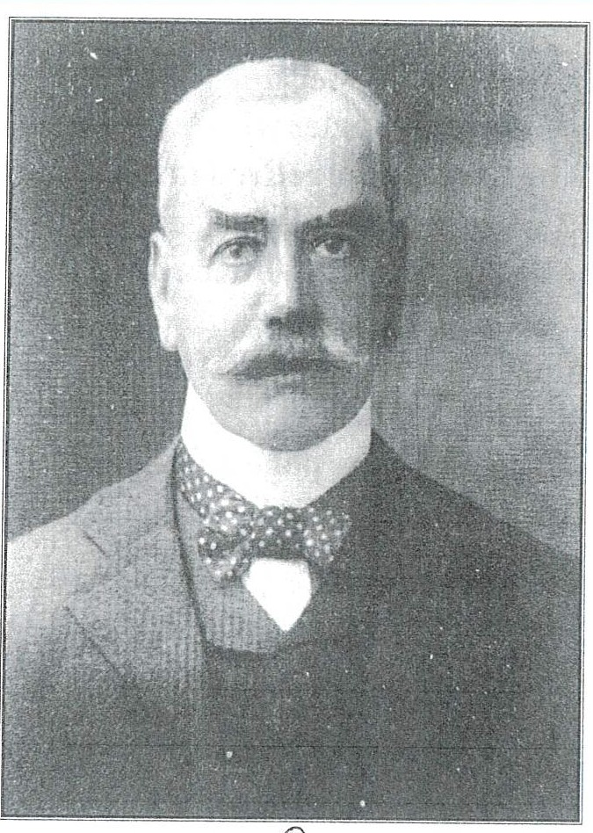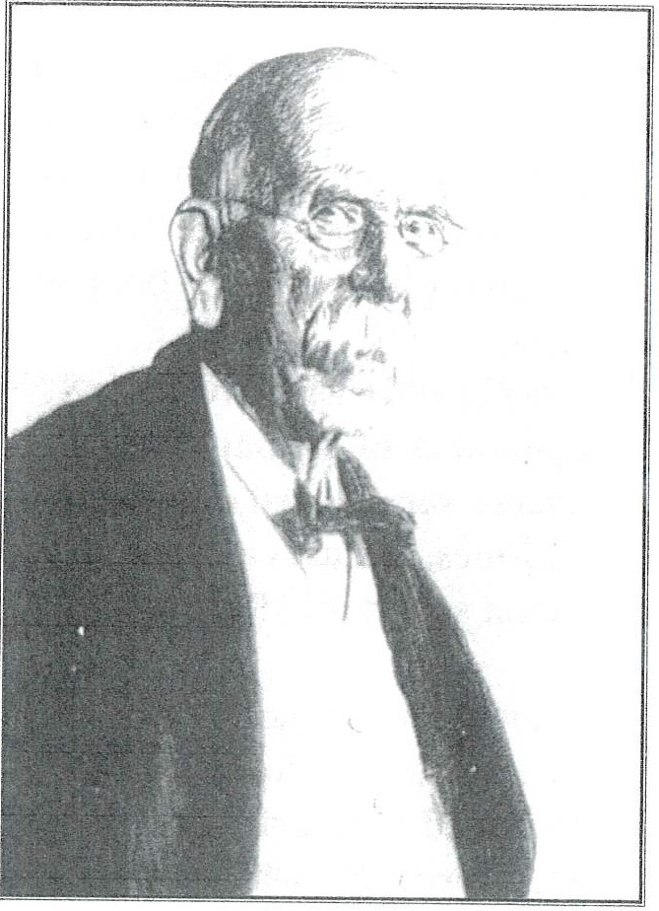

Robert Foster - Form@ editor and sole proprietor until 1881.
William S Newall - Took over as editor in 1961
William McGowan - 49 years a director of Whitehaven News Ltd.
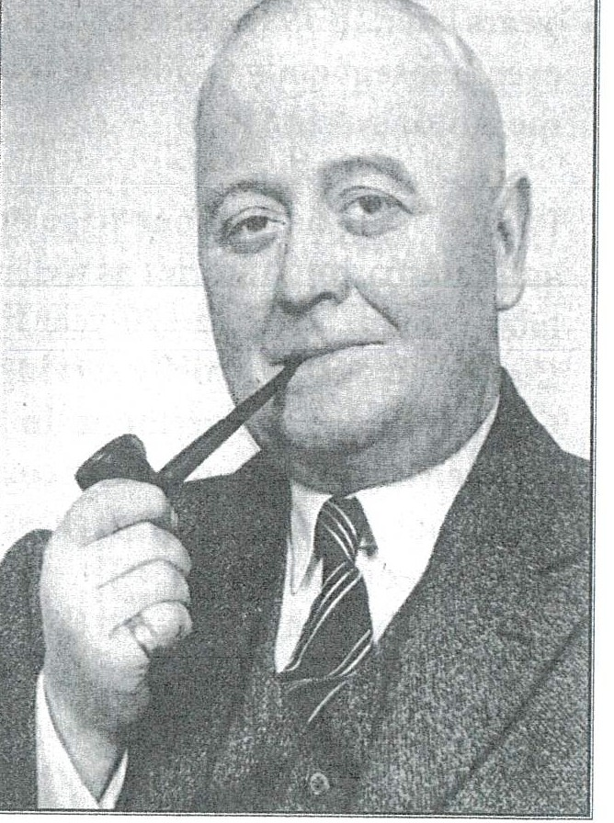

John Roger Williams - Director/manager marked the centenary in 1952 with a book about the history of The Whitehaven News.

After Foster, George Stalker, who wrote with a quill, became the newspaper's second editor, followed by George G Carter who expanded its circulation to over 19,000 by the time he retired in 1961. The paper marked its centenary in 1952 when director/ manager J R Williams put together a book about the history of The Whitehaven News.
It was in 1961 when William S Newall took over as editor that the appearance of the paper changed dramatically. Public notices and adverts were moved onto page 2 and for the first time page 1 featured headlines, pictures and news stories! Egremothian Newall occupied the hot seat until 1967.

When chairman James McGowan died, the Whitehaven News was acquired, in August 1962, by Cumberland Newspapers, but continued to be printed and published at its Queen Street offices until April 1969 when printing was transferred to Carlisle. The
editorial department, however, under editor Walter Thomson, and its advertising operations, remained at Whitehaven. On retirement in 1986 Walter Thomson was succeeded by Roy Maddison and 10
years later, in 1996 Hilary Scott, the paper's first female editor took over. Subsequently Colin Edgar and Deanne Shallcross have occupied the editor's chair.

From its origins as a four-page broadsheet, often featuring national and international stories as well as local news, the paper, now in tabloid form, marks a 170-year history as a strongly-based West Cumbrian weekly, chiefly serving the communities of Whitehaven, Cleator Moor and Egremont. In 2002 it marked its 150-year anniversary with an open-air concert on the harbour given by the Liverpool Philharmonic Orchestra, a popular event enjoyed by
I0,000 people.
The building which housed the Whitehaven News had been leased until 1909 when it was bought from Mr and Mrs John Quayle of Egremont. It was further enlarged by the purchase, in 1923, of 149 Queen Street which for many years had been a successful butchers run by Thomas Wilson.

Plans were drawn up for renovations in three phases - to build a new press and composing rooms (completed in 1925); to demolish the old press and composing rooms; and to rebuild the editorial and commercial offices which involved taking out all the outside walls up to first floor level and creating a new frontage to both Queen Street and Roper Street, with a new corner entrance. The final stage was completed in 1931.
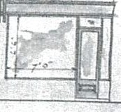
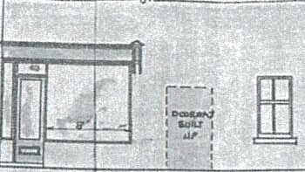
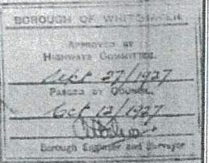
:---,
r::1
I#! !
--..:.J

fl!:VATIQ.1.1 TO R..OPCR.. :ST.
COUWT'Ut.
-! 2
I
(
ti •
- a
l[
I I I I I I I I
I
I I I
I
If)
::;:
LI
ILi
::i
(J
1-l
PR,OP0.5,1:D 5HOP WINDOW AT
J.§_..Q.tft.t: - 51'. l""oR. THE WHITEHAVEtf
.YJ _ws_ !:-._T!·_
5CAL?:._8 _1'1'.f.T TO ! I NCl1.
(--;
·o J•
.
f
ci f
.. .,.
. ,.
& •
......
- - .-,,
PLAU
Plans from 1927 for the new frontage including a corner entrance.
The installation of a more up-to-date press improved the quality of the printing and enabled the size of the newspaper to increase from 8 to 12 pages.

In 1937 Whitehaven News Ltd bought the old Theatre Royal which was next door, on Roper Street. It had opened in 1769 - and dosed in the 1930s after its popularity waned. The old theatre building was converted into a warehouse for the newspaper, then it was demolished in the 1960s for an extension to the print works.

When printing operations moved to Carlisle in 1969 as Cumbrian Newspapers took over the ownership of the title, the space was no longer needed. The auctioneer David King's used it for a time for

regular sales of household goods and antique furniture.
Further alterations were carried out in 1978 when it became Michael Moon's Bookshop (which has since moved to Lowther Street).
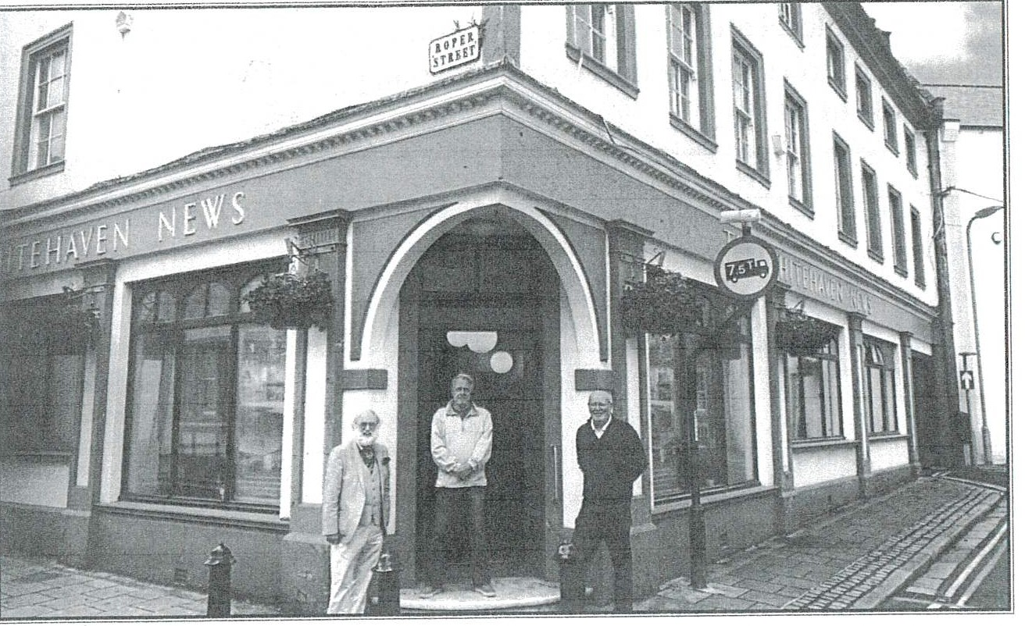
Whitehaven Town Council members outside the former Whitehaven News building.
The Whitehaven News, under its new ownership, Newsquest Ltd, relinquished its tenure of 148 Queen Street in 2017 and the building was put up for sale. It was subsequently bought by the Whitehaven Town Council, which had been formed in May 2015 and needed permanent headquarters. The council moved in on 6 July, 2020 and has its own plans for a major refurbishment which will render the building better suited to its new purpose.

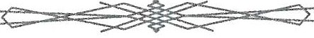

..,._
·-·- "';.-
. r :- 0, • ::.:,;._
•- •
., ... "'

Z.AAT ff' coe To"l·\YN lx.FL:i.R,BOl/,R
OF
WHITE llA"'1rl N
u1, tbe f/c>tm[F.'?/·
C l[T '1J1[ JB JE Jli JL r,;JJ}e7'1/ YJ)
a-l:h,uu(_Q./l.tA;tMJ,y
( .,-
,}f.1Hiow

,.. ·'• :,-· .
\).. ·.• t. .(' !-
•r• :::; • ..:J••t.;•

. : ··i ;:•.:'.
. 'i ·

·','>(><.'· Qq rdr,ns

..i..-. •. w.. .
- ,..,.;, .I., '·
....
,:,.._ -- ,_
. . ., -
- - .....,: ·-
- .,,..
i.i.- -v:d ,s
.
- , ·:•-.,_.
-- -··;.•
- .:··•'··

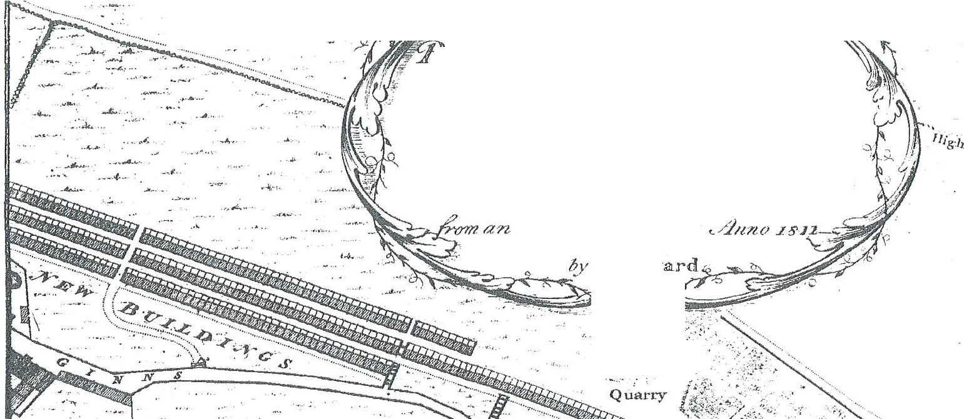
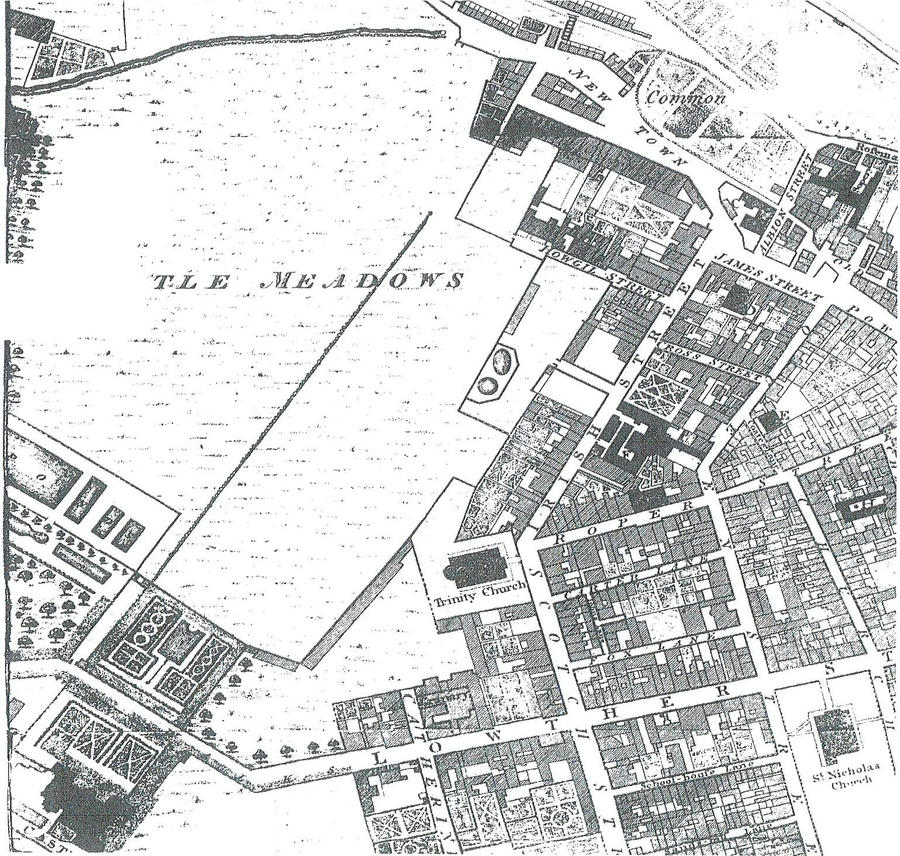
. ...
,......

, .

:.-

The
Whitehaven News

A TRADITIONAL local newspaper The Whitehaven News was founded in July 1852 by William Alsop, a bookseller, printer and devout Quaker.
It was developed by his son, also William, who by 1861 had increased its circulation to 4,000 and moved production from his father's small printing shop in King
Street to premises at the corner of Roper Street and Queen Street. This building remained the headquarters of The Whitehaven News for 156 years.

by Margaret Crosby
October 2023

WTC 26/10/2023

Item 10

HANGING BASKETS
Purpose of the Report and Recommendation

To inform Members of a quote received for the purchase of additional hanging baskets and to consider whether to suspend Financial Regulations in order that the quote be accepted.

1.0 INTRODUCTION

  - Whitehaven Town Council currently supply a total of 167 hanging baskets within the Town Centre.

  - Of these 167, Whitehaven Town Council own 124 with the remaining 43 'loaned' from Cumberland Council.

  - Attached at Appendix 1 is a quote from Amberol, the Councils preferred supplier for an additional 60 hanging baskets. This would mean that the Council would own a total of 184 hanging baskets and would no longer be reliant on a third party for the loaning of hanging baskets. When not in use the baskets are taken down and stored in our secure unit at Sneckyeat.

  - In order to purchase the hanging baskets from the Council's preferred supplier the Council will have to consider suspending Financial Regulation 11 to permit this. In order to suspend Financial Regulation 11, Financial Regulation 18 states that "The Council may by resolution of the Council duly notified prior to the relevant meeting of Council, suspend any part of these Financial Regulations provided that reasons for the suspension are recorded and that an assessment of the risks arising has been drawn up and presented in advance to members of the Council".

  - The reasons for suspension are as follows:

    - It is a value for money product;
    - It is a quality product;
    - The preferred supplier has supplied all of the Town Councils hanging baskets.

Risks:

    - There is a risk that the hanging baskets could be obtained cheaper by another supplier but this is a very small risk.

2.0 BUDGET IMPLICATIONS

2.1 The 2023/2024 Budget for Whitehaven in Bloom is
£12,000.00 and to date £7,814.50 has been spent.

3.0 RECOMMENDATION

3.1 It is recommended that the Council considers making a resolution to suspend the Financial Regulation 11 to allow the hanging baskets to be purchased from the preferred supplier and if making the resolution

3.2 Agree to the reasons for the suspension which will be recorded and also that the assessment above of the risks provided be accepted and approved.

amberol
greener and cleaner
,c. 2.bl10(2023
A M IT-EM to
Amberol Limited A DI'( I.
The Plantation, King Street ALFRETON, Derbyshire DE55 7TT Great Britain
Tel: 01773 830930 Fax: 01773834191
Email: sales@amberol.co.uk Web Site: www.amberol.co.uk

Whitehaven Town Council 148 Queen Street
Quotation

Whitehaven Cumbria CA28 ?AW
Number | Date | Account | For The Attention Of | Valid For
0000019761 | 12/10/2023 | WHI012 | Whitehaven Town Council | 30 Days

Item Code Description Quantity Unit Price

CAS-0P  CARRIAGE | 410mm diameter Self Watering Cup & Saucer 'Anging Basket. With Chains. (Black)  Pallet - Standard delivery and Carriage Charges | 60 | 28.22  54.50 | Each | 1,693.44  54.50
 | Delivery Time is currently three weeks from receipt of official instructions
 | All our Self Watering Planters include both wick and mats - to ensure that plant material receives an even distribution of water
Thank you for this opportunity of quoting for our
product. Please do not hesitate to contact us should you require any further information

Prices shown on this quotation apply to acceptance of the whole quotation.
Any amendment to the quotation will be regarded as a new quotation and the price may vary.

Amberols Standard Terms & Conditions of sale apply All Amounts in Pound Sterling | Quote Amount | £ 1,747.94
Your consultant will be North | TOTAL VAT | £ 349.59
 | TOTAL GROSS | £ 2,097.53
Amberol offers all customers a 5 year guarantee agamst defects m materials and workmanship (from date of purchase)* tem1s and conditions may apply to certain products.

Registered in England No 950595 VAT Registration No 126 6416 75 on behalf of Amberol Limited

WTC 26/10/2023

Item 12

REMEMBRANCE SUNDAY 2023

Purpose of the Report

To approve additional expenditure for the Remembrance Sunday Parade on 12th November 2023 and to inform Members about the decision received from Cumberland Council in respect of the Road Closure Orders.

  - INTRODUCTION

  - The Whitehaven Brass band has informed the Council that they will be in Castle Park as they are not able to march with the procession. They will start playing a marching beat when the parade approaches Castle Park and when the parade exits the park. They will also play the chosen hymn and The National Anthem. The cost has yet to be confirmed but is expected to be in the region of £250.00 (last year it was £210.00).

  - Cumberland Council have informed us that the Road Closure Order fee of £133.00 each has been waived for Remembrance Sunday. Our thanks to Counci1lor Emma Williamson for her help with this matter.

  - The expenditure for Remembrance Sunday will be under Section 137 of the Local Government Act 1972. Where there is no alternative power and no statutory provision the Council can incur expenditure under s.137. The Council has firstly to be satisfied:

    - That there is a direct benefit to the area or part of the area, or to some or all of the inhabitants, and
    - secondly the Council must ensure that the direct benefit accruing to its area or residents is commensurate with the expenditure incurred.

2.0 RECOMMENDATION

  - That Members approve the additional expenditure of approx.
£250.00 for Whitehaven Brass Band and;

  - The information relating to the Road Closure Orders is noted.

WTC 26/10//2023

Item 14

CHRISTMAS CLOSING
Purpose of the Report and Recommendation

To consider Christmas closing for the Council's Office..

  - INTRODUCTION
  - The Council's Office is normally closed between Christmas and
New Year. This year Christmas day is on a Monday and Boxing Day in on a Tuesday.

RECOMMENDATION

  - That the Council Office closes at noon on Friday 22th December 2023 and re-opens on Tuesday 2nd January 2024.

