3

Whitehaven Town Council Notice of conclusion of audit
Annual Governance & Accountability Return for the year ended 31 March 2022

Sections 20(2) and 25 of the Local Audit and Accountability Act 2014 Accounts and Audit Regulations 2015 {SI 2015/234)

- The audit of accounts for Whitehaven Town Council for the year ended 31 March 2022 has been completed and the accounts have been published.

- The Annual Governance & Accountability Return is available for inspection by any local government elector of the area of Whitehaven Town Council on application to:

(a)

(b)

- Copies will be provided to any person on payment of£ I, 09{c) for each copy of the Annual Governance & Accountability Return.

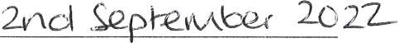
Announcement made by: (d) Date of announcement: (e)
Notes

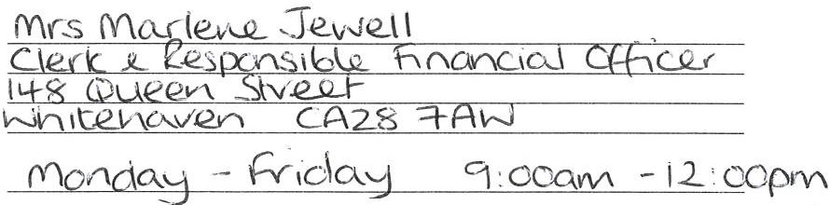This notice and Sections 1. 2 & 3 of the AGAR must be published by 30 September. This must include publication on the smaller authority's website.
The smaller authority must decide how long to publish the Notice for: the AGAR and external auditor report must be publicly available for 5 years.

- Insert the name, position and address of the person to whom local government electors should apply to inspect the AGAR

- Insert the hours during which inspection rights may be exercised

- Insert a reasonable sum for copying costs

- Insert the name and position of person placing the notice

- Insert the date of placing of the
notice

, www.pkf-l.com

